**3GPP TSG-RAN WG4 Meeting #94-e draft R4-2002437**

**Electronic Meeting, 24 Feb. – 6 Mar., 2020**

**Source:** Huawei

**Title:** TP to the TR 37.941: OTA measurement systems

**Agenda Item:** 8.19.2

**Document for:** Agreement

# Introduction

In this contribution we provide TP to External TR on OTA BS testing for the OTA measurement systems section.

Technical content is based on the draft TR shared on the RAN4 Drafts reflector before the e-meeting. Technical content is sourced from the following legacy TRs (indicated by individual Track Changes IDs), with additional text corrections applied by the Rapporteur:

* TR 37.842, v13.3.0
* TR 37.843, v15.6.0
* TR 38.817-02, v15.6.0

Structure of sections is based on the TR Skeleton as in [2].

# References

[1] RP-193225 Over the air (OTA) base station (BS) testing TR, WID

[2] R4-2001807 Skeleton for TR 37.941 on OTA BS testing, Rel-15

# TP to the External TR on OTA BS testing

*------------------------------ Modified section ------------------------------*

# 7 OTA measurement systems

## 7.1 General

All the measurement systems are described for measurement in Normal test conditions, unless otherwise stated.

## 7.2 Indoor Anechoic Chamber

### 7.2.1 Measurement system description, Normal test conditions

This method measures the EIRP in an anechoic chamber with the separation between the manufacturer declared coordinate system reference point of the BS and the phase centre of the receiving antenna of no less than 2D2/λ, where D is the largest dimension of the antenna of BS and λ is the wavelength. The measurement system setup is as depicted in figure 7.2.1-1 for TX requirements, and in figure 7.2.1-2 for RX requirements.

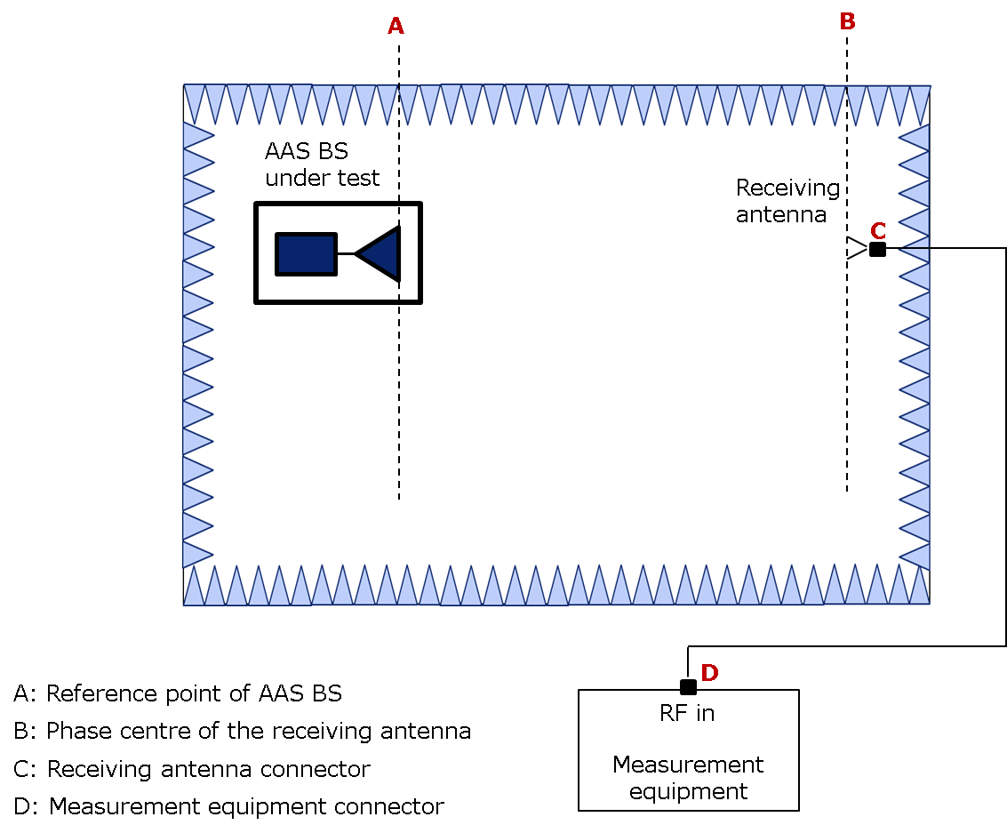

Figure 7.2.1-1: IAC measurement system setup for TX requirements

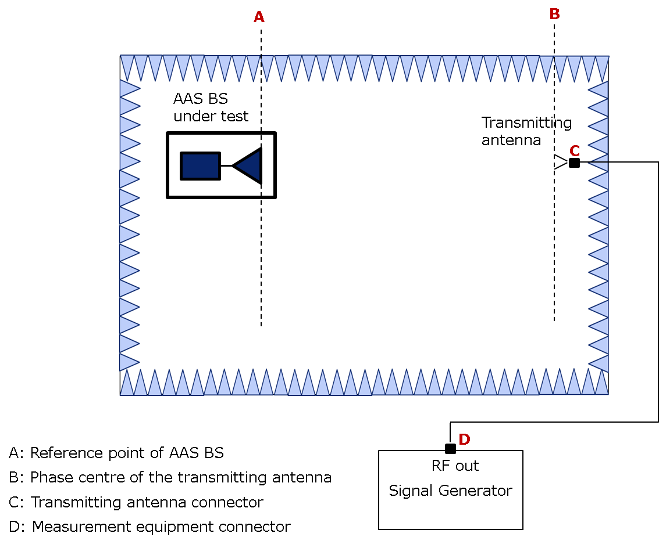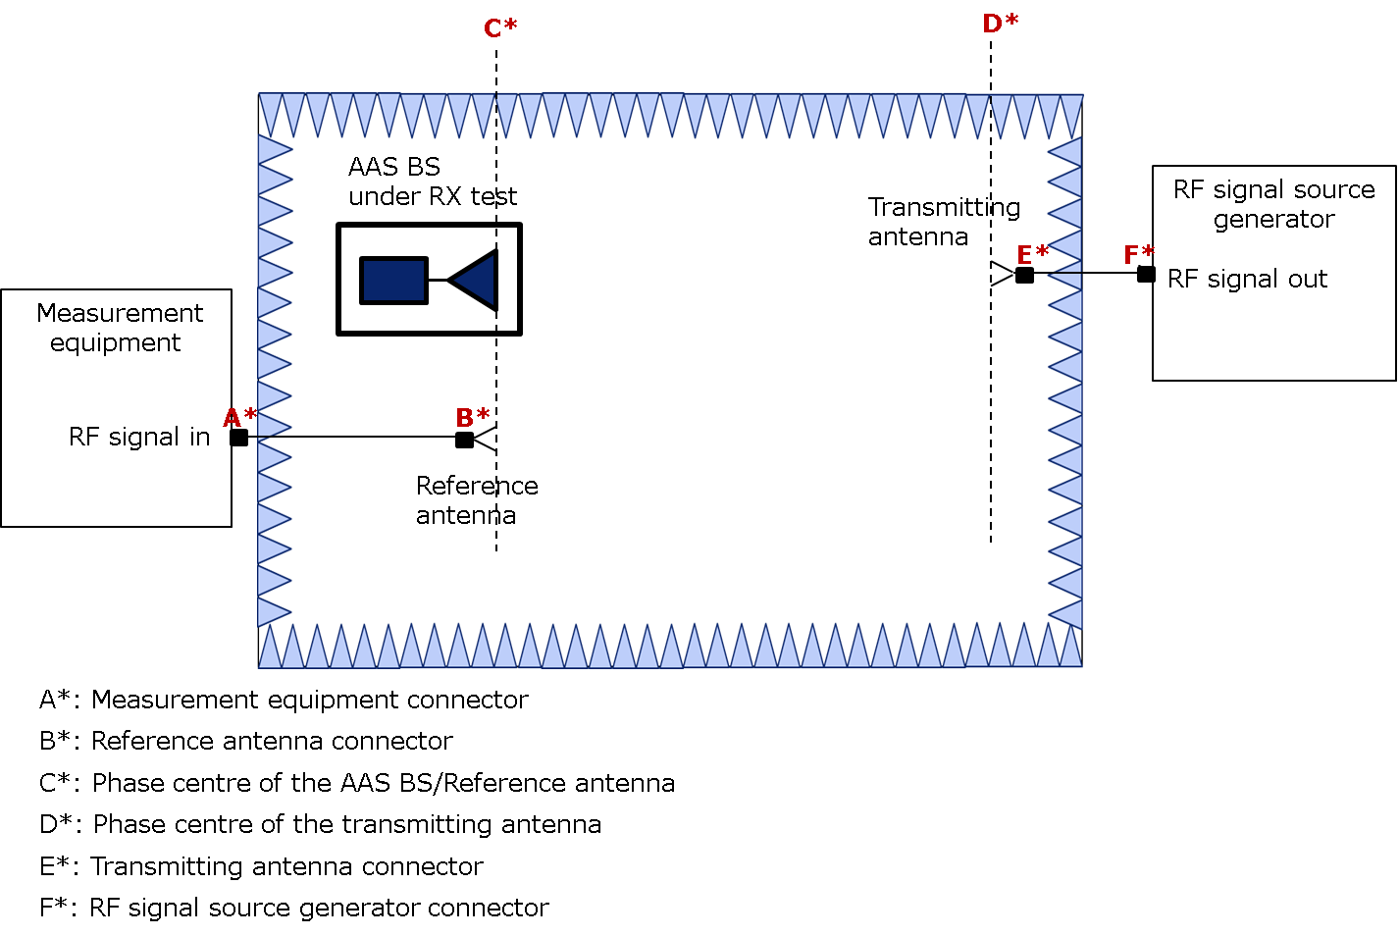

Figure 7.2.1-2: IAC measurement system setup for RX requirements

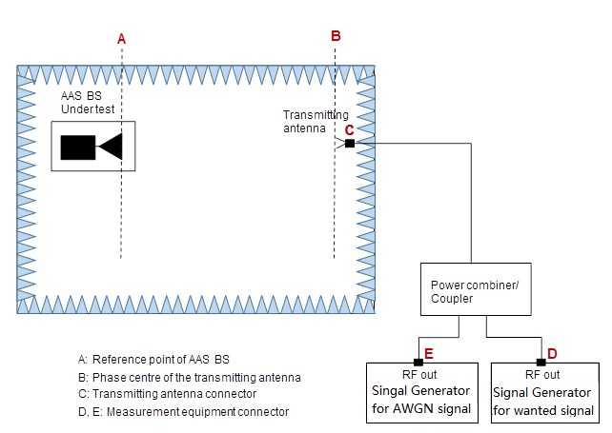

Figure 7.2.1-3: IAC measurement system setup for OTA dynamic range



Figure 7.2.1-4: IAC measurement system setup for adjacent channel selectivity, general blocking, narrowband blocking and in-channel selectivity



Figure 7.2.1-5: IAC measurement system setup for OTA receiver intermodulation



(a) General set-up (top view)  
(Positioner is not described here)

Figure 7.2.1-6: IAC measurement system setup for co-location requirements

### 7.2.2 Measurement system description, Extreme test conditions

This method places the BS under test inside a RF transparent environmentally sealed enclosure so that the BS temperature can be controlled whilst the result of the OTA chamber facility is at nominal temperature.

The separation between the manufacturer declared coordinate system reference point of the BS and the phase centre of the receiving antenna of no less than 2D2/λ, where D is the largest dimension of the antenna of BS and λ is the wavelength. The measurement system setup is as depicted in figure 7.2.2-1.



**Figure 7.2.2-1: IAC measurement system setup for EIRP accuracy, Extreme test conditions**

### 7.2.3 Test method limitations

The maximum size of the BS is a chamber restriction that would affect the quality of the quiet zone. For larger BS sizes larger size chambers should be considered such that the uncertainty of the quiet zone is taken into account.

## 7.3 Compact Antenna Test Range

### 7.3.1 Measurement system description, Normal test conditions

In case of TX requirements measurement, the Compact Antenna Test Range (CATR) uses the BS which radiates a wavefront to a range antenna reflector which will then collimate the radiated spherical wavefront into a feed antenna. The sufficient separation between the BS and the receiver (feed antenna shown in figure 7.3.1-1) so that the emanating spherical wave reaches nearly plane phase fronts from transmitter to receiver. The BS transmits a wavefront that will illuminate the range antenna reflector, which will then reflect the transmitted energy into the feed antenna. The range feed antenna is connected to a vector network analyzer or other equivalent test equipment.



Figure 7.3.1-1: CATR measurement system setup, TX requirements

In case of RX requirements, the CATR uses the feed antenna which radiates a spherical wavefront to a range reflector antenna which will then collimate the radiated spherical wavefront to the EUT. There is sufficient separation between the EUT and the transmitter (feed antenna shown in figure 7.3.1-2) so that the emanating spherical wave reaches nearly plane phase fronts from transmitter to receiver. The feed antenna transmits a wavefront that will illuminate the range antenna reflector, which will then reflect the transmitted energy towards the EUT.



Figure 7.3.1-2: CATR measurement system setup, RX requirements

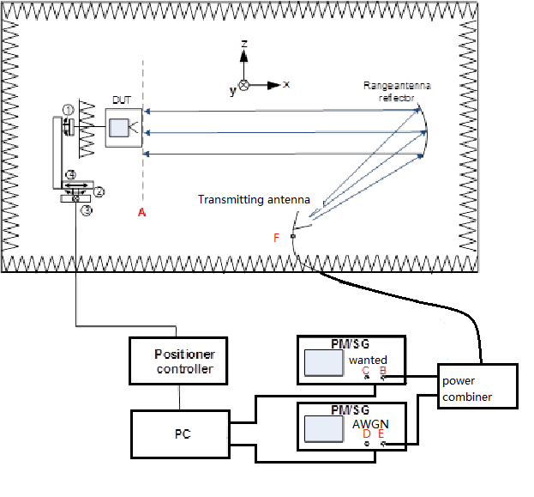

Figure 7.3.1-3: CATR measurement system setup, RX OTA dynamic range, ACS, general blocking and narrowband blocking

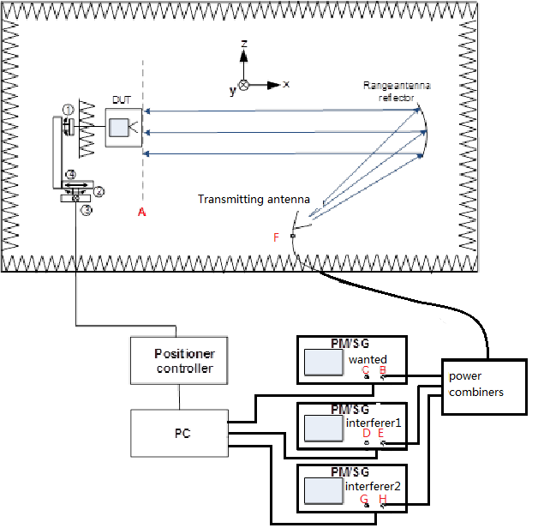

Figure 7.3.1-4: CATR measurement system setup, OTA RX IMD

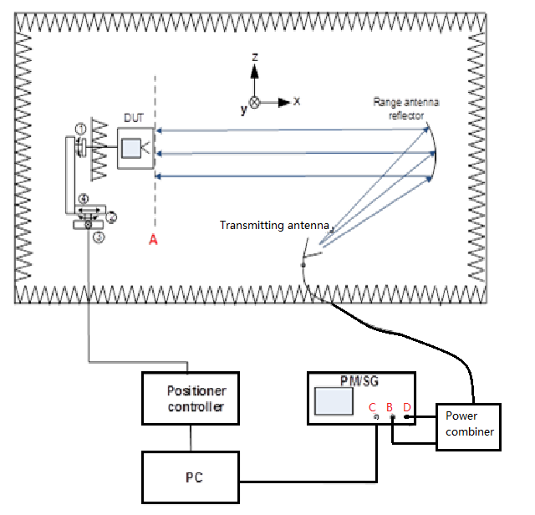

Figure 7.3.1-5: CATR measurement system setup for OTA ICS

### 7.3.2 Measurement system description, Extreme test conditions

This method places the BS under test inside a RF transparent environmentally sealed enclosure so that the BS temperature can be controlled whilst the result of the OTA chamber facility is at nominal temperature.

The Compact Antenna Test Range (CATR) uses the BS which radiates a wave front to a range antenna reflector which will then collimate the radiated spherical wave front into a feed antenna. The sufficient separation between the BS and the receiver (feed antenna shown in figure 6.3.3.1-1) so that the emanating spherical wave reaches nearly plane phase fronts from transmitter to receiver. The BS transmits a wave front that will illuminate the range antenna reflector, which will then reflect the transmitted energy into the feed antenna. The range feed antenna is connected to a vector network analyzer or other equivalent test equipment.

For the environmental control of the BS required to produce the extreme temperature environment the BS under test is placed inside a RF transparent environmentally sealed enclosure so that the EUT temperature can be controlled whilst the result of the OTA chamber facility is at nominal temperature.



Figure 7.3.2-1: CATR measurement system setup for EIRP accuracy in Extreme test conditions

### 7.3.3 Test method limitations

The maximum size of the BS is a chamber restriction that would affect the quality of the quiet zone. For larger BS sizes larger size chambers should be considered such that the uncertainty of the quiet zone is taken into account.

The CATR is not suitable for low frequency measurements.

## 7.4 One Dimensional Compact Range

### 7.4.1 Measurement system description

The principle of the One Dimensional Compact Range measurement setup is shown in figure 7.4.1-1. It closely resembles the standard compact range chamber. But for the generation of the plane wave in the quiet zone the proposed method uses a special one dimensional probe instead of the standard set up comprising a concave mirror and a feed horn. The main advantage is a reduced chamber size and a simplified probe system replacing the standard mirror feed horn set up.

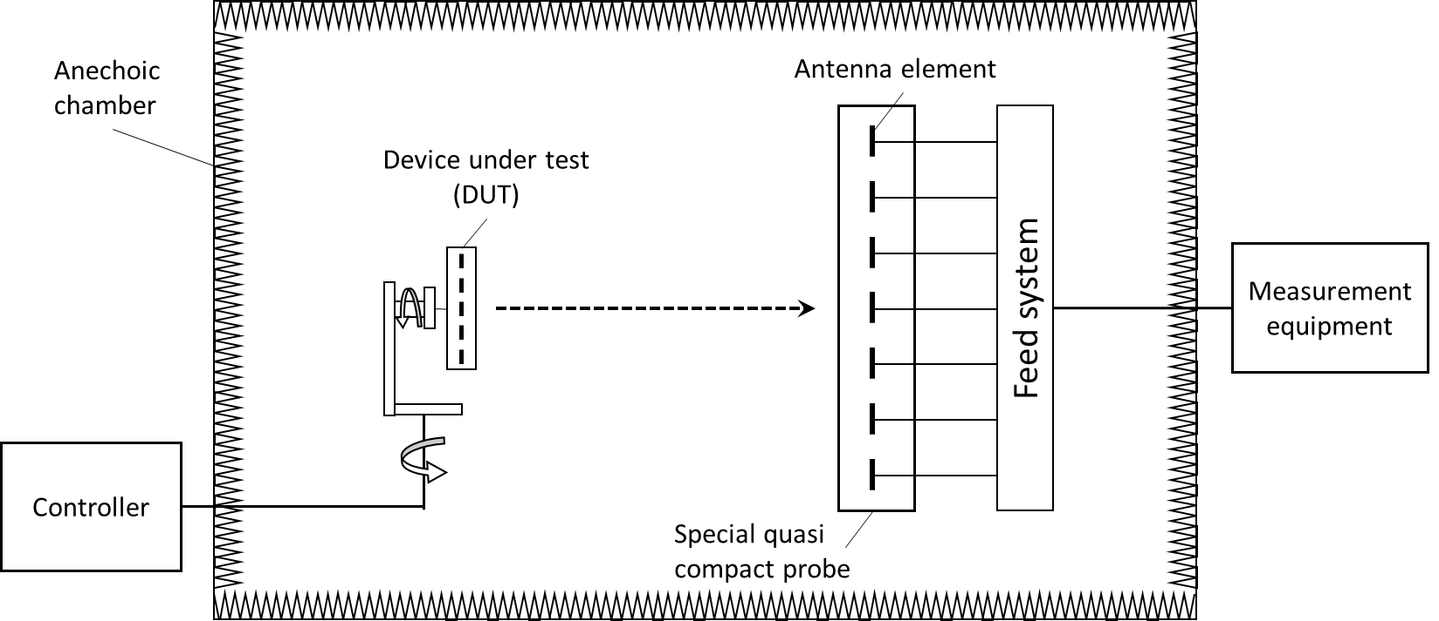

Figure 7.4.1-1: One Dimensional Compact Range measurement  
system setup for EIRP accuracy

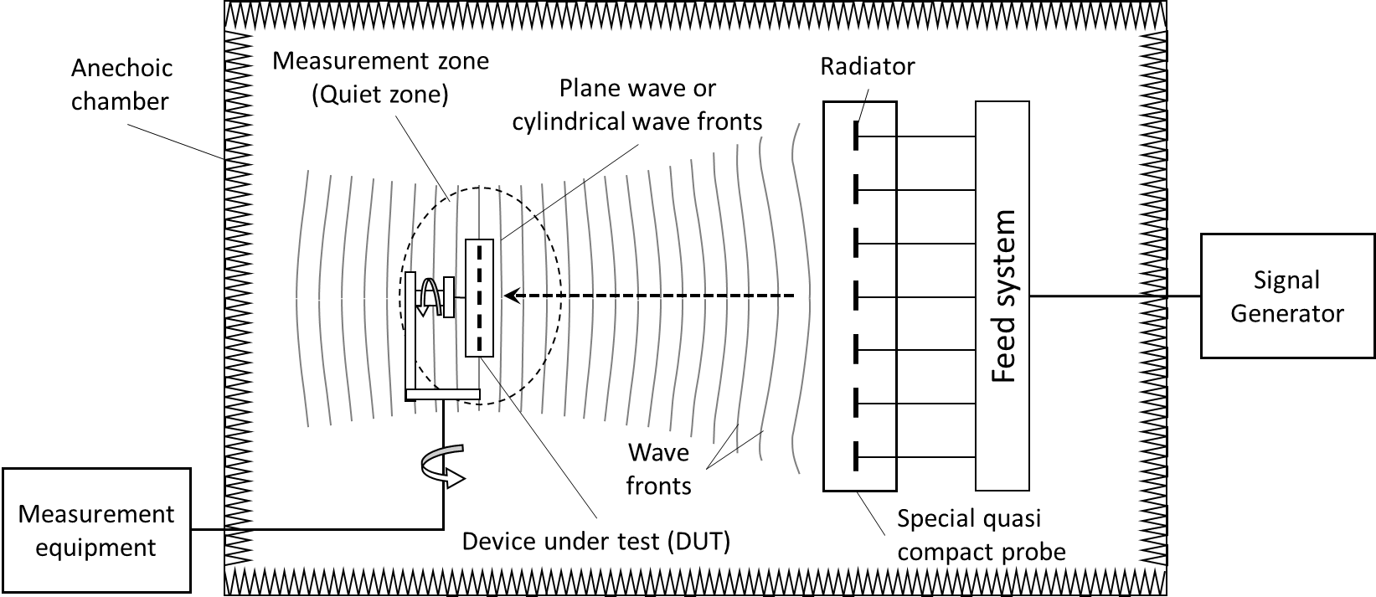

Figure 7.4.1-2: One Dimensional Compact Range measurement  
system setup for OTA sensitivity

The probe antenna is set up of a one dimensional array of antenna modules, connected by a special feed system. Optimized amplitude and phase settings in the feed system result in a plane wave in vertical direction. As no near field to far field transformation has to be carried out, it is not required to measure a whole set of azimuth and elevation angles.

### 7.4.2 Test method limitations

One Dimensional Compact Range test method is only suitable for BS whose *antenna array* consists of a single column *antenna array*. For a BS equipped with multi-column *antenna array*, this method would not be suitable due to the high amplitude uncertainty of edge column elements. High amplitude uncertainty makes testing of the declared steering angles not possible to meet EIRP accuracy requirements.

## 7.5 Near Field Test Range

### 7.5.1 Measurement system description

The Near Field Test Range (NFTR) measurement techniques consist in measuring amplitude and phase of the modulated signal at the BS under test, on some specific surfaces such as planar, cylindrical, and spherical. Each of the near field test methods can be implemented by one or more mechanical rotations of the probe and/or BS under test as shown in figure 14.4.1-1. One or more mechanical movement can be substitute by a probe array. All the scanning methods will need an RF transmit and receive system equipped with an automated scanning, a data collection and control system, and computerized analysis ability.

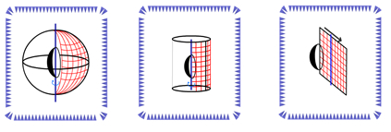

Figure 14.4.1-1: Probe/scanner near field systems: spherical, cylindrical and planar

NOTE: Although there are three methods available for obtaining the near field data, the spherical method is used as a working example.

In case the radiated field is sampled on a sphere surrounding completely the BS under test, the 3D full sphere value of the measured parameter can be measured in near field when the BS is:

- transmitting (for TX requirements) a defined modulated signals in a declared beam, or

- receiving (RX requirements) a defined modulated signals.

The near field measurement technique would imply the use of mathematical artefact, NF to FF transform in order to have the measured parameter’s value the in far field. The near field to far field transform is based on the well-known Huygens-Fresnel principle. The spherical modal wave expansion is the implicit application of the Huygens principle. A direct solution of the Helmholtz equations is found by applying boundary conditions on the surface S at infinity. From the tangential fields over the surface, the modal coefficients can be determined using the orthogonality of the modal expansion. Based on this formulation, the near field sampling criteria does play an important role.

### 7.5.2 Test method limitations

#### 7.5.2.1 OTA EVM measurement

For BS implementations that point a beam in the EVM conformance direction during testing, the near field technique may report too high, but will never report too low EVM. In case the BS does not point a beam centre in the test direction, there is a risk of the near field technique report too low EVM.

#### 7.5.2.2 OTA RX directional requirements

There are some limitations on the use of that the BS must not have any BB beam forming. Considering that BS must have at least 8 TRX the probability of it meeting the restrictive conditions is small. In addition there are some issues surrounding the interference requirements when testing in the near field as the wanted and interfering signal may experience different beam forming.

#### 7.5.2.3 OTA sensitivity measurement

The near field test method is suitable for OTA sensitivity measurement of BS implementations where the beam forming is done on in a fixed or pre-set manner for the measured OSDD declaration, i.e. there is only one interface to digital/baseband processing. The near field test method is not suitable if for the measured OSDD declaration any combining is not fixed or preset. Some examples of architectures for which near field test method is possible and for which it is not possible are depicted on figure 10.3.2.1.4.2-2. The BS under test should not have any other non-linear behaviour that would cause the near field to far field transformation to fail or cause increased OTA sensitivity measurement uncertainty (for example, Automatic Gain Control if applicable must be disabled and the receiver dynamic range must be sufficient to prevent any increased measurement uncertainty due to the range of the near field values.

 

Figure 7.5.2.3-1: Examples of limit of OSDD functionality testable  
with near field test method for a single OSDD

 

Figure 7.5.2.3-2: Examples of limit of OSDD functionality not testable  
with near field test method for a single OSDD

## 7.6 Plane Wave Synthesizer

### 7.6.1 Measurement system description

This method is a natural extension of a CATR measurement method as captured in subclause 9.2.3, where the reflector is replaced by an antenna array, or Plane Wave Synthesizer (PWS), capable of approximating a plane wave within a specified quiet zone in front of the antenna in a similar manner as the reflector in a CATR system.

The principle of the Plane Wave Synthesizer is shown in figure 7.6.1-1:

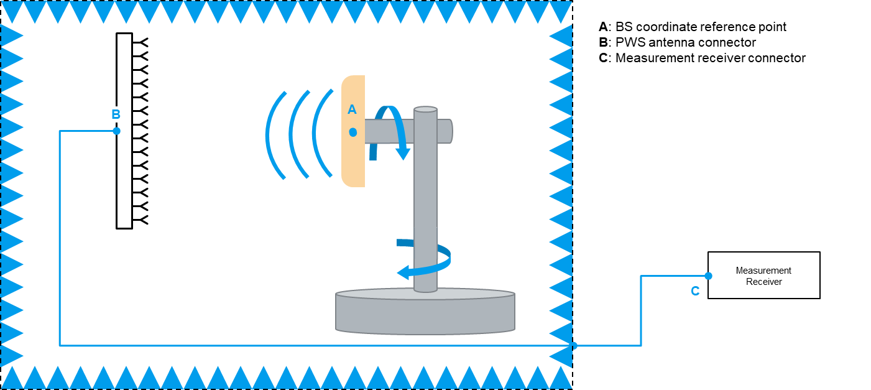

Figure 7.6.1-1: PWS test system diagram

The PWS typically consists of two main components: the *radiating elements* arranged in the structure of an array and the feeding system. The architecture of the later depends on the adopted technology, e.g. it could be fed by a standard Beam Forming Network (BFN) or by an active system.

Using similar technique of setting the phase and amplitude of the array signals, a quiet zone containing planar waves as a linear superposition of the array elements' spherical radiation waves can be created within the near field of the array.

The PWS can achieve far-field testing conditions in a Quiet Zone (QZ) as in the case of CATRs it enables direct measurements of far-field BS performance in a controlled indoor environment as an alternative to CATR.

### 7.6.2 Test method limitations

The maximum rated Power Density (PD) per section of the PWS area (e.g. dBm/cm2) might be restricted depending on the implementation. This Power Density at a specific reference plane can be calculated for each BS as a function of the total radiated power, the test distance and the radiation pattern of the BS.

## 7.7 General chamber

### 7.7.1 Measurement system description

TBD

## 7.8 Reverberation chamber

### 7.8.1 Measurement system description

A reverberation chamber (RC) is an electrically large shielded metal enclosure that employs one or several “stirring” methods to randomize the fields, such as moving paddles, turntables, etc. In this way, a large number of uncorrelated samples is obtained. The volume in the room where the field is well-stirred is the working volume. Here the E-field, averaged over an entire stirring cycle, is independent of the location in the room, i.e. the field is spatially uniform.

For a proper analysis of the measured data a sufficient number of uncorrelated samples is required. The auto-correlation function is used to calculate the offset between statistically uncorrelated samples using the following expression [11]:

where the modulus operator mod(x,y) is the remainder of x/y, here performing a circular shift of the measurement samples over a distance k. The symbols ⟨x⟩ and σ = "std" (x) denote the average value and standard deviation. The threshold value for uncorrelated samples is defined as [11]:

$k_{lim}≤0.37(1-7.22/N^{0.64})$

The distance $k_{lim}$ $k_{\text{lim}}$ between uncorrelated samples is calculated as the minimum k-value satisfying $r\left(k\right)≤r_{\text{lim}}$. The number of uncorrelated samples is calculated as:



When properly designed, this facility can be used for non-directional antenna measurements, such as TRP. In fact, a well-stirred RC is capable of measuring TRP in a reliable way, regardless of the directivity pattern of the emission or frequency range. When measuring TRP of sources with a directive pattern, special care must be taken to characterize the working volume of the chamber.

The purpose of the chamber characterization is to ensure that the effect of a non-uniform field distribution in the chamber has a negligible influence on the measurement result when the BS is placed in the working volume. Lack of chamber uniformity is a major contributor to measurement uncertainty in reverberation chambers and should be handled with care.

The uniformity test can be quite time consuming and the test can be performed separate from the BS measurement. Due to the non-negligible size of BS equipment the BS can have a significant influence on the uniformity. To take this effect into account, either the BS itself must be present in the room during characterization or an absorber with dimensions equal or larger than the BS must be placed at the BS’s location in the room.

The characterization procedure consists of placing a reference transmitter antenna (REF TX ant) at different locations and with different orientations in the room and measuring the Power Transfer (PTF) function between the REF TX and chamber’s RX antenna, see figure 7.7.1-1. The actual mode of RC operation shall be used, including stirrer movement, BS movement, diversity antenna usage, etc. The directivity of the REF TX ant will influence the spatial uniformity of the room, a more directive REF TX ant is better at detecting parts of the room that are less-well stirred. Therefore, the REF TX ant chosen for the uniformity test should excite the chamber in a similar way as the BS.

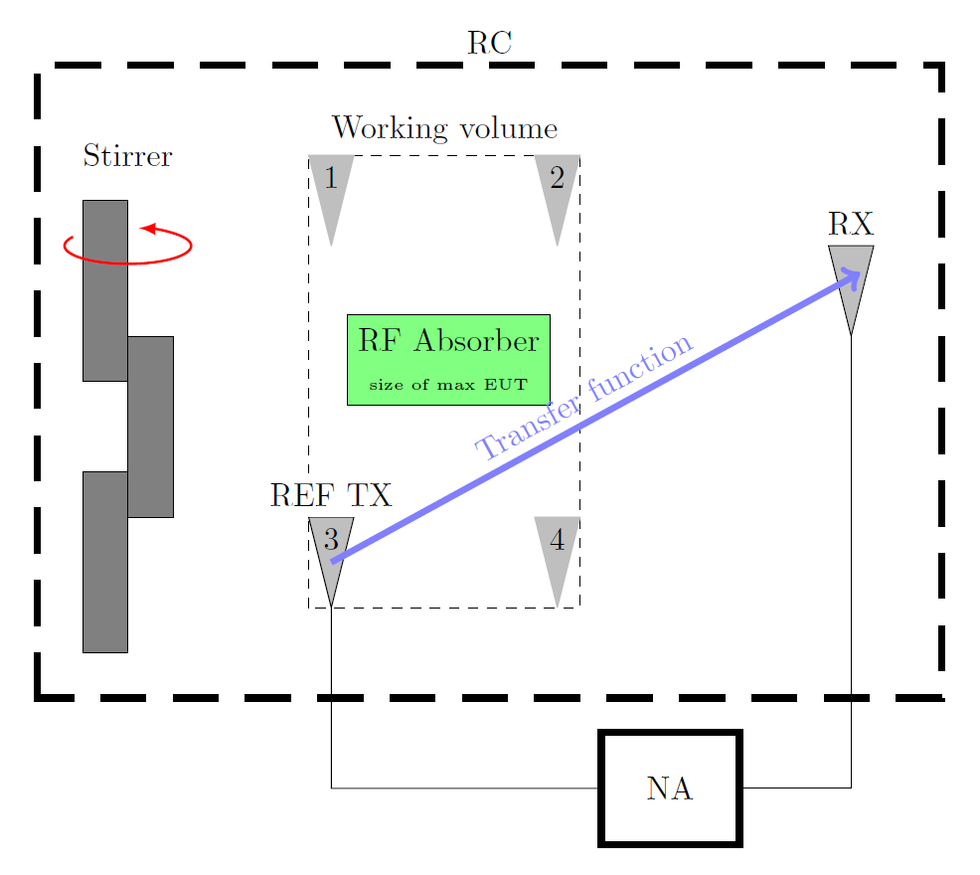

Figure 7.7.1-1: Setup for characterization of a reverberation chamber

The working volume shall be at least half a wavelength from the chamber walls and other electromagnetic reflective objects according to [12]. According to [11] this distance may be restricted to 0.75 m below 100 MHz. The number of positions and orientations to use depends on the chamber size and the directivity of the REF TX ant. Measurements made at positions and orientations at the edges of the working volume are used to characterize the chamber and derive certain components of uncertainty.

The exact number of positions and orientations remain for further study, but at least (3) uncorrelated locations should be used and (6) uncorrelated orientations per position when directive spurs are to be detected.

Different test equipment set ups can be used for the acquisition of the PTF between REF TX and RX. Such as devices capable of directly extracting the PTF, like a Vector Network Analyzer (VNA) or a set up with separate transmitter and receiver test equipment, such as a Signal Generator (SG) and Spectrum/signal Analyzer (SA) configuration. In the latter case the operator should account for the losses in the set up originating from cables, mismatch, etc.

When using a VNA, the REF TX ant and the measurement receive antenna (RX) are connected to the test equipment. For each location/orientation *n* of the REF TX ant, RC sample, and desired frequency *f $f$*, the power transfer function

$P_{n}=〈{\left|S_{21}\right|}^{2}〉$

is measured. The explicit dependence on RC sample and frequency is not written out here.

In case of using a SG and SA the PTF is calculated as follows:

$P_{n} = \frac{〈\left|{U_{r}}^{2}\right|〉}{50 P_{t}M_{t}L_{s}}$

with Ur the received voltage, 50 Ω being the reference impedance of the SA, Pt the transmit power of the signal source, Ls the losses in in the cables, Mt the mismatch efficiency at the TX antenna calculated as $M_{t}= 1-{\left|S_{11}\right|}^{2}$.

At least 250 uncorrelated samples shall be used per position/orientation. Using a lower number is not compatible with the underlying analysis on measurement uncertainty, see [11, 13].

The following tests are performed and shall be verified for each frequency:

a) Uniformity of transfer function: For each location/orientation evaluate $P_{n}$*Pn*. The standard deviation of these average values shall be below the assumed measurement uncertainty level for UID 9, captured in table xx.

b) Dynamic range: The dynamic range of each $P_{n}$*Pn* shall be at least 20 dB.

c) Uncorrelated samples: At least 250 uncorrelated samples shall be used.

It is important to note that spatial uniformity (and number of uncorrelated samples) in an RC is harder to achieve for more directive antenna patterns. As such, the measurement uncertainty of a sub-optimally configured room will be higher and additional measures to randomize the fields should be considered. Optimization of the BS position in the chamber and positional stirring are good starting points.

### 7.8.2 Test method limitations

The reverberation chamber test method is not suitable for testing spurious emissions at very low frequencies. The MU evaluation is applicable for the frequency above 380 MHz.

*----------------------------- End of modified section ------------------------------*