3GPP TSG-RAN WG4 Meeting #94-e R4-20xxxxx
Electronic Meeting, Feb.24th – Mar.6th 2020

Agenda item: xx.xx.xx
Source: Moderator (Apple)
Title: Email discussion summary for RAN4#94e_#61_NR_RF_FR2_req_enh_RRM
Document for: Information

Introduction
Two RRM core requirements related aspects are identified in Rel-16 FR2 RF enhancement WI. One is related to MRTD in FR2 and the other is related to non-simultanous UL transmission
List of candidate target of email discussion for 1st round and 2nd round
- 1st round:
  - 8.14.2 RRM core requirements (38.133) [NR_RF_FR2_req_enh]:
  - 8.15.1.9 Non-simultaneous UL carrier operation in FR2
- 2nd round: TBA

Topic #1: RRM for inter-band CA in FR2
Main technical topic overview. The structure can be done based on sub-agenda basis.

Companies’ contributions summary
T-doc number | Company | Proposals / Observations
R4-2000456 | MediaTek | Observation 1: Given no deployments or devices for FR2 inter-band CA at this moment, the concern of backward compatibility due to revising the MRTD requirements should not be a problem here  Observation 2: According to current inter-band CA MRTD and TAE requirements, the max difference in propagation delay is 1500m which is obvious an over design of the FR2 system. It is possible to reduce the MRTD so that we can save some UE complexity without scarifying the flexibility in FR2 deployment.  Proposal 1: To align with the discussion in FR session, RRM session should also consider 2 different MRTD requirements for FR2 inter-band CA from the same group (28+28 or 39+39) and different groups (28+39).  Proposal 2: Revise the MRTD requirement for FR2 inter-band CA to  - Within the same group (28+28 or 39+39): 260ns  - Across different groups (28+39): [4 or 5]us
R4-2000786 | Apple | Proposal 1: reduce the MRTD for FR2 inter-band CA to 4us: Max propagation delay difference is 1us.  Proposal 2: If the DL symbols are not SSB symbols or CSI-RS symbols or RSSI symbols for mobility measurement, it is UE implementation issue to discard DL symbols that cannot be processed overlapped/before/after UL symbols, and no RAN4 requirement will be defined for this case.  Observation: If UE can indicate network the exact time difference between CCs, that would be helpful to network to decide how many symbols can be scheduled during Rx/Tx transition.  Proposal 3: If the DL symbols are SSB symbols or CSI-RS symbols or RSSI symbols for mobility measurement, the R15 FR2 scheduling restriction requirement shall apply, and those DL symbols shall be prioritized than the UL transmission to serving cell.
R4-2001581 | Huawei, HiSilicon | Observation 1: For UE capable of common beam management, 3us~8us MRTD would cause that additional 1 symbol margin need to be considered for defining measurement and scheduling restriction requirements for FR2 inter-band CA.  Proposal 1: From RRM perspective, there is no need to reduce current MRTD requirements for FR2 inter-band CA.

Open issues summary
Before e-Meeting, moderators shall summarize list of open issues, candidate options and possible WF (if applicable) based on companies’ contributions.

Sub-topic 1-1: MRTD for inter-band CA in FR2
Sub-topic description: In RAN4#93, it was agreed in R4-1916024 that
- There shall be no change in BS TAE requirement.
- In RRM session in RAN4#94, discuss if MRTD can be reduced or not.
  - Alt.1: Max propagation delay difference is 1 us, and MRTD can be revised to 4 us
  - Alt.2: No change in MRTD, i.e., 8us.
  - Alt.3: Other values not precluded.

Issue 1-1: MRTD value
- Proposals
  - Option 1: Reduce the MRTD for FR2 inter-band CA (2 companies)
    - Option 1-1: 2 different MRTD requirements for FR2 inter-band CA from the same group (28+28 or 39+39) and different groups (28+39).
      - Within the same group (28+28 or 39+39): 260ns
      - Across different groups (28+39): [4 or 5]us
    - Option 1-2: Reduce the MRTD for FR2 inter-band CA to 4us: Max propagation delay difference is 1us.
  - Option 2: Keep MRTD for FR2 inter-band CA unchanged (1 company)
- Recommended WF

Sub-topic 1-2: Interruption and scheduling restriction for UE not supporting simultanous Tx/Rx for inter-band CA
Sub-topic description: In RAN4#93, it was agreed in R4-1916024 that
- For UE not supporting simultaneous Tx/Rx for inter-band CA, a solution to avoid simultaneous Tx & Rx in FR2 DL CA scenarios is needed; potential alternatives are:
  - Alt. 1: Assume all CCs in FR2 inter-band CA combinations have the same UL/DL TDD configuration and reflect the worst case alignment as an interruption requirement; further specification details can be discussed as part of the Rel-16 RRM work
  - Alt. 2: It is UE implementation issue to discard DL symbols that can not be processed before UL; the specification impact is FFS and can be discussed as part of the Rel-16 RRM work
  - Alt. 3: Other solutions are not precluded

Issue 1-2: Interruption and scheduling restriction for UE not supporting simultaneous Tx/Rx for inter-band CA
- Proposal on interruption: If the DL symbols are not SSB symbols or CSI-RS symbols or RSSI symbols for mobility measurement, it is UE implementation issue to discard DL symbols that cannot be processed overlapped/before/after UL symbols, and no RAN4 requirement will be defined for this case.
- Proposal on scheduling restriction: If the DL symbols are SSB symbols or CSI-RS symbols or RSSI symbols for mobility measurement, the R15 FR2 scheduling restriction requirement shall apply, and those DL symbols shall be prioritized than the UL transmission to serving cell.
- Recommended WF

Companies views’ collection for 1st round

Open issues
Company | Comments
XXX | Sub topic 1-1:  Sub topic 1-2:  ….  Others:

CRs/TPs comments collection
Major close-to-finalize WIs and Rel-15 maintenance, comments collections can be arranged for TPs and CRs. For Rel-16 on-going WIs, suggest to focus on open issues discussion on 1st round.
CR/TP number | Comments collection
XXX | Company A
 | Company B
YYY | Company A
 | Company B

Summary for 1st round

Open issues
Moderator tries to summarize discussion status for 1st round, list all the identified open issues and tentative agreements or candidate options and suggestion for 2nd round i.e. WF assignment.
 | Status summary
Sub-topic#1 | Tentative agreements:  Candidate options:  Recommendations for 2nd round:

Recommendations on WF/LS assignment
 | WF/LS t-doc Title | Assigned Company,  WF or LS lead
#1

CRs/TPs
Moderator tries to summarize discussion status for 1st round and provides recommendation on CRs/TPs Status update
CR/TP number | CRs/TPs Status update recommendation
XXX | Based on 1st round of comments collection, moderator can recommend the next steps such as “agreeable”, “to be revised”

Discussion on 2nd round (if applicable)

Summary on 2nd round (if applicable)
Moderator tries to summarize discussion status for 2nd round and provided recommendation on CRs/TPs/WFs/LSs Status update suggestion
CR/TP/LS/WF number | T-doc Status update recommendation
XXX | Based on 2nd round of comments collection, moderator can recommend the next steps such as “agreeable”, “to be revised”

Topic #2: Non-simultanous UL for non-contiguous UL CA in FR2
Main technical topic overview. The structure can be done based on sub-agenda basis.

Companies’ contributions summary
T-doc number | Company | Proposals / Observations
R4-2002163 | Apple | Observation 1: BWP switching framework is more efficient in terms of switching delay. However the feasible is subject to further study.  Observation 2: SCell activation framework should be feasible to enable NSU. The related activation/deactivation delay should be further investigated.  Observation 3: SCell configuration framework will result in long switching delay to make NSU less efficient in terms of switching delay. However, compared to Alt. 2, Alt. 3 can be more power efficient.  Proposal: RRM related work should be kicked off to investigate  - the feasibility of extending BWP switching framework to NSU  - the SCell activation framework based NSU switching delay and how to fit it into NSU time frame.

Sub-topic 2-1: Non-simultanous UL for non-contiguous UL CA in FR2
The following agreements in R4-1913055 were reached during the RAN4 #92bis meeting

Non-simultaneous uplink in NC carriers (1)
- Definitions
- Simultaneous operation refers to active and allocated UL CCs in multiple non-contiguous sub-blocks
- Non-simultaneous operation refers to active and allocated UL CCs in a single sub-block of contiguous carriers
- Proposed mechanisms to enable non-simultaneous operation
- Alt.1: apply the BWP switching framework
- DCI-based, RRC-based, and timer-based scenarios are not precluded
- Alt.2: apply the MAC CE based SCell activation framework
- UL and DL are activated and deactivated together
- Alt.3: apply the RRC based SCell configuration framework
- Only Alt.3 is applicable to SA FR2+FR2 CA or NSA LTE+FR2+FR2 DC scenarios

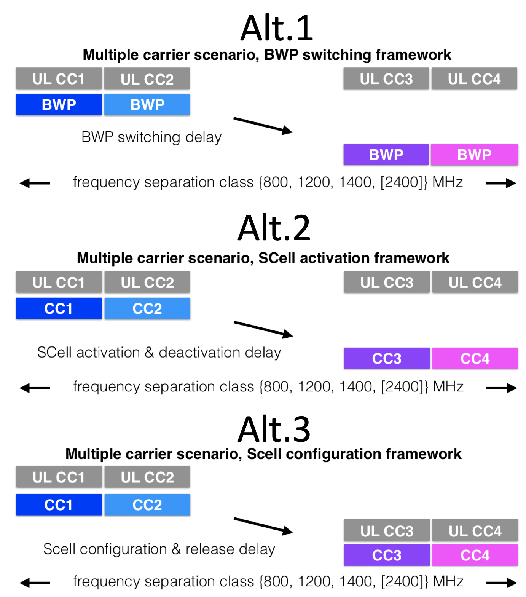

Non-simultaneous uplink in NC carriers (2)
- RAN4 will further study the benefit of non-simultaneous UL in non-contiguous carriers from the points of view of improved output power due to reduced MPR and reduced power consumption, e.g., FR1 (pcell) + FR2 (scells) configuration
- RAN4 will further study the feasibility of non-simultaneous UL in non-contiguous carriers
- The switching mechanism shall be down-selected between Alt.1, Alt.2, and Alt.3 during the RAN #93 meeting.
- Other options are not precluded

Issue 2-1: Feasibility and down-selection of the switching mechanism for non-simultaneous UL

- - Alt.1: apply the BWP switching framework
  - - DCI-based, RRC-based, and timer-based scenarios are not precluded
- - Alt.2: apply the MAC CE based SCell activation framework
  - - UL and DL are activated and deactivated together
- - Alt.3: apply the RRC based SCell configuration framework
  - Only Alt.3 is applicable to SA FR2+FR2 CA or NSA LTE+FR2+FR2 DC scenarios

Companies views’ collection for 1st round

Open issues
Company | Comments
XXX | Sub topic 1-1:  Sub topic 1-2:  ….  Others:

CRs/TPs comments collection
Major close-to-finalize WIs and Rel-15 maintenance, comments collections can be arranged for TPs and CRs. For Rel-16 on-going WIs, suggest to focus on open issues discussion on 1st round.
CR/TP number | Comments collection
XXX | Company A
 | Company B
YYY | Company A
 | Company B

Summary for 1st round

Open issues
Moderator tries to summarize discussion status for 1st round, list all the identified open issues and tentative agreements or candidate options and suggestion for 2nd round i.e. WF assignment.
 | Status summary
Sub-topic#1 | Tentative agreements:  Candidate options:  Recommendations for 2nd round:

Recommendations on WF/LS assignment
 | WF/LS t-doc Title | Assigned Company,  WF or LS lead
#1

CRs/TPs
Moderator tries to summarize discussion status for 1st round and provides recommendation on CRs/TPs Status update
CR/TP number | CRs/TPs Status update recommendation
XXX | Based on 1st round of comments collection, moderator can recommend the next steps such as “agreeable”, “to be revised”

Discussion on 2nd round (if applicable)

Summary on 2nd round (if applicable)
Moderator tries to summarize discussion status for 2nd round and provided recommendation on CRs/TPs/WFs/LSs Status update suggestion
CR/TP/LS/WF number | T-doc Status update recommendation
XXX | Based on 2nd round of comments collection, moderator can recommend the next steps such as “agreeable”, “to be revised”

