3GPP TSG-WG RAN4 Meeting #94-e Revised R4-2000133

Electronic Meeting, 24 Feb. - 6 Mar., 2020
CR-Form-v12.0
CHANGE REQUEST
 | 38.101-3 | CR | 0160 | rev | 1 | Current version: | 16.2.0
For HELP on using this form: comprehensive instructions can be found at
http://www.3gpp.org/Change-Requests.

Proposed change affects: | UICC apps |  | ME | X | Radio Access Network |  | Core Network

Title: | CR to TS 38.101-3: Switching time mask between two uplink carriers in EN-DC
Source to WG: | China Telecom, …
Source to TSG: | R4
Work item code: | NR_RF_FR1-Core |  |  |  |  |  | Date: |  |  | 2020-02-01
Category: | B |  |  |  |  |  | Release: |  |  | Rel-16
 | Use one of the following categories:  F (correction)  A (mirror corresponding to a change in an earlier release)  B (addition of feature),  C (functional modification of feature)  D (editorial modification)  Detailed explanations of the above categories can  be found in 3GPP TR 21.900. |  |  |  |  |  |  |  | Use one of the following releases:  Rel-8 (Release 8)  Rel-9 (Release 9)  Rel-10 (Release 10)  Rel-11 (Release 11)  Rel-12 (Release 12)  Rel-13 (Release 13)  Rel-14 (Release 14)  Rel-15 (Release 15)  Rel-16 (Release 16)
Reason for change: |  | For UE supporting maximum two concurrent transmission, Tx switching between two uplink carriers can enable 1 Tx on E-UTRA carier and 2 Tx on NR carrier.
Summary of change: |  | Introduce UE time mask requirements to allow switching between two uplink carriers for inter-band EN-DC.
Consequences if not approved: |  | UE is not allowed to support Tx switching between two uplink carriers.
Clauses affected: |  | New section 6.3B.4
 |  | Y | N
Other specs |  |  | X | Other core specifications |  |  |  | TS/TR ... CR ...
affected: |  | X |  | Test specifications |  |  |  | TS 38.521-3
(show related CRs) |  |  | X | O&M Specifications |  |  |  | TS/TR ... CR ...
Other comments:
This CR's revision history:

< Start of change >

6.3B.4 Output power dynamics for switching between two uplink carriers

6.3B.4.1 E-UTRA and NR switching time mask between two uplink carriers
The switching time mask is specified in clause 6.3B.4.1 is applicable when switching between an uplink band pair of an EN-DC configuration is supported, and only applicable when uplink transmission is switched between E-UTRA UL carrier with 1Tx chain and NR UL carrier with 2Tx chains, where the two uplink carriers are in different bands with different carrier frequencies.
The switching periods described in 6.3B.4-1 are only located in NR carrier, and the length of switching period X depends on UE capability [TBD].
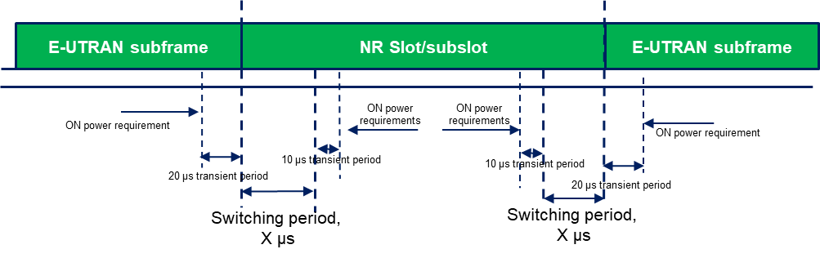
Figure 6.3B.4.1-1: Time mask for switching between E-UTRA UL carrier and NR UL carrier, where the switching period is located in E-UTRA carrier
NOTE 1: The requirements apply for the case of co-located and synchronized network deployment for the two uplink carriers.
NOTE 2: Power class delcaration for the uplink transmission switching follows the general definition of power class.
NOTE 3: For UE supporting uplink transmission switching, it is mandated to support 2-layer UL-MIMO transmission and single-layer transmission on carrier 2 following the BS scheduling and rank adaptation (if rank adaptation is applicable).

< End of change >

