3GPP TSG RAN WG4 Meeting #94-e R4-2002785
Online, 24th Feb. – 06th March, 2020

Agenda Item: 8.4.4.1

Source: LG Electronics

Title: TP on additional On/OFF Switching Time Mask for TDM operation between LTE SL and NR SL at n47
Document for: Approval
- Introduction
In the last RAN4 #93 meetings, RAN4 agreed the NR V2X operating scenarios and priorities for 5G V2X service.
Based on the 1st priority of NR V2X service, we provide how to specify the LTE SL and NR SL TDM operation at n47.

****************** Start of the TP in clause 8 of TR38.886 ************************

8 Transmitter characteristics

8.1 NR V2X UE Tx requirements in FR1
When a NR V2X UE is TDM operating between NR SL and LTE SL at n47, the NR V2X UE need to satisfy the individual V2X Tx requirements of each RAT.
<Unchanged sections are omitted>

8.1.7 ON/OFF time mask for NR V2X UE
For NR V2X service, additional requirements on ON/OFF time masks for V2X physical channels and signals are specified in this clause.

8.1.7.4 Additional Time mask for TDM operation between NR SL and LTE SL at n47

When a NR V2X UE is operated with TDM between NR SL and LTE SL at n47 without dual PA capability, the maximum UL switching time is defined as [TBD] us and SL reception interruption is allowed during UL switching time masks in Figure 8.1.7.4-1 and Figure 8.1.7.4-2 shall apply.
The switched time will be decided in candidate option as [140, 150 and 210 us]. And RAN4 will not specify the RF specific requirements during the switched period.
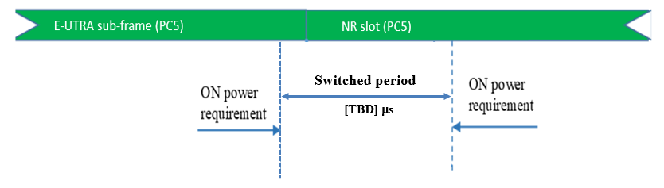
Figure 8.1.7.4-1: E-UTRA V2X to NR V2X switching time mask at n47 without dual PA capability
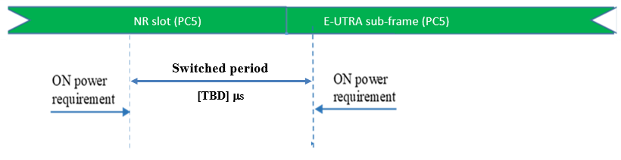
Figure 8.1.7.4-2: NR V2X to E-UTRA V2X switching time mask at n47 without dual PA capability

<Unchanged sections are omitted>

9 Receiver characteristics

9.1 NR V2X UE Rx requirements in FR1
When a NR V2X UE is TDM operating between NR SL and LTE SL at n47, the NR V2X UE need to satisfy the individual V2X Rx requirements of each RAT.

<End of Changes>

