Invitation to 3GPP RAN WG1/2/3/4/5 Meetings
August 24 - 28, 2009
Shenzhen, P. R. China

Dear Colleagues,

Huawei Technologies Co., LTD is pleased to invite you to the 3GPP RAN1#58, RAN2#67, RAN3#65, RAN4#52 and RAN5#44 meetings in Shenzhen, P. R. China.
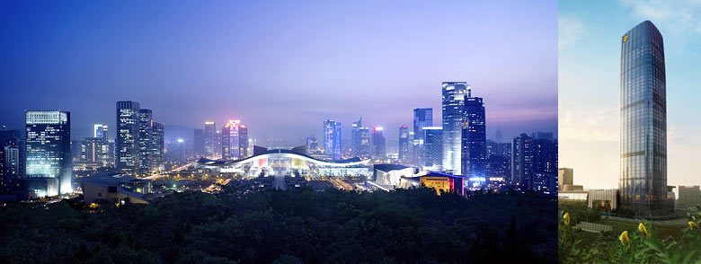
The meetings will be held at the Futian Shangri-La, Shenzhen. A block of rooms has been reserved at the hotel under the name 3GPP. The group rate for Deluxe Single/Double is CNY 1400 (~USD 205) per night (including one breakfast buffet, service charge and taxes). Broadband Internet access is free in guest rooms. Delegates are responsible for their own hotel reservations. Please send the reservation form (Appendix B) to the hotel by fax and the cutoff date is 23 July 2009 (Note that reservation beyond this point may be considerably high and subject to availability).
In addition to hotel reservation, it is important to perform the online meeting registration at the website: 3GPP Meeting Registration before 2 August 2009. This provides meeting planners with important planning information.
For entering China, it is required to hold either tourism or business visa. Should you require a personal letter of invitation for your business visa application, please contact the people listed in Appendix A via email. Your email should attach the form in Appendix A filled with all necessary information and be sent out before 2 August 2009. For Chinese Embassy or Consulate information, please visit website http://www.fmprc.gov.cn/eng/. You may need multiple-entry visa if you will go to Hong Kong or Macau during your stay in Shenzhen.
The meeting will start on Monday 24 August at 9:00 and end on Friday 28 August by 17:00. Meeting directions and general information are provided in the following pages.
We are looking forward to seeing you in Shenzhen, China.

Sincerely yours,
Ms. Katherine Woo
On behalf of Huawei Technologies Co., Ltd.
Meeting Information

Meetings & Dates:
3GPP RAN1#58, RAN2#67, RAN3#65, RAN4#52 and RAN5#44 August 24~28, 2009

Location:
Shenzhen, P. R. China

Main Contact from the host:
Ms. Katherine Woo
Tel: +86 10 82836311
Fax : +86 10 82836920
Email: kathywoo@huawei.com

Mr. Hao Hu
Tel: +86 10 82836609
Fax : +86 10 82836920
Email: huhaoby@huawei.com

Hotel Information:
Futian Shangri-La, Shenzhen
Address: 4088 Yi Tian Road, Futian District, Shenzhen Guangdong 518048, P. R. China
Phone: + 86 755 8828 4088
Email: slft@shangri-la.com
Website: www.shangri-la.com/en/property/shenzhen/futianshangrila

EDH requirements:
This will be a paperless meeting. Participants are requested to bring a wireless LAN adapter for their laptops. For your convenience, please be sure you have Oblique flat blades (inverted V-shape) with ground or Flat blade attachment plug to use in hotel guest room.
In meeting rooms, the host will provide power extensions with outlets fit for the power plug types illustrated in following picture.

Reservation Information

The Futian Shangri-La, Shenzhen will be providing the accommodations for the meetings.

Deluxe Single
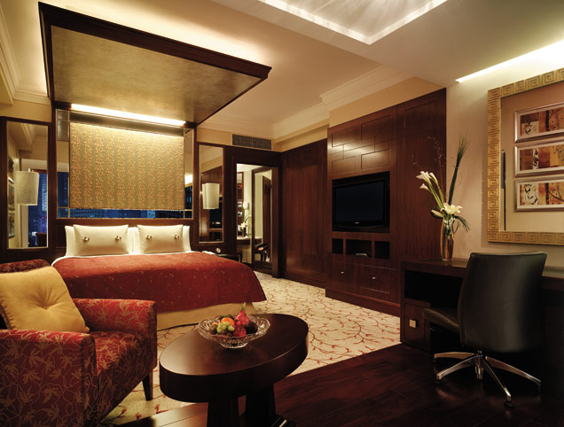

Premier Single
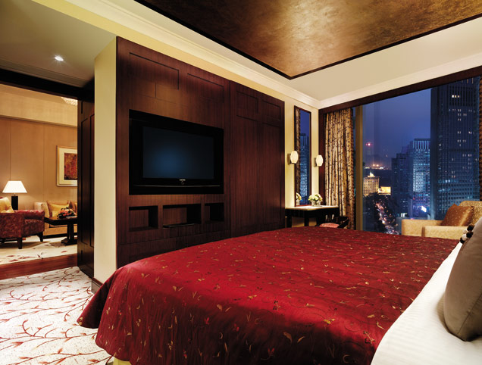

Group Rate:
Deluxe Single/Double: CNY 1400 (~USD 205) per room per night
Deluxe Parkview Single/Double: CNY 1500 (~USD 220) per room per night
Premier Single/Double: CNY 1800 (~USD 264) per room per night
Horizon Single/Double: CNY 2000 (~USD 293) per room per night

The above rate includes one breakfast buffet, service charge and taxes. Additional buffet breakfast will be charged at CNY 100 net per person. Broadband Internet access is complimentary in guest rooms.

Benefit for Horizon Rooms:
- Breakfast buffet at the Horizon Club Lounge
- Complimentary beverages throughout the day, evening cocktails and canapés at the Horizon Club Lounge
- Daily 2-hour complimentary usage of the meeting room at the Horizon Club
- Check in and check out at the Horizon Club

Cut-off Date: 23 July 2009
Please make your reservation before the cut off date to insure the reduced group rate. Reservation beyond this point may be considerably high and subject to availability.

Check-in/Check-out Time:
Check in after 02:00 PM
Check out before 12:00 PM

Reservations:
Please fill out the form in Appendix B and fax the completed form to the hotel.

Cancellation Policy:
- All reservations must be guaranteed by a one-night room rate advanced deposit by cash, bank draft or major credit cards. For credit card guarantee, the Hotel requires the billing information mentioned in Appendix B. Guaranteed reservations will be held until noon on the following day of the confirmed arrival date.
- All non-guaranteed reservations will be released after 18:00 hours on the date of scheduled arrival. Thereafter, guest rooms will be subject to availability.
- All guest accommodations blocked for this event that are not reserved before 23 July, 2009 will be released and may be resold by the Hotel. Any guest accommodations desired by the group after the cut-off date will be on a space availability basis at the prevailing Select Rate.
- Any cancellation made after 02 August, 2009 or no show will result in a late cancellation charge equivalent to full duration of stay. Early departure will be charged for the duration as originally reserved.

Please Note:
Huawei Technologies Co., Ltd is not responsible for reservation confirmations, cancelled or changed reservations, or no-shows. Please contact the hotel directly to make any changes.
Transportation Information

Located in the heart of Futian business district, Futian Shangri-La, Shenzhen offers easy access to the business centre, shopping malls and tourist attractions within Shenzhen. It is just minutes away from the Huang Gang and Futian Port border crossings into Hong Kong, 15 minutes' drive from the Louhu Railway Station and 30 minutes away from Shenzhen Bao'an International Airport and the Shekou Ferry Terminal.

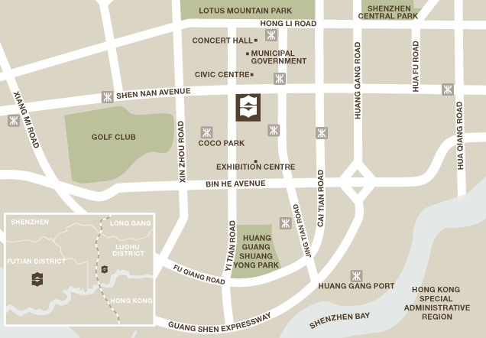

The two airports close to the hotel are the Shenzhen and Hong Kong Airports.

- From Shenzhen Bao’an International Airport to Futian Shangri-La, Shenzhen

Taxis are recommended with price running CNY 120.

NOTE: The taxi drivers may not speak English, so make sure you have the name of your hotel or address written in Chinese. The following is the name, address and phone number of the Futian Shangri-La, Shenzhen in Chinese; please print it for your convenience.

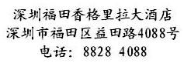

If you choose to flight from your residing country to Beijing or Shanghai instead, you can then transfer to Shenzhen by domestic flight immediately after you arrive at Beijing or Shanghai airport. There are many direct flights between Beijing or Shanghai and Shenzhen every day and you can contact the information counter at airport for further information as soon as you land.

- From Hong Kong International Airport to Futian Shangri-La, Shenzhen

Hong Kong airport has more international flights than Shenzhen. Hong Kong resides in the Hong Kong Special Economic Zone, so if you arrive in Hong Kong you will receive a temporary Transit Visa for Hong Kong. Then you will go across Hong Kong and make a border crossing into the main part of the PRC. You can take a bus or a ferry from the Hong Kong airport to one of the border crossings into the PRC.

You can choose either of the two route options to get to Futian Shangri-La, Shenzhen, the venue and accommodation.

To pay for transportation in Hong Kong and Shenzhen, you may need some local currency. If you go to Shenzhen via Hong Kong, you need to exchange some local currency to pay for the ferry or shuttle bus from Hong Kong to Shenzhen, approximately HK$300. For taxi in Shenzhen, you may need CNY 200.

Note: Credit card is not acceptable for taxis in China.

Option 1: By ferry

We suggest that you take the SkyPier ferry from Hong Kong International Airport to Shenzhen (with no Immigration and Customs formalities). When you arrive at Terminal 1, Hong Kong International Airport, you purchase ferry ticket and present baggage tag receipt at the Ferries to Mainland/Macau Desk at Transfer Area E2. After the security check at Transfer Area E1, you can board the bonded bus to SkyPier at Boarding Gate 10. The ferry ticket costs about HK$250. You will arrive in Shenzhen Shekou ferry pier and claim your luggage in the pier and go through the Immigration/Custom inspection.

NOTE: please do not go through the Hong Kong Immigration/Custom.

The ferry will leave every hour approximately from 09:00 to 21:20. The below ferry schedule is for your reference.

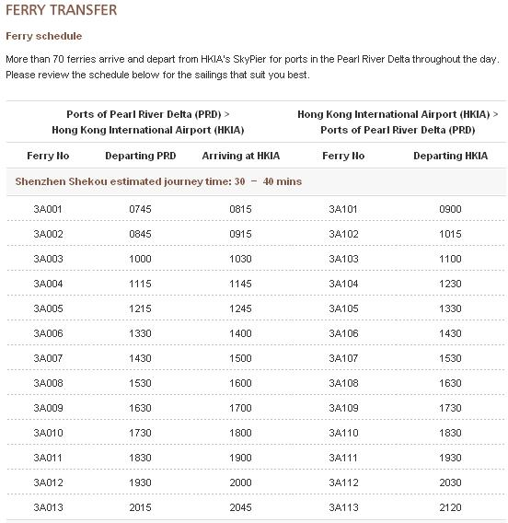

It takes 30 to 40 minutes to travel to Shenzhen Shekou ferry pier. When arriving at the Shekou ferry pier, you can take taxi to Futian Shangri-La, Shenzhen.

NOTE: The charge by taxi from the She Kou ferry pier to Futian Shangri-La, Shenzhen is around ￥150 CNY.

Option 2: By cross-boundary shuttle bus

Coach services are available at the Mainland Coach Station of Terminal 2. Regular services depart from the airport between 07:00 and 23:00 to destinations such as Shenzhen, Guangzhou, Dongguan, Huizhou, Foshan and Zhongshan.

Route details are available from individual service providers, please find below for contact information.

Service Provider | Destination | Boarding Point | Ticketing Point |  | Telephone
Service Provider | Destination | Boarding Point | Terminal 1 | Terminal 2 | Telephone
China Travel Tours Transportation Services HK Ltd | Shenzhen, Guangzhou, Macau, etc. | Coach Station  (Terminal 2) | Arrivals Hall  Counter A09 | Coach Station, C05 | +852 2261 2472
Eternal East Cross-Border Coach Mgt. Ltd | Shenzhen, Guangzhou, etc. | Coach Station  (Terminal 2) | Arrivals Hall  Counter A08 | Coach Station, C04 | +852 2261 0176
Go Go Bus | Shenzhen, Guangzhou, etc. | Coach Station  (Terminal 2) | Arrivals Hall Counter A10 | Coach Station, C06 | +852 2261 0296

NOTE: Passengers are reminded that a valid travel document/visa for Mainland China is required before boarding the coaches.

General Information for Stay in Shenzhen

GSM/CDMA Coverage:
There is GSM / CDMA coverage in Shenzhen.

Currency:
Until April 2009, 1 U.S. dollar was worth ￥ 6.83 CNY and 1 Euro was worth ￥ 8.88 CNY. Most foreign currencies are easily changed at banks or hotels.

Time Zone:
GMT +8 hours

Voltage:
Commercial power in China is 220V. Please be sure you have the correct adapter. Voltage converters will not be provided at the meeting.

Sightseeing:
There are several popular theme parks, such as Splendid China, China Folk Culture Villages, Window of the World and Happy Valley, are located near the meeting venue.
(Refer to: http://www.asia-planet.net/china/splendid-china-shenzhen.htm )

Average temperatures are 26~30°C.
Visit http://english.sz.gov.cn/tis/ for more travel information in Shenzhen.

Please don’t hesitate to direct any questions regarding the logistical arrangements of this meeting to the Meeting Coordinators:
Ms. Katherine Woo
Have a successful meeting and enjoy your stay in Shenzhen!
Appendix A
3GPP RAN WG1/2/3/4/5 Meetings (August 24 - 28, 2009) Shenzhen, China

INVITATION LETTER REQUEST FORM

To enter China for the meetings indicated above, you may need a letter of invitation from the Chinese host, which you will need to present to the Chinese Embassy/Consulate in your area in order to obtain your visa. In order to obtain the invitation letter, please:

- fill out the form below
- a copy of your passport (the name, date of birth, nationality, passport number, valid date of passport, etc. must be seen clearly; to ensure readability, a scanned photograph page is preferred.)
- a copy of previous Chinese visa and records if your entry is not the first time
- send all of the above to the contact below of the respective WG via email before 2 August 2009.

WG | Contact | Email
RAN1 | Ms. Meng Zhao | zhaomeng51947@huawei.com
RAN2 | Mr. Xudong Yang | yangxudong@huawei.com
RAN3 | Mr. Xuelong Wang | xuelong.wang@huawei.com
RAN4 | Ms. Liyan Yin | yinliyan@huawei.com
RAN5 | Ms. Xiang Li | trica_li@huawei.com

Company
Applicant Information | [ Click and Type in your full name ] |  |  | rMr rDr rMs rMrs
Applicant Information | [ Nationality ] |  |  | [ Passport No.]
Applicant Information | Date of birth : [ Year ] [ Month] [ Day ] |  |  | [ Job Title ]
Applicant Information | If the country in which you'll obtain your visa is different from your nationality, please indicate it here:  [ Country to obtain your visa]
Address | [Click and Type in your address and ZIP code]  Telephone Number: [Click and Type in phone number]  Fax Number: [Click and Type in fax number]  E-mail: [Click and Type in email]
Places to visit after entry | (In this case, it is Shenzhen by default; if you want to visit other places than Shenzhen, please indicate here.)
Date of arrive at China |  |  | Date of departure from China
End of form

(Please do not forget to attach a copy of your passport photograph page before sending.)

Appendix B
3GPP Hotel Reservation Form
Please fax the completed form to the Futian Shangri-La, Shenzhen at + 86 755 8256 0698 before July 23, 2009 for room reservation.
If you have not received a faxed or emailed confirmation within 72 hours of faxing this form, please contact the Futian Shangri-la, Shenzhen at + 86 755 2151 3999 (Reservations) or + 86 755 2151 3919 (Sales).

Guest Information
Title: □ Mr. □ Mrs.

Name: Fax number: .

Email address: .Telephone number: _

Room Type:
□ Smoking □ Non-Smoking
□ Deluxe Single/Double CNY 1400 (~USD 205) per room per night
□ Deluxe Parkview Single/Double: CNY 1500 (~USD 220) per room per night
□ Premier Single/Double: CNY 1800 (~USD 264) per room per night
□ Horizon Single/Double: CNY 2000 (~USD 293) per room per night
Note: The room rates are inclusive of one buffet breakfast, service charge and taxes. Additional buffet breakfast will be charged at CNY 100 net per person. Broadband Internet access is free.
Period of Stay
CHECK-IN：August . CHECK -OUT：August . Nights

Billing information to be used as a guarantee

Credit Card Type: □ VISA □ American Express □ Diners □ Master □ JCB
Credit Card Number: _____________________________________________________
Expiration Date: _________________________________________________________
Credit Card Holder: _______________________________________
________________________________________________________________________
Authorization Signature_________________________________________________
Special diet_______________________________________________

Please make your reservations before the cut-off date (July 23) to enjoy the special room rate and room availability.
- All reservations must be guaranteed by a one-night room rate advanced deposit by cash, bank draft or major credit cards. For credit card guarantee, the Hotel requires the billing information mentioned above. Guaranteed reservations will be held until noon on the following day of the confirmed arrival date.
- All non-guaranteed reservations will be released after 18:00 hours on the date of scheduled arrival. Thereafter, guest rooms will be subject to availability.
- All guest accommodations blocked for this event that are not reserved before 23 July 2009 will be released and may be resold by the Hotel. Any guest accommodations desired by the group after the cut-off date will be on a space availability basis at the prevailing Select Rate.
- Any cancellation made after 02 August 2009 or no show will result in a late cancellation charge equivalent to full duration of stay. Early departure will be charged for the duration as originally reserved.

