Hello all,

This is an invitation to RAN4#116-bis Webinar sessions on 13– 17 October 2025. This invitation covers three sessions in 3 separate rooms: Main (Yang Session), RRM_Demod_OTA (Shan Session), RF,NTN,A-IOT (Gene Session).

GoToWebinar (GTW) conference calls will be set in each session. And one-way remote participants can be supported.

Please remember that consistent registration format is important for session chairing and hence **use the following format when you register: BriefCompanyName - Firstname, Lastname. An example is shown below**

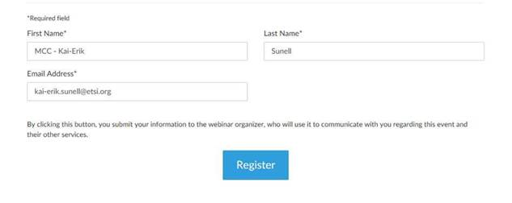

**where BriefCompanyName is ‘MCC’, Firstname is ‘Kai-Erik’ and Lastname is ‘Sunell’.**

Your email address for Webinar registration needs to be the same as for your 3GPP meeting registration.

Registration links are found below and they are session specific. You may register to all sessions, e.g. if you plan to switch between sessions or if you are able to listen to all sessions at the same time. Once you have registered for a session your registration is valid for the whole week.

**The starting time for all sessions 13 Oct is 09:00 local time 19:30 local time(GMT+2)**

**The starting time for all sessions 14-16 Oct is 08:30 local time 19:30 local time(GMT+2)**

**The starting time for all sessions 17 Oct is 08:00 local time 17:30 local time(GMT+2)**

|  |  |  |
| --- | --- | --- |
| |  |  | | --- | --- | | |  | | --- | | **RAN4#116bis Main Webinar Session (13 - 17 Oct)**  Mon, Oct 13, 2025 9:00 AM - 7:30 PM CEST | | |
| |  |  |  | | --- | --- | --- | | **RAN4#116bis Main Webinar Session (13 - 17 Oct)**  Join us for a webinar beginning on Oct 13, 2025 at 9:00 AM CEST.   |  |  | | --- | --- | | |  | | --- | | [Register now!](https://attendee.gotowebinar.com/register/5012849883433151574) | |   After registering, you will receive a confirmation email containing information about joining the webinar.  [View System Requirements](https://link.gotowebinar.com/help-system-requirements-attendees) | |

|  |  |  |
| --- | --- | --- |
| |  |  | | --- | --- | | |  | | --- | | **RAN4#116bis RRM_Demod_OTA (Shan Session) Webinar Session (13- 17 Oct)**  Mon, Oct 13, 2025 9:00 AM - 7:30 PM CEST | | |
| |  |  |  | | --- | --- | --- | | **RAN4#116bis RRM_Demod_OTA (Shan Session) Webinar Session (13- 17 Oct)**  Join us for a webinar beginning on Oct 13, 2025 at 9:00 AM CEST.   |  |  | | --- | --- | | |  | | --- | | [Register now!](https://attendee.gotowebinar.com/register/8350336065686978399) | |   After registering, you will receive a confirmation email containing information about joining the webinar.  [View System Requirements](https://link.gotowebinar.com/help-system-requirements-attendees) | |

|  |  |  |
| --- | --- | --- |
| |  |  | | --- | --- | | |  | | --- | | **RAN4#116bis RF,NTN,A-IOT (Gene Session) (13 - 17 Oct)**  Mon, Oct 13, 2025 9:00 AM - 7:30 PM CEST | | |
| |  |  |  | | --- | --- | --- | | **RAN4#116bis RF,NTN,A-IOT (Gene Session) (13 - 17 Oct)**  Join us for a webinar beginning on Oct 13, 2025 at 9:00 AM CEST.   |  |  | | --- | --- | | |  | | --- | | [Register now!](https://attendee.gotowebinar.com/register/5165764463065855577) | |   After registering, you will receive a confirmation email containing information about joining the webinar.  [View System Requirements](https://link.gotowebinar.com/help-system-requirements-attendees) | |

Note 1: One-way remote participant is default and entail listen only mode.

Instructions on how to join the Webinars will be sent automatically every day.

Regards,

Jin Lian