|  |  |
| --- | --- |
| 3GPP TR 38.749 V0.3.0 (2025-05) | |
| Technical Report | |
| 3rd Generation Partnership Project;  Technical Specification Group Radio Access Network;  NR;  Protection of Earth Exploration Satellite Service (EESS)  (Release 19) | |
|  | |
|  |  |
|  | |
| The present document has been developed within the 3rd Generation Partnership Project (3GPP TM) and may be further elaborated for the purposes of 3GPP. The present document has not been subject to any approval process by the 3GPPOrganizational Partners and shall not be implemented. This Specification is provided for future development work within 3GPPonly. The Organizational Partners accept no liability for any use of this Specification. Specifications and Reports for implementation of the 3GPP TM system should be obtained via the 3GPP Organizational Partners' Publications Offices. | |

|  |
| --- |
|  |
| ***3GPP***  Postal address  3GPP support office address  650 Route des Lucioles - Sophia Antipolis  Valbonne - FRANCE  Tel.: +33 4 92 94 42 00 Fax: +33 4 93 65 47 16  Internet  http://www.3gpp.org |
| ***Copyright Notification***  No part may be reproduced except as authorized by written permission. The copyright and the foregoing restriction extend to reproduction in all media.  © 2025, 3GPP Organizational Partners (ARIB, ATIS, CCSA, ETSI, TSDSI, TTA, TTC).  All rights reserved.  UMTS™ is a Trade Mark of ETSI registered for the benefit of its members  3GPP™ is a Trade Mark of ETSI registered for the benefit of its Members and of the 3GPP Organizational Partners LTE™ is a Trade Mark of ETSI registered for the benefit of its Members and of the 3GPP Organizational Partners  GSM® and the GSM logo are registered and owned by the GSM Association |

Contents

Foreword 4

1 Scope 6

2 References 6

3 Definitions of terms, symbols and abbreviations 7

3.1 Terms 7

3.2 Symbols 7

3.3 Abbreviations 7

4 Work item objective 7

5 Study outcome in previous releases for EESS 7

6 Regulation background 8

6.1 ITU 8

6.2 Europe and CEPT 9

7 A-MPR evaluation and analysis for EESS protection in the frequency bands 23.6-24 GHz 9

7.1 A-MPR simulation results for single carrier 9

7.2 A-MPR simulation results for carrier aggregation 12

7.2.1 Overview of EESS requirements in 23.6 to 24.0 GHz 12

7.2.2 Legacy procedure to derive NS_203 A-MPR 12

7.2.3 Derivation for backoff requirements for Phase 2 (‘NS_205’) 13

7.2.3.1 Contiguous RB allocations 13

7.2.3.2 Non-contiguous RB allocations 13

8 UE RF requirements 14

8.1 Background 14

8.2 UE RF impacts 15

9 BS RF requirements 16

9.1 Background 16

9.2 BS RF impacts 16

Annex A (informative): Change history 17

# Foreword

This Technical Report has been produced by the 3rd Generation Partnership Project (3GPP).

The contents of the present document are subject to continuing work within the TSG and may change following formal TSG approval. Should the TSG modify the contents of the present document, it will be re-released by the TSG with an identifying change of release date and an increase in version number as follows:

Version x.y.z

where:

x the first digit:

1 presented to TSG for information;

2 presented to TSG for approval;

3 or greater indicates TSG approved document under change control.

y the second digit is incremented for all changes of substance, i.e. technical enhancements, corrections, updates, etc.

z the third digit is incremented when editorial only changes have been incorporated in the document.

In the present document, modal verbs have the following meanings:

**shall** indicates a mandatory requirement to do something

**shall not** indicates an interdiction (prohibition) to do something

The constructions "shall" and "shall not" are confined to the context of normative provisions, and do not appear in Technical Reports.

The constructions "must" and "must not" are not used as substitutes for "shall" and "shall not". Their use is avoided insofar as possible, and they are not used in a normative context except in a direct citation from an external, referenced, non-3GPP document, or so as to maintain continuity of style when extending or modifying the provisions of such a referenced document.

**should** indicates a recommendation to do something

**should not** indicates a recommendation not to do something

**may** indicates permission to do something

**need not** indicates permission not to do something

The construction "may not" is ambiguous and is not used in normative elements. The unambiguous constructions "might not" or "shall not" are used instead, depending upon the meaning intended.

**can** indicates that something is possible

**cannot** indicates that something is impossible

The constructions "can" and "cannot" are not substitutes for "may" and "need not".

**will** indicates that something is certain or expected to happen as a result of action taken by an agency the behaviour of which is outside the scope of the present document

**will not** indicates that something is certain or expected not to happen as a result of action taken by an agency the behaviour of which is outside the scope of the present document

**might** indicates a likelihood that something will happen as a result of action taken by some agency the behaviour of which is outside the scope of the present document

**might not** indicates a likelihood that something will not happen as a result of action taken by some agency the behaviour of which is outside the scope of the present document

In addition:

**is** (or any other verb in the indicative mood) indicates a statement of fact

**is not** (or any other negative verb in the indicative mood) indicates a statement of fact

The constructions "is" and "is not" do not indicate requirements.

# 1 Scope

The present document is a technical report for the protection of Earth Exploration Satellite Service (EESS) in Rel-19 according to WRC-23 conclusion. It covers the A-MPR/MPR simulation evaluations for protection of the EESS -5dBm/200MHz in the frequency bands 23.6-24 GHz, analysis on A-MPR needed to comply with the regulatory requirements and NS values aligned with the WRC-23 outcome.

# 2 References

The following documents contain provisions which, through reference in this text, constitute provisions of the present document.

- References are either specific (identified by date of publication, edition number, version number, etc.) or non‑specific.

- For a specific reference, subsequent revisions do not apply.

- For a non-specific reference, the latest version applies. In the case of a reference to a 3GPP document (including a GSM document), a non-specific reference implicitly refers to the latest version of that document *in the same Release as the present document*.

[1] 3GPP TR 21.905: "Vocabulary for 3GPP Specifications".

[2] ITU-R Radio Regulations, 2020 Edition

[3] EU Decision 2019/784, Commission Implementing Decision (EU) 2019/784 of 14 May 2019 on harmonisation of the 24,25-27,5 GHz frequency band for terrestrial systems capable of providing wireless broadband electronic communications services in the Union.

[4] EU Decision 2020/590, Commission Implementing Decision (EU) 2020/590 of 24 April 2020 amending Decision (EU) 2019/784 as regards an update of relevant technical conditions applicable to the 24,25-27,5 GHz frequency band.

[5] ECC(20) 055 Annex 18, CEPT letter dated 6 March 2020 ‘CEPT response on additional input regarding the impact of the WRC-19 outcome on the harmonised technical conditions for the 26 GHz band’

[6] ECC Decision(18)06, Harmonised technical conditions for Mobile/Fixed Communications Networks (MFCN) in the band 24.25- 27.5 GHz, Approved 06 July 2019, last amended 20 November 2020.

[7] R4-2417982, Discussion on Rel-19 EESS, Huawei, Hisilicon, RAN4#113

[8] R4-2415726, 24 GHz EESS band phase 2 requirements and UE compliance, Qualcomm Incorporated, RAN4#112bis

[9] R4-2415329, Initial considerations on EESS protection requirements, Apple, RAN4#112bis

[10] R4-2416065, mmWave UE spurious emission UE RF, Nokia, RAN4#112bis

[11] 3GPP TS 38.104: “NR; Base Station (BS) radio transmission and reception”.[12] 3GPP TS 38.141-2: "NR; Base Station (BS) conformance testing; Part 2: Radiated conformance testing".

[13] 3GPP TS 38.174: “NR; Integrated Access and Backhaul (IAB) radio transmission and reception”.

[14] 3GPP TS 38.176-2: “NR; Integrated Access and Backhaul (IAB) conformance testing; Part 2: Radiated conformance testing”

[15] 3GPP TS 38.106: “NR repeater radio transmission and reception”.

[16] 3GPP TS 38.115-2: “NR; Repeater conformance testing - Part 2: Radiated conformance testing.

# 3 Definitions of terms, symbols and abbreviations

## 3.1 Terms

For the purposes of the present document, the terms given in TR 21.905 [1] and the following apply. A term defined in the present document takes precedence over the definition of the same term, if any, in TR 21.905 [1].

**example:** text used to clarify abstract rules by applying them literally.

## 3.2 Symbols

For the purposes of the present document, the following symbols apply:

<symbol> <Explanation>

## 3.3 Abbreviations

For the purposes of the present document, the abbreviations given in TR 21.905 [1] and the following apply. An abbreviation defined in the present document takes precedence over the definition of the same abbreviation, if any, in TR 21.905 [1].

EESS Earth Exploration-Satellite Service

IMT International Mobile Telecommunications

ITU‑R Radiocommunication Sector of the International Telecommunication Union

WRC World Radiocommunication Conference

# 4 Work item objective

For UE, specify additional spurious emission requirements of -5dBm/200Mz for 23.6-24 GHz frequency range for n257 and n258, where

- Introduce new corresponding Network Signalling(s) and associated A-MPR(s) if needed by taking into the consideration of the relationship with the existing NS_200, NS_202, NS_203, CA_NS_200, CA_NS_202 and CA_NS_203

- All the power classes (FR2 PC1, PC2, PC3, PC4, PC5, PC6, PC7) are considered in the above work

For BS/IAB/Repeater, reflect the latest regulatory requirements on protection of Earth Exploration Satellite Service requirements if any

# 5 Study outcome in previous releases for EESS

In Rel-15, protection of EESS frequency range 23.6-24GHz was discussed with the following study outcomes:

- In RAN4#88 meeting, CR(R4-1811499) was agreed to introduce NS_201and CA_NS_201 for NR band n258, compliance with the additional spurious emission requirement of -8dBm/200MHz based on ECC decision [6]*.*

- In RAN4#92 meeting, Draft CR(R4-1910261) was endorsed to introduce NS_202 and CA_NS_202 for NR bands n257 and n258 with updates NS_201 and CA_NS_201 A-MPR requirements, compliance with -10dBm/100MHz additional spurious emission requirement to keep the consistence with ERC Rec. 74-01[3].

- In RAN4#95e meeting, CR(R4-2006785) was agreed to update the NS_202 requirements to stay consistent with EU emissions requirement changes (+1 dBm/200MHz).

In Rel-16, protection of EESS frequency range 23.6-24GHz was also discussed based on the outcome of WRC-19, the study outcome can be summarized in the following:

- In RAN4#97e meeting, CR (R4-2016785) was agreed to introduce NS_203 and CA_NS_203 for NR band n258 from Rel-15 TS38.101-2 specification, compliance with +1dBm/200MHz additional spurious emission requirement. *ModifiedMPRbehaviour* indication for NS_203 and CA_NS_203 is also captured in the specification.

- NS_201 and CA_NS_201 are obsolete.

- In addition, RAN4 agreed to apply -5dBm/200MHz after Sep, 2027. But it is not reflected in RAN4 specification that revision is needed before the requirement taking effect, given that companies didn’t come to consensus. More details can be referred to clause 7.5.4 in TR38.817-01.

# 6 Regulation background

## 6.1 ITU

The ITU-R World Radiocommunication Conference in 2019 (WRC-19) identified on a global basis the 24.25-27.5 GHz (’26 GHz’) frequency band for IMT, with focus on 5G. The ITU-R Radio Regulations [2], as amended by WRC-19 Resolution 750, introduced the technical conditions for use of the 26 GHz frequency band, as captured in Figure 6.1-1.

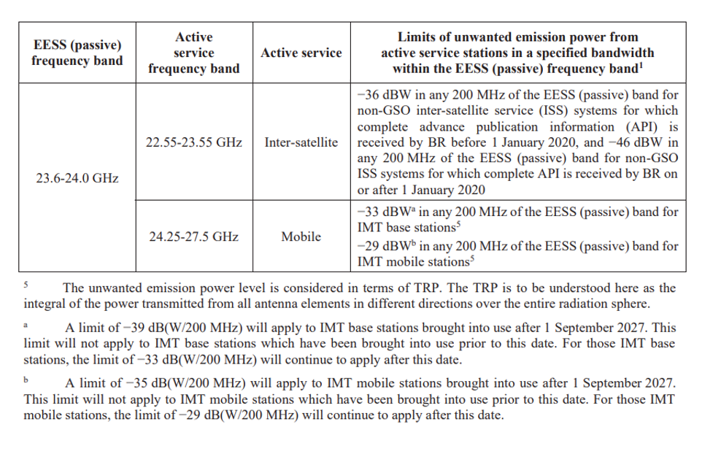

Figure 6.1-1: Extract from Radio Regulations [2] - WRC-19 Resolution 750

To protect EESS services, ITU-R has specified two sets of unwanted emissions limits for IMT base stations and IMT mobile:

- The first set with less stringent limits (respectively -33dBW/200MHz and -29dBW/200MHz) is applicable to BS and mobile brought into use before the 1 September 2027.

- The second set with more stringent limits (respectively -39dBW/200MHz and -35dBW/200MHz) is applicable to BS and mobile brought into use after the 1 September 2027.

## 6.2 Europe and CEPT

The ECC Decision(18)06, amended on 20 November 2020 [6], on harmonised technical conditions for mobile/fixed communications networks (MFCN) in the 26 GHz (24.25-27.5 GHz) band reflects the objective of CEPT to harmonise the 24.25-27.5 GHz band for Europe for 5G. Like ITU-R, WRC-19 Resolution 750, this ECC Decision specifies as well 2 sets of unwanted emissions in the 23.6-24.0 GHz frequency range but with different application date, the transition date being 1 January 2024 in this ECC Decision.

In April 2020, the EU Decision 2019/784 [3] was amended with the Commission Implementing Decision 2020/590 [4]. Based on CEPT recommendation [5], the EU decided to set the transition to the second stage limits to an earlier date (1 January 2024) , this to better protect EESS in the 23.6-24.0 GHz frequency range while early enabling 26GHz deployment. Such decision is binding to all EU countries.

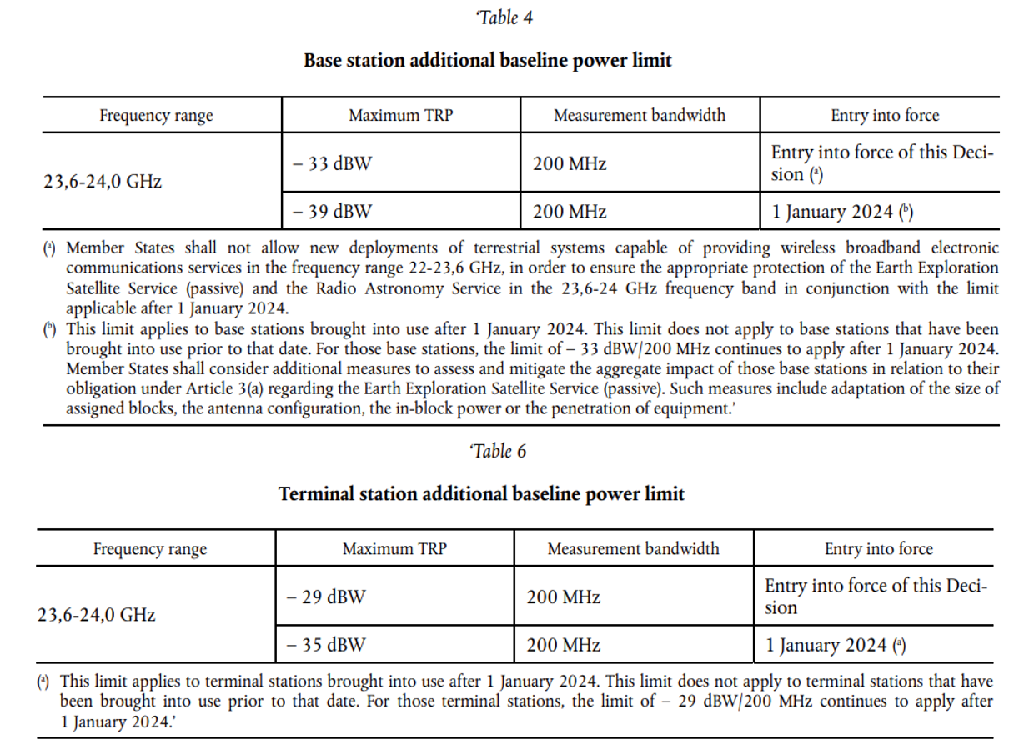

Figure 6.2-1: Annex of EU Decision 2020/590 [4] amending EU Decision 2019/784

# 7 A-MPR evaluation and analysis for EESS protection in the frequency bands 23.6-24 GHz

## 7.1 A-MPR simulation results for single carrier

In [7], PA calibration point should follow current definition in Spec 38.101-2:

- The waveform defined by BW = 100 MHz, SCS = 120 kHz, DFT-S-OFDM QPSK, 20RB23 is the reference waveform with 0 dB MPR and is used for the power class definition.

- Calculate MPR as total backoff needed for 256QAM from this calibration point.

For band n258, to satisfy the RF requirements of EESS with -5dBm/200MHz additional spurious emission, SEM, ACLR, etc, the maximum power back-off is approximately 4.5dB for PC1, which is not higher than MPR or A-MPR corresponded to NS_202, even though the margin is taken into consideration.

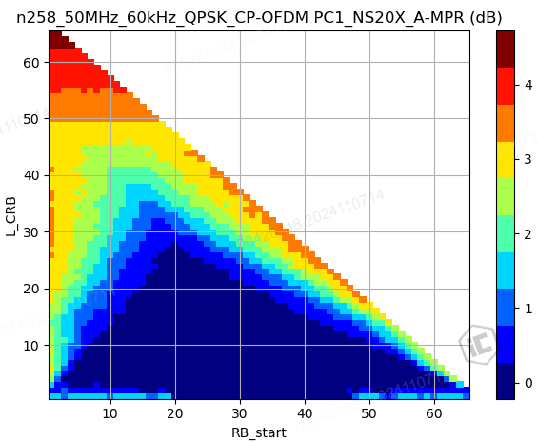

Figure 7.1: Power back-off for band n258 to meet RF requirements including EESS

In [8], for NS_205 introduced in correspondence to NS_203,

|  |  |  |  |
| --- | --- | --- | --- |
|  | Back off requirements (dB) by spur type: | | Summary back off requirement (dB) |
| First Order | Higher Order |
| PC1 | 9-1x3=6 | < 5-1/3*3, i.e. < 4 | 8.0 (reducing to 6.0 with enough frequency offset) |
| PC2/3/4 | 9-1x3=6 | < 9-1/3*3, i.e. < 8 | 9.0 (reducing to 6.0 with enough frequency offset) |

In [9], the power back-off is simulated as 1dB for 400MHz channel placed at the lower band edge of n258. The carrier frequency is at 24.45GHz. This leaves a 250MHz gap between the lower edge of the channel and the upper edge of the protected EESS range.

|  |  |
| --- | --- |
|  |  |

Figure 7.2: Power back-off of QPSK modulated 400MHz carrier with fc at 24.45GHz

In [10], it is evaluated that the A-MPR for power class 3 is 0dB.

Figure 7.3: 400 MHz full allocation (n257, n258)

Figure 7.4: 100 MHz full allocation (n257, n258)

Figure 7.5: 1RB allocation (n258)

## 7.2 A-MPR simulation results for carrier aggregation

### 7.2.1 Overview of EESS requirements in 23.6 to 24.0 GHz

The emission limits for UEs over the protected EESS band (23.6 ≤ f ≤ 24.0, GHz) are summarized below.

**Table 7.1:** *3GPP ‘additional emissions requirements’ for the EESS band corresponding to WRC19 limits*

|  |  |  |  |
| --- | --- | --- | --- |
| Spectrum emission limit (dBm) | Measurement BW (MHz) | **Handle** | **Notes** |
| +1 | 200 | NS_203 | Phase 1 |
| -5 | 200 | NS_205 | Phase 2 |
| -8 | 200 | NS_201 | Reference for back off derivation |

Signalling solution for the application of phase 2 EESS emission limits is represented by NS_205. As is evident, NS_203 involved a **9** dB relaxation from NS_201 limits, while NS_205 represents a **3** dB relaxation.

**Note**: Any time there is a new combination of region and applicability date of the phase 2 regulations, a new NS will need to be created.

## 7.2.2 Legacy procedure to derive NS_203 A-MPR

NS_203 backoff values for single CC UL and contiguous allocations in contiguous CA were derived from those of the now obsolete NS_201 by extrapolating for a **9** dB relaxation relative to the NS_201 emissions limit [18]. This procedure is reproduced below, and the reader is directed to [18] for further details. Note the factor of **1** for the rate of signal power reduction to reduction of first order products, and a factor **1/3**  for rate of signal power reduction to reduction of third order products.

**Table 7.2:** *PC1 NS_203 A-MPRs derivation*

|  |  |  |  |
| --- | --- | --- | --- |
| PC1 | Back off requirements (dB) by spur type: | | A-MPR assuming co-location of all types (dB) |
| First Order | Higher Order |
| CA_NS_203, contiguous allocations | 9-**1**x9=0 | < 9-1/3*9, i.e. < 6 | 6.5 (reducing to 0.0 with enough frequency offset) |

**Table 7.3:** *PC2/3/4/5/6/7 NS_203 A-MPRs derivation*

|  |  |  |  |
| --- | --- | --- | --- |
| PC2/3/4 | Back off requirements (dB) by spur type: | | A-MPR assuming co-location of all types (dB) |
| First Order | Higher Order |
| CA_NS_203, contiguous allocations | 0 | <5-1/3*9, i.e.  < 2 | 2.5 (reducing to 0.0 with enough frequency offset) |

## 7.2.3 Derivation for backoff requirements for Phase 2 (‘NS_205’)

### 7.2.3.1 Contiguous RB allocations

The procedure used in [18] is now repeated for NS_205 in tables 2.4.1-1 -2, with a **3** dB relaxation from NS_201, rather than **9** dB for NS_203.

**Table 7.4:** *PC1 CA_NS_205, derivation of necessary backoff*

|  |  |  |  |
| --- | --- | --- | --- |
| PC1, contiguous allocations | Back off requirements (dB) by spur type: | | Summary back off requirement (dB) |
| First Order | Higher Order |
| CA_NS_205 | 9-1x**3**=6 | < 9-1/3\***3**, i.e. < 8 | 9.0 (reducing to 6.0 with enough frequency offset) |

**Table 7.5:** *PC2/3/4/5/6/7 CA_NS_205, derivation of necessary backoff*

|  |  |  |  |
| --- | --- | --- | --- |
| PC2/3/4, contiguous allocations | Back off requirements (dB) by spur type: | | Summary back off requirement (dB) |
| First Order | Higher Order |
| CA_NS_205 | 0 (assume marginal) | <5-1/3\***3**, i.e. < 4 | 5.0 (reducing to 0.0 with enough frequency offset) |

Note that for PC1 with NS_205 (Table 3 above), no amount of frequency offset will restore the required back-off to 0, it stays floored at 6 dB. This is because first order spurs do not fall off with distance from the UL signal (a first order approximation). Therefore, PC1 UEs in n257/n261 will also need backoff due to first order spurs (despite the large frequency distance from the EESS protection band).

### 7.2.3.2 Non-contiguous RB allocations

NC RB allocation refers to the condition where the UL comprises multiple contiguous chunks of RBs separated in frequency. NC RB allocations primarily manifest with non-contiguous CA, but because the standard does not preclude NC RB allocations in contiguous CA, UEs need to check for this latter case as well and take appropriate back off for emissions compliance. Consequently, the standard must provide for both cases, and they are treated together here.

In general, owing to some frequency distance between band edge and the protected band, some non-contiguous RB allocations can ‘concentrate’ more emissions in the protected band than contiguous CA. Consequently, larger back-offs are foreseen for emissions compliance.

Due to wide frequency spread of PA output for the NC allocation case, we turned to measurements from commercially available hardware. Our method is outlined below:

1. Employ ‘RAN4 calibration’ procedure of normalizing the UE’s TRP limit to the 0 dB MPR reference waveform, as outlined in 6.2.2 in TS38.101-2
2. 2 NC RB allocation test condition: Since the measurement BW is large for NS_205, power in signal is more important than PSD. In this context, only the relative powers in the two clusters are important, the RB lengths in each allocation less so. To capture the worst-case relative power condition (to maximize low side IMD product), our tests were conducted with a 2RB + 1RB CP-OFDM UL with equal PSD.
3. Correction for higher number of RB allocations: As the number of contiguous RB allocations that comprise the NC RB allocation arrangement increases, the amount of power in IMD tones inside the protected band can increase from the 2-cluster baseline. Mathematical analysis shows an additional 2 dB of back off is required to cover these conditions.

For Steps 1 and 2 (i.e. limited to 2-allocation consideration), our observations from measurements are presented below.

**Table 7.6:** *Backoffs required for phase 2 EESS compliance*

|  |  |  |  |
| --- | --- | --- | --- |
| UE power class | TRP limit | Back-off needed for 2-allocation UL for NS205 | Back-off needed for UL with more than 2 allocations for NS205 |
| PC1 | 35 dBm | 10 dB | 12 dB |
| PC2/3/4/5/6/7 | 23 dBm | 6 dB | 8 dB |

A final consideration is first-order spurs. These are not caused by non-linearities in the PA, and so, remain unchanged whether generated by single RB allocation or multiple. The back-off requirements for first-order spurs are thus identical to those derived for contiguous RB allocations.

The data and arguments are summarized as follows for non-contiguous RB allocations:

**Table 7.7:** *PC1 NS_205, derivation of necessary backoff*

|  |  |  |  |
| --- | --- | --- | --- |
| PC1, NC allocations | Back off requirements (dB) by spur type: | | Summary back off requirement (dB) |
| First Order (unchanged from contiguous case) | Higher Order |
| [NS_205] as well as CA_[NS_205] | 6 | 12 | 13.0 (reducing to 6.0 with enough frequency offset) |

**Table 7:** *PC2/3/4/5/6/7 NS_205, derivation of necessary backoff*

|  |  |  |  |
| --- | --- | --- | --- |
| PC2/3/4, NC allocations | Back off requirements (dB) by spur type: | | Summary back off requirement (dB) |
| First Order (unchanged from contiguous case) | Higher Order |
| [NS_205] as well as CA_[NS_205] | 0 | 8 | 8.0 (reducing to 0.0 with enough frequency offset) |

# 8 UE RF requirements

## 8.1 Background

The Earth Exploration Satellite Service (EESS) protection requirements in the frequency range 23.6-24.0 GHz (as per WRC-19 Radio Regulations Resolution 750 [2] and EU Decision 2020/590 [4]) were specified using NS_202/CA_NS_202 and NS_203/CA_NS_203 signaling.

NS_202 should be signaled for operation in band 257 or n258 in CEPT countries, while NS_203 would be signaled for operation in those bands in other countries.

Nevertheless, only the +1dBm/200MHz limit was captured, which is applicable until 1 September 2027 (ITU-R) and until 1 January 2024 (CEPT countries).

In terms of the EU Decision 2020/590 [4], the additional UE spurious emission requirement for EESS passive services protection in the 23.6GHz-24GHz for band n257 and n258 are defined in table 8.1.

Table 8.1: Additional emission requirements for only EESS requirement in Rel-19

|  |  |  |
| --- | --- | --- |
| Frequency band  (GHz) | Spurious emission limit (dBm) | Measurement bandwidth |
| 23.6  f  24.0 | -5dBm | MHz |

The above limit of -5dBm/200MHz was not considered, not anticipating 1 September 2027 when this limit should apply. Also, this is causing a major issue for CEPT countries where this limit is applicable for any device brought to use from 1 January 2024.

## 8.2 UE RF impacts

Within this WI, to address the Regulation issues mentioned above, the modifications in legacy specification TS38.101-2 are:

- The legacy NS_202 and CA_NS_202 are updated by replacing the limit of +1 dBm/200 MHz with -5dBm/200MHz, and the corresponding A-MPR values were adjusted based on this new more stringent limit.

- The newly introduced NS_205/CA_NS_205 with -5dBm/200MHz limit for band n257 and n258, and the corresponding A-MPR values were also specified.

The above NS values specified in Rel-19 for UE EESS are mandatory. For bands n257 and n258, a corresponding *modifiedMPRbehavior* bit indicated in the IE *RF-Parameters* are specified:

- A *modifiedMPRbehaviour* bit to differentiate between legacy NS_202/CA_NS_202 and new NS_202/CA_NS_202 requirements. It is mandatory to report *modifiedMPRbehaviour* bit from Rel-15 for new UEs.

- A *modifiedMPRbehaviour* bit to indicate the UE supports NS_205 and CA_NS_205. It is mandatory to report *modifiedMPRbehavior* bit from Rel-15 for new UEs.

The detailed descriptions of *modifiedMPRbehavior* indication in Rel-19 TS38.101-2 are captured in Table 8-2.

Table 8-2. *modifiedMPRbehavior* indication for NS_202/CA_NS_202 and NS_205/CA_NS_205 in Rel-19

|  |  |  |  |
| --- | --- | --- | --- |
| NR Band | Index of field  (bit number) | Definition  (description of the supported functionality if indicator set to one) | Notes |
| n257 | 0 (leftmost bit) | ... | ... |
|  | 1 | - NS_202 as defined in clause 6.2.3.3 or both NS_202 and CA_NS_202 as defined in clause 6.2A.3.3 of 38.101-2 v19.0.0 | - This bit shall be set to 1 by a UE supporting n257 or both n257 and CA_n257 |
|  | 2 | - NS_205 as defined in clause 6.2.3.6 or both NS_205 and CA_NS_205 as defined in clause 6.2A.3.6 of 38.101-2 v19.0.0 | - This bit shall be set to 1 by a UE supporting n257 or both n257 and CA_n257 |
| n258 | 0 (leftmost bit) | ... | ... |
|  | 1 | ... | ... |
|  | 2 | .... | ... |
|  | 3 | - NS_202 as defined in clause 6.2.3.3 or both NS_202 and CA_NS_202 as defined in clause 6.2A.3.3 of 38.101-2 v19.0.0 | - This bit shall be set to 1 by a UE supporting n258 or both n258 and CA_n258 |
|  | 4 | - NS_205 as defined in clause 6.2.3.6 or both NS_205 and CA_NS_205 as defined in clause 6.2A.3.6 of 38.101-2 v19.0.0 | - This bit shall be set to 1 by a UE supporting n258 or both n258 and CA_n258 |

As those updates have been considered as critical to comply with the Regulations, they have been reported back to Rel-15. i.e. TS38.101-2 v15.26.0.

In CEPT countries where the -5dBm/200MHz limit already applies, only NS_202 and CA_NS_202 shall be broadcasted by the network.

While in other ITU-R countries, from 1 September 2027, the network will have to broadcast NS_205 (and CA_NS_205) followed by NS_203 (and CA_NS_203) to allow any UE brought to use after or before 1 September 2027 to connect to the network.

The A-MPR requirements for NS_202/CA_NS_202 to comply with the -5dBm/200MHz limit have been updated according to Table 8.3.

Table 8.3. Updated A-MPR for NS_202 and CA_NS_202 with the *modifiedMPR-Behavior* indication

|  |  |  |  |
| --- | --- | --- | --- |
| NS values | Single band/intra-band CA | Updated A-MPR for PC1 (dB) | Updated A-MPR for PC2~PC7 (dB) |
| NS_202 | Single band | 11.0 | 2.0 |
| CA_NS_202 | Contiguous UL CA with contiguous allocation | 11.0 | [5.0] if offset frequency < BWintraCA, 2.0 otherwise. |
|  | Contiguous UL CA with non-contiguous allocation or NC UL CA | [13.0] if offset frequency < BWintraCA, 11.0 otherwise | [8.0] if offset frequency < BWintraCA, 2.0 otherwise. |

The A-MPR requirements for NS_205/CA_NS_205 to comply with the -5dBm/200MHz limit have been updated according to in Table 8.4.

Table 8.4. A-MPR requirements for NS_205 and CA_NS_205

|  |  |  |  |
| --- | --- | --- | --- |
| NS values | Single band/intra-band CA | A-MPR for PC1 (dB) | A-MPR for PC2~PC7 (dB) |
| NS_205 | Single band | 7.0 if Offset frequency < BWchannel, 6.0 otherwise | 2.0 if offset frequency < BWchannel, 0.0 otherwise |
| CA_NS_205 | Contiguous UL CA with single contiguous RB allocation | [9.0] if offset frequency < BWintraCA, 6.0 otherwise. | [5.0] if offset frequency < BWintraCA, 0.0 otherwise. |
|  | Contiguous UL CA with non-contiguous allocation or NC UL CA | [13.0] if offset frequency < BWintraCA, 6.0 otherwise. | [8.0] if offset frequency < BWintraCA, 0.0 otherwise. |

NOTE 1: For NS_202 and NS_205, the Offset frequency is defined as the frequency from the upper edge of the protected frequency range to the lower edge of the channel bandwidth.

NOTE 2: For CA_NS_202 and CA_NS_205, the Offset frequency is defined as the frequency from the upper edge of the protected frequency range to the lower edge of the lowest CC among the configured UL CA.

# 9 BS RF requirements

## 9.1 Background

The Earth Exploration Satellite Service (EESS) protection requirements in the frequency range 23.6-24.0 GHz (as per WRC-19 Radio Regulations Resolution 750 [2] and EU Decision 2020/590 [4])were specified via additional OTA OBUE requirements and additional OTA spurious emission requirements in the BS specifications.

Additional OTA OBUE requirements and additional OTA spurious emission requirements were previously considering the ITU-R applicability date of 1 September 2027.

As mentioned in clause 6.2, the ECC Decision(18)06 amended on 20 November 2020 [6] and the EU Decision 2019/784 [3] amended with the Commission Implementing Decision 2020/590 [4] specified the same sets of unwanted emission limits but with a different transition date (i.e., 1 January 2024 instead of 1 September 2027) for European Union and other CEPT countries.

## 9.2 BS RF impacts

Within this WI, to address the Regulation issues mentioned above, the BS additional OTA OBUE limits (clause 9.7.4.3.4.1) and additional OTA transmitter spurious emissions requirements (clause 9.7.5.3.3.1) for protection of EESS were updated in TS 38.104 [11]:

- The Note 1 (Table 9.7.4.3.4.1-1 and Table 9.7.5.3.4.1-1), clarifies the limit pointed by this note (-3dBm/200MHz) is applicable “in countries not adopting EU Decision 2020/590”.

- The Note 2 (Table 9.7.4.3.4.1-1 and Table 9.7.5.3.4.1-1) clarifies that the limit pointed by this note (-9dBm/200MHz) is also applicable to “BS in countries adopting EU Decision 2020/590”.

Similar updates were made to the following specifications:

- BS conformance, TS 38.141-2 [12].

- IAB core and conformance specifications, TS 38.174 [13] and TS 38.176-2 [14].

- Repeater core and conformance specifications, TS 38.106 [15] and TS 38.115-2 [16].

The new BS/IAB/Repeater requirements apply in the earliest releases of the respective specifications, from Rel-15 onwards.

Annex A (informative):  
Change history

|  |  |  |  |  |  |  |  |
| --- | --- | --- | --- | --- | --- | --- | --- |
| **Change history** | | | | | | | |
| **Date** | **Meeting** | **TDoc** | **CR** | **Rev** | **Cat** | **Subject/Comment** | **New version** |
| 2024-10 | RAN4-112bis | R4-2417199 |  |  |  | TR Skeleton | 0.0.1 |
| 2023-11 | RAN4-113 | R4-2418920 |  |  |  | EESS protection - TP to TR 38.749 on regulatory aspects |  |
| 2023-11 | RAN4-113 | R4-2420355 |  |  |  | TP for TR38.749 BS requirements (Clause 9) |  |
| 2025-02 | RAN4-114 | R4-2500144 |  |  |  | TP for TR38.749: EESS in Rel-19 |  |
| 2025-02 | RAN4-114 | R4-2500945 |  |  |  | TP for TR38.749 Study outcome in previous releases (Clause 5) |  |
| 2025-02 | RAN4-114 | R4-2502128 |  |  |  | TP to TR 38.749: BS RF requirements section correction (clause 9) |  |
| 2025-02 | RAN4-114 | R4-2500145 |  |  |  | TR 38.749 v0.1.0 Protection of Earth Exploration Satellite Service (EESS) | 0.1.0 |
| 2025-04 | RAN4-114bis | R4-2505130 |  |  |  | TP for TR38.749 UE RF requirements (Clause 8) |  |
| 2025-04 | RAN4-114bis | R4-2505132 |  |  |  | EESS protection - TP to TR 38749 - BS updates |  |
| 2025-04 | RAN4-114bis | R4-2503146 |  |  |  | TR 38.749 v0.2.0 Protection of Earth Exploration Satellite Service (EESS) | 0.2.0 |
| 2025-05 | RAN4-115 | R4-2507912 |  |  |  | TP to TR38.749 on 24 GHz EESS band phase 2 requirements: Carrier Aggregation A-MPR Analysis |  |
| 2025-05 | RAN4-115 | R4-2505328 |  |  |  | TR 38.749 v0.3.0 Protection of Earth Exploration Satellite Service (EESS) | 0.3.0 |