**3GPP TSG-RAN WG4 Meeting #114 R4-2502878**

**Agenda item:** 7.1.3

**Source:** Huawei, HiSilicon

**Title:** WF on Power domain enhancement

**Document for:** Approval

# Topic #1: Power domain enhancements for single carrier

## Sub-topic 1-1: Applicable requirements

#### **Issue 1-1-1: Boundary to apply SE**

* Options
  + Option 1: The SE limits apply for the frequency ranges that are more than UE CBW+5MHz from the edge of the extended UE CBW
  + Option 2: Boundary between NR out of band and general spurious emission domain on power domain enhancements for single carrier context is defined as Extended UE CBW + 5 MHz
* WF
  + option 1, to meet the ITU recommendation

#### **Issue 1-1-2: Integral region basis for OOBE**

* Options
  + Option 1: The OOBE requirements are based on UE CBW (MTK, Sony, vivo, QC, Lenovo, OPPO, LGE, HW, ZTE, Spreadtrum, Skyworks, Xiaomi, CATT, E//)
  + Option 2: The OOBE requirements are based on extended UE CBW (Nokia)

|  |  |
| --- | --- |
| OP 1 |  |
| OP 2 |  |

* WF
  + option 1

Nokia: it is not complete solution and need further work in the future release.

Skyworks: the main reason to choose option 1 is to meet ITU recommendation. Next step we can make all things work. If not, we have to revisit.

Xiaomi: UE channel bandwidth >10MHz we can still transmit.

#### **Issue 1-1-3: A-MPR handling**

* Proposals
  + Option 1:
    - If A-MPR is specified for a given RB allocation X, then the UE performs

max(MPRenh(X), A-MPR(X))

* + - If A-MPR is not specified for a given RB allocation, then the UE performs

max(MPR(X), A-MPR(X))

* + Option 2:
    - For a given additional emissions requirement and corresponding A-MPR table, if it can be confirmed that A-MPR is specified for all RB allocations X for which

$$A-MPR(X)≥\min_{X∈S}\left\{MPR(X)\right\}$$

where S is the set of all possible RB allocations for the given carrier, then the UE performs

max(MPRenh(X), A-MPR(X))

* + Option 3: Only apply the power domain enhancement scheme to channels which are not subject to A-MPR. In many cases A-MPR is defined for the channel located closest to the additional emission requirement while channels with certain guard gap default to MPR. Those channels could benefit from the power enhancement scheme while minimising the risk for implementation. (Apple)
  + Others
* WF
  + FFS, considering that additional emission in most cases are applied on one side of the UE CBW

#### **Issue 1-1-4: How to derive the extended IBE**

* Options
  + Option 1: Fixed IBE used for extended CBW at each side of UE CBW, the value is derived from the outmost allocated RB of UE CBW (illustrated in the figure below)



* + - For UE CBW with full RB allocation, the IBE of the extended part could be simplified with $\left|Δ_{RB}\right|$ =1 or $\left|Δ_{RB}\right|$ =0. FFS the specific offset value.
    - IBE is not used in the GB
  + Option 2: The extended IBE requirements between the edge of the configured UE CBW and the edge of the virtual CBW should be an extension of the IBE requirement of the configured UE CBW by replacing NRB and LCRB with NRB,V and LCRB,V as below functions (Moderator: NRB,V and LCRB,V could be replaced by other terms, but the concept is similar)

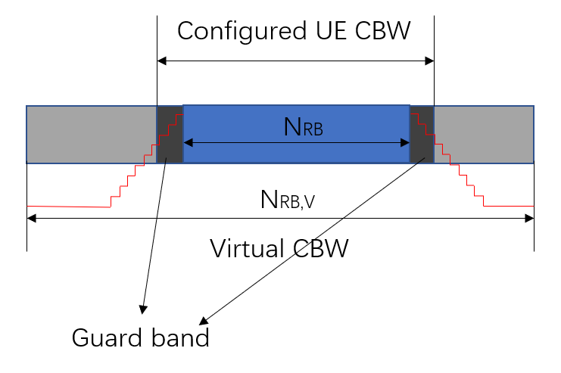

* + Option 3: Others
* WF
  + FFS Extended IBE can be used in the original GB of UE CBW
  + FFS the extended IBE in the GB of extended CBW

#### **Issue 1-1-5: Modulation order for the extended IBE**

* Proposals
  + For the IBE derivation for the extended CBW, use the general part of legacy IBE requirements and fix the EVM parameter to the one for BPSK.

**Table. Comparison of emission level @ the first 1MHz adjacent to the UE CBW**

|  |  |  |  |  |  |  |  |  |  |  |  |  |  |  |
| --- | --- | --- | --- | --- | --- | --- | --- | --- | --- | --- | --- | --- | --- | --- |
|  | UE CBW (MHz) | | | | | | | | | | | | | |
| 10 | 15 | 20 | 25 | 30 | 35 | 40 | 45 | 50 | 60 | 70 | 80 | 90 | 100 |
| SEM  (dBm/30kHz) | -18.2 | -20.0 | -21.2 | -22.2 | -23.0 | -23.6 | -24.2 | -24.8 | -24.0 | | | | | |
| IBE QPSK 26dBm  (dBm/30kHz) | -16.7 | -18.7 | -20.0 | -21.0 | -21.8 | -22.5 | -23.2 | -23.7 | -24.1 | -25.0 | -25.7 | -26.3 | -26.8 | -27.2 |
| IBE 16QAM 26dBm  (dBm/30kHz) | -19.6 | -21.6 | -22.9 | -24.0 | -24.8 | -25.5 | -26.1 | -26.6 | -27.1 | -28.0 | -28.6 | -29.2 | -29.7 | -30.2 |
| IBE BPSK 26dBm  (dBm/30kHz) | -12.0 | -14.0 | -15.3 | -16.4 | -17.2 | -17.8 | -18.5 | -19.0 | -19.5 | -20.3 | -21.0 | -21.6 | -22.1 | -22.6 |

* WF
  + FFS whether the extended IBE with high order EVM could have impact on MPR for new inner RB allocation

## Sub-topic 1-2: Approaches to enable MPR reduction for both scenario 1 and scenario2

***Scenarios discussed previous RAN4 meetings:***

* ***Scenario 1-1****: Scenario with no adjacent in-band/out-of-band co-existence issue (single operator)*
* ***Scenario 1-2****: Scenario with no adjacent in-band/out-of-band co-existence issue (adjacent operators)*
* ***Scenario 2****: Narrower UE channel BW within wider BS bandwidth*

*Sub-topic description*

#### **Issue 1-2-1: Width/RB numbers of extended CBW at each side of UE CBW**

* Options
  + Option 1: Fixed 0.5* UE CBW is considered
    - Symmetrical extension is 0.5 * UE CBW on each side.
    - Asymmetric extension is 0.5 * UE CBW on one side.
  + Option 2: ≤ 0.5* UE CBW, namely flexible size at each side pending on deployment scenario, and offset of the edges between UE CBW and BS CBW, etc.
  + Option 3: In scenario 2 no limitations are needed on width/RB numbers of extended CBW at each side of UE CBW except that Extended UE BW is limited to BS CBW. Scenario 1 needs more discussion.
  + Option 4: The CBW extension shall be aligned with existing channel bandwidth sizes. The extension should always result into a total number of RBs (“original UE channel RBs” + “RB extension”) being an element of Table 5.3.2-1 from TS 38.101-1.
  + Option 5: Extension is performed by 1/6 of the UE channel bandwidth on each side, totaling 4/3 of the original UE channel bandwidth
* WF
  + FFS in next meeting
    - The max size of the extension at each side of UE CBW
    - Whether extended CBW is fixed or could be flexible

#### **Issue 1-2-2: How to get the width/RB numbers of extended CBW at each side of UE CBW**

* Options
  + Option 1: Fixed value, i.e., 0.5* UE CBW is stipulated in the spec
  + Option 2: Flexible value signalled by the NW, the extended CBW at each side ≤ 0.5* UE CBW but not necessarily the one in Table 5.3.2-1 in TS 38.101-1
  + Option 2a: Flexible value signalled by the NW, the extended CBW at each side should be the CBW specified in Table 5.3.2-1 in TS 38.101-1
  + Option 3: Based on SIB1 cell specific CBW
* WF
  + FFS in next meeting

#### **Issue 1-2-3: Guard band for extended CBW**

* Options
  + Option 1: if extended CBW at each side is from CBW in Table 5.3.2-1 in TS 38.101-1, the RB number is the maximum transmission bandwidth configuration corresponding to the subcarrier spacing of the component carrier and the extended CBW, GB is determined accordingly
  + Option 2: guard band for extended CBW is derived from the total RBs including the extended ones, which is larger than the larger guard band between:
    - The guard band of the CBW which is immediately lower than the bandwidth corresponding to the total number of RBs (UE RBs + extended RB).
    - The guard band of the CBW which is immediately higher than the bandwidth corresponding to the total number of RB (UE RBs + extended RB)
  + Option 3: For fixed 0.5* UE CBW case, The GB of the original CBW should be retained, and the ‘GB’ of the extension part should only be retained on the side that is far away from the original CBW.
    - ‘GB’ of the extension part = [(0.5* BWChannel x 1000 (kHz) – ceil(NRB/2) x SCS x 12) -SCS/2], BWChannel and NRB correspond to the original UE CBW.
  + Others



* WF
  + FFS in next meeting

#### **Issue 1-2-4: Approaches of deriving the new inner RB region with RBs in extended CBW**

* Options
  + Option 1: Fixed value case with extended CBW
    - If both sides of the UE extend by 0.5 times the UE CBW, then the entire RB allocation inside the original UE CBW is inner region.

If only the higher side of the UE extends by 0.5 times the UE CBW, then the inner RB region should be re-defined as:

RBStart_Low ≤ RBStart ≤ NRB – LCRB, andLCRB ≤ ceil(2/3 *NRB)

If only the lower side of the UE extends by 0.5 times the UE CBW, then the inner RB region should be re-defined as:

RBStart ≤ RBStart,High, and LCRB ≤ ceil(2/3 *NRB)

* + Option 2: Flexible value case with extended CBW at each side
    - Variety expressions from companies, but essentially are based on the new NRB to derive the new inner region, e.g.
 ${N'}_{RB}=N_{extended_low}+N_{RB}+N_{extended_high}$

 + Option 3: Using cell specific CBW to derive the new inner region
* WF
  + FFS in next meeting

## Sub-topic 1-3: Signaling

#### **Issue 1-3-1: NW signaling**

* Proposals
  + Proposal 1: (NTT DOCOMO)
    - BS indication should be designed to allow selection of which ACLR/SEM/spurious emission can be relaxed to fully enable this feature.
  + Proposal 2: (MediaTek)
    - Define RRC signalling from network to UE to permit UE to apply “shifted OOBE + MPR improvement”, in order to allow mobile operators the choice of whether to allow it or not.
  + Proposal 3: (vivo)
    - Based on the fixed extension ratio, i.e., 0.5* UE CBW on each side, the following signaling mechanism could be considered:
      * It is up to the NW to judge the gap width on both sides of the UE.
      * When the gap on one side is ≥ 0.5* UE CBW and the UE supports [MPR improvement with BW extension-r19], the NW sends the signaling (e.g., BWExtension -LowerSide-Rel19, or BWExtension-HigherSide-Rel19) to indicate the extension on the corresponding side.
      * When the gap on both sides is ≥ 0.5* UE CBW and the UE supports [MPR improvement with BW extension-r19], the NW sends two signaling (e.g., BWExtension -LowerSide-Rel19 + BWExtension-HigherSide-Rel19) or one combined signaling (e.g., BWExtension -BothSides-Rel19) to indicate the extension on both sides.
  + Proposal 4: (Skyworks)
    - Proposal on RB extension:
      * Bandwidth extensions are signalled by the BS to the UE with the lower side and higher side RB extensions expressed as: RBextL and RBextH
      * Maximum RBextL and RBextH is NRB_UE/2, and thus for the BS, this is NRB/2 of the largest supported UE CBW.
      * Inner and outer allocation can be redefined by the UE, using the existing inner/outer allocation equations where:
        + NRB is replaced by NRB+RBextL+RBextH
        + RBstart is replaced by RBstart+RBextL
      * With 273RB for 100MHz CBW, the maximum RB extension value is 137, thus can be signalled with 8 bits, corresponding to 16bit total for the lower and higher side RB extensions. For 15kHz SCS cases, 50MHz has NRB/2=135, thus the same number of bits.
      * Note that for the 100MHz case in 30kHz SCS and 50MHz in 15kHz SCS, the RB extension would correspond to BS bandwidth cases with DL CA or multiple channels (for example band n41 100+90MHz case in the US, or 100+60MHz case in China)
      * several unused codes can be used as “short-cut” signalling: for example, all 1s would mean that all allocations can be turned to inner.
  + Others
* WF
  + FFS whether NW signalling need to consider different requirements or just a function enabler without considering specific requirements

#### **Issue 1-3-2: UE capability**

* Proposals
  + Proposal 1:
    - If the UE reports the capability supporting MPR reduction with extended CBW, e.g. [*MPR improvement with BW extension-r19*], the NW decides whether to allow such feature with specific signaling.
  + Proposal 2: If any reduction of MPR would be specified in the end, it should be an optional feature for UE with per-band capability (Sony)
  + Proposal 3: Define separate UE capabilities for scenario 1 and scenario 2 (Nokia)
  + Proposal 4: (Skyworks)
    - A UE capability is needed to inform the BS that the UE can reassign its outer/edge allocations to inner. Two levels of UE capability may be considered:
      * One where the UE is able to reassign outer/edge to inner, based on 1RB granularity of signalled RB extension.
      * One where the UE is only able to turn all or none of its outer/edge RBs into inner (this may be a valid option for RedCap UEs).
  + Others
* WF
  + MPR reduction with extended CBW is an optional feature with UE capability
    - FFS details of UE capability

# Topic #2: MPR applicability for FR2

### Sub-topic 2-1: CC activation based enhancement for FR2

#### **Issue 2-1-1: Interaction between configuration-based and activation-based enhancements**

* Proposals
  + Proposal 1: For Rel-19 FR2 UE MPR enhancement, the capabilities for ‘configuration-based’ enhancements and ‘activation-based’ enhancement are separate and independent. (Qualcomm)
  + Proposal 2: (Samsung)
    - Introduce new UE capabilities which are not mutually exclusive to reflect the status indicated in table 1.

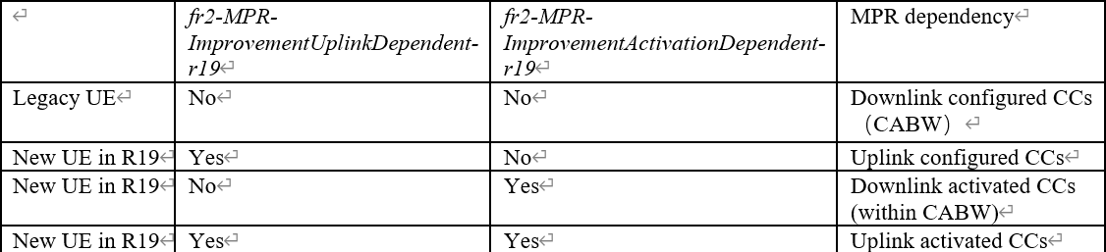

* + - To avoid misleading, the two levels of MPR enhancements (configuration based & activation based) should be renamed as uplink dependent MPR and activation dependent MPR
    - Send RAN2 LS to trigger the work early
  + Proposal 3: (vivo)
    - The enhancement capabilities for configuration-based and activation-based should be independent but not mutually exclusive.
    - Inorder to perform MPR reduction, whether *extendedDC-LocationReport-r17* must be supported together with the two capabilities needs discussion
  + Proposal 4: RAN4 should define distinct UE capabilities, considering cases where activated CABW is applied in addition to cases where configured UL BWchannel_CA or activated UL CCs bandwidth are used as the bandwidth basis for FR2 CA MPR table. (NTT DOCOMO)
  + Proposal 5: As the implementation assumption behind the capabilities on configuration-based and activation-based could be the support of separate Tx/Rx LO and LO tuning respectively, these two capabilities do not need to be mutually exclusive (Huawei)
* Recommended WF (to be discussed in main session)
  + For Rel-19 FR2 UE MPR enhancement, the capabilities for ‘configuration-based’ enhancements and ‘activation-based’ enhancement are separate and independent.
    - ~~FFS whether to~~ To rename the capabilities as [uplink dependent MPR] and [activation dependent MPR]
      * The two capabilities do not need to be mutually exclusive
    - ~~FFS whether distinct UE capabilities to be defined considering cases where activated CABW is applied in addition to cases where configured UL BW~~~~channel_CA~~ ~~or activated UL CCs bandwidth are used~~
  + ~~To further discuss whether LS could be sent to RAN2 on the capabilities to be introduced for the FR2 MPR enhancement~~

NTT DOCOMO: agree with Recommend WF. We agree with proposal2.

Samsung: The main bullet is agreeable. For the first bullet, we should rename.

Qualcomm: General support to make something more clear. We do not need the second sub-bullet.

Apple: the activation case, configuration cases should be taken into account.

#### **Issue 2-1-2: Applicable emission requirements for CC activation based enhancement**

* Proposals
  + Proposal 1: For the agreed Rel-19 ‘activation based’ enhancements, the emissions requirements are unchanged from legacy CA, whether the feature is supported or not. (Qualcomm)
  + Proposal 2: No change is needed to existing emission requirements for enhanced MPR feature (Samsung)
  + Proposal 3: For Rel-19 FR2 intra-band contiguous UL CA MPR improvement (both configuration based and activation based), the OOB requirements are still based on UL aggregated channel bandwidth as defined in TS 38.101-2. (Huawei)
* WF
  + No change is needed to existing emission requirements for enhanced MPR feature

#### **Issue 2-1-3: Bandwidth basis applicability**

* Proposals
  + Proposal 1: (Samsung)-
    - Correct the applicable MPR when bandwidth basis=400 MHz or 800MHz
    - 800MHz upper limit of uplink aggregated bandwidth can be addressed in Table 5.5A.1-1 of TS 38.101-2
  + Proposal 2: Since the PC3 CA MPR Table was intentionally changed to ≤400 MHz based on technical rationale, the boundary should not be altered**.** (NTT DOCOMO)
* WF
  + No change is needed to existing requirements in terms of bandwidth basis applicability