3GPP TSG-RAN WG4 Meeting #109 R4-2321820
Chicago, US, November 13 – 17, 2023

Agenda item: 8.20.3
Source: vivo, CMCC, Qualcomm, Ericsson, ZTE, Sony, Nokia, Murata
Title: TP to TR 38.869 LP-WUS receiver architectures
Document for: Approval

1 Introduction
This TP provide RAN4 analysis on LP-WUR receiver architectures, the update is based on the approved TP in [1].

2 References
- R4-2317775, TP to TR 38.869 on LP-WUS receiver architectures, vivo, Huawei, Qualcomm, Ericsson, Nokia, Apple, RAN4#108bis
- 3GPP TR 38.869 v1.1.1

3 Text Proposal to TR 38.869

--------------Start of text proposal 1-------------

7.1.2 RAN4 studies of the receiver
Editor’s note: RAN4 RF related conclusions

7.1.2.1 General
This Clause captures the study outcome of LP-WUR RF impacts. RAN4 focus on FR1 frequency ranges as first priority, 2.6GHz is selected as an example band for evaluation purpose.
For evaluation purpose, RAN4 define a new term named as guard RB for LP-WUS, which is Granularity of RB for ACS/ASCS protection. Meanwhile, the traditional guardband for NR channel bandwidth defined in Clause 5.3, TS 38.101-1 is unchanged. The LP-WUS guard RB definition can be described different for ASCS and ACS as following:
- For ASCS guard RB, the required guard RB(s) should be blanked RB(s), which belong to WUS carrier/BW (i.e., WUS signal plus ASCS guard RB(s))
- For ACS guard RB, the required guard RB(s) are RB(s) between WUS signal edge and nearest edge of guardband of channel bandwidth
- It includes ASCS guard RB(s) (if allocated) and RBs (which could be blanked RBs or RBs used for NR transmission) between WUS carrier/BW edge and nearest edge of guardband of channel bandwidth as defined in spec TS 38.101-1

RAN4 agrees there is no need to restrict symmetric guard RBs for interference rejection of WUS, both ACS and ASCS.
RAN4 suggests overall bandwidth of the wake-up signal in the NR channel i.e., desired signal along with all the required guard RBs shall fit in the maximum transmission bandwidth configuration as defined in Table 5.3.2-1 of TS 38.101-1.
(case 1: WUS within large channel)
(case 2: WUS within narrow channel, WUS bandwidth is comparable with channel bandwidth)

Figure 7.1.2.1-1: Definition of the guardband of NR channel and guard RBs for both LP-WUS ACS and ASCS

7.1.2.2 ACS evaluation
Adjacent channel selectivity (ACS) is a measure of a receiver's ability to receive an NR signal at its assigned channel frequency in the presence of an adjacent channel signal at a given frequency offset from the centre frequency of the assigned channel. ACS is the ratio of the receive filter attenuation on the assigned channel frequency to the receive filter attenuation on the adjacent channel(s).
In general, NR ACS requirement is derived based on co-existence study to meet max 5% throughput loss metric. While for LP-WUS, the purpose in the study of ACS is not for justification of co-existence between contained LP-WUS and adjacent NR carrier, but to evaluate the required guard RBs in-between the different signals. Given the WUS waveform would be different from NR signal, the traditional throughput loss metric can not be reused. Therefore, RAN4 agrees to focus on the evaluation of required guard RB rather than ACS requirements with co-existence simulation.
Framework in RAN4 to evaluate ACS and ASCS vs guard RBs:
- ACS and ASCS guard RB can be evaluated based on the following aspects:
  - Typical filter characteristic, e.g., filter order, pass BW, cut-off frequency
  - Guard RB size
  - RF impairment can also be considered
- RAN4 adopts two approaches for guard RB evaluation, i.e., filter suppression level analysis and link level simulation
- Averaged power attenuation at ACS or ASCS frequency range
- FFS whether SINR of the wanted signal at detector input is needed
- FFS whether use ICS to instead ASCS
- FFS Coexistence-simulation-based framework can also be considered
  - FFS on details of coexistence study (if needed) of LP-WUS
  - Coverage should be considered
RAN4 Consider a limited set of WUS scenarios in table below for study purpose in RAN4, as shown in Table 7.1.2.2-1.
Table 7.1.2.2-1: Common LP-WUS evaluation parameters for ACS
NR RF channel BW | 20MHz/100MHz for 5MHz WUS
Guardband of NR channel | Unchanged, defined in Clause 5.3.3 in TS 38.101-1.  810kHz for wanted cell1 20MHz (5MHz WUS at edge), and 510kHz for interference cell2 5MHz.
WUS BW within NR channel | Max 5.04 MHz
WUS RB allocation (Note 1) | 24 RB (15kHz SCS) or 12 RB (30kHz SCS) within 5.04 MHz;
WUS placement within NR channel | Edge of channel, i.e., close to guardband
Guard RB size of LP-WUS | 0 RB, 0.5RB,1RB, 2RB, 3RB
ACS interferer (cell 2) | 5MHz with guardband
Filter characteristic | 2nd to 5th order Butterworth  lowpass@ baseband  bandpass@100 MHz  bandpass@2.6 GHz
Filter passband BW | Same as WUS bandwidth (number of RBs)
Target ACS | TBD; reuse NR value as starting point
Target WUS SNR | TBD
WUS SNR condition | TBD
NR power level | TBD
RF impairment | Max. Center frequency offset based on companies report
Note 1: For easy evaluation, the number of allocated WUS RBs is fixed. The number of Guard RBs is changed.

The frequency response of 2nd to 5th order Butterworth filters are shown as below:
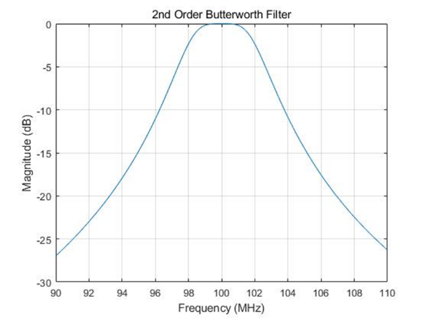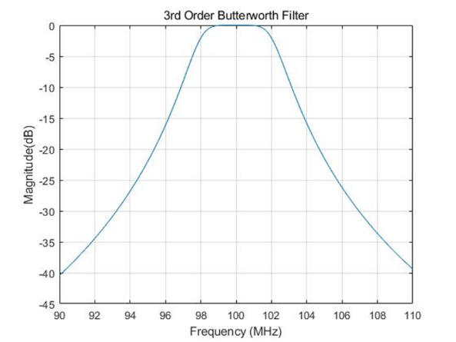
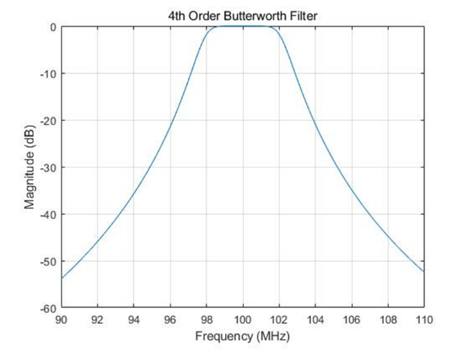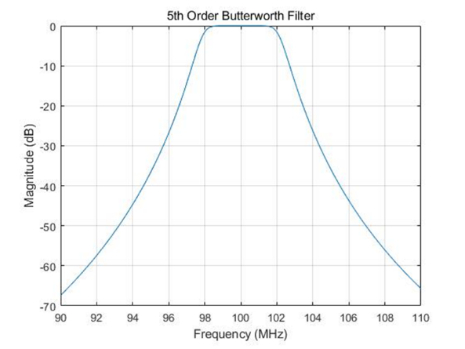
Figure 7.1.2.2-1: Frequency response of Butterworth filters

For ACS guard RB evaluation, RAN4 focus on the WUS at the edge of NR channel case, as shown in Figure 7.1.2.2-2.
Figure 7.1.2.2-2: WUS at the edge of NR channel
Conclusions for RAN4 ACS guard RB analysis:
Based on the analysis above, RAN4 observed that for 5th order filter, the guard RB number for LP-WUS ACS is in the range of 1RB ~ 6RBs for 30kHz SCS, or 2RBs ~12RBs for 15kHz SCS. For lower power, i.e., lower order filters, the required guard RBs may increases. There is no recommendation on which filter order should be considered to the baseline in SI phase.
- As the analysis from companies did not comprehensively consider all impairments, and individual results are missing the impact of one or many of the following: phase noise, non-linearity, frequency error, implementation margin. For the evaluation, companies have used OOK waveform and FSK waveform, other type of WUS signals are not used. Final conclusion on the number of guard RB is left to WI discussion.

Companies’ input on simulation analysis of ACS have been presented as following:
Filter suppression level analysis:
For filter suppression level calculation, the suppression level is calculated with averaged power attenuation at ACS frequency range.

Company 1 (R4-2314665)
The parameter assumption is aligned with that in Table 7.1.2.2-1. The required guard RB is provided in the Table 7.1.2.2-1 below. CFO from 0ppm~200ppm is considered as RF impairment impacts.
Table 7.1.2.2-2: Required number of Guard RBs for 5MHz ACS
Filter order |  |  | ACS, BW_{interference} = 5MHz
Filter order | Guard RB  CBW | Frequency  Offset | 0RB | 0.5RB | 1RB | 2RB | 3RB
5th | 20MHz, SCS = 15kHz | 0 ppm | -28.20 | -29.51 | -30.37 | -32.43 | -34.40
5th | 20MHz, SCS = 15kHz | 5 ppm | -27.95 | -29.26 | -30.11 | -32.18 | -34.14
5th | 20MHz, SCS = 15kHz | 10 ppm | -27.69 | -29.01 | -29.86 | -31.92 | -33.88
5th | 20MHz, SCS = 15kHz | 50 ppm | -25.73 | -27.02 | -27.87 | -29.92 | -31.87
5th | 20MHz, SCS = 15kHz | 200 ppm | -19.35 | -20.52 | -21.31 | -23.24 | -25.13
5th | 100MHz, SCS = 30kHz | 0 ppm | -34.51 | -36.33 | -38.07 | -41.33 | -44.33
5th | 100MHz, SCS = 30kHz | 5 ppm | -34.25 | -36.07 | -37.81 | -41.07 | -44.07
5th | 100MHz, SCS = 30kHz | 10 ppm | -33.99 | -35.81 | -37.55 | -40.81 | -43.81
5th | 100MHz, SCS = 30kHz | 50 ppm | -31.97 | -35.53 | -33.79 | -38.79 | -41.79
5th | 100MHz, SCS = 30kHz | 200 ppm | -25.21 | -27.00 | -28.72 | -31.97 | -34.97
4th | 20MHz, SCS = 15kHz | 0 ppm | -23.71 | -24.70 | -25.35 | -26.92 | -28.42
4th | 20MHz, SCS = 15kHz | 5 ppm | -23.51 | -24.50 | -25.15 | -26.72 | -28.22
4th | 20MHz, SCS = 15kHz | 10 ppm | -23.31 | -24.30 | -24.94 | -26.51 | -28.01
4th | 20MHz, SCS = 15kHz | 50 ppm | -21.75 | -22.73 | -23.37 | -24.92 | -26.41
4th | 20MHz, SCS = 15kHz | 200 ppm | -16.73 | -17.61 | -18.20 | -19.65 | -21.08
4th | 100MHz, SCS = 30kHz | 0 ppm | -28.35 | -29.76 | -31.11 | -33.64 | -35.97
4th | 100MHz, SCS = 30kHz | 5 ppm | -28.14 | -29.55 | -30.90 | -33.43 | -35.77
4th | 100MHz, SCS = 30kHz | 10 ppm | -27.94 | -29.34 | -30.69 | -33.22 | -35.56
4th | 100MHz, SCS = 30kHz | 50 ppm | -26.34 | -27.74 | -29.08 | -31.61 | -33.95
4th | 100MHz, SCS = 30kHz | 200 ppm | -20.98 | -22.34 | -23.67 | -26.17 | -28.50
3rd | 20MHz, SCS = 15kHz | 0 ppm | -18.80 | -19.49 | -19.94 | -21.04 | -22.10
3rd | 20MHz, SCS = 15kHz | 5 ppm | -18.65 | -19.34 | -19.79 | -20.89 | -21.94
3rd | 20MHz, SCS = 15kHz | 10 ppm | -18.50 | -19.19 | -19.64 | -20.74 | -21.79
3rd | 20MHz, SCS = 15kHz | 50 ppm | -17.36 | -18.04 | -18.48 | -19.56 | -20.61
3rd | 20MHz, SCS = 15kHz | 200 ppm | -13.68 | -14.29 | -14.69 | -15.70 | -16.69
3rd | 100MHz, SCS = 30kHz | 0 ppm | -21.90 | -22.90 | -23.87 | -25.70 | -27.39
3rd | 100MHz, SCS = 30kHz | 5 ppm | -21.75 | -22.75 | -23.72 | -25.54 | -27.24
3rd | 100MHz, SCS = 30kHz | 10 ppm | -21.59 | -22.60 | -23.56 | -25.39 | -27.09
3rd | 100MHz, SCS = 30kHz | 50 ppm | -20.41 | -21.41 | -22.37 | -24.19 | -25.88
3rd | 100MHz, SCS = 30kHz | 200 ppm | -16.46 | -17.43 | -18.36 | -20.14 | -21.82
2nd | 20MHz, SCS = 15kHz | 0 ppm | -13.43 | -13.84 | -14.11 | -14.77 | -15.41
2nd | 20MHz, SCS = 15kHz | 5 ppm | -13.34 | -13.75 | -14.02 | -14.68 | -15.31
2nd | 20MHz, SCS = 15kHz | 10 ppm | -13.25 | -13.65 | -13.92 | -14.58 | -15.22
2nd | 20MHz, SCS = 15kHz | 50 ppm | -12.52 | -12.92 | -13.18 | -13.83 | -14.45
2nd | 20MHz, SCS = 15kHz | 200 ppm | -10.16 | -10.53 | -10.77 | -11.36 | -11.95
2nd | 100MHz, SCS = 30kHz | 0 ppm | -15.18 | -15.80 | -16.40 | -17.54 | -18.62
2nd | 100MHz, SCS = 30kHz | 5 ppm | -15.08 | -15.70 | -16.30 | -17.44 | -18.52
2nd | 100MHz, SCS = 30kHz | 10 ppm | -14.98 | -15.60 | -16.20 | -17.34 | -18.41
2nd | 100MHz, SCS = 30kHz | 50 ppm | -14.22 | -14.83 | -15.42 | -16.56 | -17.62
2nd | 100MHz, SCS = 30kHz | 200 ppm | -11.70 | -12.28 | -12.85 | -13.94 | -14.98

Company 5 (R4-2311502)
The evaluation parameters are listed in Table 7.1.2.2-3 below.
Table 7.1.2.2-3 Evaluation assumptions.
WUS signal bandwidth | 4.32 MHz
Interferer power level | 0 dBc
F0 | 2.6 GHz
Filter Type | Butterworth

Table 7.1.2.2-4 Guard required in kHz for a target interference level of -10 dBc.
CFO | Filter order
 | 1 | 2 | 3 | 4 | 5
± 0 ppm | 4320.0 | 1598.4 | 972.0 | 691.2 | 540
± 5 ppm | 4346.0 | 1608.0 | 977.9 | 695.4 | 543.3
± 50 ppm | 4580.0 | 1694.6 | 1030.5 | 732.8 | 572.5
± 100 ppm | 4840.0 | 1790.8 | 1089.0 | 774.4 | 605.0
± 200 ppm | 5360.0 | 1983.2 | 1206.0 | 857.6 | 670.0

Based on the results in Table 7.1.2.2-4, it is suggested that for 5th order filter, the guard RB number for LP-WUS can be 2RBs for 30kHz SCS, or 3RBs ~ 4RBs for 15kHz SCS.

Company 6 (R4-2315194)
Following list our filter evaluation analysis assumption.
Table 7.1.2.2-5: LP-WUS evaluation scenarios
NR RF channel BW | 20MHz/100MHz for 5MHz WUS
Guardband of NR channel | Unchanged, defined in Clause 5.3.3 in TS 38.101-1, i.e.  For 15kHz SCS, 242.5kHz guardband for 5MHz CBW and 452.5kHz guard band for 20MHz CBW  For 30kHz SCS, 505kHz guardband for 5MHz CBW and 845kHz guard band for 100MHz CBW
WUS BW within NR channel | 5.04 MHz
WUS RB allocation (Note 1) | 24 RB, i.e. total 4.32MHz
WUS placement within NR channel | Carrier edge for ACS and carrier center for ASCS
Guard RB size of LP-WUS | 0 RB, 0.5 RF, 1RB, 2RBs, 3RB at each side.  Only symmetric guard RB has been considered
ACS interferer | 5MHz
Filter characteristic | 2rd and 5th order Butterworth  Both analog and digital filter can be considered
Filter passband BW | 4.32/2=2.16MHz for low-pass filter  4.32MHz for band-pass filter
Following list the S21 of 2nd and 5th order butterworth filters and related parameters.
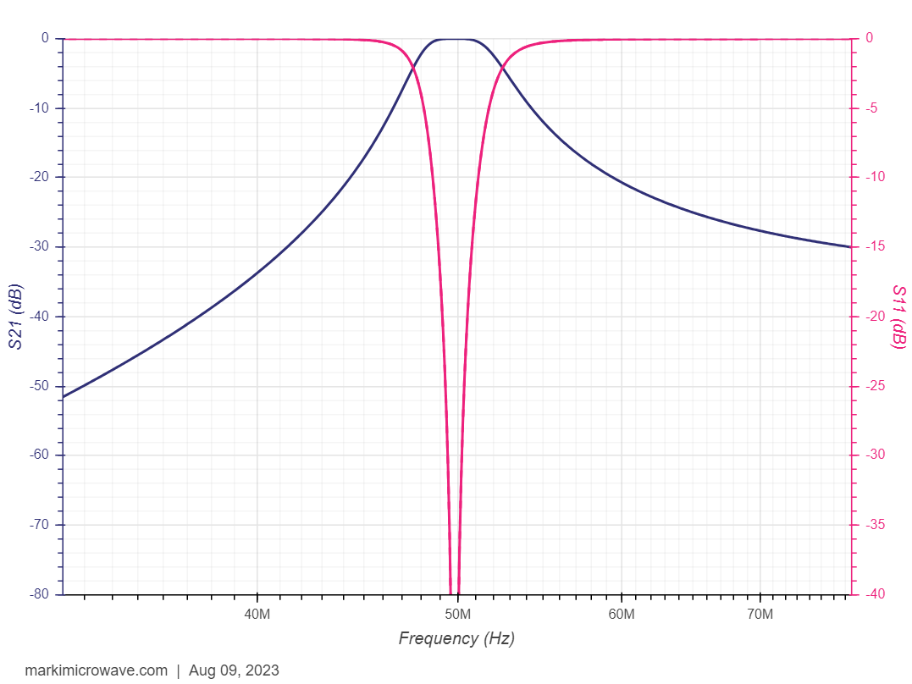
Figure 7.1.2.2-3: Frequency response of 2nd Butterworth filters
Figure 7.1.2.2-4: Frequency response of 5th Butterworth filters
Following table list ACS value based on low-pass filter for zero-IF envelop detector architecture, in which pass bandwidth is 4.32/2=2.16MHz.
Table 7.1.2.2-6. evaluated ACS based on low-pass filter with 2.16MHz pass bandwidth
Filter order |  |  | ACS, BW_{interference} = 5MHz
Filter order | Guard RB  CBW | Frequency  Offset | 0RB/  30kSCS | 0.5RB/  30kSCS | 1RB/  30kSCS | 2RB/  30kSCS | 3RB/  30kSCS
5th | 20MHz, SCS = 15kHz | 0 ppm | -27.75 | -29.88 | -31.9 | -35.65 | -39.07
5th | 20MHz, SCS = 15kHz | 5 ppm | -27.6 | -29.73 | -31.76 | -35.52 | -38.95
5th | 20MHz, SCS = 15kHz | 10 ppm | -27.44 | -29.58 | -31.61 | -35.39 | -38.83
5th | 20MHz, SCS = 15kHz | 50 ppm | -26.15 | -28.35 | -30.45 | -34.34 | -37.87
5th | 20MHz, SCS = 15kHz | 200 ppm | -21.1 | -23.47 | -25.78 | -30.11 | -34.03
5th | 100MHz, SCS = 30kHz | 0 ppm | -35.00 | -36.78 | -38.47 | -41.65 | -44.59
5th | 100MHz, SCS = 30kHz | 5 ppm | -34.87 | -36.65 | -38.35 | -41.54 | -44.49
5th | 100MHz, SCS = 30kHz | 10 ppm | -34.74 | -36.52 | -38.23 | -41.43 | -44.38
5th | 100MHz, SCS = 30kHz | 50 ppm | -33.66 | -35.5 | -37.25 | -40.53 | -43.55
5th | 100MHz, SCS = 30kHz | 200 ppm | -29.36 | -31.4 | -33.35 | -36.97 | -40.27
2nd | 20MHz, SCS = 15kHz | 0 ppm | -12.62 | -13.28 | -13.93 | -15.18 | -16.34
2nd | 20MHz, SCS = 15kHz | 5 ppm | -12.57 | -13.24 | -13.89 | -15.13 | -16.3
2nd | 20MHz, SCS = 15kHz | 10 ppm | -12.52 | -13.19 | -13.84 | -15.09 | -16.26
2nd | 20MHz, SCS = 15kHz | 50 ppm | -12.12 | -12.8 | -13.47 | -14.74 | -15.93
2nd | 20MHz, SCS = 15kHz | 200 ppm | -10.59 | -11.3 | -12.01 | -13.36 | -14.63
2nd | 100MHz, SCS = 30kHz | 0 ppm | -14.96 | -15.56 | -16.13 | -17.24 | -18.28
2nd | 100MHz, SCS = 30kHz | 5 ppm | -14.91 | -15.51 | -16.09 | -17.2 | -18.24
2nd | 100MHz, SCS = 30kHz | 10 ppm | -14.87 | -15.47 | -16.05 | -17.16 | -18.21
2nd | 100MHz, SCS = 30kHz | 50 ppm | -14.51 | -15.13 | -15.72 | -16.85 | -17.91
2nd | 100MHz, SCS = 30kHz | 200 ppm | -13.12 | -13.77 | -14.41 | -15.62 | -16.76
Following table is based on analog band-pass filter for RF/IF envelop detector architecture, in which pass bandwidth is 4.32MHz.
Table 7.1.2.2-7. evaluated ACS based on analog band-pass filter with 4.32MHz pass bandwidth
Filter order |  |  | ACS, BW_{interference} = 5MHz
Filter order | Guard RB  CBW | Frequency  Offset | 0RB/  30kSCS | 0.5RB/  30kSCS | 1RB/  30kSCS | 2RB/  30kSCS | 3RB/  30kSCS
5th | 20MHz, SCS = 15kHz | 0 ppm | -17.96 | -19.16 | -20.34 | -22.64 | -24.83
5th | 20MHz, SCS = 15kHz | 5 ppm | -17.88 | -19.08 | -20.26 | -22.56 | -24.75
5th | 20MHz, SCS = 15kHz | 10 ppm | -17.79 | -18.99 | -20.18 | -22.48 | -24.68
5th | 20MHz, SCS = 15kHz | 50 ppm | -17.09 | -18.3 | -19.49 | -21.82 | -24.05
5th | 20MHz, SCS = 15kHz | 200 ppm | -14.46 | -15.67 | -16.89 | -19.3 | -21.63
5th | 100MHz, SCS = 30kHz | 0 ppm | -22.23 | -23.35 | -24.44 | -26.55 | -28.56
5th | 100MHz, SCS = 30kHz | 5 ppm | -22.15 | -23.27 | -24.36 | -26.47 | -28.49
5th | 100MHz, SCS = 30kHz | 10 ppm | -22.07 | -23.19 | -24.29 | -26.4 | -28.42
5th | 100MHz, SCS = 30kHz | 50 ppm | -21.41 | -22.54 | -23.66 | -25.8 | -27.84
5th | 100MHz, SCS = 30kHz | 200 ppm | -18.86 | -20.05 | -21.22 | -23.47 | -25.63
2nd | 20MHz, SCS = 15kHz | 0 ppm | -8.18 | -8.56 | -8.94 | -9.7 | -10.43
2nd | 20MHz, SCS = 15kHz | 5 ppm | -8.15 | -8.53 | -8.92 | -9.67 | -10.4
2nd | 20MHz, SCS = 15kHz | 10 ppm | -8.12 | -8.51 | -8.89 | -9.64 | -10.38
2nd | 20MHz, SCS = 15kHz | 50 ppm | -7.9 | -8.28 | -8.67 | -9.43 | -10.17
2nd | 20MHz, SCS = 15kHz | 200 ppm | -7.05 | -7.44 | -7.83 | -8.6 | -9.36
2nd | 100MHz, SCS = 30kHz | 0 ppm | -9.56 | -9.93 | -10.3 | -11.02 | -11.72
2nd | 100MHz, SCS = 30kHz | 5 ppm | -9.53 | -9.91 | -10.27 | -10.99 | -11.69
2nd | 100MHz, SCS = 30kHz | 10 ppm | -9.51 | -9.88 | -10.25 | -10.97 | -11.67
2nd | 100MHz, SCS = 30kHz | 50 ppm | -9.29 | -9.67 | -10.04 | -10.76 | -11.47
2nd | 100MHz, SCS = 30kHz | 200 ppm | -8.47 | -8.85 | -9.23 | -9.97 | -10.7

Less pass bandwidth will lead to better filter suppression capability, so table 7.1.2.2-6 with less pass bandwidth will have better performance.

Link-level simulation analysis:
Company 1 (R4-2314665)
The detailed parameters are listed in Table 7.1.2.2-8.
Table 7.1.2.2-8: LP-WUS ACS and ASCS simulation parameters
Attributes | Assumptions
Carrier Frequency | 2.6GHz
Case name | OOK-1 waveform | OOK-2 waveform | OOK-4 waveform
Channel structure | data: 6 bits CRC: 8 bits | data: 20 bits CRC: 8 bits | data: 20bits CRC: 8 bits
Chip rate | M=1 | M=2 | M=2
WUS duration | 28 symbols
Waveform | OOK -1/OOK-2/OOK-4
Coding | 1/2 rate Manchester coding
Time error | 0
residual Frequency error | 0/10/20/50/22700 ppm(for ASCS evaluation)
SCS | 30kHz
gNB Channel BW | 20MHz (50 RB)
WUS BW | 12RB ~4.32MHz
Guardband of NR channel (ACS) | 27RE~810kHz for wanted cell1 20MHz (5MHz WUS at edge), and 510kHz for interference cell2 5MHz.
Guard RB | Outer GB:2/1/0.5RB on each side of LP-WUS bandwidth (2 RB for ACS)  Inner GB: 4RE between segments
Filter | 3th/5th Order lowpass Butterworth with 4.32MHz bandwidth  (2.1 MHz bandwidth for OOK-2 M=2)
ASCS | PDSCH mapped on RBs not used for LP-WUS and Guard RB;  EPRE of PDSCH /EPRE of LP-WUS = 0 dB  Same PSD with WUS signal
ACS | PDSCH mapped on RBs(14RB~5MHz), one side;  EPRE of PDSCH /EPRE of LP-WUS = 31.5 dB  31.5dB higher
Sampling Rate | 7.68MHz
ADC bit width | 4 bits ADC for ASCS, 8 bits ADC for ACS;
Phase noise | unable
Power boosting | 0dB for OOK-1/4  3dB for OOK-2
Channel Model | TDL-C 300
Performance metric | {FAR, MDR}: {1%, 1%}

The simulation results are in Figure 7.1.2.2-5 for ACS.
Figure 7.1.2.2-5. ACS guard RB evaluation
It can be observed that 1 RB of 30kHz SCS with 5th order filtering is sufficient for OOK-1, OOK-2, and OOK-4 LP-WUS.

Company 2 (R4-2312248)
The 5MHz interferer is 31.5dB higher than the wanted signal for ACS simulation. Simulations for the waveforms in Figure 7.1.2.2-6 have been performed.
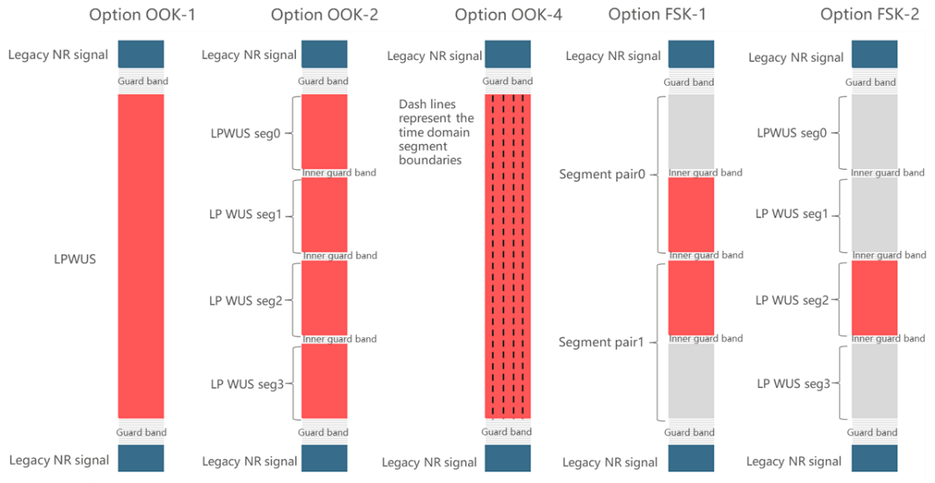
Figure 7.1.2.2-6: Some of the LP-WUS waveform options
For waveform options of OOK-2, FSK-1 and FSK-2, since segmented RB allocations are considered, several narrower filters would be needed to filter out the interference in contrast to a single filter used for OOK-1 and OOK-4.
Figure 7.1.2.2-7 shows the simulation results for the aforementioned waveforms.
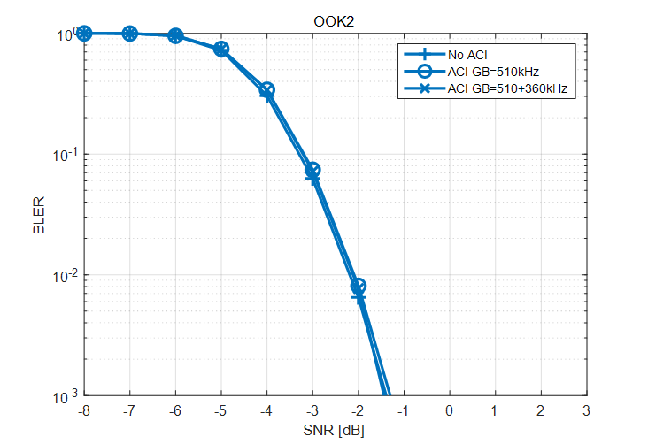
a) Guard RB evaluation of OOK-1 b) Guard RB evaluation of OOK-2
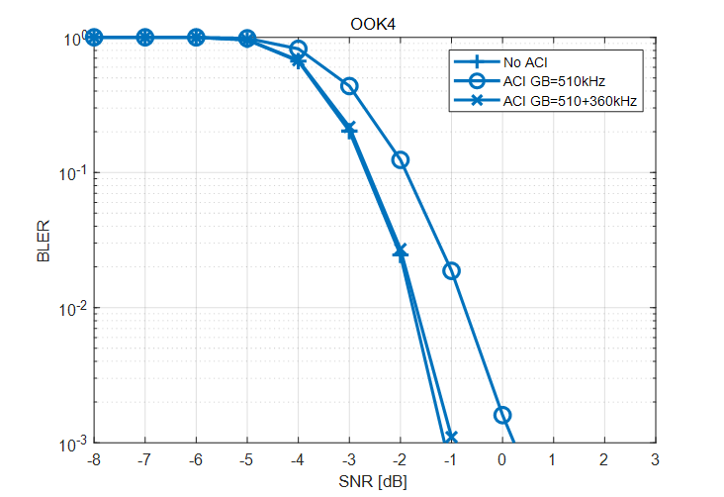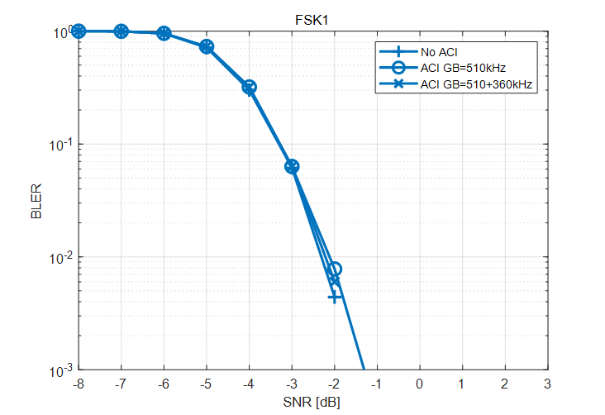
c) Guard RB evaluation of OOK-4 d) Guard RB evaluation of FSK-1
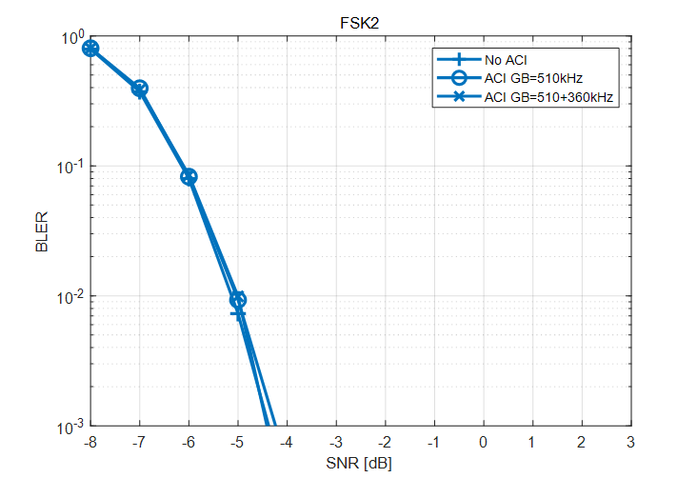
e) Guard RB evaluation of FSK-2
Figure 7.1.2.2-7: ACS guard RB evaluation for several waveforms
For the evaluated waveform options of OOK-1, OOK-2, OOK-4, FSK-1 and FSK-2, guard RB with the size of one 30kHz SCS RB could provide necessary protection of LP-WUS from interference of adjacent NR carrier. For 5th order Butterworth filter assumption, it is proposed to reserve 1 RB for 30kHz SCS or 2RBs for 15kHz SCS for protection of LP-WUS from interference of the adjacent NR carrier.

Company 3 (R4-2311902, and R4-2316697)
Simulations were done to evaluate the impact of adjacent channel and adjacent subcarrier interference. The simulation configuration was created closely match with existing RAN4 minimum requirement for adjacent channel selectivity. Minor adaptations needed to be done as 30 kHz SCS was used. The details of the simulation configuration are provided in Table 7.1.2.2-9.

Table 7.1.2.2-9: Simulation configuration
NR system BW | 20 MHz
Subcarrier spacing | 30 kHz
Guardband of NR channel | 810 kHz
WUS BW within NR channel | 12 RB = 4.32 MHz
WUS signal | OOK-4
Guard RB size of LP-WUS | 0 or 1 RB. GB is placed outside of the 12 RB carrying WUS
WUS placement within NR channel | - Immediately adjacent to system BW edge, NR channel GB is respected  - Additional 3RB = 1.08 MHz offset from system BW edge compared to case 1)  - Additional 6 RB = 2.16 MHz offset from system BW edge compared to case 1  - Additional 12 RB = 4.32 offset from system BW edge compared to case 1  NOTE: Together with 1 RB GB, total offset from system BW edge to first WUS RB is reported offset + 360 kHz
ACS interferer signal | 12 RB = 4.32 MHz, center of interferer 2.52 MHz offset from system BW channel edge
ACS interferer signal level | Relative difference to signals within system BW aligned with Table 7.5-3 in TS 38.101-1 for 20 MHz channel bandwidth
Adjacent subcarrier interference | Except for the Guard RB size of LP-WUS of 0 or 1 RB, all subcarriers within system BW carry OFDM QPSK data
Filter characteristic | 2nd to 5th order Butterworth
Filter passband BW (-3 dB) | 4.32 MHz  5 MHz  6 MHz
LO frequency | In the middle of WUS
Frequency error | 0, 50, 100 ppm
Phase noise | Not modelled
Non-linearities | Not modelled
Channel model | TDL-C 300 ns
NR system BW | 20 MHz
Subcarrier spacing | 30 kHz
Guardband of NR channel | 810 kHz
WUS BW within NR channel | 12 RB = 4.32 MHz
WUS signal | OOK-4
Guard RB size of LP-WUS | 0 or 1 RB. GB is placed outside of the 12 RB carrying WUS
WUS placement within NR channel | Immediately adjacent to system BW edge, NR channel GB is respected  Additional 3RB = 1.08 MHz offset from system BW edge compared to case 1)  NOTE: Together with 1 RB GB, total offset from system BW edge to first WUS RB is 4 RB = 1.44 MHz
ACS interferer signal | 12 RB = 4.32 MHz, center of interferer 2.52 MHz offset from system BW channel edge
ACS interferer signal level | Relative difference to signals within system BW aligned with Table 7.5-3 in TS 38.101-1 for 20 MHz channel bandwidth
Adjacent subcarrier interference | Except for the Guard RB size of LP-WUS of 0 or 1 RB, all subcarriers within system BW carry OFDM QPSK data
Filter characteristic | 2nd to 5th order Butterworth
Filter passband BW (-3 dB) | 4.32 MHz  5 MHz  6 MHz
LO frequency | In the middle of WUS
Frequency error | Not modelled
Phase noise | Not modelled
Non-linearities | Not modelled
Channel model | TDL-C 300 ns

Simulation results are also optimistic as no frequency error, phase noise or non-linearities were modelled. For filter passband BW 3 options were used. With the narrowest passband BW the filter already cuts into WUS with 3 dB attenuation at WUS edges. Wider bandwidths are used to model practical implementation imperfections as well as possibility of missing or simplified calibration for filter corner frequency.
First an example of ACI impact and GB impact are presented in Figures 7.1.2.2-8 and 7.1.2.2-9.
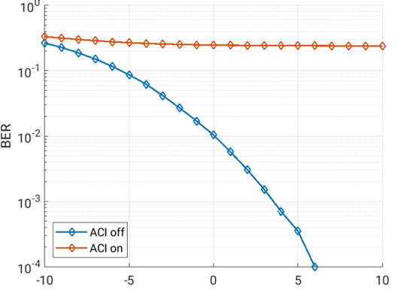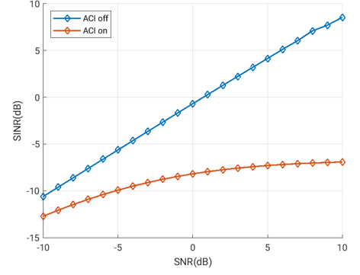
Figure 7.1.2.2-8: Impact of ACI, 3rd order filter, 4.32 MHz filter BW, WUS at system BW edge with GB = 0 RB

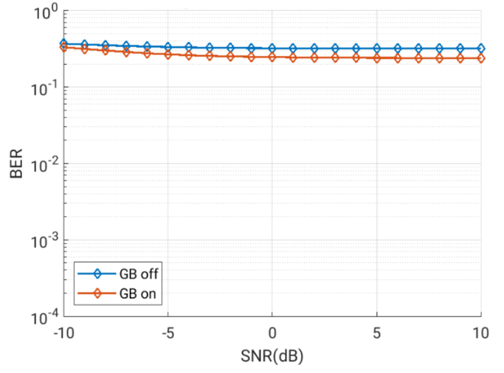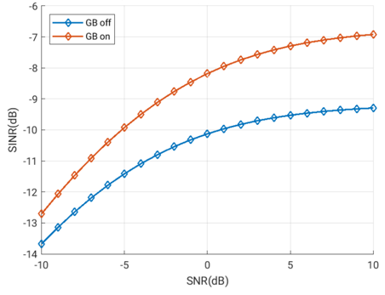
Figure 7.1.2.2-9: Impact of GB, 3rd order filter, 4.32 MHz filter BW, WUS at system BW edge with GBoff meaning GB = 0RB and with GBon meaning 1 RB GB. ACI is on for both curves.
It can be seen that for the chosen example scenario, adding ACI results in extremely poor BER. With no ACI present, there is clear relationship between SNR and BER. Whether guard band of 1 RB = 360 kHz is present or not does not change the results meaningfully. When looking at the SINR vs. SNR, the explanation is clear: when ACI is present, SINR never increase above -7 dB when SNR increases to 10 dB.
Next results are presented for different filter bandwidths and filter orders when ACI is present in Figures 7.1.2.2-10 and 7.1.2.2-11.
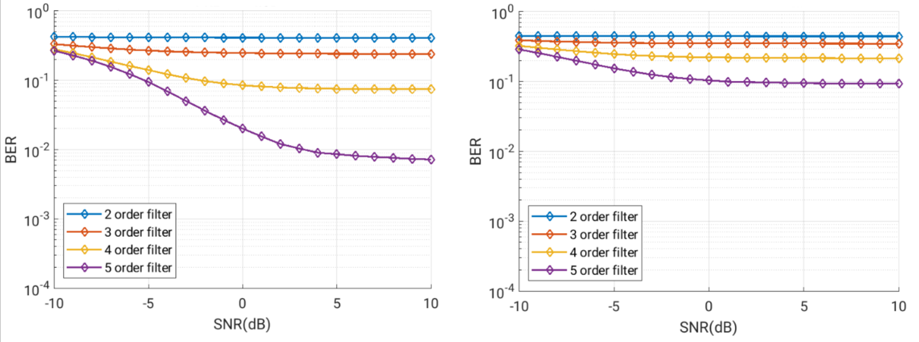
Figure 7.1.2.2-10: Left: BER vs. SNR, 4.32 MHz filter BW, WUS at system BW edge, GB = 1 RB; Right: BER vs. SNR, 5 MHz filter BW, WUS at system BW edge, GB = 1 RB

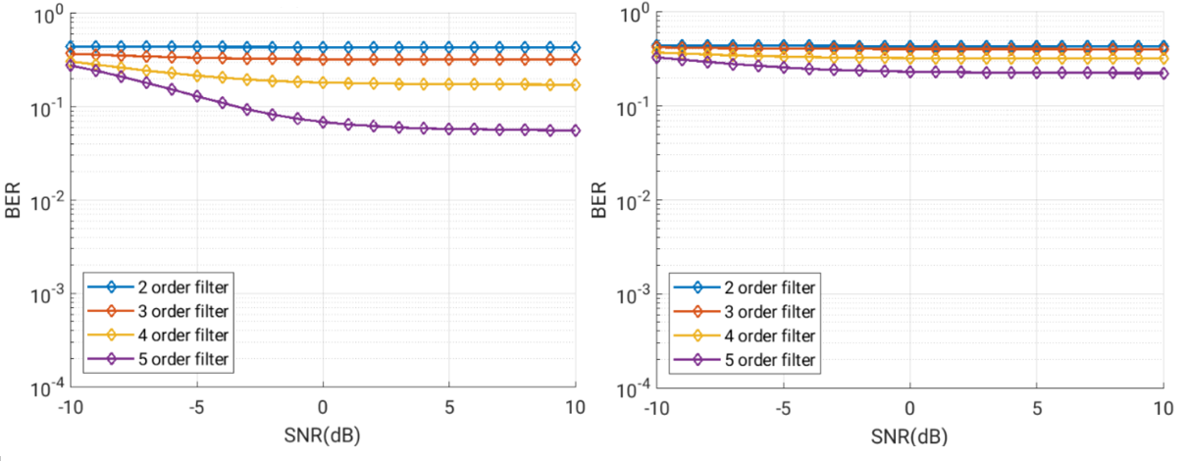
Figure 7.1.2.2-11: Left: BER vs. SNR, 4.32 MHz filter BW, WUS at system BW edge, GB = 0 RB; Right: BER vs. SNR, 5 MHz filter BW, WUS at system BW edge, GB = 0 RB
It can be seen that with 1 RB GB, BER is starting to be borderline acceptable with higher SNR levels only with 5th order filter which for which the -3 dB bandwidth is exactly aligned with WUS BW. This is when no phase noise, non-linearities, frequency error, or practical filter implementation aspects are considered. Also with 15 kHz SCS, the NR channel GB would be narrower and performance with the same 360 kHz GB would be worse. Therefore, we conclude that 360 kHz GB at channel edge does not enable low-power low-cost RF implementation of wake-up receiver.
To estimate the required GB we simulated how the performance changes if 3 additional RBs, i.e. additional 1.08 MHz, are used for guard band at channel edge. These RBs carry NR OFDM signal. Together with the WUS GB of 0 or 1 RB, the total separation from system BW edge is up to 1.44 MHz, and this is on top of the NR channel GB of 810 kHz. Results are shown in Figures 7.1.2.2-12 to 7.1.2.2-13.
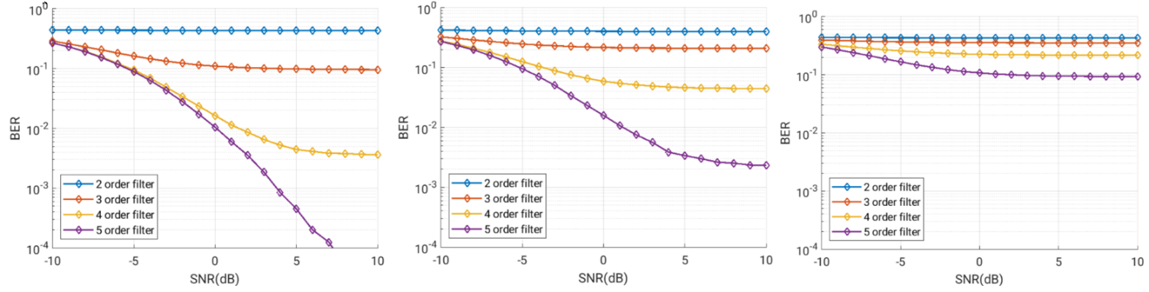
Figure 7.1.2.2-12: Left: BER vs. SNR, 4.32 MHz filter BW, WUS 3 RB offset from system BW edge, GB = 0 RB; Middle: BER vs. SNR, 5 MHz filter BW, WUS 3 RB offset from system BW edge, GB = 0 RB; Right: BER vs. SNR, 6 MHz filter BW, WUS 3 RB offset from system BW edge, GB = 0 RB
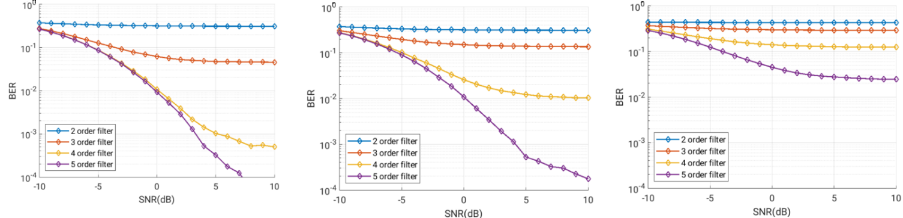
Figure 7.1.2.2-13: Left: BER vs. SNR, 4.32 MHz filter BW, WUS 3 RB offset from system BW edge, GB = 1 RB; Middle: BER vs. SNR, 5 MHz filter BW, WUS 3 RB offset from system BW edge, GB = 1 RB; Right: BER vs. SNR, 6 MHz filter BW, WUS 3 RB offset from system BW edge, GB = 1 RB
In Figure 7.1.2.2-14 and 7.1.2.2-15, BER vs, SNR results are presented for case where LP-WUS is placed 6 RB offset from system BW edge, and when additional 1 RB GB is applied on top of this.
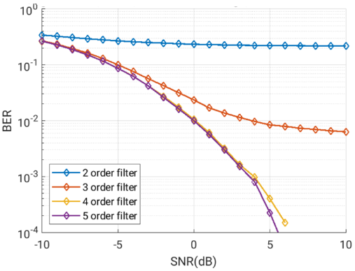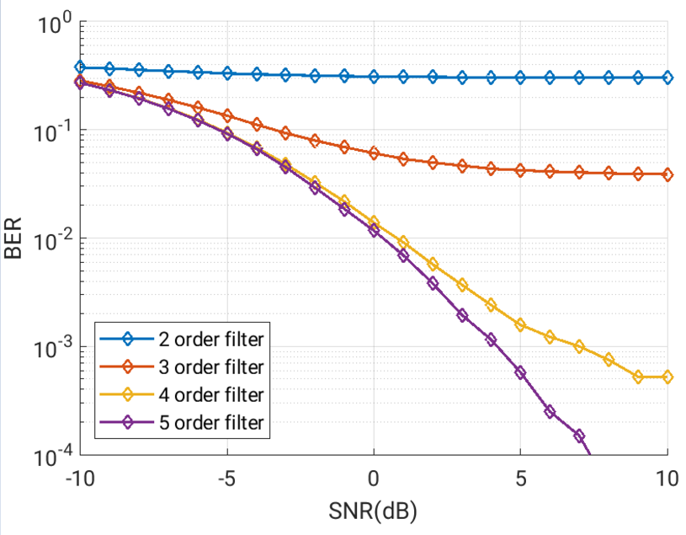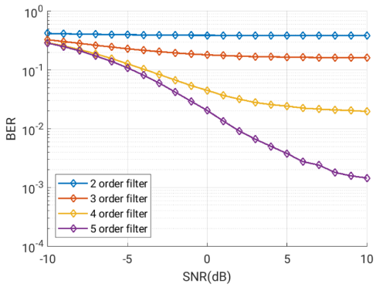

Figure 7.1.2.2-14:
Left: BER vs. SNR with ASCI and ACI, 4.32 MHz filter BW, LP-WUS 6 RB offset from system BW edge with no RB GB towards ASCS.
Middle: BER vs. SNR with ASCI and ACI, 5 MHz filter BW, LP-WUS 6 RB offset from system BW edge with no RB GB towards ASCS.
Right: BER vs. SNR with ASCI and ACI, 6 MHz filter BW, LP-WUS 6 RB offset from system BW edge with no RB GB towards ASCS.

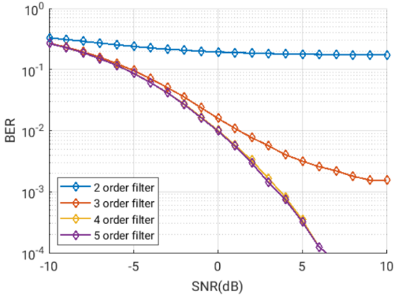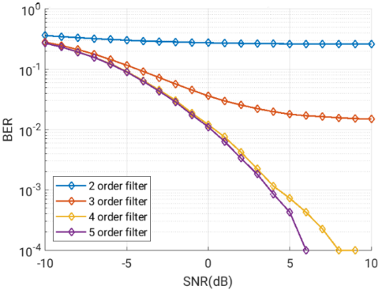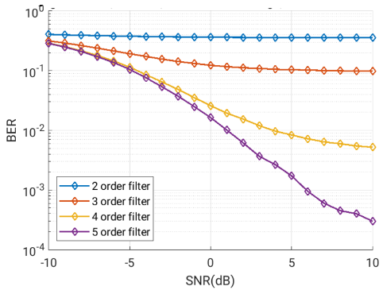

Figure 7.1.2.2-15:
Left: BER vs. SNR with ASCI and ACI, 4.32 MHz filter BW, LP-WUS 6+1 RB offset from system BW edge with no RB GB towards ASCS.
Middle: BER vs. SNR with ASCI and ACI, 5 MHz filter BW, LP-WUS 6+1 RB offset from system BW edge with no RB GB towards ASCS.
Right: BER vs. SNR with ASCI and ACI, 6 MHz filter BW, LP-WUS 6+1 RB offset from system BW edge with no RB GB towards ASCS.

The results in above Figures show that performance is still far from ideal with lower order filters even with 6 RB offset. When looking at the data, there are some things to consider: while frequency error, phase noise and non-linearities will make the performance even worse, RAN4 allows a significant relaxation to wanted signal level in ACS test. Therefore, the correct SNR range to be looked at would be rather towards the right side of the plots.
Finally Figure 7.1.2.2-16 shows performance with 3rd filter with different offsets from system BW edge.

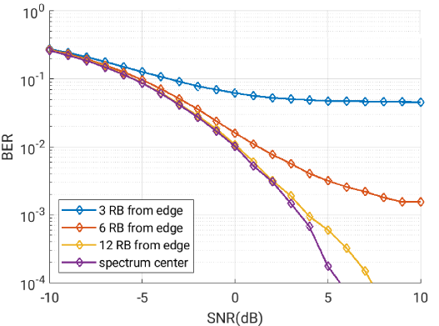
Figure 7.1.2.2-16: Performance with 3rd order filter at different RB offsets from system BW edge with 4.32 MHz filter BW
The results in Figures 7.1.2.2-8 to Figure 7.1.2.2-13 show that even with total of 1.44 MHz separation from system BW edge, on top of the 810 kHz NR channel GB the SINR with 3rd order filter will not rise above 0 dB. This is with the filter BW matched to WUS BW, no nonlinearities, no frequency error and no phase noise present. If some practical filter implementation aspects are considered and therefore 5 MHz filter BW is considered, only 5th order filter reaches acceptable performance. With 15 kHz SCS the NR channel GB would be narrower, and performance would be worse.
The results in Figures 7.1.2.2-14 to Figure 7.1.2.2-16 further show that more than 2.16 MHz offset from system BW edge, on top of the NR channel GB, is preferred for improved system performance with lower complexity implementation.
When frequency error is considered in addition, there is additional negative impact to performance, as exemplified in Figure 7.1.2.2-17.
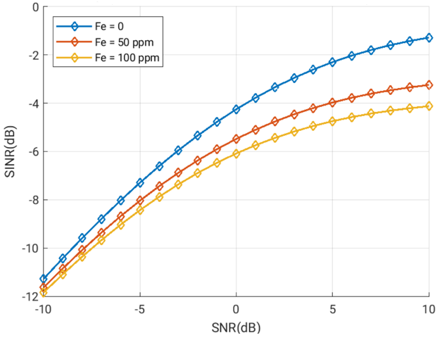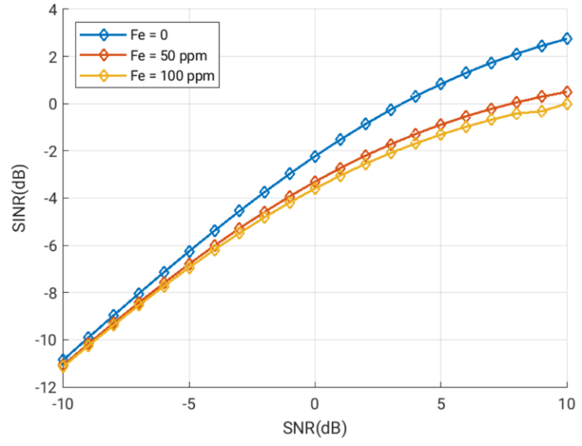
Figure 7.1.2.2-17:
Left: SINR vs. SNR with ASCI and ACI, 3rd order filter with 4.32 MHz filter BW, LP-WUS 3 RB offset from system BW edge with 1 RB GB towards ASCS.
Right: SINR vs. SNR with ASCI and ACI, 3rd order filter with 4.32 MHz filter BW, LP-WUS 6 RB offset from system BW edge with 1 RB GB towards ASCS.

In Figure 7.1.2.2-17 it can be seen that frequency error has a clear negative impact to SINR, and e.g. in case of 6+1 RB offset from adjacent channel, having frequency error in place can result in need of up to 7 dB higher input SNR to reach the same SINR when compared to against case with no frequency error. With 3+1RB offset to band edge in left sub-figure, impact of frequency error makes it very difficult to reach SINR range where successful operation would be possible. It should be noted that while LP-WUS receiver is expected to periodically synchronize itself, there will also be long sleep periods during which frequency can drift. Therefore, considering large frequency offsets is not unreasonable.
If full flexibility for WUS location within NR channel bandwidth is needed, the opportunities for low-power implementation are severely limited for envelope detection based RF implementations. Analog filtering is not sufficient if WUS is placed on the RBs closest to channel edge. Even with 4RB, i.e., 1.44 MHz offset with 30 kHz SCS, performance challenges remain unless complex high order filtering with accurate filter BW is used. For 15 kHz, the performance is expected to be worse due to narrower NR channel GB.
To enable digital filtering, analog-to-digital conversion needs to have sufficient dynamic range to digitize also the interfering signal. Increase in ADC complexity results in higher power consumption.
Analog envelope detection architectures will perform poorly or require a complex implementation if WUS is placed immediately adjacent to channel edge. To improve the likelihood of successful operation and allowing possibilities for low-power implementation, greater than 2.16 MHz offset from outermost RB edge at channel edge is preferred, but exact value needs further study. For architectures using digital detection, placing WUS away from channel edge can enable use of simpler RF HW and power savings.
In case only adjacent subcarrier interference is considered, situation is greatly improved. Figure 7.1.2.2-18 shows impact to performance with 3rd order filter (4.32 MHz filter BW) with and without 1 RB GB between WUS and other NR subcarriers:
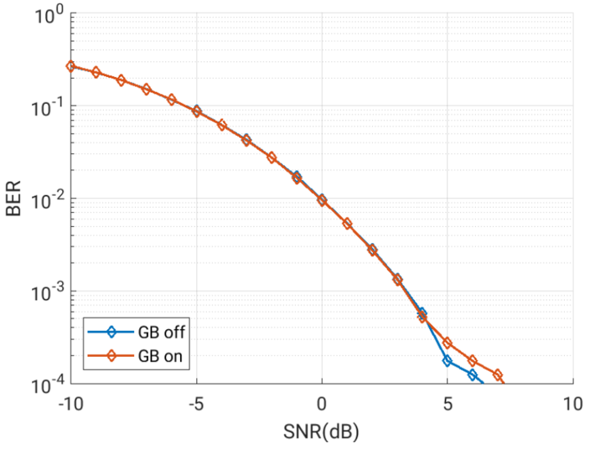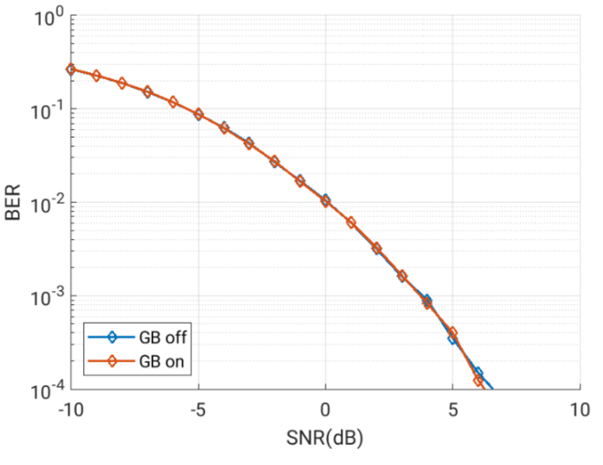
Figure 7.1.2.2-18:
Left: BER vs. SNR with ASCI only, 3rd order filter with 4.32 MHz filter BW, LP-WUS 3 RB offset from system BW edge. Comparison between 0 and 1 RB GB.
Right: BER vs. SNR with ASCI only, 3rd order filter with 4.32 MHz filter BW, LP-WUS 6 RB offset from system BW edge. Comparison between 0 and 1 RB GB.

Based on the results, guard band does not impact the performance and no guard band is required between WUS and other NR subcarriers.

Company 4 (R4-2313476 and R4-2316280)
The simulation parameters are listed in Table 7.1.2.2-10 below.
Table 7.1.2.2-10: LLS parameters
Parameters | Value
Carrier frequency | 2.6 GHz
Channel | AWGN
SCS | 30 kHz
UE Rx antennas | 1 for WUR
WUR sampling rate | 10 Msps
WUS bandwidth | For OOK WUS:  5 MHz (for 30 kHz SCS: 12 PRBs+ ~ 1 PRB guard band each side of WUS)
Number of ADC bits | 8
Receiver filter | 4, 6 , 8 and 10th order of chebyshev filter, filter BW is the same as WUS BW
Non-WUS transmissions | Adjacent channel interference from other NR transmissions is considered.
Max. false alarm due to noise or random symbols | 0.1%
Frequency offset (ppm) | For OOK WUS:  50 ppm maximum frequency error
Rx approach | Payload based: based on Manchester decoding.
RF impairments | Phase noise profile
   | Phase noise (dBc/Hz)
  Offset | NF 9 dB | NF 12 dB | NF 15 dB
  @5MHz | -99.4 | -99.4 | -99.4
  @10MHz | -108.1 | -105 | -102.1
  @15MHz | -120 | -117 | -114

For ASCS case, phase noise has little impact on the needed guard RB. For ACS case, the phase noise may degrade the SNR at least 3 dB for filter order of 8 and 10.
The number of guard RB within the WUS signal for ASCS case does not need to be greater than 1 as illustrated in Figure 7.1.2.2-19, increasing the number of the guard RB within the WUS signal may have penalty on the SNR in Figure 7.1.2.2-20.
For ACS case, there is a need to shift the WUS away from the adjacent carrier to get more filter attenuation for the adjacent carrier, the number of the shifted RB depends on the WUR filter order and the number of bits per OFDM symbol. For example, it is preferred placing the WUS signal in the middle of 20MHz channel for OOK-2 for WUR with a filter of order 6. For OOK1 and for WUR with a filter of order 6, the WUS signal should be placed with 6 to 10 RB away from the Adjacent carrier channel edge excluding the NR channel guard band. This is illustrated in Figure 7.1.1.2.2-21.
The observations from ACS simulation impacts the ACS test case design. The ACS is to test the UE receiver selectivity and the requirement is specified with a special test condition, e.g., ACI level, the UL and DL RB placement. From the simulation results, it can be observed that it is necessary to introduce additional offset from the edge of WUS signal to ACI for certain filter design. As it is not clear whether to test OOK1, OOK2 or OOK4 and which filter order WUR should be implemented, the detailed design of ACS test case could be discussed in work item phase.
Observed from the simulation, there is no need to introduce additional guard RB beyond the WUS BW. For ACS, blanking more RB adjacent to the WUS BW does not help to attenuate the leakage power from ACI, shifting the WUS signal away from the ACI helps more to attenuate ACI because the leakage power from ACI much higher than leakage power from adjacent subcarrier.
Figure 7.1.2.2-19: BLER for OOK1 w/wo phase noise for ASCS case
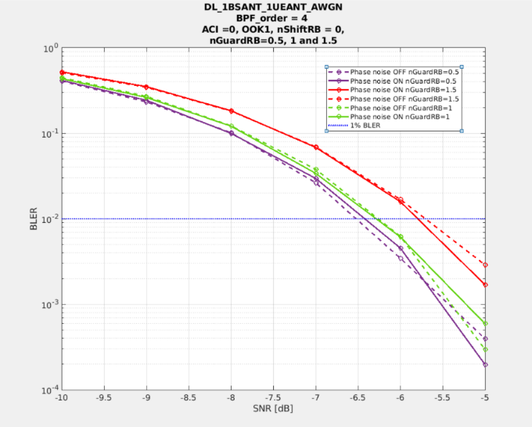
Figure 7.1.2.2-20: BLER for OOK1 with phase noise ON/OFF for ASCS case and Guard RB number =1/2, 1 and 1.5 for filter order 4
Figure 7.1.2.2-21: BLER performance for BFP order =6 and different # of shift RB with ACI = 33 dB

7.1.2.3 ASCS evaluation
To evaluate the in-channel interference, RAN4 has defined a new metric as Adjacent Subcarrier Selectivity (ASCS) for evaluation purpose, which is the ratio of the receive filter attenuation on the assigned channel frequency to the receive filter attenuation on the adjacent sub-carrier(s).
The ACSC BW_{interference} is set as 5MHz, for both ~5MHz and ~1.4MHz WUS cases, as a starting point for ASCS evaluation. The same PSD of WUS and NR signal is assumed within the channel.
As shown in Figure 7.1.2.3-1, WUS at the center of NR channel would be the worst case of ASCS. For ASCS, the required guard RBs belongs to WUR bandwidth.
Figure 7.1.2.3-1：WUS at the centre of NR channel, only ASCS needs to be considered.
Table 7.1.2.3-1: LP-WUS evaluation parameters for WUS at centre
NR RF channel BW | 20MHz/100MHz for 5MHz WUS
Guardband of NR channel | Unchanged, defined in Clause 5.3.3 in TS 38.101-1
WUS BW within NR channel | Max 5.04 MHz
WUS RB allocation (Note 1) | 24 RB (15kHz SCS) or 12 RB (30kHz SCS) in 5.04 MHz;
WUS placement within NR channel | case 1: Center;
Guard RB size of LP-WUS | 0 RB, 0.5RB,1RB, 2RB, 3RB at each side  Symmetric guard RB
ASCS interferer | 5MHz
Filter characteristic | 2nd to 5th order Butterworth  lowpass@ baseband  bandpass@100MHz  bandpass@2.6GHz
Filter passband BW | Same as WUS bandwidth (number of RBs)
Target ACS | TBD
Target ASCS | TBD
Target WUS SNR | TBD
NR power level | Same PSD with WUS signal
RF impairment | Max. Center frequency offset = 5, 10, 50, 200 ppm. Initial search
Note 1: For easy evaluation, the number of allocated WUS RBs is fixed. The number of Guard RBs is changed.

Conclusion for RAN4 ASCS guard RB analysis:
Based on the following analysis, RAN4 observed that for 5th order filter, the guard RB number for LP-WUS ASCS is in the range of 0RB ~ 1RBs for 30KHz SCS, or 0RBs ~2RBs for 15KHz SCS. Similar number of guard RBs could be applied also with lower filter orders as performance was observed to remain similar with 3rd order filter.

Companies’ input on simulation analysis of ASCS have been presented as following:
Filter suppression level analysis:
Company 1 (R4-2314665)
The parameter assumption is aligned with that in Table 7.1.2.2-1. The required guard RB is provided in the Table 7.1.2.3-1 below.
Table 7.1.2.3-2: 5MHz LP-WUS ASCS results for WUS at center
Filter order |  |  | ASCS, BW_{interference} = 5MHz
Filter order | Guard RB  CBW | Frequency  Offset | 0RB | 0.5RB | 1RB | 2RB | 3RB
5th | 20MHz, SCS = 15kHz | 0 ppm | -19.25 | -20.67 | -21.63 | -24.04 | -26.39
5th | 20MHz, SCS = 15kHz | 5 ppm | -19.04 | -20.45 | -21.40 | -23.79 | -26.13
5th | 20MHz, SCS = 15kHz | 10 ppm | -18.83 | -20.22 | -21.17 | -23.55 | -25.89
5th | 20MHz, SCS = 15kHz | 50 ppm | -17.26 | -18.54 | -19.42 | -21.68 | -23.95
5th | 20MHz, SCS = 15kHz | 200 ppm | -12.73 | -13.63 | -14.26 | -15.96 | -17.81
5th | 100MHz, SCS = 30kHz | 0 ppm | -18.24 | -20.63 | -22.97 | -27.59 | -31.80
5th | 100MHz, SCS = 30kHz | 5 ppm | -18.03 | -20.40 | -22.72 | -27.34 | -31.54
5th | 100MHz, SCS = 30kHz | 10 ppm | -17.82 | -20.17 | -22.48 | -27.08 | -31.28
5th | 100MHz, SCS = 30kHz | 50 ppm | -16.25 | -18.42 | -20.61 | -25.11 | -29.28
5th | 100MHz, SCS = 30kHz | 200 ppm | -11.74 | -13.27 | -14.90 | -18.70 | -22.60
4th | 20MHz, SCS = 15kHz | 0 ppm | -16.99 | -18.06 | -18.78 | -20.58 | -22.34
4th | 20MHz, SCS = 15kHz | 5 ppm | -16.82 | -17.88 | -18.60 | -20.39 | -22.14
4th | 20MHz, SCS = 15kHz | 10 ppm | -16.56 | -17.71 | -18.42 | -20.20 | -21.95
4th | 20MHz, SCS = 15kHz | 50 ppm | -15.37 | -16.36 | -17.03 | -18.73 | -20.42
4th | 20MHz, SCS = 15kHz | 200 ppm | -11.54 | -12.28 | -12.80 | -14.15 | -15.57
4th | 100MHz, SCS = 30kHz | 0 ppm | -16.03 | -17.84 | -19.57 | -23.06 | -26.27
4th | 100MHz, SCS = 30kHz | 5 ppm | -15.87 | -17.65 | -19.38 | -22.86 | -26.06
4th | 100MHz, SCS = 30kHz | 10 ppm | -15.70 | -17.47 | -19.19 | -22.65 | -25.86
4th | 100MHz, SCS = 30kHz | 50 ppm | -14.42 | -16.08 | -17.72 | -21.10 | -24.27
4th | 100MHz, SCS = 30kHz | 200 ppm | -10.61 | -11.87 | -13.15 | -16.05 | -18.99
3rd | 20MHz, SCS = 15kHz | 0 ppm | -14.18 | -14.92 | -15.42 | -16.65 | -17.86
3rd | 20MHz, SCS = 15kHz | 5 ppm | -14.05 | -14.79 | -15.28 | -16.51 | -17.71
3rd | 20MHz, SCS = 15kHz | 10 ppm | -13.92 | -14.66 | -15.15 | -16.37 | -17.57
3rd | 20MHz, SCS = 15kHz | 50 ppm | -12.95 | -13.64 | -14.11 | -15.28 | -16.45
3rd | 20MHz, SCS = 15kHz | 200 ppm | -9.95 | -10.51 | -10.89 | -11.87 | -12.87
3rd | 100MHz, SCS = 30kHz | 0 ppm | -13.33 | -14.58 | -15.76 | -18.17 | -20.42
3rd | 100MHz, SCS = 30kHz | 5 ppm | -13.20 | -14.44 | -15.62 | -18.02 | -20.27
3rd | 100MHz, SCS = 30kHz | 10 ppm | -13.07 | -14.31 | -15.48 | -17.87 | -20.12
3rd | 100MHz, SCS = 30kHz | 50 ppm | -12.10 | -13.28 | -14.40 | -16.73 | -18.95
3rd | 100MHz, SCS = 30kHz | 200 ppm | -9.13 | -10.07 | -10.10 | -13.04 | -15.08
2nd | 20MHz, SCS = 15kHz | 0 ppm | -10.71 | -11.15 | -11.44 | -12.17 | -12.88
2nd | 20MHz, SCS = 15kHz | 5 ppm | -10.62 | -11.06 | -11.35 | -12.08 | -12.78
2nd | 20MHz, SCS = 15kHz | 10 ppm | -10.54 | -10.98 | -11.27 | -11.99 | -12.69
2nd | 20MHz, SCS = 15kHz | 50 ppm | -9.89 | -10.31 | -10.59 | -11.29 | -11.98
2nd | 20MHz, SCS = 15kHz | 200 ppm | -7.86 | -8.22 | -8.46 | -9.06 | -9.67
2nd | 100MHz, SCS = 30kHz | 0 ppm | -10.05 | -10.79 | -11.49 | -12.92 | -14.27
2nd | 100MHz, SCS = 30kHz | 5 ppm | -9.97 | -10.71 | --11.40 | -12.82 | -14.18
2nd | 100MHz, SCS = 30kHz | 10 ppm | -9.89 | -10.62 | -11.31 | -12.73 | -14.08
2nd | 100MHz, SCS = 30kHz | 50 ppm | -9.25 | -9.96 | -10.62 | -12.00 | -13.33
2nd | 100MHz, SCS = 30kHz | 200 ppm | -7.24 | -7.85 | -8.42 | -9.65 | -10.87

Company 4 (R4-2311502)
The evaluation parameters are listed in Table 7.1.2.3-3 below.
Table 7.1.2.3-3 Evaluation assumptions.
WUS signal bandwidth | 4.32 MHz
Interferer power level | 0 dBc
F₀ | 2.6 GHz
Filter Type | Butterworth

Table 7.1.2.3-4 Guard required in KHz for a target interference level of -10 dBc.
CFO | Filter order
 | 1 | 2 | 3 | 4 | 5
± 0 ppm | 4320.0 | 1598.4 | 972.0 | 691.2 | 540
± 5 ppm | 4346.0 | 1608.0 | 977.9 | 695.4 | 543.3
± 50 ppm | 4580.0 | 1694.6 | 1030.5 | 732.8 | 572.5
± 100 ppm | 4840.0 | 1790.8 | 1089.0 | 774.4 | 605.0
± 200 ppm | 5360.0 | 1983.2 | 1206.0 | 857.6 | 670.0

Based on the above table, we suggest that for 5th order filter, the guard RB number for LP-WUS can be 2RBs for 30kHz SCS, or 3RBs ~ 4RBs for 15kHz SCS.

Company 6 (R4-2315194)
Following table is based on low-pass filter for zero-IF envelop detector architecture, in which pass bandwidth is 4.32/2=2.16MHz.
Table 7.1.2.3-5. evaluated ASCS based on low-pass filter with 2.16MHz pass bandwidth
Filter order |  |  | ASCS, BW_{interference} = 5MHz
Filter order | Guard RB  CBW | Frequency  Offset | 0RB/  15kSCS | 1RB/  15kSC | 2RB/  15kSC | 4RB/  15kSC
5th | 20MHz, SCS = 15kHz | 0 ppm | -20.05 | -22.39 | -24.75 | -29.25
5th | 20MHz, SCS = 15kHz | 5 ppm | -19.89 | -22.22 | -24.58 | -29.1
5th | 20MHz, SCS = 15kHz | 10 ppm | -19.72 | -22.05 | -24.41 | -28.94
5th | 20MHz, SCS = 15kHz | 50 ppm | -18.44 | -20.7 | -23.05 | -27.67
5th | 20MHz, SCS = 15kHz | 200 ppm | -14.31 | -16.06 | -18.08 | -22.66
2nd | 20MHz, SCS = 15kHz | 0 ppm | -10.71 | -11.42 | -12.12 | -13.47
2nd | 20MHz, SCS = 15kHz | 5 ppm | -10.65 | -11.37 | -12.07 | -13.42
2nd | 20MHz, SCS = 15kHz | 10 ppm | -10.6 | -11.31 | -12.02 | -13.38
2nd | 20MHz, SCS = 15kHz | 50 ppm | -10.19 | -10.9 | -11.61 | -12.99
2nd | 20MHz, SCS = 15kHz | 200 ppm | -8.66 | -9.36 | -10.07 | -11.49
Following table is based on analog band-pass filter for RF/IF envelop detector architecture, in which pass bandwidth is 4.32MHz.
Table 7.1.2.3-6. evaluated ASCS based on analog low-pass filter with 4.32MHz pass bandwidth
Filter order |  |  | ASCS, BW_{interference} = 5MHz
Filter order | Guard RB  CBW | Frequency  Offset | 0RB/  15kSCS | 1RB/  15kSC | 2RB/  15kSC | 4RB/  15kSC | 0RB/  15kSCS
5th | 20MHz, SCS = 15kHz | 0 ppm | -14.41 | -15.59 | -16.79 | -19.2 | -21.56
5th | 20MHz, SCS = 15kHz | 5 ppm | -14.33 | -15.51 | -16.71 | -19.12 | -21.48
5th | 20MHz, SCS = 15kHz | 10 ppm | -14.24 | -15.42 | -16.62 | -19.03 | -21.39
5th | 20MHz, SCS = 15kHz | 50 ppm | -13.58 | -14.74 | -15.93 | -18.34 | -20.72
5th | 20MHz, SCS = 15kHz | 200 ppm | -11.24 | -12.29 | -13.39 | -15.73 | -18.13
2nd | 20MHz, SCS = 15kHz | 0 ppm | -7.25 | -7.64 | -8.02 | -8.79 | -9.54
2nd | 20MHz, SCS = 15kHz | 5 ppm | -7.22 | -7.61 | -8 | -8.76 | -9.52
2nd | 20MHz, SCS = 15kHz | 10 ppm | -7.2 | -7.58 | -7.97 | -8.73 | -9.49
2nd | 20MHz, SCS = 15kHz | 50 ppm | -6.97 | -7.36 | -7.74 | -8.51 | -9.27
2nd | 20MHz, SCS = 15kHz | 200 ppm | -6.14 | -6.52 | -6.91 | -7.68 | -8.45
Less pass bandwidth will lead to better filter suppression capability, so Table 7.1.2.3-5 with less pass bandwidth will have better performance.

Link-level simulation analysis:
Company 1 (R4-2314665)
The detailed parameters are listed in Table 7.1.2.2-3. The simulation results are in Figure 7.1.2.3-2 with consideration of CFO RF impairment.
Figure 7.1.2.3-2: ASCS guard RB evaluation with CFO RF impairment

Company 2 (R4-2312248)
Different from ACS, for evaluation of ASCS we consider the PSD for all RBs including both LP-WUS and NR signal is flat and no power boosting is considered for LP-WUS signal. Figure 7.1.2.3-3 shows the ASCS guard band evaluation for several different waveforms, all the simulations are based on 5th order Butterworth filter.
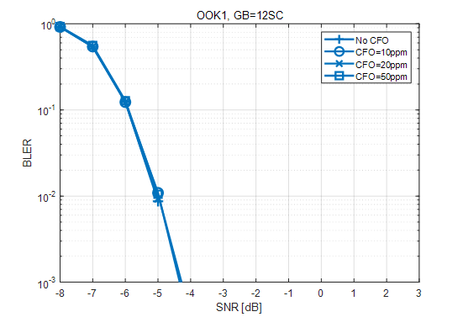
a) ASCS guard RB evaluation for OOK-1
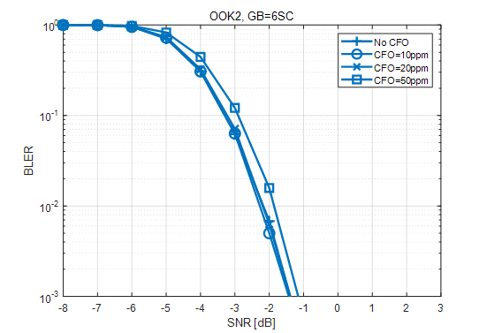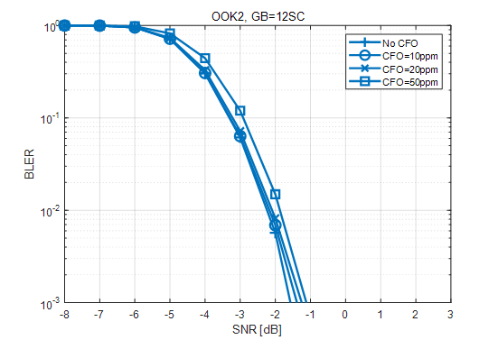
b) ASCS guard RB evaluation for OOK-2
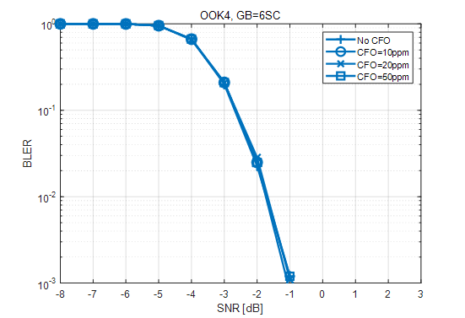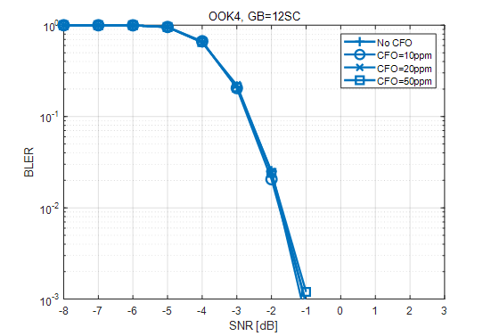
c) ASCS guard RB evaluation for OOK-4
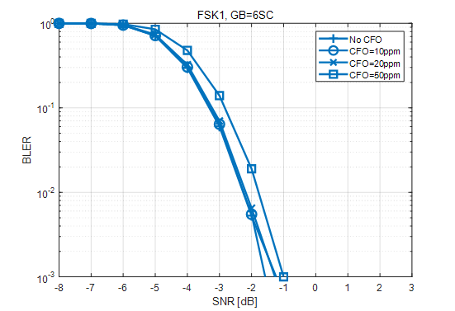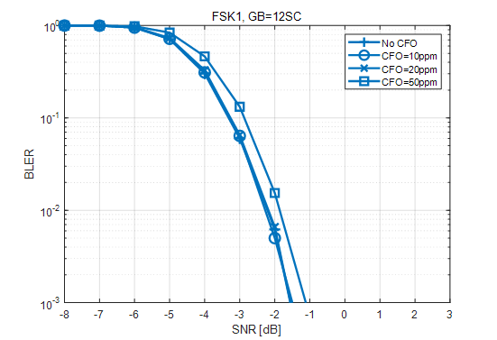
d) ASCS guard RB evaluation for FSK-1
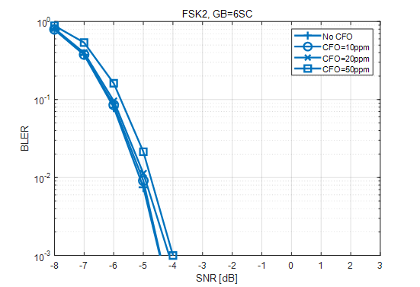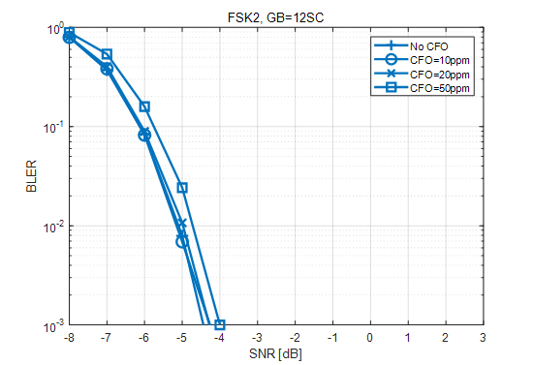
e) ASCS guard RB evaluation for FSK-2
Figure 7.1.2.3-3: ASCS guard RB evaluation
Less guard RB is required for ASCS compared to ACS between LP-WUS and NR signals. Considering frequency offset impact, guard RB with the size of one 15kHz SCS RB could provide necessary protection of LP-WUS from interference of adjacent NR sub-carriers.

Company 3 (R4-2313476 and and R4-2320546)
For ASCS, it can be observed that 1st order filter performs worst while and even with adding 6 RB, the link performance only slightly improves., This means that guard RB does not considerably help if filter order is so low in WUR implementation. For higher than 2nd and 3rd order, the needed Guard RB is not obvious. In simulated link performance vs # RB for 3rd order filter in Figure 7.1.2.3-4, the SNR improvement for 2 RB is 0.2 dB.
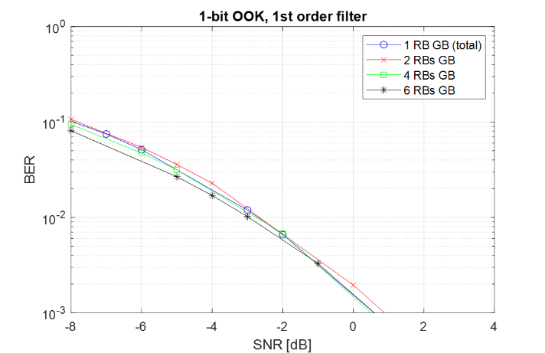
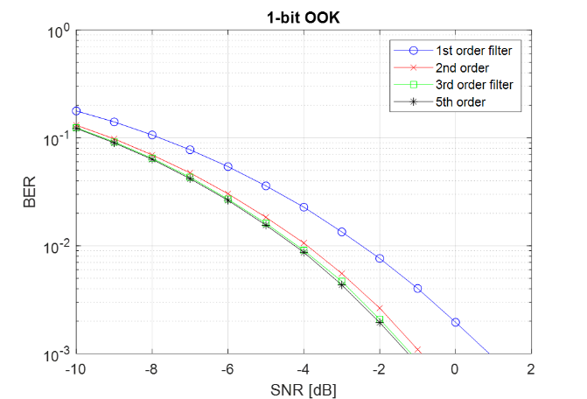

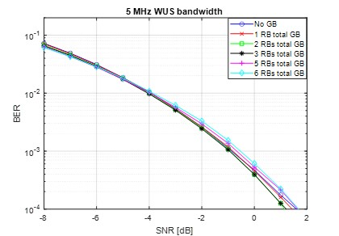
Figure 7.1.2.3-4: Link performance for ASCS selectivity with different filter order
If the filter order is higher than and equal to 2, smaller guard RB (1 to 2 RB) is sufficient between adjacent subcarrier of eMBB signal and a WUS signal. If the filter order is too low, the guard RB does not help to improve the ASCS selectivity.
To investigation the ADC impact on the ASCS, the below simulation with different ADC setting is assumed. The following ADC parameters are used:
- ADC number of bit [2, 4, 6,8] and ADC sampling rate [down sampling factor 4, 8, 16, 32]
It can be observed that generally there is SNR degradation when sampling rate down-sampling factor is increased from 4 to 32 for the same number of ADC bits and the same BPF order. Such SNR degradation is most prominent for ADC 2 bit case where 1.8 dB SNR degradation is observed in 7.1.2.3-5. Higher ADC bits can reduce the SNR degradation. For example, for ADC bits of 4, 6 and 8, the SNR degradation is around 1 dB. With Higher BPF order (>=6), SNR degradation can be further reduced to around 0.5 dB.
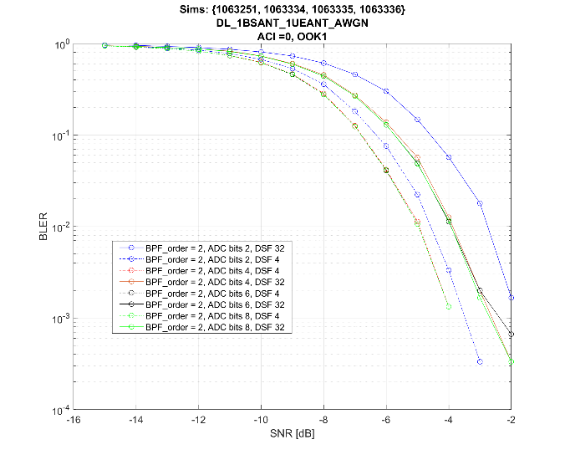
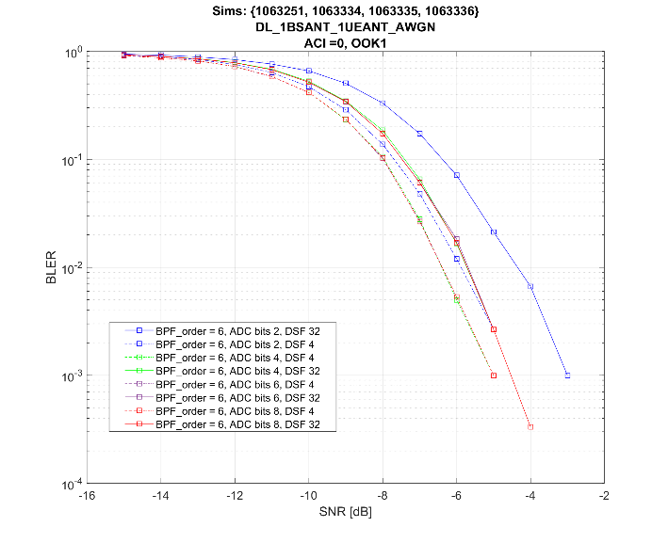

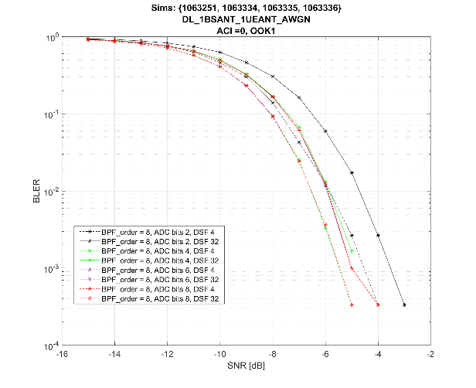
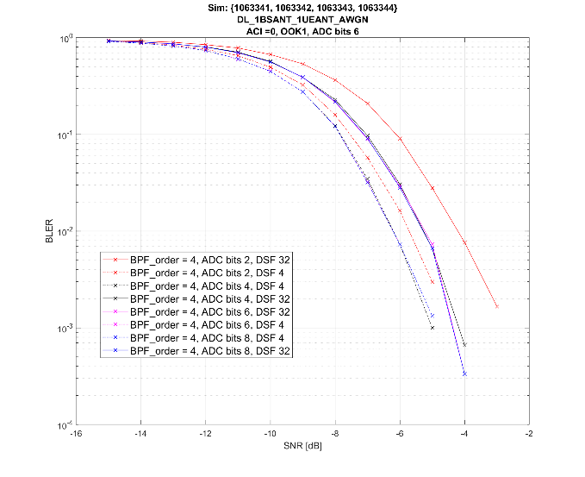

Figure 7.1.2.3-5: Link performance for ASCS selectivity for filter order 4 and 6 when ADC impairment is enabled.

Company 4 (R4-2315206)
Link-level simulations to evaluate the required guard RBs for ASCS were performed based on the assumptions as listed in Table 1. Simulations were done for OOK1 and OOK4 modulation. Simulations were repeated for different filter order, guard RBs, and residual frequency error. SNR required to achieve 1% BLER are reported in the following tables.
Table 7.1.2.3-7 LP-WUS link-level simulation parameters.
Attributes | Assumptions
Carrier Frequency | 2.6 GHz
Case name | OOK-1 waveform | OOK-4 waveform
Channel structure | data: 6 bits CRC: 8 bits | data: 20bits CRC: 8 bits
Chip rate | M=1 | M=2
WUS duration | 28 symbols
Waveform | OOK -1/OOK-4
Coding | 1/2 rate Manchester coding
Time error | 0
residual Frequency error | 0/10/20/50/200 ppm
SCS | 30kHz
gNB Channel BW | 20MHz (50 RB)
WUS BW | 12RB ~ 4.32MHz
Position within channel | Center
Guardband of NR channel, both wanted cell and interfer cell (ACS) | 27RE~810kHz for wanted cell1 20MHz (5MHz WUS at edge), and 510kHz for interference cell2 5MHz.
Guard RB | Outer GB:2/1RB on each side of LP-WUS bandwidth (2 RB for ACS)  Inner GB: 4RE between segments
Filter | 3th/5th Order lowpass Butterworth with 4.32MHz bandwidth
ASCS | PDSCH mapped on RBs not used for LP-WUS and Guard RB;  EPRE of PDSCH /EPRE of LP-WUS = 0 dB  Same PSD with WUS signal
ADC bit width | No ADC.
Phase noise | none
Power boosting | 0dB for OOK-1/4
Channel Model | TDL-C 300
Performance metric | BLER 1%

Table 7.1.2.3-8 SNR required for 1% BLER with 3rd order filter. Modulation used is OOK1.
Guard RBs | CFO
 | ± 0 ppm | ± 10 ppm | ± 20 ppm | ± 50 ppm | ± 100 ppm | ± 200 ppm
1 | 2.31 | 2.3 | 2.36 | 2.34 | 2.5 | 3.09
2 | 2.31 | 2.28 | 2.38 | 2.34 | 2.5 | 3

Table 7.1.2.3-9 SNR required for 1% BLER with 4th order filter. Modulation used is OOK1.
Guard RBs | CFO
 | ± 0 ppm | ± 10 ppm | ± 20 ppm | ± 50 ppm | ± 100 ppm | ± 200 ppm
1 | 2.28 | 2.28 | 2.34 | 2.31 | 2.5 | 3.09
2 | 2.28 | 2.27 | 2.34 | 2.33 | 2.48 | 2.97

Table 7.1.2.3-10 SNR required for 1% BLER with 5th order filter. Modulation used is OOK1.
Guard RBs | CFO
 | ± 0 ppm | ± 10 ppm | ± 20 ppm | ± 50 ppm | ± 100 ppm | ± 200 ppm
1 | 2.25 | 2.25 | 2.3 | 2.31 | 2.47 | 3.09
2 | 2.28 | 2.31 | 2.3 | 2.31 | 2.47 | 2.95

Table 7.1.2.3-11 SNR required for 1% BLER with 3rd order filter. Modulation used is OOK4.
Guard RBs | CFO
 | ± 0 ppm | ± 10 ppm | ± 20 ppm | ± 50 ppm | ± 100 ppm | ± 200 ppm
1 | 4.23 | 4.22 | 4.25 | 4.3 | 4.53 | 5.47
2 | 4.25 | 4.22 | 4.25 | 4.3 | 4.53 | 5.02

Table 7.1.2.3-12 SNR required for 1% BLER with 4th order filter. Modulation used is OOK4.
Guard RBs | CFO
 | ± 0 ppm | ± 10 ppm | ± 20 ppm | ± 50 ppm | ± 100 ppm | ± 200 ppm
1 | 4.19 | 4.19 | 4.22 | 4.25 | 4.5 | 5.44
2 | 4.2 | 4.19 | 4.22 | 4.25 | 4.5 | 5

Table 7.1.2.3-13 SNR required for 1% BLER with 5th order filter. Modulation used is OOK4.
Guard RBs | CFO
 | ± 0 ppm | ± 10 ppm | ± 20 ppm | ± 50 ppm | ± 100 ppm | ± 200 ppm
1 | 4.19 | 4.17 | 4.22 | 4.25 | 4.53 | 5.47
2 | 4.19 | 4.19 | 4.2 | 4.25 | 4.53 | 5

Based on the above presented data, following observations can be made: One PRB worth of guard RB with 30 kHz SCS is enough, provided the CFO is under ±100 ppm. However, in case of ±200 ppm of residual frequency error, there is a minor improvement in the required SNR by an additional guard RB. Given the low chip rate, filter order doesn’t seem to impact performance, as in, given a modulation scheme, number of guard RBs and residual frequency error, increasing the filter order does not provide significant reduction in the required SNR.
Therefore, in for 30kHz SCS one PRB worth of guard RB can be used.

7.1.2.4 Phase noise
At WUR receiver, reciprocal mixing occurs when a high-power level adjacent interferer signal that presents at antenna mixes with the oscillator noise sideband (phase noise). The reciprocal mixing generates cochannel interference to the WUR receiver passband as illustrated in Figure 7.1.2.4-1.
Figure 7.1.2.4-1 Reciprocal mixing for ACI case

7.1.2.5 gNodeB RF impacts
The power boosting of 3 dB or 6 dB of a WUS signal relative to the average power of a configured NR carrier can improve the WUS signal coverage. It is beneficial to enable the 3dB or 6 dB power boosting at the existing network. Therefore, RAN4 assumes to reuse the legacy RF specification as a starting point. Some company observed that 3 dB or 6 dB power boosting for a 24 RB WUS signal may not be feasible for some of deployed gNB when average power is kept the same before and after power boosting. It is feasible to configure different PSD carriers in a multiple carrier configuration where WUS signal can be placed in a higher PSD carrier among all configured carriers. The amount of boosting is up to manufacture declaration following the legacy manufacture declaration.
BS manufacture could declare if power boosting for WUS signal is supported and the boosting level in the range of [0] to [6] dB is considered. Final power boosting level and the condition of power boosting will be decided based on further analysis in WI phase.

7.1.2.6 Multi-band capability
RF envelop detection architecture is more appropriate for single-band operation. IF envelop detection and BB envelop detection are more appropriate for multi-bands operation. Multi-band here still means that only one band at a time is being received. Multi-band capability for other architectures is FFS.

7.1.2.7 Noise Figure
RAN4 noticed that the assumed NF in RAN1 simulation may be different with RAN4. RAN4 will derive RF requirement based on NF which is feasible from coverage and implementation perspective. RAN4 will focus on sensitivity evaluation instead of specific NF value in the normative work.
Generally, noise figure and power consumption are competing specifications, it is very challenging to achieve both low noise figure and low power consumption at the same time, and power consumption typically increases when sensitivity is improved. There is a delicate balance between lower power consumption, e.g., higher noise figure, and system performance.

7.1.2.8 Band operation for LP-WUS
RAN4 has discussed the band operation for LP-WUS according to the scenarios listed below with the understanding that the associated RF aspects could be analysed in the work item phase, depending on the scope of the related normative work.
1) The band for the low-power radio (LR) and main radio (MR) can be the same, e.g., WUS is located within the NR band used for LP-WUR. In this scenario the WUS and NR DL could be multiplexed according to TDM/FDM modes.
2) The band for LR and MR can be different, e.g., WUS is located within an NR band for LP-WUR, and another NR band is used for the MR.
Additionally, RAN4 has concluded the following aspects from RF perspective, which are provided for information:
- WUS located in an SDO band in 3GPP TS 36.101 is proposed by some companies, and RAN4 recognize that there exist dependencies on other WGs that have not been considered in this study.
- Some companies have expressed a concern that SDO bands may not be IMT bands.

--------------End of text proposal 1-------------

