3GPP TSG-RAN WG4 Meeting # 108bis R4-2315801
Xiamen, China, October 09 – October 13, 2023

Source: Nokia, Nokia Shanghai Bell
Title: On mIAB RF core requirements
Agenda item: 5.33.2 RF core requirements [NR_mobile_IAB-Core]
Document for: Approval

- Introduction
During RAN4#108 meeting following agreements presented below were agreed as tentative agreements on RF core requirements based on Way forward [1]:
IAB-MT RF requirements
- Reuse the legacy ACLR and ACS for mobile IAB-MT for both FR1 and FR2
IAB-MT dynamic range
- UE type of Tx dynamic range is needed for mobile IAB-MT.
Mobile IAB requirements
- Use the local area IAB-MT to specify the mobile IAB feature.

Also, in Way forward [1] it was agreed that RAN4#108bis meeting should conclude co-existence related RF requirements and discuss how to include mobile IAB requirements in core IAB specification TS 38.174. In this contribution we further discuss some details related to mIAB RF core requirements.

- Discussion
  - IAB-MT ACLR and ACS requirements
As much there have been evaluation results provided, the legacy requirements for ACLR and ACS seem to sufficiently protect the existing network from the interference caused by mIAB deployment. The assuptions for IAB-MT TX power and usage of local area IAB-MT as the basis for mIAB can therefore be converted to RAN4 agreements.
Proposal 1. RAN4 confirm WF proposals for mIAB-MT TX power and usage of local area IAB-MT assumption and convert those as agreements.

  - IAB-MT dynamic range requirement
The dynamic range of mIAB-MT TX power was assumed to be the same as that of a UE. For legacy IAB, the dynamic range was limited to 5dB and 10dB for WA and LA IAB, respectively. These values were deemed sufficient for non-moving scenarios and enabling alternative implementation options for IAB RF. In mobile scenarios Rel.16 restrictions are not sufficient to avoid excessive performance degradation of the existing RAN. There could be, however, some intermediate solution to have limitation for the dynamic range that may be still acceptable from the co-existence point of view. If the performance degradation was non-acceptable, there could be a new value for the ACLR requirement to compensate for the additional interference the limited dynamic range may cause. Evaluation results would be needed to find out if such option was feasible.
Fig.1 shows some results about the cell edge throughput behavior with different IAB-MT TX power ranges (30/20/10dB) as the function of ACLR (17/20/24/28dB). The results indicate that with ACRL of 20dB or 24dB the cell edge throughput loss is 5% for 30dB or 20/10dB ranges, respectively.
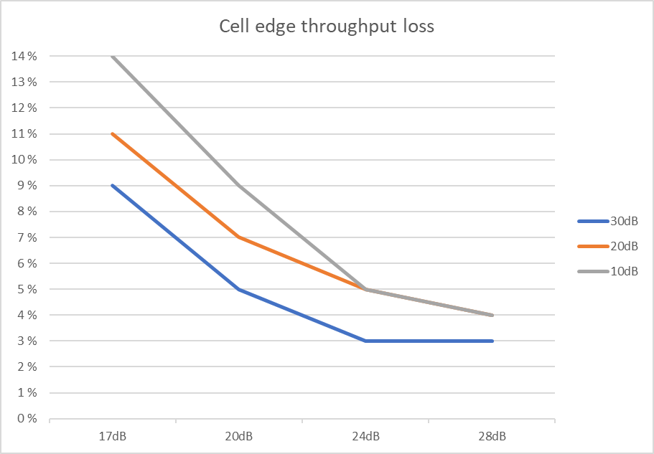
Figure 1. Cell edge throughput loss as the function of ACLR with varying TX power range.

Proposal 2. RAN4 to consider mIAB specific limitation for the MT TX power dynamic range if the resulted additional interference was marginal, or if that could be compensated with other requirements.

- Conclusion
In this contribution we have discussed the WF for RF requirements and we made following proposals:
Proposal 1. RAN4 confirm WF proposals for mIAB-MT TX power and usage of local area IAB-MT assumption and convert those as agreements.
Proposal 2. RAN4 to consider mIAB specific limitation for the MT TX power dynamic range if the resulted additional interference was marginal, or if that could be compensated with other requirements.

References
- R4-2313901, WF for Mobile IAB RF requirements and co-existence study, Qualcomm

