3GPP TSG-RAN WG4 Meeting #108 rev of R4-2312570
Toulouse, France, August 21 – August 25, 2023

Agenda item: 8.20.2
Source: vivo
Title: Discussions on low-power wake-up receiver architectures
Document for: Approval
- Introduction
In RAN4#106bis meeting, group’s understanding on a new term Guard RBs for WUS receiver is aligned [1].
Issue 2-2-1: Guard RBs definition for LP-WUS
Agreements:
- RAN4 use guard RBs (if needed) for LP-WUS, which is Granularity of RB. The traditional guardband for NR channel bandwidth defined in TS 38.101-1 should not be changed.
  - For case when WUS is smaller than NR channel bandwidth
    - For case 2-1, the LP-WUS guard RB is number RBs between LP-WUS and NR signals (edge of WUR RB location to nearest edge of eMBB RB)
    - For case 2-2, the WUS is placed at the edge of the NR channel bandwidth, i.e. the lowest/highest RB of WUS with guard RBs is aligned with the lowest/highest NR transmission bandwidth configuration in spec TS 38.101-1.
  - [For case when the WUS/WUR is same as NR channel bandwidth]
    - For case 1, the LP-WUS guard RBs is number RBs between LP-WUS and traditional guardband (edge of WUR RB location to Outermost of N_{RB})
    - RAN4 should further check with RAN1 for this case
- FFS whether the guard RBs should be symmetric within the WUS channel bandwidth.
Issue 2-2-2: Whether guard RBs is needed for LP-WUR
Agreement:
- How many RBs (if needed) for guard is FFS. RAN4 should further evaluate this number based on the cases identified in issue 2-2-1.
- The size of guard RBs from implementation perspective for LP-WUS should be determined in RAN4.

In RAN4#107 meeting, the framework on ACS and ASCS evaluation has been further refined [2]:
Issue 1-1-1: Refinement of ACS evaluation framework for LP-WUR in RAN4
Agreement:
- Focus on the issues in the RAN1 LS.
- For ACS evaluation, focus on the evaluation of guard RB rather than ACS requirements
  - Take implementation complexity into account
Issue 1-1-2: Target ACS value for LP-WUR receiver
Agreement:
- The methodology for guard RB is that at first conclude the relationship between guard RB and adjacent channel selectivity.
- WUR ACS should be further discussed in the context of the guard RB design and main receiver test requirement.
Issue 1-2-1: ASCS evaluation
Agreements:
- RAN4 should define a detailed description for ASCS metric for evaluation purpose, i.e., similar to ACS, for 5MHz WUS, the ACSC BW_{interference} is set as 5MHz, for both ~5MHz and ~1.4MHz WUS cases, as a starting point.
Issue 1-2-3: Guard RBs for LP-WUS ASCS
Agreement:
- The methodology for adjacent sub-carrier selectivity is that at first conclude the relationship between guard RB and adjacent sub-carrier selectivity.
- WUR ASCS should be further discussed in the context of the guard RB design
  - Assume the same PSD with WUS signal
    - Power boosting evaluation for BS is not precluded
- FFF whether ASCS evaluation should consider two different cases, e.g., high SNR and Low SNR

RAN1 part of this SI is targeted for completion in August meeting, so RAN4 reply LS to RAN1 should be concluded this meeting. The outcome of RAN4 analysis and conclusions should be captured in the TR 38.869 that has a dedicated Clause for RAN4 part.
An initial draft TP to capture RAN4 outcome is prepared [3], further update based on meeting agreements is needed.
- Low-power WUR architectures
  - Adjacent Channel/SubCarrier Selectivity (ACS/ASCS) for LP-WUR
For ASCS evaluation purpose, the interference bandwidth is agreed as 5MHz BW_{interferer}. The following ASCS vs Guard RBs analysis is based on case 1 assumption and evaluation parameters in Table 1.
Case1: WUS at the center of NR channel, as shown in Figure 1.
Figure 1. Case1: WUS at the center of NR channel, only ASCS needs to be considered. Worst case of ASCS
Table 1: LP-WUS evaluation parameters for case 1

NR RF channel BW | 20MHz/100MHz for 5MHz WUS
Guardband of NR channel | Unchanged, defined in Clause 5.3.3 in TS 38.101-1
WUS BW within NR channel | Max 5.04 MHz
WUS RB allocation (Note 1) | 24 RB (15kHz SCS) or 12 RB (30kHz SCS) in 5.04 MHz;
WUS placement within NR channel | Center, or close to center;
Guard RB size of LP-WUS | 0RB, 0.5RB,1RB, 2RB, 3RB
ASCS interferer | 5MHz
Filter characteristic | 2nd to 5th order Butterworth  lowpass@ baseband  bandpass@100MHz  bandpass@2.6GHz
Filter passband BW | Same as WUS bandwidth (number of RBs)
Target ACS | TBD
Target ASCS | TBD
Target WUS SNR | TBD
NR power level | Same PSD with WUS signal
RF impairment | Max. Center frequency offset = 5, 10, 50, 200 ppm. Initial search
Note 1: For easy evaluation, the number of allocated WUS RBs is fixed. The number of Guard RBs is changed.

The 2nd to 5th Butterworth filters is shown in Figure 2.
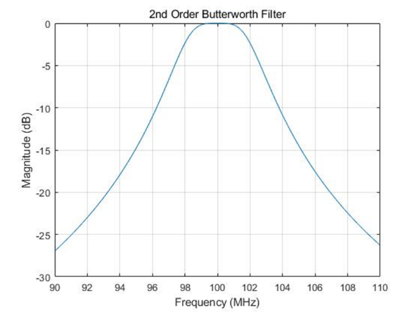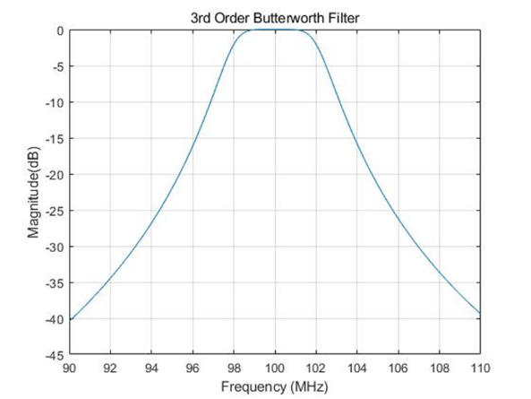

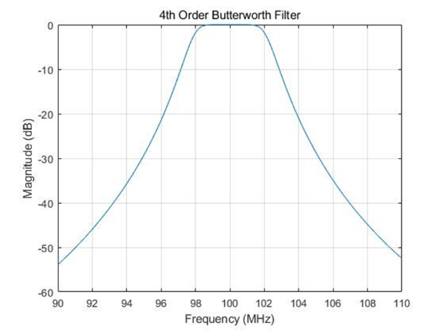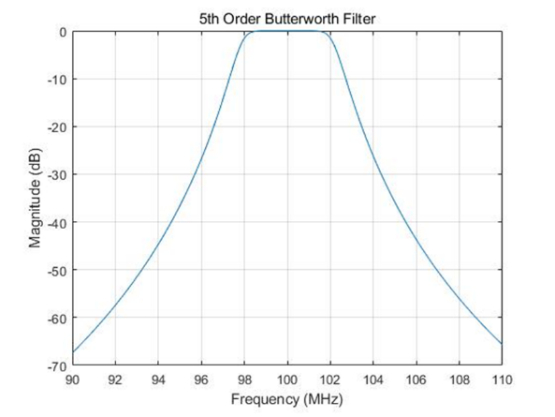
Figure 2: Frequency response of Butterworth filters

In case 1, the ACS impact can be ignored. The ASCS vs guard RB is provided in Table 2.
Table 2: LP-WUS ASCS results for case 1
Filter order |  |  | ASCS, BW_{interference} = 5MHz
Filter order | Guard RB  CBW | Frequency  Offset | 0RB | 0.5RB | 1RB | 2RB | 3RB
5th | 20MHz, SCS = 15KHz | 0 ppm | -19.25 | -20.67 | -21.63 | -24.04 | -26.39
5th | 20MHz, SCS = 15KHz | 5 ppm | -19.04 | -20.45 | -21.40 | -23.79 | -26.13
5th | 20MHz, SCS = 15KHz | 10 ppm | -18.83 | -20.22 | -21.17 | -23.55 | -25.89
5th | 20MHz, SCS = 15KHz | 50 ppm | -17.26 | -18.54 | -19.42 | -21.68 | -23.95
5th | 20MHz, SCS = 15KHz | 200 ppm | -12.73 | -13.63 | -14.26 | -15.96 | -17.81
5th | 100MHz, SCS = 30KHz | 0 ppm | -18.24 | -20.63 | -22.97 | -27.59 | -31.80
5th | 100MHz, SCS = 30KHz | 5 ppm | -18.03 | -20.40 | -22.72 | -27.34 | -31.54
5th | 100MHz, SCS = 30KHz | 10 ppm | -17.82 | -20.17 | -22.48 | -27.08 | -31.28
5th | 100MHz, SCS = 30KHz | 50 ppm | -16.25 | -18.42 | -20.61 | -25.11 | -29.28
5th | 100MHz, SCS = 30KHz | 200 ppm | -11.74 | -13.27 | -14.90 | -18.70 | -22.60
4th | 20MHz, SCS = 15KHz | 0 ppm | -16.99 | -18.06 | -18.78 | -20.58 | -22.34
4th | 20MHz, SCS = 15KHz | 5 ppm | -16.82 | -17.88 | -18.60 | -20.39 | -22.14
4th | 20MHz, SCS = 15KHz | 10 ppm | -16.56 | -17.71 | -18.42 | -20.20 | -21.95
4th | 20MHz, SCS = 15KHz | 50 ppm | -15.37 | -16.36 | -17.03 | -18.73 | -20.42
4th | 20MHz, SCS = 15KHz | 200 ppm | -11.54 | -12.28 | -12.80 | -14.15 | -15.57
4th | 100MHz, SCS = 30KHz | 0 ppm | -16.03 | -17.84 | -19.57 | -23.06 | -26.27
4th | 100MHz, SCS = 30KHz | 5 ppm | -15.87 | -17.65 | -19.38 | -22.86 | -26.06
4th | 100MHz, SCS = 30KHz | 10 ppm | -15.70 | -17.47 | -19.19 | -22.65 | -25.86
4th | 100MHz, SCS = 30KHz | 50 ppm | -14.42 | -16.08 | -17.72 | -21.10 | -24.27
4th | 100MHz, SCS = 30KHz | 200 ppm | -10.61 | -11.87 | -13.15 | -16.05 | -18.99
3rd | 20MHz, SCS = 15KHz | 0 ppm | -14.18 | -14.92 | -15.42 | -16.65 | -17.86
3rd | 20MHz, SCS = 15KHz | 5 ppm | -14.05 | -14.79 | -15.28 | -16.51 | -17.71
3rd | 20MHz, SCS = 15KHz | 10 ppm | -13.92 | -14.66 | -15.15 | -16.37 | -17.57
3rd | 20MHz, SCS = 15KHz | 50 ppm | -12.95 | -13.64 | -14.11 | -15.28 | -16.45
3rd | 20MHz, SCS = 15KHz | 200 ppm | -9.95 | -10.51 | -10.89 | -11.87 | -12.87
3rd | 100MHz, SCS = 30KHz | 0 ppm | -13.33 | -14.58 | -15.76 | -18.17 | -20.42
3rd | 100MHz, SCS = 30KHz | 5 ppm | -13.20 | -14.44 | -15.62 | -18.02 | -20.27
3rd | 100MHz, SCS = 30KHz | 10 ppm | -13.07 | -14.31 | -15.48 | -17.87 | -20.12
3rd | 100MHz, SCS = 30KHz | 50 ppm | -12.10 | -13.28 | -14.40 | -16.73 | -18.95
3rd | 100MHz, SCS = 30KHz | 200 ppm | -9.13 | -10.07 | -10.10 | -13.04 | -15.08
2nd | 20MHz, SCS = 15KHz | 0 ppm | -10.71 | -11.15 | -11.44 | -12.17 | -12.88
2nd | 20MHz, SCS = 15KHz | 5 ppm | -10.62 | -11.06 | -11.35 | -12.08 | -12.78
2nd | 20MHz, SCS = 15KHz | 10 ppm | -10.54 | -10.98 | -11.27 | -11.99 | -12.69
2nd | 20MHz, SCS = 15KHz | 50 ppm | -9.89 | -10.31 | -10.59 | -11.29 | -11.98
2nd | 20MHz, SCS = 15KHz | 200 ppm | -7.86 | -8.22 | -8.46 | -9.06 | -9.67
2nd | 100MHz, SCS = 30KHz | 0 ppm | -10.05 | -10.79 | -11.49 | -12.92 | -14.27
2nd | 100MHz, SCS = 30KHz | 5 ppm | -9.97 | -10.71 | --11.40 | -12.82 | -14.18
2nd | 100MHz, SCS = 30KHz | 10 ppm | -9.89 | -10.62 | -11.31 | -12.73 | -14.08
2nd | 100MHz, SCS = 30KHz | 50 ppm | -9.25 | -9.96 | -10.62 | -12.00 | -13.33
2nd | 100MHz, SCS = 30KHz | 200 ppm | -7.24 | -7.85 | -8.42 | -9.65 | -10.87
In our simulation, the filter characteristic under different center frequency is nearly the same, with the resulted ASCS value difference within 1dB. Therefore, we perform all the simulations but just show the baseband filter results in the table 2 for simplification. The higher center frequency impacts can be considered from filter implementation perspective.
To conclude the relationship between guard RB and adjacent sub-carrier selectivity, we propose to capture the Table 2 and corresponding simulation scenario as RAN4 LP-WUR ASCS vs Guard RB analysis outcome, into RAN1 TR.
Proposal 1: The evaluation results of ASCS vs guard RBs in Table 2 and corresponding evaluation parameters in Table 1 can be considered as RAN4 outcome in reply LS to RAN1, and recorded in TR 38. 869.
For ACS, the analysis follows current ACS definition, i.e., 5MHz BW_{interferer}, below 2.7GHz. The ACS vs Guard RBs analysis is based on case 2 assumption and evaluation parameters in Table 3.
Case 2: WUS at the edge of NR channel. If the WUS is placed close to the edge of the channel, we should consider both ASCS and ACS, and this is the worst case of ACS, as shown in Figure 3.
Figure 3. Case 2: WUS at the edge of NR channel, ASCS and ACS should be considered. Worst case of ACS
For case 2: we calculate the averaged power attenuation at ACS frequency range to perform the ACS analysis, the following parameters in Table 3 are used:
Table 3: LP-WUS ACS evaluation parameters for case 2
NR RF channel BW | 20MHz/100MHz for 5MHz WUS
Guardband of NR channel | Unchanged, defined in Clause 5.3.3 in TS 38.101-1
WUS BW within NR channel | Max 5.04 MHz
WUS RB allocation (note 1) | 24 RB (15kHz SCS) or 12 RB (30kHz SCS) in 5.04 MHz;
WUS placement within NR channel | Edge of NR channel (cell 1);
Guard RB size of LP-WUS | 0 RB, 0.5RB,1RB, 2RB, 3RB
ACS interferer (cell 2) | 5MHz with guardband
Filter characteristic | 2nd to 5th order Butterworth  lowpass@ baseband  bandpass@100MHz  bandpass@2.6GHz
Filter passband BW | Same as WUS bandwidth (number of RBs)
Target ACS | TBD
Target ASCS | TBD
Target WUS SNR | TBD
WUS SNR condition | TBD
RF impairment | Max. Center frequency offset = 5, 10, 50, 200 ppm. Initial search
Note 1: For easy evaluation, the number of allocated WUS RBs is fixed. The number of Guard RBs is changed.

In case 2, ACS is the worst case, the ACS vs guard RB is provided in the Table 4 below (note that, the traditional guardband for WUS channel and NR channel has been considered):

Table 4: LP-WUS ACS results for case 2
Filter order |  |  | ACS, BW_{interference} = 5MHz
Filter order | Guard RB  CBW | Frequency  Offset | 0RB | 0.5RB | 1RB | 2RB | 3RB
5th | 20MHz, SCS = 15KHz | 0 ppm | -28.20 | -29.51 | -30.37 | -32.43 | -34.40
5th | 20MHz, SCS = 15KHz | 5 ppm | -27.95 | -29.26 | -30.11 | -32.18 | -34.14
5th | 20MHz, SCS = 15KHz | 10 ppm | -27.69 | -29.01 | -29.86 | -31.92 | -33.88
5th | 20MHz, SCS = 15KHz | 50 ppm | -25.73 | -27.02 | -27.87 | -29.92 | -31.87
5th | 20MHz, SCS = 15KHz | 200 ppm | -19.35 | -20.52 | -21.31 | -23.24 | -25.13
5th | 100MHz, SCS = 30KHz | 0 ppm | -34.51 | -36.33 | -38.07 | -41.33 | -44.33
5th | 100MHz, SCS = 30KHz | 5 ppm | -34.25 | -36.07 | -37.81 | -41.07 | -44.07
5th | 100MHz, SCS = 30KHz | 10 ppm | -33.99 | -35.81 | -37.55 | -40.81 | -43.81
5th | 100MHz, SCS = 30KHz | 50 ppm | -31.97 | -35.53 | -33.79 | -38.79 | -41.79
5th | 100MHz, SCS = 30KHz | 200 ppm | -25.21 | -27.00 | -28.72 | -31.97 | -34.97
4th | 20MHz, SCS = 15KHz | 0 ppm | -23.71 | -24.70 | -25.35 | -26.92 | -28.42
4th | 20MHz, SCS = 15KHz | 5 ppm | -23.51 | -24.50 | -25.15 | -26.72 | -28.22
4th | 20MHz, SCS = 15KHz | 10 ppm | -23.31 | -24.30 | -24.94 | -26.51 | -28.01
4th | 20MHz, SCS = 15KHz | 50 ppm | -21.75 | -22.73 | -23.37 | -24.92 | -26.41
4th | 20MHz, SCS = 15KHz | 200 ppm | -16.73 | -17.61 | -18.20 | -19.65 | -21.08
4th | 100MHz, SCS = 30KHz | 0 ppm | -28.35 | -29.76 | -31.11 | -33.64 | -35.97
4th | 100MHz, SCS = 30KHz | 5 ppm | -28.14 | -29.55 | -30.90 | -33.43 | -35.77
4th | 100MHz, SCS = 30KHz | 10 ppm | -27.94 | -29.34 | -30.69 | -33.22 | -35.56
4th | 100MHz, SCS = 30KHz | 50 ppm | -26.34 | -27.74 | -29.08 | -31.61 | -33.95
4th | 100MHz, SCS = 30KHz | 200 ppm | -20.98 | -22.34 | -23.67 | -26.17 | -28.50
3rd | 20MHz, SCS = 15KHz | 0 ppm | -18.80 | -19.49 | -19.94 | -21.04 | -22.10
3rd | 20MHz, SCS = 15KHz | 5 ppm | -18.65 | -19.34 | -19.79 | -20.89 | -21.94
3rd | 20MHz, SCS = 15KHz | 10 ppm | -18.50 | -19.19 | -19.64 | -20.74 | -21.79
3rd | 20MHz, SCS = 15KHz | 50 ppm | -17.36 | -18.04 | -18.48 | -19.56 | -20.61
3rd | 20MHz, SCS = 15KHz | 200 ppm | -13.68 | -14.29 | -14.69 | -15.70 | -16.69
3rd | 100MHz, SCS = 30KHz | 0 ppm | -21.90 | -22.90 | -23.87 | -25.70 | -27.39
3rd | 100MHz, SCS = 30KHz | 5 ppm | -21.75 | -22.75 | -23.72 | -25.54 | -27.24
3rd | 100MHz, SCS = 30KHz | 10 ppm | -21.59 | -22.60 | -23.56 | -25.39 | -27.09
3rd | 100MHz, SCS = 30KHz | 50 ppm | -20.41 | -21.41 | -22.37 | -24.19 | -25.88
3rd | 100MHz, SCS = 30KHz | 200 ppm | -16.46 | -17.43 | -18.36 | -20.14 | -21.82
2nd | 20MHz, SCS = 15KHz | 0 ppm | -13.43 | -13.84 | -14.11 | -14.77 | -15.41
2nd | 20MHz, SCS = 15KHz | 5 ppm | -13.34 | -13.75 | -14.02 | -14.68 | -15.31
2nd | 20MHz, SCS = 15KHz | 10 ppm | -13.25 | -13.65 | -13.92 | -14.58 | -15.22
2nd | 20MHz, SCS = 15KHz | 50 ppm | -12.52 | -12.92 | -13.18 | -13.83 | -14.45
2nd | 20MHz, SCS = 15KHz | 200 ppm | -10.16 | -10.53 | -10.77 | -11.36 | -11.95
2nd | 100MHz, SCS = 30KHz | 0 ppm | -15.18 | -15.80 | -16.40 | -17.54 | -18.62
2nd | 100MHz, SCS = 30KHz | 5 ppm | -15.08 | -15.70 | -16.30 | -17.44 | -18.52
2nd | 100MHz, SCS = 30KHz | 10 ppm | -14.98 | -15.60 | -16.20 | -17.34 | -18.41
2nd | 100MHz, SCS = 30KHz | 50 ppm | -14.22 | -14.83 | -15.42 | -16.56 | -17.62
2nd | 100MHz, SCS = 30KHz | 200 ppm | -11.70 | -12.28 | -12.85 | -13.94 | -14.98

Proposal 2: The evaluation results of ACS vs guard RBs in Table 4 and corresponding evaluation parameters in Table 3 can be considered as RAN4 outcome in reply LS to RAN1, and recorded in TR 38. 869.
Given the required 1~2RB at the edge of NR channel is for ACS suppression, which is not mandated to be empty RBs, but could also be used for NR signal allocation within the channel.
Proposal 3: The guard RBs at channel edge for LP-WUS ACS suppression is not mandated to be empty RBs but also can be used for NR downlink signal within the channel.
For case 3, the required guard RBs would be the value between case 1 and case 2, no specific analysis for case 3 is provided.
Case 3: WUS located between the center and edge of NR channel, as shown in Figure 4.
Figure 4. Case 3: WUS located between the center and edge of NR channel, ASCS is between case 1 and case 2
Proposal 4: For other WUS position, the required guard RBs could be the value between case 1 and case 2.
In the WF, flexible WUS location in the channel should be studied in RAN4.
Issue 1-2-4: WUS location within the carrier
Agreements:
- Study UE and filter complexity and power consumption due to flexible WUS frequency location within the NR carrier except the traditional minimum guard-band of NR channel
- The guard RBs within WUS should not be overlapped with NR guardband
- The WUS flexibility vs UE and filter complexity is aimed to be documented in the TP to RAN1 TR and sent to RAN1

Based on above analysis, our understanding is that the WUS can be flexible located within NR carrier as long as the required guard RBs are configured.
Proposal 5: LP-WUS can be flexible located within NR carrier as long as the required guard RBs are configured.
In addition, for 5MHz WUS within 5MHz NR carrier case, based on RAN1 reply LS [4], this case is not considered.
For LP-WUS/WUR evaluation purpose, RAN1 has not included the case when the WUS/WUR is same as NR channel bandwidth. As the starting point for link level simulations for LP-WUS, RAN1 has agreed on the following for gNB channel BW and LP-WUS BW:
gNB Channel BW | 20MHz, FFS other values
LP-WUS BW | Option 1:  - 5MHz including subcarriers for guard band  - 4.32MHz (i.e.,12 RBs) for LP-WUS transmission for 30kHz SCS  Option 2:  - {2.16, 4.32} MHz including subcarriers for guard band  - 1.44MHz, 2.88MHz (i.e.{4, 8} RBs) for LP-WUS transmission for 30kHz SCS  FFS: other options are up to companies to report  GB is symmetrically placed on each side of LP-WUS

Given the ACS and ASCS is the suppression level of interference, our paper focus on the filter characteristics analysis based on the agreed framework in WF [1]. We also notice that some companies analyze the link level simulation, aiming to decide the guard RB based on assumed targeting SNR and BLER level, which is also a feasible approach and quite similar to the link-level work undergoing in RAN1. We suggest to consider both of the two approaches (interference suppression ratio analysis and link-level simulation), and capture the outcome (if any) into RAN1 TR.
Proposal 6: The analysis outcome of two approaches (interference suppression ratio analysis and link-level simulation) can both be considered, and outcome can be recorded in RAN1 TR.

  - Noise Figure(s)

For FR1, the baseline NF assumption to define FR1 REFSENS is ~9dB. In TR 38.921, the noise figure of UE was assumed to be within the range of 9~13 dB, but only for ITU WP5D studies and not for RF specification.
To ensure a better coverage/sensitivity of LP-WUS, the phase noise of different architecture is expected not much worse than main receiver. RAN4 should further discuss whether comparable NF level as main receiver is achievable.
The coverage and SNR targets for LP-WUR are still under discussion, it would be difficult for RAN4 to decide the feasible phase noise level of each architecture. In addition, given RAN1 is performing link level simulation with some SNR and NF level assumptions and targets to reach conclusion in August meeting, RAN4 can further check the NF feasibility based on RAN1 analysis and initial outcome in next two meetings.
Proposal 7: RAN4 further discuss the NF based on the outcome of SNR and coverage in RAN1.
  - gNB RF requirements impacts

RAN4 has agreed to further study feasible WUS power boosting level:
Issue 1-4-1: LP-WUS power boosting
Agreement:
  - Study whether gNB can boost WUS of 24 RB with X dB., e.g X = 3 or 6 dB based on the information from RAN1 LS in R4-2307012.

In RAN4 BS requirements, TS 38.104 Table 6.3.2.2-1, the RE power control dynamic range is defined:

RE power control dynamic range:
Table 6.3.2.2-1: RE power control dynamic range (in TS 38.104)
Modulation scheme used | RE power control dynamic range (dB)
on the RE | (down) | (up)
QPSK (PDCCH) | -6 | +4
QPSK (PDSCH) | -6 | +3
16QAM (PDSCH) | -3 | +3
64QAM (PDSCH) | 0 | 0
256QAM (PDSCH) | 0 | 0
1024QAM (PDSCH) | 0 | 0
NOTE: The output power per carrier shall always be less or equal to the maximum output power of the base station.

RAN1 has made the decision that the WUS signal can be generated based on current NR OFDM, e.g., OOK WUS can be generated by transmitting one bit per OFDM symbol, “1” WUS subcarriers carry data (e.g., using QPSK modulation) while “0” is generated with zero-power WUS subcarriers. Existing DL NR sequence generation approaches can be reused for OFDMA-based LP-WUS waveform generation. Therefore, the waveform for WUS would not be new, existing RE power control dynamic range of BS can be met without hardware update.

Proposal 8: Reuse existing RE power control dynamic range of BS in TS 38.104 for LP-WUS.

For NB-IoT, the power dynamic range is even higher, as defined in TS 38.104.

NB-IoT RB power dynamic range for NB-IoT operation in NR in-band shall be larger than or equal to the level specified in Table 6.3.4.2-1. This power dynamic range level is only required for one NB-IoT RB.
Table 6.3.4.2-1: NB-IoT RB power dynamic range for NB-IoT operation in NR in-band (in TS 38.104)
BS channel bandwidth (MHz) | NB-IoT RB frequency position | NB-IoT RB power dynamic range (dB)
5, 10 | Any | +6
15 | Within center 77*180kHz+15kHz at each edge | +6
 | Other | +3
20 | Within center 102*180kHz+15kHz at each edge | +6
 | Other | +3
25, 30, 35, 40, 45, 50, 60, 70, 80, 90, 100 | Within center 90% of BS channel bandwidth | +6
 | Other | +3

Triggered by RAN1 reply LS, RAN4 further study whether the assumed 6dB power boosting of LP-WUS is feasible.
Proposal 9: RAN4 further check the feasibility of 6dB power boosting for LP-WUS assumed by RAN1.

  - Link level simulation

To further evaluate the required guard RBs, we perform the link level simulation for ACS and ASCS:
Table 5: LP-WUS ACS and ASCS simulation parameters
Attributes | Assumptions
Carrier Frequency | 2.6GHz
Case name | OOK-1 waveform | OOK-2 waveform | OOK-4 waveform
Channel structure | data: 6 bits CRC: 8 bits | data: 20 bits CRC: 8 bits | data: 20bits CRC: 8 bits
Chip rate | M=1 | M=2 | M=2
WUS duration | 28 symbols
Waveform | OOK -1/OOK-2/OOK-4
Coding | 1/2 rate Manchester coding
Time error | 0
residual Frequency error | 0/10/20/50/22700 ppm(for ASCS evaluation)
SCS | 30kHz
gNB Channel BW | 20MHz (50 RB)
WUS BW | 12RB ~4.32MHz
Guardband of NR channel (ACS) | 27RE~810kHz for wanted cell1 20MHz (5MHz WUS at edge), and 510kHz for interference cell2 5MHz.
Guard RB | Outer GB:2/1/0.5RB on each side of LP-WUS bandwidth (2 RB for ACS)  Inner GB: 4RE between segments
Filter | 3th/5th Order lowpass Butterworth with 4.32MHz bandwidth  (2.1 MHz bandwidth for OOK-2 M=2)
ASCS | PDSCH mapped on RBs not used for LP-WUS and Guard RB;  EPRE of PDSCH /EPRE of LP-WUS = 0 dB  Same PSD with WUS signal
ACS | PDSCH mapped on RBs(14RB~5MHz), one side;  EPRE of PDSCH /EPRE of LP-WUS = 31.5 dB  31.5dB higher
Sampling Rate | 7.68MHz
ADC bit width | 4 bits ADC for ASCS, 8 bits ADC for ACS;
Phase noise | unable
Power boosting | 0dB for OOK-1/4  3dB for OOK-2
Channel Model | TDL-C 300
Performance metric | {FAR, MDR}: {1%, 1%}

The simulation results are in Figure 5 for ACS and Figure 6 for ASCS:
Figure 5. ACS guard RB evaluation
Figure 6. ASCS guard RB evaluation

Observation 1: for ACS, the link level simulation results show that 1RB of 30kHz SCS with 5th order filtering is sufficient for OOK-1, OOK-2, and OOK-4 LP-WUS.
Observation 2: for ASCS, 1RB of 15kHz SCS or 0.5RB of 30kHz SCS with 5th order filtering is sufficient even under 50ppm CFO.

- Conclusion
In this contribution, we share our views on LP-WUR and have the following proposals:
Observation 1: for ACS, the link level simulation results show that 1RB of 30kHz SCS with 5th order filtering is sufficient for OOK-1, OOK-2, and OOK-4 LP-WUS.
Observation 2: for ASCS, 1RB of 15kHz SCS or 0.5RB of 30kHz SCS with 5th order filtering is sufficient even under 50ppm CFO.
Proposal 1: The evaluation results of ASCS vs guard RBs in Table 2 and corresponding evaluation parameters in Table 1 can be considered as RAN4 outcome in reply LS to RAN1, and recorded in TR 38. 869.
Proposal 2: The evaluation results of ACS vs guard RBs in Table 4 and corresponding evaluation parameters in Table 3 can be considered as RAN4 outcome in reply LS to RAN1, and recorded in TR 38. 869.
Proposal 3: The guard RBs at channel edge for LP-WUS ACS suppression is not mandated to be empty RBs but also can be used for NR downlink signal within the channel.
Proposal 4: For other WUS position, the required guard RBs could be the value between case 1 and case 2.
Proposal 5: LP-WUS can be flexible located within NR carrier as long as the required guard RBs are configured.
Proposal 6: The analysis outcome of two approaches (interference suppression ratio analysis and link-level simulation) can both be considered, and outcome can be recorded in RAN1 TR.
Proposal 7: RAN4 further discuss the NF based on the outcome of SNR and coverage in RAN1.
Proposal 8: Reuse existing RE power control dynamic range of BS in TS 38.104 for LP-WUS.
Proposal 9: RAN4 further check the feasibility of 6dB power boosting for LP-WUS assumed by RAN1.

References
- R4-2310299, WF on LP-WUS, vivo, RAN4#107
- R4-2306617, WF on LP-WUS, vivo, RAN4#106bis
- R4-2312572, [Draft] TP to TR 38.869 on LP-WUR architectures RAN4 part
- R4-2311027, Reply LS to RAN4 on LP WUR architectures, RAN1

