Hello all,

This is an invitation to RAN4#106-bis-e Webinar sessions on 24 April – 26 2023. (There will be a separate announcement for next week’s Webinars.) As announced by RAN4 Chairman, there will be 3 recurrent events (RRM), (Main) and (BS RF Demod Test) with 3 parallel sessions. This invitation covers two sessions in two separate GTWs: Main and RRM.

Please remember that consistent registration format is important for session chairing and hence **use the following format when you register: BriefCompanyName - Firstname, Lastname. An example is shown below**

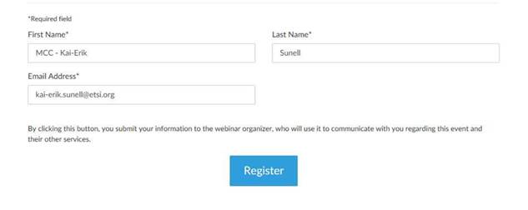

**where BriefCompanyName is ‘MCC’, Firstname is ‘Kai-Erik’ and Lastname is ‘Sunell’.**

Your email address for Webinar registration needs to be the same as for your 3GPP meeting registration.

Registration links are found below and they are session-specific. You may register to all sessions, e.g. if you plan to switch between sessions or if you are able to listen to all sessions at the same time. Once you have registered for a session your registration is valid for the whole week.

**The starting time for RRM, Main Webinar sessions (24 – 26 April) is 13:00 UTC** but you can join already 15 minutes earlier, i.e. 12:45 UTC, to check that your speakers and microphones work fine. (Observe, registration links below show time in CET which is UTC + 2 hour.) Webinars are scheduled to stop at 16:00 UTC but there is some extra time reserved for all sessions after 16:00 UTC . The intention is to avoid abrupt termination of the Webinar at 16:00 UTC sharp but, please, try to wrap up your comments latest at 16:00 UTC.

3GPP TOHRU will be used in this meeting (previously RAN4 used external TOHRU tool)

Hyperlink: <https://tohru.3gpp.org/>

Together with the invitation for the GotoWebinar MCC provides you with a "Meeting name" individually after your registration

* The three sessions meeting TOHRU Meeting ID are listed below:
  + RAN4_Main (TOHRU Meeting ID for Main Session)
  + RAN4_RRM (TOHRU Meeting ID for RRM session)
* This "3GPP TOHRU Meeting ID" has to be entered on the web page and in addition under "Your Name:" you have to provide:  
  **<represented company> - <first name> <family name>**  
  e.g.: XY Telecom - Peter Mustermann

Need to manually push "Refresh Queue" or use "Automatically refresh queue every 3 seconds", since this is different from the original TOHRU tool.

The other buttons are similar as the previous external TOHRU tool

Instructions on how to join the Webinars will be sent automatically every day.

|  |  |  |  |  |  |
| --- | --- | --- | --- | --- | --- |
| |  | | --- | |  | | **RAN4#106-bis-e RRM Webinar Sessions (24 April - 26 April)**  Join us for a webinar beginning on Apr 24, 2023 at 3:00 PM CEST.   |  |  | | --- | --- | | |  | | --- | | [Register now!](https://attendee.gotowebinar.com/register/1591259837593115992) | |   After registering, you will receive a confirmation email containing information about joining the webinar.  [View System Requirements](https://link.gotowebinar.com/help-system-requirements-attendees) | |  | |

|  |  |  |  |  |  |
| --- | --- | --- | --- | --- | --- |
| |  | | --- | |  | | **RAN4#106-bis-e Main Webinar Sessions (24 April - 26 April)**  Join us for a webinar beginning on Apr 24, 2023 at 3:00 PM CEST.   |  |  | | --- | --- | | |  | | --- | | [Register now!](https://attendee.gotowebinar.com/register/4127430741616667485) | |   After registering, you will receive a confirmation email containing information about joining the webinar.  [View System Requirements](https://link.gotowebinar.com/help-system-requirements-attendees) | |  | |

Regards,

Carolyn