|  |  |
| --- | --- |
| 3GPP TR 38.891 V0.2.0 (2022-08) | |
| Technical Report | |
| 3rd Generation Partnership Project;  Technical Specification Group Radio Access Network;  User Equipment (UE) Further enhancements of NR RF requirements for frequency range 2 (FR2) for Rel-18  (Release 18) | |
|  | |
| *5G-logo_175px* | 3GPP-logo_web |
|  |
|  |
|  |
|  |
| The present document has been developed within the 3rd Generation Partnership Project (3GPP TM) and may be further elaborated for the purposes of 3GPP. The present document has not been subject to any approval process by the 3GPPOrganizational Partners and shall not be implemented. This Specification is provided for future development work within 3GPPonly. The Organizational Partners accept no liability for any use of this Specification. Specifications and Reports for implementation of the 3GPP TM system should be obtained via the 3GPP Organizational Partners' Publications Offices. | |

|  |
| --- |
|  |
| ***3GPP***  Postal address  3GPP support office address  650 Route des Lucioles - Sophia Antipolis  Valbonne - FRANCE  Tel.: +33 4 92 94 42 00 Fax: +33 4 93 65 47 16  Internet  http://www.3gpp.org |
| ***Copyright Notification***  No part may be reproduced except as authorized by written permission. The copyright and the foregoing restriction extend to reproduction in all media.  © 2022, 3GPP Organizational Partners (ARIB, ATIS, CCSA, ETSI, TSDSI, TTA, TTC).  All rights reserved.  UMTS™ is a Trade Mark of ETSI registered for the benefit of its members  3GPP™ is a Trade Mark of ETSI registered for the benefit of its Members and of the 3GPP Organizational Partners LTE™ is a Trade Mark of ETSI registered for the benefit of its Members and of the 3GPP Organizational Partners  GSM® and the GSM logo are registered and owned by the GSM Association |

Contents

Foreword 4

1 Scope 6

2 References 6

3 Definitions of terms, symbols and abbreviations 6

3.1 Terms 6

3.2 Symbols 6

3.3 Abbreviations 7

4 Background 7

5 Study for FR2 UL 256QAM 7

5.1 General 7

5.2 Simulation 7

5.2.1 System level simulation 7

5.2.2 Link level simulation 7

5.2.2.1 Simulation assumptions 8

5.2.3 MPR simulation 8

5.3 Implementation impact for UE 9

5.4 Specification impact 9

5.5 Conclusion 9

6 Study for beam correspondence 9

6.1 General 9

6.2 Implementation impact to UE 9

6.3 Specification Impact 9

6.3.1 RF 9

6.3.2 RRM 9

6.4 Testing impact 9

6.5 Conclusion 9

Annex <A> (informative): Change history 10

# Foreword

This Technical Report has been produced by the 3rd Generation Partnership Project (3GPP).

The contents of the present document are subject to continuing work within the TSG and may change following formal TSG approval. Should the TSG modify the contents of the present document, it will be re-released by the TSG with an identifying change of release date and an increase in version number as follows:

Version x.y.z

where:

x the first digit:

1 presented to TSG for information;

2 presented to TSG for approval;

3 or greater indicates TSG approved document under change control.

y the second digit is incremented for all changes of substance, i.e. technical enhancements, corrections, updates, etc.

z the third digit is incremented when editorial only changes have been incorporated in the document.

In drafting the TS/TR, pay particular attention to the use of modal auxiliary verbs! TRs shall not contain any normative provisions.

In the present document, modal verbs have the following meanings:

**shall** indicates a mandatory requirement to do something

**shall not** indicates an interdiction (prohibition) to do something

The constructions "shall" and "shall not" are confined to the context of normative provisions, and do not appear in Technical Reports.

The constructions "must" and "must not" are not used as substitutes for "shall" and "shall not". Their use is avoided insofar as possible, and they are not used in a normative context except in a direct citation from an external, referenced, non-3GPP document, or so as to maintain continuity of style when extending or modifying the provisions of such a referenced document.

**should** indicates a recommendation to do something

**should not** indicates a recommendation not to do something

**may** indicates permission to do something

**need not** indicates permission not to do something

The construction "may not" is ambiguous and is not used in normative elements. The unambiguous constructions "might not" or "shall not" are used instead, depending upon the meaning intended.

**can** indicates that something is possible

**cannot** indicates that something is impossible

The constructions "can" and "cannot" are not substitutes for "may" and "need not".

**will** indicates that something is certain or expected to happen as a result of action taken by an agency the behaviour of which is outside the scope of the present document

**will not** indicates that something is certain or expected not to happen as a result of action taken by an agency the behaviour of which is outside the scope of the present document

**might** indicates a likelihood that something will happen as a result of action taken by some agency the behaviour of which is outside the scope of the present document

**might not** indicates a likelihood that something will not happen as a result of action taken by some agency the behaviour of which is outside the scope of the present document

In addition:

**is** (or any other verb in the indicative mood) indicates a statement of fact

**is not** (or any other negative verb in the indicative mood) indicates a statement of fact

The constructions "is" and "is not" do not indicate requirements.

# 1 Scope

The present document captures finding of the study on FR2 UL 256QAM and beam correspondence for RRC\_INACTIVE and initial access. The purpose of this TR is to study the performance gain and implementation aspects for FR2 UL 256QAM and to ensure good UE RACH msg1 performance and UL coverage in FR2 deployments by specifying the beam correspondence requirements for RRC\_INACTIVE and initial access as defined in Work Item “NR RF requirements enhancement for frequency range 2 (FR2), Phase 3” [2].

# 2 References

The following documents contain provisions which, through reference in this text, constitute provisions of the present document.

- References are either specific (identified by date of publication, edition number, version number, etc.) or non‑specific.

- For a specific reference, subsequent revisions do not apply.

- For a non-specific reference, the latest version applies. In the case of a reference to a 3GPP document (including a GSM document), a non-specific reference implicitly refers to the latest version of that document *in the same Release as the present document*.

[1] 3GPP TR 21.905: "Vocabulary for 3GPP Specifications".

[2] RP-220967, “new WID: NR RF requirements enhancement for frequency range 2 (FR2), Phase 3”, Nokia, Xiaomi

[3] 3GPP TR 38.803: "Study on new radio access technology: RF and co-existence aspects".

…

[x] <doctype> <#>[ ([up to and including]{yyyy[-mm]|V<a[.b[.c]]>}[onwards])]: "<Title>".

# 3 Definitions of terms, symbols and abbreviations

This clause and its three subclauses are mandatory. The contents shall be shown as "void" if the TS/TR does not define any terms, symbols, or abbreviations.

## 3.1 Terms

For the purposes of the present document, the terms given in 3GPP TR 21.905 [1] and the following apply. A term defined in the present document takes precedence over the definition of the same term, if any, in 3GPP TR 21.905 [1].

Definition format (Normal)

**<defined term>:** <definition>.

**example:** text used to clarify abstract rules by applying them literally.

## 3.2 Symbols

For the purposes of the present document, the following symbols apply:

Symbol format (EW)

<symbol> <Explanation>

## 3.3 Abbreviations

For the purposes of the present document, the abbreviations given in 3GPP TR 21.905 [1] and the following apply. An abbreviation defined in the present document takes precedence over the definition of the same abbreviation, if any, in 3GPP TR 21.905 [1].

Abbreviation format (EW)

<ACRONYM> <Explanation>

# 4 Background

At the 3GPP RAN #95 meeting, the Work Item on “NR RF requirements enhancement for frequency range 2 (FR2), Phase 3” was approved for Rel-18. The objectives of the core part in the Work Item are as follows:

**UL 256QAM**

* Investigate and enable UL 256QAM for FR2-1 [RAN4]
  + Study the gain, operating SNR, phase noise model and implementation aspects
  + Specify the UE RF requirements
  + First priority: Targeted power classes are PC1, PC2 and PC5
  + Second priority: Targeted power class is PC3

**Beam correspondence requirements for RRC\_INACTIVE and initial access**

* Specify UE beam correspondence requirements for initial access and RRC\_INACTIVE state, for SSB-based beam correspondence without UL beam sweeping [RAN4 RF]
* For RRC\_INACTIVE specify at least requirements for Random Access SDT and Configured Grant SDT
  + Requirements for other transmission within RRC\_INACTIVE state are not precluded.
* For initial access, specify requirements and verification of beam correspondence requirements based on msg1 spherical coverage (at least)

Study the potential impact on testability aspects (i.e., test time).

This TR aims to study the objectives and further capture the impact on the specification if applicable.

# 5 Study for FR2 UL 256QAM

Editor’s note: This clause collects the simulation results and implementation aspects for FR2 UL 256QAM study for Rel-18. If necessary, new agenda can be assigned.

## 5.1 General

## 5.2 Simulation

### 5.2.1 System level simulation

The system level simulation as supplementary for link level simulation is to check whether the UE working on FR2 UL 256QAM can achieve target SNR at BS side and to further confirm FR2 UL 256QAM is feasible.

#### 5.2.1.1 Simulation assumptions

**Table 5.2.1.1-1 System level simulation assumptions**

|  |  |  |  |
| --- | --- | --- | --- |
| **Parameters** | | **Urban macro** | **Indoor** |
| Network layout | | hexagonal grid, 19 macro sites, 3 sectors per site with wrap around | 50m x 120m, 12BSs |
| Inter-site distance | | 200m (baseline)  300m (optional) | 20m |
| BS antenna height | | 25 m | 3 m |
| UE location | Outdoor/indoor | Outdoor and indoor | Indoor |
| Indoor UE ratio | 20% |  |
| Low/high Penetration loss ratio | 50% low loss, 50% high loss |  |
| LOS/NLOS | LOS and NLOS | LOS and NLOS |
| UE antenna height | Same as 3D-Uma in TR 36.873 | 1.5 m |
| UE distribution (horizontal) | | Uniform | |
| Minimum BS – UE distance (2D) | | 35 m | 0 m |
| Shadowing correlation | | Between cells: 1.0  Between sites: 0.5 |  |
| Pathloss | | Uma LOS and NLOS in table 5.2.2.1-1 of 38.803 | InH – Office LOS and NLOS in table 5.2.2.1-1 of 38.803 |
| Carrier frequency | | 29GHz, 39GHz | |
| BS antenna configuration | | (Mg, Ng, M, N, P) = (1, 1, 8, 16, 2)  (dv, dh) = (0.5λ, 0.5λ)  GE,max = 8 dBi | (Mg, Ng, M, N, P) = (1, 1, 8, 16, 2)  (dv, dh) = (0.5λ, 0.5λ)  GE,max = 5 dBi |
| UE antenna configuration | | First priority:  PC1/PC2/PC5:  (Mg, Ng, M, N, P) = (1, 1, 4, 4, 2) (dv, dh) = (0.5λ, 0.5λ)  GE,max = 5 dBi  Second priority:  PC3:  (Mg, Ng, M, N, P) = (1, 1, 2, 2, 2) (dv, dh) = (0.5λ, 0.5λ)  GE,max = 5 dBi | |
| System bandwidth | | 200MHz | |
| Target SNR at BS side | | FFS | |
| UE max output power | | PC1: 35 dBm/PC2: 23dBm/PC3: 23 dBm/PC5: 23 dBm | |

### 5.2.2 Link level simulation

Link level simulation is targeted as mainstream way to evaluate if FR2 256QAM can achieve benefit by comparing to 64QAM.

#### 5.2.2.1 Simulation assumptions

The link level simulation assumptions are listed as in table 5.2.2.1-1, based on which, to evaluate the throughput difference between 64QAM and 256QAM. The study aims to identify conditions where UL 256QAM provides performance benefits, does not reflect side conditions for setting the UE RF requirement for UL 256QAM.

**Table 5.2.2.1-1 link level simulation assumptions**

|  |  |
| --- | --- |
| **Parameter** | **Value** |
| Carrier frequency | 29 GHz (n257), 39 GHz (n260) and 48GHz (n262) |
| CBW | 50 MHz, 100MHz |
| SCS | 120 kHz |
| Allocated RBs | Full allocation |
| Propagation | TDL-A 30ns delay spread, 35Hz Doppler frequency  TDL-D 30ns delay spread, 35Hz Doppler frequency  Static (AWGN) |
| MCS | 64QAM:  CP-OFDM: MCS 23, 24 in TS 38.214 Table 5.1.3.1-1, other MCSs are not precluded.  DFT-s-OFDM: MCS 22, 23 in TS 38.214 Table 6.1.4.1-1, other MCSs are not precluded.  256QAM:  CP-OFDM/DFT-s-OFDM: MCS 21, 23 in TS 38.214 Table 5.1.3.1-2, other MCSs are not precluded.  Baseline: fixed MCSs |
| Symbol type | CP-OFDM; DFT-s-OFDM |
| HARQ | 8, None |
| Antenna configuration | Fading channel: 2x2 for Rank1 and Rank2, Low correlation  Static channel: 1x2 for Rank1, 2x2 for Rank2 (using the diagonal matrix) |
| Channel estimation | Practical |
| Receiver type | MMSE |
| PUSCH configuration | Type A mapping, Start symbol 0, Duration 14 |
| DMRS configuration | Type 1, Single symbol, 1 additional DMRS |
| PTRS configuration | CP-OFDM: KPTRS : 2 (every 2 RBs), LPTRS : 1 (every 1 symbol)  DFT-s-OFDM: (,)=(4, 4), LPTRS : 1 (every 1 symbol) |
| Phase noise compensation | Practical based on PTRS |
| Phase noise model | TR 38.803 model (in section 6.1.10 and section 6.1.11)  modelled Phase noise for TX and RX  Option a): example1 (UE)  + example1(BS)  Option b): example2 (UE) + example2(BS)  Option d): example1 (UE) + example2(BS) |
| txEVM + rxEVM excluding phase noise for 256QAM | txEVM: 3%, 3.5%, 4%, rxEVM: 3%, 3.5%, 4%  Option 1: txEVM >= rxEVM; |
| Other parameters | follow assumptions in TS38.104 Section 11.2.2 . |

#### 5.2.2.2 Simulation results from Nokia [R4-2215577]

The link level simulation results at 29 GHz (n257) and 39 GHz (n260) using the highlighted parameters in table 1 are shown in figures 1 and 2, respectively.

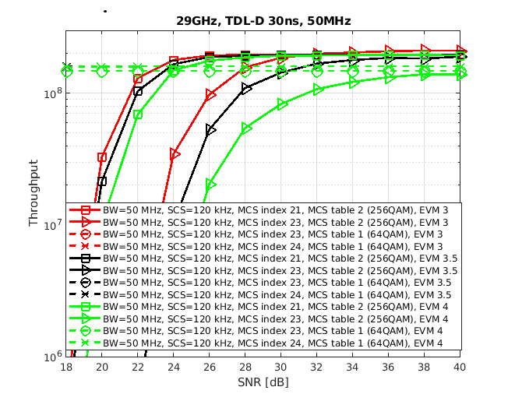

Figure 1. Simulation results at 29 GHz (n257)

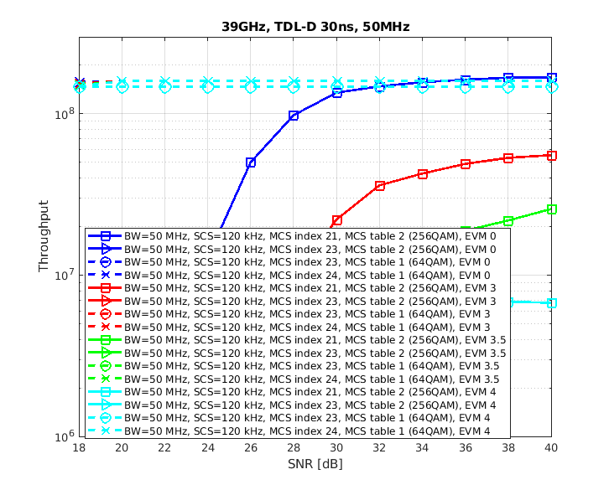

Figure 2. Simulation results at 39 GHz (n260)

It can be observed from figure 1 that at 29 GHz (n257):

- If MCS index is 21, 256QAM goes over 64QAM in around 24-25 dB for all simulated EVMs.

- If MCS index is 23, 256QAM goes over 64QAM in around 28 dB for (transmit and receive) EVM of 3%, around 32 dB for (transmit and receive) EVM of 3.5%, and loses for (transmit and receive) EVM of 4%.

On the other hand, it can be observed from figure 2 that at 39 GHz (n260):

- Only with (transmit and receive) EVM of 0%, MCS21 for 256QAM seems to win 64QAM in around 36 dB.

#### Note that the PN is challenging case at 39 GHz (n260), and due to small allocation, the number of PTRS symbols is quite low so even higher complexity ICI compensation would not really help here.5.2.2.3 Simulation results from LG Electronics [R4-2215920]

Table 2 shows the cross throughput point, where the cross throughput point indicates the SNR value at which the throughput of 64QAM and 256QAM is same, that is, after the corresponding SNR, the throughput of 256QAM is higher than 64QAM

Table 2 Cross throughput point (29 GHz and 48 GHz, CBW:100 MHz, EVM:Tx=Rx)

Referebce: MCS24(64QAM, PUSCH Table 1, OFDM)

|  |  |  |  |  |  |  |
| --- | --- | --- | --- | --- | --- | --- |
| **Propagation**  **MCS**  **Mode** | **EVM: 2%** | | **EVM: 3%** | | **EVM: 3.5%** | |
| **29 GHz** | **48 GHz** | **29 GHz** | **48 GHz** | **29 GHz** | **48 GHz** |
| **TDL-A**  **MCS 21 (256 QAM, PDSCH Table 2, OFDM)** | 24.5 dB | N/A | 27 dB | N/A | 30 dB | N/A |
| **TDL-A**  **MCS 23 (256 QAM, PDSCH Table 2, OFDM)** | 29 dB | N/A | N/A | N/A | N/A | N/A |
| **TDL-D**  **MCS 21 (256 QAM, PDSCH Table 2, OFDM)** | 18.5 dB | 30 dB | 20 dB | N/A | 21 dB | N/A |
| **TDL-D**  **MCS 23 (256 QAM, PDSCH Table 2, OFDM)** | 23 dB | N/A | 24.5 dB | N/A | 27 dB | N/A |
| **AWGN**  **MCS 21 (256 QAM, PDSCH Table 2, OFDM)** | 16 dB | 22.5 dB | 16.5 dB | 24 dB | 17 dB | 27.5dB |
| **AWGN**  **MCS 23 (256 QAM, PDSCH Table 2, OFDM)** | 19 dB | N/A | 20 dB | N/A | 21 dB | N/A |

**29 GHz (n257), EVM(Tx=Rx):3.5%**

|  |  |
| --- | --- |
|  |  |
| Fig1. Throughput performance between 256QAM and 64QAM in TDL-A | Fig2. Throughput performance between 256QAM and 64QAM in TDL-D |
|  | |
| Fig3. Throughput performance between 256QAM and 64QAM in AWGN | |

**29 GHz (n257), EVM(Tx=Rx):3%**

|  |  |
| --- | --- |
|  |  |
| Fig4. Throughput performance between 256QAM and 64QAM in TDL-A | Fig5. Throughput performance between 256QAM and 64QAM in TDL-D |
|  | |
| Fig6. Throughput performance between 256QAM and 64QAM in AWGN | |

**29 GHz (n257), EVM(Tx=Rx):2%**

|  |  |
| --- | --- |
|  |  |
| Fig7. Throughput performance between 256QAM and 64QAM in TDL-A | Fig8. Throughput performance between 256QAM and 64QAM in TDL-D |
|  | |
| Fig9. Throughput performance between 256QAM and 64QAM in AWGN | |

**48 GHz (n262), EVM(Tx=Rx):3.5%**

|  |  |
| --- | --- |
|  |  |
| Fig10. Throughput performance between 256QAM and 64QAM in TDL-A | Fig11. Throughput performance between 256QAM and 64QAM in TDL-D |
|  | |
| Fig12. Throughput performance between 256QAM and 64QAM in AWGN | |

**48 GHz (n262), EVM(Tx=Rx):3%**

|  |  |
| --- | --- |
|  |  |
| Fig13. Throughput performance between 256QAM and 64QAM in TDL-A | Fig14. Throughput performance between 256QAM and 64QAM in TDL-D |
|  | |
| Fig15. Throughput performance between 256QAM and 64QAM in AWGN | |

**48 GHz (n262), EVM(Tx=Rx):2%**

|  |  |
| --- | --- |
|  |  |
| Fig16. Throughput performance between 256QAM and 64QAM in TDL-A | Fig17. Throughput performance between 256QAM and 64QAM in TDL-D |
|  | |
| Fig18. Throughput performance between 256QAM and 64QAM in AWGN | |

From the simulation results, the followings are observed for UL 256QAM performance gain,

***Observation1***: In 29 GHz & TDL-A,

* There is the performance gain in MCS21 when EVM ≥ 3.0%
* There is no performance gain in MCS23

***Observation2***: In 29 GHz & TDL-D

* There is the perfornace gain when EVM = 3.5%

***Observation3***: In 29 GHz & AWGN

* There is the perfornace gain at a relatively low SNR when EVM = 3.5%.

***Observation4:*** In 48 GHz,

* There is no performance gain in most cases

#### 5.2.2.4 Simulation results from vivo [R4-2216128]

* 29 GHz
* TDL-A

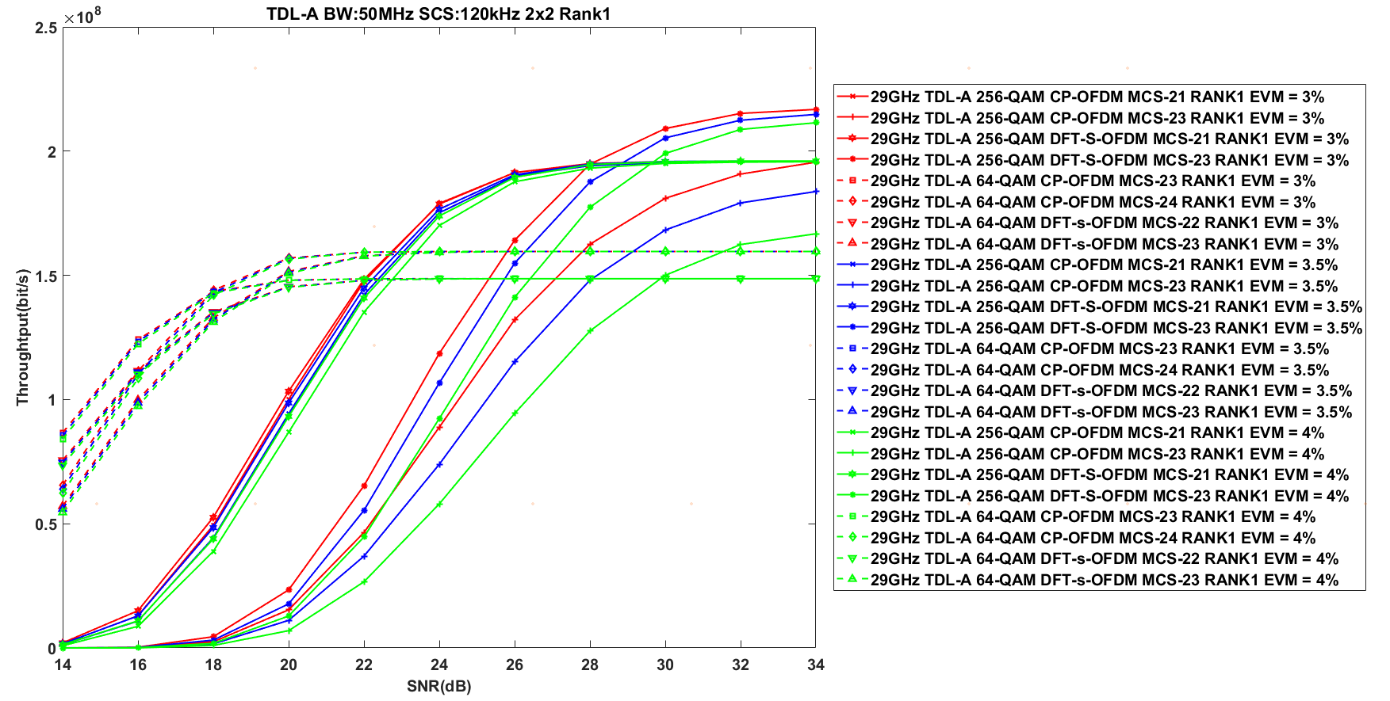

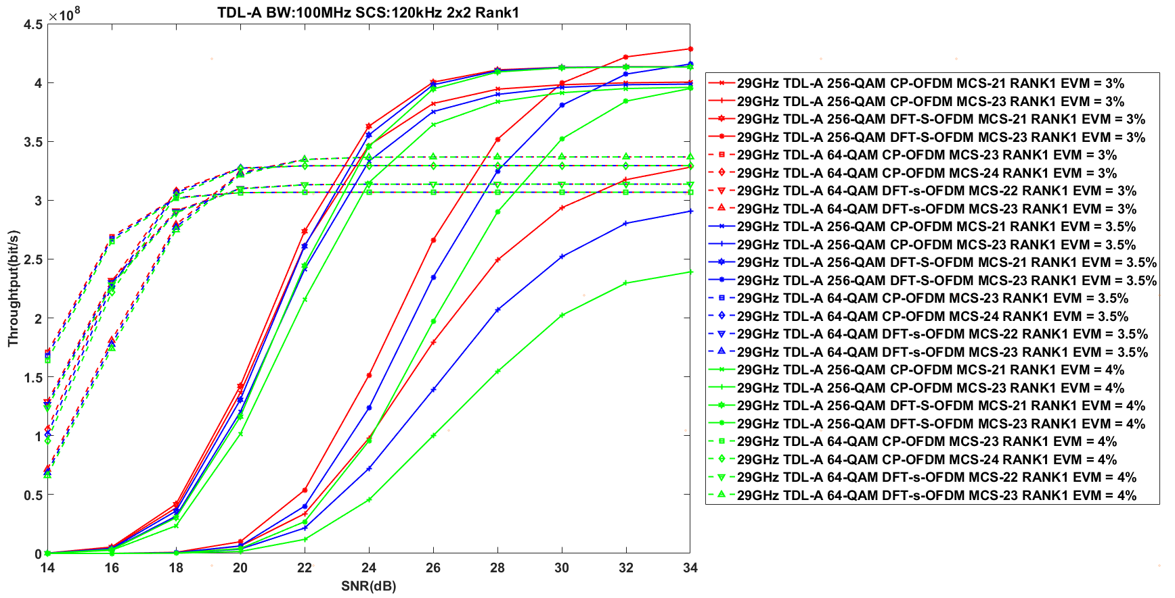

* TDL-D

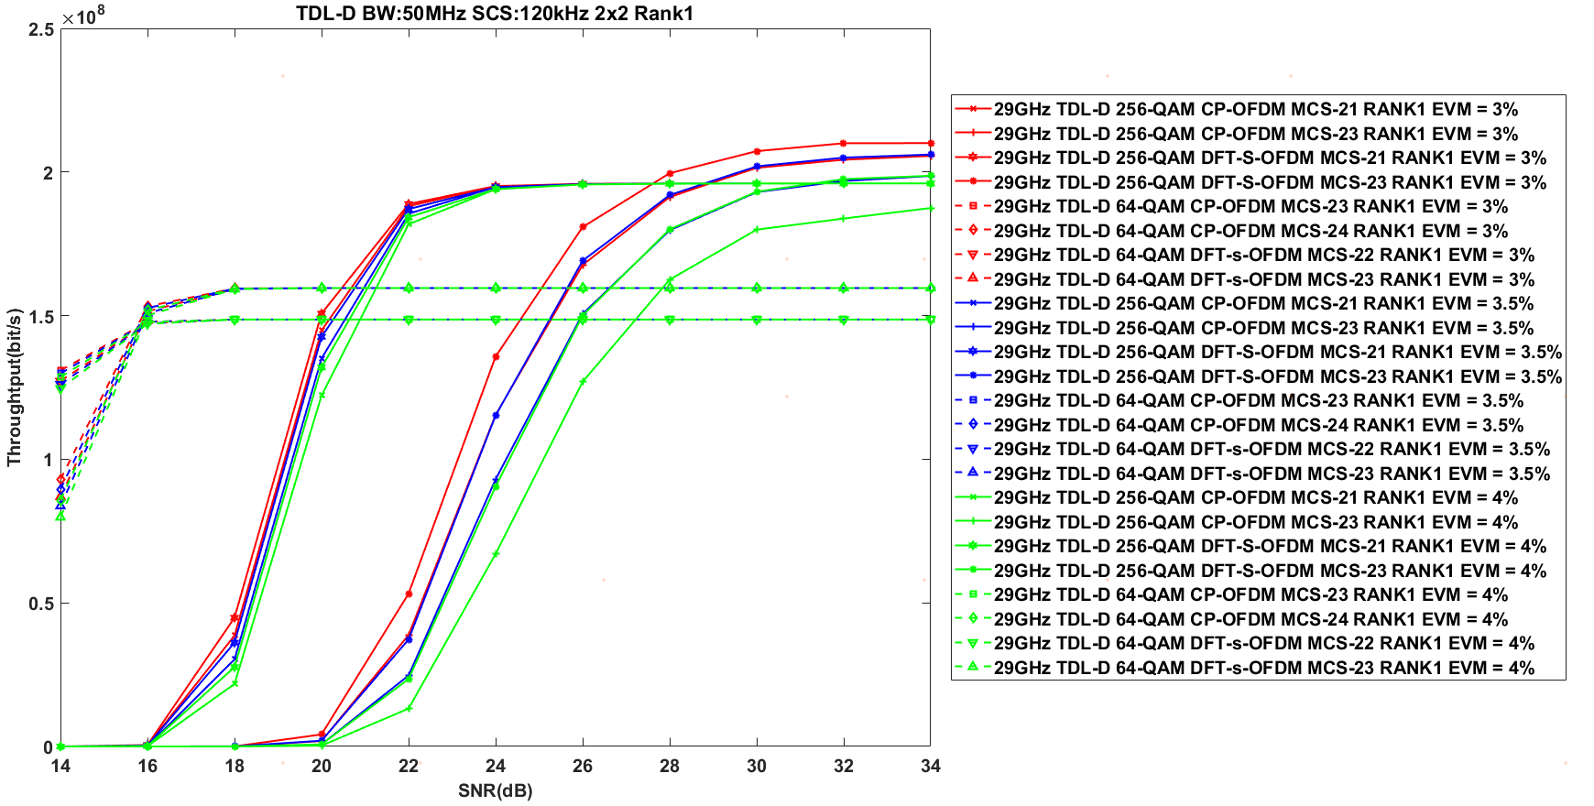

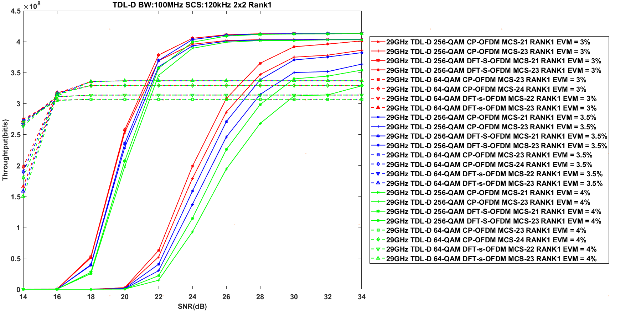

* AWGN

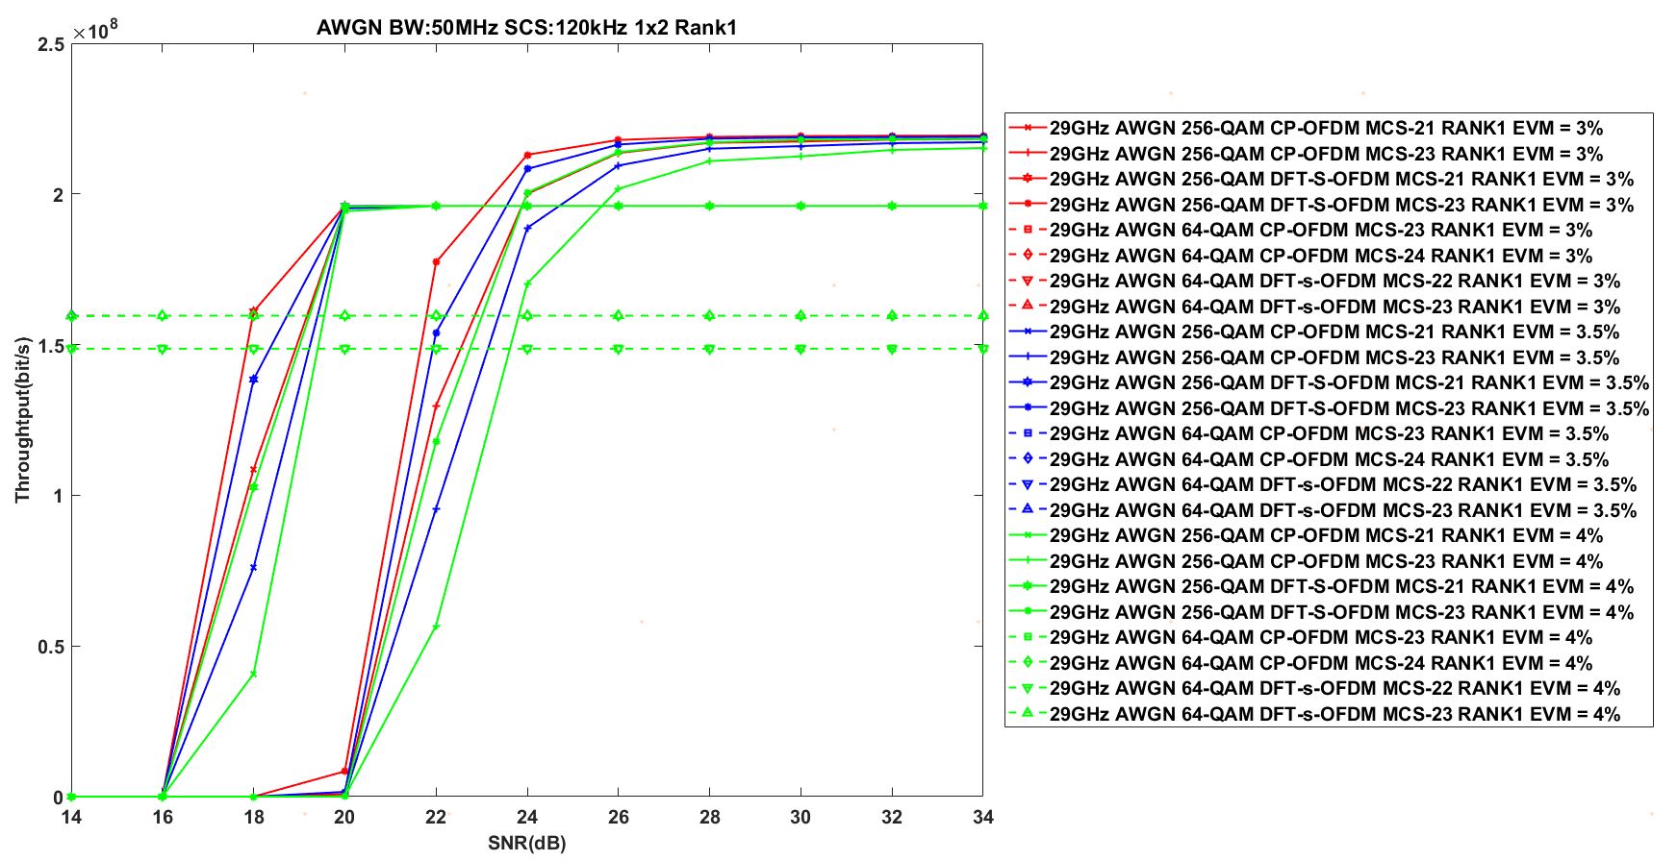

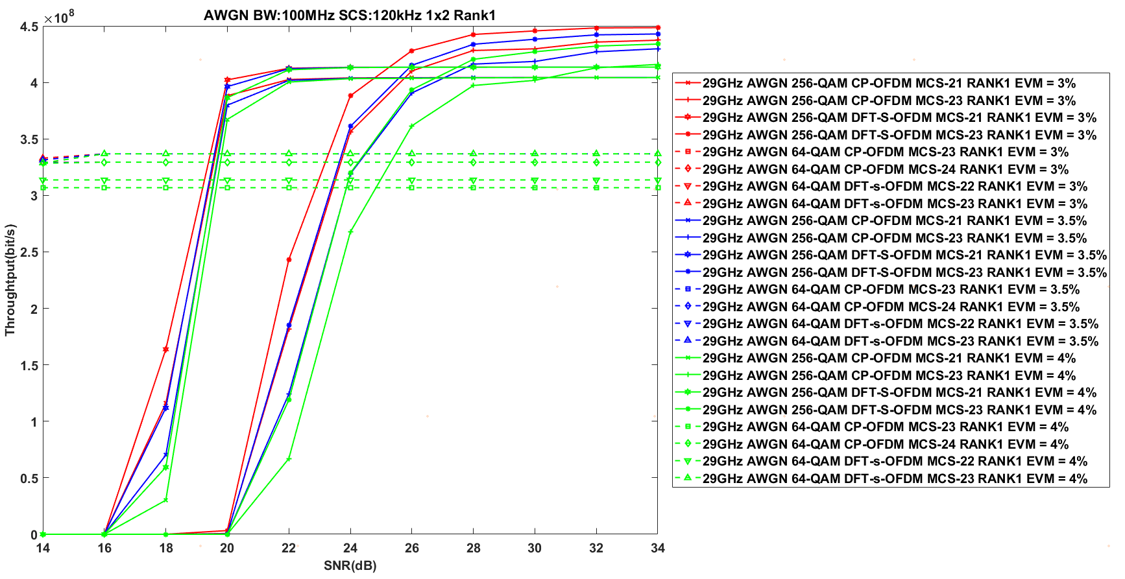

The simulation results above are summarized as follows.

**Observation 1：**The UL 256 QAM under 29 GHz can achieve performance gain at:

|  |  |  |  |  |  |  |
| --- | --- | --- | --- | --- | --- | --- |
| **Tx\_EVM = Rx\_EVM =3%** | **TDL-A** | | **TDL-D** | | **AWGN** | |
| 50 MHz | 100MHz | 50 MHz | 100MHz | 50 MHz | 100MHz |
| **DFT-s-OFDM** | 22.0 dB | 22.8 dB | 20 dB | 21 dB | 18 dB | 19.2 dB |
| **CP-OFDM** | 22.5 dB | 23.8 dB | 20.3 dB | 21.5 dB | 19.2 dB | 19.7 dB |

|  |  |  |  |  |  |  |
| --- | --- | --- | --- | --- | --- | --- |
| **Tx\_EVM = Rx\_EVM =3.5%** | **TDL-A** | | **TDL-D** | | **AWGN** | |
| 50 MHz | 100MHz | 50 MHz | 100MHz | 50 MHz | 100MHz |
| **DFT-s-OFDM** | 22.2 dB | 23.1 dB | 20.3 dB | 21.2 dB | 18.5 dB | 19.5 dB |
| **CP-OFDM** | 22.7 dB | 24 dB | 20.8 dB | 21.8 dB | 19.5 dB | 19.7 dB |

|  |  |  |  |  |  |  |
| --- | --- | --- | --- | --- | --- | --- |
| **Tx\_EVM = Rx\_EVM =4%** | **TDL-A** | | **TDL-D** | | **AWGN** | |
| 50 MHz | 100MHz | 50 MHz | 100MHz | 50 MHz | 100MHz |
| **DFT-s-OFDM** | 22.9 dB | 23.5 dB | 20.6 dB | 21.5 dB | 19.2 dB | 19.7 dB |
| **CP-OFDM** | 23.2 dB | 24.7 dB | 21.2 dB | 22 dB | 19.8 dB | 19.9 dB |

* 39 GHz
* TDL-A

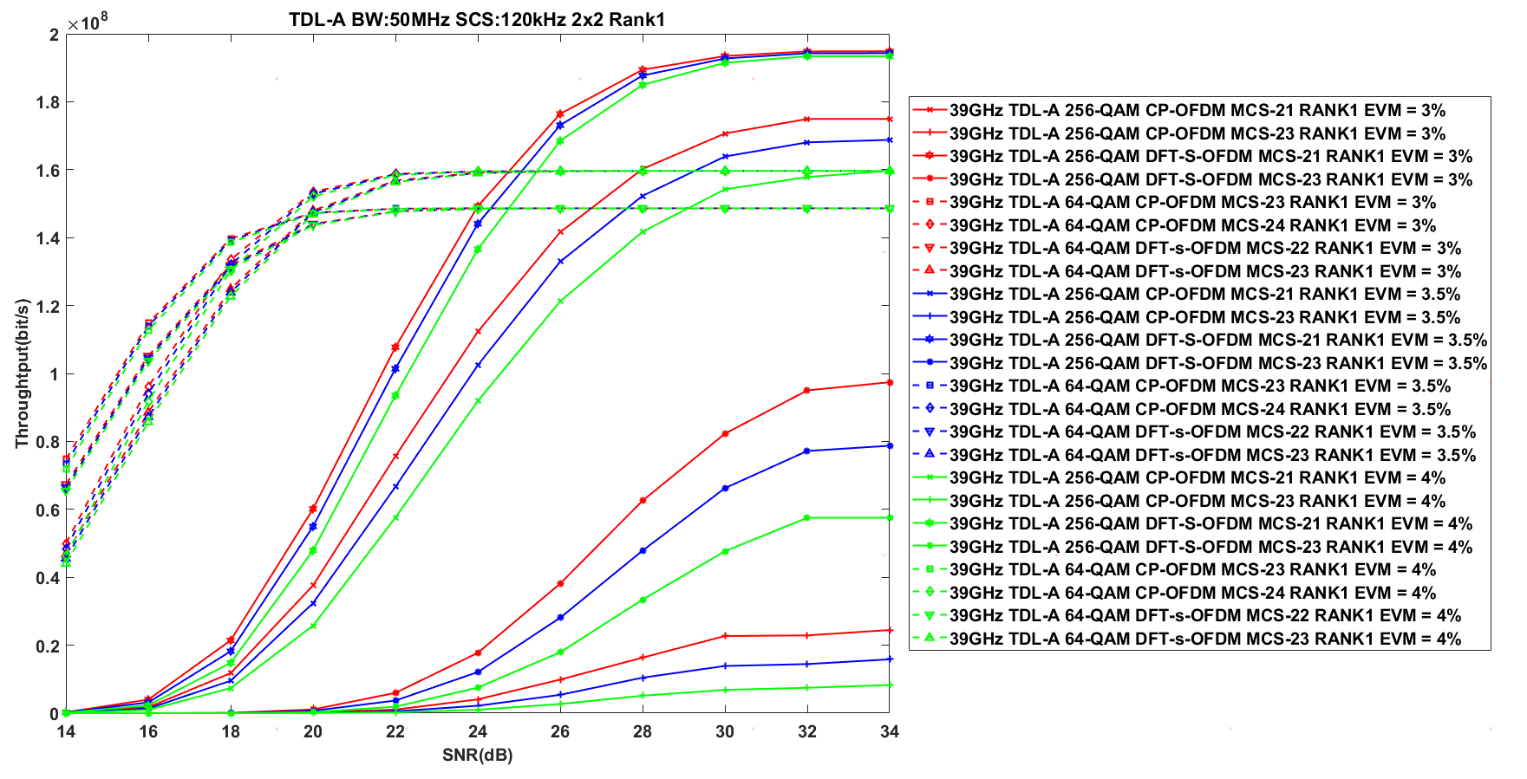

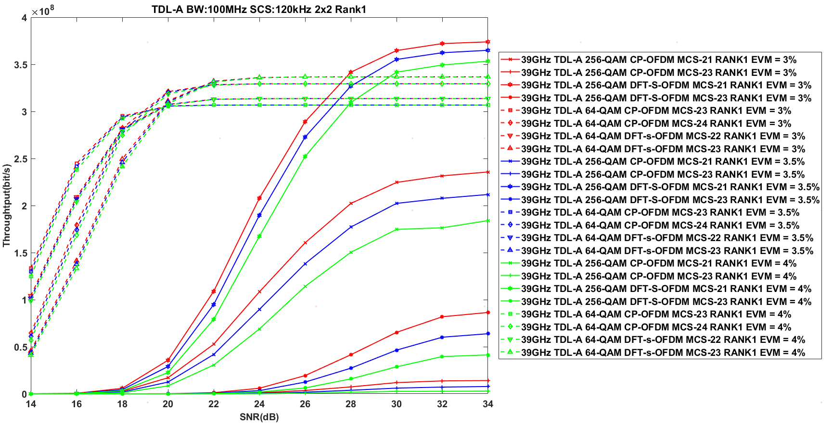

* TDL-D

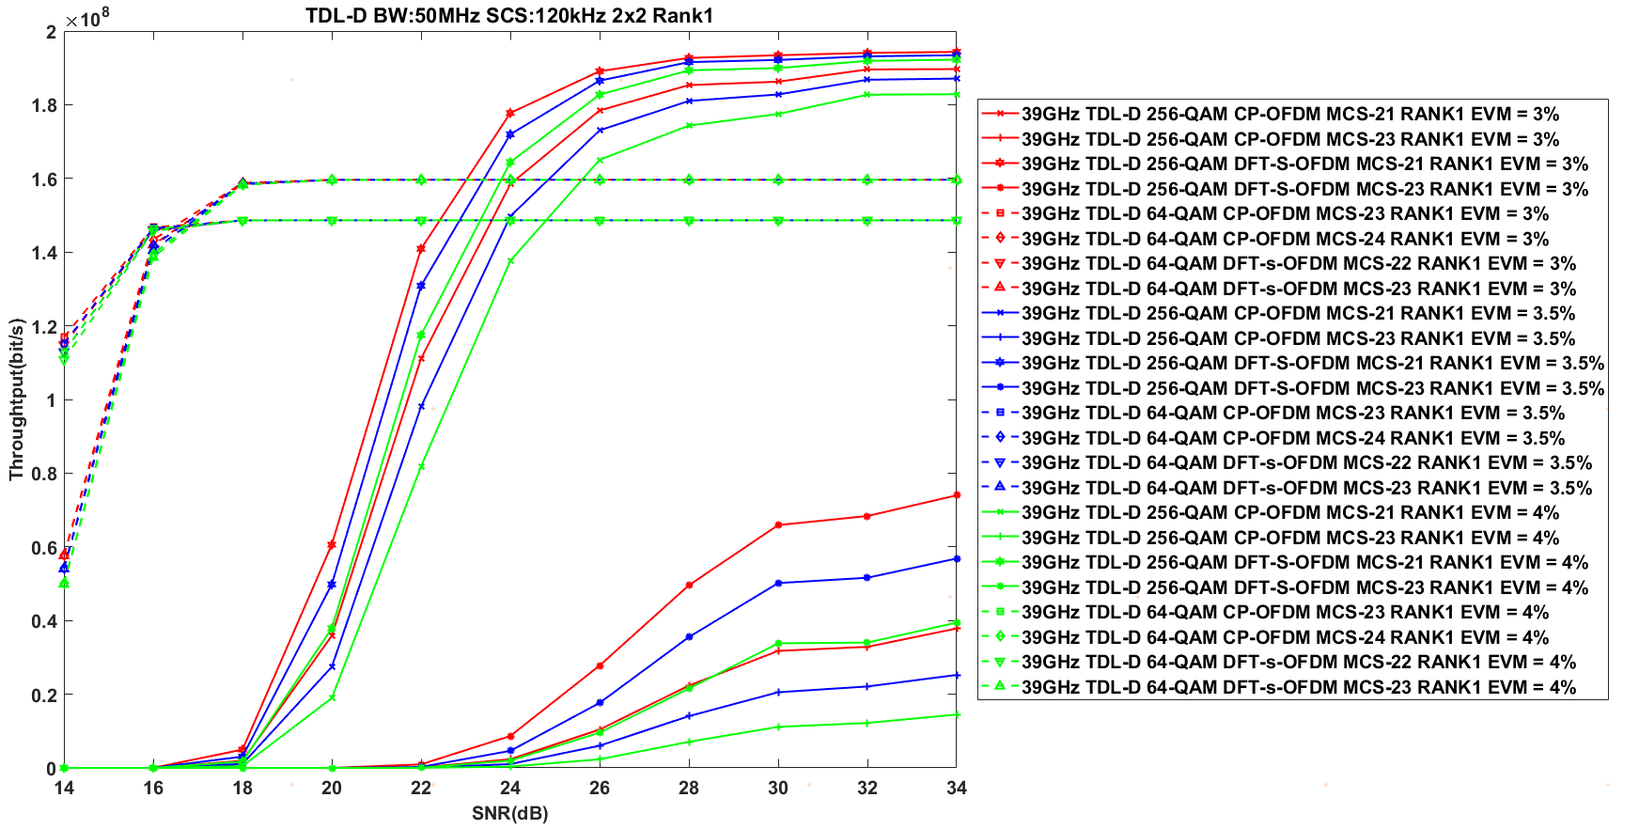

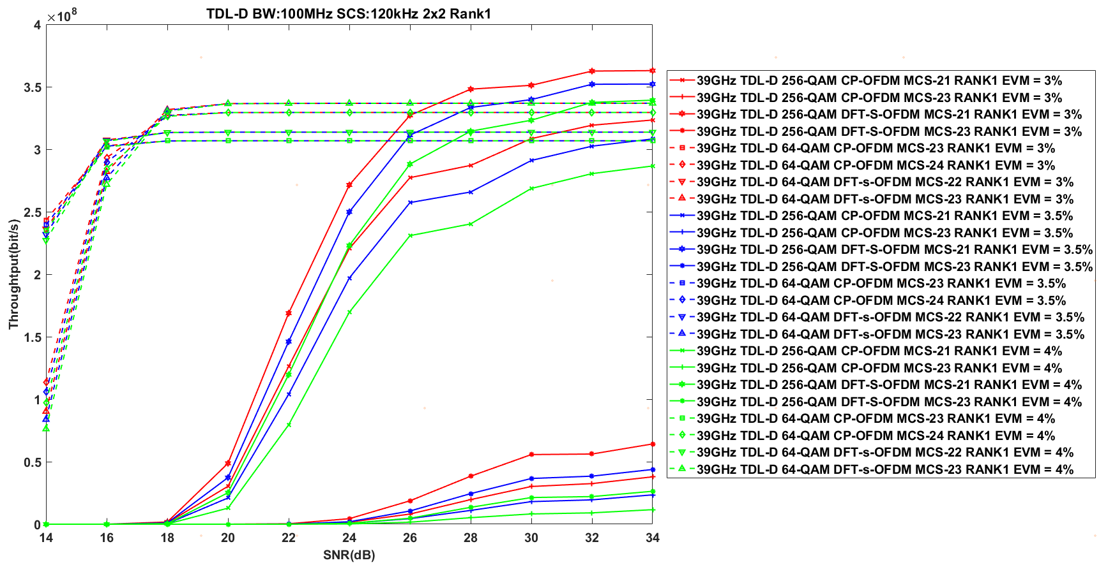

* AWGN

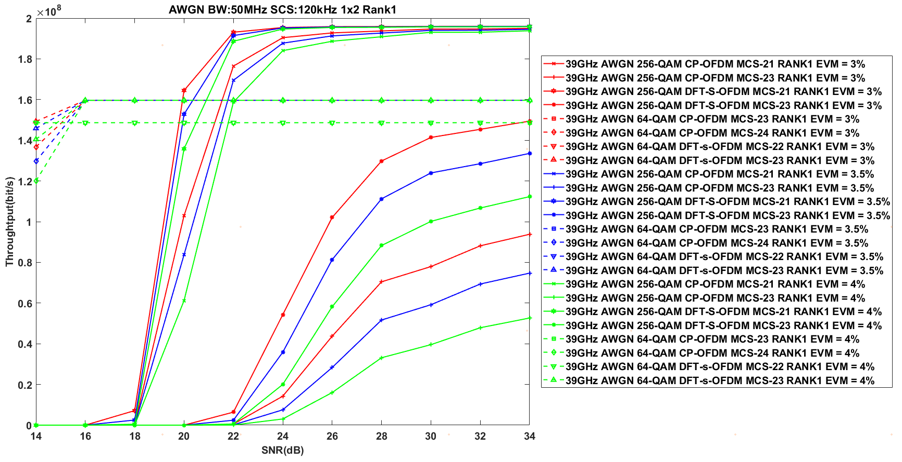

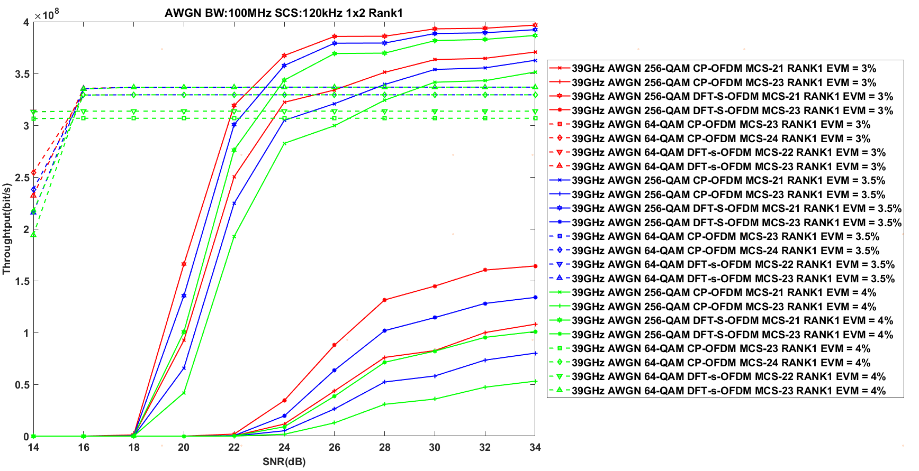

**Observation 2：**The UL 256 QAM under 39 GHz can achieve performance gain at:

|  |  |  |  |  |  |  |
| --- | --- | --- | --- | --- | --- | --- |
| **Tx\_EVM = Rx\_EVM =3%** | **TDL-A** | | **TDL-D** | | **AWGN** | |
| 50 MHz | 100MHz | 50 MHz | 100MHz | 50 MHz | 100MHz |
| **DFT-s-OFDM** | 24 dB | 27 dB | 22.3 dB | 25.8 dB | 19.9 dB | 22 dB |
| **CP-OFDM** | 28 dB | N/A | 24 dB | N.A. | 21.5 dB | 26 dB |

|  |  |  |  |  |  |  |
| --- | --- | --- | --- | --- | --- | --- |
| **Tx\_EVM = Rx\_EVM =3.5%** | **TDL-A** | | **TDL-D** | | **AWGN** | |
| 50 MHz | 100MHz | 50 MHz | 100MHz | 50 MHz | 100MHz |
| **DFT-s-OFDM** | 24.4 dB | 27.5 dB | 23 dB | 26 dB | 20 dB | 23 dB |
| **CP-OFDM** | 29.2 dB | N/A | 25 dB | N.A. | 21.8 dB | 28 dB |

|  |  |  |  |  |  |  |
| --- | --- | --- | --- | --- | --- | --- |
| **Tx\_EVM = Rx\_EVM =4%** | **TDL-A** | | **TDL-D** | | **AWGN** | |
| 50 MHz | 100MHz | 50 MHz | 100MHz | 50 MHz | 100MHz |
| **DFT-s-OFDM** | 24.8 dB | 28.2 dB | 23.3 dB | 28 dB | 20.3 dB | 23 dB |
| **CP-OFDM** | 34 dB | N/A | 25.8 dB | N.A. | 22 dB | 30 dB |

* 48 GHz
* TDL-A

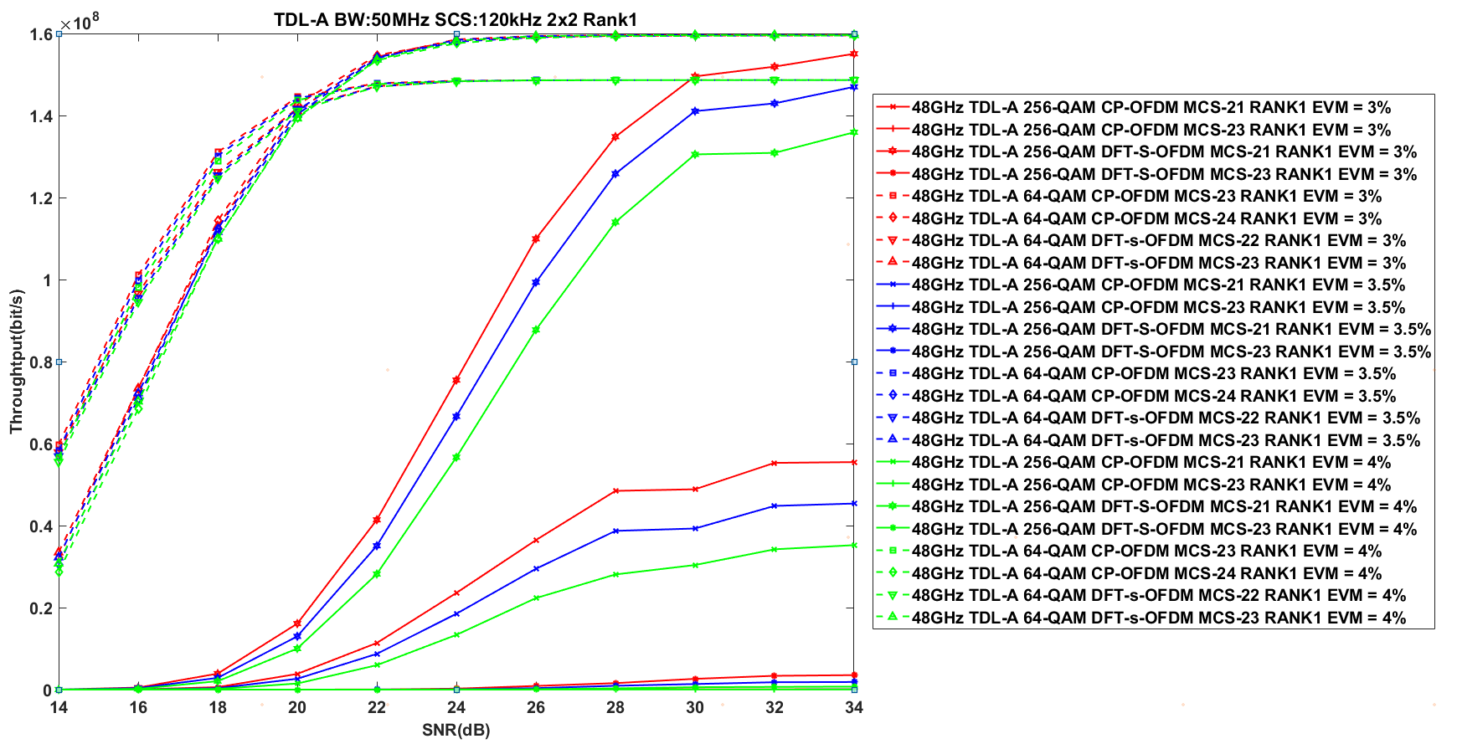

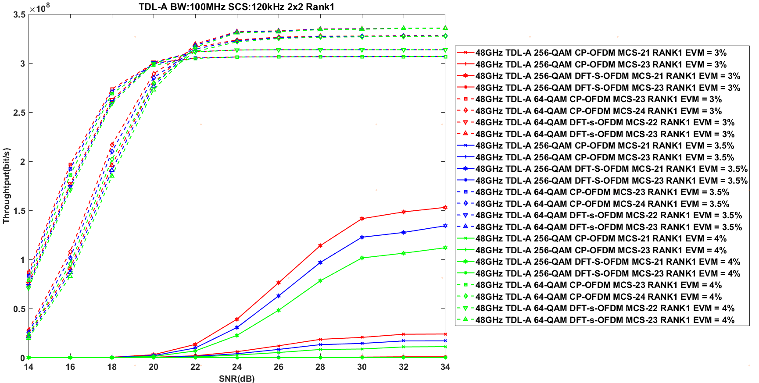

* TDL-D

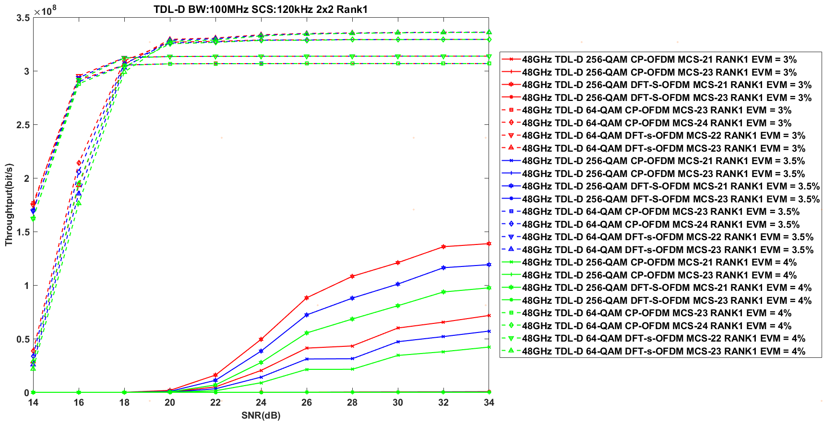

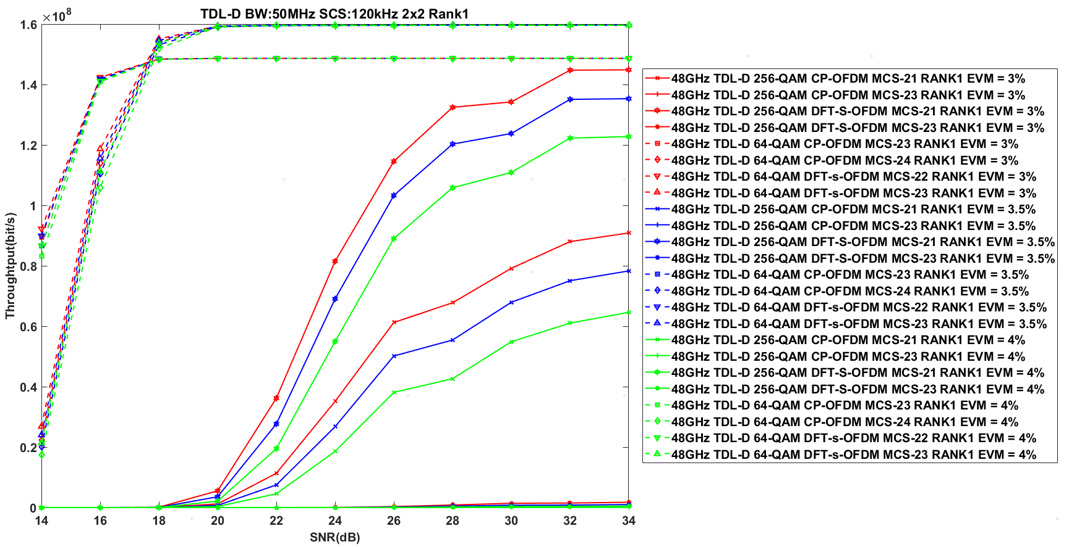

* AWGN

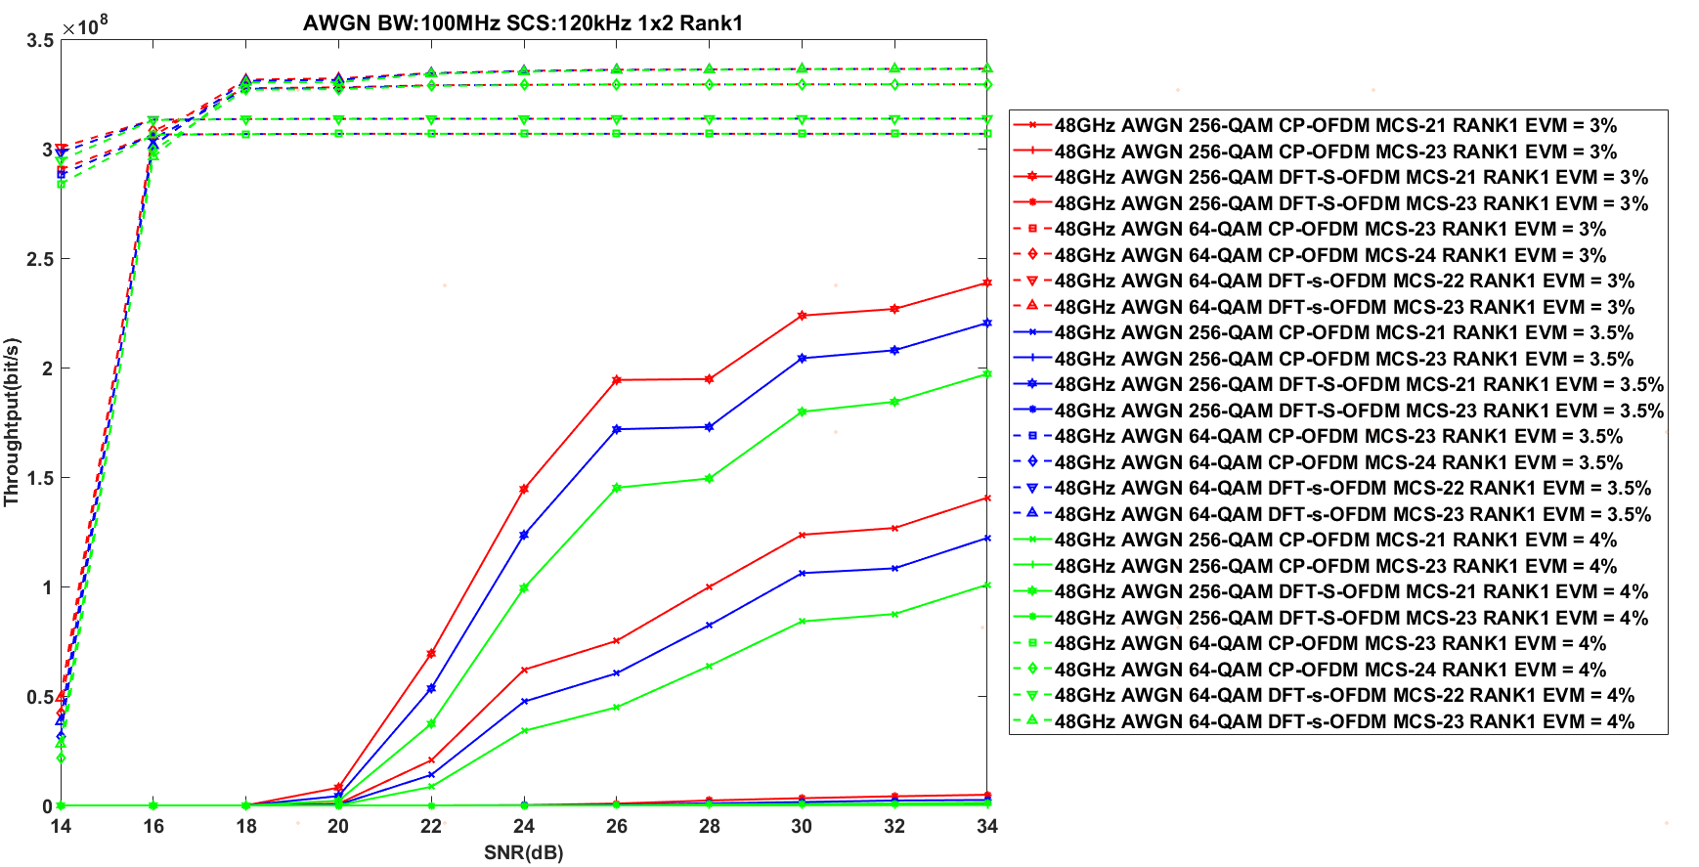

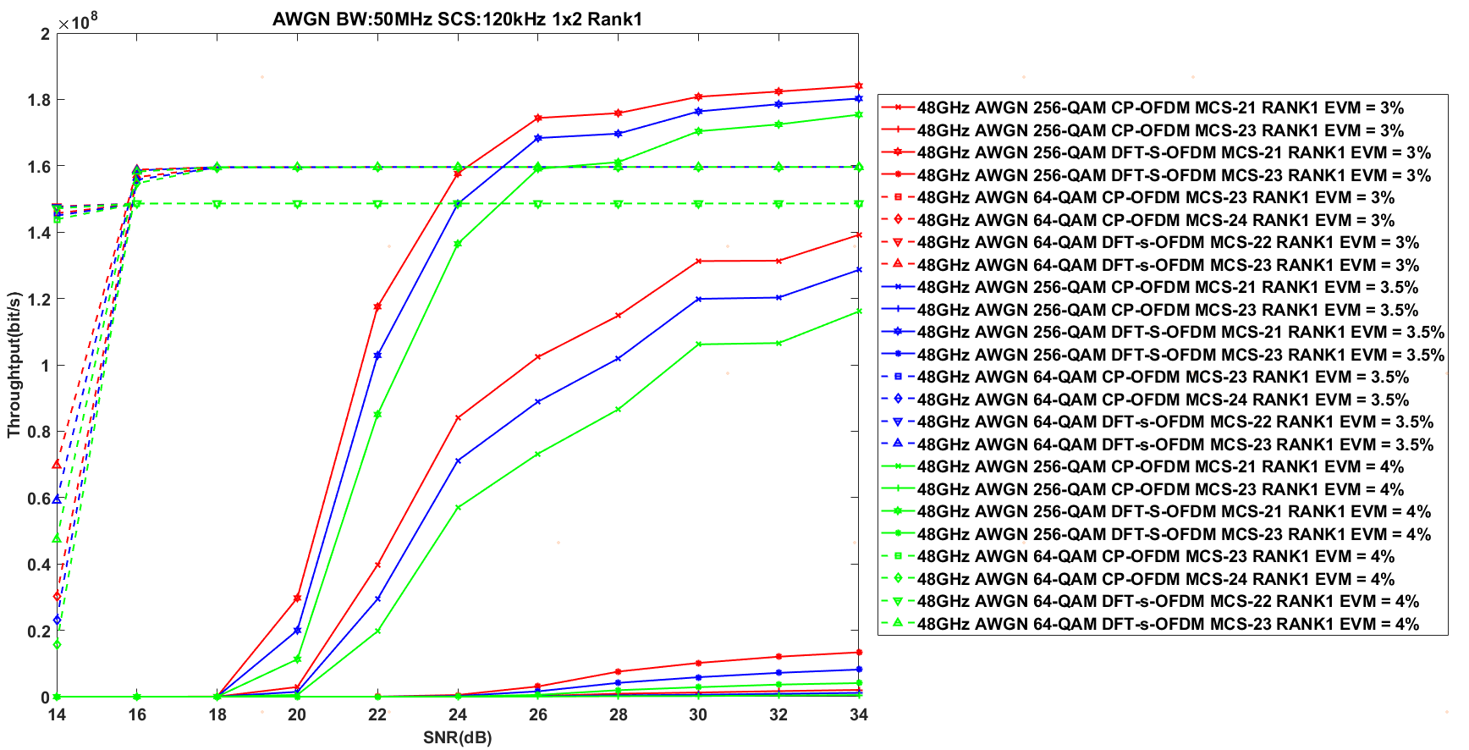

**Observation 3：**The UL 256 QAM is hard to bring performance gain under 48 GHz

#### 5.2.2.5 Simulation results from Huawei [R4-2216245]

The link lever simulation results are shown in Figure 2-1, Figure 2-2 and Figure 2-3 for TDL-D in different frequency ranges. From the simulation results, it is shown that support 256 QAM can provide significant performance gain over 64QAM where the UE is in good propagation condition.

**Figure 2-1** Throughput comparison of 256QAM and 64QAM for RANK1\_29 GHz

**Figure 2-2** Throughput comparison of 256QAM and 64QAM for RANK1\_39GHz

**Figure 2-3** Throughput comparison of 256QAM and 64QAM for RANK1\_48GHz

#### 5.2.2.6 Simulation results from Sony [R4-2216251]

We performed simulations and compared the throughput between 64QAM and 256QAM for three different transmit and receive EVM values (3%, 3.5%, and 4%). TX EVM has been the same as RX EVM in each simulation. The simulations are done according to the agreed simulation assumptions [3]. Only Rank-1, and AWGN for 29 GHz, respectively 48 GHz, are simulated so far. 100MHz channel BW and no HARQ have been used. Phase noise is added according to option 2 in the simulation assumptions, i.e., example2, at both the UE and BS.

* 29 GHz

We performed simulations to address whether 256-QAM works in FR2-1 and to demonstrate its performance gain. The result is shown in Figure 1.

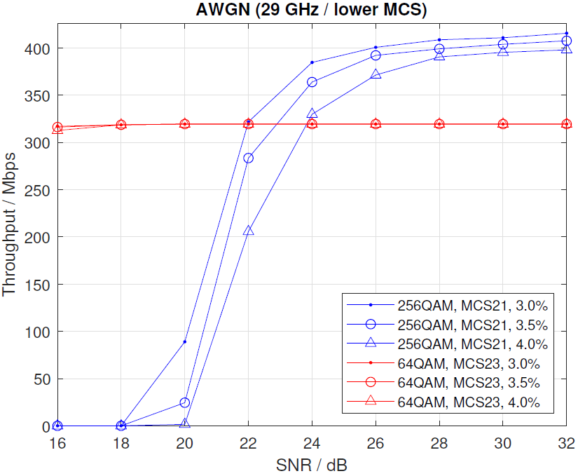

Figure 1 Throughput comparing 64QAM and 256QAM with AWGN for 29GHz, EVM 3%, 3.5% and 4%.

Figure 1 shows that throughput for 64QAM (red curve) has already saturated at an SNR level of 16dB. For 256QAM, SNR levels of 22 dB (EVM=3%), 23 dB (3.5%) and 24 dB (EVM=4%) are required to exceed the throughput performance of 64QAM. The simulations have been carried out with a simple receiver, and further studies of advanced receivers are needed to determine whether the above results could be improved.

Observation 1 For 256QAM to exceed throuput performance of 64QAM SNR levels of 22 dB (EVM=3%) to 24 dB (EVM=4%) are required.

#### 5.2.2.7 Simulation results from Xiaomi [R4-2216350]

We compare the UL 256QAM and UL 64QAM performance under different channel conditions and carrier frequencies to determine whether UL 256QAM can provide gains over UL 64QAM for FR2-1. For all simulation, we assumed 50MHz channel bandwidth with 120kHz SCS and phase noise model of example2 (UE) + example2(BS) based on above simulation assumptions.

1. CP-OFDM
2. 29GHz

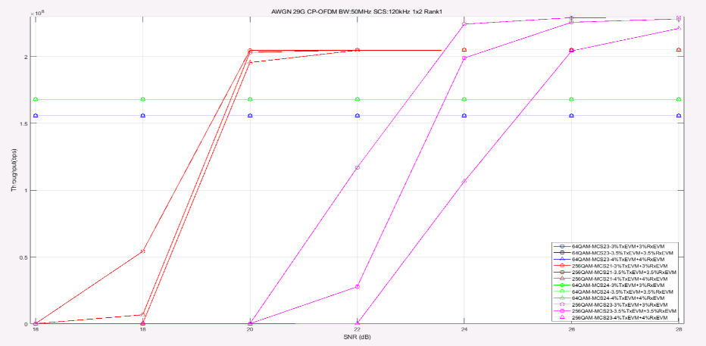

**Figure 2.1-1 Throughput performance for 29GHz under AWGN, CP-OFDM**

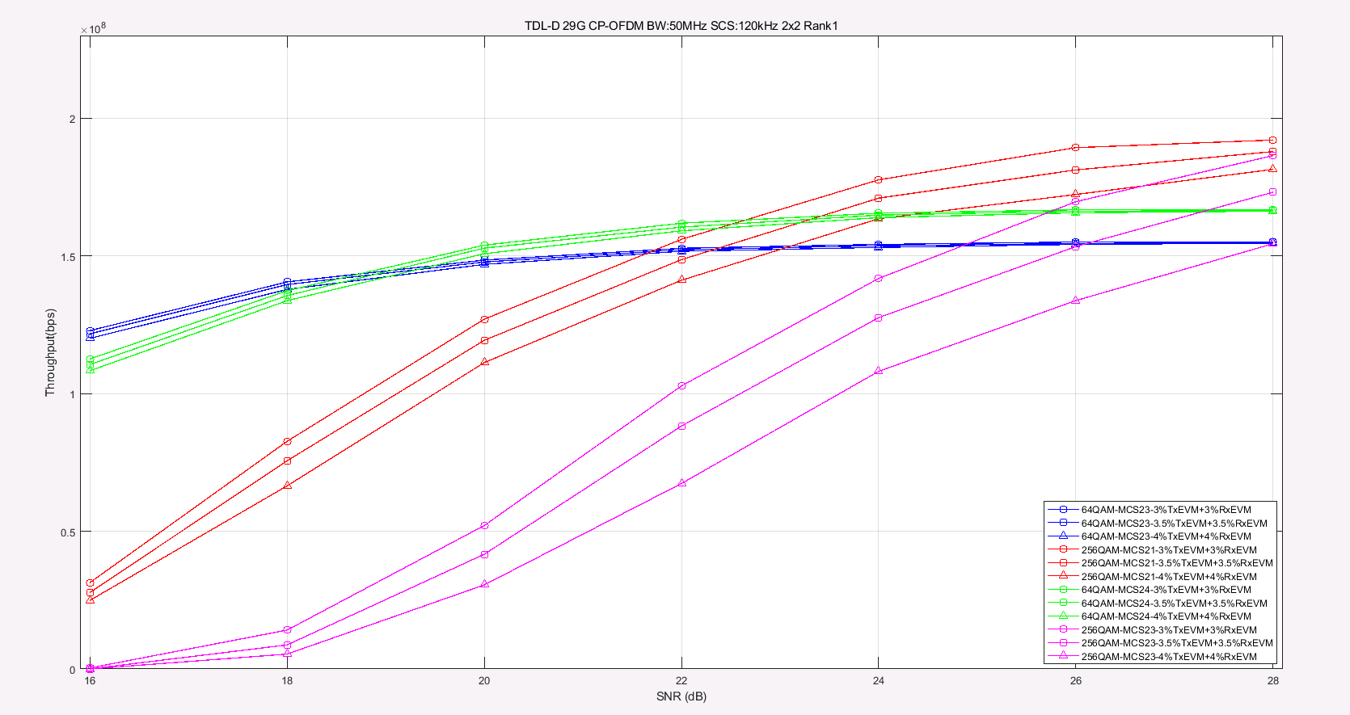

**Figure 2.1-2 Throughput performance for 29GHz under TDL-D, CP-OFDM**

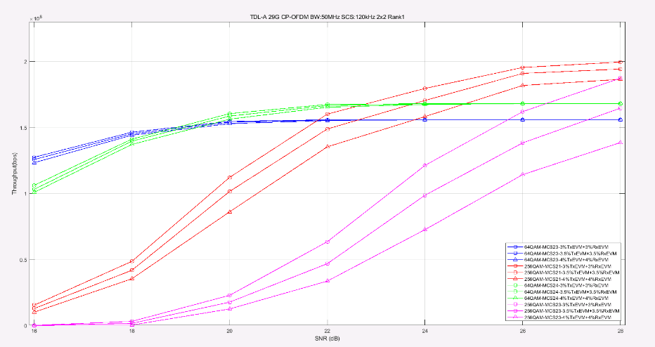

**Figure 2.1-3 Throughput performance for 29GHz under TDL-A, CP-OFDM**

1. 39GHz

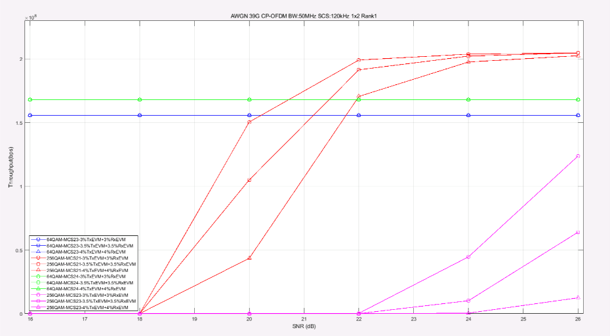

**Figure 2.1-4 Throughput performance for 39GHz under AWGN, CP-OFDM**

**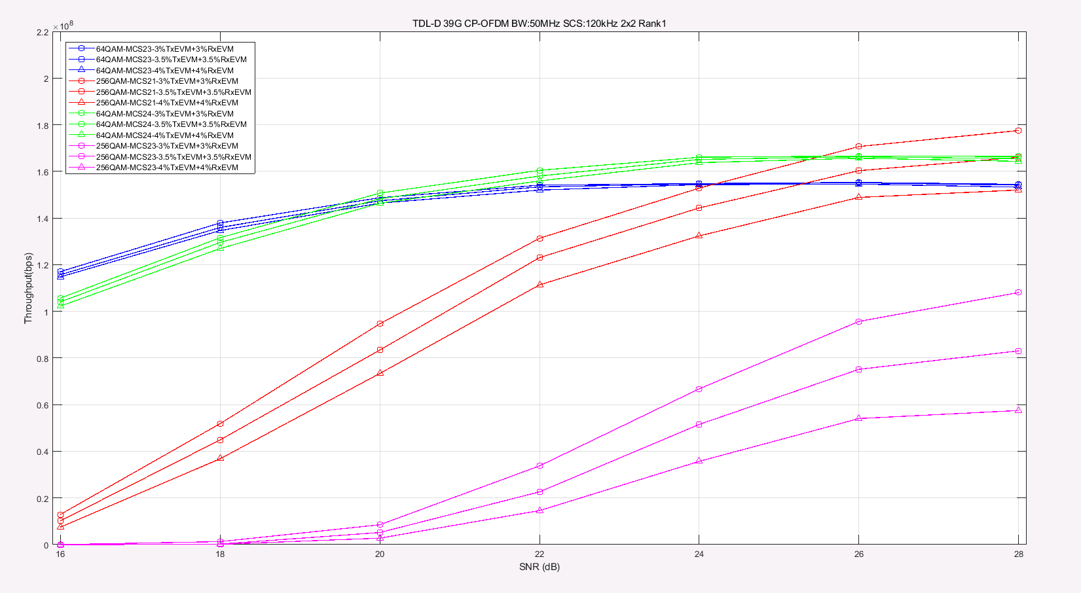**

**Figure 2.1-5 Throughput performance for 39GHz under TDL-D, CP-OFDM**

**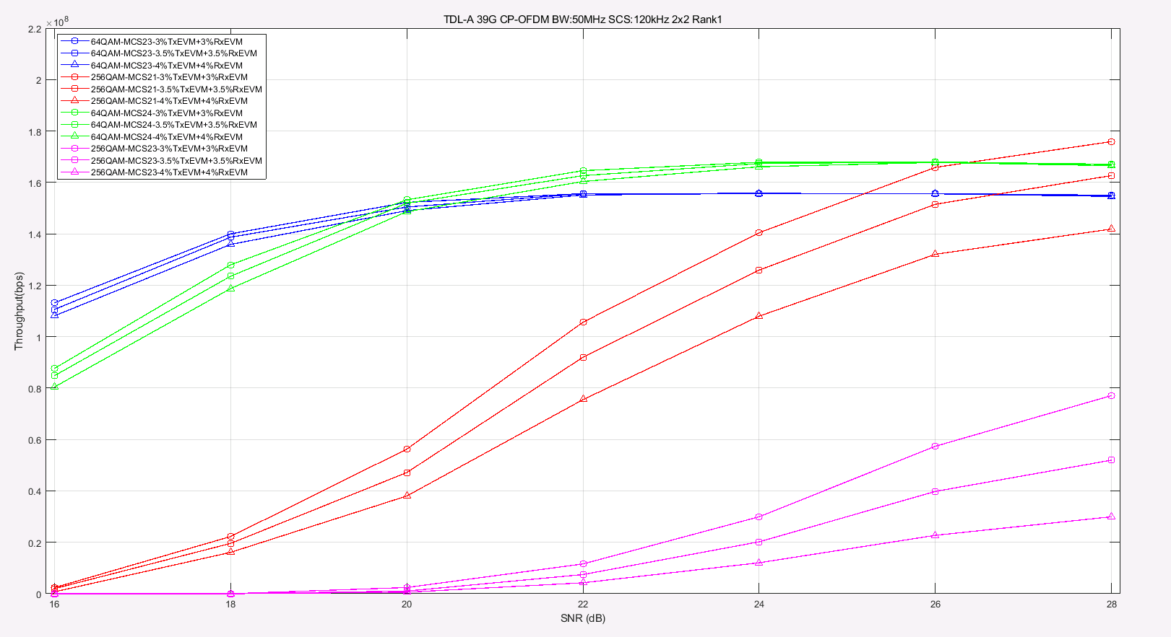**

**Figure 2.1-6 Throughput performance for 39GHz under TDL-A, CP-OFDM**

1. 48GHz

**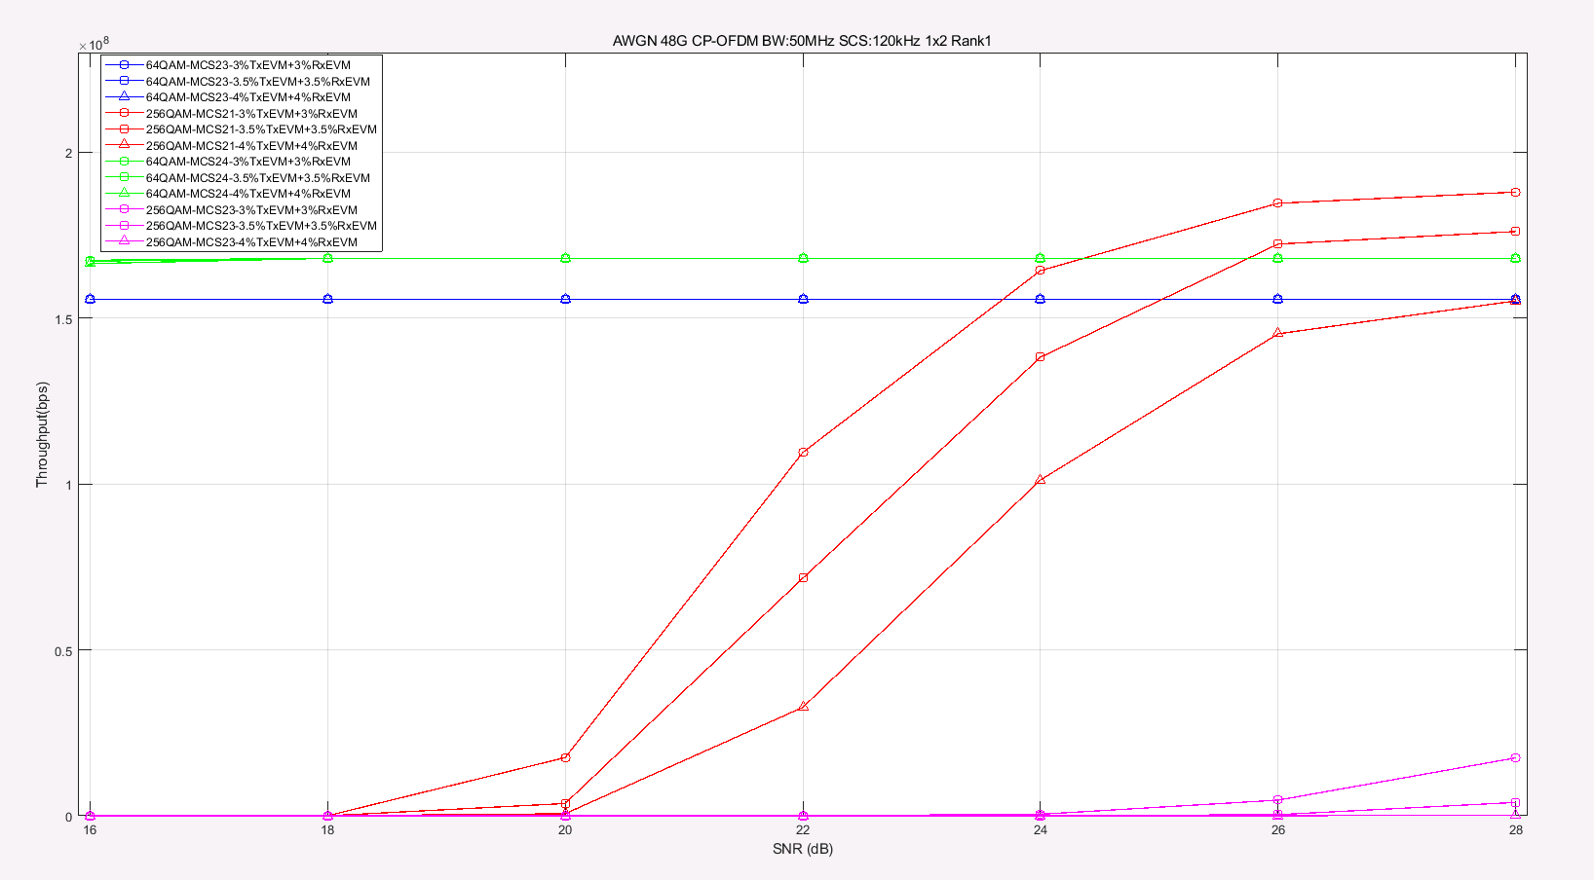**

**Figure 2.1-7 Throughput performance for 48GHz under AWGN,** **CP-OFDM**

1. DFT-s-OFDM
2. 29GHz

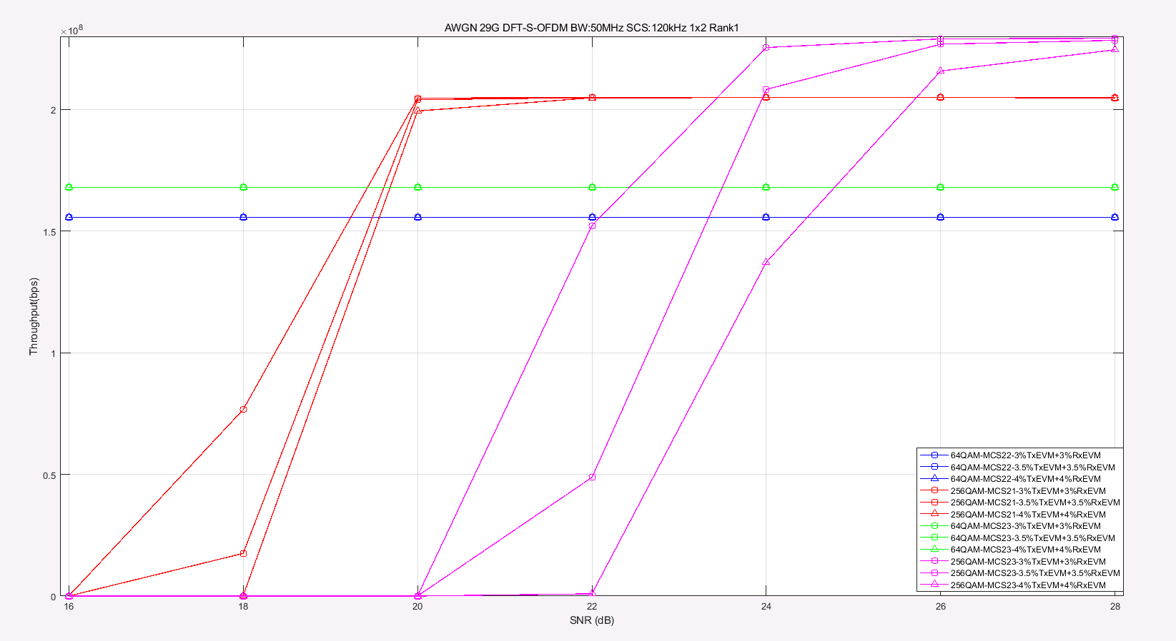

**Figure 2.1-8 Throughput performance for 29GHz under AWGN, DFT-s-OFDM**

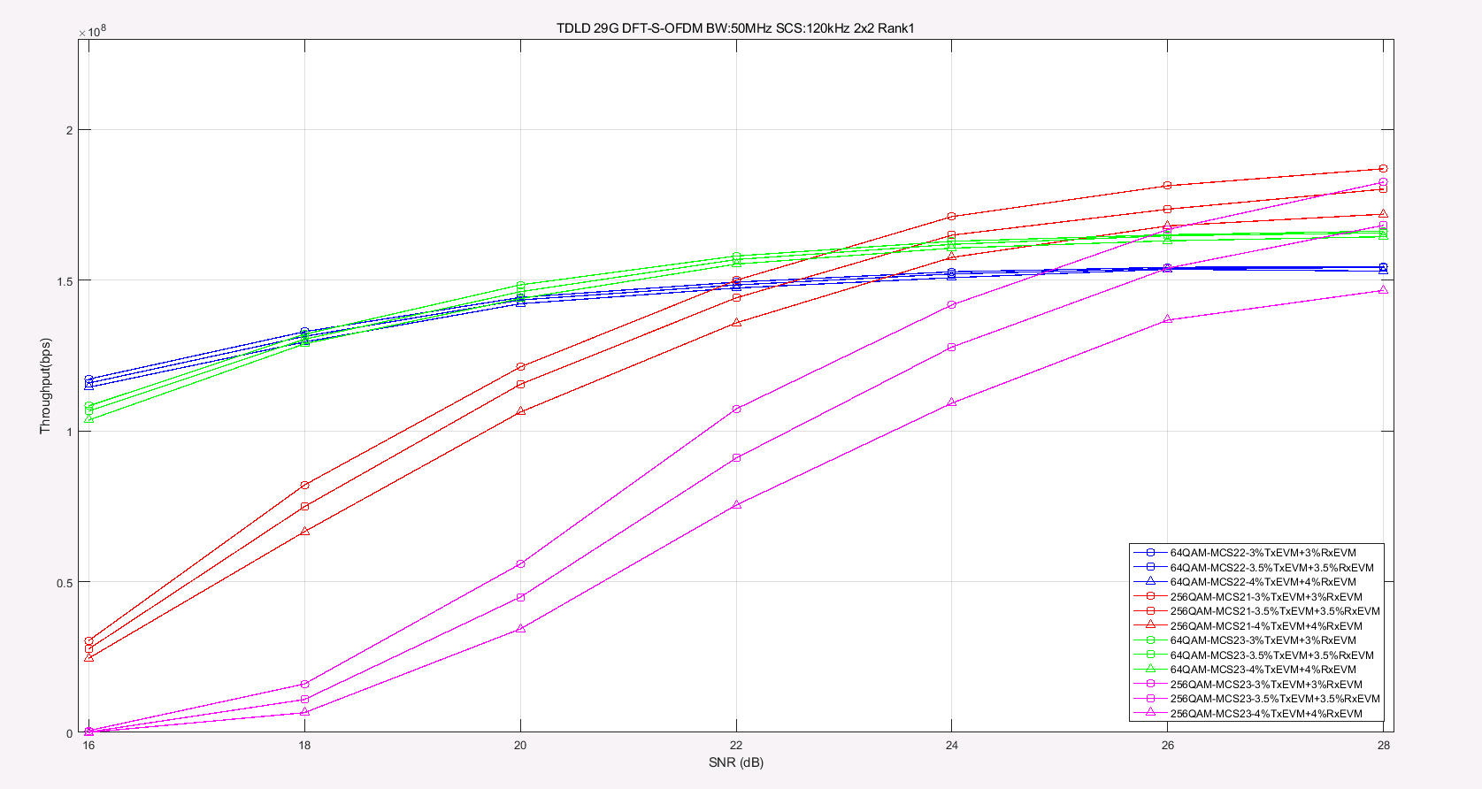

**Figure 2.1-9 Throughput performance for 29GHz under TDL-D, DFT-s-OFDM**

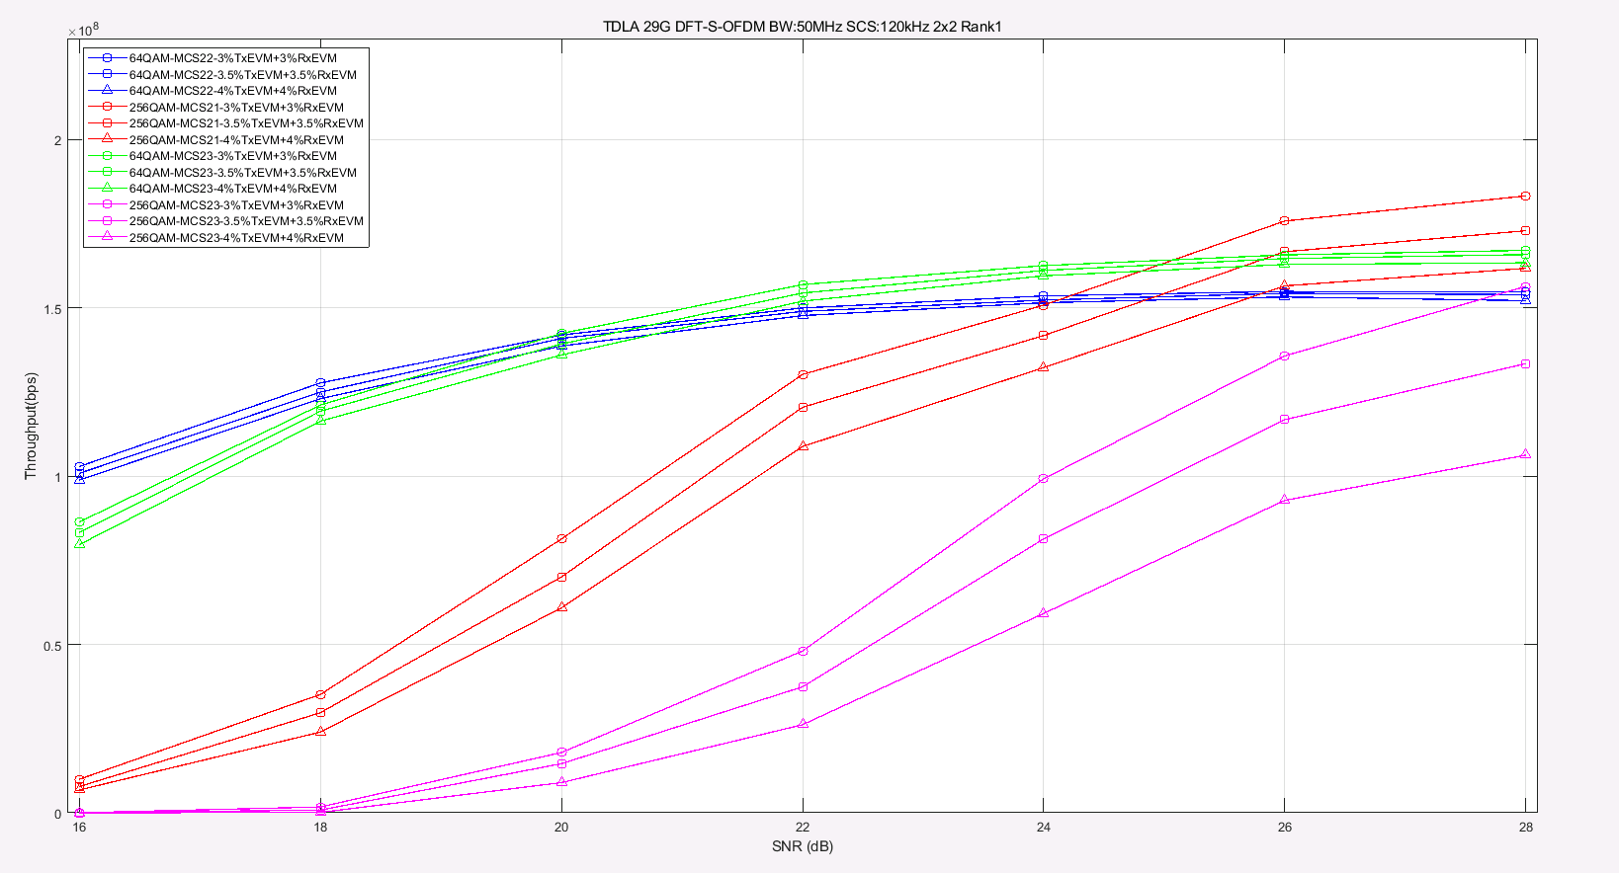

**Figure 2.1-10 Throughput performance for 29GHz under TDL-A, DFT-s-OFDM**

1. 39GHz

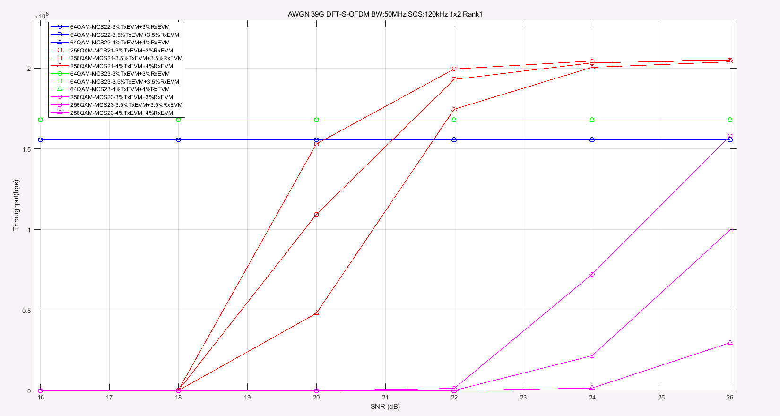

**Figure 2.1-11 Throughput performance for 39GHz under AWGN, DFT-s-OFDM**

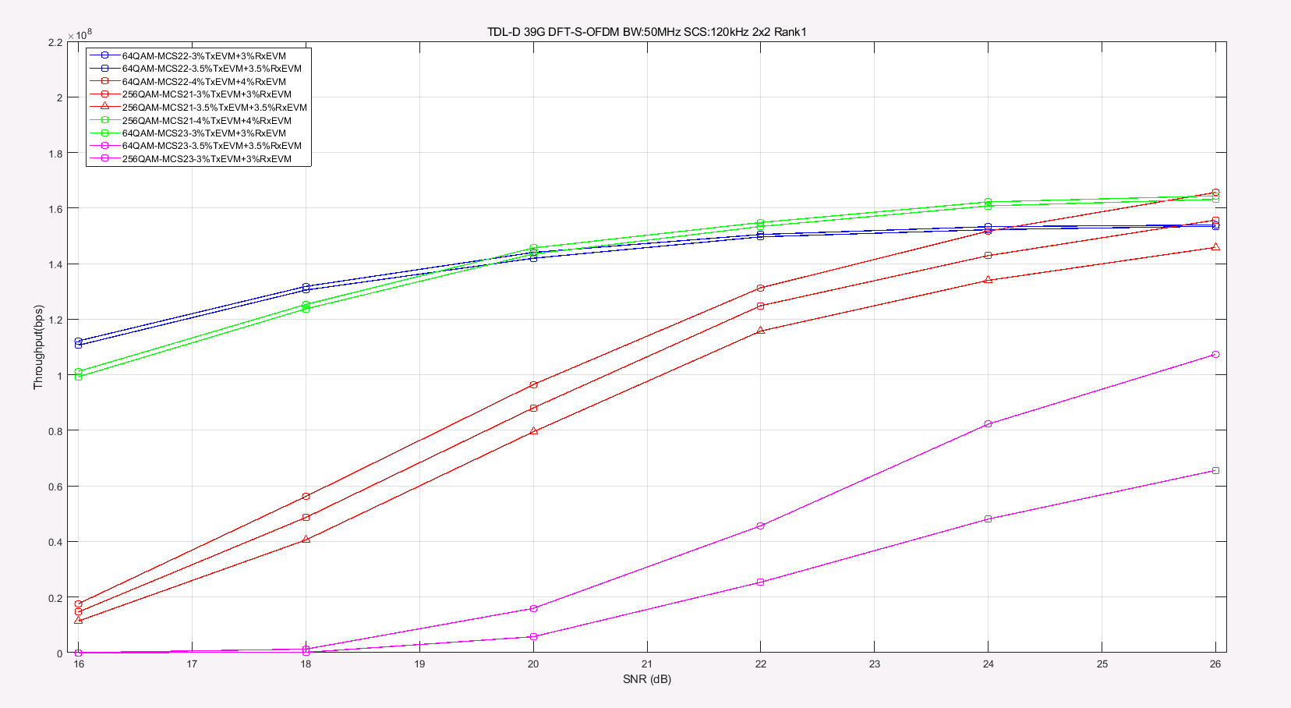

**Figure 2.1-12 Throughput performance for 39GHz under TDL-D, DFT-s-OFDM**

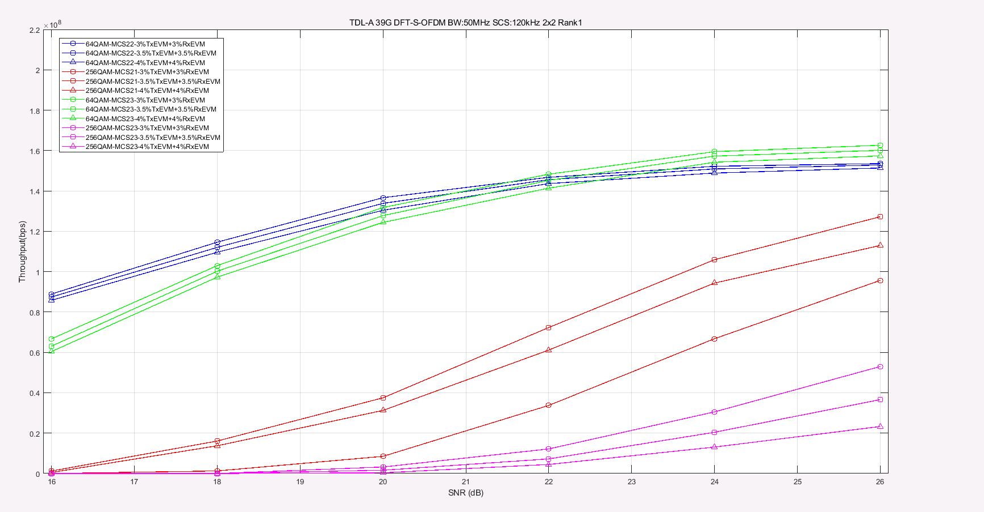

**Figure 2.1-13 Throughput performance for 39GHz under TDL-A, DFT-s-OFDM**

1. 48GHz

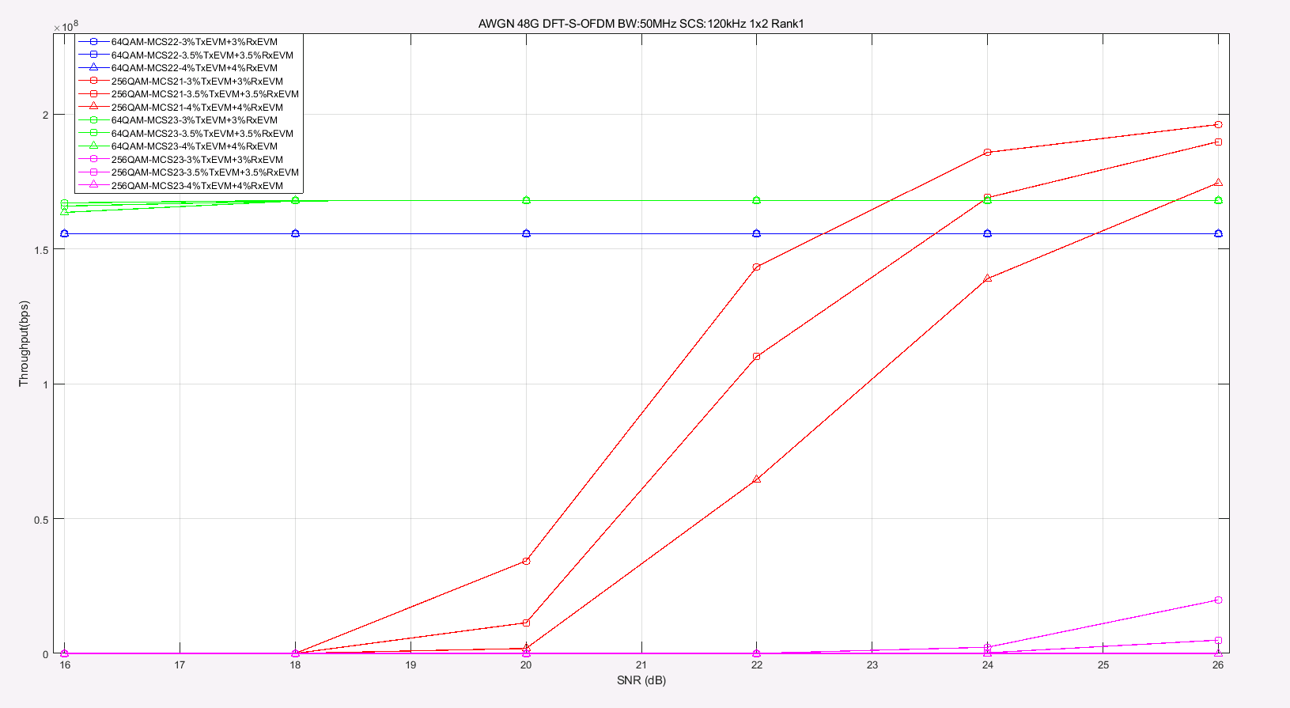

**Figure 2.1-14 Throughput performance for 39GHz under TDL-A, DFT-s-OFDM**

From the simulation results, table 2.1-1 summary the SNR required to achieve gains for 256QAM compare to 64QAM:

**Table 2.1-1 UL 256QAM required SNR to achieve gains compare to 64QAM**

|  |  |  |  |  |  |  |  |  |  |  |  |  |  |
| --- | --- | --- | --- | --- | --- | --- | --- | --- | --- | --- | --- | --- | --- |
| **Parameters for UL 256QAM** | | | **SNR required to achieve gains for 256QAM [dB]** | | | | | | | | | | |
| 29GHz | | | | | 39GHz | | | 48GHz | | |
| Channel | MCS | | | 3%+3% | 3.5%+3.5% | 4%+4% | 3%+3% | | 3.5%+3.5% | 4%+4% | 3%+3% | 3.5%+3.5% | 4%+4% | |
| AWGN  1x2 RANK1 | MCS21 | CP-OFDM | | 19.3 | 19.5 | 19.6 | 20 | | 21.5 | 22 | 24 | 25 | 28 | |
| DFT-OFDM | | 19.3 | 19.5 | 19.6 | 20.1 | | 21.1 | 21.7 | 22.5 | 23.6 | 25 | |
| MCS23 | CP-OFDM | | 23 | 23.5 | 25.5 | NA | | NA | NA | NA | NA | NA | |
| DFT-OFDM | | 22.5 | 23.5 | 24.7 | NA | | NA | NA | NA | NA | NA | |
| TDL-D  2x2 RANK2 | MCS21 | CP-OFDM | | 21.8 | 22.5 | 23.1 | 24.1 | | 25.2 | 28 | - | - | - | |
| DFT-OFDM | | 22 | 22.6 | 23.3 | 24.1 | | 25.7 | 28 | - | - | - | |
| MCS23 | CP-OFDM | | 25.8 | 27.3 | NA | NA | | NA | NA |  |  |  | |
| DFT-OFDM | | 25.7 | 26.1 | 28 | NA | | NA | NA | - | - | - | |
| TDL-A  2x2 RANK2 | MCS21 | CP-OFDM | | 21.8 | 22.7 | 23.8 | 25.2 | | 26.7 | NA | - | - | - | |
| DFT-OFDM | | 21.8 | 22.7 | 23.8 | NA | | NA | NA | - | - | - | |
| MCS23 | CP-OFDM | | 26.5 | 28 | NA | NA | | NA | NA | - | - | - | |
| DFT-OFDM | | 25.8 | 27.5 | NA | NA | | NA | NA | - | - | - | |
| - means the related simulations haven’t been done due to time limit. | | | | | | | | | | | | | | |

**Observation:**

And it is shown that supporting UL 256 QAM can provide significant performance gain over UL 64QAM for 3.5% EVM.

For AWGN channel with 3.5% Tx EVM+3.5% Rx EVM, a SNR of >19.5 dB is needed for 29GHz, a SNR of >21.1 dB is needed for 39GHz and a SNR of >23.6 dB is needed for 48GHz.

For TDL-A and TDL-D fading channel with 3.5% Tx EVM+3.5% Rx EVM, a SNR of >22.5 dB is needed for 29GHz, a SNR of >25.2 dB is needed for 39GHz, due to lime limit, the related simulation for 48GHz haven’t been done.

#### 5.2.2.8 Simulation results from ZTE [R4-2216426]

To study the gain and operating SNR, link level simulation approach was adopted to compare 256QAM with 64QAM. The simulation assumptions are from [2] as listed in Annex A1, and the parameters used in this simulation are marked in red. The throughput curves for CP-OFDM Rank1 transmission are listed in figure A.1~ figure A.9 in Annex for reference.

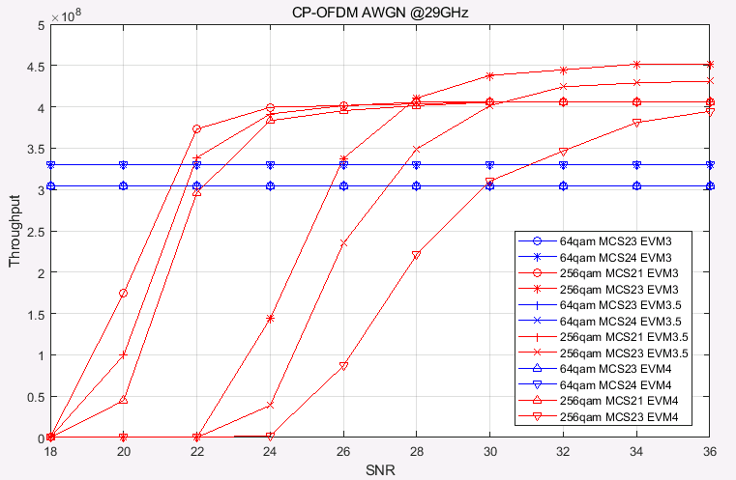

**Figure A.1: Throughput performance comparison between FR2 UL 256QAM and FR2 UL 64QAM @29GHz AWGN channel**

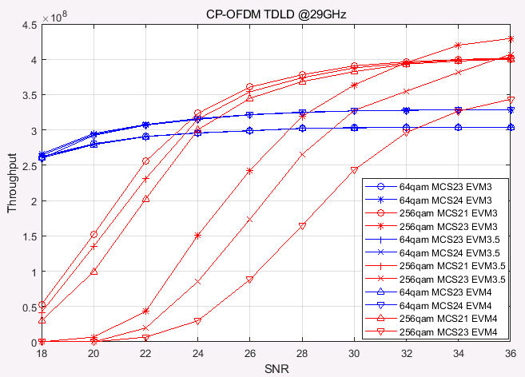

**Figure A.2: Throughput performance comparison between FR2 UL 256QAM and FR2 UL 64QAM @29GHz TDLD channel**

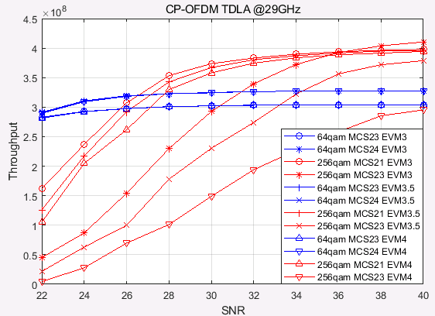

**Figure A.3: Throughput performance comparison between FR2 UL 256QAM and FR2 UL 64QAM @29GHz TDLA channel**

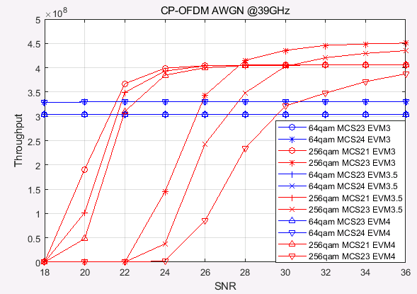

**Figure A.4: Throughput performance comparison between FR2 UL 256QAM and FR2 UL 64QAM @39GHz AWGN channel**

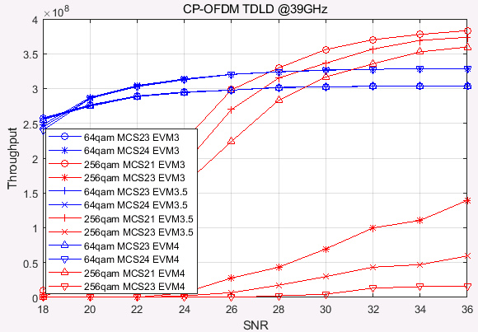

**Figure A.5: Throughput performance comparison between FR2 UL 256QAM and FR2 UL 64QAM @39GHz TDLD channel**

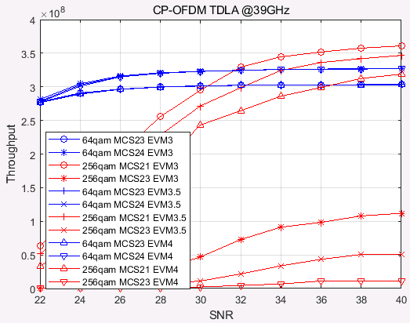

**Figure A.6: Throughput performance comparison between FR2 UL 256QAM and FR2 UL 64QAM @39GHz TDLA channel**

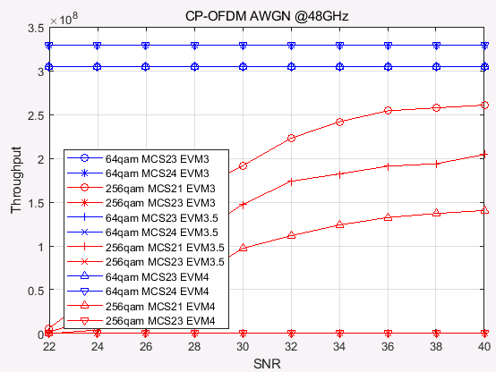

**Figure A.7: Throughput performance comparison between FR2 UL 256QAM and FR2 UL 64QAM @48GHz AWGN channel**

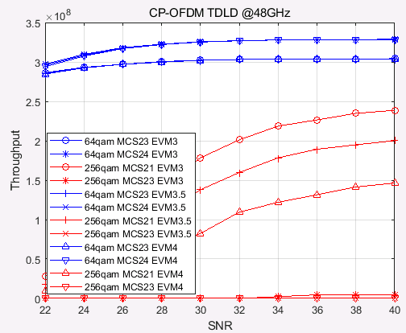

**Figure A.8: Throughput performance comparison between FR2 UL 256QAM and FR2 UL 64QAM @48GHz TDLD channel**

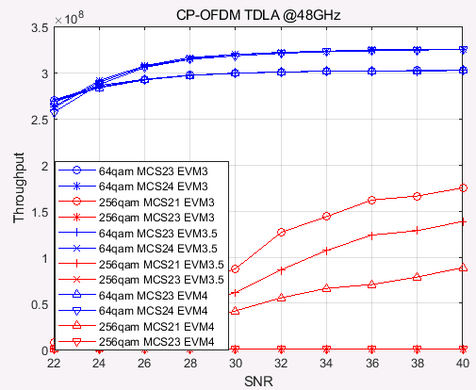

**Figure A.9: Throughput performance comparison between FR2 UL 256QAM and FR2 UL 64QAM @48GHz TDLA channel**

The target SNR values are summarized in table 1, where “-” means that 256QAM can not provide better performance in the given SNR range compared to 64QAM.

Table 1. Target SNR for CP-OFDM, Rank 1 transmission

|  |  |  |  |  |  |  |
| --- | --- | --- | --- | --- | --- | --- |
| index | frequency | Channel | Test setup (64QAM/256QAM) | Target SNR | | |
| EVM 3.0+3.0 | EVM 3.5+3.5 | EVM 4.0+4.0 |
| 1 | 29GHz | AWGN | MCS23/21 | 21.31 | 21.71 | 22.19 |
| 2 | MCS24/23 | 25.92 | 27.66 | 31.06 |
| 3 | TDL-D | MCS23/21 | 23.42 | 23.73 | 24.16 |
| 4 | MCS24/23 | 28.44 | 30.10 | 34.28 |
| 5 | TDL-A | MCS23/21 | 25.90 | 26.45 | 27.23 |
| 6 | MCS24/23 | 31.49 | 34.31 | - |
| 7 | 39GHz | AWGN | MCS23/21 | 21.28 | 21.64 | 21.95 |
| 8 | MCS24/23 | 25.86 | 27.64 | 30.62 |
| 9 | TDL-D | MCS23/21 | 26.36 | 27.50 | 29.23 |
| 10 | MCS24/23 | - | - | - |
| 11 | TDL-A | MCS23/21 | 30.48 | 32.35 | 36.62 |
| 12 | MCS24/23 | - | - | - |
| 13 | 48GHz | AWGN | MCS23/21 | - | - | - |
| 14 | MCS24/23 | - | - | - |
| 15 | TDL-D | MCS23/21 | - | - | - |
| 16 | MCS24/23 | - | - | - |
| 17 | TDL-A | MCS23/21 | - | - | - |
| 18 | MCS24/23 | - | - | - |

Based on the simulation results, the following observations are given:

**Observation 1:** For 29GHz:

256QAM performance gain can be expected in the following cases:

* AWGN and TDL-D channel,
* TDL-A channel when MCS21(256QAM)/MCS23(64QAM) are selected,
* TDL-A channel when MCS23(256QAM)/MCS24(64QAM) and EVM3.0+3.0 or EVM3.5+3.5 are selected

However, 256QAM performance gain can not be expected in the following cases:

* TDL-A channel when MCS23(256QAM)/MCS24(64QAM) and EVM4.0+4.0 are selected.

**Observation 2:** For 39GHz:

256QAM performance gain can be expected in the following cases:

* AWGN
* TDL-D and TDL-A channel when MCS21(256QAM)/MCS23(64QAM) are selected

However, 256QAM performance gain can not be expected in the following cases:

* TDL-D and TDL-A channel when MCS23(256QAM)/MCS24(64QAM) are selected.

For 48GHz, using the same phase noise model, the phase noise becomes larger as frequency increases.

**Observation 3:** For 48GHz:

256QAM performance gain can not be expected for AWGN, TDL-D and TDL-A channel for all the MCS.

### 5.2.3 MPR simulation

## 5.3 Implementation impact for UE

## 5.4 Specification impact

## 5.5 Conclusion

# 6 Study for beam correspondence

## 6.1 General

## 6.2 Implementation impact to UE

## 6.3 Specification Impact

### 6.3.1 RF

### 6.3.2 RRM

## 6.4 Testing impact

## 6.5 Conclusion

Editor’s note:

# Annex <A> (informative): Change history

|  |  |  |  |  |  |  |  |
| --- | --- | --- | --- | --- | --- | --- | --- |
| **Change history** | | | | | | | |
| **Date** | **Meeting** | **TDoc** | **CR** | **Rev** | **Cat** | **Subject/Comment** | **New version** |
| 2022-08 | RAN4 #104-e | R4-2212590 |  |  |  | TR skeleton | 0.0.1 |
| 2022-10 | RAN4 #104-bis-e | R4-2217730 |  |  |  | TP for TR 38.891 on link level simulation assumptions for FR2 UL 256QAM | 0.1.0 |
| 2022-11 | RAN4 #105 | R4-2219122 |  |  |  | TP for TR 38.891 on link level simulation results and system level simulation assumption for FR2 UL 256QAM | 0.2.0 |

Change history of this template:

|  |  |  |
| --- | --- | --- |
| 2001-07 | Copyright date changed to 2001; space character added before TTC in copyright notification; space character before first reference deleted. | 1.3.3 |
| 2002-01 | Copyright date changed to 2002. | 1.3.4 |
| 2002-07 | Extra Releases added to title area. | 1.3.5 |
| *2002-12* | *"TM" added to 3GPP logo.* | *1.3.6* |
| *2003-02* | *Copyright date changed to 2003.* | *1.3.7* |
| *2003-12* | *Copyright date changed to 2004. Chinese OP changed from CWTS to CCSA* | *14.0* |
| *2004-04* | *North American OP changed from T1 to ATIS* | *1.5.0* |
| *2005-11* | *Stock text of clause 3 includes reference to 21.905.* | *1.6.0* |
| *2005-11* | *Caters for new TSG structure. Minor corrections.* | *1.6.1* |
| *2006-01* | *Revision marks removed.* | *1.6.2* |
| *2008-11* | *LTE logo line added, © date changed to 2008, guidance on keywords modified; acknowledgement of trade marks; sundry editorial corrections and cosmetic improvements* | *1.7.0* |
| *2010-02* | *3GPP logo changed for cleaner version, with tag line; LTE-Advanced logo line added;  © date changed to 2010; editorial change to cover page footnote text; trade marks acknowledgement text modified; additional Releases added on cover page; proforma copyright release text block modified* | *1.8.0* |
| *2010-02* | *Smaller 3GPP logo file used.* | *1.8.1* |
| *2010-07* | *Guidance note concerning use of LTE-Advanced logo added.* | *1.8.2* |
| *2011-04-01* | *Guidance of use of logos on cover page modified; copyright year modified.* | *1.8.3* |
| *2013-05-15* | *Changed File Properties to MCC macro default.*  *Removed R99, added Rel-12/13.*  *Modified Copyright year.*  *Guidance on annex X Change history.* | *1.8.4* |
| *2014-10-27* | *Updated Release selection on cover. In clause 3, added "3GPP" to TR 21.905.* | *1.8.5* |
| *2015-01-06* | *New Organizational Partner TSDSI added to copyright block. Old Releases removed.* | *1.9.0* |
| *2015-12-03* | *Provision for LTE Advanced Pro logo  Update copyright year to 2016* | *1.10.0* |
| *2016-03-08* | *Standarization of the layout of the Change History table in the last annex.(Unreleased)* | *1.11.0* |
| *2016-06-15* | *Minor adjustment to Change History table heading* | *1.11.1* |
| *2017-03-13* | *Adds option for 5G logo on cover* | *1.12.0* |
| *2017-05-03* | *Smaller 5G logo to reduce file size* | *1.12.1* |
| *2019-02-25* | *Replacement of frames on cover pages by in-line text.*  *Clarification of help text on when to use 5G logo. Removal of defunct keywords frame on page 2. Add Rel-16, Rel-17 options, eliminated earlier, frozen, Releases (cover page, below title) Corrections to some guidance text, addition of guidance text concerning automatic page headers under Word 2016 ff. Use of modal auxiliary verbs added to Foreword. More explicit guidance on Bibliography and Index annexes. Converted to .docx format.* | *1.13.0* |