3GPP TR 38.833 V1.2.0 (2022-03)
Technical Report
3rd Generation Partnership Project;
Technical Specification Group Radio Access Networks;
Further enhancement on NR demodulation performance
(Release 17)

The present document has been developed within the 3rd Generation Partnership Project (3GPP TM) and may be further elaborated for the purposes of 3GPP.
The present document has not been subject to any approval process by the 3GPP Organizational Partners and shall not be implemented.
This Report is provided for future development work within 3GPP only. The Organizational Partners accept no liability for any use of this Specification.
Specifications and Reports for implementation of the 3GPP TM system should be obtained via the 3GPP Organizational Partners' Publications Offices.

3GPP
Postal address

3GPP support office address
650 Route des Lucioles - Sophia Antipolis
Valbonne - FRANCE
Tel.: +33 4 92 94 42 00 Fax: +33 4 93 65 47 16
Internet
http://www.3gpp.org

Copyright Notification
No part may be reproduced except as authorized by written permission.
The copyright and the foregoing restriction extend to reproduction in all media.

© 2022, 3GPP Organizational Partners (ARIB, ATIS, CCSA, ETSI, TSDSI, TTA, TTC).
All rights reserved.

UMTS™ is a Trade Mark of ETSI registered for the benefit of its members
3GPP™ is a Trade Mark of ETSI registered for the benefit of its Members and of the 3GPP Organizational Partners
LTE™ is a Trade Mark of ETSI registered for the benefit of its Members and of the 3GPP Organizational Partners
GSM® and the GSM logo are registered and owned by the GSM Association

Contents
Foreword 4
1 Scope 6
2 References 6
3 Definitions, symbols and abbreviations 6
3.1 Terms 6
3.2 Symbols 7
3.3 Abbreviations 7
4 Inter-user interference suppression for MU-MIMO 7
4.1 Scenario and interference modelling 7
4.1.1 Scenario 7
4.1.2 Interference model 11
4.2 Receiver structure 11
4.2.1 General 11
4.2.2 MMSE IRC receiver 12
4.3 Link performance characterization 12
4.3.1 Parameters for link level evaluation 12
4.3.2 Link level simulation results 15
4.3.3 Summary of link level evaluation 18
5 LTE CRS interference handling for NR UE 20
5.1 Scenario and interference modelling 20
5.1.1 Scenario 20
5.1.2 LTE interference model 21
5.2 Receiver structure 21
5.2.1 General 21
5.2.2 Reference receiver of LTE-CRS interference mitigation 21
5.2.3 LTE cell configuration detection 22
5.3 Link performance characterization 22
5.3.1 Parameters for link level evaluation 22
5.3.1.1 General 22
5.3.1.2 Serving cell PDSCH parameters 22
5.3.1.3 Interference cell parameters 23
5.3.1.4 Summary of simulation cases 24
5.3.2 Link level simulation results 24
5.3.2.1 General 24
5.3.2.2 NR UE PDSCH performance for Scenario 1 25
5.3.2.3 NR UE PDSCH performance for Scenario 2 25
5.3.2.4 LTE UE performance 26
5.3.3 Summary of link level evaluation 27
6 Conclusions 27
6.1 Conclusion on inter-user interference suppression for MU-MIMO scenario 27
6.2 Conclusion on CRS interference handling in scenarios with overlapping spectrum for LTE and NR 28
Annex A: Change history 30

Foreword
This Technical Report has been produced by the 3rd Generation Partnership Project (3GPP).
The contents of the present document are subject to continuing work within the TSG and may change following formal TSG approval. Should the TSG modify the contents of the present document, it will be re-released by the TSG with an identifying change of release date and an increase in version number as follows:
Version x.y.z
where:
x the first digit:
1 presented to TSG for information;
2 presented to TSG for approval;
3 or greater indicates TSG approved document under change control.
y the second digit is incremented for all changes of substance, i.e. technical enhancements, corrections, updates, etc.
z the third digit is incremented when editorial only changes have been incorporated in the document.
In the present document, modal verbs have the following meanings:
shall indicates a mandatory requirement to do something
shall not indicates an interdiction (prohibition) to do something
The constructions "shall" and "shall not" are confined to the context of normative provisions, and do not appear in Technical Reports.
The constructions "must" and "must not" are not used as substitutes for "shall" and "shall not". Their use is avoided insofar as possible, and they are not used in a normative context except in a direct citation from an external, referenced, non-3GPP document, or so as to maintain continuity of style when extending or modifying the provisions of such a referenced document.
should indicates a recommendation to do something
should not indicates a recommendation not to do something
may indicates permission to do something
need not indicates permission not to do something
The construction "may not" is ambiguous and is not used in normative elements. The unambiguous constructions "might not" or "shall not" are used instead, depending upon the meaning intended.
can indicates that something is possible
cannot indicates that something is impossible
The constructions "can" and "cannot" are not substitutes for "may" and "need not".
will indicates that something is certain or expected to happen as a result of action taken by an agency the behaviour of which is outside the scope of the present document
will not indicates that something is certain or expected not to happen as a result of action taken by an agency the behaviour of which is outside the scope of the present document
might indicates a likelihood that something will happen as a result of action taken by some agency the behaviour of which is outside the scope of the present document
might not indicates a likelihood that something will not happen as a result of action taken by some agency the behaviour of which is outside the scope of the present document
In addition:
is (or any other verb in the indicative mood) indicates a statement of fact
is not (or any other negative verb in the indicative mood) indicates a statement of fact
The constructions "is" and "is not" do not indicate requirements.

1 Scope
The present technical report documents the Phase I study outcome on inter-user interference suppression for NR MU-MIMO and techniques to cope with LTE CRS interference for NR UE, with the detailed objectives as follows:、
• MMSE-IRC receiver for suppressing intra-cell inter-user interference
- Phase I: Evaluate the performance under practical MU-MIMO interference profile for the candidate reference receiver.
∘ Identify practical MU-MIMO interference modelling methodology
∘ Reference receiver: MMSE-IRC receiver. Use the DMRS-based interference covariance estimation method as a starting point
∘ Prioritize slot-based transmission scenario
• Evaluate techniques to cope with CRS interference in scenarios with overlapping spectrum for LTE and NR
- Candidate reference receiver to enable neighboring cell CRS-IM
∘ The performance benefit of neighboring cell LTE CRS-IM over the existing rate matching solutions specified in Rel-15 and Rel-16 shall be evaluated.
∘ Feasibility of the considered solution regarding NR PDSCH processing timeline need to be checked.
∘ Priority will be given to solutions not having RAN1 specification impact.
- Synchronous network scenario is prioritized. As second priority, RAN4 could evaluate the feasibility and usefulness of the asynchronous network scenario and specify if feasible and useful.
- 15 kHz SCS for NR is prioritized. RAN4 should evaluate the feasibility and usefulness of 30 kHz SCS for scenarios with LTE and NR deployed in neighboring BSs/areas and specify if feasible and useful.

2 References
The following documents contain provisions which, through reference in this text, constitute provisions of the present document.
- References are either specific (identified by date of publication, edition number, version number, etc.) or non-specific.
- For a specific reference, subsequent revisions do not apply.
- For a non-specific reference, the latest version applies. In the case of a reference to a 3GPP document (including a GSM document), a non-specific reference implicitly refers to the latest version of that document in the same Release as the present document.
[1] 3GPP TR 21.905: "Vocabulary for 3GPP Specifications".
[2] 3GPP TS 38.214: “NR: Physical layer procedures for data”.

3 Definitions, symbols and abbreviations

3.1 Terms
For the purposes of the present document, the terms given in 3GPP TR 21.905 [1] and the following apply. A term defined in the present document takes precedence over the definition of the same term, if any, in 3GPP TR 21.905 [1].

3.2 Symbols
Void

3.3 Abbreviations
For the purposes of the present document, the abbreviations given in 3GPP TR 21.905 [1] and the following apply. An abbreviation defined in the present document takes precedence over the definition of the same abbreviation, if any, in 3GPP TR 21.905 [1].
AL Aggregation level
AP Antenna port
BWP Bandwidth part
CBW Channel bandwidth
CDM Code division multiple
CORESET Control resource set
CRS Cell-specific reference signal
CRS-IC CRS interference cancellation
CRS-IM CRS interference mitigation
CRS-RM CRS rate matching
CSI-RS Channel state information reference signal
DMRS Demodulation reference signal
DSS Dynamic spectrum sharing
FD-CDM Frequency division - code division multiple
ISD Inter-site distance
MMSE-IRC Minimum mean square error - interference rejection combining
MMSE-MRC Minimum mean square error - maximal ratio combining
MU-MIMO Multi-user MIMO
NZP Non-zero-power
PSS Primary synchronization signal
PT-RS Phase-tracking reference signal
QCL Quasi co-location
RB Resource block
RSRP Reference signal received power
SCS Subcarrier spacing
SINR Signal-to-interference-and-noise ratio
SSB Synchronization signal block
SSS Secondary synchronization signal
TBS Transport block size
TCI Transmission configuration indicator
TDL Tapped delay line
TM Transmission mode

4 Inter-user interference suppression for MU-MIMO

4.1 Scenario and interference modelling

4.1.1 Scenario
MU-MIMO allows gNB to transmit data to multiple UEs in the same time-frequency resources through spatial multiplexing. The process of selecting paired UEs is called ‘pairing’. As illustrated in Figure 4.1.1-1, UE1 and UE2 are paired and gNB transmits data to both UEs with suitable precoders through the same time-frequency resources. However, the gNB cannot guarantee the perfect pairing of multiple users in the real network. The paired UEs may not perfectly spatially orthogonal to each other and this will induce the intra-cell interference between paired UEs.
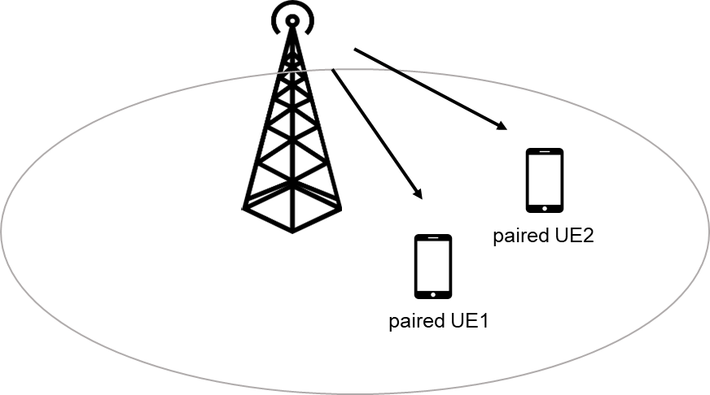
Figure 4.1.1-1. gNB transmit data to paired UE1 and UE2 with the same time-frequency resources
To evaluate the performance of UE with intra-cell interference induced by spatial multiplexing, the following scenarios illustrated from Figure 4.1.1-2 to Figure 4.1.1-6 are considered for the case of number of paired UEs is 2.
• Target UE with single DMRS antenna port:
- Scenario 1-1: Number of CDM group without data is 1
∘ AP1000 for target UE, AP1001 for interference UE
- Scenario 1-2: Number of CDM group without data is 2
∘ AP1000 for target UE, AP1001 for interference UE
- Scenario 1-3: Number of CDM group without data is 2
∘ AP1000 for target UE, AP1002 for interference UE
• Target UE with two DMRS antenna ports:
- Scenario 2-1: Number of CDM group without data is 2
∘ AP1000 and 1001 for target UE, AP1002 and 1003 for interference UE
- Scenario 2-2: Number of CDM group without data is 2
∘ AP1000 and 1001 for target UE, AP1002 for interference UE
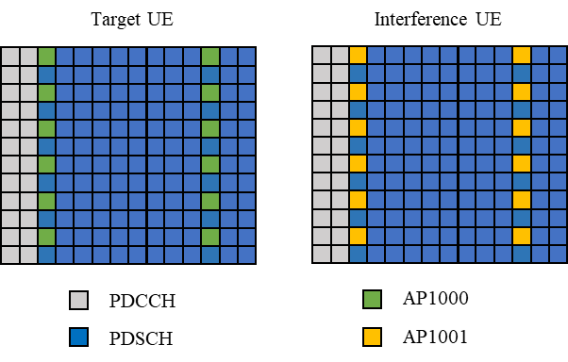
Figure 4.1.1-2: Scenario 1-1, number of CDM group without data is 1 and AP1000 for target UE, AP1001 for interference UE
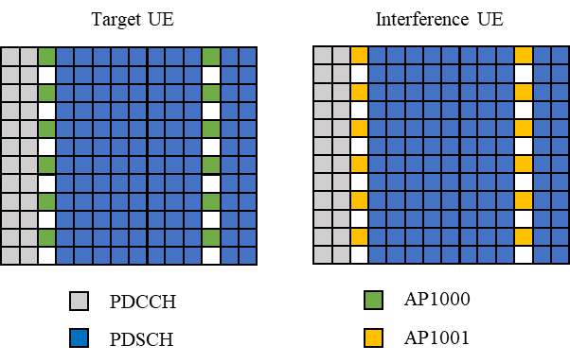
Figure 4.1.1-3: Scenario 1-2, number of CDM group without data is 2 and AP1000 for target UE, AP1001 for interference UE

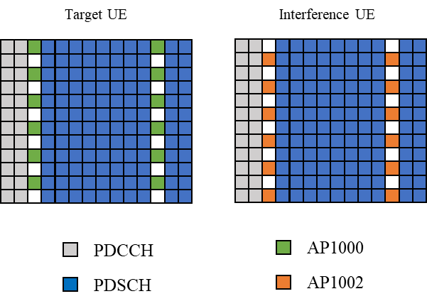
Figure 4.1.1-4: Scenario 1-3, number of CDM group without data is 2 and AP1000 for target UE, AP1002 for interference UE

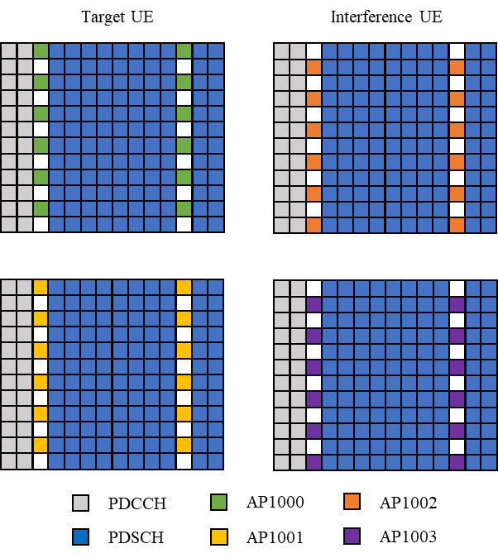
Figure 4.1.1-5: Scenario 2-1, number of CDM group without data is 2 and AP1000 and 1001 for target UE, AP1002 and 1003 for interference UE

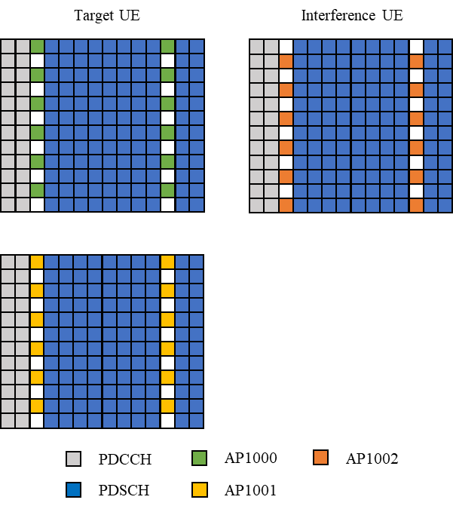
Figure 4.1.1-6: Scenario 2-2, number of CDM group without data is 2 and AP1000 and 1001 for target UE, AP1002 for interference UE

4.1.2 Interference model
The PDSCH and DMRS of the paired UEs are precoded prior to transmission. The precoder for each user is denoted by $W_{1}^{'}$ and $W_{2}^{'}$ respectively.
$W_{i}$is the precoder matrix of i^{th} UE, of size N_{TX} x N_{Li} from Type I single panel codebook as described in [2]. Where, N_{TX} is the number of TX antenna, N_{Li} is the number of layers from i^{th} UE. The combined precoder ${W = [W}_{1} W_{2}]$, of size N_{TX} x N_{L} where, N_{L} is the total number layers across all users.
The precoder of the target UE $W_{1}$ is randomly selected. For the co-scheduled UE, the precoder $W_{2}$ is selected in one of the two ways below.
• Orthogonal precoder: $W_{2}$ is randomly selected from the codebook with a constraint that the combined precoder W has orthogonal columns, i.e., the off-diagonal entries of W^{H}W are zero.
• Random precoder: $W_{2}$ is randomly selected from the codebook ensuring any column of $W_{2}$ is not identical to any column of $W_{1}$
To maintain the average per UE signal power as N_{Li} /N_{L,} an additional scaling is applied to the each precoder as:
$$W_{i}^{'}= \sqrt{\frac{N_{Li}}{N_{L}}}*W_{i}$$

4.2 Receiver structure

4.2.1 General
In this clause, we provide the system equations for evaluating the performance of intra-cell inter-user interference mitigation.
The N_{Rx}-dimensional received signal vector r of the $k$-th subcarrier and the $l$-th OFDM symbol is assumed to be expressed as a sum of target’s UE own signal $H_{1}\left(k,l\right)d_{1}\left(k,l\right)$, and co-scheduled UEs’ interference signals $H_{j}\left(k,l\right)d_{j}\left(k,l\right)$ (j>1) and the white noise $n(k,l)$;
$$r\left(k, l\right)= H_{1}\left(k,l\right)d_{1}\left(k,l\right)+\sum_{j=2}^{N_{UE}}{H_{j}\left(k,l\right)d_{j}\left(k,l\right)}+n(k,l)$$
Where,
$d_{j}\left(k,l\right)$ and $H_{j}\left(k,l\right), j=\{2,…N_{UE}\}$ represent the N_{layer,j} x1 transmitted signal vector and the (N_{Rx} x N_{layer,j}) channel matrix between the j-th co-scheduled UE’s interference and the UE containing the contribution from receiver branches, with $H_{j}=\left[\begin{matrix}{(H_{j,1})}^{H} \\ {(H_{j,2})}^{H}\end{matrix}\right]$ for two receiver antennas and $H_{j}=\left[\begin{matrix}\begin{matrix}{(H_{j,1})}^{H} \\ {(H_{j,2})}^{H}\end{matrix} \\ \begin{matrix}{(H_{j,3})}^{H} \\ {(H_{j,4})}^{H}\end{matrix}\end{matrix}\right]$ for four receiver antennas, where, $H_{j,i}$ channel-matrix of size N_{layer,j} x1 for the i-th receiver antenna, respectively.
$N_{UE}$ is the number of paired UEs plus one (the target UE), and $N_{UE}=2$ in this technical report.
The recovered N_{layer,1} x 1 signal vector at the UE, ${\hat{d}}_{1}(k,l)$ is detected by using the (N_{layer,1} x N_{Rx}) receiver weight matrix $W_{RX,1}\left(k,l\right)$ as follows.
$${\hat{d}}_{1}\left(k,l\right)=W_{RX,1}\left(k,l\right)r\left(k, l\right)$$

4.2.2 MMSE IRC receiver
To suppress the co-scheduled UE’s interference, the candidate MMSE IRC receiver type is captured in this subclause. The MMSE IRC receiver weight matrix is expressed as follow:
$$W_{RX,1}\left(k,l\right)={\hat{H}}_{1}^{H}(k,l)R^{-1}$$
$R= P_{1}{\hat{H}}_{1}\left(k,l\right){\hat{H}}_{1}^{H}\left(k,l\right)+\frac{1}{N_{re}}\sum_{k,l∈DMRS of N_{UE}}{\tilde{r}(k,l){\tilde{r}(k,l)}^{H}}$,
$\tilde{r}\left(k,l\right)=r\left(k, l\right)-{\hat{H}}_{1}(k,l)d_{1}\left(k,l\right)$ if co-scheduled UE is in the same CDM group with target UE, and
$\tilde{r}\left(k,l\right)=r\left(k, l\right)$, if co-scheduled UE is in the different CDM group with target UE.
Where,
${\hat{H}}_{j}^{H}\left(k,l\right)$ and $d_{1}(k,l)$ denote the estimated channel matrix and the transmit signal of target UE’s DMRS symbols, respectively, where the estimated channel matrix is also based on DMRS.
$N_{re}$ is the number of sampling REs of intra-user’s DMRS.
P₁ is the transmission power of the serving cell and is equal to $E\left[{\left|d_{1}\left(k,l\right)\right|}^{2}\right]$.

4.3 Link performance characterization

4.3.1 Parameters for link level evaluation
General simulation assumptions are listed in Table 4.3.1-1 and detail simulation assumptions are listed in Table 4.3.1-2.
Table 4.3.1-1: General simulation assumptions
Parameter |  |  | Unit | Value
PDSCH transmission scheme |  |  |  | Transmission scheme 1
Carrier configuration | Offset between Point A and the lowest usable subcarrier on this carrier (Note 2) |  | RBs | 0
 | Subcarrier spacing |  | kHz | 15
DL BWP configuration #1 | Cyclic prefix |  |  | Normal
 | RB offset |  | RBs | 0
 | Number of contiguous PRB |  | PRBs | Maximum transmission bandwidth configuration as specified in clause 5.3.2 of TS 38.101-1 for tested channel bandwidth and subcarrier spacing
Common serving cell parameters | Physical Cell ID |  |  | 0
 | SSB position in burst |  |  | First SSB in Slot #0
 | SSB periodicity |  | ms | 20
PDCCH configuration | Slots for PDCCH monitoring |  |  | Each slot
 | Symbols with PDCCH |  | Symbols | 0, 1
 | Number of PRBs in CORESET |  |  | Table 5.2-2 of TS 38.101-4 for tested channel bandwidth and subcarrier spacing
 | Number of PDCCH candidates and aggregation levels |  |  | 1/AL8
 | CCE-to-REG mapping type |  |  | Non-interleaved
 | DCI format |  |  | 1_1
 | TCI state |  |  | TCI state #1
 | PDCCH & PDCCH DMRS Precoding configuration |  |  | Single Panel Type I, Random per slot with equal probability of each applicable i₁, i₂ combination, and with REG bundling granularity for number of Tx larger than 1
Cross carrier scheduling |  |  |  | Not configured
CSI-RS for tracking | First subcarrier index in the PRB used for CSI-RS |  |  | k₀=0 for CSI-RS resource 1,2,3,4
 | First OFDM symbol in the PRB used for CSI-RS |  |  | l₀ = 6 for CSI-RS resource 1 and 3  l₀ = 10 for CSI-RS resource 2 and 4
 | Number of CSI-RS ports (X) |  |  | 1 for CSI-RS resource 1,2,3,4
 | CDM Type |  |  | 'No CDM’ for CSI-RS resource 1,2,3,4
 | Density (ρ) |  |  | 3 for CSI-RS resource 1,2,3,4
 | CSI-RS periodicity |  | Slots | 15 kHz SCS: 20 for CSI-RS resource 1,2,3,4  30 kHz SCS: 40 for CSI-RS resource 1,2,3,4
 | CSI-RS offset |  | Slots | 15 kHz SCS:  10 for CSI-RS resource 1 and 2  11 for CSI-RS resource 3 and 4
 | Frequency Occupation |  |  | Start PRB 0  Number of PRB = BWP size
 | QCL info |  |  | TCI state #0
NZP CSI-RS for CSI acquisition | First subcarrier index in the PRB used for CSI-RS |  |  | k₀ = 0
 | First OFDM symbol in the PRB used for CSI-RS |  |  | l₀ = 12
 | Number of CSI-RS ports (X) |  |  | Same as number of transmit antenna
 | CDM Type |  |  | 'No CDM' for 1 transmit antenna  'FD-CDM2' for 2 and 4 transmit antenna
 | Density (ρ) |  |  | 1
 | CSI-RS periodicity |  | Slots | 15 kHz SCS: 20
 | CSI-RS offset |  | Slots | 0
 | Frequency Occupation |  |  | Start PRB 0  Number of PRB = BWP size
 | QCL info |  |  | TCI state #1
ZP CSI-RS for CSI acquisition | First subcarrier index in the PRB used for CSI-RS |  |  | k₀ = 4
 | First OFDM symbol in the PRB used for CSI-RS |  |  | l₀ = 12
 | Number of CSI-RS ports (X) |  |  | 4
 | CDM Type |  |  | 'FD-CDM2'
 | Density (ρ) |  |  | 1
 | CSI-RS periodicity |  | Slots | 15 kHz SCS: 20
 | CSI-RS offset |  | Slots | 0
 | Frequency Occupation |  |  | Start PRB 0  Number of PRB = BWP size
TCI state #0 | Type 1 QCL information | SSB index |  | SSB #0
 |  | QCL Type |  | Type C
 | Type 2 QCL information | SSB index |  | N/A
 |  | QCL Type |  | N/A
TCI state #1 | Type 1 QCL information | CSI-RS resource |  | CSI-RS resource 1 from 'CSI-RS for tracking' configuration
 |  | QCL Type |  | Type A
 | Type 2 QCL information | CSI-RS resource |  | N/A
 |  | QCL Type |  | N/A
PT-RS configuration |  |  |  | PT-RS is not configured
Maximum number of code block groups for ACK/NACK feedback |  |  |  | 1
Maximum number of HARQ transmission |  |  |  | 4
HARQ ACK/NACK bundling |  |  |  | Multiplexed
Redundancy version coding sequence |  |  |  | {0,2,3,1}
Symbols for all unused REs |  |  |  | OP.1 FDD as defined in Annex A.5.1.1 of TS 38.101-4  OP.1 TDD as defined in Annex A.5.2.1 of TS 38.101-4
Physical signals, channels mapping and precoding |  |  |  | As specified in Annex B.4.1 of TS 38.101-4
Note 1: UE assumes that the TCI state for the PDSCH is identical to the TCI state applied for the PDCCH transmission.
Note 2: Point A coincides with minimum guard band as specified in Table 5.3.3-1 from TS 38.101-1 for tested channel bandwidth and subcarrier spacing.

Table 4.3.1-2: Detailed simulation assumptions
Parameter |  | Unit | Value
 |  |  | Target UE | Co-scheduled UE
Channel Bandwidth/SCS |  | MHz/KHz | 10/15
Duplex mode |  |  | FDD
MCS |  |  | Rank 1: 4,13  Rank 2: 13,19 | 16 QAM random symbols
Allocation for interference UE and target UE | Rank allocation |  | 1 | 1
 |  |  | 2 | 1
 |  |  | 2 | 2
 | DMRS port allocation |  | For rank 1+1: Port 1000  For rank 2+1 and 2+2: Port 1000 and 1001 | For rank 1+1:  Option 1: Port 1001  Option 2: Port 1002  For rank 2+1: Port 1002  For rank 2+2: Port 1002 and 1003
MIMO configuration |  |  | 2T2R ULA Low and 2T4R ULA Low for case with rank1+1 and 4T4R ULA Low (Note 1) for case with rank 2+1 and rank 2+2
Number of CDM groups without data |  |  | Option 1: 1  Option 2: 2
HARQ process number |  |  | 4
Precoding model | Target UE |  | Random precoding with Single panel Type 1 per PRB bundling size per slot | Option 1: Select the precoding matrix to ensure orthogonality with target UE  Option 2: Select the precoding matrix randomly ensuring the selected precoding matrix shall not be identical to the precoding matrix of target UE
PDSCH configuration | Mapping type |  | Type A
 | Starting symbol (S) |  | 2
 | Length (L) |  | 12
 | PRB bundling size |  | 2
 | PRB bundling type |  | Static
PDSCH DMRS configuration | DMRS Type |  | DMRS Type 1
 | Number of additional DMRS |  | 1
 | Maximum number of OFDM symbols for DL front loaded DMRS |  | 1
Propagation conditions |  |  | TDLA30-10, TDLC300-100
Receiver type |  |  | MMSE-IRC and MMSE-MRC | N/A
Test metric |  |  | SNR @ %70 of maximum Throughput | N/A
Note 1: RAN4 recognize that under practical MU-MIMO scenario, BS with larger antenna scales like 8Tx, 16TX is more likely to be used. However, with the random precoder selection method for the target and the co-scheduled UEs, the performance for 8Tx and 16Tx is too poor to show performance gain for the inter-user interference suppressing receiver. Therefore, for this study, we use 2Tx and 4Tx to serve the same purpose. For UEs capable of inter-user interference suppression ability discussed in this TR, they can also be used in the deployments with larger number of Tx ports configuration.

4.3.2 Link level simulation results
In this sub-clause, link level simulation results from different companies are collected for analysis of PDSCH performance in scenario with inter-user MU-MIMO interference. The link level analysis of PDSCH performance is performed under assumptions from sub-clause 4.3.1.
The detailed simulation results from different companies are provided in the attached file ‘Attachment 1 - R4-2119048_Summary of simulation results for intra cell inter-user MMSE-IRC receiver’ and ‘Attachment 3 - R4-2200993_Summary of simulation results for intra cell inter user MMSE-IRC receiver requirements’.
Table 4.3.2-1 provide the summary of simulation results from different companies for scenarios with 2 Tx antenna and TDL-A channel model.
Table 4.3.2-2 provide the summary of simulation results from different companies for scenarios with 2 Tx antenna and TDL-C channel model.
Table 4.3.2-3 provide the summary of simulation results from different companies for scenarios with 4 Tx antenna and TDL-A channel model.
Table 4.3.2-4 provide the summary of simulation results from different companies for scenarios with 4 Tx antenna and TDL-C channel model.
Table 4.3.2-1: Summary of simulation results from different companies for 2 Tx case and TDL-A channel
Parameters |  |  |  | SNR for 70% of max T-put, [dB] |  |  |  | MMSE-IRC SNR gain, [dB]
 |  |  |  | MMSE-MRC |  | MMSE-IRC
#CDM | #Rx | MCS | PMI | Span | Avg | Span | Avg
1 | 2 | 4 | Rand | 1.6 | 2.3 | 1.5 | 1.9 | 0.4
 |  |  | Orthog | 1.9 | 1.6 | 1.6 | 1.3 | 0.3
 |  | 13 | Rand | N/A | Inf | 2.4 | 12.7 | Inf
 |  |  | Orthog | N/A | Inf | 2.3 | 11.1 | Inf
 | 4 | 4 | Rand | 1.4 | -1.7 | 1.0 | -1.4 | -0.3
 |  |  | Orthog | 1.8 | -2.5 | 1.0 | -2.2 | -0.3
 |  | 13 | Rand | No results |  | 1.7 | 7.3
 |  |  | Orthog | No results |  | 1.4 | 6.0
2 | 2 | 4 | Rand | 2.3 | 2.0 | 2.5 | 1.7 | 0.3
 |  |  | Orthog | 2.5 | 1.4 | 2.6 | 1.1 | 0.3
 |  | 13 | Rand | N/A | Inf | 2.1 | 12.5 | Inf
 |  |  | Orthog | N/A | Inf | 2.3 | 11.0 | Inf
 | 4 | 4 | Rand | 2.5 | -2.1 | 2.6 | -2.1 | 0.0
 |  |  | Orthog | 1.9 | -4.0 | 2.0 | -4.1 | 0.1
 |  | 13 | Rand | No results |  | No results
 |  |  | Orthog | No results |  | No results

Table 4.3.2-2: Summary of simulation results from different companies for 2 Tx case and TDL-C channel
Parameters |  |  |  | SNR for 70% of max T-put, [dB] |  |  |  | MMSE-IRC SNR gain, [dB]
 |  |  |  | MMSE-MRC |  | MMSE-IRC
#CDM | #Rx | MCS | PMI | Span | Avg | Span | Avg
1 | 2 | 4 | Rand | 0.9 | 2.9 | 0.9 | 2.6 | 0.4
 |  |  | Orthog | 1.4 | 2.1 | 1.3 | 1.8 | 0.4
 |  | 13 | Rand | N/A | Inf | 2.0 | 14.9 | Inf
 |  |  | Orthog | N/A | Inf | 1.0 | 13.0 | Inf
 | 4 | 4 | Rand | 1.3 | -1.0 | 1.0 | -0.9 | -0.1
 |  |  | Orthog | 1.8 | -1.9 | 0.7 | -1.6 | -0.3
 |  | 13 | Rand | N/A | Inf | 1.4 | 9.1 | Inf
 |  |  | Orthog | 4.1 | 11.1 | 1.0 | 6.9 | 4.2
2 | 2 | 4 | Rand | 1.8 | 2.6 | 2.2 | 2.0 | 0.6
 |  |  | Orthog | 2.5 | 1.7 | 2.8 | 1.3 | 0.4
 |  | 13 | Rand | N/A | Inf | 2.0 | 14.7 | Inf
 |  |  | Orthog | N/A | Inf | 2.1 | 13.1 | Inf
 | 4 | 4 | Rand | 2.1 | -1.5 | 2.1 | -1.6 | 0.1
 |  |  | Orthog | No results |  | No results
 |  | 13 | Rand | N/A | Inf | 2.0 | 8.7 | Inf
 |  |  | Orthog | 3.7 | 11.2 | 1.9 | 6.8 | 4.4

Table 4.3.2-3: Summary of simulation results from different companies for 4 Tx case and TDL-A channel
Parameters |  |  |  |  | SNR for 70% of max T-put, [dB] |  |  |  | MMSE-IRC SNR gain, [dB]
 |  |  |  |  | MMSE-MRC |  | MMSE-IRC
#Rx | SUE  Rank | IUE  Rank | SUE  MCS | PMI | Span | Avg | Span | Avg
4 | 2 | 1 | 13 | Rand | No results |  | 3.1 | 10.4
 |  |  |  | Orthog | No results |  | No results
 |  |  | 19 | Rand | N/A | Inf | 1.8 | 16.8 | Inf
 |  |  |  | Orthog | N/A | Inf | 0.9 | 13.4 | Inf
 |  | 2 | 13 | Rand | N/A | Inf | 3.2 | 16.6 | Inf
 |  |  |  | Orthog | N/A | Inf | 2.9 | 12.7 | Inf
 |  |  | 19 | Rand | No results |  | No results
 |  |  |  | Orthog | N/A | Inf | 2.2 | 19.3 | Inf

Table 4.3.2-4: Summary of simulation results from different companies for 4 Tx case and TDL-C channel
Parameters |  |  |  |  | SNR for 70% of max T-put, [dB] |  |  |  | MMSE-IRC SNR gain, [dB]
 |  |  |  |  | MMSE-MRC |  | MMSE-IRC
#Rx | SUE  Rank | IUE  Rank | SUE  MCS | PMI | Span | Avg | Span | Avg
4 | 2 | 1 | 13 | Rand | N/A | Inf | 2.0 | 11.8 | Inf
 |  |  |  | Orthog | No results |  | No results
 |  |  | 19 | Rand | N/A | Inf | 0.7 | 20.9 | Inf
 |  |  |  | Orthog | N/A | Inf | 2.2 | 17.2 | Inf
 |  | 2 | 13 | Rand | No results |  | No results
 |  |  |  | Orthog | N/A | Inf | 2.1 | 15.2 | Inf
 |  |  | 19 | Rand | N/A | Inf | N/A | Inf | N/A
 |  |  |  | Orthog | N/A | Inf | N/A | Inf | N/A

4.3.3 Summary of link level evaluation
According to the PDSCH link-level simulation results in clause 4.3.2, RAN4 initial observations are as follows:
For FDD 10MHz/15kHz scenario
• For RANK 1+1, 2T2R ULA low MIMO configuration
- For MCS 4, DMRS with same CDM group
∘ The performance gain is observed, the average gain is less than 1dB
• Similar performance gain can be achieved with the assumption of Random PMI matrix selection and Orthogonal PMI matrix selection
• Similar performance gain can be achieved under channel model TDLA30-10 and TDLC300-100
- For MCS 4, DMRS with different CDM group
∘ The performance gain is observed, the average gain is less than 1dB
• Similar performance gain can be achieved with the assumption of Random PMI matrix selection and Orthogonal PMI matrix selection
• Similar performance gain can be achieved under channel model TDLA30-10 and TDLC300-100
- For MCS 13, DMRS with same CDM group
∘ The performance gain cannot be estimated since MMSE-MRC cannot reach 70% of maximum throughput
- For MCS 13, DMRS with different CDM group
∘ The performance gain cannot be estimated since MMSE-MRC cannot reach 70% of maximum throughput
- The average performance gain with the assumption of DMRS with different CDM group is similar with the average performance gain with the assumption of DMRS with same CDM group.
• For RANK 1+1, 2T4R ULA low MIMO configuration
- For MCS 4, DMRS with same CDM group
∘ The performance loss is observed under both channel models, the average loss is about 0.3dB.
- For MCS 4, DMRS with different CDM group
∘ The performance gain is observed, the average gain is less than 1dB.
• Similar performance gain can be achieved with the assumption of Random PMI matrix selection and Orthogonal PMI matrix selection
• Similar performance gain can be achieved under channel model TDLA30-10 and TDLC300-100
- For MCS 13, DMRS with same CDM group
∘ Under channel model TDLC300-100, the performance gain is observed with the assumption of Orthogonal PMI matrix selection, the average gain is 4.2dB
∘ Under channel model TDLC300-100, the performance gain cannot be estimated with the assumption of Random PMI matrix selection, since MMSE-MRC cannot reach 70% of maximum throughput
- For MCS 13, DMRS with different CDM group
∘ Under channel model TDLC300-100, the performance gain is observed with the assumption of Orthogonal PMI matrix selection, the average gain is 4.4dB
∘ Under channel model TDLC300-100, the performance gain cannot be estimated with the assumption of Random PMI matrix selection, since MMSE-MRC cannot reach 70% of maximum throughput
- The average performance gain with the assumption of DMRS with different CDM group is similar with the performance gain with the assumption of DMRS with same CDM group.
• For RANK 2+1, 4T4R ULA low MIMO configuration
- For MCS 13
∘ Under channel model TDLC300-100, the performance gain cannot be estimated with the assumption of Random PMI matrix selection, since MMSE-MRC cannot reach 70% of maximum throughput
- For MCS 19
∘ The performance gain cannot be estimated since MMSE-MRC cannot reach 70% of maximum throughput
• For RANK 2+2, 4T4R ULA low MIMO configuration
- For MCS 13
∘ Under channel model TDLA30-10, the performance gain cannot be estimated since MMSE-MRC cannot reach 70% of maximum throughput
∘ Under channel model TDLC300-100, the performance gain cannot be estimated with the assumption of Orthogonal PMI matrix selection, since MMSE-MRC cannot reach 70% of maximum throughput
- For MCS 19
∘ Under channel model TDLA30-10, the performance gain cannot be estimated with the assumption of Orthogonal PMI matrix selection, since MMSE-MRC cannot reach 70% of maximum throughput
∘ Under channel model TDLC300-100, MMSE-IRC cannot reach 70% of maximum throughput

5 LTE CRS interference handling for NR UE

5.1 Scenario and interference modelling

5.1.1 Scenario
Dynamic spectrum sharing (DSS) provides a very useful migration path from LTE to NR. To help faster 5G rollout, the network operators can deploy 5G using their existing LTE frequency bands and base stations dynamically share the resources based on the traffic load. As the time and frequency resources are shared between NR UE and LTE UE, the core requirement for DSS is that existing essential channels of LTE, such as CRS (cell-specific reference signal), should be still transmitted for backward compatibility. In DSS scenario (namely scenario 1), serving cell CRS rate matching is assumed to be configured for NR PDSCH, but the always-on CRS signals from interference cells will interfere NR UE.
Another scenario with overlapping spectrum for LTE and NR is that LTE and NR are deployed in neighboring BSs/areas (namely scenario 2), when the refarming progress is different in different areas. In scenario 2, the CRS is not transmitted on the NR serving cell, and the CRS from neighboring LTE cell will cause interference to NR UE in the overlapping spectrum.
To evaluate performance of different CRS interference handling schemes, the two scenarios with overlapping spectrum for LTE and NR are considered below in Figure 1.
• Scenario 1: Serving and interference cells are both operating in DSS (NR+LTE) mode
• Scenario 2: Serving cell is operating in NR mode and interference cell is operating in LTE mode
Scenario 1: | Scenario 2:
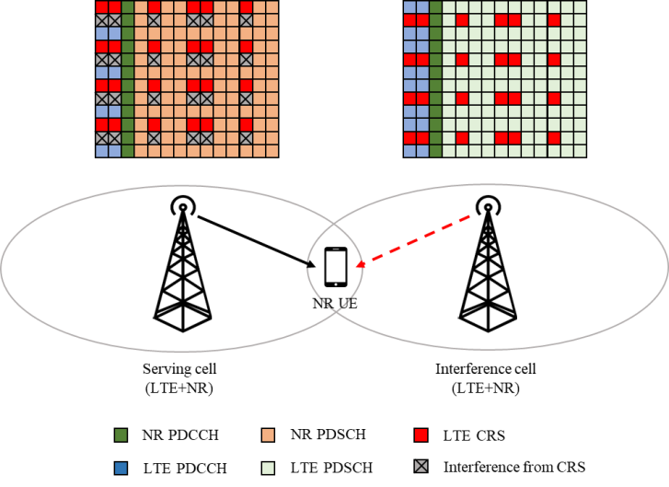 | 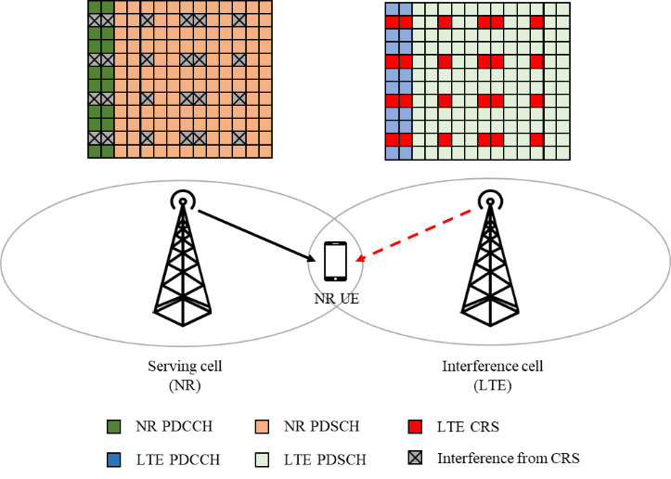
Figure 5.1.1-1. Scenarios for CRS interference in overlapping spectrum for LTE and NR
For the performance evaluation, 15 kHz SCS and synchronous network with 4 CRS ports are assumed in the first phase.

5.1.2 LTE interference model
This subclause provides interference modelling for each explicitly modelled LTE interfering cell in the simulation scenario. The interference modelling methodology and interference profiles from LTE CRS interference mitigation (CRS-IM) for homogenous deployments in [TR 36.863] are reused. INR-i (signal level of the i-th dominant interference over Noc) is used as the interference power measure, and two dominant interferers are explicitly modelled in the simulation.
In each subframe, each interfering cell shall transmit randomly modulated data over the entire PDSCH region and the full transmission bandwidth according to the probabilities of occurrence. Transmitted physical channels shall include PSS, SSS and PBCH. Probabilities of occurrence of LTE PDSCH in each subframe are as specified in clause 5.3. If the probabilities of occurrence in each subframe are not specified in clause 5.3, as default, they are equal to 1.
For each subframe and each CQI subband as defined in subclause 7.2 of [TS 36.213], a transmission rank shall be randomly determined independently from other CQI subbands as well as other interfering cells. Probabilities of occurrence of each possible transmission rank are as specified in clause 5.3.
For each subframe and CQI subband, a precoding matrix for the number of layers associated to the selected rank shall be selected randomly from Table 6.3.4.2.3-1 of [TS 36.211]. Note that codebook index 0 shall be excluded from random precoder selection when the number of layers is .
Precoding for spatial multiplexing with CRS for the number of antenna ports in the simulation scenario shall be applied to 16QAM randomly modulated layer symbols, as specified in subclause 6.3.4.2.1 of [TS 36.211] with the selected precoding matrices for each subframe and each CQI subband.
For unallocated REs in the control region, precoding for transmit diversity for the number of antenna ports in the simulation scenario shall be applied to QPSK randomly modulated layer symbols, as specified in subclause 6.3.4.3 of [TS 36.211]. The EPRE ratio for these REs shall be as defined for PDCCH in Annex C.3.2 of [TS 36.101].
The EPRE ratio of LTE CRS of i-th dominant interferer to NR SSS of serving cell shall be defined as INR-i/SNR, where Noc is same for serving cell and all interfering cells.

5.2 Receiver structure

5.2.1 General
The baseline reference receiver to evaluate the NR performance in scenarios with overlapping spectrum for LTE and NR is MMSE-IRC, which is used to define the minimum demodulation performance requirements in NR. For CRS interference handling, performance is evaluated with two categories of schemes:
1. LTE CRS interference mitigation (CRS-IM)
2. LTE CRS Rate matching (CRS-RM)

5.2.2 Reference receiver of LTE-CRS interference mitigation
For dealing with neighboring LTE CRS interference, two candidate receiver types for CRS-IM are captured in this subclause, and the neighboring cell CRS-IM is used together with LMMSE-IRC for demodulating NR PDSCH.
• CRS interference cancellation (CRS-IC)
- Receiver may reconstruct neighboring LTE CRS interference based on detected neighboring LTE cell(s)’ channel estimation and cancel the interference
∘ May have iteration for multiple strongest neighboring LTE interference cells
• Log-likelihood ratio (LLR) weighting
- Receiver may estimate the power of neighboring LTE CRS interference and apply the weight to the estimated LLRs for REs which occupy with LTE CRS.
In particular, the following CRS-IM receiver assumptions are used for the evaluation:
• Synchronization network deployment is assumed in the first phase.
• Single FFT processing for synchronized network.
• UEs are not restricted to mitigate more than 1 LTE cell’s interference, and this is left up to UE implementation.
• UE with LLR weighting shall meet NR PDSCH processing procedure time requirement defined in TS 38.214 clause 5.3.

5.2.3 LTE cell configuration detection
The performance analysis in the technical report is provided under assumption of with and without the knowledge of the interferer cell(s) CRS configuration.
When the information of the dominant interferer cell CRS is not signaled to the UE by RRC signaling, the UE is expected to blindly detect the LTE cells and decode MIB for LTE cell configuration of the interference cells for LTE CRS-IM. Some UEs may not be capable of blindly detecting such information.

5.3 Link performance characterization

5.3.1 Parameters for link level evaluation

5.3.1.1 General
The link-level simulation assumptions for serving cell PDSCH, interference cells and summary of simulation cases are provided in clause 5.3.1.2, 5.3.1.3 and 5.3.1.4 respectively. Note that these assumptions are used for the performance evaluation in the study phase, and the parameters for performance requirement definition will be discussed separately.

5.3.1.2 Serving cell PDSCH parameters
Simulation assumptions for serving cell PDSCH are captured in Table 5.3.1.2-1.
Table 5.3.1.2-1: Simulation assumptions for NR serving cell PDSCH
Parameter |  | Unit | Value
Channel Bandwidth |  | MHz | 10MHz with full PRB allocation
SCS |  | kHz | 15
Duplex mode |  |  | FDD
MCS |  |  | 4, 13
Antenna configuration |  |  | 4x2, 4x4
HARQ process number |  |  | 4
Number of layers |  |  | 1
PDSCH configuration | Mapping type |  | Type A
 | Starting symbol (S) |  | If Rel-15 or Rel-16 Rate Matching pattern is configured: S = 3, else S =2
 | Length (L) |  | For scenario 1: 9  For scenario 2: L=9, [11] if RM is configured, 12 otherwise.
 | PRB bundling size |  | 2
 | PRB bundling type |  | Static
 | Precoding model |  | Random precoding with Single panel Type 1 per PRB bundling size per slot
 | Overhead for TBS determination |  | If Rel-15 or Rel-16 CRS-RM is configured: 18, else 0
PDSCH DMRS configuration | DMRS Type |  | DMRS Type 1
 | Number of additional DMRS (Note 2) |  | 1
 | Maximum number of OFDM symbols for DL front loaded DMRS |  | 1
 | Number of PDSCH DMRS CDM group(s) without data |  | 1
CRS for rate matching for Scenario 1 (Note 1) | LTE carrier centre subcarrier location |  | Same as NR carrier centre subcarrier location
 | LTE carrier BW | MHz | 10
 | Number of antenna ports |  | 4
 | v-shift |  | 0
SSB position |  |  | First SSB in slot #0 in every 20 ms periodicity that is not scheduled for PDSCH transmission
Propagation conditions and MIMO correlation |  |  | TDLA30-10 ULA Low
Note 1: No MBSFN is configured on LTE carrier
Note 2: The additional DMRS is alternated for scenario 2 rate-matching with L=11

5.3.1.3 Interference cell parameters
Simulation assumptions for interference cell are captured in Table 5.3.1.3-1.
Table 5.3.1.3-1: Simulation assumptions for interference cells parameters
Parameter |  | Value | Interference Cell #1 | Interference Cell #2
Interference power level |  | dB | INR1=10.45dB | INR2=4.6dB
CRS pattern | LTE carrier centre subcarrier location |  | Same as NR serving carrier centre subcarrier location | Same as NR serving carrier centre subcarrier location
 | LTE carrier BW | MHz | 10 | 10
 | Number of antenna ports |  | 4 | 4
 | v-shift |  | 1 | 2
PDSCH loading level |  |  | 20% probability of occurrence of LTE data transmission in time domain, and full bandwidth allocation in frequency domain. | 20% probability of occurrence of LTE data transmission in time domain, and full bandwidth allocation in frequency domain.
Modulation order for interference PDSCH when exists |  |  | 16 QAM randomly modulated symbols | 16 QAM randomly modulated symbols
Time offset |  | us | 3 | -1
Frequency offset |  | Hz | 300 | -100
Transmission rank |  |  | 80% and 20% probability for rank 1 and rank 2 respectively | 80% and 20% probability for rank 1 and rank 2 respectively
Propagation conditions and MIMO configuration (Note 1) |  |  | TDLA30-10 ULA Low | TDLA30-10 ULA Low
Note 1: The channel for interference cells and serving cell are independent.

5.3.1.4 Summary of simulation cases
Simulation results with assumptions listed in Table 5.3.1.2-1 and Table 5.3.1.3-1 for following cases listed in Table 5.3.1.4-1 are captured in clause 5.3.2.
Table 5.3.1.4-1: Summary of simulation cases
Scenario 1 | Reference scheme | Rel-15 serving cell CRS-RM without interference cell CRS handling
 | Scheme #1 | Rel-16 CRS-RM for 1 interference cell (The rate matched CRS is always the first dominant interference)
 | Scheme #2 (Optional) | Rel-16 CRS-RM for 1 interference cell (The rate matched CRS is NOT always the first dominant interference. i.e. 50% probability for rate matching (RM) for the first dominant interference and 50% probability for RM for the second dominant interference)
 | Scheme #3 | Rel-15 RB symbol level CRS-RM for 2 interference cells
 | Scheme #4 | CRS-IC with network assistance
 | Scheme #5 | CRS-IC without network assistance
 | Scheme #6 | LLR weighting with network assistance
 | Scheme #7 | LLR weighting without network assistance
Scenario 2 | Reference scheme | Without interference cell CRS handling
 | Scheme #1 | Rel-15 CRS-RM for 1 interference cell (The rate matched CRS is always the first dominant interference)
 | Scheme #2 (Optional) | Rel-15 CRS-RM for 1 interference cell (The rate matched CRS is NOT always the first dominant interference. i.e. 50% probability for RM for the first dominant cell and 50% probability for RM for the second dominant interference)
 | Scheme #3 | Rel-16 CRS-RM for 2 interference cells
 | Scheme #4 | CRS-IC with network assistance
 | Scheme #5 | CRS-IC without network assistance
 | Scheme #6 | LLR weighting with network assistance
 | Scheme #7 | LLR weighting without network assistance

5.3.2 Link level simulation results

5.3.2.1 General
In this clause link level simulation results from different companies are collected for analysis on UE CRS interference handling for NR UE in scenario with overlapping spectrum for LTE and NR. The link level analysis of NR UE PDSCH performance is performed under assumptions from clause 5.3.1 and presented in clause 5.3.2.1 and 5.3.2.2. Also, this clause contains the analysis from different companies with impact of considered CRS interference handling schemes on LTE UE performance which is presented in clause 5.3.2.3.
The details of NR UE PDSCH performance analysis are presented in the attached file ‘Attachment 2 - R4-2112151_Simulation result collection for CRS interference handling’.

5.3.2.2 NR UE PDSCH performance for Scenario 1
This clause contains the summary of simulation results of link level analysis of NR UE performance for Scenario 1.
Table 5.3.2.1-1 provides the summary of average simulation results from different companies with information about SNR points corresponding to 70% of maximum achievable throughput of Reference scheme. Table 5.3.2.1-2 provides the information about SNR performance difference of different schemes in comparison to Reference scheme for average simulation results.
Table 5.3.2.1-1: Average SNR simulation results for Scenario 1
MIMO | MCS index | Ref scheme | Scheme #1 | Scheme #2 | Scheme #3 | Scheme #4 | Scheme #5 | Scheme #6 | Scheme #7
4Tx 2Rx Low | QPSK MCS4 | 3.3 | 1.6 | 3.3 | 1.7 | -0.1 | 0.2 | 0.6 | -0.4
 | 16QAM MCS13 | 11.2 | 9.9 | 11.7 | 11.2 | 7.8 | 7.7 | 8.9 | 8.3
4Tx 4Rx Low | QPSK MCS4 | -0.2 | -2.0 | -0.5 | -2.1 | -3.4 | -3.4 | -2.5 | -3.9
 | 16QAM MCS13 | 7.4 | 5.9 | 7.6 | 7.0 | 3.8 | 3.7 | 5.4 | 4.4

Table 5.3.2.1-2: SNR performance difference for Scenario 1
MIMO | MCS index | Scheme #1 | Scheme #2 | Scheme #3 | Scheme #4 | Scheme #5 | Scheme #6 | Scheme #7
4Tx 2Rx Low | QPSK MCS4 | 1.7 | 0.0 | 1.6 | 3.3 | 3.1 | 2.7 | 3.7
 | 16QAM MCS13 | 1.3 | -0.5 | 0.0 | 3.4 | 3.4 | 2.3 | 2.9
4Tx 4Rx Low | QPSK MCS4 | 1.8 | 0.2 | 1.9 | 3.2 | 3.2 | 2.2 | 3.7
 | 16QAM MCS13 | 1.5 | -0.2 | 0.5 | 3.6 | 3.7 | 2.1 | 3.0

5.3.2.3 NR UE PDSCH performance for Scenario 2
This clause contains the summary of simulation results of link level analysis of NR UE performance for Scenario 2.
Table 5.3.2.2-1 provides the summary of simulation results from different companies and average results with information about SNR points corresponding to 70% of maximum achievable throughput of Reference scheme. Table 5.3.2.2-2 provides the information about SNR performance difference of different schemes in comparison to Baseline scheme for average simulation results.
Table 5.3.2.2-1: Average SNR simulation results for Scenario 2
MIMO | MCS index | Ref scheme | Scheme #4 | Scheme #5 | Scheme #6 | Scheme #7
4Tx 2Rx Low | QPSK MCS4 | 2.0 | -0.6 | -0.5 | -0.1 | -0.9
 | 16QAM MCS13 | 9.9 | 7.4 | 7.6 | 8.1 | 7.8
4Tx 4Rx Low | QPSK MCS4 | -1.7 | -4.0 | -4.1 | -3.3 | -3.6
 | 16QAM MCS13 | 6.1 | 3.6 | 3.6 | 4.7 | 4.8

Table 5.3.2.2-2: SNR performance difference for Scenario 2
MIMO | MCS index | Scheme #4 | Scheme #5 | Scheme #6 | Scheme #7
4Tx 2Rx Low | QPSK MCS4 | 2.6 | 2.5 | 2.2 | 2.9
 | 16QAM MCS13 | 2.5 | 2.3 | 1.8 | 2.1
4Tx 4Rx Low | QPSK MCS4 | 2.3 | 2.4 | 1.6 | 1.9
 | 16QAM MCS13 | 2.5 | 2.6 | 1.4 | 1.3

For Scenario 2, SNR results and SNR performance difference in comparison to Reference Scheme is not provided for Schemes #1,2 and 3, because per slot TBS values and, as a result, maximum achievable throughput values are different for these schemes.
Table 5.3.2.2-3 provides the information about TBS values for different schemes and different MCSs.
Table 5.3.2.2-3: TBS values for Scenario 2
MCS index | Reference Scheme,  Scheme #4, 5, 6, 7 | Scheme #1, 2, 3
 |  | PDSCH 9 symb | PDSCH 11 symb
QPSK MCS4 | 4096 | 2472 | 3240
16QAM MCS13 | 13064 | 7680 | 10248

5.3.2.4 LTE UE performance
This clause provides the observations and analysis from different companies with performance impact of CRS-RM schemes on LTE UE performance:
• Due to RM applied in interference cells, the CRS REs and data REs under LTE cells will observe different interference level with SINR offset.
- From companies’ analysis:
∘ Based on the INR levels used for RAN4 link-level simulation, for UE at 5% geometry, the delta of SINR observed at CRS RE and data RE is 5.86 dB and 11.75 dB for one dominant interference cell CRS-RM and two interference cell CRS-RM respectively.
- From one company result:
∘ Based on the system level simulation for ISD of 1000m from one company in R4-2115629, the average delta of SINR observed at CRS RE and data RE is ~2.5 dB to ~4.5 dB for one dominant interference cell CRS-RM and two interference cell CRS-RM respectively.
• The interference mismatch among CRS REs and data REs may bring impact on LTE cells considering the following aspects:
- LTE CQI/RI/PMI is computed based on CRS for TM 1-8 and certain configuration of TM9 (when the parameter pmi-RI-Report is not configured by higher layers for TM9).
- CRS is used for LTE PDSCH demodulation processing for TMs 1-6.
- LTE RSSI is measured only from OFDM symbols containing CRS port 0 of measurement subframes unless indicated otherwise by higher layers, and it can be measured from all OFDM symbols of the DL part of measurement/indicated subframes if indicated by higher layers. LTE RSRQ is calculated based on RSRP and RSSI.
The following NW implementation solutions were provided by one company to address above LTE cell impact and the feasibility of such solutions from network implementation perspective needs further discussion:
• Transmit signal energy in rate-matched REs on top of rate matching. This signal energy could be NZP CSI-RS, random data, copy of PDSCH data or some other signal.

5.3.3 Summary of link level evaluation
According to the PDSCH link-level simulation results for 15 kHz SCS and synchronous network in clause 5.3.2, RAN4 initial observations are as follows:
• CRS-IC with the assumption of NW signaling can achieve better performance compared to RM scheme 1.
• CRS-IC without NW assistant signaling achieve similar or lower performance compared to CRS-IC schemes with the assumption of NW signalling.
• LLR weighting with the assumption of NW signaling can achieve better or similar performance compared to RM scheme 1.
• LLR weighting without NW assistant signaling achieve similar or lower performance compared to LLR weighting with the assumption of NW signalling.
• Note: RM scheme 1 is under the assumption that RM always applied for the strongest interference cell.
In addition, due to RM applied in interference cells, the CRS REs and data REs under LTE cells will observe different interference level with SINR offset. The interference mismatch among CRS REs and data REs may bring impact on LTE cells considering the LTE CQI/RI/PMI reporting, PDSCH demodulation and RSSI/RSRQ measurement. NW implementation solutions were provided by one company to address LTE cell impact and the feasibility of such solutions from network implementation perspective needs further discussion.

6 Conclusions

6.1 Conclusion on inter-user interference suppression for MU-MIMO scenario
This technical report has documented the RAN4 evaluation on techniques to cope with downlink intra-cell inter-user interference. The major work includes the determination of network scenario, interference modelling, interference suppressing receiver structure, link-level simulation parameters and performance evaluations.
MU-MIMO scenario with gNB transmits PDSCH to the paired UEs through the same time-frequency resources is evaluated.
gNBs equipped with 2Tx and 4Tx antennas are considered in the RAN4 performance evaluation. However, for the UEs capable of inter-user interference suppression ability discussed in this TR, they can also be used in the deployments with larger number of Tx ports configuration. 2 paired UEs are considered, and both rank 1 and rank 2 for the target UE and co-scheduled UE are covered in the evaluation.
Random precoder selection is applied for the target UE, and both orthogonal and random co-scheduled UE precoder selection methods are considered.
Under the scenario that rank 1 transmission is scheduled to the target and the co-scheduled UEs, both same and different CDM group configuration for the target and the co-scheduled UEs’ DMRS are considered.
Both TDLA30-10 and TDLC300-100 channel models with ULA Low antenna correlation is considered as the propagation condition.
MMSE-IRC receiver without network assistance signalling is considered as the reference receiver structure. DMRS based interference covariance estimation is assumed.
For UE PDSCH parameters, 10 MHz CBW with 15kHz for FDD is included in the evaluation.
Under the scenario that rank 1 transmission is scheduled to the target UE, both MCS 4 and MCS 13 transmission is considered. Under the scenario that rank 2 transmission is scheduled to the target UE, both MCS 13 and MCS 19 transmission is considered.
PDSCH link-level simulations are performed to evaluate the performance gain of MMSE-IRC processing over the baseline MMSE-MRC processing under intra-cell inter-user interference scenario. 48 simulation cases with different antenna and rank configurations for target and interference UEs, different antenna correlation, different duplex modes and CBW configurations are included. The simulation results can be summarized as follows:
• It is observed that MMSE-IRC receiver achieves performance gain over the baseline MMSE-MRC receiver, in the simulation with rank 1+1, 2T2R MIMO configuration.
• Except for the case with MCS 4 and DMRS with same CDM group, it is observed that MMSE-IRC receiver achieves performance gain over the baseline MMSE-MRC receiver, in the simulation with rank 1+1, 2T4R MIMO configuration.
• It is observed that MMSE-IRC receiver achieves performance gain over the baseline MMSE-MRC receiver, in the simulation with rank 2+1 and rank 2+2, under 4T4R MIMO configuration.
• For all test cases with rank 1+1, the average performance gain with the assumption of DMRS with different CDM group is similar with the average performance gain with the assumption of DMRS with same CDM group.
Based on the above evaluations, it is recommended to define NR PDSCH demodulation requirements for inter-user interference suppression receiver for MU-MIMO scenario in Rel-17.

6.2 Conclusion on CRS interference handling in scenarios with overlapping spectrum for LTE and NR
This technical report has documented the RAN4 evaluation on techniques to cope with CRS interference in scenarios with overlapping spectrum for LTE and NR. The major work includes the determination of typical network scenarios, interference models and interference profiles, definition of reference receiver structures, and link-level performance evaluations.
Two typical network scenarios, including scenario 1 with LTE/NR DSS and scenario 2 with NR/LTE deployed in neighbouring BSs/areas, are covered. 15 kHz SCS and synchronous network are assumed in the phase I evaluation.
The inter-cell interference modelling methodology and interference profiles from LTE CRS-IM receiver in homogenous deployments are reused. INR-i (signal level of the i-th dominant interference over N_{oc}) is used as the interference power measure, and two dominant interferers are explicitly modelled in the simulation.
The MMSE-IRC receiver is used to suppress the inter-cell interference for the reference scheme without interference cell CRS handling and the CRS-RM schemes. Three different CRS-RM schemes, including CRS-RM for 1 interference cell always with the strongest interference, CRS-RM for 1 interference cell not always with the strongest interference (optional), and CRS-RM for 2 strongest interference cells, are evaluated.
For CRS-IM schemes, interference cell CRS-IM is used together with MMSE-IRC receiver, and CRS-IC and LLR weighting are considered as two different implementations of CRS-IM.
PDSCH link-level simulations are performed to evaluate the performance gain of CRS-RM and CRS-IM schemes over the reference scheme without interference cell CRS handling. 8 simulation cases with different network scenarios, Rx antenna numbers and MCS levels are included, and 7 CRS interference handling schemes in addition to the reference scheme are evaluated for each simulation case. RAN4 initial observations from link-level evaluation results for 15 kHz SCS and synchronous network:
• CRS-IC with the assumption of NW signaling can achieve better performance compared to RM scheme 1.
• CRS-IC without NW assistant signaling achieve similar or lower performance compared to CRS-IC schemes with the assumption of NW signalling.
• LLR weighting with the assumption of NW signaling can achieve better or similar performance compared to RM scheme 1.
• LLR weighting without NW assistant signaling achieve similar or lower performance compared to LLR weighting with the assumption of NW signalling.
• Note: RM scheme 1 is under the assumption that RM always applied for the strongest interference cell.
In addition, due to RM applied in interference cells, the CRS REs and data REs under LTE cells will observe different interference level with SINR offset. The interference mismatch among CRS REs and data REs may bring impact on LTE cells considering the LTE CQI/RI/PMI reporting, PDSCH demodulation and RSSI/RSRQ measurement. NW implementation solutions were provided by one company to address LTE cell impact and the feasibility of such solutions from network implementation perspective needs further discussion.
Based on these evaluations, it is recommended to define NR PDSCH demodulation requirements for neighbouring cell LTE CRS-IM in scenarios with overlapping spectrum for LTE and NR in Rel-17:
• Use LLR weighting as baseline reference receiver, and further discuss the feasibility of CRS-IC receiver taking into account the UE complexity and PDSCH processing time.
• Synchronous network scenario is prioritized. The asynchronous network scenario will be discussed after RAN #93e meeting.
• 15 kHz SCS for NR is prioritized. The 30 kHz SCS scenario will be discussed after RAN #93e meeting.
• RAN4 will further discuss the necessity of network assistance signaling and UE capability signaling during requirements definition phase.

Annex A:
Change history
Change history
Date | TSG # | TSG Doc. | CR | Rev | Subject/Comment | Old | New
2021-04 | RAN4 #98e-bis | R4-2104952 |  |  | TR skeleton |  | 0.0.1
2021-09 | RAN4 #100-e | R4-2112224 |  |  | Implemented the following TPs approved at RAN4 #100-e:  R4-2115739, TP to TR 38.833 Scenario for LTE CRS interference handling for NR UE, MediaTek  R4-2115742, TP to TR 38.833: Interference Modeling for LTE CRS-IM, Qualcomm  R4-2115737, TP to TR 38.833: Receiver structure for CRS-IM performance, Ericsson  R4-2115738, TP: Introduction of simulation assumptions for CRS-IM receiver, Huawei, HiSilicon  R4-2115736, TP to TR 38.833: Link level simulation results for LTE CRS interference handling for NR UE, Intel Corporation  R4-2115735, TP to TR 38.833: Summary of link level evaluation and conclusion for CRS-IM, China Telecom  Editorial modifications | 0.0.1 | 0.1.0
2021-11 | RAN4 #101-e | R4-2117189 |  |  | Implemented the following TPs approved at RAN4 #101-e:  R4-2120710, TP to TR 38.833: Interference Modeling for intra-cell inter-user interference, Apple  R4-2120711, TP to TR 38.833: Summary of link level evaluation for inter-user interference suppression for MU-MIMO, CMCC  R4-2120712, TP to TR 38.833: Link level simulation results for inter-user interference suppression for MU-MIMO, Intel Corporation  R4-2120713, draftTP to TR38.833: receiver structure for intra-cell inter-user IRC, Ericsson  R4-2120714, TP to TR 38.833: Conclusion for phase I evaluation on inter-user interference suppression for MU-MIMO scenario, China Telecom  R4-2120715, TP: Introduction of simulation assumptions for intra cell inter user MMSE-IRC receiver, Huawei, HiSilicon  R4-2120716, TP to TR 38.833 Scenario for inter-user interference suppression for MU-MIMO, MediaTek inc. | 0.1.0 | 0.2.0
2021-12 | RAN #94-e | RP-212947 |  |  | Presented at RAN#94e for information. | 0.2.0 | 1.0.0
2021-12 | RAN #94-e | RP-213465 |  |  | Editorial corrections | 1.0.0 | 1.0.1
2022-01 | RAN4 #101-e-bis | R4-2200017 |  |  | Implemented the following TPs approved at RAN4 #101-e-bis:  R4-2200018, TP to TR 38.833: Symbols and abbreviations, China Telecom  R4-2203007, TP to TR 38.833: Link level simulation results for Inter-user interference suppression for MU-MIMO, Intel Corporation  R4-2200807, TP to TR 38.833: Summary of link level evaluation for inter-user interference suppression for MU-MIMO, CMCC  R4-2200904, TP to TR 38.833: Updated conclusion for phase I evaluation on inter-user interference suppression for MU-MIMO scenario, China Telecom  R4-2200989, TP to TR 38.833: Introduction of simulation assumptions of intra cell inter user MMSE-IRC receiver, Huawei, HiSilicon  R4-2200380, TP to TR 38.833: Scenario for inter-user interference suppression for MU-MIMO, MediaTek inc.  Editorial modifications | 1.0.1 | 1.1.0
2022-03 | RAN4 #102-e | R4-2207241 |  |  | Implemented the following TPs approved at RAN4 #102-e:  R4-2203768, TP to TR 38.833: MU-MIMO-Receiver structure, Apple  R4-2207249, TP to TR 38.833: Link level simulation results for Inter-user interference suppression for MU-MIMO, Intel Corporation | 1.1.0 | 1.2.0

