3GPP TSG-RAN WG4 Meeting # 102-e R4-22XXXXX

Electronic Meeting, February 21 – March 3, 2022

Agenda item: 4.1.8.1, 4.1.8.2, 4.2.4.1, 5.1.1.4, 5.1.2.2, 5.1.5.4.1, 5.1.5.4.2, 6.2.4
Source: Moderator (Apple)
Title: Email discussion summary for [102-e][317] Demod_Maintenance_UE
Document for: Information

Introduction
In this email thread for UE Demod Maintenance, the following topics will be covered:
- Rel-15 NR and LTE UE Demodulation and CSI requirements maintenance (4.1.8.1, 4.1.8.2, 4.2.4.1)
- Rel-16 NR UE Demodulation and CSI requirements maintenance (5.1.1.4, 5.1.2.2, 5.1.5.4.1, 5.1.5.4.2, 6.2.4)

Topic #1: Rel-15 NR and LTE UE Demodulation and CSI requirements maintenance

Companies’ contributions summary
T-doc number | Company | Proposals / Observations
NR
R4-2205100 | Ericsson | draft CR: Correction of TBS for CQI reporting tests  TBS changed from 14343 to 14344 in CSI RMC Table A.4-1
R4-2205101 | Ericsson | draft CR: Correction of TBS for CQI reporting tests  Cat-A CR
R4-2205102 | Ericsson | draft CR: Correction of TBS for CQI reporting tests  Cat-A CR
R4-2205779 | Huawei,HiSilicon | CR:Updates to test setup for PDSCH and PDCCH requirements in TS 38.101-4 (Rel-15)  - Change the antenna configuarion from 4x4 to 2x4 in Table 5.2.3.1.2-3.  - Add the clarification of PDCCH DMRS mapping type in Table 5.3.1 and Table 7.3.1  - Add the row index according to the agreed simulation assumptions to the common parameters table for PDSCH demodulation requirments.
R4-2205780 | Huawei,HiSilicon | CR:Updates to test setup for PDSCH and PDCCH requirements in TS 38.101-4 (Rel-16)  Cat-A CR
R4-2205781 | Huawei,HiSilicon | CR:Updates to test setup for PDSCH and PDCCH requirements in TS 38.101-4 (Rel-17)  Cat-A CR
R4-2205782 | Huawei,HiSilicon | CR:Updates to test setup for CSI requirements in TS 38.101-4 (Rel-15)  Change the antenna configuration from 8x4 to 4x4 for 4TX PMI reporting test in FDD
R4-2205783 | Huawei,HiSilicon | CR:Updates to test setup for CSI requirements in TS 38.101-4 (Rel-16)  Cat-A CR
R4-2205784 | Huawei,HiSilicon | - CR:Updates to test setup for CSI requirements in TS 38.101-4 (Rel-17)  - Cat-A CR
LTE
R4-2203617 | Rohde & Schwarz | Correction to Cat1bis RMCs  Update Note 4 to add R.86 in Table A.3.4.3.2-1: Fixed Reference Channel for CDM-multiplexed DM RS
R4-2203618 | Rohde & Schwarz | Correction to Cat1bis RMCs  Cat-A CR
R4-2203619 | Rohde & Schwarz | Correction to Cat1bis RMCs  Cat-A CR
R4-2203620 | Rohde & Schwarz | Correction to Cat1bis RMCs  Cat-A CR
R4-2205785 | Huawei,HiSilicon | CR: Updates to NPDSCH repetition number for LTE NPDSCH requirements with multi-TB interleaved transmission (Rel-16)  Change the repetition number from 1 to 32 in Table 8.12.1.1.4-2  Moderator: TDoc reserved as discussion paper not draftCR
R4-2205786 | Huawei,HiSilicon | CR: Updates to NPDSCH repetition number for LTE NPDSCH requirements with multi-TB interleaved transmission (Rel-17)  Cat-A CR

Open issues summary
None

Companies views’ collection for 1st round

Open issues
None

CRs/TPs comments collection
CR/TP number | Comments collection
R4-2205100 (Ericsson) | Apple: Okay with the change
 | Anritsu: Confirmed the value matched with our calculation.
R4-2205779 (Huawei) | Qualcomm: Can Huawei further explain why Change #2 for PDCCH DMRS mapping is needed? It doesn’t seem to provide any new information. Also, please correct the row indices in the reason for change # 3 in CR cover sheet.
 | Apple: Same question as Qualcomm. Not sure why the PDCCH DMRS mapping is needed.
Anritsu: Regarding Change #2, may I suggest simply specifying the reference of TS38.211 cl.7.4.1.3 in Table 5.3-1 and Table 7.3-1? Like “As defined in TS 38.211 7.4.1.3 [9].”
Also typo can be seen with the spec number on the coversheet. (Now shown as 38.104 instead of 38.101-4)
Huawei: @Qualcomm, Apple and Anritsu. Tanks for the comments.
Based on the descrption in clause 7.4.1.3 in TS 38.211, PDCCH DMRS resource allocation depends on the precoder granularity. The current paramters table only provide precoder granularity of 2TX. Therefore, the it is not clear how to map PDCCH DMRS for 1TX. In order to make it more clear, we propose to add a separate parameter such as PDCCH DMRS mapping to clarify it.
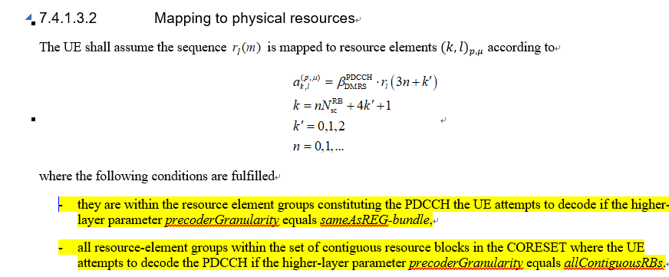
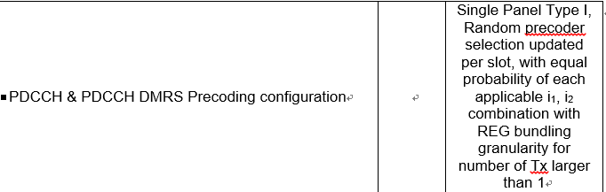
As for other comments, we will correct it and revised version is needed.
Moreover, we just find that the brackets for requirements of PDSCH Mapping Type B and UE processing capability 2 in Table 5.2.2.1.7-3 and Table 5.2.3.1.7-3 are still existing. We propose to remove it in this CR.

R4-2205782 (Huawei) | Qualcomm: Thank you for providing this CR. Can you please also correct (N1,N2) to (2,1)?
 | Apple: The table 6.3.3.2.1-1seems to be repeated. Suggest to delete the first table as it seems to be for FDD. The parameters in the 2nd part seem to be all correct. We can keep that part of the table without further revisions.
 | Anritsu: Typo with the spec number on the coversheet. (Now shown as 38.104 instead of 38.101-4.)
R4-2203617 (R&S) | Apple: Okay with the change
 | Company B:
R4-2205785 (Huawei) | Moderator: TDoc reserved as discussion paper not draft CR
 | Huawei: Thanks for your correction. Maybe revised Tdoc number is needed in the 2nd round.
 | Qualcomm: Can Huawei provide the tdoc reference for the agreed simulation assumptions?
Huawei: @Qualcomm: Please refer to R4-2008759
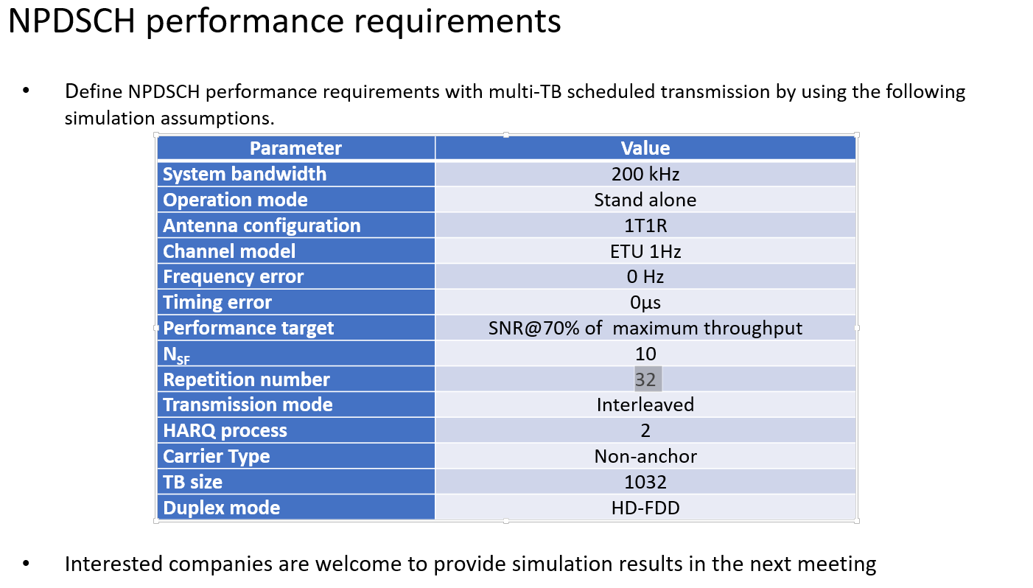

Summary for 1st round

Open issues
None

CRs/TPs
Moderator tries to summarize discussion status for 1st round and provides recommendation on CRs/TPs Status update
Note: The tdoc decisions shall be provided in Section 3 and this table is optional in case moderators would like to provide additional information.
CR/TP number | CRs/TPs Status update recommendation
XXX | Based on 1st round of comments collection, moderator can recommend the next steps such as “agreeable”, “to be revised”

Discussion on 2nd round (if applicable)

Topic #2: Rel-16 NR UE Demodulation and CSI requirements maintenance

Companies’ contributions summary

TDoc# | Company | Proposals / Observations
NR-U
R4-2205957 | Apple | Editorial CR for NR-U demod requiremetns for 2RX  Moved 5.2.2.2.15 under 5.2.2.2 from 5.2.2.1
R4-2205911 | MediaTek inc. | Draft CR to TS38.101-4, Correction the misalignment for subsection 5.2.2.2.15 in Rel-16 and Rel-17  1) Place the subsetction 5.2.2.2.15 under section 5.2.2.2
eMIMO
R4-2205909 | MediaTek inc. | Draft CR to TS38.101-4, Correction to reference channels for PDSCH requirements with single-DCI based FDM Scheme A (Rel-16)  - Remove the redundant ‘space’ for for refrence channel R.PDSCH.1-2.6 FDD, R.PDSCH.2-2.6 TDD, R.PDSCH.1-2.6 FDD, R.PDSCH.2-1.3 TDD, R.PDSCH.2-2.6 TDD  - Modify some values for R.PDSCH.1-2.5 FDD in Table A.3.2.1.1  - Fix the typo for “tapped delay line”
R4-2205910 | MediaTek inc. | Draft CR to TS38.101-4, Correction to reference channels for PDSCH requirements with single-DCI based FDM Scheme A (Rel-17)  Cat-A CR
R4-2205746 | Huawei,HiSilicon | Draft CR on correction to eMIMO FRC (TS38.101-4, Rel-16)  For FRC correction, update Table A.3.2.1.1-2.  Moderator: TDoc reserved as discussion paper not draftCR
R4-2205747 | Huawei,HiSilicon | Draft CR on correction to eMIMO FRC (TS38.101-4, Rel-17)  Cat-A CR  Moderator: TDoc reserved as discussion paper not draftCR
PDSCH CA
R4-2205572 | China Telecom | Draft CR on removing square brakets for CA demodulation test requirements (Rel-16)  Remove the square brakets on all the CA demodulation test requirements for FR1 and FR2 tests.
R4-2205573 | China Telecom | Draft CR on removing square brakets for CA demodulation test requirements (Rel-17)  Cat-A CR
R4-2205740 | Huawei,HiSilicon | Draft CR on correction to test applicability reference for CA performance requirements (TS38.101-4, Rel-16)  There is wrong reference to the applicability rule for normal CA performance requirements. For correcting clause reference, update clause 5.2A.2.1 and 5.2A.3.1.  Moderator: TDoc reserved as discussion paper not draftCR
R4-2205741 | Huawei,HiSilicon | Draft CR on correction to test applicability reference for CA performance requirements (TS38.101-4, Rel-17)  Cat-A CR  Moderator: TDoc reserved as discussion paper not draftCR
R4-2206118 | Qualcomm Incorporated | Draft CR on PDSCH CA requirements  [] are removed for FR1 4Rx CA and FR2 CA PDSCH requirements.
R4-2206122 | Qualcomm Incorporated | Draft CR on PDSCH CA requirements  Cat-A CR
HST-DPS
R4-2205742 | Huawei,HiSilicon | Draft CR on update on HST DPS channel model (38.101-4, Rel16)  For channel model correction, update clause B.3.3.  Moderator: TDoc reserved as discussion paper not draftCR
R4-2205743 | Huawei,HiSilicon | Draft CR on update on HST DPS channel model (38.101-4, Rel17)  Cat-A CR  Moderator: TDoc reserved as discussion paper not draftCR
R4-2206124 | Qualcomm Incorporated | Draft CR on corrections for HST DPS channel model  Corrected the visibility of RRH and clarified the purpose of two figures in Doppler shift figures.
R4-2206128 | Qualcomm Incorporated | Draft CR on corrections for HST DPS channel model  Cat-A CR
UE PS
R4-2205744 | Huawei,HiSilicon | Draft CR on updating to power saving requirements (TS38.101-4, Rel-16)  For removing square brackets, update clause 5.3.2.1.3 – UE power saving requiremetns.  Moderator: TDoc reserved as discussion paper not draftCR
R4-2205745 | Huawei,HiSilicon | Draft CR on updating to power saving requirements (TS38.101-4, Rel-17)  Cat-A CR  Moderator: TDoc reserved as discussion paper not draftCR

Open issues summary
None

Companies’ views collection for 1st round

Open issues
None

CRs/TPs comments collection

CR/TP number | Comments collection
NR-U
R4-2205957 (Apple) | Company A:
 | Company B:
R4-2205911  (MediaTek) | Qualcomm: It has same correction as in R4-2205957. We suggest to merge this with R4-2205957. Also, “Clauses Affected” section in CR cover sheet is incorrect.
 | Apple: Can it be merged with our CR (R4-2205957)?
 | MediaTek: Thanks for the correction from QC. We are OK to be merged with Apple’s CR (R4-2205957).
eMIMO
R4-2205909  (MediaTek) | Apple: Okay with changes.
 | Company B:
R4-2205746  (Huawei) | Moderator: TDoc reserved as discussion paper not draft CR
 | Huawei: Thanks for your correction. Maybe revised Tdoc number is needed in the 2nd round.
 | Ericsson: The correction is included in R4-2205909. We propose to merge to R4-2205909.
 | Qualcomm: We have same comments as Ericsson and prefer to merge it with R4-2205909.
Apple: Same comments as Ericsson and Qualcomm.
Huawei: Fine for us.
PDSCH CA
R4-2205572  (China Telecom) | Apple: We suggest to merge some changes in R4-2205740 into this CR.  Note 1 in minimum performance tables.
 | Company B:
R4-2205740  (Huawei) | Moderator: TDoc reserved as discussion paper not draft CR
 | Huawei: Thanks for your correction. Maybe revised Tdoc number is needed in the 2nd round.
 | Ericsson: Correction is ok. We suggest to merge to R4-2205572 because of the same correcion.
Qualcomm: Same comment as Ericsson.
Apple: Can be merged with R4-2205572.
Huawei: R4-2205740 is NOT related to same part with R4-2205572 or R4-2206118.
- R4-2205572 (China Telecom): Removing square brackets (Section 5 and 7).
- R4-2205740 (Huawei): Correction wrong reference.
- R4-2206118 (Qualcomm): Removing square brackets (Section 5).
We think it is berrer to merge R4-2206118 into R4-2205572, but R4-2205740 has different updated contents. It is reasonable to agree this CR directly to avoid any unnecessary merge work.
R4-2206118  (Qualcomm) | Ericsson: Correction is ok. We suggest to merge to R4-2205572 because of the same correcion.
 | Qualcomm: We are ok with Ericsson’s suggestion.
 | Apple: Can be merged with R4-2205572.
HST-DPS
R4-2205742  (Huawei) | Moderator: TDoc reserved as discussion paper not draft CR
 | Huawei: Thanks for your correction. Maybe revised Tdoc number is needed in the 2nd round.
 | Ericsson: Correction is ok. We suggest to merge to R4-2206124 because of the same correcion.
Qualcomm: Same comment as Ericsson.
Apple: Same comments as Ericsson and Qualcomm.
Huawei: Fine for us.
R4-2206124  (Qualcomm) | Apple: Ok with change.
 | Company B:
UE PS
R4-2205744  (Huawei) | Moderator: TDoc reserved as discussion paper not draft CR
 | Huawei: Thanks for your correction. Maybe revised Tdoc number is needed in the 2nd round.
 | Company B:

Summary for 1st round

Open issues
None

CRs/TPs
Moderator tries to summarize discussion status for 1st round and provided recommendation on CRs/TPs Status update suggestion
CR/TP number | CRs/TPs Status update recommendation
XXX | Based on 1st round of comments collection, moderator can recommend the next steps such as “agreeable”, “to be revised”

Discussion on 2nd round (if applicable)
Moderator can provide summary of 2nd round here. Note that recommended decisions on tdocs should be provided in the section titled ”Recommendations for Tdocs”.

Recommendations for Tdocs

1st round
New tdocs
Title | Source | Comments
WF on … | YYY
LS on … | ZZZ | To: RAN_X; Cc: RAN_Y

Existing tdocs
Tdoc number | Title | Source | Recommendation | Comments

Notes:
- Please include the summary of recommendations for all tdocs across all sub-topics incl. existing and new tdocs.
- For the Recommendation column please include one of the following:
  - CRs/TPs: Agreeable, Revised, Merged, Postponed, Not Pursued
  - Other documents: Agreeable, Revised, Noted
- For new LS documents, please include information on To/Cc WGs in the comments column
- Do not include hyper-links in the documents

2nd round

Tdoc number | Title | Source | Recommendation | Comments
R4-210xxxx | CR on … | XXX | Agreeable, Revised, Merged, Postponed, Not Pursued
R4-210xxxx | WF on … | YYY | Agreeable, Revised, Noted
R4-210xxxx | LS on … | ZZZ | Agreeable, Revised, Noted

Notes:
- Please include the summary of recommendations for all tdocs across all sub-topics.
- For the Recommendation column please include one of the following:
  - CRs/TPs: Agreeable, Revised, Merged, Postponed, Not Pursued
  - Other documents: Agreeable, Revised, Noted
- Do not include hyper-links in the documents

Annex
Contact information
Company | Name | Email address
Ericsson | Kazuyoshi Uesaka | kazuyoshi.uesaka@ericsson.com
Qualcomm | Gaurav Nigam | gnigam@qti.qualcomm.com
Apple | Manasa Raghavan | Manasa.raghavan@apple.com
Anritsu | Osamu Yamashita | Osamu.Yamashita@anritsu.com
MediaTek | Licheng Lin | licheng.lin@mediatek.com

Note:
- Please add your contact information in above table once you make comments on this email thread.
- If multiple delegates from the same company make comments on single email thread, please add you name as suffix after company name when make comments i.e. Company A (XX, XX)

