3GPP TSG-RAN WG4 Meeting #102-e R4-2207267

Electronic meeting, Feb 21st – March 3rd , 2022

Source: UIC, Ericsson, Nokia
Title: TP 900MHz RMR band – BS RF
Agenda item: 9.4.3
Document for: Approval

Introduction
The 900MHz NR band for European RMR WI has been approved (revisions in RAN#92e meeting) to enable the use of RMR 900MHz band with 3GPP 5G NR technology.
Following the discussion in RAN4#101-e/RAN4#101-bis-e meeting, this contribution is addressing the subject of maximum gain, encompassing the consideration of feeder loss, and further coupling losses impacting the BS RF conducted requirements applicable for the use of RMR900 spectrum. The scope of references will be enlarged by ECC Report 318 [2] and CEPT Report 76 [3]. Both reports are used as the basis for ECC Decision (20)02 [1].
Infrastructure managers considers to re-use present GSM-R site infrastructure. The maximum gain encompassing antenna gain and others, e.g., feeder loss will impact ISD and can significantly increase the amount of investments especially in large countries. Such investments are then made by taxpayers.
Hence, certain flexibility need to be envisaged for potential deployment scenarios for railway lines. The use of fixed antenna gain may cause confusions using such wording.

ECC

Discussion
Infrastructure managers in Europe will consider various antenna types depending on the deployment scenario and corresponding losses. For the examination of e.g. ECC Decision OBUE E.I.R.P limits and the use of BS Category B applicable to Europe, a maximum gain needs to be considered rather than a fixed antenna gain.
The antenna gain of 17dBi corresponds to ECC Report 318 table 5 but internal losses in ECC Report 318 are considered and agreed as 4dB.
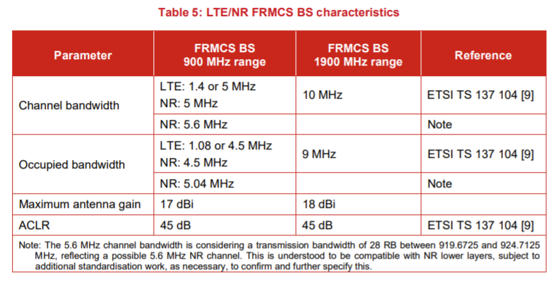
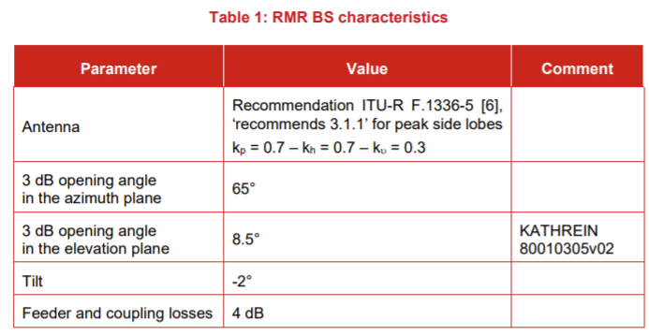
The resulting maximum gain applicable for RMR900 yields to 13 dB.
Observation 1: For BS operating in band n100, the BS rated output power P_{rated,c,AC} should not exceed (64.5 - GmaxRMR900/5MHz + (f_{DL} - 922.1) × 40/3 dB) (assuming certain antenna gain and losses).
Observation 2: The maximum gain may vary depending on the deployment scenario e.g. flat surface, hilly terrain or tunnel. In this context, the assumption of the maximum gain requires further clarification.

Conclusion
In this contribution, the context of maximum gain based on ECC Report 318 are further studied which will require revision of the corresponding clauses in 3GPP TR 38.853.
The following proposals are made :
Proposal 1: To allow the necessary flexibility for deployment along railway lines it is proposed to use the term of “maximum gain” (defined as antenna gain and losses) instead of “antenna gain”.
Proposal 2: Accordingly the approach in TR 38.853 need to be revised.
Proposal 3: Capture the revisions in CRs applicable for band n100 in 3GPP TS 38.104.

References
- ECC Decision(20)02, Harmonised use of the paired frequency bands 874.4-880.0 MHz and 919.4-925.0 MHz and of the unpaired frequency band 1900-1910 MHz for Railway Mobile Radio (RMR), 20 November 2020
- ECC Report 318, Compatibility between RMR and MFCN in the 900 MHz range, the 1900-1920 MHz band and the 2290-2300 MHz band
- CEPT Report 76, Report from CEPT to the European Commission in response to the Mandate on spectrum for the future railway mobile communications system, Report B: EU-harmonised technical conditions for the future railway mobile radio communications system (Task 5)

Annex TP to introduce maximum gain

***********************************************1st Change******************************************

7.1.1 General
According to ECC Decision (20)02 [1], the BS RF work for RMR900 is limited to the Wide Area Base Stations, determined by the use along railway lines and their corresponding characteristics defined by 3GPP TS 38.104 [4].
In accordance to ECC Decision 20(02) [1], the related studies es were done for the non-AAS BS architectures, defined in 3GPP TS 38.104 [4]. Therefore the RAN4 requirements derivation was limited to the BS type 1-C requirements, only.
As the EIRP limits were defined in the ECC Decision (20)02 [1], consideration of non-AAS BS architecture required to convert those EIRP limits into the conducted requirements assuming a maximum gain that can vary depending on the used antenna and related antenna gain as well as the potential losses, e.g., feeder. In the present consideration an antenna gain of 17 dBi and 4 dB losses are assumed in accordance to ECC Report 318 [xx] resulting to a maximum gain value of G_{maxRMR900} = 13 dBi. Other assumptions may lead to other maximum gain values and conducted requirements.

***********************************************2nd Change******************************************

7.1.2.1 BS maximum output power
Based on ECC Decision (20)02 [1], the BS maximum output power for BS operating in band n100 applicable for [uncoordinated deployment], should not exceed the P_{rated,c,AC} derived based on table 4.3.1-1 EIRP limits, with the assumption of a maximum gain value of the BS GmaxRMR900 as:
(64.5 – G_{maxRMR900}) dBm / 5 MHz + (f_{DL}-922.1) x 40/3 dB = 51.5 dBm/5MHz + (f_{DL} - 922.1) × 40/3 dB,
where G_{maxRMR900} is the maximum gain (antenna gain and losses) for RMR900 BS consideration.

***********************************************3rd Change******************************************

7.1.2.1.2 OBUE
Emission mask of the OBUE Cat B Option 2 limits in 3GPP TS 38.104 [4] applicable to Europe was compared to the one derived from ECC Decision (20)02 [1], in order to verify the need for additional RMR-specific OBUE requirement introduction.
The following was observed:
- Both masks were derived with different measurement bandwidths;
- Emission limits comparison (after measurement bandwidths scaling) revealed that the existing OBUE Cat B Option 2 mask is more stringent only for part of the Δf offset range (Δf < 0.2 MHz).
Based on the above motivation the following OBUE requirement are necessary for band n100 in 3GPP TS 38.104 [4], based on conversion of the EIRP limits from ECC Decision (20)02 [1], as summarized in table 7.1.2.1.2-1. The requirement is derived based on table 4.3.1-4, with the assumption of a maximum gain value of the BS G_{maxRMR900}:
- Table 7.1.2.1.2-1: OBUE requirement derivation for n100
- Frequency offset of measurement filter -3dB point, Δf | - Frequency offset of measurement filter centre frequency, f_offset | - Basic limits (NOTE) | - Measurement bandwidth
0 MHz ≤ Δf < 0.2 MHz | 0.1 MHz ≤ f_offset < 0.3 MHz | 19.5 dBm | 200 kHz
0.2 MHz ≤ Δf <  1 MHz | 0.6MHz ≤ f_offset <  1.4 MHz | 1 dBm | 800 kHz
1 MHz ≤ Δf ≤ 10 MHz | 1.5 MHz ≤ f_offset < 10.5 | -8 dBm | 1 MHz
NOTE: Assuming 13 dBi maximum gain (antenna gain and losses) for G_{maxRMR900}.

***********************************************4th Change******************************************

7.1.2.1.3 Tx spurious emissions
The following Tx spurious emission requirements are considered for band n100 in 3GPP TS 38.104 [x], based on conversion of the EIRP limits from ECC Decision (20)02 [1], as summarized in table 7.1.2.1.3-1:
- Table 7.1.2.1.3-1: Additional Tx spurious emissions requirement derivation for n100
- Spurious frequency range | - Basic limit | - Measurement bandwidth
880 MHz – 915 MHz | - 49 - G_{maxRMR900} = - 62 dBm (NOTE) | 5 MHz
NOTE: Assuming 13 dBi maximum gain (antenna gain and losses) for G_{maxRMR900}.

*********************************************End of Changes******************************************

