3GPP TSG-RAN WG4 Meeting # 102-e R4-21XXXXX
Electronic Meeting, 21 February – 3 March 2022

Agenda item: 11.4.1, 11.4.2, 11.4.3, 11.4.4, 11.4.5, 11.4.6
Source: Moderator (Qualcomm Incorporated)
Title: Email discussion summary for [102-e][141] FS_NR_Opt_pi2BPSK
Document for: Information

1.0 Introduction
In this paper, RAN4 will treat the SI ‘Optimizations of pi/2 BPSK uplink power in NR’ in Rel-17.
Suggested email discussion for 1st round is as follows:
- 1st round: RAN4 to discuss:

  - Topic #1-1: Power boost
  - Topic #1-2: MPR
  - Topic #1-3: General and workplan

Main technical topic overview. The structure can be done based on sub-agenda basis.

Company contributions summary
T-doc number | Company | Proposals / Observations
R4-2203682 | Apple | Proposal 1: Use conditions provided in Table 4 and the coefficients in Table 5 for classifying the RB regions  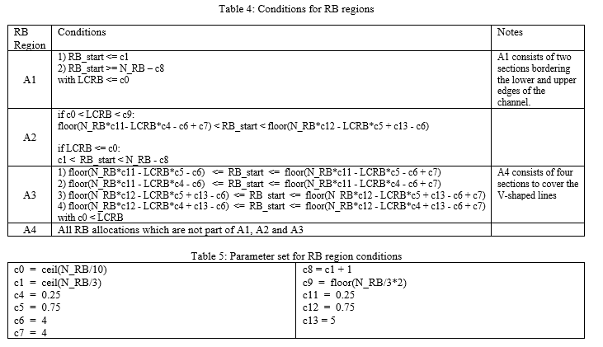  Proposal 2: In case the maximum power boost would be set to 1.5dB use MPR provided in Table 6  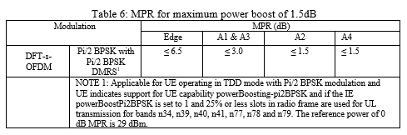  Proposal 3: In case the maximum power boost would be set to 1.0dB use MPR provided in Table 7  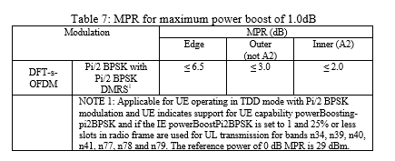  Proposal 4: Limit UL slots in radio frame to max 25% to guarantee SAR compliance and to reduce strain on amplifier
R4-2204012 | Qualcomm Incorporated | TR38.868 on optimizations of pi/2 BPSK UL power
R4-2204013 | Qualcomm Incorporated | TP for TR38.868 with company contributions from RAN4#101-bis-e
R4-2204016 | Qualcomm Incorporated | Proposal 1: PC2 power boost limited to 1 dB  Observation 1: Gain compression with output power causes PAs to require even larger input drives to achieve higher power boost values  Observation 2: Maintaining high boost powers at higher frequencies requires even larger PA input drive due to gain roll-off with frequency and gain compression with output power. This larger input drive will impact the reliability of the PA and the drive requirements of the RF transceiver.  Observation 3: Higher boost powers increase PA power consumption and leads to the need for higher current drive PMUs.  Observation 4: Larger PA bias currents leads to greater thermal dissipation and may lead to heating issues inside the UE and impact PA reliability  Observation 5: Thermal reliability of the front-end components must be evaluated to ensure they can withstand the higher PA powers  Observation 6: If a larger PC2 PA is adopted for obtaining higher gain boost then the MPRs all other modulations and waveform types using the same PA would have to be re-evaluated.  Observation 7: Our studies indicate that 1 dB of power boost is achievable with today’s hardware while boost > 1 dB would require redesign of the transceiver TX chain and PC2 PA and a comprehensive overhaul of the PC2 MPRs
R4-2204085 | Huawei, HiSilicon | Observation 1: For DFT-s-OFDM waveforms with Pi/2 BPSK modulation, it might be possible to boost the PC2 PA power by 1~2dB. However, the higher the power is boosted, the larger challenge it imposes on the PA/PMU, RFIC as well as other front-end components in terms of stability and sustainability.  Proposal 1: The minimum requirement on PC2 power boosting is ≤ 1dB, i.e. MPR ≥ 2dB w.r.t. 29dBm. And a UE is allowed to boost more than 1 dB if it’s able to.  Proposal 2: The percentage of the maximum number of uplink transmission slots in a radio frame is <= [25%].  Observation 2: For the inner centred region, the Tx power can be boosted with no/moderate filtering, while moderate/aggressive filtering is needed for other regions.  Observation 3: The loss of Rx performance (e.g. Rx SNR@10%BLER) increases with the aggressiveness of the filter. More than 1 dB loss was reported for the 3-tap filter [0.335, 1, 0.335].  Observation 4: The net gain for the inner centred region should be the most and it diminishes in other regions.  Observation 5: The study of power boosting has been focused on small number of RBs such as 2/4/8/16/64, which are the typical use cases for cell edge UEs.  Proposal 3: Adopt simpler RB classification scheme such as new-inner, new-outer and edge allocations. The exact definitions are left for the WI stage to allow more time for refinement and verification.  Proposal 4: Define the MPR requirements of Pi/2 BPSK for PC2 1Tx as in Table 1.  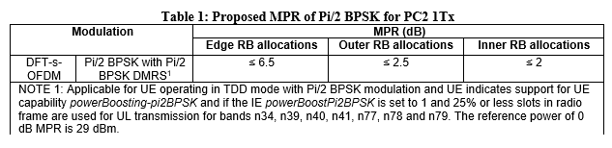  Proposal 5: Further study the power boosting requirements for PC2 with dual Tx. More measurements are needed. This can be done in the study phase of the future WI, or the SI is extended by one quarter, which can be discussed in RAN#95-e.
R4-2204414 | Intel Corporation | Based on TP [1] for the TR 38.868 from RAN4 101-bis-e, the following text proposals and modifications are made:  - Section 5.5 – Addition of BLER figures to further support LLS tables already included  - Section 6.2.3 – Inclusion of Tx + Rx Link margin analysis as noted in RAN4 101-bis-e meeting  - New analysis of Tx+Rx link margin comparing filters  - Section 8.4 – Update of power enhancement MPR curves.  - Change of reference value from 29dBm to 26dBm to be more consistent with the rest of TR 38.868.  - Additional MPR figures.
R4-2204415 | Intel Corporation | Observation 1: The moderately aggressive [0.28 1 0.28] filter also gives the highest performance for outer RB locations  Observation 2: for inner RB locations no filter or the least aggressive [0.2 1 0.2] filter is best for avoiding Rx performance degradation due to filtering.  Observation 3: The MPR values in the inner RBs for LCRB < 20, are the same for all filters including the no filter results. In this RB region, filtering provides no clear advantage.
R4-2204481 | MediaTek Inc. | Proposal 1: Option 1 is proposed. For 1Tx PC2 PAs, the power boost should be limited to within 1dB  Proposal 2: We support option 2: Update MPR tables (at least Table 6.2.2-2) in TS 38.101-1. Reclassification of RB regions for MPR shall be postponed to Rel-18
R4-2204794 | Nokia, Nokia Shanghai Bell | Observation 1: There is not a single solution for all the evaluated cases. Depending on the allocation configuration, different filters (i.e., more or less aggressive) perform differently.  Observation 2: The required MPR depends on the filter, and there can be up to 1 dB difference in required MPR for different filters.  Observation 3: Current MPR regions could be used to define the MPR values.  Proposal 1: The MPR should be defined according to the filter requiring the largest MPR.
R4-2204795 | Nokia, Nokia Shanghai Bell | Observation 1: The most aggressive filters have up to 0.6-0.8 dB loss with respect to the less aggressive filters in the small allocations  Observation 2: For allocation sizes ≤ 16 PRB, less aggressive filters perform better than aggressive filters in terms of achievable output power and link performance.  Observation 3: There is not a single solution for all the evaluated cases. Depending on the allocation configuration, different filters (i.e., more or less aggressive) perform differently.  Observation 4: Based on the previous agreement in RAN4#101bis-e [6], if spectrum flatness requirements are not tightened for small allocations, net gain cannot be guaranteed.  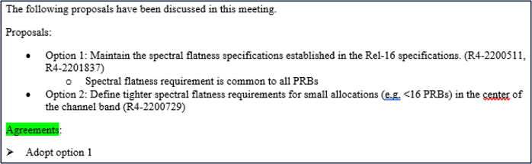
R4-2204796 | Nokia, Nokia Shanghai Bell | Observation 1: Link loss due to more aggressive spectral shaping filtering is higher with small bandwidths.  Observation 2: For given number of PRBs, the performance difference between the used filters is quite similar for all the channel models.
R4-2204797 | Nokia, Nokia Shanghai Bell | Proposal 1: Due to practical considerations, the power boost should be limited to within 1dB.  Proposal 2: Discussion related to the percentage of maximum number of uplink transmission slots in a radio frame can be deprioritized in the current SI.  Proposal 3: Discussion related to further RB regions can be deprioritized in the current SI.
R4-2204937 | vivo | Proposal 1: For 1Tx PC2 PAs, the power boost should be limited to within 1dB. When the reference power of 0 dB MPR is 29dBm, the MPR value is more than 2dB.
R4-2206139 | Skyworks Solutions Inc. | Observation 1: Practical considerations limit the maximum amount of power boosting to within 1dB above the PC2 0dB MPR power level for shaped Pi/2 BPSK waveforms. This corresponds to WF [1] option 1. Restrictions on the maximum number of uplink transmission slots is 25%.  Observation 4: 1dB boost may be supported with reasonable margins in the centred inner region triangle of width (1/3)N_{RB} and summit (2/3)N_{RB}. The inner triangle is illustrated in blue in Figure 4.  Proposal 1: Adopt the following new-inner, new-outer and edge allocation classification illustrated in Figure 6 for shaped Pi/2 BPSK PC2 and adopt maximum power reduction specifications with following text proposal.  “For UE power class 2, the allowed maximum power reduction (MPR) is defined in Table 6.2.2-2 for channel bandwidths ≤ 100 MHz.  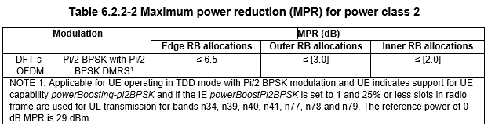  Where the following parameters are defined to specify valid RB allocation ranges for Outer and Inner RB allocations:  - NRB is the maximum number of RBs for a given Channel bandwidth and sub-carrier spacing defined in Table 5.3.2-1;  - RB_{Start,Low} = Max(1, Floor(N_{RB}/3 - L_{CRB}/4);) and,  - RB_{Start,High} = N_{RB} – RB_{Start,Low} – L_{CRB}.  where max() indicates the largest value of all arguments and floor(x) is the greatest integer less than or equal to x.  The RB allocation is an inner RB allocation if the following conditions are met:  - RB_{Start,Low} ≤ RB_{Start} ≤ RB_{Start,High} AND and L_{CRB} ≤ Ceil(2/3 N_{RB}).  where Ceil(x) is the smallest integer greater than or equal to x.  An Edge RB allocation is one for which the RB(s) is (are) allocated at the lowermost or uppermost edge of the channel with L_{CRB} ≤ 4 RBs.  The RB allocation is an Outer RB allocation for all other allocations which are not an Inner RB allocation or an Edge RB allocation.”

1.2 Open issues summary
  - Topic #1-1: Power boost
  - Topic #1-2: MPR
  - Topic #1-3: General and workplan

1.2.1 Topic #1-1
Topic description: Power boost
Issue 1-1-1: PC2 Power boosting above MPR0

- Proposals
  - Option 1: For 1Tx PC2 PAs, the power boost should be limited to within 1dB. (R4-2204016, R4-2204085, R4-2204481, R4-2204797, R4-2204937, R4-2206139)
  - Moderator WF: adopt option 1

Company | Comments
Qualcomm | Support moderator WF
Nokia, NSB | Support moderator WF

Issue 1-1-2: Uplink transmission slots

- Proposals
  - Option 1: Limit UL slots in radio frame to max 25% to guarantee SAR compliance and to reduce strain on amplifier (R4-2203682, R4-2204085)
  - Option 2: Discussion related to the percentage of maximum number of uplink transmission slots in a radio frame can be deprioritized in the current SI (R4-2204797).
  - Option 3: Other, please detail

Company | Comments
Qualcomm | Option 2: Further discussion on this topic can be reserved for the WI phase where companies will have more time to investigate the thermal issues in greater detail.
Nokia, NSB | Option 2.

Issue 1-1-3: Power boost for PC2 with dual TX

- Proposals
  - Option 1: Further study the power boosting requirements for PC2 with dual Tx. More measurements are needed. This can be done in the study phase of the future WI, or the SI is extended by one quarter, which can be discussed in RAN#95-e. (R4-2204085)
  - Option 2: Other, please detail

Company | Comments
Qualcomm | Option 2: It can be further discussed in the WI if it is deemed we need different requirements for 2 Tx.
Nokia, NSB | Option 2: Power boosting requirements for PC2 with dual Tx is deprioritized in the current SI. Dual Tx is not a coverage bottleneck because it can benefit from precoding gain.

1.2.2 Topic #1-2
Topic description: MPR
Issue 1-2-1: MPR tables for various power boosts

- Proposals
  - Option 1: In case the maximum power boost would be set to 1.5dB use MPR provided in Table 6 (R4-2203682)

  - Option 2: In case the maximum power boost would be set to 1.0dB use MPR provided in Table 7 (R4-2203682)
  - Option 3: Define the MPR requirements of Pi/2 BPSK for PC2 1Tx as in Table 1 (R4-2204085)

  - Option 4: For UE power class 2, the allowed maximum power reduction (MPR) is defined in Table 6.2.2-2 for channel bandwidths ≤ 100 MHz. (R4-2206139)

  - Option 5: Update MPR tables (at least Table 6.2.2-2) in TS 38.101-1. Reclassification of RB regions for MPR shall be postponed to Rel-18 (R4-2204481)

  - Option 6: The MPR should be defined according to the filter requiring the largest MPR (R4-2204794)

  - Option 7: Other, please detail

Company | Comments
Qualcomm | Option 7: The primary issue is to first agree on a maximum power boost value. Based on this value it can be decided in the WI phase whether it is more appropriate to update the existing MPR tables or redefine the current MPR regions and what MPRs to assign for each region.
Nokia, NSB | Option 6 and Option 7.  Option 7: define the MPR values in the WI  Based on our results different filters (i.e., more or less aggressive) perform differently depending on the allocation configuration. This means that required MPR depends on the filter, and there can be up to 1 dB difference in required MPR for different filters.  Due to practical considerations, we define maximum achievable power boost based on filter requiring the largest MPR. This will ensure sufficient flexibility for UE to select filter according to UE implementation and/or according to filter optimizing the net gain.  Based on our results, the maximum power boost  - It’s the biggest in inner RB allocations  - It’s always at least 1dB.  For some channel bandwidths, it can be up-to ~1.5 dB.

1.2.3 Topic #1-3
Sub-topic description: General and workplan
Issue 1-3-1: TP detailing company contributions from RAN4#101-bis-e for TR on optimization of pi/2 BPSK uplink power in NR (R4-2204013)
- Proposals
  - Option 1: TP is agreeable.
  - Option 2: Needs further updating
Company | Comments
Qualcomm | Option 1
Nokia, NSB | Option 1

Issue 1-3-2: TP containing additional data and modification of previous data from Intel for TR on optimization of pi/2 BPSK uplink power in NR (R4-2204414)
- Proposals
  - Option 1: TP is agreeable.
  - Option 2: Needs further updating
Company | Comments
Qualcomm | Option 1
Nokia, NSB | Option 1

Issue 1-3-3: Latest revision of TR on optimization of pi/2 BPSK uplink power in NR (R4-2204012)
- Proposals
  - Option 1: TR on optimization of pi/2 BPSK uplink power is agreeable.
  - Option 2: Needs further updating
Company | Comments
Qualcomm | Option 1
Nokia, NSB | Option 1

1.3 Companies views’ collection for 1st round

1.3.1 CRs/TPs comments collection
CR/TP number | Comments collection

1.4 Summary for 1st round

1.4.1 Open issues
Moderator tries to summarize discussion status for 1st round, list all the identified open issues and tentative agreements or candidate options and suggestion for 2nd round i.e. WF assignment.

1.5 Discussion on 2nd round

1.5.1 Open issues

RAN4 will further discuss based on the WF and revised TRs/CRs in 2nd round.
T-doc number | Company | Comments

2 Recommendations for Tdocs

1st round
New tdocs
Title | Source | Comments
LS on … | ZZZ | To: RAN_X; Cc: RAN_Y

Existing tdocs
Tdoc number | Title | Source | Recommendation | Comments
R4-2203682 | PI/2 BPSK enhancements | Apple
R4-2204012 | TR skeleton for SI on optimizations of pi_2 BPSK uplink power | Qualcomm Incorporated
R4-2204013 | TP for Pi/2 BPSK study item for TR38.868 | Qualcomm Incorporated
R4-2204016 | PC2 power boost for Pi/2 BPSK | Qualcomm Incorporated
R4-2204085 | On Remaining Issues for Optimisations of Pi/2 BPSK UL Power | Huawei, HiSilicon
R4-2204414 | TP for TR 38.868: Filter Analysis Update | Intel Corporation
R4-2204415 | Views on Tx+Rx link margin filter delta | Intel Corporation
R4-2204481 | Discussion on Pi_2_BPSK power boosting | MediaTek Inc.
R4-2204794 | Transmitter performance for pi/2 BPSK with spectral shaping | Nokia, Nokia Shanghai Bell
R4-2204795 | Shaping filter characteristics including transmitter and link performance | Nokia, Nokia Shanghai Bell
R4-2204796 | Receiver performance for pi/2 BPSK with spectral shaping | Nokia, Nokia Shanghai Bell
R4-2204797 | Identify?potential changes for?RAN4 requirements | Nokia, Nokia Shanghai Bell
R4-2204937 | Further discussion on pi/2 BPSK UE Tx power | vivo
R4-2206139 | MPR Proposal for PC2 Pi_2 BPSK | Skyworks Solutions Inc.

Notes:
- Please include the summary of recommendations for all tdocs across all sub-topics incl. existing and new tdocs.
- For the Recommendation column please include one of the following:
  - CRs/TPs: Agreeable, Revised, Merged, Postponed, Not Pursued
  - Other documents: Agreeable, Revised, Noted
- For new LS documents, please include information on To/Cc WGs in the comments column
- Do not include hyper-links in the documents

2nd round

Tdoc number | Title | Source | Recommendation | Comments

Notes:
- Please include the summary of recommendations for all tdocs across all sub-topics.
- For the Recommendation column please include one of the following:
  - CRs/TPs: Agreeable, Revised, Merged, Postponed, Not Pursued
  - Other documents: Agreeable, Revised, Noted
- Do not include hyper-links in the documents

