# Summary of companies’ simulation results for phase tolerance

|  |  |  |  |  |  |  |
| --- | --- | --- | --- | --- | --- | --- |
| **Company** | **Phase offset model** | **Performance metric** | **Number of repetitions** | **SNR degradation w.r.t. no phase offset** | **SNR gain w.r.t. no JCE** | **Proposed phase tolerance** |
| Sony R4-2200471 | Option 1 | PUCCH BLER | 8 slots | 0.3-0.5dB for [-40, 40]o | 1-1.5dB for [-40, 40]o | 40o with option 1 |
| PUSCH TP | 10 slots | ~0.3dB for [-40, 40]o | ~0.1dB for [-40, 40]o |
| HW R4-2201958 | Option 1 | PUSCH BLER | 12 and 16 slots | ~0.3dB for [-30, 30]o  ~0.6dB for [-40, 40]o | Around more than 2dB | 30o with option 1 |
| Option 2 | PUSCH BLER | 12 and 16 slots | ~0.2dB for [-15, 15]o  ~0.5dB for [-20, 20]o | Around more than 2dB |  |
| E/// R4-2201706 | Option 1 | PUSCH BLER | 32 slots | 3dB for [-40, 40]o  1dB for [-20, 20]o  (Note: compared to [-10, 10]o) |  | 30o with option 1 |
| Option 2 | PUSCH BLER | 5.5dB for [-40, 40]o  1.5dB for [-20, 20]o  (Note: compared to [-10, 10]o) |  |  |
| QC | Option 2 | PUSCH BLER | 8 slots | ~0.8dB for [-40, 40]o | ~2.1dB for [-40, 40]o | 40o with option 2 |
| China Telecom R4-2200022 | Option 1 | PUSCH 2% BLER | 16 slots | ~0.6dB for [-30, 30]o | ~2.5dB for [-30, 30]o | 30o with option 1 |
| 32 sots | 0.6~0.9dB for [-30, 30]o | 1.7~2.4dB for [-30, 30]o |
| Option 2 | PUSCH 2% BLER | 16 slots | ~0.6dB for [-15, 15]o | ~2.5dB for [-15, 15]o | 15o with option 2 |
| 32 sots | 0.6~1 dB for [-15, 15]o | 1.6~2.3dB for [-15, 15]o |
| MTK R4-2113504 | [Option 1] | PUSCH BLER |  | 0.2dB for [-30, 30]o | 0.6dB for [-30, 30]o |  |
| ZTE R4-2119193 | Option 1 | PUSCH BLER | 2/8 slots | 0.6dB for [-20, 20]o |  | 20o with option 1 |

# Annex

## Sony R4-2200471

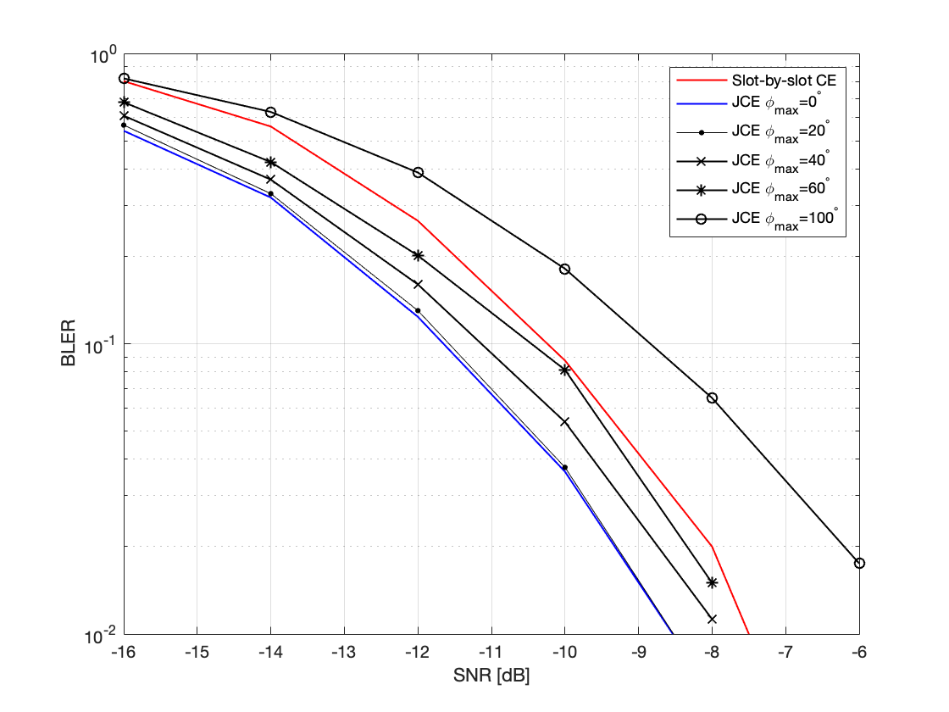

**Figure 1. PUCCH Simulation results for UE speed 30 km/h.**

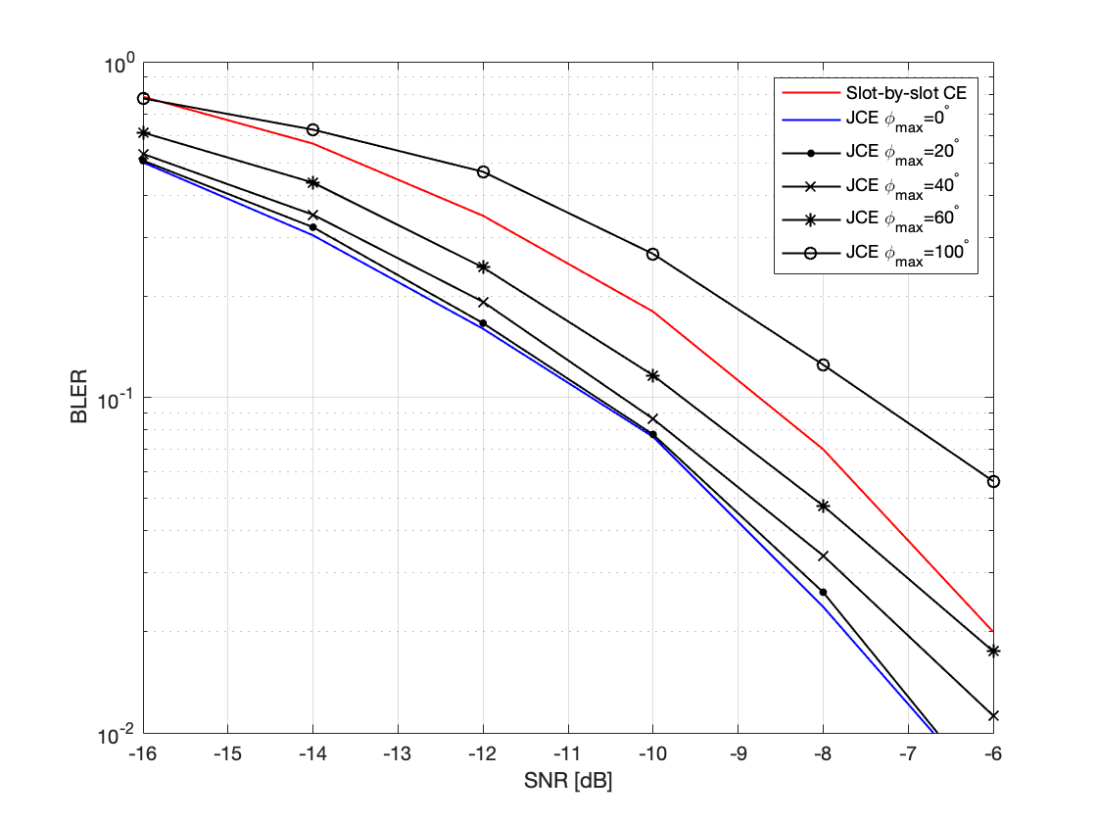

**Figure 2. PUCCH Simulation results for UE speed 10 km/h.**

**Figure 3. Simulation of PUSCH results for 6PRB allocation.**

**Figure 4. Simulation of PUSCH results for 2PRB allocation.**

## HW R4-2201958

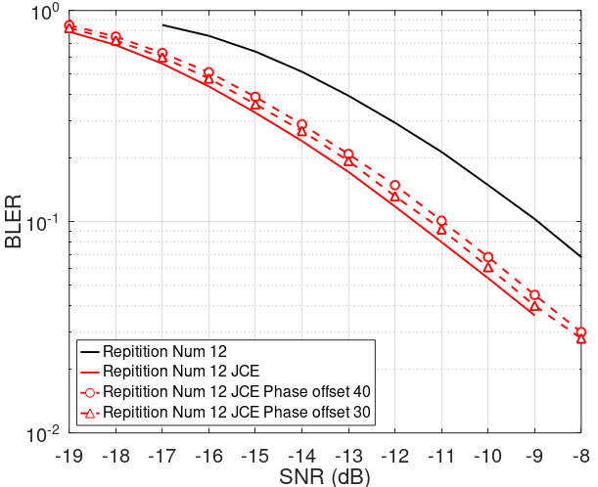

**Figure 1. Non-accumulated phase offset on 12 slots bundling JCE for PUSCH**

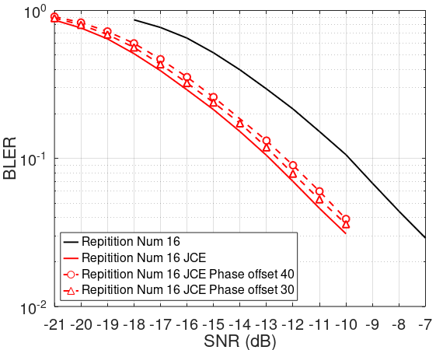

**Figure 2. Non-accumulated phase offset on 16 slots bundling JCE for PUSCH**

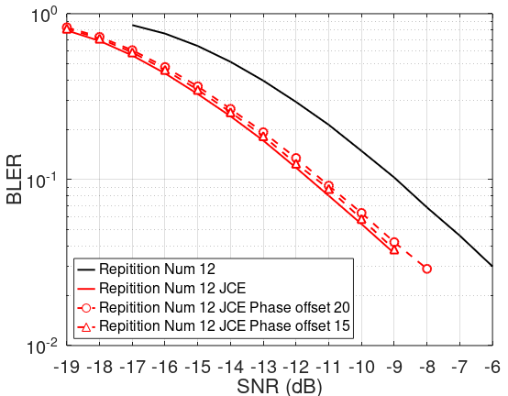

**Figure 3. Accumulated phase offset on 12 slots bundling JCE for PUSCH**

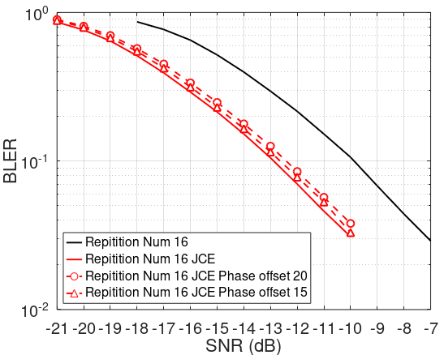

**Figure 4. Accumulated phase offset on 16 slots bundling JCE for PUSCH**

## E/// R4-2201706



Figure 2: BLER performance for JCE and non-JCE with added phase option 1 and option 2 and uniformly distributed power error with different ranges

## QC R4-2205882

Figure 1. Increase in required CINR with same phase discontinuity for longer bundles

## CTC R4-2200022

Table 2. SNR at 2% BLER, **FR1 15 kHz SCS, 16 repetitions**

|  |  |  |  |  |  |
| --- | --- | --- | --- | --- | --- |
| **Phase offset** | | **SNR (dB)** | | | |
| **Phase offset option 1** | | **Phase offset option 2** | |
| **Required SNR** | **Delta SNR** | **Required SNR** | **Delta SNR** |
| Without JCE | | -2.8 | N.A. | -2.8 | N.A. |
| JCE | 0° | -6.0 | Baseline | -6.0 | Baseline |
| 5° |  |  | -5.8 | -0.2 |
| 10° | -5.7 | 0.3 | -5.4 | 0.6 |
| 15° |  |  | -5.3 | 0.7 |
| 20° | -5.5 | 0.5 | -5.2 | 0.8 |
| 30° | -5.3 | 0.7 |  |  |
| 40° | -5.2 | 0.8 |  |  |

Table 3. SNR at 2% BLER, **FR1 15 kHz SCS, 32 repetitions**

|  |  |  |  |  |  |
| --- | --- | --- | --- | --- | --- |
| **Phase offset** | | **SNR (dB)** | | | |
| **Phase offset option 1** | | **Phase offset option 2** | |
| **Required SNR** | **Delta SNR** | **Required SNR** | **Delta SNR** |
| Without JCE | | -6.2 | N.A. | -6.2 | N.A. |
| JCE | 0° | -8.8 | Baseline | -8.8 | Baseline |
| 5° |  |  | -8.3 | 0.5 |
| 10° | -8.8 | 0 | -8 | 0.8 |
| 15° |  |  | -7.8 | 1 |
| 20° | -8.5 | 0.3 | -7.4 | 1.4 |
| 30° | -7.9 | 0.9 |  |  |
| 40° | -7.5 | 1.3 |  |  |

Table 4. SNR at 2% BLER, **FR1 30 kHz SCS, 16 repetitions**

|  |  |  |  |  |  |
| --- | --- | --- | --- | --- | --- |
| **Phase offset** | | **SNR (dB)** | | | |
| **Phase offset option 1** | | **Phase offset option 2** | |
| **Required SNR** | **Delta SNR** | **Required SNR** | **Delta SNR** |
| Without JCE | | -3.1 | N.A. | -3.1 | N.A. |
| JCE | 0° | -6.2 | Baseline | -6.2 | Baseline |
| 5° |  |  | -6.1 | 0.1 |
| 10° | -6 | 0.2 | -5.9 | 0.3 |
| 15° |  |  | -5.6 | 0.6 |
| 20° | -5.8 | 0.4 | -5.4 | 0.8 |
| 30° | -5.6 | 0.6 |  |  |
| 40° | -5.4 | 0.8 |  |  |

Table 5. SNR at 2% BLER, **FR1 30 kHz SCS, 32 repetitions**

|  |  |  |  |  |  |
| --- | --- | --- | --- | --- | --- |
| **Phase offset** | | **SNR (dB)** | | | |
| **Phase offset option 1** | | **Phase offset option 2** | |
| **Required SNR** | **Delta SNR** | **Required SNR** | **Delta SNR** |
| Without JCE | | -6.2 | N.A. | -6.2 | N.A. |
| JCE | 0° | -9.1 | Baseline | -9.1 | Baseline |
| 5° |  |  | -8.7 | 0.4 |
| 10° | -8.9 | 0.2 | -8.6 | 0.5 |
| 15° |  |  | -8.5 | 0.6 |
| 20° | -8.7 | 0.4 | -8.2 | 0.9 |
| 30° | -8.6 | 0.6 |  |  |
| 40° | -8.2 | 0.9 |  |  |

Table 6. SNR at 2% BLER, **FR2 60 kHz SCS, 16 repetitions**

|  |  |  |  |  |  |
| --- | --- | --- | --- | --- | --- |
| **Phase offset** | | **SNR (dB)** | | | |
| **Phase offset option 1** | | **Phase offset option 2** | |
| **Required SNR** | **Delta SNR** | **Required SNR** | **Delta SNR** |
| Without JCE | | -4.7 | N.A. | -4.7 | N.A. |
| JCE | 0° | -5.7 | Baseline | -5.7 | Baseline |
| 5° |  |  | -5.7 | 0 |
| 10° | -5.7 | 0 | -5.6 | 0.1 |
| 15° |  |  | -5.5 | 0.2 |
| 20° | -5.5 | 0.2 | -5.3 | 0.4 |
| 30° | -5.4 | 0.3 |  |  |
| 40° | -5.3 | 0.4 |  |  |

Table 7. SNR at 2% BLER, **FR2 60 kHz SCS, 32 repetitions**

|  |  |  |  |  |  |
| --- | --- | --- | --- | --- | --- |
| **Phase offset** | | **SNR (dB)** | | | |
| **Phase offset option 1** | | **Phase offset option 2** | |
| **Required SNR** | **Delta SNR** | **Required SNR** | **Delta SNR** |
| Without JCE | | -7.8 | N.A. | -7.8 | N.A. |
| JCE | 0° | -7.4 | Baseline | -7.4 | Baseline |
| 5° |  |  | -5.2 | 2 |
| 10° | -7.2 | 0.2 | -3.8 | 3.6 |
| 15° |  |  | -3.6 | 3.8 |
| 20° | -7.2 | 0.2 | -3.5 | 3.9 |
| 30° | -7.1 | 0.3 |  |  |
| 40° | -6.9 | 0.5 |  |  |

## MTK R4-2113504

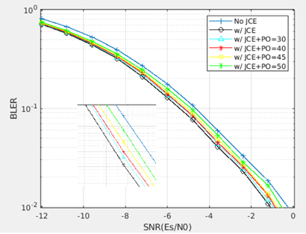

**Figure 1: Phase tolerance impacts on performance**

## ZTE R4-2119193

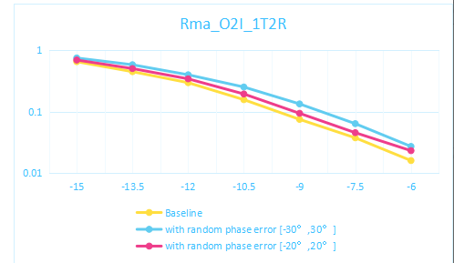

Figure 1. The performance impact of phase error on joint channel estimation for PUSCH for 700MHz

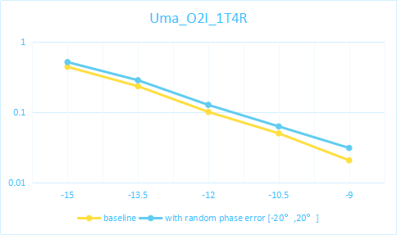

Figure 2. The performance impact of phase error on joint channel estimation for PUSCH for 4GHz