3GPP TSG-RAN WG4 Meeting # 102-e R4-22TBD
Electronic Meeting, February 21 – March 4, 2022

Agenda item: 10.16.3
Source: Moderator (Qualcomm)
Title: DRAFT Email discussion summary for [102-e][134] NR_ext_to_71GHz_Part_2
Document for: Information

Introduction
Scope is UE RX and TX requirements for 60 GHz.

Topic #1: UE TX and RX
Main technical topic overview.

Companies’ contributions summary TX
T-doc number | title | Company | Proposals / Observations
R4-2203707 | On UE spherical coverage for band n263 | Apple | Observation 1: Lensing effects can create limitations in scanning range that also exhibit frequency-dependent behaviour. The limitation in scanning range due to the lensing effect impacts the spherical coverage.  Proposal 1: RAN4 shall define the UE spherical coverage for power class 3 for n263 as 1.6 dBm – as shown in Table 1.  Proposal 2: RAN4 shall define the EIS spherical coverage for power class 3 for n263 as -61.4 dBm/400MHz – as shown in Table 2.
R4-2204330 | Specifications of FR2-2 handheld UE | Murata Manufacturing Co Ltd. | Observation 1: Minimum peak EIRP is 16.2 dBm in n263.  Observation 2: Handheld UE can communicate over half of ISD, when its minimum peak EIRP is in the range of [13.2 to 14.1] dBm.  Proposal 1: We propose 16.2 dBm minimum peak EIRP, but we can compromise to 14.1 dBm.  Proposal 2: We propose -72.3 dBm REFSENS.  Observation 3: It will contribute to discussions to consider communication quality in addition to specification values.  Observation 4: UE will be able to communicate only less than 3.0m with 1 panel in spherical coverage condition.  Proposal 3: We propose using 2 panels in discussion as base line.  Observation 5: Spherical coverage is 5.7 dBm with 2 panels and its communication range is 6.0m.
R4-2204038 | Minimum Tx requirement for handheld and FWA UEs at 60 GHz | Sony | Observation 1: The degradation between 50% and 100% array gain at 60 GHz is no worse than at 28 GHz.  Observation 2: Single panel is not feasible for practical usage due to more sparse propagation environment and more severe body blockage in FR2-2 than FR2-1.  Observation 3: For FWA type of devices, the performance may be limited by the regulatory requirement rather than the antenna and RF component performances.  Proposal 1: The minimum peak EIRP is about 16.5 dBm for an 8-element array in mobile handsets.  Proposal 2: 8.5 dB drop from peak EIRP/REFSEN for the spherical coverage. Minimum EIRP at 50% = 8 dBm.  Proposal 3: Minimum Peak EIRP of FWA devices for n263 is around 30 dBm.
R4-2204227 | Proposals on FR2-2 spherical drop for requirement calculation | MediaTek Beijing Inc. | Proposal: FR2-2 Power Class 3 spherical EIRP/EIS requirements shall consider the calculated spherical drop value [14.1-18.3] dB.
R4-2204359 | Handheld UE RF TX requirements for n263 in FR2-2 | NTT DOCOMO, INC. | Observation 1: Assume a single-band implementation. Multi-band relaxation should be discussed after agreeing the requirements for single-band implementation.  Proposal 1: Based on our analysis, minimum peak EIRP for n263 is 17.0 dBm.  Observation 2: 50 %-tile gain drop for EIRP is approximately 3.0 dB based on 2 panels assumption.  Proposal 2: Based on our analysis, EIRP spherical coverage for n263 is 14.0 dBm at 50 %-tile.
R4-2204590 | Views on FR2-2 FWA UE | Murata Manufacturing Co Ltd. | Observation 1: Considering the deployment scenarios, communication range between UE and BS should be larger than 75.5m.  Observation 2: In n263, the communication range is 60m when min peak EIRP is [25.9-26.0] dBm (UMi NLOS Scenario), so we concern that the use case similar to Dense urban scenario cannot be supported.  Proposal 1: Before determining the number of antenna elements, RAN4 needs to discuss the required communication range and use case.  Observation 3: It is difficult for 32 antenna element UE to support Dense urban use case. To support this scenario UE seems to need 64 antenna elements.  Proposal 2: RAN4 uses 64 antenna elements for FWA discussion as baseline.  Proposal 3: Min peak EIRP of PC1 is 32.1 dBm in n263.
R4-2204619 | UE output power for 57-71 GHz | Ericsson | Proposal 1: The minimum peak EIRP is about 18.5 dBm for an 8-element array in mobile handsets.  Observation 1: The degradation between 50% and 100% array gain at 60 GHz is not worse than that at 28 GHz.  Observation 2: a single panel is not feasible for practical usage due to the propagation environment and more severe body blockage in FR2-2.  Proposal 2: 8.5 dB drop from peak EIRP/REFSEN for the spherical coverage. Minimum EIRP at 50% = 10 dBm.
R4-2204934 | Further discussion on handheld UE EIRP and spherical coverage requirements for 52.6~71 GHz | vivo | Proposal 1: Pick the middle value 13.7dBm in the range of 13.2 to 14.1 to finalize the minimum peak EIRP for handheld UE in FR2-2.  Observation 1: For the handheld UE spherical coverage, the peak to 50% percentile gain drop is 14.59 dB with 8 antenna elements based on one panel configuration.  Proposal 2：We propose -0.89dBm (14.59 dB gain drop compared to minimum peak EIRP 13.7dBm) as the Min EIRP at 50%-tile CDF for handheld UE spherical coverage.
R4-2205173 | Draft CR to 38.101-2 on band n263 Tx aspects | Apple
R4-2205188 | On 60GHz UE Tx RF requirements | Huawei, HiSilicon | Proposal 1: For 60GHz handheld UE, 12dBm is proposed for min peak EIRP requirement.  Proposal 2: For 60GHz handheld UE, the averaging is executed in the way of ‘Average (linear) excluding extremes.  Proposal 3: For 60GHz handheld UE, 13.7dB is proposed for 50%-tile gain drop for 1 panel case.  Proposal 4: 64 elements antenna and single panel are assumed for FWA UE in FR2-2.  Proposal 5: For 60GHz FWA UE, adopt 26.8dBm for minimum peak EIRP.  Proposal 6: Specify only 5us ON/ON transient periods in Rel-17.  Proposal 7 The beam direction switching time assumption for FR2-2 shall be the same as FR2-1.
R4-2205210 | draft CR on vehicular UE Tx RF requirements in FR2-2 | LG Electronics Finland
R4-2205227 | Discussion on Tx RF requirements in FR2-2 | LG Electronics Finland | Proposal 1: For vehicular UE, minimum peak EIRP of 22.7 dBm is proposed (based on 16 antenna elements)  Proposal 2: For vehicular UE, EIRP at 60%-tile CDF is 15.1 dB lower than minimum peak EIRP (based on 16 antenna elements).
R4-2205246 | 60 GHz UE TX | Qualcomm Incorporated | Handheld array size:  Proposal 1: 8 elements are used for spec development per our previous meeting agreement, and per normal RAN4 working methods other implementations are not precluded.  Handheld spherical coverage:  Observation: 1 panel covers at best a hemisphere, and 2 panels back-to-back work together to cover most of the sphere  Observation: Using 1 panel degrades the %ile coverage CDF significantly.  Proposal: Specifications should be derived assuming a minimum of 2 antenna panels  Handheld min peak EIRP:  Proposal: Handheld min peak EIRP is 15 dBm, per our submissions from previous meetings. If the group decides to stay within the [] range, our preference is 14.2 dBm.  Observation: Peak to 50%ile gain drop is approximately 3 dB higher in FR2-2 than FR2-1 due to antenna pattern and other considerations, and n262 has a 13.1 dB drop. Therefore FR2-2 drop should be 16.1 dB.  Proposal: 50th %ile spherical coverage point is 16.1 dB less than the min peak dBm  PC1 UE min peak EIPR and antenna size:  Observation: The Umi UL outage can benefit from higher UL EIRP.  Proposal: Use 64 elements per polarization assumption to reduce the uplink outage develop the PC1 UE specification  Proposal: PC1 UE minimum peak EIRP is 35 dBm EIRP  PC1 UE spherical coverage:  Proposal: Use the 1-panel curve and additional losses due to beamforming errors and radiated UE structure and material losses to develop minimum performance requirement.  Proposal: Specify the 85%ile at 14 dB down from the peak EIRP value.  UE ACLR:  Proposal: UE ALCR is 15 dBc.  ON/ON transient periods  Proposal: The transient period from FR2-1 is based on the capability of the UE to configure the transmitter and receiver. The same capability will exist in FR2-2. Use the same 5usec for FR2-2.  Beam direction only switching time baseline assumption  Proposal: UE requires 200 nsec for beam direction only switching for all SCS  Observation: Our understanding is the UE can perform a beam direction change, or a power control change, or both during this 200 nsec time.
R4-2205313 | System parameters for a NR band in the range 52.6GHz – 71GHz | Nokia, Nokia Shanghai Bell | Proposal 3: Consider similar spectrum utilization for scenarios with 800MHz and 1600MHz as already endorsed for 120 kHz SCS in FR2-2.  Proposal 4: Support reduced spectrum utilization for 960 kHz SCS & 2 GHz CBW  Proposal 6: For optional ON-ON transient time, only one value among 1 us or 2 us is specified.
R4-2205459 | Further Discussion on spectral utilization requirements for FR2-2 | ZTE Corporation | Proposal 1: the existing spectral utilization requirements for FR2-1 could be reused at least for 100MHz and 400MHz with 120kHz SCS.  Proposal 2: to propose the following transmission bandwidth configuration for FR2-2:  Table 5.3.2-3: Transmission bandwidth configuration N_{RB} for FR2-2  SCS (kHz) 100 MHz 400 MHz 800 MHz 1600 MHz 2000 MHz  N_{RB} N_{RB} N_{RB} N_{RB} N_{RB}  120 66 132 N/A N/A N/A  480 N/A 66 132 264 N/A  960 N/A 33/32 66 132 165
R4-2205552 | On UE Tx RF aspects for FR2-2 | Nokia, Nokia Shanghai Bell | Observation 1: How many panels including the agreed 8 antenna elements is still FSS.  Proposal 1: Assumption of antenna elements per antenna panel shall be discussed.  Proposal 2: Minimum UE beamforming requirements shall be defined for devices with a TRP exceeding 20 dBm.  Observation 2: Maximum power level TRP is in Europe defied at 25 dBm for a handheld device and 55 dBm for a fixed outdoor device with ≥ 30 dB transmit directivity.  Proposal 3: Maximum power level TRP of 25 dBm shall be considered.  Observation 3: Minimum peak EIRP, REFSENS and EIS spherical coverage are still needed agreed to confirm applicable power classes for FR2-2.  Proposal 4: In FR2-2 band n263, handheld UE minimum peak EIRP is specified 17.9 dBm  Proposal 5: Assume a minimum of 2 antenna panels for a handheld UE.  Proposal 6: Use a UE beam direction switching time of 59 ns.
R4-2205999 | UE Tx RF requirements for FR2-2 | Intel Corporation | Handheld UE power class  Observation 1: The average considering all proposals in Table 1, is 14.1 dBm. Removing the max and min values of the data set leads to a 13.7 dBm average, which is also the midpoint of the range captured in the WF. These figures are subject to the addition of new proposals and potential revaluation during this meeting.  Proposal 1: Define the single-band minimum peak EIRP of PC3 in FR2-2 as 13.7 dBm.  Observation 2: Given the larger array assumption used for FR2-2, its characteristics, and added complexities/losses, the drop from peak of band n263 should be larger than that of band n262 (13.1 dB).  FWA UE power class  Observation 3: Considering we do not specify the number of antenna elements and the small difference in minimum peak EIRP derivations, the agreed range of 32 to 64 elements should be kept for PC1 in FR2-2.  Proposal 2: Define the single-band minimum peak EIRP of PC1 in FR2-2 as 26 dBm.  Observation 4: Performance degradation is expected compared to previously defined FR2-1 bands and the spherical coverage requirement should reflect this. A drop from peak value around 9 – 10 dB can be considered and further discussed for band n263.  ON/ON transient period  Observation 5:  - Option 1: No gNB scheduling optimizations for ON/ON transient period  - Using 5 µS ON/ON transient period leads to high throughput reduction due to corruption of the PUSCH data symbols. Up to 50% and 12% throughput loss can be expected for bundling size 2 and 8, respectively.  - An improved ON/ON transient period faster than 5 µS is required to support at least full MCS for 16 QAM modulation.  - Option 2: Optimized gNB scheduling for ON/ON transient period  - Using 5 µS ON/ON transient period leads to high throughput loss even with optimized gNB scheduling without corrupted symbols on UE side. Up to 25% and 6% throughput loss can be expected for bundling size 2 and 8, respectively.  An improved ON/ON transient period faster than 5 µS allows better throughput performance with almost 20%, 10% and 5% improvement for scenarios with bundling size 2, 4 and 8, respectively.  Proposal 3: Introduce 2 µS improved ON/ON transient period as optional UE capabilities for 480 and 960 kHz SCS.

Companies’ contributions summary RX
T-doc number | title | Company | Proposals / Observations
R4-2204039 | Minimum Rx requirement for handheld UEs at 60 GHz | Sony | Proposal 1: REFSENS -76 dBm/400MHz for n263  Proposal 2: 8.5 dB drop from REFSEN to the spherical coverage EIS at 50% CDF, which leads to 67.5 dBm/400MHz for n263.
R4-2204360 | Handheld UE RF RX requirements for n263 in FR2-2 | NTT DOCOMO, INC. | Observation 1: Assume a single-band implementation. Multi-band relaxation should be discussed after agreeing the requirements for single-band implementation.  Proposal 1: Based on our analysis, REFSENS for n263 is -80.7 dBm/400MHz.  Observation 2: 50 %-tile gain drop for EIS is approximately 3.0 dB based on 2 panels assumption.  Proposal 2: Based on our analysis, EIS spherical coverage for n263 is -77.7 dBm/400MHz at 50 %-tile.
R4-2204935 | Further discussion on handheld UE EIS requirements for 52.6~71 GHz | vivo | Table 1: Reference sensitivity for power class 3  Operating band REFSENS (dBm) / Channel bandwidth  100 MHz 400 MHz 800 MHz 1600 MHz 2000 MHz  n263 -79.0 -73.0 -70.0 -67.0 -66  Table 2: EIS spherical coverage for power class 3  Operating band EIS at 50th %-tile CCDF (dBm) / Channel bandwidth  100 MHz 400 MHz 800 MHz 1600 MHz 2000 MHz  n263 -64.4 -58.4 -55.4 -52.4 -51.4
R4-2205189 | On 60GHz UE Rx RF requirements | Huawei, HiSilicon | Proposal 1: For 60GHz handheld UE, the REFSENS requirement for 52.6~71 GHz is -75.5 dBm/100 MHz based on 8 elements antenna array assumption.  Proposal 2: For 60GHz handheld UE, the averaging is executed in the way of ‘Average (linear) excluding extremes.  Proposal 3: For 60GHz handheld UE, the EIS spherical coverage requirement could be decided by reusing the analysis of EIRP gain drop from 50%-tile to peak EIRP.
R4-2205229 | draft CR on vehicular UE Rx RF requirements in FR2-2 | LG Electronics Finland
R4-2205231 | Discussion on Rx RF requirements in FR2-2 | LG Electronics Finland | Proposal 1: For vehicular UE, reference sensitivity at channel band width of 400MHz is -80.3dBm is proposed (based on 16 antenna elements).  Proposal 2: For vehicular UE, EIS spherical coverage 60%-tile CDF is 15.1 dB higher than reference sensitivity (based on 16 antenna elements).
R4-2205292 | 60 GHz UE RX | Qualcomm Incorporated | REFSENS  Proposal: REFSENS for PC1 based on 64 array elements  Proposal: n263 PC1 REFSENS is -88.3 dBm under the assumption of 95% spectral occupancy, 64 elements, and 400 MHz.  Proposal: REFSENS for PC3 based on 8 array elements  Proposal: n263 PC3 REFSENS is -79.2 under the assumption of 95% spectral occupancy, 8 elements, and 400 MHz.  EIS Spherical coverage  Proposal: For PC1 specify the 85%ile at 14 dB down from the peak sensitivity value, based on 64 elements and 400MHz CBW/95% spectral occupancy.  Proposal: For PC3 specify the 50%ile at 16.1 dB down from the peak sensitivity value, based on 8 elements and 400MHz CBW/95% spectral occupancy.
R4-2205553 | On UE Rx RF aspects for FR2-2 | Nokia, Nokia Shanghai Bell | Proposal 1: In FR2-2 band n263, handheld UE REFSENS for 400 MHz channel bandwidth is specified -82.0 dBm.
R4-2206000 | UE EIS requirements for band n263 | Intel Corporation | Handheld UE  Observation 1: The average considering all proposals in Table 1, is -71 dBm. Removing the max and min values of the data set leads to a -71.2 dBm average. These figures are subject to the addition of new proposals and potential revaluation during this meeting.  Proposal 1: Further discussion of the complete list of proposals is needed. Based on current data, we can consider defining the single-band minimum peak EIS of PC3 in FR2-2 as -71 dBm (400MHz CBW).  FWA UE  Observation 3: The minimum peak EIS requirements (400MHz CBW) of FR2-1 bands range from -88.5 dBm at 28 GHz, to -83.5 dBm for band n262 [6]. As degradation is expected for band n263, a larger than -83.5 dBm value is reasonable. This should be considered when discussing the FR2-2 requirement.  Proposal 2: Define the PC1 minimum peak EIS single-band requirement as -76.2 dBm (400MHz).  Observation 4: Given the anticipated degradation compared to previously defined FR2-1 bands, a drop from peak value around 9 –10 dB can be considered and further discussed for band n263

Open issues summary
Before e-Meeting, moderators shall summarize list of open issues, candidate options and possible WF (if applicable) based on companies’ contributions.

Minimum peak EIRP
Sub-topic description:
Open issues and candidate options before e-meeting:
- Proposals
 | Power class 3 |  | Power class 1 |  | Power class 2
 | EIRP | EIRP last meeting  (for reference) | EIRP | elements | EIRP | elements
Murata | 16.2 (14.1 OK) | 15.7 | 32.1 | 64
Sony | 16.5 |  | 30 | 64
NTT DOCOMO | 17
Ericsson | 18.5
vivo | 13.7 | 11.3
Huawei, HiSilicon | 12 | 12 | 26.8 | 64
LGE |  | 14.7 |  |  | 22.7 | 16
QCOM | 15 | 15 | 35 | 64
Nokia, Nokia Shanghai Bell | 17.9 | 20
Intel | 13.7 | 13.6 | 26 | 32 to 64 range
Apple | 9.2

- PC3 Min Peak EIRP
Range of [13.1 – 14.2] was agreed last meeting as WF based on averaging in power and in dB
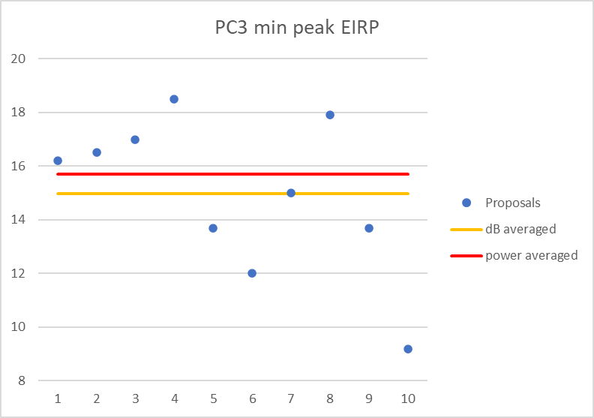

- Option 1: 13.1 dBm (from [] last meeting)
- Option 2: 14.2 dBm (from [] last meeting)
- Option 3: 15 dBm (dB averaged based on inputs this meeting)
- Option 4: 15.7 dBm (power averaged based on inputs this meeting)
- Option 5: Something else and describe
  - Recommended WF
    - Companies discuss between the 4 options
Company | PC3 Min Peak EIRP Comments
XXX | YYY

- PC1 Number of elements per polarization
Range Between 32 and 64 elements was agreed last meeting as WF
- Option 1: 64 element assumption (Murata, Sony, Huawei/HiSilicon, QCOM)
- Option 2: any value between 32 and 64 elements (Intel)
  - Recommended WF
    - 64 elements by 4 to 1 majority
Company | PC1 elements Comments
XXX | YYY

- PC1 Min Peak EIRP
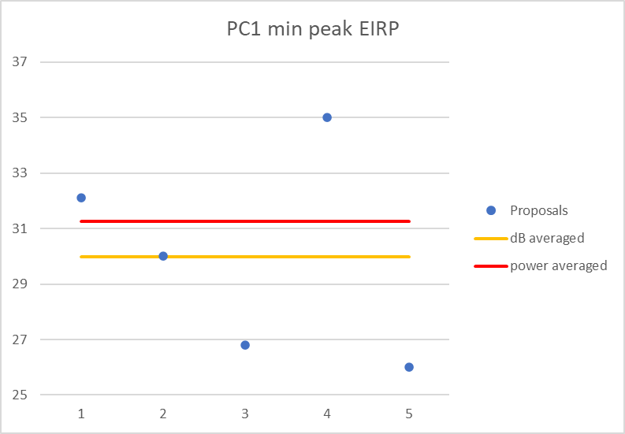
- Option 1: 30 dBm (average in dB)
- Option 2: 31.25 dBm (average in power)
- Option 3: Something else and describe
  - Recommended WF
    - Further discuss between these options
Company | PC1 Min Peak EIRP Comments
XXX | YYY

- PC2 Number of elements per polarization and Min peak EIRP
Greater than or equal to handheld was agreement last meeting
- Proposal 1: 22.7 dBm based on 16 element assumption
  - Recommended WF
    - companies discuss proposal 1
Company | PC2 elements and min peak EIRP Comments
XXX | YYY

Moderator tries to summarize discussion status for 1st round, list all the identified open issues and tentative agreements or candidate options and suggestion for 2nd round i.e., WF assignment
Tentative agreements:
Candidate options:
Recommendations for 2nd round:

Antenna panels and spatial coverage
Sub-topic description:
Open issues and candidate options before e-meeting:
- Proposals
Company | PC3 panels | PC3 drop | PC1 %ile | PC1 drop | PC2 panels | PC2 drop | PC2 %ile | PC2 elements
Apple | 2 | 11.6
Murata | 2 | 10.5
QCOM | 2 | 16.1 | 85% | 14
Sony | 2 | 8.5
MediaTek | unstated | 14.1 to 18.3 dB
DOCOMO | 2 | 3
Ericsson | 2 | 8.5
vivo | 1 | 14.59
Huawei, HiSilicon | 1 | 13.7
LGE |  |  |  |  | 1 | 15.1 | 60% | 16
Intel |  | >13.1 |  | 9 to 10 dB further discuss

- PC3 Panels
- Option 1: >=2
- Option 2: >=1
  - Recommended WF
    - companies further discuss the options
Company | PC3 Panels Comments
XXX | YYY

- PC3 Drop
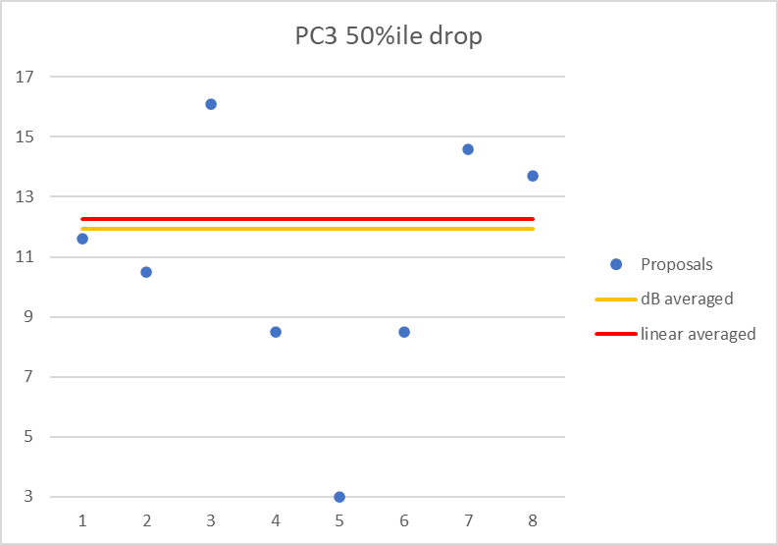

- Proposal 1: 12 dB drop (dB or linear average are close, 3 dB outlier removed
- Proposal 2: Between 14.1 and 18.3
- Proposal 3: >13.1
- Proposal 4: Something else
  - Recommended WF
    - further discuss the proposals
Company | PC3 Drop Comments
XXX | YYY

- PC1 %ile
- proposal 1: 85%
  - Recommended WF
    - agree proposal 1
Company | PC1 %ile Comments
XXX | YYY

- PC1 Drop
- Option 1: 14 dB
- Option 2: 9 to 10 dB
- Option 3: Something else
  - Recommended WF
    - further discuss options
Company | PC1 Drop Comments
XXX | YYY

- PC2 %ile
- Proposal 1: 60%
  - Recommended WF
    - discuss proposal 1
Company | PC2 %ile Comments
XXX | YYY

- PC2 panels and drop
- Proposal 1: 1 panel 15.1 dB drop
  - Recommended WF
    - discuss proposal 1
Company | PC2 Drop Comments
XXX | YYY

Moderator tries to summarize discussion status for 1st round, list all the identified open issues and tentative agreements or candidate options and suggestion for 2nd round i.e., WF assignment
Tentative agreements:
Candidate options:
Recommendations for 2nd round: Continue discussion in round 2

REFSENS and EIS
Sub-topic description:
Open issues and candidate options before e-meeting:
- Proposals
 | PC3 | PC1 | PC2
Sony | -76
NTT DOCOMO | -80.7
vivo | -73
Murata | -72.3
Huawei HiSilicon | -69.5
LGE |  |  | -80.3
QCOM | -79.2 | -88.3
Nokia, Nokia Shanghai Bell | -82.0
Intel | -71 | -76.2
Apple | -61.4

- PC3 REFSENS 400 MHz CCBW

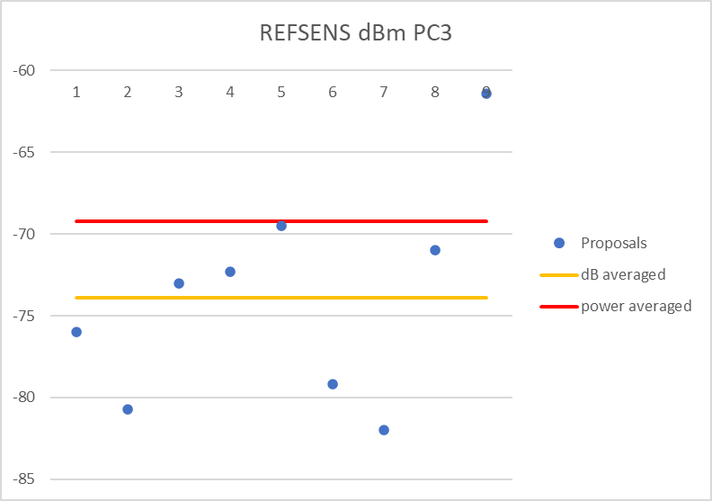

- Option 1: average of dB values (-74 dBm)
- Option 2: average of power values (-69 dBm)
- Option 3: Something else
  - Recommended WF
    - further discuss options

Company | PC3 REFSENS Comments
XXX | YYY

- PC1 REFSENS 400 MHz CCBW
- Option 1: -88.3 dBm
- Option 2: -76.2 dBm
- Option 3: Something else
  - Recommended WF
    - further discuss options
Company | PC1 REFSENS Comments
XXX | YYY

- PC2 REFSENS 400 MHz CCBW
- proposal 1: -80.3 dBm
  - Recommended WF
    - discuss proposal 1
Company | PC2 REFSENS Comments
XXX | YYY

- EIS for all power classes
- Proposal 1 1: use the spherical coverage drops from each power class to determine the EIS
  - Recommended WF
    - proposal 1
Company | EIS for all power classes Comments
XXX | YYY

Moderator tries to summarize discussion status for 1st round, list all the identified open issues and tentative agreements or candidate options and suggestion for 2nd round i.e., WF assignment
Tentative agreements:
Candidate options:
Recommendations for 2nd round:

TRP
Sub-topic description:
Previous agreements:
Open issues and candidate options before e-meeting:
- Proposals
  - Proposal 1: Minimum UE beamforming requirements shall be defined for devices with a TRP exceeding 20 dBm.
  - Proposal 2: Maximum power level TRP of 25 dBm shall be considered.
- Recommended WF
  - further discuss proposals
Company | Comments
XXX | YYYY

Moderator tries to summarize discussion status for 1st round, list all the identified open issues and tentative agreements or candidate options and suggestion for 2nd round i.e., WF assignment
Tentative agreements:
Candidate options:
Recommendations for 2nd round:

UE ACLR
Sub-topic description:
Previous agreements:
Open issues and candidate options before e-meeting:
- Proposals
  - Proposal 1: 15 dB ACLR
- Recommended WF
  - Proposal 1
Company | Comments
XXX | YYYY

Moderator tries to summarize discussion status for 1st round, list all the identified open issues and tentative agreements or candidate options and suggestion for 2nd round i.e., WF assignment
Tentative agreements:
Candidate options:
Recommendations for 2nd round:

Spectral utilization
Sub-topic description:
Previous agreements: 66/264 for 120 SCS has been endorsed in draft CR R4-2202364
Open issues and candidate options before e-meeting:
- Spectral utilization
- Proposal 1: Table proposes 400 MHz (480 and 960 SCS), and 800 – 2000 MHz SU.
- Table 5.3.2-3: Transmission bandwidth configuration N_{RB} for FR2-2
SCS (kHz) | 100 MHz | 400 MHz | 800 MHz | 1600 MHz | 2000 MHz
 | N_{RB} | N_{RB} | N_{RB} | N_{RB} | N_{RB}
120 | 66 | 264 | N/A | N/A | N/A
480 | N/A | 66 | 132 | 264 | N/A
960 | N/A | 33/32 | 66 | 132 | 165

Note: 66/264 for 120 SCS has been endorsed in draft CR R4-2202364
- Proposal 2: Use same SU for 800 and 1600 MHz as agreed for 120 kHz SCS
- Proposal 3: Specify lower spectral utilization for 2000 MHz CCBW as compared to other CCBWs
  - Recommended WF
    - discuss proposals
Company | SU comments
XXX | YYY

Moderator tries to summarize discussion status for 1st round, list all the identified open issues and tentative agreements or candidate options and suggestion for 2nd round i.e., WF assignment
Tentative agreements:
Candidate options:
Recommendations for 2nd round:

ON/ON transient periods for 480 and 960 SCS
Sub-topic description:
Tentative agreement from last meeting: Use the same 5usec for FR2-2.
FFS on introduction of a single value among {1, 2, 3} µS improved ON/ON transient period as the optional UE capabilities for 480 and 960 kHz SCS

Open issues and candidate options before e-meeting:
- Proposals
  - Option 1: 5usec for all SCS (Huawei/HiSilicon, QCOM)
  - Option 2: Introduce 2 µS improved ON/ON transient period as optional UE capabilities for 480 and 960 kHz SCS. (Intel)
  - Option 3: Specify exactly 1 optional capability, either 1usec or 2usec.
- Recommended WF
  - discuss the 3 options

Company | Comments
XXX | XXX

Moderator tries to summarize discussion status for 1st round, list all the identified open issues and tentative agreements or candidate options and suggestion for 2nd round i.e., WF assignment
Tentative agreements:
Candidate options:
Recommendations for 2nd round:

UE beam direction switching time
Sub-topic description:
Open issues and candidate options before e-meeting:
- Proposals
  - Option 1: 200 nsec as in FR2-1 (Huawei/HiSilicon, QCOM)
  - Option 2: 59 nsec. (Nokia)
- Recommended WF
  - discuss the options
Company | Comments
XXX | YYY

Moderator tries to summarize discussion status for 1st round, list all the identified open issues and tentative agreements or candidate options and suggestion for 2nd round i.e., WF assignment
Tentative agreements:
Candidate options:
Recommendations for 2nd round:

Companies views’ collection for 1st round

CRs/TPs comments collection
For close-to-finalize Wis and maintenance work, comments collections can be arranged for TPs and CRs. For ongoing Wis, suggest focusing on open issues discussion on 1st round.
CR/TP number | Comments collection
R4-2205173 | Company A
 | Company B
R4-2205210 | Company A
 | Company B
R4-2205229 | Company A
 | Company B

Summary for 1st round

Open issues
Moderator tries to summarize discussion status for 1st round, list all the identified open issues and tentative agreements or candidate options and suggestion for 2nd round i.e., WF assignment.
 | Status summary
Sub-topic #1 | Tentative agreements:  Candidate options:  Recommendations for 2nd round:

CRs/TPs
Moderator tries to summarize discussion status for 1st round and provides recommendation on CRs/TPs Status update
Note: The tdoc decisions shall be provided in Section 3 and this table is optional in case moderators would like to provide additional information.
CR/TP number | CRs/TPs Status update recommendation
 | Based on 1st round of comments collection, moderator can recommend the next steps such as “agreeable”, “to be revised”

Discussion on 2nd round (if applicable)

Recommendations for Tdocs

1st round
New tdocs
Title | Source | Comments

Existing tdocs
T-doc number | title | Source | Recommendation | Comments
R4-2203707 | On UE spherical coverage for band n263 | Apple
R4-2204330 | Specifications of FR2-2 handheld UE | Murata Manufacturing Co Ltd.
R4-2204033 | Discussion on NR coverage enhancement PUSCH demodulation | Ericsson
R4-2204038 | Minimum Tx requirement for handheld and FWA UEs at 60 GHz | Sony
R4-2204227 | Proposals on FR2-2 spherical drop for requirement calculation | MediaTek Beijing Inc.
R4-2204359 | Handheld UE RF TX requirements for n263 in FR2-2 | NTT DOCOMO, INC.
R4-2204590 | Views on FR2-2 FWA UE | Murata Manufacturing Co Ltd.
R4-2204619 | UE output power for 57-71 GHz | Ericsson
R4-2204934 | Further discussion on handheld UE EIRP and spherical coverage requirements for 52.6~71 GHz | vivo
R4-2205173 | Draft CR to 38.101-2 on band n263 Tx aspects | Apple
R4-2205188 | On 60GHz UE Tx RF requirements | Huawei, HiSilicon
R4-2205210 | draft CR on vehicular UE Tx RF requirements in FR2-2 | LG Electronics Finland
R4-2205227 | Discussion on Tx RF requirements in FR2-2 | LG Electronics Finland
R4-2205246 | 60 GHz UE TX | Qualcomm Incorporated
R4-2205459 | Further Discussion on spectral utilization requirements for FR2-2 | ZTE Corporation
R4-2205552 | On UE Tx RF aspects for FR2-2 | Nokia, Nokia Shanghai Bell
R4-2205999 | UE Tx RF requirements for FR2-2 | Intel Corporation
R4-2204034 | Discussion on NR coverage enhancement PUCCH demodulation | Ericsson
R4-2204039 | Minimum Rx requirement for handheld UEs at 60 GHz | Sony
R4-2204360 | Handheld UE RF RX requirements for n263 in FR2-2 | NTT DOCOMO, INC.
R4-2204935 | Further discussion on handheld UE EIS requirements for 52.6~71 GHz | vivo
R4-2205189 | On 60GHz UE Rx RF requirements | Huawei, HiSilicon
R4-2205229 | draft CR on vehicular UE Rx RF requirements in FR2-2 | LG Electronics Finland
R4-2205231 | Discussion on Rx RF requirements in FR2-2 | LG Electronics Finland
R4-2205292 | 60 GHz UE RX | Qualcomm Incorporated
R4-2205553 | On UE Rx RF aspects for FR2-2 | Nokia, Nokia Shanghai Bell
R4-2206000 | UE EIS requirements for band n263 | Intel Corporation

Notes:
- Please include the summary of recommendations for all tdocs across all sub-topics incl. existing and new tdocs.
- For the Recommendation column please include one of the following:
  - CRs/TPs: Agreeable, Revised, Merged, Postponed, Not Pursued
  - Other documents: Agreeable, Revised, Noted
- For new LS documents, please include information on to/Cc WGs in the comments column
- Do not include hyper-links in the documents

2nd round

Tdoc number | Title | Source | Recommendation | Comments

Notes:
- Please include the summary of recommendations for all tdocs across all sub-topics.
- For the Recommendation column please include one of the following:
  - CRs/TPs: Agreeable, Revised, Merged, Postponed, Not Pursued
  - Other documents: Agreeable, Revised, Noted
- Do not include hyper-links in the documents

Annex
Contact information
Company | Name | Email address
Qualcomm Inc | Phil Coan | pcoan@qti.qualcomm.com
AT&T | Ron Borsato | ronald.borsato@att.com
vivo | Shuai Zhou | Shuai.zhou@vivo.com
DOCOMO | Ryu Kitagawa | ryuu.kitagawa.pn@nttdocomo.com

Note:
- Please add your contact information in above table once you make comments on this email thread.
- If multiple delegates from the same company make comments on single email thread, please add you name as suffix after company name when make comments i.e., Company A (XX, XX)

