3GPP TSG-RAN WG4 Meeting # 102-e draft revised R4-2205135
Electronic Meeting, February 21 – March 3, 2022
Agenda item: 10.15.3.2
Source: Xiaomi
Title: TP for TR 38.785: switching time mask between SL and Uu
Document for: Approval

Introduction
In this text proposal, it is proposed following switching time mask between SL and Uu for both same carrier and different carrier case.

2 References
[1] TR 38.785 v0.5.0

Annex: TP for channel arrangement in TR38.785
============================ Start of TP ============================

5.2.3.2 Tx requirements for intra-band V2X operation with TDM operation

5.2.3.2.1 Additional Tx requirements for TDM operation
To decide the switching position for TDM operation in same/different carrier, RAN4 would be considered as following priority rule in TS38.321
- if both sl-PrioritizationThres and ul-PrioritizationThres are configured, the value of the priority of each NR SL and NR Uu is over the each threshold, then NR Uplink is high priority than NR SL transmission.
- if both sl-PrioritizationThres and ul-PrioritizationThres are configured, the value of the priority of each NR SL and NR Uu is lower the each threshold, NR Uplink is high priority than NR SL transmission.
- if both sl-PrioritizationThres and ul-PrioritizationThres are configured, the value of the priority of NR SL is lower the sl-PrioritizationThres and NR Uu is over the ul-PrioritizationThres, then NR uplink is high priority than NR SL transmission.
- if both sl-PrioritizationThres and ul-PrioritizationThres are configured, the value of the priority of NR SL is over the sl-PrioritizationThres and NR Uu is lower the ul-PrioritizationThres, then NR SL transmisison is high priority than NR uplink.

For the TDM operation in same carrier, the following transmit ON/OFF time mask are applied.
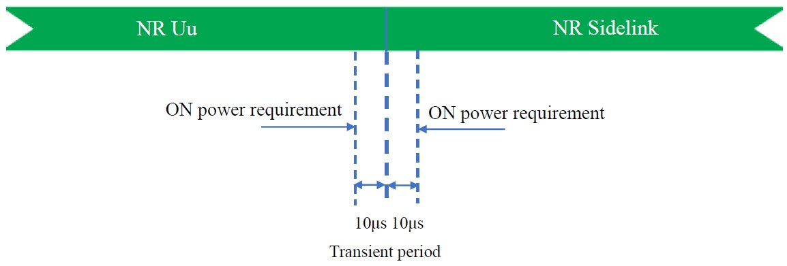
Figure 5.2.3.2.1-1: ON/OFF Time mask for TDM operation in same carrier from NR Uu to NR SL in licensed band

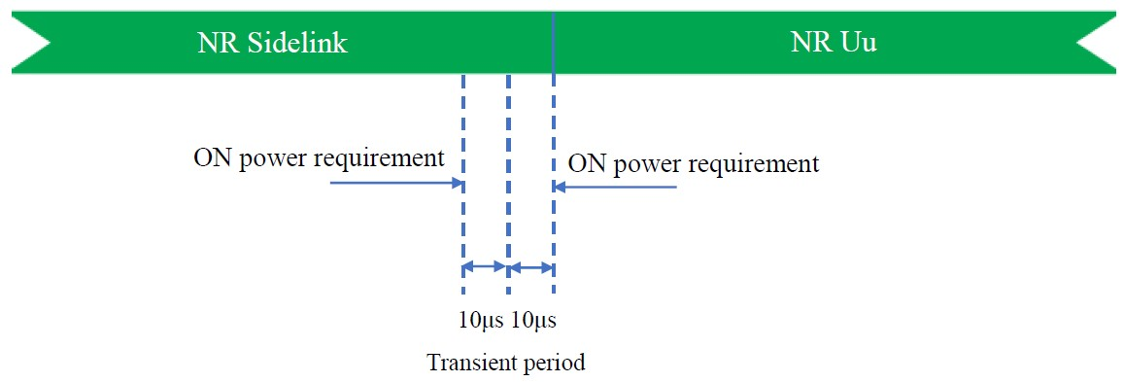
Figure 5.2.3.2.1-2: ON/OFF Time mask for TDM operation in same carrier from NR SL to NR Uu in licensed band
For the TDM operation in different carrier, the following transmit ON/OFF time mask is applied.
The switching time shall be located on the RAT of low priority when NR Uu and NR SL have different priorities based on priority information specified in TS 38.213. It is up to UE implementation when NR Uu and NR SL have the same priority based on priority information specified in TS 38.213.
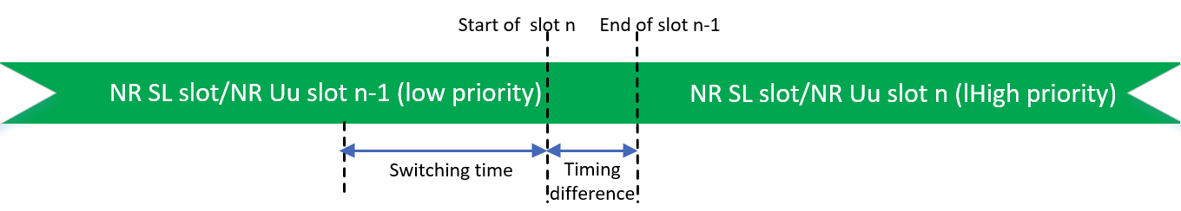
Figure 5.2.3.2.1-3: Time mask for switching between SL and Uu for different carrier case
In the real field, there is a timing advance difference, i.e. $N_{TA}∙T_{c}$ between NR Uu slot and NR SL slot due to different timing advance of NR Uu and NR SL which has been specified in sub-clause 5.2.1. The On/Off time mask can be shifted due to the time advance difference in the same carrier and different carrier.

============================ End of TP ============================

