3GPP TSG-RAN WG4#101bis-e R4-220xxxx
Electronic meeting, 17th – 25th January 2022

Source: Ericsson
Title: TP to TR 38.854: Coverage analysis
Agenda Item: 6.9.1
Document for: Approval

Introduction
This contribution proposes text capturing Ericsson analysis for HST FR2 Scenario A, B uni- and bi- directional operation. The analysis is in line with the decisions to consider uni-directional for scenario A, uni- and bi- directional for scenario B and the numbers of beams in each case.

Text Proposal

6.3.3.x Link level performance from Ericsson
For scenario A and B, uni- and bi-directional scenarios, Ericsson provided evaluation in contributions R4-2104679 and R4-2104680. The analysis has been performed using the antenna array configurations in sections 6.1.1 and 6.1.3.

6.3.3.x.1 Scenario-A, Uni-directional RRH Deployment
For this scenario, it was assumed that the RRHis positioned such that the antenna(s) face directly along the track; i.e. a zero degree steered beam is parallel to the track (in both azimuth and elevation). The UE on the train is positioned such that it’s antenna(s) point directly along the track.
Zero beam steering was assumed, and so the RRHbeam points along the track (but is 10m away from the track) and the UE beam points along the track.
These assumptions are not fully optimal, but they are sufficient to demonstrate that a single TX and a single RX beam is sufficient.
The antenna radiation patterns in azimuth for the UE and RRHare depicted in figure 6.3.3.x.1-1. The array is symmetrical in both axes, so the elevation patterns are the same as the azimuth patterns.

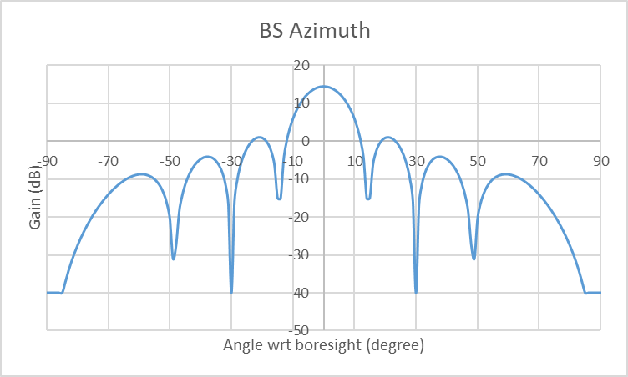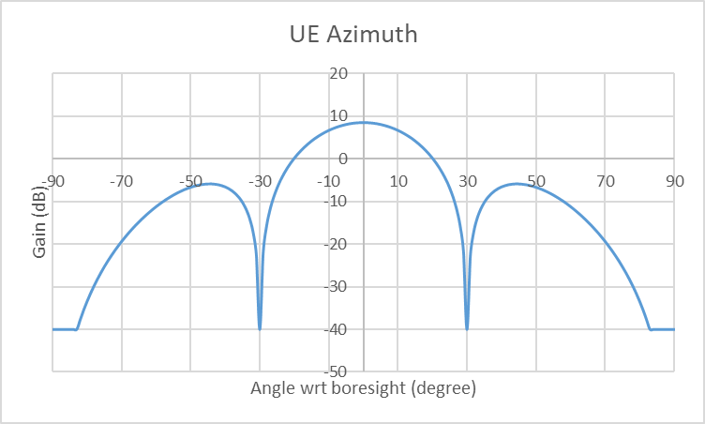

Figure 6.3.3.x.1-1: RRH and UE antenna radiation patterns in azimuth (Elevation patterns are the same)
The most critical link for coverage is the uplink. Thus, the uplink was modelled considering 23dBm transmitter power for the UE. For a train mounted UE, this may be an underestimate for the power.
The coverage pattern for the single TX / RX beam is depicted in figure 6.3.3.x.1-3. A uni-directional deployment is considered in which the RRHantenna is pointing in the direction of movement of the train and the UE antenna away from the direction of movement of the train. The x axis represents the distance along the track from the point on the track that is closest to the RRH. (That implies, at zero on the x axis the UE on the side is parallel to the RRH which is 10m away from the side of the track). The y axis represents UL SNR assuming 10dB noise figure at the RRH

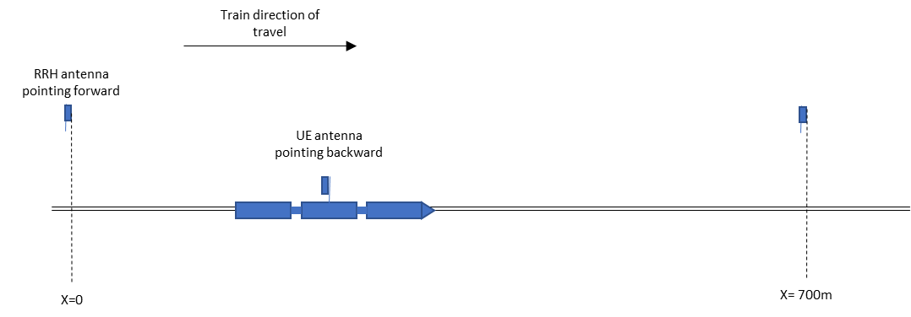
Figure 6.3.3.x.1-2: Unidirectional deployment scenario

As can be seen in the figure, good coverage is obtained when the train is further than 60-70m along the track from the RRH. Furthermore, the SNR remains good from 700-800m; i.e. the SNR from the RRHat position zero on the track is still good as the UE passes the next RRH (located at 700m along the track)

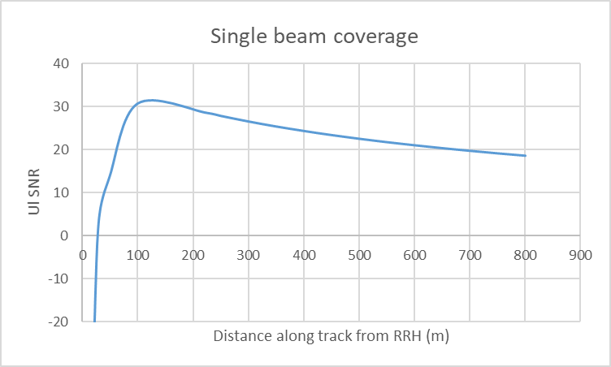

Figure 6.3.3.x.1-3: UL SNR for single TX and single RX beam

Using DPS, the UE can switch RRH after travelling around 60-70m along the track from RRH2 in the figure. Assuming that this is the case, then the SNR observed when travelling along the track is as depicted in figure 4. For downlink, the SNR will be greater.

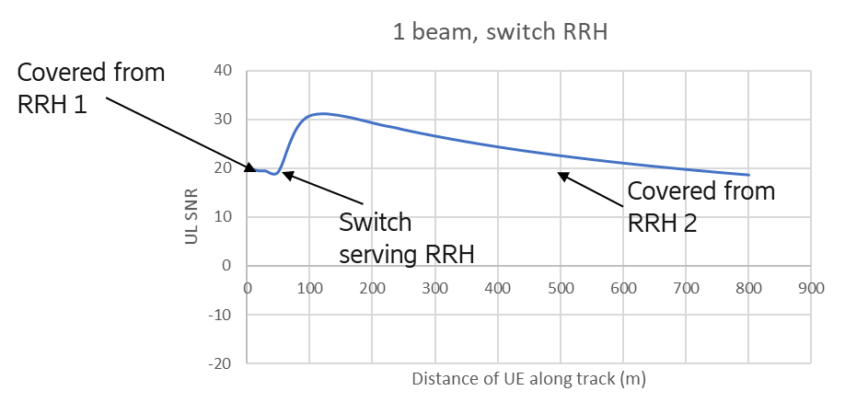
Figure 6.3.3.x.1-4: UL SNR assuming single TX/RX beam and DPS switching between RRH

Based on this analysis, we observe that in scenario 1, in a uni-directional deployment it is sufficient to operate with a single TX beam and a single RX beam.

6.3.3.x.2 Scenario-A, Bi-directional RRH Deployment
Uni-directional deployment in Scenario A provides very good coverage. Bi-directional deployment would require connection to the second nearest basestation when the UE would be within around 50m from a basestation due to the large azimuth angle to the nearest RRH at that point. Thus, bi-directional deployment would require double the antenna infrastructure at basestations with no coverage or capacity gain.
If RRH are equipped with two antenna, improved throughput can be obtained by operating each direction as an independent uni-directional UE. In a future release, multi-antenna single UE operation may also be introduced.

6.3.3.x.3 Scenario-B, Uni-directional RRH Deployment
To consider the number of beams and coverage, a deployment has been analyzed considering scenario B. The RRH antennas are rotated by 13 degrees towards the track, whilst the UE antenna points parallel to the track. Up to 3 RRH beams and up to 2 UE beams are considered. Uplink SNR is considered for depicting the coverage of the beams, since UL SNR is the most critical scenario. DL SNR will be larger than UL SNR.
The x axis represents the distance along the track from the point on the track that is closest to the RRH. (That implies, at zero on the x axis the UE on the side is parallel to the RRH, which is 150m away from the side of the track). The y axis represents UL SNR assuming 10dB noise figure at the RRH and 23dBm UE TRP.

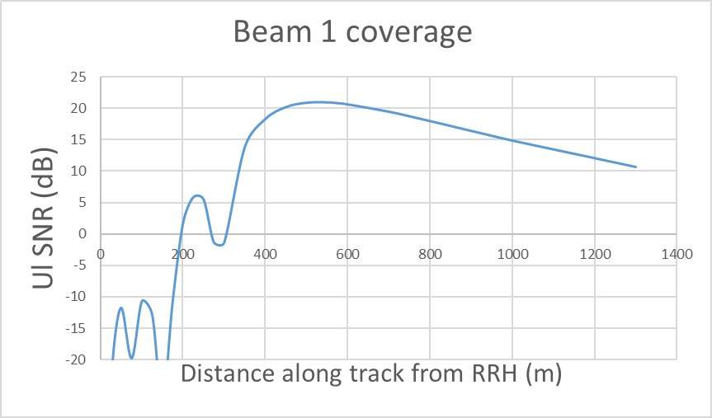
Figure 6.3.3.x.3-1: Coverage of RRH beam 1 + UE beam 1

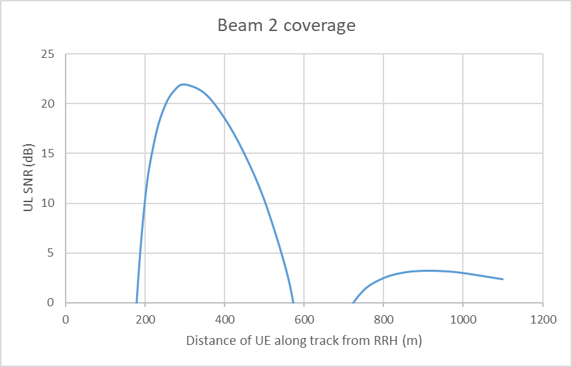
Figure 6.3.3.x.3-2: Coverage of RRH beam 2 + UE beam 1

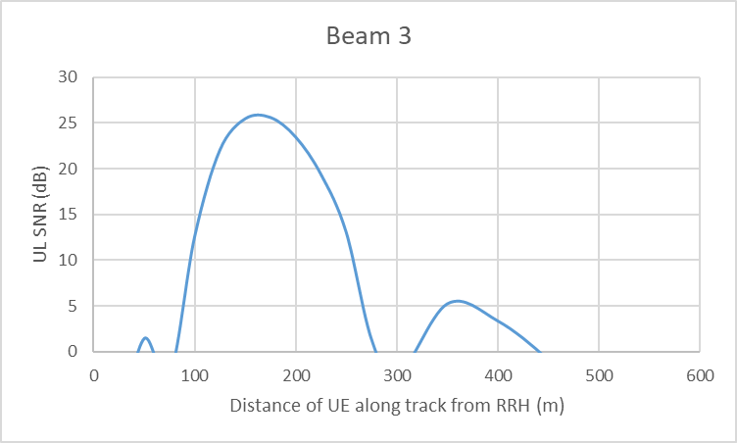
Figure 6.3.3.x.3-3: Coverage of RRH beam 3 + UE beam 2

Figure 6.3.3.x.3-1 indicates that the first RRH beam can provide coverage from around 300-400m along the track to around 1km along the track. This means that the RRH can provide coverage to a point well beyond the following RRH. Figures 6.3.3.x.3-2 and 6.3.3.x.3-3 indicate that the remaining beams can provide coverage closer to the RRH.
There is little point in providing more beams. Beam 3 provides coverage from around 100-150m from the RRH. Closer to the RRH, beam 1 from the previous RRH is able to provide coverage. Further beams closer to the RRH would be narrow in coverage and do not improve SNR.
Figure 6.3.3.x.3-4 indicates the SNR if a single TX/RX beam (beam 1) is used and coverage close to the RRH is provided from the previous/next RRH. The figure indicates that good UL SNR of above 15dB (DL SNR will be larger than this) can be provided along the length of the track with one TX and one RX beam.

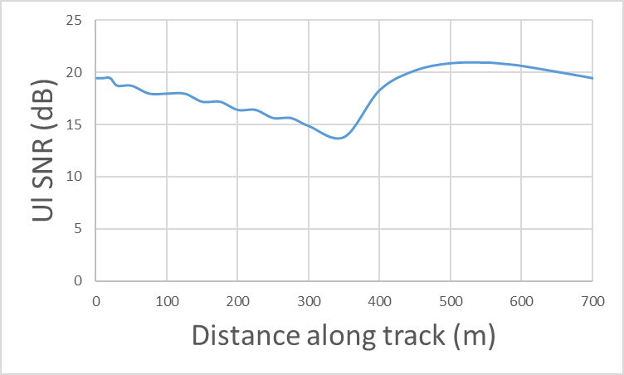
Figure 6.3.3.x.3-4: Coverage provided from next and previous RRH with 1 beam per RRH and UE antenna.

Figure 6.3.3.x.3-5 depicts the coverage obtained with 3 beams per RRH antenna and 2 beams per UE antenna, considering both the current and previous RRH. The figure shows that the lowest SNR level can be improved a few dB compared to the single beam case.

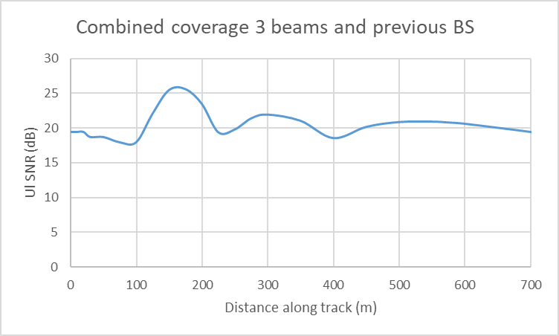
Figure 6.3.3.x.3-5: Coverage provided from next and previous RRH with 3 beams per RRH antenna and 2 beams per UE antenna.

Thus, we observe that it is perfectly feasible to assume just on beam per antenna also for scenario B as long as the RRH antenna is oriented slightly towards the track. There is some scope for further optimization if 3 RRH / 2 UE beams are considered. Also, allowing for more beams offers more robustness for covering track curves.

6.3.3.x.4 Scenario-B, Bi-directional RRH Deployment
For bi-directional deployment, half of the distance along the track would be covered by one RRH and the other half by the following RRH

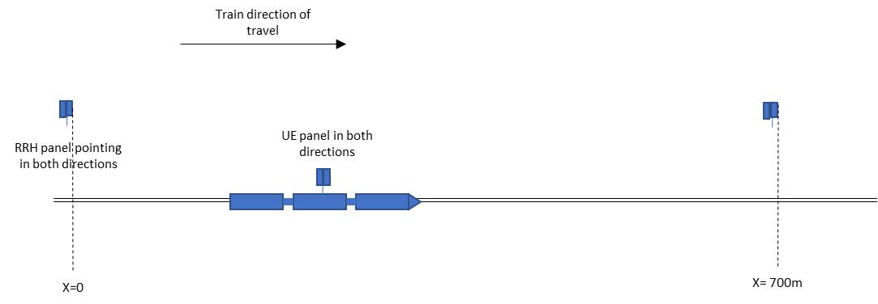

Figure 6.3.3.x.4-1: Bi-directional deployment scenario

The figure below depicts the achievable coverage using 3 beams at the RRH and 3 beams at the UE, with the RRH and UE antennas pointed parallel to the track. After 350m along the track, coverage would be provided by the next RRH. To avoid a break in coverage close to the RRH, the next nearest RRH should be used to serve the UE when it is close in to a RRH.

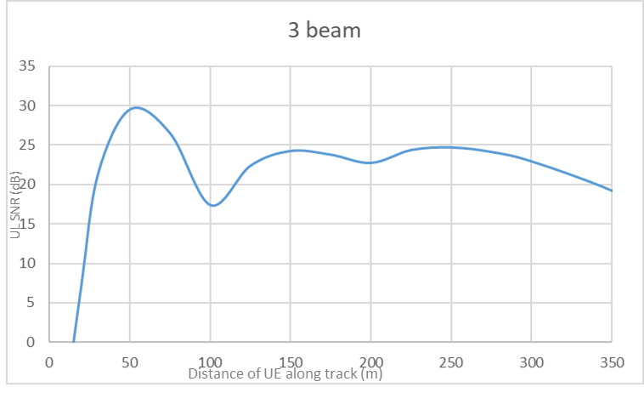
Figure 6.3.3.x.4-2: UL SNR with 3 beams per UE and RRH in each direction with DPS switching between beams and RRH

