3GPP TSG-RAN WG4 Meeting #101bis-e Final draft R4-2203088

Electronic Meeting, 17th - 25th Jan, 2022

Title: TP to TR 38.854 on Deployment Scenario Analysis for FR2 HST
Source: Huawei, HiSilicon
Agenda item: 6.9.2
Document for: Discussion

1 Background
In this contribution, we provide our text proposal to TR 38.854 on deployment scenario analysis for FR2 HST based our contribution [1] and [2].

2 Reference
- R4-2119021, Discussion on NR FR2 HST deployment Scenario-A, RAN4#101-e, Huawei, HiSilicon
- R4-2119022, Discussion on NR FR2 HST deployment Scenario-B, RAN4#101-e, Huawei, HiSilicon

3 Text proposal

6.3.3.2 Link performance Evaluation from Huawei

6.3.3.2.1 Scenario A
For Scenario-A, uni-directional and bi-directional deployment, Huawei provide the evaluation in the contributions R4-2119021 based on simulation assumption as shown in clause 6.1 and Table 6.3.3.2.1-1.
Table 6.3.3.2.1-1 Simulation assumption for Scenario-A
Parameter | Value
Carrier frequency | 30GHz
Ds | 700m
Dmin | 10m
RRH Tx power | 47dBm
RRH height | 15m
RRH antenna array | [Mg, Ng, M, N, P]=[1, 1, 8, 8, 2]
Path Loss | RMa LoS
UE antenna height | 5m
UE antenna array | [Mg, Ng, M, N, P]=[1, 1, 4, 4, 2]
UE noise figure | 10dB
ILs | 13 dB
SNR | 18.6dB (i.e. FR2 Test 2-6, 64QAM CR=0.43 and Rank2 in TS 38.101-4)

6.3.3.2.1.1 Scenario A, Bi-directional
There are two schemes for Bi-directional deployment. Considering very small Dmin, the angle between RRH-UE line and the railway can be negligible, so only Scheme-1 is for further analysis.
Figure 6.3.3.2.1.1-1 Scheme-1 for Bi-directional deployment
For Scheme-1, 1 beam per RRH panel and 6 beam per UE panel is selected. Note that a single RRH panel or UE panel refers to the antenna configuration in Table 6.3.3.2.1-1. The RRH panel boresight is pointed to the railway at the distance of Ds, the beam is pointed to the railway at the distance of Ds. When the UE is at the distance of Ds, the UE panel boresight is point to RRH panel boresight rightly. The link budget analysis is shown as Figure 6.3.3.2.1.1-2 below.
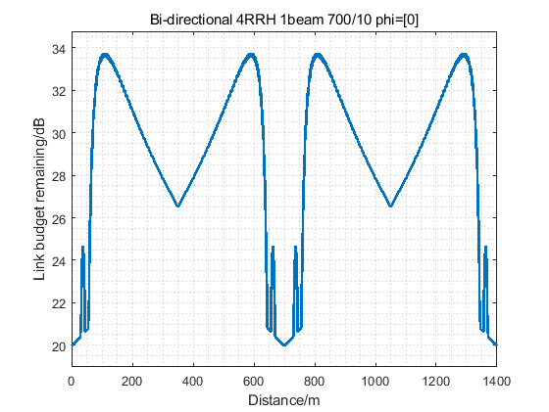
Figure 6.3.3.2.1.1-2 Link budget for Scheme-1
For Scheme-1, the power of side-lobes for different beams change rapidly when UE is near to the RRH and the minimum time duration for the best beam with same beam index can be far less than 160 ms that is the L1-RSRP measurement period for HST FR2 scenario. It is a great challenge for the UE to ensure the performance not to degrade in such location. UE can use different strategy by implementation, such as select the best beam as per RSRP measurement result or directly switch the UE beam point to the main-lobe beam transmission from the next RRH. For the former one, the best beam may be unavailable with high probability once UE beam switching has been performed.
6.3.3.2.1.2 Scenario A, Uni-directional
For Uni-directional deployment, 1 beam per RRH panel and 2 beam per UE panel is selected. Note that a single RRH panel or UE panel refers to the antenna configuration in Table 6.3.3.2.1-1. The RRH panel boresight is pointed to the railway at the distance of Ds, the beam is pointed to 0 degrees. When the UE is at the distance of Ds, the UE panel boresight is point to RRH panel boresight rightly. The link budget analysis is shown as Figure 6.3.3.2.1.2-1 below.
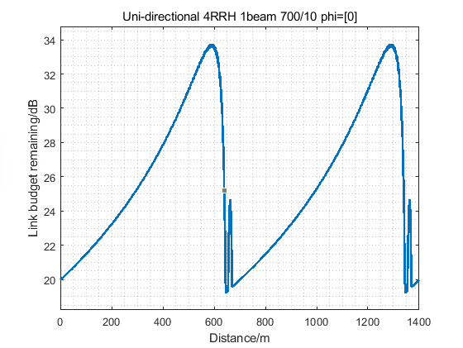
Figure 6.3.3.2.1.2-1 Link budget for Uni-directional deployment
The link budget remaining and the minimum beam dwelling time for Uni-directional deployment is shown as Table 6.3.3.2.1.2-1 below.
Table 6.3.3.2.1.2-1 Link budget remaining and minimum beam dwelling time
link budget remaining[dB] | minimum beam dwelling time[s] | Beam switching point[m]
19.2 | 7.20 | 50

6.3.3.2.2 Scenario B
For Scenario-B, uni-directional and bi-directional deployment, Huawei provide the evaluation in the contributions R4-2119022 based on simulation assumption as shown in clause 6.1 and Table 6.3.3.2.2-1.
Table 6.3.3.2.2-1 Simulation assumption for Scenario-B
Parameter | Value
Carrier frequency | 30GHz
Ds | 700m
Dmin | 150m
RRH Tx power | 47dBm
RRH height | 15m
RRH antenna array | [Mg, Ng, M, N, P]=[1, 1, 8, 8, 2]
Path Loss | RMa LoS
UE antenna height | 5m
UE antenna array | [Mg, Ng, M, N, P]=[1, 1, 4, 4, 2]
UE noise figure | 10dB
ILs | 13 dB
SNR | 18.6dB (i.e. FR2 Test 2-6, 64QAM CR=0.43 and Rank2 in TS 38.101-4)

6.3.3.2.2.1 Scenario B, Bi-directional
There are four schemes for Bi-directional deployment are for further analysis.
a) Scheme-1 b) Scheme-2
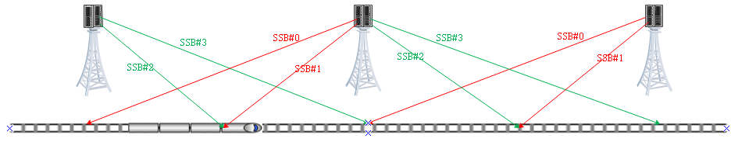
c) Scheme-3
Figure 6.3.3.2.2.1-1 Candidate schemes for Bi-directional deployment
For Scheme-1, 1 beam per RRH panel and 6 beam per UE panel is selected. Note that a single RRH panel or UE panel refers to the antenna configuration in Table 6.3.3.2.2-1. The RRH panel boresight is pointed to the railway at the distance of Ds, the beam is pointed to the railway at the distance of Ds. When the UE is at the distance of Ds, the UE panel boresight is point to RRH panel boresight rightly. The link budget analysis is shown as Figure 6.3.3.2.2.1-2 below.
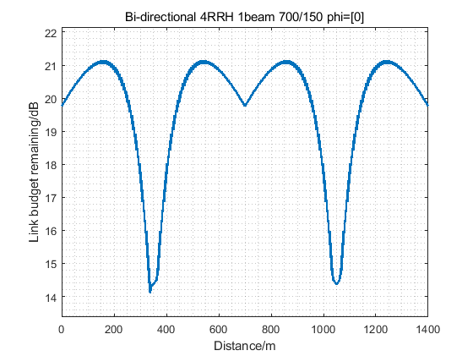
Figure 6.3.3.2.2.1-2 Link budget for Scheme-1
For Scheme-2, 1 beam for one RRH panel and 2 beams for another RRH panel and 6 beam per UE panel is selected. Note that a single RRH panel or UE panel refers to the antenna configuration in Table 6.3.3.2.2-1. The RRH panel boresight is pointed to the railway at the distance of Ds, the beam is pointed to 0 and 10 degrees. When the UE is at the distance of Ds, the UE panel boresight is point to RRH panel boresight rightly. The link budget analysis is shown as Figure 6.3.3.2.2.1-3 below.
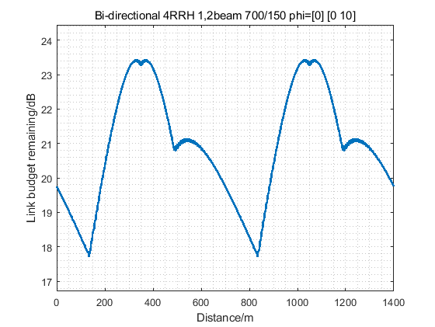
Figure 6.3.3.2.2.1-3 Link budget for Scheme-2
For Scheme-3, 2 beam per RRH panel and 6 beam per UE panel is selected. The RRH panel boresight is pointed to the railway at the distance of Ds, the beam is pointed to 0 and 10 degrees. When the UE is at the distance of Ds, the UE panel boresight is point to RRH panel boresight rightly. The link budget analysis is shown as Figure 6.3.3.2.2.1-4 below.
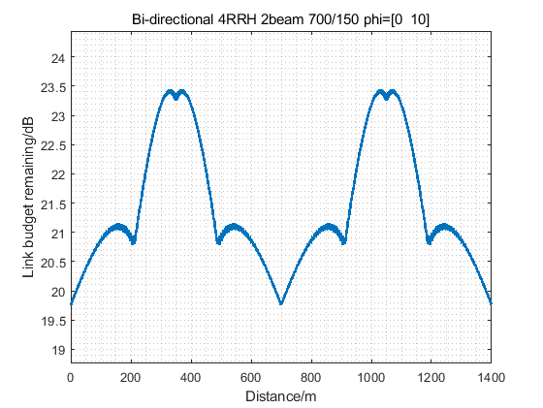
Figure 6.3.3.2.2.1-4 Link budget for Scheme-3
The link budget remaining and the minimum beam dwelling time for three schemes are shown as Table 6.3.3.2.2.1-1 below.
Table 6.3.3.2.2.1-1 Link budget remaining and minimum beam dwelling time
 | link budget remaining[dB] | Minimum beam dwelling time[s] | Beam switching point[m]
Scheme-1 | 14.3 | 3.60 | [0,350]
Scheme-2 | 17.7 | 2.06 | [150, 350, 500]
Scheme-3 | 19.8 | 1.54 | [0, 200, 350, 500]

6.3.3.2.2.2 Scenario B, Uni-directional
For Uni-directional deployment, 2 beams per RRH panel and 6 beam per UE panel is selected. The RRH panel boresight is pointed to the railway at the distance of Ds, the beam is pointed to 0 and 10 degrees. When the UE is at the distance of Ds, the UE panel boresight is point to RRH panel boresight rightly. The link budget analysis is shown as Figure 6.3.3.2.2.2-1 below.
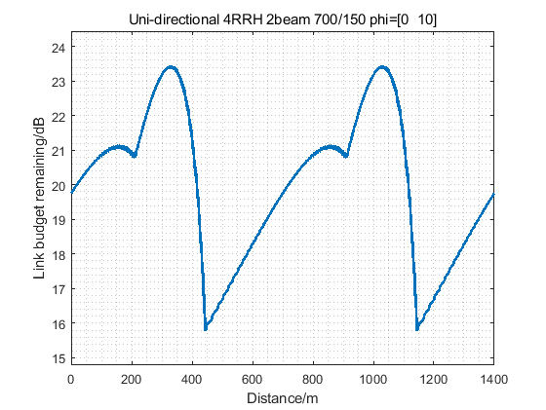
Figure 6.3.3.2.2.2-1 Link budget for Uni-directional deployment
The link budget remaining and the minimum beam dwelling time for Uni-directional deployment is shown as Table 6.3.3.2.2.2-1 below.
Table 6.3.3.2.2.2-1 Link budget remaining and minimum beam dwelling time
link budget remaining[dB] | minimum beam dwelling time[s] | Beam switching point[m]
15.8 | 2.57 | [200, 450]

