**3GPP TSG-RAN WG4 Meeting # 101bis-e R4-220xxxx**

Electronic Meeting, 17-25 January 2022

**Source:** Qualcomm Incorporated, Skyworks Solutions Inc.,

**Title:** WF on triple beat evaluation and specification framework

**Agenda Item:** 5.6.1

**Document for:** Approval

# Background – Motivation for Way Forward

* Band combinations with 3 ULCCs were analysed in [1]
* Further analysis and measurements were completed recently in [4]
* 3 active UL CCs create triple beat distortion and can lead to RX de-sensitization.
* Eligible REL-17 band combinations from [1][2] that were detected to create triple beat distortion are highlighted in yellow in table below. According to RAN plenary guidelines [6], the combinations highlighted are not eligible for REL-17 and should not be requested or specified.

|  |  |  |  |  |
| --- | --- | --- | --- | --- |
| 3A_n7B | 3A_n41C | 3A_n78(2A) | 7C_n28A | 41C_n3A |
| 28A_n7B | 3C_n1A | 3C_n77A | 7C_n78A | 41C_n77A |
| 1A_n7B | 3C_n5A | 3C_n78A | 8A_n79C | 41C_n78A |
| 1C_n3A | 3C_n7A | 3C_n79A | 25A_n41C | 41C_n79A |
| 2C_n41A | 3C_n28A | 7C_n1A | 30_n77(2A) | 42C_n28A |
| 2C_n71A | 3C_n41A | 7C_n3A | 39C_n41A | 42C_n3A |
| 2A_n77(2A) | 3A_n77(2A) | 7C_n5A | 40C_n78A | 66_n77(2A) |

# Background – Detection

* The detection mechanism for the 1st order triple beat is shown below from [2]
  + - Duplex Offset is the duplex offset of the victim FDD band
    - ULCAMBW is the non-contiguous 2 tone allocation spacing
    - TXMBW and RXBW is the FDD victim band TX transmission measured BW and the RX DL channel BW respectively



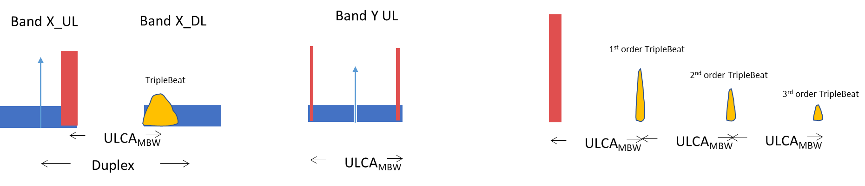

# Background – Analysis

* Triple beat distortion occurs at RX and TX and is a 3rd order non-linearity that is mainly α (TX22TX1) and is more prominent for non-contiguous RB allocations.
* For TX
  + - Both forward and reverse triple beat products can occur at the transmitter
    - It was shown that the triple beat distortion at the ULCA transmitter path is dominant for TX due to 2:1 variation with ULCA output power
    - PCB isolation from FDD band PA to ULCA band PA will affect forward TX distortion
    - ULCA Filter rejection and antenna isolation will affect the reverse TX distortion
* For RX
  + - RX path filter rejection for both TX bands and the 3rd order non-linearity specification determines the RX triple beat distortion
* Power Back-off
  + - For ULCA band, the power is backed off to meet the general emission requirements or CA_NS_04 requirement.
      * this can be a function of tone spacing.
    - For FDD band, the power is backed off to meet the NS_01 requirement
    - Backed off power must meet the power class requirement
    - Worst case triple beat will occur with equal power on the 3ULCCs if both power class and emission requirements are met.

# Background – Previous Framework for Specification [5]

* Mainly consider the 1st order triple beat α (TX22TX1) of 3rd order non-linearity -> this is shown in the table as triple beat order 1.
  + Detection -> $Duplex Offset<{1∙ULCA}_{MBW}+\frac{{TX}_{MBW}}{2} +\frac{RXBW}{2}$
* Further check the 2nd order triple beat α (TX24TX1) of 5th order non-linearity -> this would be shown in the table as triple beat order 2.
  + Detection -> $Duplex Offset<{2∙ULCA}_{MBW}+\frac{{TX}_{MBW}}{2} +\frac{RXBW}{2}$
  + This may come into play for higher TX power for power class 2 capable bands
  + Neglect the 3rd order triple beat α (TX26TX1) of 7th order non-linearity.
  + Detection -> $Duplex Offset<{3∙ULCA}_{MBW}+\frac{{TX}_{MBW}}{2} +\frac{RXBW}{2}$
* Verify MSD test points including RB positions and consider following framework for specification.
  + If FDD victim TX band allocation is fully allocated, then RB positions in table are chosen so that ULCA tone spacing is at the duplex offset
  + Tone spacing and RB positions also chosen for least amount of back-off to meet emission requirements

# WF on TP Guidelines

## Triple Beat with 2TX band and 3ULCC with at least 1 FDD band

* ULCA band (TDD or FDD)
  + - ULCA BW = CC1BW + W gap + CC2BW
    - In REL-17, eligible combinations are restricted to intra-band contiguous UL CA, so Wgap is not applicable for REL-17 combinations [6].
* Non-ULCA band
  + - Must be FDD band
    - Duplex Offset
    - RX BW
    - TX MBW
* Triple Beat Condition
  + - **1st order is TRUE** if Duplex Offset < ULCA BW + FDD RXBW/2 + FDD TX MBW/2
    - **and**
    - The non-ULCA band must be a FDD band
    - Only Investigate 1st order triple beat and further check if MSD for 2nd order triple beat is required
    - Example of condition for band combinations is shown in table below

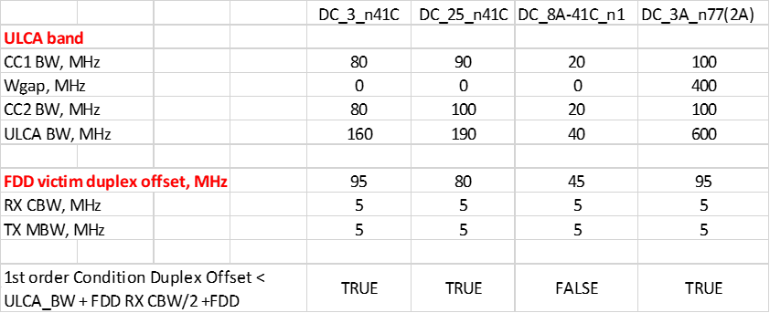

## Triple Beat Test Point Parameters

* ULCA band (TDD or FDD) Parameters
  + - Must have non-contiguous RB allocation in UL LCRB (ie. 1RB + 1RB)
    - Duplex mode (ie. FDD or TDD)
    - Spacing between RB allocations in each CC must equal the FDD Victim band duplex offset
    - UL CC1 BW and UL CC1 Fc
    - UL CC2 BW and UL CC2 Fc
* Non-ULCA FDD band Parameters
  + - DL Fc and UL Fc
    - TX LCRB
    - RX BW
    - TX BW
* Triple Beat Order
  + - 1st order triple beat is for 3rd order non-linearity
    - Further investigate if 2nd order triple beat (5th order non-linearity) is required

|  |  |  |  |  |  |  |  |  |
| --- | --- | --- | --- | --- | --- | --- | --- | --- |
| **NR or E-UTRA Band / Channel bandwidth / NRB / MSD** | | | | | | | | |
| **EN-DC**  **Configuration** | **EUTRA or NR band** | **UL Fc  (MHz)** | **UL/DL**  **BW (MHz)** | **UL  LCRB** | **DL Fc**  **(MHz)** | **MSD  (dB)** | **Duplex mode** | **Triple beat order** |
| DC_3A-n41C | 3 | 1782.5 | 5 | 25 | 1877.5 | [12.7] | FDD | 1 |
| n41C | 2555  2635 | [80]  [80] | [1 (RBstart=88)]  [1 (RBstart=128)] | 2555  2635 | N/A | TDD | N/A |
| DC_25A-n41C | 25 | 1912.5 | 5 | 25 | 1992.5 | [5.4] | FDD | 1 |
| n41C | 2545  2595 | 90  100 | 1 (RBstart=150)  1 (RBstart=122) | 2545  2595 | N/A | TDD | N/A |
| DC_8A-n79C | 8 | 912.5 | 5 | 25 | 957.5 | [0] | FDD | 1 |
| n79C | 4545  4645 | 100  100 | 1 (RBstart=212)  1 (RBstart=60) | 4545  4645 | N/A | TDD | N/A |

## WF Recommendation of TB MSD Framework

* TB MSD evaluation is not trivial as several coupling paths need to be evaluated: FWD and REV IMD for each PA + LNA contribution. Depending on the coupling isolation assumptions, reverse TB IMD may play an important role.



* On one coupling path, there seem to agreements between two contributing companies for DC_3A_n41C. [1] [4]
* Considering the short time left to complete the missing REL-17 TB MSD analysis, the remaining task seems challenging.
* These guidelines are intended to help companies bring MSD analysis.

## Examples using minimum parameters for triple beat MSD

* Power backoff for each of 3CCs
  + Must not violate the power class
  + MSD is worst case when good filter is used to minimize back-off
* TB IMD at PA output
* PA-PA PCB rejection for forward PA triple beat
* Filter rejections
  + Triple beat rejection from PA to antenna
  + Reverse PA TX filter rejection
  + TX-RX filter rejections for TX at RX LNA input (to calculate triple beat for RX LNA)
* TB IP3 for LNA
* MSD with some example parameters is shown for DC_3_n41C and DC_25_n41C in table below

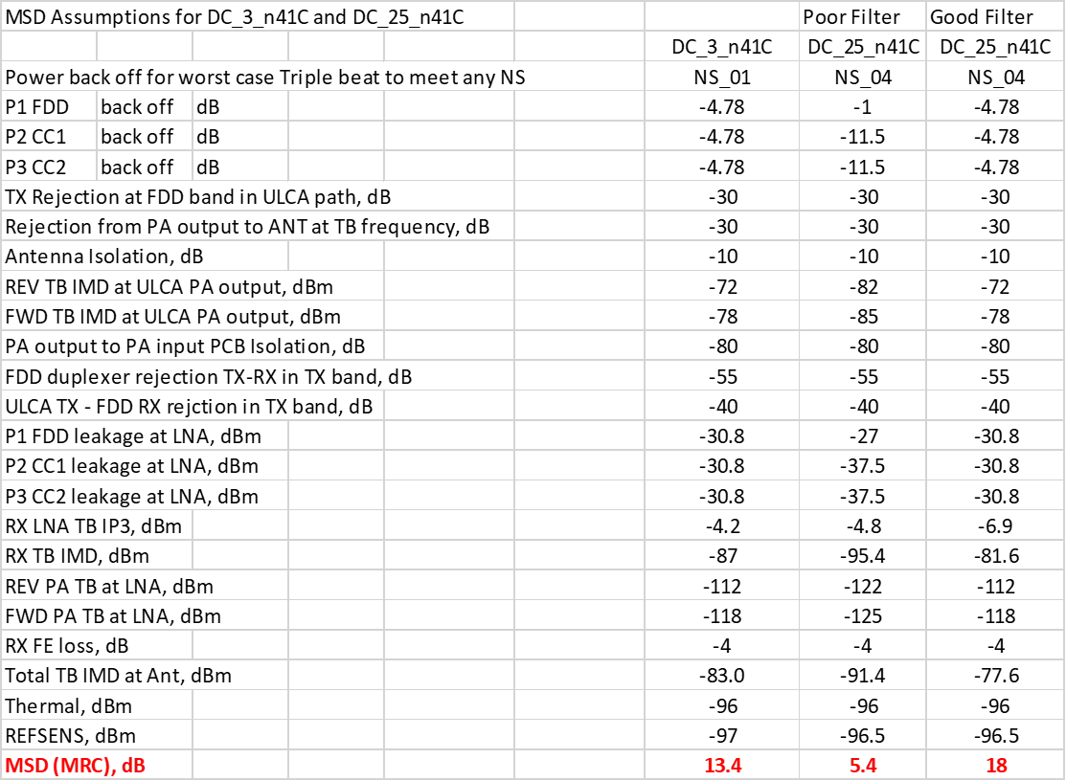

# References

[1] R4-2107627, Triple beat and 3ULCC MSD, Qualcomm Incorporated, R4#99-e

[2] R4-2111016 MSD Due to NR Intra-band ULCA IMD within Inter-band Combinations, Skyworks, R4#99-e

[3] R4-2105335 Way forward on analysis and framework of triple beat issue of 3CC UL with contiguous intra band UL CA , Qualcomm Inc., R4#98bis-e

[4] R4-2202154 rev of R4-2202034 Triple beat B3 MSD evaluation for DC_3A_n41C, Skyworks, R4#101Bis-e

[5] R4-2107803 WF on MSD due to triple beat of intra-band UL CA UL + FDD UL configurations, Skyworks, Qualcomm, R4#99-e

[6] RP-210639, Guidelines for FR1 CA/DC band combinations not subject to block approval, 3GPP TSG-RAN #91-e , Apple Inc., Skyworks Solutions Inc.