3GPP TSG-RAN WG4 Meeting #100-e R4-2115761

Electronic Meeting, August 16-27, 2021
CR-Form-v12.1
CHANGE REQUEST
 | 38.827 | CR | draft | rev | 1 | Current version: | 16.3.0
For HELP on using this form: comprehensive instructions can be found at
http://www.3gpp.org/Change-Requests.

Proposed change affects: | UICC apps |  | ME | X | Radio Access Network |  | Core Network

Title: | Draft CR to TR 38.827: correction of power validation
Source to WG: | vivo
Source to TSG: | R4
Work item code: | FS_NR_MIMO_OTA_test |  |  |  |  |  | Date: |  |  | 2021-7-10
Category: | F |  |  |  |  |  | Release: |  |  | Rel-16
 | Use one of the following categories:  F (correction)  A (mirror corresponding to a change in an earlier release)  B (addition of feature),  C (functional modification of feature)  D (editorial modification)  Detailed explanations of the above categories can  be found in 3GPP TR 21.900. |  |  |  |  |  |  |  | Use one of the following releases:  Rel-8 (Release 8)  Rel-9 (Release 9)  Rel-10 (Release 10)  Rel-11 (Release 11)  …  Rel-15 (Release 15)  Rel-16 (Release 16)  Rel-17 (Release 17)  Rel-18 (Release 18)
Reason for change: |  | In TR 38.827, the power validation frequency and test procedure is not correct.
Summary of change: |  | Update the power validation frequency and test procedure.
Consequences if not approved: |  | Power validation can not be performed.
Clauses affected: |  | 7.4.1, 7.4.1.5
 |  | Y | N
Other specs |  |  | X | Other core specifications |  |  |  | TS/TR ... CR ...
affected: |  |  | X | Test specifications |  |  |  | TS/TR ... CR ...
(show related CRs) |  |  | X | O&M Specifications |  |  |  | TS/TR ... CR ...
Other comments:
This CR's revision history:

< start of change 1>

7.4 Verification of Channel Model implementation

7.4.1 Channel Models validation
This clause describe the MIMO OTA validation measurements, in order to ensure that the channel models are correctly implemented and hence capable of generating the propagation environment, as described by the model, within the test zone.
The following measurements shall be done for FR1 channel model validation:
Power Delay Profile (PDP)
Doppler/Temporal correlation
Spatial correlation
Cross-polarization
Power validation

The following measurements shall be done for FR2 channel model validation:
Power Delay Profile (PDP)
Doppler/Temporal correlation
PAS similarity percentage (PSP)
Cross-polarization
Power validation
Frequencies to be used to test for channel model validation and quality of quiet zone validation:
Table 7.4.1-1: Frequencies for PDP, Doppler, Spatial correlation, Cross-polarization validation, and Quality of Quiet Zone validation
NR FR1 Bands | Range | Test frequency (MHz)
n71 | Low | 617MHz
n12, n17, n29, n14, n28 | Low | 722MHz
n5, n8, n18, n20 | Low | 836.5MHz
n50, n51, n74 | Mid | 1575.42MHz
n3, n2, n25, n39 | Mid | 1880MHz
n1, n34, n65 | Mid | 2132.5MHz
n7, n30, n41, n40, n38, [n90] | Mid | 2450MHz
n77,n78 | High | 3600MHz
n79 | High | [4700MHz]
Table 7.4.1-2: Channel model validation and Quality of Quiet Zone validation frequencies
NR FR2 Bands | Range | Test Frequency (MHz)
n257 | Low | 27750
n260 | High | 38500
n258 | Low | 25875
n261 | Low | 27925

Table 7.4.1-3: Frequencies for FR1 power validation
NR FR1 Bands | Range | Test frequency (center frequency of each band)
n71 | Low | n71
n12, n17, n29, n14, n28 | Low | n28
n5, n8, n18, n20 | Low | n8
n50, n51, n74 | Mid | n51
n3, n2, n25, n39 | Mid | n3
n1, n34, n65 | Mid | n1
n7, n30, n41, n40, n38, [n90] | Mid | n41
n77, n78 | High | n78
n79 | High | n79

< end of change 1>

< start of change 2>

7.4.1.5 Power validation
FR1 power validation procedure for MPAC system:
This measurement checks the total power in the center of the test zone. The power validation is measured with a spectrum analyzer as shown in Figure 7.4.1.5-1.
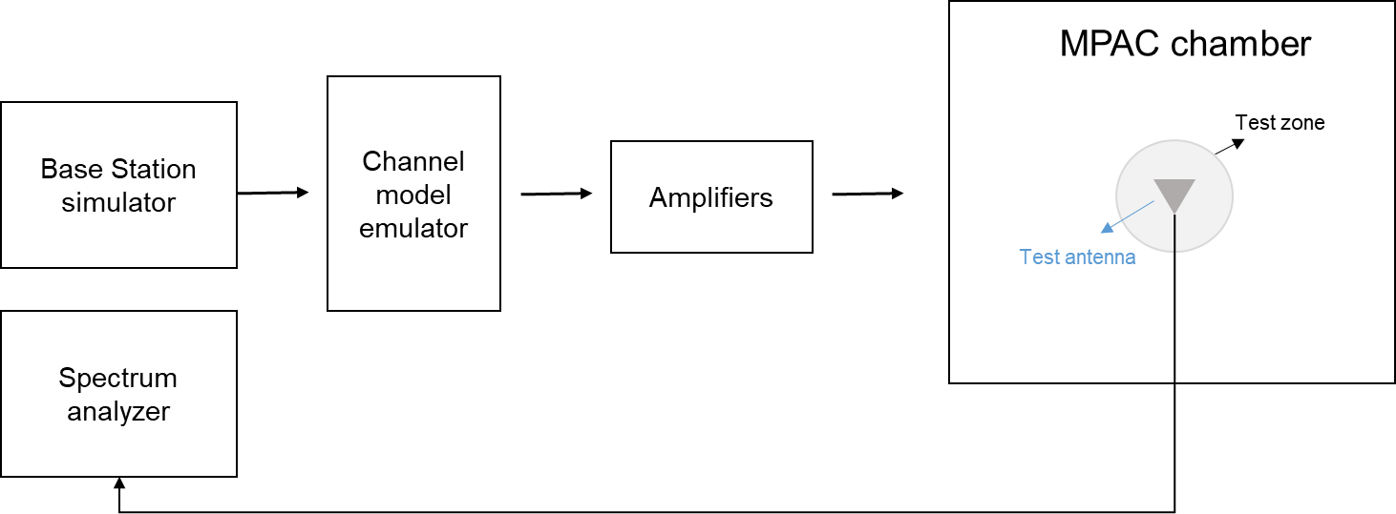
Figure 7.4.1.5-1: Setup for power validation measurements
Spectrum analyzer settings:
Table 7.4.1.5-1: Spectrum analyzer settings for Power validation measurements
Item | Unit | Value
Center frequency | MHz | Downlink center frequency  in Table 7.4.1-3
Integrated Channel Span | Hz | 20MHz
RBW | Hz | 30 kHz
VBW | Hz | ≥10MHz
Number of points |  | ≥400
Averaging |  | ≥100
Detector |  | RMS

Measurement Procedure:
1. Place a vertical reference dipole in the center of the test zone connected to a spectrum analyzer (or power meter) via a cable.
2. Record the cable and reference dipole gains.
3. Load the target channel model into the channel emulator.
4. Start the NR FR1 signaling in the base station emulator with the required parameter identical to the measurements conditions.
5. Average the power received by the spectrum analyzer for a sufficient amount of time to account for the fading channel – one full channel simulation might be unnecessary.
6. Repeat steps 1 to 4 with a magnetic loop for the horizontal polarization, or a horizontally polarized sleeve dipole measured in at least four orthogonal horizontal positions and summed to measure the H component.
7. Calculate the total power received at the test area as the sum of the power in the two polarizations.
Note: in step 6, if horizontally polarized sleeve dipole is used, the reference gain correction should be the average of the theta gain pattern cut of the dipole. Besides, more horizontal positions for averaging will improve the measurement accuracy but increase the total measurement time.
The power validation result is considered as systematic offset, which needs to be corrected on the UE final sensitivity value to further reduce measurement uncertainty.

< end of change 2>

