VIA G. Reiss Romoli 274
10148 TORINO (Italy)

Name: Daniele FRANCESCHINI
Phone: +39 11 228 5203
Fax: +39 11 228 7613
E-Mail: daniele.franceschini@cselt.it
Pages: 7
26/01/1999

3GPP TSG RAN WG4 meeting

Dear Delegates,

CSELT has the pleasure of inviting you to Turin to the second 3GPP TSG RAN WG4 meeting. The meeting will start on Monday 15th February at 9.00 a.m. and finish by 3.00 p.m. on Friday 19th February.

The meeting will be held at CSELT Headquarters. The address is:

CSELT
via G. Reiss Romoli, 274
Torino

Room Auditorium

You are kindly asked to send by fax (+39 11 228 7613) or e-mail (daniele.franceschini@cselt.it) your intention to attend 3GPP TSG RAN WG4 #2 no later than Friday 5th February (see the enclosed registration form).

Any document you want to be numbered and copied before the meeting has to be sent to the following ETSI address:
- 3GPP_TSG_RAN_WG4@LIST.ETSI.FR no later than Friday 5th February;
Before sending the contributions through the reflector, you have to contact the 3GPP TSG RAN WG4 Convenor (mailto:bennh@ecid.cig.mot.com) for a Tdoc number.
Please note that it will NOT be possible to copy documents circulated later than the indicated date. If you wish to submit a late contribution, you MUST bring with you at the meeting at least 80 copies of your document.

Please find enclosed:
- A registration form
- Local travelling information
- A list of hotels in Turin
- Hotel Reservation Form (the deadline for the hotel reservation is 8-2-99)

The Agenda of the meeting was already distributed by the 3GPP TSG RAN WG4 Convenor.

I look forward to meeting you in Turin.

Best Regards,

Daniele Franceschini

3GPP TSG RAN WG4 #2

Registration form
Turin, February 15 to 19, 1999

E-Mail to: daniele.franceschini@cselt.it or Fax to: +39 11 228 7613 by 5th February 1999

Delegate’s name: _______________________________________________

Delegate’s company: _______________________________________________

Telephone: _______________________________________________

Facsimile: _______________________________________________

E-mail: _______________________________________________

Join the meeting on: _______________________________________________

Leave the meeting on: _______________________________________________

GETTING TO TURIN

CSELT Headquarters are located in North Turin.

Arriving by air....

From Caselle airport to CSELT: CSELT can be reached directly by taxi (approx 20 minutes). The fare is around L.45.000 (30 US$).
From Caselle airport to Turin downtown: taxi or bus service from Caselle Airport to the centre of the town (the airbus terminal is very close to Porta Nuova railway station). The trip takes about 40 minutes.

Arriving by train....

Railways connections in the easterly (Milan, Venice) and southerly (Genoa, Florence, Rome, Naples) directions. Direct international connections with France.

Trains arrive at Porta Nuova and Porta Susa railway stations. The Porta Susa is the closest one to CSELT; Porta Nuova is the closest to most of the hotels. From both Porta Susa and Porta Nuova you can reach CSELT by bus or by taxi.

Arriving by car....

Turin is connected to the Italian Highways system. Approximately 2 hours drive from France (Mont Blanc Tunnel) and Switzerland (St. Bernard Tunnel); 1 and a half hour from Milan and Genoa.

CSELT is located on the outskirts of Turin near the ring motorway exit of "Borgaro" (the Italian name for the ring motorway is Tangenziale).

Parking may be a problem in Turin although there are a number of parking facilities in downtown and close to the major hotels. Please note that in the city centre there is a "Blue Zone" with restricted circulation.

How to get to CSELT’s Headquarters from the city centre:

By Taxi: The trip takes approx 20 minutes and cost around L.25.000.

By Bus: At the main railway station Porta Nuova or Porta Susa you have to take the bus #52 (direction ‘Scialoja’) BEFORE 8.20am. The bus stop is located just outside the stations main entrance just across the road. Before you board the bus you have to buy the ticket. It is available at most news-stands. Ask the bus driver to indicate you the right stop for CSELT (ask for via Reiss Romoli, 274); the trip takes about 40 minutes from Porta Nuova, 30 minutes from Porta Susa; the bus stop is right in front of CSELT. After 8.20am take a taxi.

Accommodation

In the following pages we suggest a list of hotels, some of them located in the city centre, other located near the airport. We suggest you to book one of the below hotels in Turin center. Then either by taxi or public transportation you can easily reach CSELT’s Headquarters
Please make reservations directly to the hotel by yourself and mention “CSELT/3GPP TSG RAN WG4” as reference in your reservation to ensure the block-booking rate. A hotel reservation form is provided with this invitation.

Dead-line for hotel reservation is 8.2.1999.

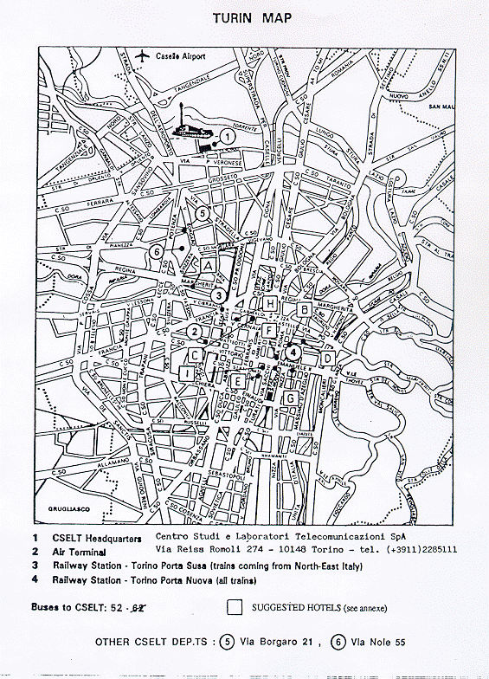
--
SUGGESTED HOTELS 1999

Ref.  to  Map | Cat | Hotel | Address | Telephone  Telex  Telefax  +3911/ | Single  room  (with  breakfast) | Double  room  (with  breakfast)
C | 1st | CITY HOTEL (**) | Via FilippoJuvarra,25 | 540546  216228  548188 | 150.000 | 220.000
E | 1st | HOLIDAY INN (**) | Via Assietta,3 | 5167111  5167699 | 170.000 | 215.000
F | 2nd | ROMA  &ROCCA  CAVOUR (**) | P.zza C.Felice,60 | 5612772  212275 ROMA  5628137 | 112.000 | 154.000
G | 2nd | GENIO (**) | C.so V.EmanueleII,47 | 6505771  220308 HOTGEN-I  6508264 | 160.000 | 220.000
I | 2nd | GENOVA E STAZIONE (**) | Via Sacchi,14 | 5629400  224242 HTLGEN-I  5629896 | 140.000 | 180.000
A | 1st | ROYAL (**) | C.so Reg.Margherita,249 | 4376777  220259 ROYAL  4376393 | 155.000 | 220.000
B | 1st | CONCORD | Via Lagrange,47 | 5176756  221323 CONCORD  5176305 | 215.000 | 280.000
D | 1st | SITEA | Via C.Alberto,35 | 5170171  220229 SITEA-I  548090 | 215.000 | 280.000
H | 2nd | DOCK MILANO | Via Cernaia,46 | 5622622  (tel.&fax) | 100.000 | 125.000

(**) Hotels in which a certain number of rooms have been booked for the meeting.

NOTES:
QUOTED RATES INITALIAN CURRENCY,GRANTED FOR DIRECT RESERVATIONS AND MENTIONING "CSELT CONVENTION"
(*)Hotel without convention

Close to the Airport:

Ref.  To  Map | Cat | Hotel | Address | Telephone  Telex  Telefax  +3911/ | Single  room  (with  breakfast) | Double  room  (with  breakfast)
--  -- | 1st  1st | ATLANTIC  PACIFIC | Str. Lanzo,163/165  BORGAROTorinese  V.le Martiri della Liberta`,76  BORGAROTorinese | 4500055  221440 ATLHOT-I  4701783  4704666  4703293 | 145.000  145.000 | 225.000  200.000
-- | 2nd | JETHOTEL | Via della Zecca, 9  CASELLE Torinese | 9913733  215896 JETHOT-I  9961544 | 160.000  (without  breakfast) | 230.000  (without  breakfast)

Further information about CSELT and Turin (city map, hotel guide, restaurants, etc.) is available at the following URL:

http://www.cselt.it/Cselt/CSELTOVERVIEW/HowToGet/index.html

HOTEL RESERVATION FORM

For the 3GPP TSG RAN WG4 #2 meeting, 15-19 February 1999, in Turin, Italy.

Reference: CSELT/3GPP_TSG_RAN_WG4

I would like to reserve ........... single/double room(s) for the following nights to the special rate.

Dates: Arrival: ................…………. Departure: ….................……..

Name: ___________________________________________________________

Company: ___________________________________________________________

Address: ______________________________________________________________

______________________________________________________________

______________________________________________________________

Fax*: ___________________________________________________________

Tel*: ___________________________________________________________

(* = including country code)

Please guarantee my room for late arrival.

Credit card to guarantee this reservation:

VISA AMEX EC DINERS OTHER ____________________________

Number:_________________________________exp. date:_____________________

Signature: __________________________________________________

