3GPP TSG-WG3 Meeting #Ad Hoc meeting R3-101958
June 29 – July 1, 2010
Beijing, P. R. China

Title: [DRAFT] LS on OAM security and OAM connection issues of RN
Release: Rel-10
Work Item: LTE-Relay-Core

Source: Huawei [to be RAN-WG3]

To: 3GPP TSG SA WG3, 3GPP TSG SA WG5, 3GPP TSG RAN2
Cc:

Contact Person:

Name: Wang Yan
Tel. Number: 86-10-82836708

E-mail Address: wangyan1013 at huawei dot com

Attachments: R3-101957

1. Overall Description:
Relay (RN) OAM was discussed in RAN3 Adhoc Beijing meeting. RAN3 assumes the Relay OAM architecture is reflected in the figure below:

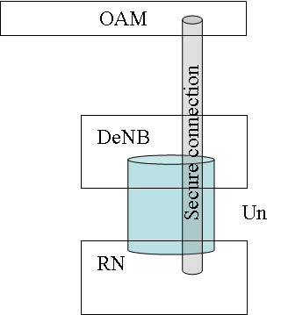
Figure 1 Relay OAM architecture.
The RN has a direct secure TLS connection to its OAM through the Donor eNB.
RAN3 assumes that RN OAM and DeNB OAM systems are different and assumes that they do not communicate with each other.

OAM security: it is assumed by RAN3 that’s RN OAM security could be considered equivalent to eNB OAM security. When the secure connection between the RN and its OAM has been established, Relay OAM information will be transported over the secure connections;

Question to SA3: RAN3 kindly asks SA3 to indicate if the assumptions above are valid and shared by SA 3 and if there are and additional requirements for RN OAM connection security.

2. Actions:
To SA3 group.
ACTION: RAN3 invites SA3 to take the above into consideration. RAN3 kindly asks SA3 to indicate if there are any additional security requirements for RN OAM connections.

To SA5 group.
ACTION: RAN3 invites SA5 to take the above into consideration

To RAN2 group.
ACTION: RAN3 kindly asks RAN2 to take the above into consideration.

3. Date of Next TSG-WG3 Meetings:
TSG-WG3 Meeting #69 23rd – 27th August 2010 Madrid, Spain.
TSG-WG3 Meeting #69bis 11th – 15th October 2010 Xi’An, P.R. China.

