TSG-RAN WG 3 meeting #25 TSGR3#25(01)3324
Makuhari, Japan 26th – 30th November 2001
Agenda Item: 10.1.8
Source: Siemens
Title: Transport Medium selection on Iu interface
Document for: Discussion

Introduction

When a call is established the MSC server requests a so called termination towards the RNC from the Media Gateway. A termination is something like an endpoint at the media gateway. In this request the MSC-Server must provide the kind of transport, i.e. IP or ATM. The Gateway returns the address of the termination which is of course transport specific . This address is passed to the RNC via RAB_ASSIGNMENT_REQUEST. The RNC uses this address to establish the bearer towards the media gateway.

The problem which occur is that the MSC server has to know what kind of transport should be used.

In REL-5 IP will be introduced as transport medium on the Iu interface. IP should co-exist with ATM. It is left to the vendors whether they provide both transport methods or only one. The issue which now occurs is that the Server does not know what kind of transport the RNC is able to provide. This document treats the selection of the transport medium on the Iu interface.

Solutions yet existing

There are 2 solutions known, which solves that problem:

- The MSC server knows the RNC capabilities by e.g. Administration (R3-012908)
- Sending both, IP and ATM address to the RNC and the RNC may choose (R3-012981).

Capabilities exchange by RANAP messages

The idea is that the RNC tells the MSC server the capabilities it is able to handle (and the preference) during RESET procedure.

Initial capability exchange
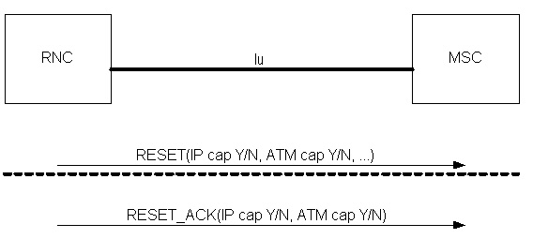
Figure 1: Initial Capability Exchange
By the means of the RESET or RESET_ACKNOWLEDGE the RNC returns to the MSC Server the capabilities it is able to handle. The capabilities could be: IP yes/no ATM yes/no. A preferred medium may also be indicated.
The Server shall associate this capabilities to the RNC in its database and use it.

Update of preferences and capabilities
The RNC may indicate its preferences to the MSC server. Via the OVERLOAD message the RNC can inhibit one kind of transport medium.
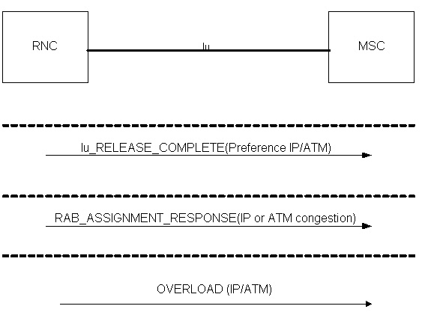
Figure 2 : Examples for Update of Capabilities and Preferences

It may be foreseen (as a future feature) that during call processing the RNC can change the preferences of transport medium. The Iu_RELEASE_COMPLETE message is used in this contribution. But any call processing message may be used.
The RNC may also indicate that a transport path is stuck via the overload message.

Proposal

If this general principle is agreed in RAN3, the proponent will provide more detailed contributions.

