3GPP TSG-RAN WG3 #129 R3-255874

Bengaluru, India, 25th - 29th Aug, 2025

Agenda Item: 15.2
Source: ZTE Corporation
Title: Summary of discussion on CB: # 27_IoTNTN
Document for: Discussion

Introduction
This is to kick off the offline discussion of CB: # IoTNTN
CB: # 27_IoTNTN
- align with NTN
- discuss store&forward and any other open topics
(ZTE)

For the Chairman’s Notes
Approved Contributions
R3-255294 Agreed
R3-255507 Agreed
R3-255509 rev in R3-255897 Agreed
R3-255750 rev in R3-255892 Agreed

Discussion
During the offline discussion, we went through the store and forward issue in R3-255513 and R3-255514. In addition, the mirror corrections from NR NTN were also discussed.

Store and Forward Issue
In R3-255513 (with response in R3-255747), it is proposed to agree that during the S&F mode transition (i.e., from the S&F mode to the normal mode or vice versa), the MME is not changed for its served UEs (for all connected/idle UEs).
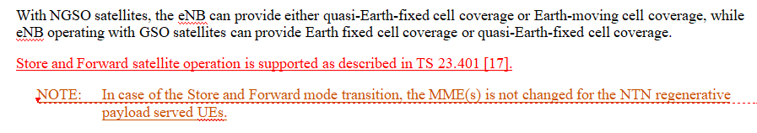
Noted
In R3-255514 (with response in R3-255748), it is proposed to introduce an OAM-provision the S&F mode indication of the neighbour cell pending to RAN2 decision. Noted
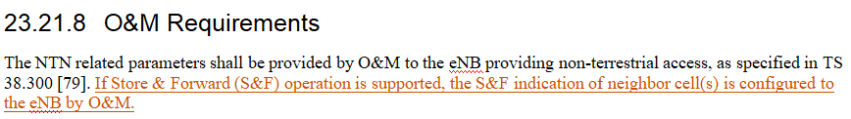
Noted

Corrections to align with NR NTN
R3-255294: The missing Removal function in Section 19.2.1.8 is added, the “instance” from “interface instance” is deleted and the typo issue is corrected.
Agreed
R3-255507: The missing Removal function in Section 7 is added, the “instance” from “interface instance” is deleted and the typo issue is corrected.
Agreed
R3-255509: Mirror TP of R3-255508 in NR NTN.
-Remove the second change and align with NR NTN TP on first change
Rev in 255897 Agreed
R3-255512: Add “or TNL functionality” in Section 23.21.5.3
Noted
R3-255516: LS to SA2 to provide RAN3’s progress in IoT NTN so far.
Noted
R3-255750: Mirror TP of R3-255547.
-Only Keep the TP
Rev in R3-255892 Agreed

Reference
RAN3#129 Contributions in AI15.2

