3GPP TSG-RAN WG3 Meeting #127-bis R3-252297
Wuhan, China, 7-11 April, 2025

Agenda Item: 16.2
Source: Huawei - Moderator
Title: Summary of Offline Discussion – CB: # AIoT1_Procedures
Document for: Approval

Introduction
This is the summary document for the following come back:
CB: # AIoT1_Procedures
- Discuss the open issues
- Capture agreements and provide TPs if agreeable
- Check R3-252244
(moderator - HW)
Summary of offline disc R3-252297
- For the Chairman’s Notes
General
- Turn previous “WA: Introduce a NGAP Class 1 Inventory Request procedure.” and “WA: Introduce a NGAP Class 1 Command Request procedure” to agreements.
- Define the Reader Index as INTEGER (1..65536, …).
- Introduce a new “A-IoT Area”. The AIOTF may indicate the Requested Service Area as a list of “A-IoT Areas” and/or a list of readers in the Inventory Request message.
- The AIOTF is aware of the area within which the gNB supports the provision of A-IoT services by means of OAM. This area may be represented as “A-IoT Areas” and/or the readers supported by the gNB.
- It is FFS whether the new A-IoT Area is encoded as GNSS info or new A-IoT Area ID.

About Inventory
- WA: Include the Correlation Identifier IE outside of the Inventory related Transfer IEs in all the Inventory related messages.
- Include the AIOTF Identifier IE outside of the Inventory related Transfer IEs in all the Inventory related messages.
- The Inventory Request Transfer IE, also includes the following:
  - Device Identification for Paging (to enable paging for single device, a group of devices, all devices)
  - Requested Service Area Information (A-IoT Area list and/or Reader list)
  - Inventory Assistance Information (Approximates Number of Target A-IoT Devices).
  - It is FFS whether the Inventory Assistance Information includes the “Estimate of Expected D2R Message Size”

About Command after inventory
- Introduce a follow-on command indication in Inventory Request Transfer IE, in case of Command after inventory.
- For command related NGAP messages, the Correlation Identifier IE is the same one as in the related Inventory procedure.
- WA: NGAP: Command Request procedure is a per single device procedure, and no need to have a Command Report procedure.
- WA: Include the Correlation Identifier IE in both inside and outside of the Command related Transfer IEs in all the Command related messages.
- Include the AIOTF Identifier IE outside of the Command related Transfer IEs in all the command related messages.
- The Command Request Transfer IE, also includes the following:
  - An A-IoT NAS PDU
  - Command Assistance Information: (Estimate of Expected D2R Message Size)
  - It is FFS whether the Command Assistance Information includes the Command Type (read, write, disable…)
- Introduce per-session per-device Device Association (“RAN NGAP Device ID”, and “(FFS) CN NGAP Device ID” pair) between gNB and AIOTF, in case of Command after inventory.
- In case of command after inventory, the gNB allocates and provides a “RAN NGAP Device ID” in the Inventory Report Transfer IE for each device.
- The Device Association is included in the Command Request Transfer IE and Command Response Transfer IE.
It is FFS whether to introduce the Device Association or a transaction ID, outside of the Transfer IEs, to allow parallel Command Request procedures for different devices between gNB and AMF.

Other open issues:
- FFS on the Release/Cancel/End related procedure(s)/IE(s) for the A-IoT service/inventory/command.
- FFS on the NGAP signaling support to provide the A-IoT RAN Information (Reader List, Reader location, Supported A-IoT Areas) to the AIOTF.

Agree the following TPs:
R3-252328 (TP to TS 38.300 BL CR) Architecture aspects CMCC
R3-252459 (TP to TS 38.300 BL CR) Update of Inventory and Command call flows Nokia
R3-252330 (TP to TS 38.300 BL CR) Protocol Stack of the AIOTF containers CATT
R3-252331 (TP to TS 38.300 BL CR) Device Locating support ZTE
R3-252332 (TP to TS 38.401 BL CR) Device Association aspects Lenovo
R3-252334 (TP to TS 38.412 BL CR) SCTP association Xiaomi
R3-252335 (TP to TS 38.413 BL CR) Updates of the Inventory and command Huawei
R3-252336 (TP to TS 38.413 BL CR) Interface management Ericsson
Agree the draft LS:
R3-252338 [Draft] LS on RAN3 Ambient IoT further progress Huawei [to be RAN3]

Background
The following progresses were made during RAN3 Tue online session:
Turn the WA to agreement, i.e., Including AIOTF information containers in NGAP.
Enhancing the existing NGAP interface management procedures.
Introducing an AIoT indicator in the NGAP Setup Request message. The detail of this indicator can be further discussed.
Introduce a “Correlation ID” in the respective NGAP inventory at least inside the transfer containers.
FFS on the command procedure.
Opt1: Reusing the existing TA in NGAP Setup Request message for AIoT, while introducing new AIoT service area in Inventory
Opt2: Introducing new AIoT service area in both NGAP Setup Request message and Inventory
Opt3: Reusing the existing TA in both NGAP Setup Request message and Inventory
Offline to discuss the assumption in RAN3 and send LS to SA2.
Turn the following WA to agreement: Upon receiving only the reader list in Inventory Request, the gNB selects the readers as indicated by the reader list?
The gNB selects the readers taking the reader list provided by CN into account in some cases.
Reader indexes and the gNB ID are mandatory included in Inventory Report Transfer IE.

Discussion

Previous WAs
WA: Introduce a NGAP Class 1 Inventory Request procedure.
WA: Introduce a NGAP Class 1 Command Request procedure
Proposal: Turn above two WAs to agreements.

Command after inventory procedure
Proposal 1: Introduce a follow-on command indication in Inventory Request Transfer IE in case of Command after inventory.
- Need:
- HW (command indication)
- QC (Follow-up command indicator)
- CATT (command indication)
- Xiaomi (service type: “inventory+command”)
- Lenovo (service type: “inventory+command”)
- E/// (Command follow-on)
- CMCC (service type indicator "A-IoT Inventory and Command")

Proposal 2: Introduce per session per device Device Association (“RAN NGAP Device ID”, and “(FFS) CN NGAP Device ID’ pair) between gNB and AIOTF, in case of Command after inventory.
- Needed: Huawei, CATT, Xiaomi, Lenovo, E///, China Telecom, CMCC

Proposal 3: In case of command after inventory case, the gNB allocates and provides a “RAN NGAP Device ID” in the Inventory Report Transfer IE for each device.

Proposal 4: The “RAN NGAP Device ID” and “[FFS]CN NGAP Device ID’ pair is included in the Command Request Transfer IE and Command Response Transfer IE.

Introduce a “Correlation ID” in the respective NGAP inventory at least inside the transfer containers.
FFS on the command procedure.
Proposal 5: For command related messages, the Correlation Identifier IE (FFS if included) included in the Transfer IE is the same one as in the related Inventory procedure.
- Same one for Inventory and Command: Huawei, QC, NEC, Lenovo, E///, CATT, Xiaomi, Nokia
- Different ones: ZTE
- No need to add Correlation Identifier IE in the Command Request procedure: CMCC

For command related messages, the Correlation Identifier IE is the same one as in the related Inventory procedure.
WA: Include the Correlation Identifier IE in both inside and outside of the Command related Transfer IEs in all the Command related messages.
WA: Include the Correlation Identifier IE outside of the Inventory elated Transfer IEs in all the Inventory related messages. (for both inventory only case, and command after inventory case)

Proposal 6: WA: NGAP: Command Request procedure is a per single device procedure, and no need to have a Command Report procedure.
- Single device command only:
  - CMCC, Huawei, Nokia, Ericsson, NEC, CATT, Lenovo
- Multiple devices commands within a single NGAP Command Request Message:
  - QC, China Telecom, ZTE, Samsung?

Allowing of parallel procedures between AMF and gNB in indirect case
Proposal 1: Include the following, in all NGAP Inventory related messages, outside of the Transfer IE.
- AIOTF identifier
- Global gNB ID

In the INVENTORY RESPONSE message and INVENTORY REPORT message, outside of the Transfer IE, includes:
- AIOTF identifier

In the INVENTORY REQUEST message, outside of the Transfer IE, includes:
- AIOTF identifier

Proposal 2:

In the COMMAND RESPONSE message, outside of the Transfer IE, includes:
- AIOTF identifier
- FFS: Device association/Transaction

In the COMMAND REQUEST message, outside of the Transfer IE, includes:
- AIOTF identifier
- FFS: Device association/Transaction

IE definitions

Reader Index definition
Reader indexes and the gNB ID are mandatory included in Inventory Report Transfer IE.
Proposals on Reader Index definition from contributions:
- Huawei: Define the Reader Index as BIT STRING (SIZE(16, …)).
- Samsung: The Reader ID included in the Inventory Report/Command Response message can be TRP ID which uniquely identifies a TRP/Reader within an AIoT RAN node.
  - Moderator: In TS 38.455, the TRP Identifier is defined as BIT STRING (SIZE(16, …))
- CATT: defined as an INTEGER, e.g. INTEGER (1..65536).

Proposal: Define the Reader Index as INTEGER (1..65536, …)

Other Sub-IEs in the Inventory Request Transfer IE
Proposal: The Inventory Request Transfer IE, also includes the following:
- Device Identification for Paging (to enable paging for single device, a group of devices, all devices)
- Requested Service Area Information (Area list and/or Reader list)
- Inventory Assistance Information
  - Approximates Number of Target A-IoT Devices
  - FFS: Estimate of Expected D2R Message Size

Other Sub-IEs in the Command Request Transfer IE
Proposal: The Command Request Transfer IE, also includes the following:
- An A-IoT NAS PDU
- Command Assistance Information:
  - Estimate of Expected D2R Message Size
  - FFS: Command Type (read, write, disable…)

QCOM, CATT: Command Type needs to be further check, no SA2 requirement

AIOTF awareness of reader location
Proposal: FFS: Reader Location is known by the AIOTF.
- AIOTF shall be/is aware of reader location: Huawei, QCOM, CATT, Xiaomi, SS, CTC, ZTE
- AIOTF may/can be aware of reader location: E///, CMCC, Nokia
- AIOTF should be aware of reader location:
Nokia: If OAM configuration only, SA5/implementation to decide the details of the Reader Location.
If NGAP signalling needed, RAN3 further discuss the details of Reader Location.

Q1: Support NGAP signalling on Reader Location from the gNB to the AIOTF
- Support: Nokia, QCOM, Huawei, CTC, Xiaomi, Lenovo
- OAM only, no NGAP signalling: E///, ZTE, CATT, NEC,

Q2: If NGAP signalling is agreed,
Option 1: New Transfer IE in NG Setup Request
Option 2: Inventory Report Transfer IE: Nokia

Reader Location Definition (regardless of NGAP signaling or OAM config)
Proposals on Reader location definition from contributions:
- Huawei: The Reader Location can be indicated by Civic Address defined in TS 29.572, or NG-RAN Access Point Position or NG-RAN High Accuracy Access Point Position defined in TS 38.455.
- Samsung: current Geographical Coordinates IE specified in TS 38.455 can be referred to
- CMCC: The details of the location of reader can be GNSS information or refer to the existing TRP Position and TRP High Accuracy Access Position defined in TS 38.455
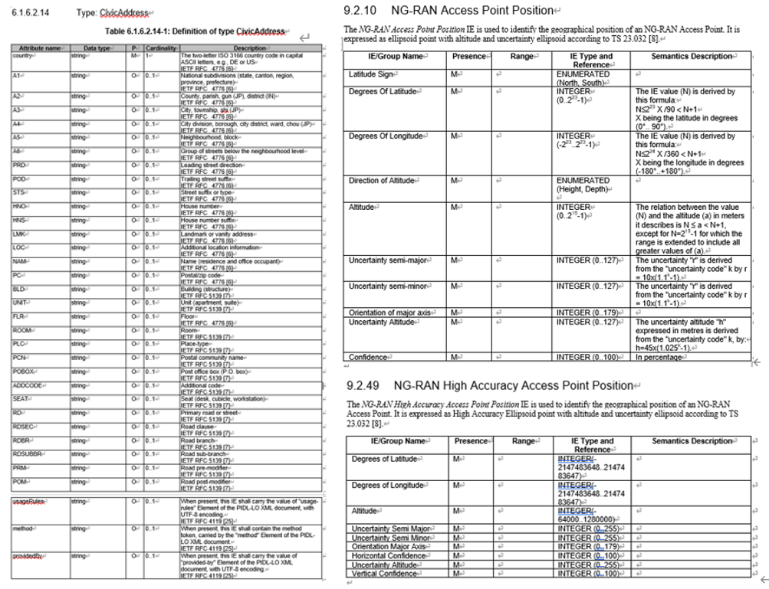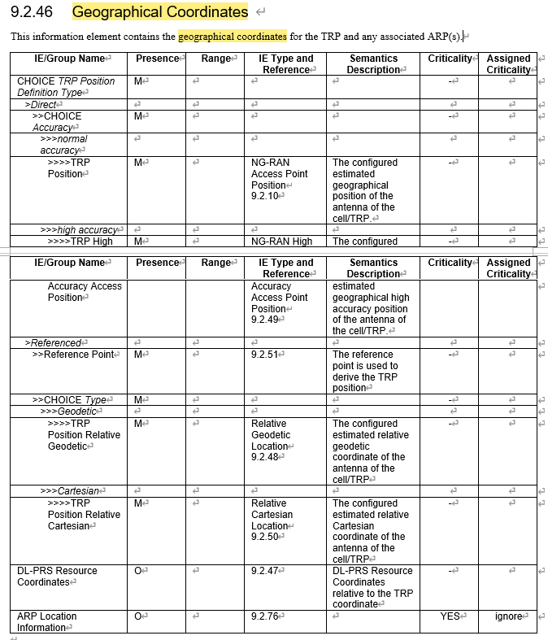
Proposal: Choose the one(s) to be used as reader location:
- Civic Address defined in TS 29.572
- NG-RAN Access Point Position defined in TS 38.455
- NG-RAN High Accuracy Access Point Position defined in TS 38.455
- Geographical Coordinates IE specified in TS 38.455

-----------Followings are the continuous discussion after the Tue online discussion---------------

New AIoT Area or AIoT dedicated TAI
Opt1: Reusing the existing TA in NGAP Setup Request message for AIoT, while introducing new AIoT service area in Inventory
Opt2: Introducing new AIoT service area in both NGAP Setup Request message and Inventory
Opt3: Reusing the existing TA in both NGAP Setup Request message and Inventory
Offline to discuss the assumption in RAN3 and send LS to SA2.
New A-IoT Area
QCOM, NEC, CMCC, Nokia, ZTE, Lenovo
A-IoT dedicated TAI
CATT, Samsung, Ericsson
In Inventory Request, it was agreed in last meeting that:
AIoT RAN node receives the requested service area information (encoded as area and/or reader ID list) from AIoT CN.
Question 1: What is the Area in the “requested service area information” in the Inventory Request Transfer IE?
- “New A-IoT Areas supported by the gNB”: CMCC, QCOM, Huawei, Xiaomi, CTC, E///
- Or
- “A-IoT dedicated TAIs supported by the gNB”: CATT, E///,

Question 2: What is the Area in the A-IoT RAN Information known by the AIOTF? (known by at least OAM)
- “New A-IoT Areas” or “A-IoT dedicated TAIs”?

Introduce a New A-IoT Area, at least to be used in the Inventory Request Transfer IE
AIOTF is aware of the supported A-IoT Area (new Area) supported by the gNB, at least by OAM.
It is FFS whether the new area is GNSS info or new A-IoT Area ID.

(If time allows) NGAP signaling support about A-IoT RAN Information
The A-IOT RAN Information includes:
- Served Reader List
- Supported A-IoT areas
- Reader location
Question 1: is NGAP signaling is acceptable for the Supported A-IoT Areas? or only rely on OAM?

Question 1a: If A-IoT dedicated TAI is used, in NG Setup Request whether to have new Transfer IE to include it or enhance existing Supported TA list?

Question 1b: If new A-IoT Area is used, define it as follows?
“A-IoT Area Identity” = “PLMN ID” + “A-IoT Area Code OCTET STRING (SIZE(3))”

Question 2: Is NGAP signaling is acceptable for the Served Reader List? Or only rely on OAM?

Question 3: Is NGAP signaling is acceptable for the Reader Location? Or only rely on OAM?

(If time allows) A-IoT Indicator in NG Setup Request
Introducing an AIoT indicator in the NGAP Setup Request message. The detail of this indicator can be further discussed.
- If only A-IoT dedicated TAIs are included, A-IoT only is implicitly indicated.
- If new A-IoT Area is introduced, the “AIoT indicator in the NGAP Setup Request message” should be “A-IoT only indicator’.

(If time allows) Reader Selection
The following agreements were achieved in last meeting:
- AIoT RAN node receives the requested service area information (encoded as area and/or reader ID list) from AIoT CN.
  - Upon receiving only the area in Inventory Request, the gNB selects readers within the indicated area.
  - Upon receiving neither the area nor the reader list in Inventory Request, the gNB selects all the served readers.
  - WA: Upon receiving only the reader list in Inventory Request, the gNB selects the readers indicated by the reader list.
  - FFS: Upon receiving both the area and the reader list in Inventory Request, the gNB selects the readers within the indicated area and the readers within the reader list.
The progress in Tue online discussion:
- Turn the following WA to agreement: Upon receiving only the reader list in Inventory Request, the gNB selects the readers as indicated by the reader list?
- The gNB selects the readers taking the reader list provided by CN into account in some cases.
Proposal: Upon receiving only the reader list in Inventory Request
- the gNB uses the readers as indicated by the reader list
- Or
- the gNB takes the indicated reader list into account

Other FFSs for next meeting
- FFS on the Release/Cancel/End related procedure(s)/IE(s) for the A-IoT service/inventory/command.

About TPs
38300 TP on the protocol stack of the AIOTF container
- CATT
38300 TP on all the other agreements for Architecture aspects
- CMCC
38300 TP to update inventory/command call flows
- Nokia
38300 TP on device locating
- ZTE
38401 TP e.g., the device association
- Lenovo
38412 TP on SCTP association for direct case
- Xiaomi
(R3-251791)
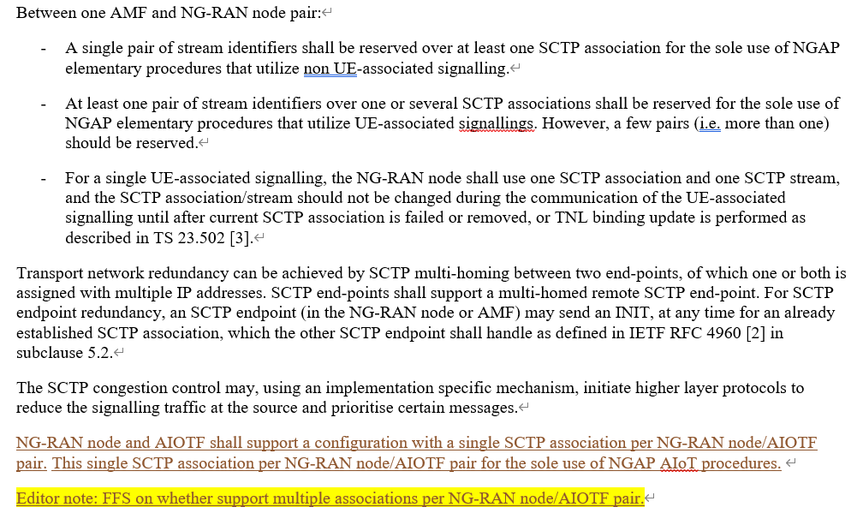
Maybe we can change the TP to: the non UE-associated signallig SCTP association(s) are used for A-IoT between the NG-RAN node and the AIOTF.

38413 TP on Inventory/Command procedures/IEs
- Huawei
38413 TP on interface management procedures/IEs
- Ericsson
R3-251603 | R3-252057
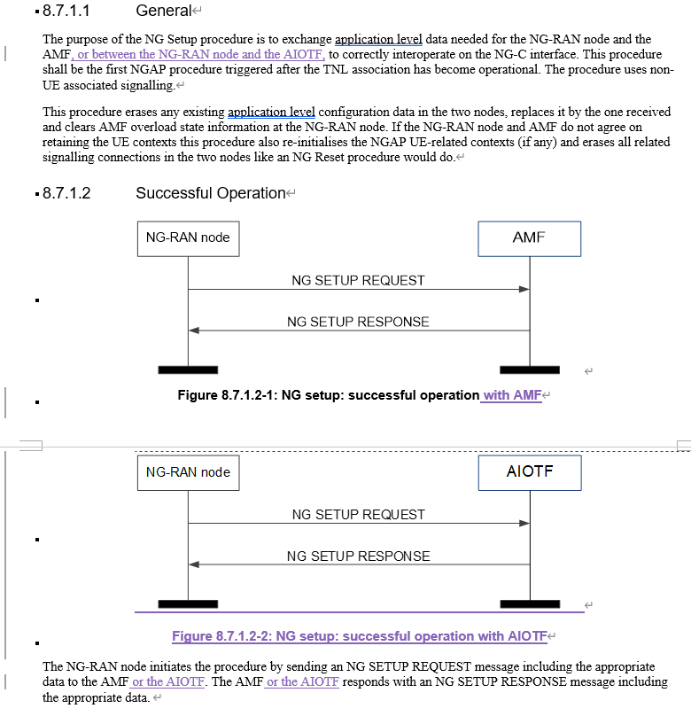 | 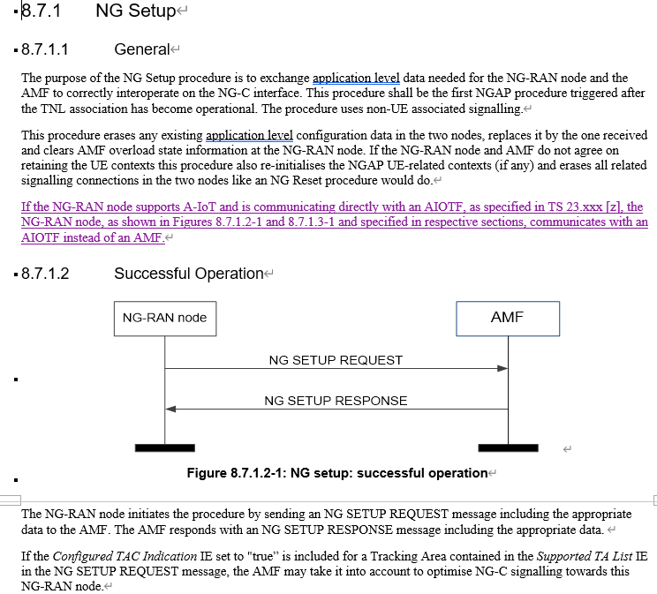

LS to other groups e.g., SA2/SA5/RAN2?
- Huawei

References
- R3-251526 Reply to LS on A-IoT Conclusions in SA WG2 SA5(China Unicom LS in
- R3-251563 BL CR to 38.300) Introduction of Ambient IoT CMCC, Huawei draftCR
- R3-251564 BL CR to 38.410) Introduction of Ambient IoT ZTE Corporation, China Telecom, Huawei, Samsung, CMCC, Nokia, Xiaomi CR
- R3-251565 Introduction of Ambient IoT Huawei CR
- R3-251603 TPs to TS 38.300 38.413 BL CRs) Architecture aspects and interface management procedures Huawei other
- R3-251585 Architecture, Protocols and Signaling to support Topology 1 of A-IoT Qualcomm Incorporated discussion
- R3-252056 TP for BL CR 38.401 and 38.300] Multiplexing several A-IoT service operations concerning multiple A-IoT devices on NG-C and other architectural topics Ericsson other
- R3-251660 Conclusion on Ambient IoT Architecture Nokia discussion
- R3-252183 TP to TS 38.300) Discussion on RAN Architecture for Ambient IoT CMCC other
- R3-252241 TP for BL CR to 38.300, 38.413, 38.410) Leftover issues on AIoT ZTE Corporation, China Telecom other
- R3-251586 Inventory and Command procedures for Topology 1 of A-IoT Qualcomm Incorporated discussion
- R3-251604 TPs to TS 38.413 38.410 BL CRs) Support of Inventory Huawei other
- R3-251605 TPs to TS 38.413 38.410 BL CRs) Support of Command Huawei other
- R3-251661 TP for BL CR AIoT for TS 38.413] Additions for AIoT protocol Nokia other
- R3-251662 Signalling Information Elements for Inventory Nokia discussion
- R3-251663 Signalling Information Elements for Command Nokia discussion
- R3-251687 Discussion on AIoT architecture aspects NEC discussion
- R3-251688 Discussion on AIoT procedures aspects NEC discussion
- R3-251715 TP to BL CR for TS38.300) A-IoT protocol stack CATT other
- R3-251716 TP to BL CR for TS38.413) A-IoT inventory and command procedures CATT other
- R3-251717 Discussion on A-IoT reader selection CATT discussion
- R3-251762 Discussion on support of AIoT Xiaomi discussion
- R3-251763 TP for TS 38.413) Support of AIoT Xiaomi other
- R3-251765 Discussion on location of the device Xiaomi other
- R3-251791 TP for TS 38.412) Support of Ambient IoT Xiaomi, Huawei, CMCC other
- R3-251813 Discussion on RAN architecture and procedures for AIoT Samsung discussion
- R3-251949 On A-IOT Inventory Procedure Lenovo discussion
- R3-251950 On A-IOT Command Procedure Lenovo discussion
- R3-252057 TP for BL CR 38.413] Applicability of NG Interface management procedures for A-IoT Ericsson other
- R3-252058 TP for BL CR 38.300] AIoT service area indication Ericsson other
- R3-252059 TP for BL CR 38.413 and 38.300 and 38.410] Introducing A-IoT protocol functions in NGAP Ericsson other
- R3-252116 Ambient IoT support Jio Platforms Ltd (JPL discussion
- R3-252165 Signalling Procedure for Inventory and Command China Telecom discussion
- R3-252184 Discussion on Inventory Procedure and Signaling CMCC discussion
- R3-252185 Discussion on Command Procedure and Signalling CMCC discussion
- R3-252242 TP for BL CR 38.413) New AIoT procedures ZTE Corporation, China Telecom other
- R3-252243 TP to BL CR 38.300, 38.410) New Ambient IoT procedures ZTE Corporation, China Telecom other
- R3-251587 Locating Ambient IoT devices Qualcomm Incorporated discussion
- R3-251689 Discussion on AIoT location reporting aspects NEC discussion
- R3-251606 TPs to TS 38.300 38.413 BL CRs) Support of Device Locating Huawei other
- R3-251718 Discussion on locating of A-IoT device CATT discussion
- R3-251814 Discussion on Location report for AIoT Samsung discussion
- R3-252186 TP to TS 38.300) Discussion on A-IoT device location reporting CMCC other
- R3-252244 TP to (BL CR to 38.300) Location AIoT device ZTE Corporation, China Telecom other
- R3-252248 Discussion on support of location report LG Electronics discussion

