3GPP TSG-RAN WG3 Meeting #125-bis R3-24xxxx
Hefei , CN, 14 - 18 Oct, 2024

Agenda Item: 10.3.1
Source: Huawei (moderator)
Title: SoD of SON for intra-NTN mobility
Document for: Approval

Introduction
This is a summary of offline discussion for SON for intra-NTN mobility.

For the Chairman’s Notes

Background

The following progress were made at RAN3 #124 meeting for SON for intra-NTN mobility.
Take the connection failure scenarios in §15.5.2.2.2 of TS 38.300 as starting point with necessary update, if needed, in MRO for intra-NTN mobility.
MRO for intra-NTN mobility shall consider the following trigger conditions:
- Measurement-based trigger condition;
- A time-based trigger condition;
- A location-based trigger condition;
- A time-based and Measurement-based combined trigger condition;
- A location-based and Measurement-based combined trigger condition;
Do not consider MRO for feeder link switch.
MRO for intra-NTN mobility shall consider both conditional and non-conditional intra-NTN handover.
FFS on whether there are any enhancements to RLF report due to support for multiple trigger conditions in intra-NTN mobility.
FFS on whether to consider any enhancement for MDT configuration e.g., area scope and trigger condition for NTN.
Discuss MRO for RACH-less HO of NTN, only for those different issues identified compared with MRO for LTM.
Time information when RLF occurs needs to be included in the RLF report, other information to be included can be checked as well in next meeting.
Further progress was made at RAN3 #125 meeting,
MRO for CHO with a time-based trigger condition:
Case 1 Too Late CHO Execution: RLF happens in the source cell before UE executes CHO (before or after T1 threshold starts), and the UE re-connects the cell other than the source cell.
- Distinguish if the RLF happens before or after T1
Case 2 Too Early CHO Execution/CHO Execution to Wrong Cell: HOF happens or RLF happens shortly after successful CHO, and the UE re-connects in the source cell or a third cell.
- FFS on whether it matters if RLF happens within the duration or after the duration period.
The RLF report includes for single time-based trigger condition:
- Absolute time (measured UTC time) when RLF occurred
- Measured UTC time when CHO is executed
Whether to consider the fallback issue from RACH-less HO to RACH-based HO for NTN?
Whether to introduce any enhancement for the Area Scope of logged MDT for NTN over NG interface?

Discussion

MRO for NTN
Time based trigger condition
Case 1 Too Late CHO Execution: RLF happens in the source cell before UE executes CHO (before or after T1 threshold starts), and the UE re-connects the cell other than the source cell.
- Distinguish if the RLF happens before or after T1
Case 2 Too Early CHO Execution/CHO Execution to Wrong Cell: HOF happens or RLF happens shortly after successful CHO, and the UE re-connects in the source cell or a third cell.
- FFS on whether it matters if RLF happens within the duration or after the duration period.
The RLF report includes for single time-based trigger condition:
- Absolute time (measured UTC time) when RLF occurred
- Measured UTC time when RLF CHO is executed

For the first FFS:

HW-R3-245621：
Proposal 1: There is no need to distinguish whether the RLF happens within the duration or after the duration.
CATT-R3-245184:
Proposal 2: For time based CHO, there is no need to distinguish RLF happens within the duration or after the duration period in case of too early/to wrong cell.
CMCC- R3-245192:
Proposal 1: There is no need to distinguish if RLF happens within the duration or after the duration period in Case 2 of MRO for time-based CHO.
QC- R3-245335:
- In case of RLF shortly after a successful time-based CHO execution, there is no need to distinguish whether RLF occurs before or after T1-Threshold + Duration. gNB can categorize this as Too Early HO/HO to wrong cell as long the RLF occurs within the T_UEcntxt_store timer
Lenovo-R3-245438:
Proposal 2: In case of Too Early CHO Execution/CHO Execution to Wrong Cell for CHO with a time-based trigger condition, it is not needed to distinguish whether the HOF or RLF happens within or after the duration period.

Discussion:

For the second, FFS:
The RLF report includes for single time-based trigger condition:
- Absolute time (measured UTC time) when RLF occurred
- Measured UTC time when RLF CHO is executed

HW-R3-245621：
Proposal 2: Reusing existing relative timers (e.g., the timeSinceCHO-Reconfig, and the timeConnFailure.) in the UE RLF report for the network to identify the use cases when time based CHO is configured.
CATT-R3-245184:
Proposal 1: For time based CHO, network can identify the time when RLF happens by timesincefailure. No need to introduce other time information.
QC- R3-245335:
- gNB can store the time it sent the CHO configuration to the UE and the CHO configuration parameters (T1-Threshold and Duration) and retrieve it via the C-RNTI and timeConnFailure received in RLF Report
- gNB can distinguish between case 1a and case 1b (i.e., whether an RLF occurred before T1-Threshold or after T1-Threshold) via the following formula:
Time it sent CHO configuration to the UE + timeSinceCHO-Reconfig < or > T1-Threshold.
- To distinguish between case 1a and case 1b, there is no need for UE to report any absolute timestamp information in RLF Report
Lenovo-R3-245438:
Proposal 3: It is unnecessary to include the absolute time (measured UTC time) when connection failure occurred and the absolute time (measured UTC time) when CHO is executed in the RLF report.
Samsung-R3-245353:
Proposal 4: Include time information when the RLF occurs into the RLF report.
CUC- R3-245618:
Proposal 1: For the case about too early CHO execution and CHO execution to wrong cell, the UE can record the handover time when the time-based CHO happen, and report this information to the gNB when the radio link failure happen.
Ericsson- R3-245654:
Proposal 8: RAN3 to suggest to RAN2 to include absolute time when the RLF occurs in the RLF report, or relative time between failure and T1.
ZTE- R3-245664
Proposal 1: Regarding the MRO for the intra-NTN CHO with time-based trigger condition, the absolute time information when the failure happens should be included in the RLF report.

Discussion:
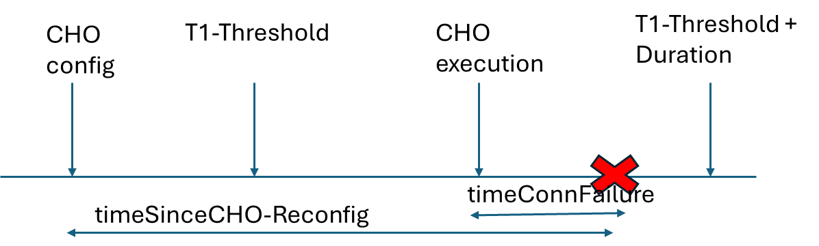

Location based trigger condition:
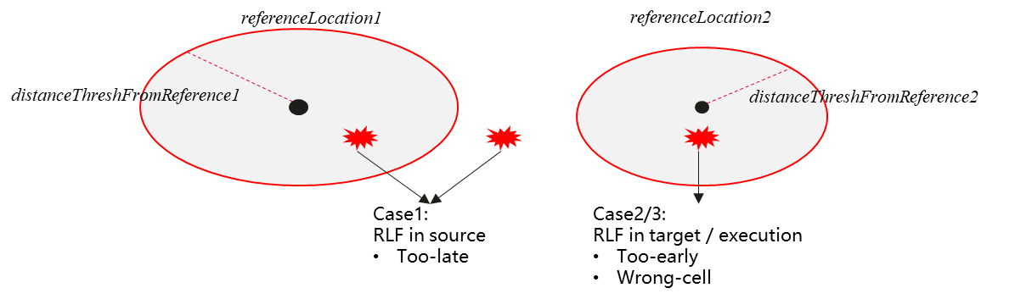
Figure 1: Failure scenarios in location-based condition
- Case 1: RLF happens in the source cell before D1/D2 is triggered. The UE re-establishes in the target cell.
- Case 2: HOF happens in the target cell after D1/D2 is triggered. The UE re-establishes in the source cell or a third cell.
- Case 3: RLF happens in the target cell short after successful HO. The UE re-establishes in the source cell or a third cell.

Huawei:
Proposal 3: The following information needs to be collected into the UE RLF report for the location based CHO optimisation:
- An indicator to indicate which threshold is fulfilled, the distanceThreshFromReference1, the distanceThreshFromReference2, or neither.
- The measured distanceFromReference1 when the condition to the candidate cell is fulfilled, or the measured distanceFromReference2 when the condition to the source cell is fulfilled.
- The time duration between the two thresholds fulfilled
CMCC:
Proposal 5: For single trigger condition in intra-NTN mobility, RLF report could be enhanced to include the information from UE for the detection of the problems in the related configuration of NTN:
  - The configured CHO execution condition, e.g., an indicator or bitmap for time-based trigger, location-based trigger, measurement-based trigger;
  - The distance between UE and the referenceLocation/moving referenceLocation in serving cell and the distance between UE and the referenceLocation/moving referenceLocation in candidate cell when the failure occurs, for the scenario where a location-based trigger condition configured;
QC：
- Existing location information reported in RLF Report is sufficient to optimize location-based CHO failures and there is no need for UE to report any relative distance information in RLF Report.

CATT:
Proposal 3: For location based CHO, network can identify the location when RLF happens by locationInfo. No need to introduce other location information.
Proposal 4: The definition of too late/too early/to wrong cell location based CHO should be same as time based CHO.

Discussion:

RRM-based trigger condition:

Huawei:
Proposal 3: The indicators that indicate whether threshold1 and threshold2 for A5 shall be included in RLF report for optimization of RRM-based CHO.

Joint trigger condition:
Samsung-R3-245353:
Proposal 5: Include CHO execution trigger into the RLF report, e.g. time-based trigger, location-based trigger, no CHO execution trigger.
Huawei:
Proposal 4: For joint-condition CHO, at least the following information shall be reported in RLF report.
  - measured UTC time in T1 or distance in D1/D2 when the RRM condition is fulfilled;
  - RRM measurement results when the time condition or the location condition is fulfilled.
  - The fulfilled event.
CMCC:
Proposal 7: The following information should be included in RLF report for the scenario where a time-based and Measurement-based combined trigger condition configured:
  - The configured CHO execution conditions;
  - The trigger condition(s) fulfilled before the failure occurs, e.g., the sequence of the fulfilled trigger condition;
Proposal 8: The following information should be included in RLF report for the scenario where a location-based and Measurement-based combined trigger condition configured:
  - The configured CHO execution conditions;
  - The trigger condition(s) fulfilled before the failure occurs, e.g., the sequence of the fulfilled trigger condition;
  - The distance between UE and the referenceLocation/moving referenceLocation in serving cell and the distance between UE and the referenceLocation/moving referenceLocation in candidate cell when the failure occurs.
Proposal 9: For multiple trigger conditions in intra-NTN mobility, RLF report could be enhanced to include the information from UE for the detection of the problems in the related configuration of NTN:
  - The configured CHO execution conditions, which is applicable for both MRO for the single trigger condition and multiple trigger conditions;
  - The trigger condition(s) fulfilled before the failure occurs, e.g., the sequence of the fulfilled trigger condition;
  - The distance between UE and the referenceLocation/moving referenceLocation in serving cell and the distance between UE and the referenceLocation/moving referenceLocation in candidate cell when the failure occurs, for the scenario where a location-based and Measurement-based combined trigger condition configured.
QC：
- In case a UE is configured with multiple trigger conditions for CHO in NTN (e.g., time-based + measurement-based or location-based + measurement-based) and the UE encounters an RLF before CHO execution, UE can include the CHO trigger condition(s) that were satisfied before the RLF occurred.
Lenovo:
Proposal 4: RLF report can be enhanced to include measurement results of source cell, target cell and candidate cell(s) at the absolute time value t1-Threshold or t1-Threshold + duration.
Proposal 5: RLF report can be enhanced to include the distance between UE and a reference location/moving reference location of source cell when the connection failure happens, and, the distance between UE and a reference location/moving reference location of candidate or target cell when the connection failure happens.
Proposal 6: RLF report can be enhanced to include the distance between UE and a reference location/moving reference location of source cell when measurement based CHO execution condition is fulfilled, or the distance between UE and a reference location/moving reference location of candidate cell(s) when measurement based CHO execution condition is fulfilled.
ZTE:
Proposal 4: There is no extra need to enhance the RLF report for the CHO with multiple trigger conditions.
CATT:
Proposal 5: For multiple triggers CHO, the network can identify all trigger conditions configured to UE via choConfig-r17 contained in RLF report.
Proposal 6: For too late case in multiple triggers CHO, network can identify the second trigger condition, which is not met the threshold via triggeredEvent-r17, and perform optimization for the second trigger accordingly.
Proposal 7: For too early/to wrong cell in multiple triggers CHO, network is able to decide how to optimize multiple trigger conditions based on network implementation.

Summary of the proposals:

MDT for NTN
New area scope:
HW-R3-245621：
Proposal 5: RAN3 to agree to introduce a geographical area as the area scope for MDT in NTN.
(a reference location plus a radius)
ZTE- R3-245664
Proposal 8: New granularity of Area Scope/Configuration should be introduced for logged MDT enhancement for NTN.
Ericsson- R3-245654:
Proposal 1: RAN3 to extend the definition of the MDT Area Scope to enable collection immediate and logged MDT measurements for the NTN coverage in a specific geographical area.
Proposal 2: Don’t include mapped cell ID for logged MDT in Area Scope of MDT.
Proposal 3: Support geographical areas with smaller granularity in the Area Scope of MDT for both logged and immediate MDT.
Samsung-R3-245353:
Proposal 1: Reuse existing Area Scope for the logged MDT configuration in Uu interface.
Proposal 2: In order to make better UE selection, an optional Mapped Cell ID is added in addition to the existing Area Scope from OAM to the gNB. LS to SA5 is needed.
QC：
- RAN3 will consider mechanisms to enable collection of logged MDT from a certain geographical area e.g., by indicating the Mapped Cell ID in the Area Scope of MDT in MDT Configuration-NR IE over NGAP
China Unicom:
Proposal 8: The network can configure the MDT measurement for the reference point, and the area scope can be configured by the network with the MDT configuration.
ZTE:
Proposal 8: New granularity of Area Scope/Configuration should be introduced for logged MDT enhancement for NTN.
CATT:
Proposal 10: For logged MDT configuration, define a new area scope with a smaller range granularity of cell.

TPs

Reference

R3-245184 | (TP for 38.300) Intra-NTN mobility for SONMDT (CATT) | other
R3-245192 | (TP to 38.300) Discussion on SONMDT enhancement for NTN (CMCC) | other
R3-245311 | [TP to BL CR to 38.423, SON] Solution to avoid restarting MRO in NTN deployments (Nokia) | other
R3-245335 | SON MDT for NTN (Qualcomm Incorporated) | discussion
R3-245353 | Discussion on SON enhancements for NTN (Samsung Electronics Nordic AB) | discussion
R3-245438 | Discussion on MRO for intra-NTN mobility (Lenovo) | discussion
R3-245618 | Discussion on SONMDT enhancements for NTN mobility (China Unicom) | discussion
R3-245621 | (TP for MDT BLCRs for TS38.413, TS38.423, TS37.320) SON for Intra-NTN mobility (Huawei) | discussion
R3-245654 | SON/MDT enhancements for NTN (Ericsson) | discussion
R3-245664 | (TP to BL CR for 38.300) Further discussion on SONMDT enhancement for NTN (ZTE Corporation) | other

