3GPP TSG-RAN WG3 Meeting #123 R3-240813
Athens, GR, 26 Feb – 01 Mar, 2024

Agenda Item: 8.1
Source: ZTE (moderator)
Title: Summary of Offline Discussion on CB: # 2_SDT
Document for: Approval

Introduction
CB: # 2_SDT
- Provide CR based on RAN2 agreement
- Any additional optimization is needed? Security issue?
(moderator - ZTE)
Summary of offline disc R3-240813

For the Chairman’s Notes
<TBD>

Discussion-First round

Backgroud
The following is abstracted from Chair note.
Nok: NBC issue does not exist, just additional function. Do not ack the issues mentioned by HW, package loss issue is acked
CATT: Share view as ZTE and HW, no enhancements are needed, only stage2 update is enough
Lenovo: Tends to agree with Nok
QC: Both solutions can work, slightly prefer to follow RAN2 solution
SS: Follow RAN2 agreement
LG: Follow what RAN2 agreed, then additional optimization can be discussed later

Any additional optimization is needed? Security issue?

Optimized solution 1 in R3-240348: Enhance XnAP signaling for non-supporting UEs
RRC setup solution with RAN3 impact for non-supporting UEs
For non-supporting UEs, a RAN3 solution could alternatively be used which consists in relocating the UE context over Xn and new serving gNB generating the classical RRC Setup.
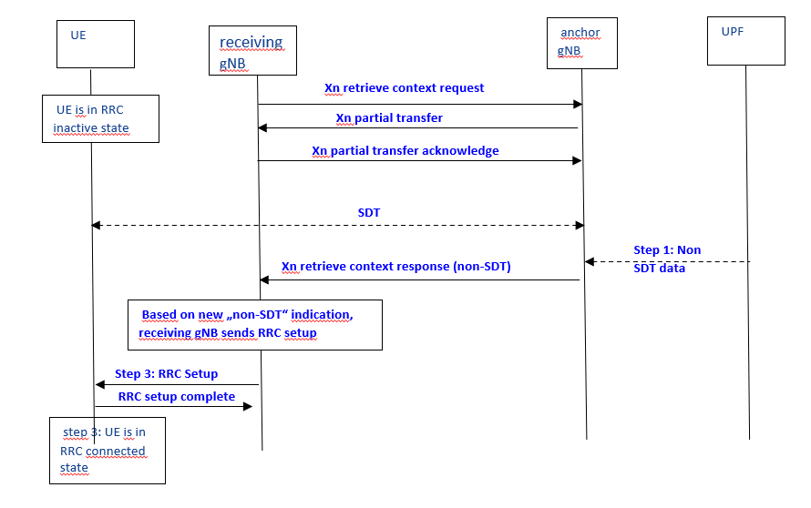
Figure 3: Optimized switch from SDT to RRC connected after partial context transfer for non-supporting UEs but RAN3 impact
The advantage of the solution shown in figure 3 is that it is supported by all UEs as classical fallback mode.
The drawback is that this requires Xn impact and receiving gNB impact because receiving gNB is no longer transparent.

[Comment from R3-240794]
It proposes to introduce a new “non-SDT data” indication in the Xn Retrieve UE context response message, then A more optimized solution would be that anchor gNB triggers immediately anchor relocation and new serving gNB receiving a new “non-SDT data” indication in the Xn Retrieve UE context response triggers RRC setup.
Currently, after Partial UE Context Transfer procedure, only Xn Retrieve UE context failure message can be used to end the ongoing SDT session, which has specified in TS38.423, as below.
TS38.423
Interaction with Partial UE Context Transfer procedure
In case of RACH based SDT, if the old NG-RAN node decides to not transfer/relocate the UE Context to the new NG-RAN node, it may trigger the Partial UE Context Transfer procedure as specified in TS 38.300 [9]. After the old NG-RAN node has decided to end the SDT session, it shall terminate the Retrieve UE Context procedure by sending the RETRIEVE UE CONTEXT FAILURE message.
Observation 2: Optimized Solution 1 (Enhance XnAP signalling for non-supporting UEs) has impact on current interaction with Partial UE Context Transfer procedure

[Comment from R3-240800]
On the other hand, from our view this newly proposed solution has many drawbacks:
1) SDT procedure from RAN2 point of view is initiated with RRC Resume request and is terminated on receiving RRC Release message. There is no DL RRC message expected from RAN2 point of view during the SDT procedure.
2) NW sending the RRC Setup in the middle of SDT procedure (i.e. after performing data transfer during SDT) is wired NW behaviour which will confuse the UE and will lead to undefined UE behaviour and will have RAN2 impacts as RAN 2 has never considered this situation.
3) Immediate sending of RRC Setup in response to RRCResume request is only considered in RAN2 specs but not after the SDT data transmission is on going.
4) Upon receiving the RRCSetup by the UE, the packets not successfully delievered will be lost, as the UE discards any stored UE Inactive AS context, release radio resources, RLC entities, PDCP entities, etc.
5) Upon receiving the RRCSetup by the UE, the UE discards any current AS security, the end-to-end security activation procedure will take quite long time, which is even worse.
Conclusion 1: the new solution mentioned in R3-240348 is not proper to be adopted.

Optimized solution 2 in R3-240565:
?Optimized Solution 2 (Enhance XnAP signalling to avoid OTA signalling) will introduce security problem.

?Proposal 1: Additional optimization is not needed.

Draft CR for 38.300

R3-240221
NOTE 1a: In case DL non-SDT data or DL non-SDT signalling arrives, or UE assistance information (i.e. UL non-SDT data arrival indication) is received from the UE, the last serving gNB terminates the SDT procedure by sending the RRCRelease message with an indicator to allow the SDT UE transiting into RRC_INACTIVE state and automatically initiates a new RRCResumeRequest, then UE is transited from RRC_INACTIVE to RRC_CONNECTED state as specified in 9.2.2.4.1.

R3-240257
NOTE 1a: In case DL non-SDT data or DL non-SDT signalling arrives, or UE assistance information (i.e. UL non-SDT data arrival indication) is received from the UE, the last serving gNB terminates the SDT procedure and directs the UE either to continue in RRC_INACTIVE state by sending the RRCRelease message without resume indication, or to initiate RRC resume procedure to move to RRC_CONNECTED state by sending the RRCRelease message with resume indication.
NOTE 1b: Based on (e.g. large size of) DL SDT data or DL SDT signalling, the last serving gNB may terminate the SDT procedure and direct the UE either to continue in RRC_INACTIVE state by sending the RRCRelease message without resume indication, or to initiate RRC resume procedure to transition to RRC_CONNECTED state by sending the RRCRelease message with resume indication.

R3-240567
NOTE 1a: In case DL non-SDT data or DL non-SDT signalling arrives, or UE assistance information (i.e. UL non-SDT data arrival indication) is received from the UE, the last serving gNB terminates the SDT procedure by sending the RRCRelease message. The last serving gNB may send to the receiving gNB a RETRIEVE UE CONTEXT FAILURE message to request for a new UE context retrieval procedure.

CR for 38.401

R3-240258
NOTE 5: Upon receiving BSR from the UE, in case that UL SDT data size in the BSR is larger than the threshold configured from the gNB-CU-CP, the gNB-DU sends the UE INACTIVITY NOTIFICATION message with the SDT volume threshold crossed indication to the gNB-CU-CP. Upon receiving such indication, the gNB-CU-CP may terminate the ongoing SDT procedure, by sending the RRCResume message to move the UE to RRC_CONNECTED, or by sending the RRCRelease message to move the UE to RRC_INACTIVE, or by sending the RRCRelease message with resume indication to trigger the UE to initiate RRC Resume procedure to move to RRC_CONNECTED state as specified in TS38.300 [2].
Upon receiving non-SDT data, the gNB-CU-UP shall send the DL DATA NOTIFICATION message to the gNB-CU-CP. The gNB-CU-CP shall terminate the ongoing SDT procedure as specified in TS 38.300 [2].
If the amount of the received DL SDT data is above the data size threshold configured by the gNB-CU-CP, the gNB-CU-UP shall send the DL DATA NOTIFICATION message with the SDT data size threshold crossed indication. The gNB-CU-CP may terminate the ongoing SDT procedure as specified in TS38.300 [2].

Other CR for R18 MT-SDT

Correction on oversize DL SDT data arrival
R3-240653 | Correction on oversize DL SDT data arrival (Huawei) | CR1203r, TS 38.423 v18.0.0, Rel-18, Cat. F  Resp in R3-240797  - update the semantic description  - Add Nok, E///, QC as co-source  Rev in R3-240913
R3-240196 | Correction on the MT-SDT Data Size within MT-SDT information in TS37.483 (ZTE) | CR0102r, TS 37.483 v18.0.0, Rel-18, Cat. F  Resp in R3-240797  - update the semantic description  - Add Nok, E///, QC as co-source  Rev in R3-240914
Data Size issue:
- Keep the value as 0…96000…, and update the semantic description in the case that if the data size exceeds 96000, the value will be set to 96000
Both E1AP and Xn AP

9.3.1.142 MT-SDT Information
This IE provides the assistant information for MT-SDT.
IE/Group Name | Presence | Range | IE Type and Reference | Semantics Description
MT-SDT Data Size | M |  | INTEGER (1..96000,…) | Indicates the total data size for all SDT bearers. Unit: byte. Corresponds to the SDAP SDU size of the received DL data. If the total data size exceeds 96000, the value will be set to 96000.

R3-240104
R3-240104 | Correction of MT SDT trigger (Nokia, Nokia Shanghai Bell) | CR0323r, TS 38.401 v18.0.0, Rel-18, Cat. F  HW, ZTE: Details can be found in stage3, may is enough  noted

Conclusion, Recommendations

References
- R3-240015 Reply LS on SDT signaling optimization for partial context transfer (RAN2(Qualcomm)) LS in
- R3-240221 Optimization on handling of DL non-SDT in case of RA-SDT without UE anchor relocation (CATT) draftCR
- R3-240348 Switch to RRC Connected after SDT Partial Context Transfer (Nokia, Nokia Shanghai Bell) discussion
- R3-240349 Correction of switch to RRC connected after SDT Partial Context Transfer (Nokia, Nokia Shanghai Bell) draftCR
- R3-240350 Correction of switch to RRC connected after SDT Partial Context Transfer (Nokia, Nokia Shanghai Bell) CR1161r, TS 38.423 v18.0.0, Rel-18, Cat. F
- R3-240351 Response LS on SDT signaling optimization for partial context transfer (Nokia, Nokia Shanghai Bell) LS out To: RAN2 CC:
- R3-240257 Correction on SDT RRC Release with resume indication (Huawei, Qualcomm Incorporated, Lenovo) draftCR
- R3-240258 Correction on SDT RRC Release with resume indication (Huawei, Qualcomm Incorporated, Lenovo) CR0335r, TS 38.401 v18.0.0, Rel-18, Cat. F
- R3-240565 Discussion on SDT signalling enhancement (Ericsson) discussion
- R3-240566 SDT context retrieval re-Request (Ericsson) CR1190r, TS 38.423 v18.0.0, Rel-18, Cat. B
- R3-240567 Update of Note 1a in SDT procedure (Ericsson) draftCR
- R3-240794 Response to R3-240348, R3-240565, ZTE
- R3-240795 Response to R3-240221, R3-240257, R3-240349, R3-240567, ZTE
- R3-240800 Response to R3-240348 and R3-240565, Huawei

