3GPP TSG-RAN WG3 Meeting #122 R3-237796

Chicago, USA, 13 - 17 November 2023

Agenda Item: 12.2.2.2
Source: ZTE (moderator)
Title: Summary of Offline Discussion on CB: # AIML2_LB
Document for: Approval

Introduction
During the online discussion, following are the agreements and left issues:
Measurement Collection periodicity does not need to be introduced in Rel-18, can be further discussed in R19.
Not introducing a new indicator in Data Collection Update message to indicate the UE performance feedback reporting termination in R18.
Revised the common understanding as follows: “For one pair of measurement IDs, the frequency at which the data collection update messages that include UE performance feedback are signaled is determined by the current reporting periodicity IE”?
Introduce New Cause value?
Introduce the new codepoint like “update”/ “modify” type in Registration Request IE, allowing the modification of the configuration of the requested information?

CB: # AIML2_LB
- Discuss the open issues above
- Provide TPs if agreeable
(moderator - ZTE)
Summary of offline disc R3-237796

For the Chairman’s Notes
xxx

Discussion

The trigger of DATA COLLECTION UPDATE message
For one pair of measurement IDs, the frequency at which the data collection update messages are signaled is determined by the current reporting periodicity IE.
In R3-237292, it is proposed to clarify the scenarios where measured UE trajectory and UE performance feedback are configured in a single DATA COLLECTION UPDATE message.
Scenario 1: Measured UE trajectory is configured for one-time reporting, and UE performance feedback is also configured for one-time reporting with different collection duration.
For this scenario, there maybe two understanding on the trigger mechanism of DATA COLLECTION UPDATE message：
- Understanding 1: Two separate DATA COLLECTION UPDATE messages are used—one for measured UE trajectory and the other for UE performance feedback. Each message is triggered after the respective collection duration for measured UE trajectory or UE performance feedback has passed. As shown in Figure 2a.
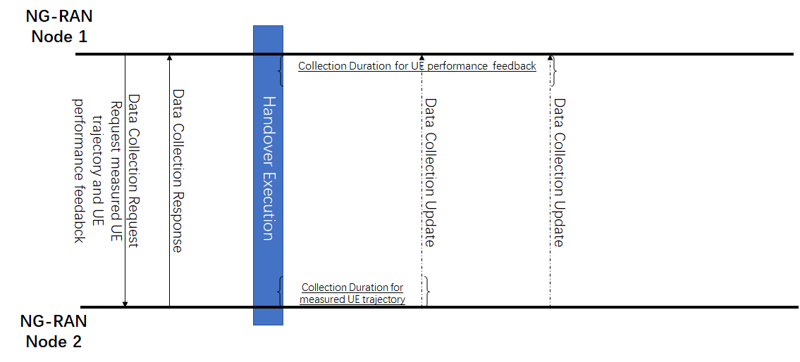
Figure 2a. Understanding 1: Two separate DATA COLLECTION UPDATE messages
- Understanding 2: One single DATA COLLECTION UPDATE message. The measurement with short collection duration should wait for the measurement with long duration, which means the DATA COLLECTION UPDATE message is triggered after the long collection duration, involving the measured UE trajectory and UE performance feedback. As shown in Figure 2b.
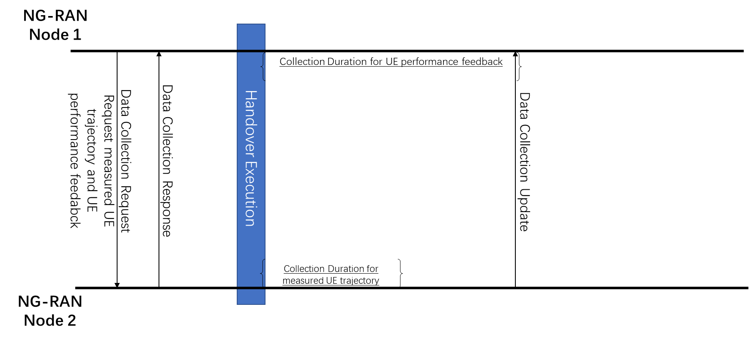
Figure 2b. Understanding 2: One single DATA COLLECTION UPDATE message

Q1: Companies are invited to provide their views on which understanding is correct.
Company | Understanding 1, 2? | Comments

Scenario 2: Measured UE trajectory is configured for one-time reporting, while UE performance feedback is configured for periodic reporting with different collection duration.
For this scenario, there maybe two understanding on the trigger mechanism of DATA COLLECTION UPDATE message：
- Understanding 1: DATA COLLECTION UPDATE message that includes UE performance feedback strictly follows reporting periodicity, while DATA COLLECTION UPDATE message that includes measured UE trajectory is triggered when its collection duration has passed, without considering the periodicity of UE performance feedback, as shown in Figure 3a.
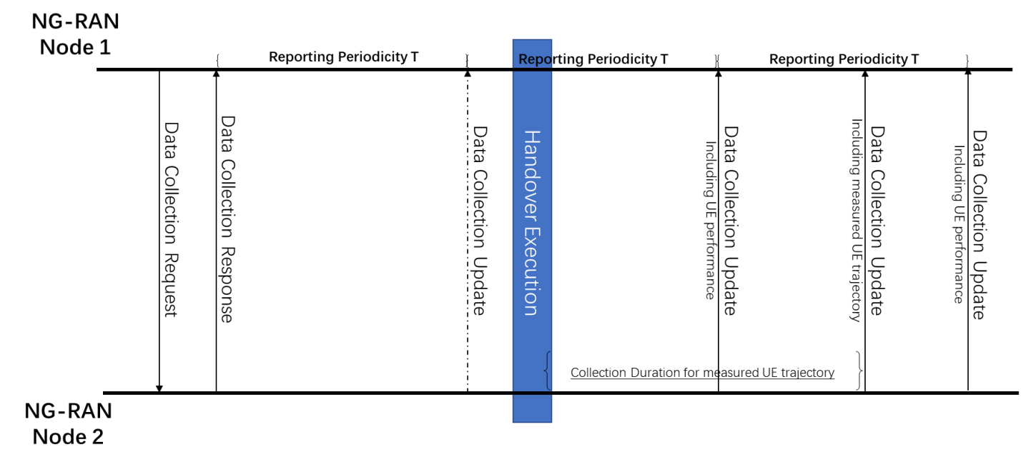
Figure 3a. Understanding1 for the scenario2
- Understanding 2: DATA COLLECTION UPDATE message that includes UE performance feedback strictly follows reporting periodicity, and the target node will not report the measured UE trajectory until the next reporting period to send an DATA COLLECTION UPDATE message, strictly to the previously agreed common understanding, as shown in Figure 3b.
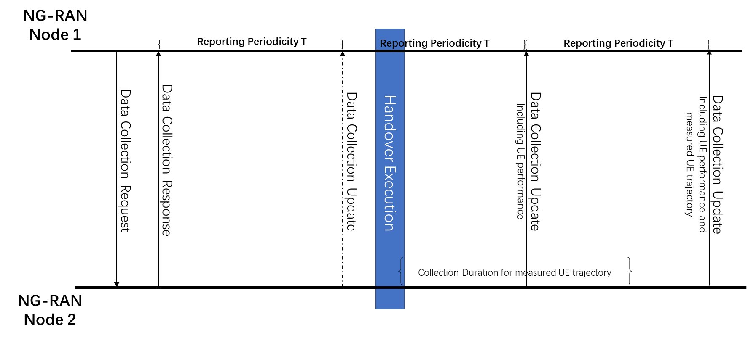
Figure 3b. Understanding2 for the scenario2
Q2: Companies are invited to provide their views on which understanding is correct.
Company | Understanding 1, 2? | Comments

Cause value
It was agreed that including failure measurement per node or per cell in the response message to support partial reporting mechanism, and each failure measurement is indicated with the corresponding cause value. Currently, it was agreed to reuse the existing cause value, e.g., “Measurement not Supported for The Object” and “Measurement Temporarily not Available”. Besides, RAN3 agreed to introduce cause values indicating failure due to timing issues.
Agree to introduce cause value(s) indicating failures due to timing issues. Further discussions are needed on which timing issues to address.
Following are cause value proposed by companies:
Option 1: Measurement not supported with requested prediction time
Option 2: Measurement not available with requested prediction time
Option 3: Measurement not supported with requested reporting periodicity
Option 4: Measurement not available with requested reporting periodicity
Option 5: Measurement not Supported For The Requested Timing Configuration
Option 6: Measurement Temporarily not Available For The Requested Timing Configuration
Note: 5&6 are the simplified version on cause value.
Q3: Companies are invited to provide their views on options are acceptable.
Company | Understanding 1, 2? | Comments

UE performance collection configuration
Following options are proposed by companies on defining the UE performance collection configuration.
Option 1: ENUMERATED TYPE

9.2.3.N UE Performance Collection Configuration
This IE indicates the configuration for UE performance measurement collection.
IE/Group Name | Presence | Range | IE Type and Reference | Semantics Description
Measurement Collection Duration | O |  | ENUMERATED(1s, 5s, 10s, 20s, 30s, 40s ,50s, 60s, ...) | Time duration in seconds, starting from successful handover execution, during which UE performance feedback is collected.

Option 2: INTEGER TYPE

9.2.3.N UE Performance Feedback Configuration
This IE indicates the configuration for UE performance measurement collection.
IE/Group Name | Presence | Range | IE Type and Reference | Semantics Description
Measurement Collection Duration | O |  | INTEGER(1..100,…) | Time duration starting at successful handover execution within which the UE performance feedback measurements are collected by NG-RAN node₂.

Q4: Companies are invited to provide their views on the IE type of measurement collection duration. Details of value can be discussed during offline discussion.
Company | ENUMERATED  or INTEGER | Comments

Discuss offline:
Procedural Text Description for condition of termination of UE performance feedback collection:
If the UE Performance Collection Configuration IE in the DATA COLLECTION REQUEST message is present, it indicates the configuration for the collection of UE performance. The NG-RAN node₂ shall take it into account when collecting the UE performance. Collection of the UE performance by the NG-RAN node₂ shall be terminated either at the expiration of the collection duration or if the UE moves to RRC_IDLE or RRC_INACTIVE or if the UE is handed over to another cell.

Remaining FFS issue

Packet Delay IE
The IE type and reference for the packet delay is still FFS. Following are the options proposed to resolve FFS.
Option 1: The Average Packet Delay for UE performance refers to the existing IE Packet Delay Budget.

9.2.3.12 Packet Delay Budget
This IE indicates the Packet Delay Budget for a QoS flow.
IE/Group Name | Presence | Range | IE type and reference | Semantics description
Packet Delay Budget | M |  | INTEGER (0..1023, ...) | Upper bound value for the delay that a packet may experience expressed in units of 0.5ms.

Option 2: Define the Packet Delay IE, as an INTEGER (0..10000, ...) in milliseconds.

9.2.3.Y UE Performance
This IE indicates the UE performance measurements metrics.
IE/Group Name | Presence | Range | IE Type and Reference | Semantics Description
Average UE Throughput DL | O |  | 9.2.3.4
Average UE Throughput UL | O |  | 9.2.3.4
Average Packet Delay | O |  | INTERGER(0..10000,...) | Unit: milliseconds
Average Packet Loss | O |  | 9.2.3.11

Q5: Companies are invited to provide their views on options above.
Company | Option1 or Option2 | Comments

Predicted Resource Status IE
There is still FFS related to the details of Predicted Radio Resource Status IE. Currently, we have reached an agreement that the predicted resource status is limited to cell level. However, Predicted Radio Resource Status IE in the BLCR refers to the existing Radio Resource Status IE, which includes PRBs per SSB, per slice and per MIMO.
- the Predicted Radio Resource Status IE, if the first bit, “Predicted Radio Resource Status” of the Report Characteristics IE included in the DATA COLLECTION REQUEST message is set to “1”. FFS on the details of Predicted Radio Resource Status IE.
Moderator thinks currently we only discuss PRBs
Option 1: Introduce a new IE for predicted radio resource status.
Option 2: Add the following semantic description:
Predicted resource status pertains only to the utilization of PRBs per MIMO and per SSB. Any other IE is ignored.
Q7: Companies are invited to provide their views on options above.
Company | Option1 or Option2 | Comments

Registration Request Type
Following are the proposals for the registration type:
- Remove the FFS related to the actions of the NG-RAN node2 and the corresponding FFS in the tabular for the encoding of the Registration Request IE.
- Introduce the “modify”/ “update” type in Registration Request IE, allowing the modification of the configuration of the requested information.
- Introduce the “add” type in Registration Request IE, to improve the signaling efficiency, when the reporting periodicities of new cells and existing ones are same.
Q7: Companies are invited to provide their views on proposals for registration type above.
Company | a,b,c | Comments

Failed Report Characteristics of UE trajectory and UE performance
In R3-237323, it is stated that “Node measurement initiation result” and “Per cell measurement initiation result” are used to inform the requesting node which measurement item(s) it can not provide. However, for the UE performance feedback and measured UE trajectory, they does not belong to node level or cell level ones. If the requested node can not feedback them, in current structure, the requested node should indicate the failure for all the cells.
Therefore it is proposed to extend the existing node level initiation result to support the requested node to inform the failed UE performance feedback and measured UE trajectory.

9.1.3.DD DATA COLLECTION RESPONSE
This message is sent by NG-RAN node₂ to NG-RAN node₁ to indicate that the requested information, for all or part of the measurement objects included in the reporting, is successfully initiated.
Direction: NG-RAN node₂ → NG-RAN node₁
IE/Group Name | Presence | Range | IE type and reference | Semantics description | Criticality | Assigned Criticality
Message Type | M |  | 9.2.3.1 |  | YES | reject
NG-RAN node1 Measurement ID | M |  | INTEGER (1..4095,...) | Allocated by NG-RAN node₁ | YES | reject
NG-RAN node2 Measurement ID | M |  | INTEGER (1..4095,...) | Allocated by NG-RAN node₂ | YES | reject
Node Measurement Initiation Result List |  | 0..1 |  | List of measurement objects that failed to be initiated in the node. | YES | ignore
> Node Measurement Initiation Result Item |  | 1 .. <maxFailedMeasPerNode> |  |  | EACH | ignore
>>Measurement Failed Report Characteristics | M |  | BITSTRING  (SIZE(128)) | Each position in the bitmap indicates measurement objects that failed to be initiated in the NG-RAN node2.  First Bit = Energy Cost,  Second Bit = Average UE Throughput DL,  Third Bit = Average UE Throughput UL,  Fourth Bit = Average Packet Delay,  Fifth Bit = Average Packet Loss,  Sixth Bit = Measured UE Trajectory.  Other bits shall be ignored by the NG-RAN node1. | –

Q8: Companies are invited to provide their views on proposals above.
Company | Yes/No | Comments

Other FFS can be easily agreed
P1: Replace the FFS in the criticality of UE Associated Info Result List in DATA COLLECTION UPDATE message to “ignore”.
P2: Set the maximum value of maxnoofUEReports to 16.
P3: Rename UE Assistant Identifier as NG-RAN node 1 UE XnAP ID in DATA COLLECTION UPDATE message?
P4: Remove all Editor’s notes.

Conclusion, Recommendations [if needed]
If needed

References
R3-237256 | Discussion on remaining open issues in UE performance for NG-RAN AI/ML (Qualcomm Incorporated) | discussion
R3-237292 | Futher discussion on remaining issues for Load Balancing (ZTE) | discussion
R3-237293 | (TP to 38.423 BLCR) AIML based Load Balancing (ZTE) | other
R3-237577 | (TP to BL CR for TS 38.423) Cause Value Discussion and Other Open Issues (Nokia, Nokia Shanghai Bell) | other
R3-237578 | (TP to BL CR for TS 38.423) UE Performance Data Collection (Nokia, Nokia Shanghai Bell) | other
R3-237172 | Discussion on UE performance feedback (CATT) | discussion
R3-237173 | TP to BLCR for 38.423 on AL/ML load balance and FFS clear up (CATT) | other
R3-237238 | RAN AI/ML on UE Performance Feedback (NEC) | discussion
R3-237239 | (TP to TS 38.423 on RAN AI/ML) on UE Performance Feedback (NEC) | other
R3-237579 | Discussion on Predicted Radio Resource Status (Nokia, Nokia Shanghai Bell, BT, Orange) | discussion
R3-237580 | (TP to BL CR for TS 38.423) Predicted Radio Resource Status (Nokia, Nokia Shanghai Bell, BT, Orange) | other
R3-237323 | (TP to TS 38.423 BLCR) Failed Report Characteristics of UE Performance Feedback and Measured UE Trajectory (Samsung) | other
R3-237324 | (TP to TS 38.423 BLCR) Support of AI/ML for LB (Samsung) | other
R3-237379 | (TP for AI/ML BL CR for TS 38.423) Remaining open issues for the Load Balancing use case (Huawei) | other
R3-237408 | Left issues related to load balancing use case (Lenovo) | discussion
R3-237409 | (TP for TS38.423 BLCR) On UE related feedback collection (Lenovo) | other
R3-237423 | Discussion on the open issue for AI/ML load balancing (LG Electronics Inc.) | discussion
R3-237424 | (TP for NR_AIML_NGRAN-Core BL CR for TS 38.423) Discussion on the open issue for AI/ML load balancing (LG Electronics Inc.) | other
R3-237481 | Periodic UE Performance Feedback measurements collection and reporting (Ericsson, Deutsche Telekom, InterDigital) | discussion
R3-237482 | (TP for AIML BL CR for TS 38.423) Periodic UE Performance Feedback measurements collection and reporting (Ericsson, Deutsche Telekom, InterDigital) | other
R3-237483 | Cause values for Data Collection Reporting Initiation (Ericsson, Deutsche Telekom, AT&T, InterDigital) | discussion
R3-237484 | (TP for AIML for BLCR to TS38.423) Cause values for Data Collection Reporting Initiation (Ericsson, Deutsche Telekom, AT&T, InterDigital) | other
R3-237485 | Data Collection Reporting clean-up (Ericsson, Deutsche Telekom, AT&T, InterDigital) | discussion
R3-237486 | (TP for AIML for BLCR to TS38423) Data Collection Reporting clean-up (Ericsson, Deutsche Telekom, AT&T, InterDigital) | other
R3-237673 | Discussion on AIML remaining issues (CMCC) | discussion
R3-237674 | (TP for 38.423)Procedure for Load Balancing (CMCC) | other

