**3GPP TSG-RAN WG3 #121 R3-234539**

**21st – 25th Aug 2023**

**Toulouse, France**

Agenda Item: 10.2.1

Source: Qualcomm Incorporated (moderator)

Title: Summary of Offline Discussion: CB: # SONMDT1_SHRSPR

Document for: Discussion

# Introduction

This is the offline summary for the following comeback:

CB: # SONMDT1_SHRSPR

- Discuss the open issues as above

- Capture agreements and open issue, no new issues are allowed to be raised

(moderator - QC)

**Summary of offline disc** **R3-234539**

# For the Chairman’s Notes

**R3-234612 LS to RAN2 on SPR and SHR – To be Agreed**

**Proposal 1: In case of MN initiated PSCell change, MN will have the final say on the T310/T312 SPR thresholds.**

**Proposal 2: Support correlation of SHR and LTE RLF Report in case both are generated during an inter-RAT HO from NR to LTE**

**Proposal 3: In order to support correlation, C-RNTI (either source C-RNTI or Target C-RNTI) and time between HO execution and SHR retrieval can be used if reported by the UE. It is up to RAN2 to decide whether to use source C-RNTI or Target C-RNTI.**

**Proposal 4: If RAN2 agrees to use Target C-RNTI in order to support correlation, Target C-RNTI should be included in the Xn HANDOVER REPORT.**

**To be continued next meeting:**

**FFS whether SN can propose its preferred T310/T312 SPR thresholds to MN**

**FFS whether the T310/T312 timer values can be provided as assistance information from SN to MN (e.g., to assist in the root cause analysis)**

**FFS whether the objective of T304 SPR trigger is to only optimize RACH access issues in target SN or whether it can be also used to optimize mobility configurations in the initiating node.**

**In case the objective of T304 SPR trigger is to optimize both RACH access issues in target SN and to optimize mobility configurations in the initiating node, RAN3 should discuss and clarify:**

* **Whether this might cause any issue e.g., result in conflicting optimizations in the target SN and the initiating node?**
* **Any spec impacts (e.g., whether we need to capture something in stage-2) or can we leave it up to gNB implementation on which node(s) the SPR is to be forwarded in case of T304 trigger being met?**

# Discussion

## Who decides T310/T312 SPR triggers in case of MN-initiated PSCell change?

**Down-select Opt2 and Opt3**

**Option 2:** Source SN decides the T310/T312 triggers and performs root cause analysis.

**Option 3:** MN decides the T310/T312 triggers and performs root cause analysis, and whether and what information from SN as input needs to be further discussed.

The moderator has formulated the following questions based on offline discussion:

**Q1: How are the T310/T312 SPR thresholds signaled to the UE in case of MN-initiated PSCell change and SN-initiated PSCell change? Are they signaled to the UE explicitly via a MN RRCReconfiguration message or is it sent transparent to the MN within a SN RRCReconfiguration message? (please check with your RAN2 colleagues internally)**

|  |  |
| --- | --- |
| **Company** | **Comment** |
| Lenovo | For MN-initiated PSCell change, MN sends the T310/T312 SPR thresholds to the UE explicitly via a MN RRCReconfiguration message.  For SN-initiated PSCell change, source SN sends T310/T312 SPR thresholds transparent to the MN, then MN sends it to the UE. |
| Nokia | The same view as Lenovo. |
| Huawei | Agree with lenovo |
| CMCC | Agree with lenovo. We propose to use the same signalling mechanism for T310/T312 SPR thresholds with PSCell change configuration. |

**Q2a: In case of MN initiated PSCell change, should MN have the final say on how/when UE reports SPR? One reasoning provided in the offline discussion was that MN might be burdened with too frequent SPR if SN (in Option 2) decides to set a very small SPR threshold.**

**Q2b: If yes, should we then accept Option 3 as the way forward?**

|  |  |
| --- | --- |
| **Company** | **Yes/No to Q2a and Q2b** |
| Lenovo | For Q2a, yes, because RAN2#120 agreed that only MN can retrieve the SPR from the UE, it is of course that MN have the decision on how/when UE reports SPR.  For Q2b, yes, we think Option3 is the better solution. |
| Nokia | Q2a) yes, but just to clarify: In case the SPR is reported too frequently or too rarely it may be either due to either improper SPR configuration or mobility thresholds. With knowing only the ratio of the timer thresholds (no information about absolute value of the timers) the MN may just guess the optimization shall be done for mobility thresholds or tuning the timer values.  Q2b, yes. |
| Huawei | Yes to both |
| CMCC | For Q2a and Q2b, YES  For Q2a, RAN2#120 meeting has agreed that only MN can retrieve the SPR from the UE. And RAN3#119bis-e has agreed that the SPR is always sent to the “old MN” firstly and then forwarded to the respective node(s). Therefore, MN has the decision on how/when UE reports SPR.  For Q2b, Option3 should be accepted as the baseline for MN-initiated PScell change /CPC, the MN node which initiates the procedure should decide the T310/T312 triggers and perform root cause analysis for the related parameters and configuration optimization. |
| Ericsson | Yes to both |
| Samsung | For 2a, ok to let MN have final control.  Option 2 can also let MN do the final control. E.g. the source SN sends the threshold to the MN via SgNB Release Request Ack. Message, then the MN can finally decide whether it will update/sends it to the UE. This option could be added to Option 3 family as well. |

**Q3: In case of Option 3, can the** **SN propose its preferred T310/T312 SPR thresholds to MN? MN would still have the final say on the T310/T312 SPR thresholds, which it can signal it to the UE via a MN RRCReconfiguration message.**

|  |  |
| --- | --- |
| **Company** | **Yes/No to Q3** |
| Lenovo | No, we think the simplest way is that MN decides the percentage value (e.g. 40%, or 60%) for SPR trigger condition without getting source SN proposed T310/T312 SPR thresholds. |
| Nokia | We don’t prefer the SN propose the thresholds, we prefer the SN provides the timer T310/T312 values (not thresholds) to MN as an assistant information. |
| Huawei | Agree it is easier if MN decides by himself. The benefit of letting SN propose is that MN can take the wish from SN into account. We are OK to discuss whether the benefit motivates the cost. |
| CMCC | No, RAN2#122 meeting has agreed that Percentage based threshold variables for SHR (T310/T312/T304) can be reused for SPR. The MN node could decide the T310/T312 triggers threshold by itself without source SN inputs and it is also helpful for source SN to optimize T310/T312 timer values if needed. And there is no Xn impact for coordination between the MN and the source SN. |
| Ericsson | Simplest solution is preferred. Benefits of some kind of negotiation between MN and SN (with MN having the final say) are not convincing. Negotiation between MN and SN always complexifies implementation. |
| Samsung | Yes.  This is reasonable. As the source SN decide the timer values so the source SN is more sensible to propose a threshold. |

**Q4a: In case of Option 3, can the T310/T312 timer values be provided as assistance information from SN to MN in order to optimize the T310/T312 threshold values?**

**Q4b: If yes to Q4a, how is this provided?**

* **Option 1: MN requests for T310/T312 timer values via SN ADDITION/MODIFICATION REQUEST and SN shall provide the T310/T312 timer values in response via SN ADDITION/MODIFICATION REQUEST ACKNOWLEDGE**
* **Option 2: SN autonomously provides the T310/T312 timer values to MN via SN MODIFICATION REQUIRED**

|  |  |
| --- | --- |
| **Company** | **Q4a (Yes/No), Q4b (Option 1 or 2 or both)** |
| Lenovo | For Q4a, no, since T310/T312 trigger threshold of SPR is a percentage value rather than an absolute value, the simplest way is that MN decides the percentage value (e.g. 40%, or 60%) for SPR trigger condition by itself without achieving the exact timer value of T310/T312 from source SN. If most companies agree inputs from source SN are needed, we are compromised to accept it. |
| Nokia | Q4a, yes.  Q4b, we prefer option 1. |
| Huawei | MN could set this based on relative thresholds. The benefit of adding is that MN can set it from time point of view. We are OK to discuss whether the benefit motivates the cost. Regarding the solution, it is probably better to select a solution that does not create additional delay. Option 1 could probably also be decided by SN by adding an optional IE in the response. |
| CMCC | For Q4a, no, see the comments of Q3. |
| Ericsson | No to Q4a. The benefit is very limited. Autonomous configuration of threshold by MN is sufficient. The threshold is a percentage of the configured value. If you want to receive many SPRs, MN will configure a low value. If you want to receive only the near failures, and not too many SPRs, you configure a high value. You can also have a learning process at the beginning to adjust the threshold to the value you need. Then the content of the SPR will allow you to understand the issue, and further adjust the threshold. Once the optimal threshold is established, no need to change it. At least not so often. Exchanging timers all the time, or having to use class-1 procedure to subscribe to it is burdensome to both nodes, without any benefit. BTW, if the timers are so critical to MN, why option 1? |
| Samsung | For Q4a, ok.  For Option 2 is preferred. If Option1, this may delay the SN change procedure, because an additional procedure needs to be triggered beforehand. |

## Objective of T304 in case of SPR

Which node needs to receive this SPR in case the trigger is T304 and the benefits? Identify the standard impact if any.

In case of T304, objective of collecting SPR is to

* **Option A:** Only optimize RACH access issues in target SN
* **Option B:** Optimize RACH access issues in target SN and to optimize mobility configurations in the initiating node

Option A is similar to SHR objective for T304 in Rel-17. Option B is enhancement on top of SHR objective for T304 in Rel-17 to also detect and optimize near failures at the initiating node.

**Conclusion from offline discussion:**

To assist the discussion next meeting, the moderator captures the following as discussion points:

**RAN3 should discuss whether the objective of T304 SPR trigger is to only optimize RACH access issues in target SN or whether it can be also used to optimize mobility configurations in the initiating node.**

**In case the objective of T304 SPR trigger is to optimize both RACH access issues in target SN and to optimize mobility configurations in the initiating node, RAN3 should discuss and clarify:**

* **Whether this might cause any issue e.g., result in conflicting optimizations in the target SN and the initiating node?**
* **Any spec impacts (e.g., whether we need to capture something in stage-2) or can we leave it up to gNB implementation on which node(s) the SPR is to be forwarded in case of T304 trigger being met?**
* **Whether to change the objective of T304 SHR trigger as well?**

**Q5: Does the above way forward look OK or any comments?**

|  |  |
| --- | --- |
| **Company** | **Comment** |
| Lenovo | The way forward looks fine. |
| Nokia | Just blind forwarding the SPR generated due to T304 also to source SN may lead to some conflicting optimization. Our proposal was that target SN first provides the needed root analysis related to possible RACH configuration issue in target side and only in case of no issue in target side the SPR is forwarded to source SN. We agree that this option would mean an additional stage 3 impact but avoid some conflicting optimization. |
| Huawei | This way forward looks OK |
| CMCC | It looks OK. |
| Ericsson | Ok with the way forward if nothing can be achieved at this meeting. But I would remove the question on T304 SHR, which might be too controversial and derailed the discussion. Let’s discuss only SPR here. |
| Samsung | This way forward looks OK |

## Correlating SHR and RLF in case of inter-RAT HO (NR🡪LTE)

**Try to find the proceed way in R18:**

**Either**

**Reusing the solution in R17, opt1-1” Correlation at source gNB based on target C-RNTI” can be further discussed in R18, and check whether LS to RAN2 is needed.**

**Or**

**Postpone correlate of inter-RAT SHR and RLF in Rel-19.**

*Option 1: Support the correlation so that the network can discard SHR if it knows that there was RLF shortly after successful HO*

* *Option 1-1: the source gNB performs the correlation based on target C-RNTI (no additional reporting from the UE is needed).*
* *Option 1-2: the source gNB performs the correlation based on the source C-RNTI and time information between HO command and SHR retrieval*
* *Option 1-3: UE assistance-based option to support the correlation indication for SHR and RLF based on new flag reported within the SHR*

*Option 2: Postpone correlation of inter-RAT SHR and RLF to Rel-19*

*Option 3: Do not support SHR and RLF Report correlation*

Based on offline discussion, the moderator proposes the following way forward for correlating SHR and RLF in case of inter-RAT HO (NR🡪LTE) for further discussion.

* **Alt A: No need to further discuss SHR and RLF Report correlation in Rel-18**
* **Alt B: Reuse Target C-RNTI introduced in Rel-17. FFS whether Target C-RNTI also needs to be included in HANDOVER REPORT**
* **Alt C: UE based correlation.**

**Q6a: Any concerns with Alt B? Do we need to address the scenario where C-RNTI gets reassigned to another UE before the 2 reports are retrieved and thereby might lead to incorrect correlation?**

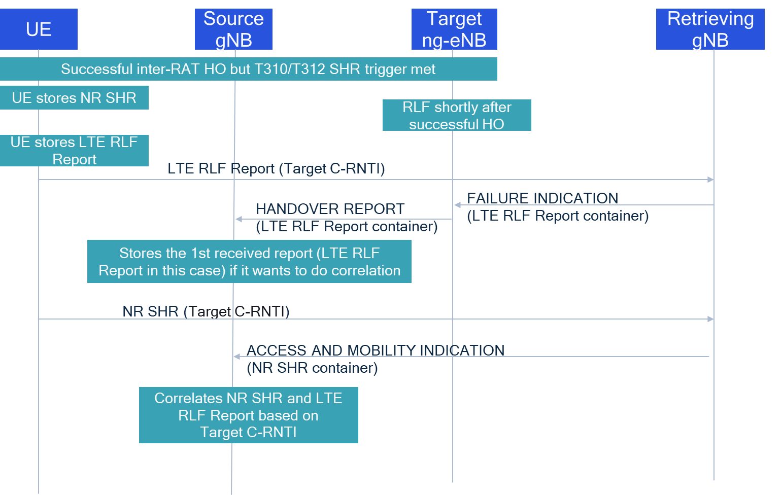

|  |  |
| --- | --- |
| **Company** | **Comment** |
| Lenovo | We want to remind that in RAN2#121, it was agreed that UE records the SHR for inter-RAT mobility in the existing IE for intra-NR SHR VarSuccessHO-Report to include source NR cell information, measurement results for source, target and neighbours, cause to indicate which inter-RAT SHR triggering condition was met and UE location Information, but RAN2 needs to further discuss if below content is needed for inter-RAT SHR when HO from NR to LTE:  a. C-RNTI (FFS target or source)  c. FFS: Time between report generating and fetching  Until now, RAN2 don't agree to include target C-RNTI in inter-RAT SHR, we can't say that target C-RNTI is already included in the inter-RAT SHR. So, for Alt B, both RAN2 and RAN3 spec impacts exist. |
| Nokia | Just pure target C-RNTI to correlate the SHR and RLF report is insufficient. |
| Huawei | We prefer to support correlation with option b. We think the time between event and reporting would be beneficial and that we can ask RAN2 about it. But even without this time we can correlate most cases |
| CMCC | For Alt B, although the source NR node could receive Inter-RAT SHR and LTE RLF report respectively, but the time between the two reports received maybe a long time. The source node supporting correlation of SHR and RLF Report has to save one report for a long time to wait for the other one, since it has no information on the present of the report it waiting for. This solution would introduce extra burden and storage requirement to the source node. |
| Ericsson | Option B is ok. We also think time is beneficial. But let’s revise this after RAN2 online session |
| Samsung | Option B is ok. |

**Q6b: For Alt B, does Target C-RNTI need to be included in HANDOVER REPORT? One reasoning provided is that the source gNB might not be able decode the LTE RLF Report container and hence the target ng-eNB can include it explicitly in HANDOVER REPORT.**

|  |  |
| --- | --- |
| **Company** | **Yes/No** |
| Lenovo | Yes |
| Nokia | Yes, but it shall be clarified it is not for correlation of the SHR and RLF for inter RAT HO from NR to LTE. |
| Huawei | Yes |
| CMCC | See the comments of Q6a |
| Ericsson | Yes |
| Samsung | Yes |

**Q7: For Alt C, UE needs to be configured with a “new timer” during which it checks whether there were correlated SHR and RLF Reports generated. Should this timer be same as Tstore_UE_cntxt defined in the network for detecting too early HO ? Isn’t this leading to duplicate functionalities at network and UE? Also, should UE discard SHR upon detecting a correlation or should it send both SHR and RLF Report with a correlation indicator?**

|  |  |
| --- | --- |
| **Company** | **Comment** |
| Lenovo | If the UE is configured with a “new timer” during which it checks whether there were correlated SHR and RLF Reports generated, it seems the easy way is that the UE discards SHR upon detecting the correlation and only sends the RLF report. |
| Nokia | The timer should be the Tstore_UE_cntxt. We do not agree on the discarding the SHR upon detecting the correlation. It shall be noted that the optimization is done on cell level for group of UEs which may be identified based on mobility profile (configuration information) meaning that if ratio of the generated SPRs correlated with RLF to total number of PSCell changes for the given source target cells pair is above the given threshold then instead of near failure optimization the optimization of PSCell change to wrong cell will be prioritized. But it does not mean that SHR even correlated with RLF cannot be used for other purposes for example detailed radio conditions analysis for the small group of UE located in the given area. Even with the correlation based on C-RNTI and time between successful PSCell change and fetching the SHR correlated with RLF report does not need to be discarded, just optimization to wrong cell is prioritized. |
| Huawei | The functionality has higher impact than the UE providing the time/C-RNTI for the network based solution. Normally we do not specify UE based solutions when the network is able to solve it.  *Small comment on the solution:* In order to provide similar functionality as network based (where network can choose how to handle the duplication) we need to send with an indicator. The other option (to discard) is also possible but removes some flexibility for the analysis in the network. |
| CMCC | Firstly, we prefer to use “UE assistance-based” for Alt C rather than “UE based”, because “UE based” can be misunderstood that UE has the final decision on the correlation of SHR and RLF and the corresponding optimization(e.g. the discarding the SHR upon detecting the correlation). For the case there is a RLF shortly after a successful inter-RAT HO from NR to LTE, the network (e.g. the source NR node) needs to perform root cause analysis and optimization.  For Alt C, a timer is needed(e.g. Tstore_UE_cntxt) and UE should send both SHR and RLF Report with a correlation indicator, which is introduced in SHR to indicate whether there is a RLF shortly after a successful inter-RAT HO from NR to LTE.  We propose that UE assistance-based option based on correlation indicator reported within the SHR **as the baseline** for correlation of SHR and RLF Report. **The correlation indicator as the assistance information** can make the gNB implementation(e.g. The source gNB performs the correlation and analysis based on C-RNTI or the source gNB collects the number of HOs with SHR linked to RLF report) more feasible and more flexible. Therefore, it is not against the gNB implementation and it is not leading to duplicate functionalities at network and UE as well. |
| Ericsson | Agree with Lenovo and Huawei |
| Samsung | Agree with Lenovo and Huawei |