3GPP TSG-RAN WG3 #119bis-e R3-231871
17th–26th April 2023
Online

Agenda Item: 10.2.4
Source: ZTE (Moderator)
Title: Summary of Offline Discussion on CB: # SONMDT4_NPN
Document for: Approval

Introduction
CB: # SONMDT4_NPN
- Check if any revisions are needed for the NGAP TP for MDT in the PNI-NPN? XnAP mirror TP?
- Discuss the solution on MDT in the SNPNs
- Capture agreements and open issues, provide TPs if agreeable
(moderator - ZTE)
Summary of offline disc R3-231871

For the first round, the deadline is Thursday, April 20th, 08:00am UTC.
For the second round <TBD, if needed> we focus on the left issue and clean up the TPs. The deadline is xxxx.

For the Chairman’s Notes
<TBD>

Discussion (1st round )

Revisions for the agreed NGAP TP for MDT in the PNI-NPN
During the RAN3#119 meeting, the solution of Area scope of MDT in PNI-NPN and the corresponding NGAP TP in R3-231022 were agreed.
- If only CAG cells are measured, the new choice of PNI-NPN based in CHOICE IE is used to indicate the CAG list. The outside PNI-NPN Area Scope of MDT IE is not present.
- If both CAG cell and normal PLMN cell are measured, both the outside PNI-NPN Area Scope of MDT IE and the legacy choice IE should be present.
The agreed tabular in R3-231022 is shown below:

CHOICE Area Scope of MDT | M
>Cell based |  |  |  | If PNI-NPN Area Scope of MDT IE is present, it covers non-CAG cells only
>>Cell ID List for MDT |  | 1..<maxnoofCellIDforMDT>
>>>NR CGI | M |  | 9.3.1.7
>TA based |  |  |  | If PNI-NPN Area Scope of MDT IE is present, it covers non-CAG cells only
>>TA List for MDT |  | 1..<maxnoofTAforMDT>
>>>TAC | M |  | 9.3.3.10 | The TAI is derived using the current serving PLMN.
>PLMN wide |  |  | NULL | If PNI-NPN Area Scope of MDT IE is present, it covers non-CAG cells only
>TAI based |  |  |  | If PNI-NPN Area Scope of MDT IE is present, it covers non-CAG cells only
>>TAI List for MDT |  | 1..<maxnoofTAforMDT>
>>>TAI | M
>PNI-NPN based
>>CAG List for MDT |  | 1..<maxnoofCAGforMDT>
>>>PLMN ID |  |  | 9.3.3.5
>>>CAG ID | M |  | 9.3.3.43
……
PNI-NPN Area Scope of MDT | O |  | 9.3.3.x | This IE is ignored if the Area Scope of MDT IE is set to “PNI-NPN based”

Some companies provides the further changes to this TP, seen below:
Proposal A : R3-231337(Samsung) and R3-231556(CATT) propose to remove the description of "This IE is ignored..." in the tabular, and add new text procedure in the abnormal case. Both companies think this sentence may have conflict with the text procedure due to it is a "shall" behaviour.

Proposal B : R3-231337(Samsung) and R3-231556(CATT) propose to remove the description of "...it covers non-CAG cells only”in all choices in the tabular.
Moderator observes that although this proposal given by two companies is the same, it is based on completely different reasons.
- 1337 thinks without adding the semantics description, the Old Choices already describes only normal PLMN cells, then this sentence can be removed.
- 1556 gives different reason for the same change, that is "when we only what to measurement PN cell and select the PLMN wide, all the cells in the PLMNs will be measurement, including the PNI-NPN cells." and "the PNI-NPN is based on the PN network, and MDT’s measurement result is almost the cell quality instead of some private information, no need to add this Semantics description.One acceptable way is that once PLMN wide/cell based/TA based/TAI based and PNI-NPN Area Scope for MDT appears together, UE will measure the union set of both two IE". Moderator believes that the latter reason is inconsistent with the RAN3's consensus achieved at the last meeting.
Proposal C : R3-231588(Ericsson) proposes to modify "..., it covers non-CAG cells only” as follows: "..., it covers non-CAG cells only, where non-CAG cells refer to cells that only provide public access."

R3-231629 (Nokia) provides the following proposals:
Proposal D : Keep legacy functionality for existing NGAP PLMN Wide choice alternative, and add a new NGAP PLMN wide choice alternative for area scope including non-CAG cells only.( the PLMN Wide choice alternative is not available in the XnAP Area Scope nor in the the RRC AreaConfiguration CHOICE structures. Over these interfaces the functionality corresponding to the PLMN Wide choice alternative, i.e. absence of area restrictions, is achieved by not including area scope information) (seen yellow highlight in below table.)
Proposal E : Add a new choice alternative for area scope including non-CAG cells only (intended for NGAP, XnAP, RRC) (seen green highlight in below table.)

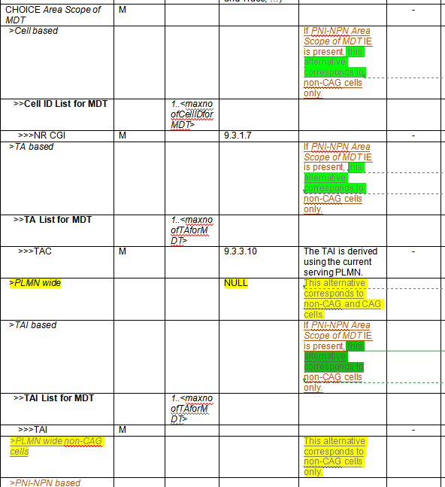

Proposal F: R3-221710(ZTE) proposes to remove the description of "..., it covers non-CAG cells only”in all choices to avoid duplicated description, and add the description in following table in the top of CHOICE IE to indicate the choice alternative for area scope including non-CAG cells only, and clarify this CHOICE IE is used for UE not operating in SNPN access mode, seen below.
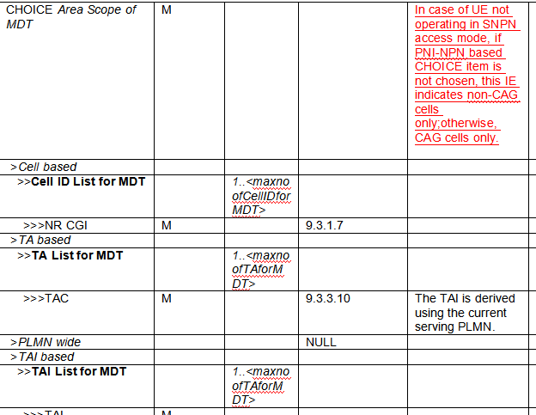

Proposal G: Remove Editor’s note 2 “Further checks are needed on whether the newly added information is compatible with configuration of MDT measurements and MDT Area Scope over RRC”.

Proposal H: Set the range of maxnoofCAGforMDT to 256.

Moderator provides a concise summary of these proposals, seen below:
- A: remove "This IE is ignored...";
- B: remove "...it covers non-CAG cells only";
- C: modify "..., it covers non-CAG cells only” as follows: “..., it covers non-CAG cells only, where non-CAG cells refer to cells that only provide public access.”.
- D: add a new "PLMN wide for non-CAG cells" choice item, keep the existing NGAP PLMN Wide choice for "PLMN wide, i.e, CAG cells and non-CAG cells".
- E: Add the description for the new choice alternative for area scope including non-CAG cells only (intended for NGAP, XnAP, RRC)
- F: remove the duplicated description of "..., it covers non-CAG cells only”in all choices, and only add the description in the top of CHOICE IE to indicate the choice alternative for area scope including non-CAG cells only.
- G: remove editor's note 2.
- H: Set the range of maxnoofCAGforMDT to 256.

Q1: Please Companies provide their views on the above proposals?
Companies | Yes/No for above proposals | Comments
ZTE | A: Prefer no , see comments  B: No  C: No strong view, Slightly prefer not needed.  D: Yes.  E: Yes, but see comments  F:Yes, but see comments  G,H: yes | For proposal A, We think this semantics description makes IE easier to understand, it is better to keep it. if companies concern the "shall" behaviour, we suggest to modify the procedure text as follows:  If the PNI-NPN Area Scope of MDT IE is included in the MDT Configuration-NR IE included in the HANDOVER REQUEST message and not ignored, the NG-RAN node shall, if supported, use it to derive the MDT area scope for MDT measurement collections in PNI-NPN areas, the NG-RAN node shall consider that the area scope for MDT measurement collections of PNI-NPN areas is defined only by the areas included in the PNI-NPN Area Scope of MDT IE.  For proposal B, we find that there are still different understandings of this IE, so we think the semantics description of this IE is necessary.  For proposal E, we propose to add description in the top of CHOICE IE to indicate the choice alternative for area scope including non-CAG cells only, like our proposal F.  For proposal F, we propose to remove the added description in all choices to avoid duplicated description, and add the description in the top of CHOICE IE. In addition, it needs to be clarified whether this IE will be used for SNPN. We also agree the proposal D, so we modify description in F as follows:  In case of UE not operating in SNPN access mode, if PNI-NPN based CHOICE item is chosen, this IE indicates CAG cells only;otherwise, Non-CAG cells only if the IE is not set to "PLMN wide".

Moderator’s summary:

For chairman notes:

XnAP TP for MDT support in PNI-NPN
R3-231184 (Huawei) and R3-221710(ZTE) provide the XnAP mirror TP for MDT support in PNI-NPN based on the agreed NGAP TP in R3-231022.

Q2: Does company agree to adopt an XnAP mirror TP for MDT support in PNI-NPN based on the agreed/revised NGAP TP?
Companies | Yes/No | Comments
ZTE | Yes

Moderator’s summary:

For chairman notes:

MDT support in SNPN

According to the approved eNPN WID in RP-230788, the Inter-SNPN mobility within equivalent SNPNs needs to be supported in Rel-18. Furthermore, during the previous RAN3 meetings, RAN3 agreed to discuss how to support MDT Area Scope for specific cells or TAs of an SNPN.
RAN3 to focus on the following use case for SNPN and to continue discussions on how to address MDT Area Scope for specific cells or TAs of an SNPN:

There are different solutions in the contributions.
- Option A: R3-231301(Intel) : add a list of SNPN into the existing Choice structure.
- Option B: R3-231588(Ericsson) : add a list of SNPN outside the existing Choice structure.
- Option C: R3-231342(Qualcomm), R3-231629(Nokia) : add "SNPN cell based" and "SNPN TA based" choice into the existing Choice structure.
- Option D: R3-231629(Nokia) : add "SNPN wide" choice into the existing Choice structure.
- Option E: R3-231556(CATT) and R3-221710 (ZTE): reuse the legacy Choice structure for SNPN, i.e, OAM configures the cell list or TA list within interested SNPN(s), there is no need to introduce a SNPN list for MDT.

Q3: Companies are invited to provide their preference of the above options.
Companies | A, B, C, D, E | Comments
ZTE | E | It shall be supported to configure MDT Area Scope for specific cells or TAs of an SNPN. Since in the solution of PNI-NPN, we assume that OAM can configure legacy Cell/TA list in the choice only covering non-CAG cells, for the same reason, we believe that OAM can configure the cell list or TA list within the interested SNPN(s), there is no need to introduce a SNPN list for MDT.

Moderator’s summary:

For chairman notes:

stage 2 TP for MDT support in NPN
R3-231185(Huawei) provides stage 2 TP for MDT support in NPN for TS 37.320, seen below:
5.4.x Support of NPN
MDT is supported in both PNI-NPN and SNPN.
For signalling based MDT in PNI-NPN, the AMF indicates a list of CAG ID in MDT Configuration to specify the area scope of the MDT task.

Q4: Please companies provide their views on the stage 2 for MDT support in NPN.

Companies | Comments
ZTE | Wait until SNPN solution is chosen, then discuss how to capture agreements into stage 2.

Moderator’s summary:

For chairman notes:

3.5 LS to RAN2 for MDT area scope in NPN
In order to support MDT in NPN, RAN3 has introduced some restrictions on legacy choice item in CHOICE Area scope for MDT IE , and some new area scope information in/outside the CHOICE IE. These updates will affect the relevant RRC AreaConfiguration definitions of RAN2. Is it time for us to send an LS to RAN2 to inform the progress of MDT support in NPN of RAN3, and CC to other some WGs?

Q5: Does company agree to send an LS to RAN2 to inform the progress of MDT support in NPN of RAN3?
Companies | Yes/No | Comments
ZTE | Yes | if the SNPN solution is agreed, RAN3 needs to send an LS to RAN2, and CC to SA2,SA5.

3.6 LS to SA5 for user consent
SA3 has sent an LS to RAN3 in S3-231399, where the following answers are provided in response to questions asked by RAN3:
--------------------------------------------------Start of Excerpt From S3-231399-----------------------------------
In reply to document R3-226006, SA3 has the following view:
"Question 1: To denote that user consent for MDT in PNI-NPN is given, whether there is a need for signaling of private network identifiers (CAG ID) to the NG-RAN or if it can be covered by signalling public network identifiers (PLMN ID) to the NG-RAN?"
SA3 considers that using public network identifiers (PLMN ID) is sufficient.

"Question 2: Whether user consent needs to be supported for MDT in SNPN, and if yes, to denote that user consent for MDT in SNPNs is given, whether there is a need for signaling of private network identifier (SNPN ID) to the NG-RAN?"
SA3 notes that the business models for SNPN are varied and SA3 assumes that the SNPN operator itself will develop operational functions that are specific to their use case. As such, SA3 has not identified any requirements for user consent in this case.

-------------------------------------------------- End of Excerpt From S3-231399-----------------------------------
R3-231588(Ericsson) thinks the user consent framework in place for MDT should not apply to SNPN networks, and suggest to send an LS reply to SA3 and SA5 to inform them that RAN3 awaits SA5´s changes to TS32.422 to align with the inputs from S3-231399.

Q6: Does company agree to send an LS to SA5 for MDT user consent in NPN?
Companies | Yes/No | Comments
ZTE | No | S3-231399 is already CC to SA5.

3.7 Other issues
if needed, some issues not covered in 1st round can be discussed in second round.

References
- R3-231184 (TP for MDT BL CR for TS 38.423) Addition of PNI-NPN in MDT Area Scope (Huawei, China Telecom, CMCC)
- R3-231185 (TP for SON BLCR for TS 37.320): MDT support in SNPN (Huawei, Orange, China Telecom, CMCC)
- R3-231301 (TP for SON BL CR for TS 38.413) MDT enhancements for SNPN (Intel Corporation)
- R3-231337 Discussion on SON/MDT for NPN (BEIJING SAMSUNG TELECOM R&D)
- R3-231342 SON MDT enhancements for Non-Public networks (Qualcomm Incorporated)
- R3-231556 Discussion on SONMDT enhancement for NPN (CATT)
- R3-231588 SON enhancements for Non-public networks (Ericsson)
- R3-231629 (TP for MDT BL CR to TS 38.413) Support of NPN in MDT area scope (Nokia, Nokia Shanghai Bell)
- R3-231710 (TPs for SON BLCRs for TS 38.413 and TS 38.423)MDT support in NPN (ZTE)
- R3-231742 (TPs for MDT BLCRs for TS 38.413, TS 38.423): MDT support in SNPN (Huawei)

