3GPP TSG-RAN WG3 #114-e R3-215830
1 - 11 Nov 2021
Online

Agenda Item: 9.3.6.1
Source: ZTE - Moderator
Title: Summary of Offline Discussion on CB: # 27_ReportIntervalMDT
Document for: Approval

Introduction
CB: # 27_ReportIntervalMDT
- Correct on the stage 3 specifications (Report Interval IE of M1 configuration) in RAN3 to align with RAN2?
- Provide CRs if agreeable
(ZTE - moderator)
Summary of offline disc R3-215830

Please Note:
Two rounds of discussion.
The first round email discussion is to be ended by Friday (24:00 UTC, 2021-11-05).
The second round email discussion is to be ended before the email deadline at second week (12:00 UTC, 2021-11-09).

2 For the Chairman’s Notes
Propose to capture the following:
RAN3 should correct the value range of M1 report interval in 38.413 and 38.423, to fix the misalignment with RAN2.

TBD in the second round.
Whether to fix the misalignment issue together with stage2 and stage3 misalignment issue, i.e., Option A or Option B.
Whether CRs can be agreed.

4 Discussion (2nd round)
During the first round of discussion, most companies agreed that the RAN3 stage 3 specifications should be corrected to align with RAN2. But there is still concern on stage2 and stage3 misalignment issues, and it is proposed that this issue should be discussed together with the stage2 and stage3 alignment issue.
It is noticed that RAN2 would discuss the stage 2 and stage 3 alignment issue on M4/M5 this week and hopefully they would agree on an LS to RAN3 this time. So, if time allowed, we can work on the stage3 misalignment issue and the stage2-stage3 misalignment issue together (Option A). But considering the limited time, it is possible that even after the deadline of the discussion, we still don’t get the reply from RAN2. So Moderator also wonder whether it is accepted that we fix the misalignment issue of M1 first (Option B).
Two Options:
Option A: Wait for the reply LS from RAN2 on the stage-stage3 misalignment issue of M4/M5. After we get the reply LS (or once we know the conclusion in RAN2), fix the misalignment issues together.
Option B: Fix misalignment issue of M1 (correct on 38.413/423) first. Then wait for the reply LS (or conclusion) from RAN2 on the stage-stage3 misalignment issue of M4/M5, and continue to work on the stage2 and stage3 misalignment issue.

Q1: Which Option do you prefer to solve the misalignment issues?
Company | OptionA/B | Comments
ZTE | Option B | We are not sure when RAN2 would finish the discussion on the stage2-stage3 misalignment issue of M4/M5. So we prefer to first fix the M1 issue to move forward. After we get the reply of RAN2 (or once we know the conclusion in RAN2), we can continue to work on the stage2 and stage3 misalignment issue.
CMCC | Option B | We do not see the connection between fix the issue on M1 and the replying LS on M4 and M5. Since M1 issue is quite clear and does not need any feedback or confirm from RAN2, we can carry on.

If Option B is selected, Please provide your opinions on the CRs contributed for the correction on 38.413 and 38.423.
Q2: Do companies think the CR[1] for 38.413 can be agreed?
Company | Yes/No | Comments

Q3: Do companies think the CR[2] for 38.423 can be agreed?
Company | Yes/No | Comments

3 Discussion (1st round)
In R3-214982, a misalignment issue between RAN3 (38.413/38.423) and RAN2(38.331) satge3 specifications is further discussed, with more considerations on the alignment throughout specifications and the necessity for backward compatibility. The proposed CRs for 38.413 and 38.423 are provided in [1] and [2].
the misalignment issue:
In RAN3 stage3 specifications (38.413/38.423), the value range of the Report Interval IE of M1 configuration is as below:
(ms120, ms240, ms480, ms640, ms1024, ms2048, ms5120, ms10240, min1, min6, min12, min30, min60)
However, as in the ASN.1 in 38.331, which is marked as the reference for report interval IE in 38.413/38.423, the value range of report interval is not aligned with that in RAN3 specifications.
ENUMERATED {ms120, ms240, ms480, ms640, ms1024, ms2048, ms5120, ms10240, ms20480, ms40960,
min1,min6, min12, min30 }

During last meeting, an old discussion about the stage2 and stage 3 misalignment on M4/M5 was mentioned. Regarding to that issue, an LS[3] has been sent to SA5 to ask about their opinion on the stage2 and stage3 misalignment issue, and we got the reply[4] from SA5 which said that stage3 specifications should be updated to match stage2 specification. After that a further reply[5] was sent to RAN2 to ask RAN2 about the feasibility about the feasibility of stage2 and stage 3 alignment. According to the history of the discussion on stage 2 and stage 3 misalignment issue, Moderator has noticed that there indeed exist misalignment issue throughout specifications. And it would be better that after we get the reply from RAN2, we fix the misalignment issue cross specifications completely.
Now come back to the misalignment issue in this CB, considering the reply from SA5, if the stage 3 specification of RAN2 is to be modified to match SA5, it means the ASN.1 in 38.331 has to be changed. This is not preferred at current time in standardization work.
To prevent the inconvenience of modifying the ASN.1 in RAN2, it is proposed that RAN3 stage 3 specifications should be corrected to align with RAN2, so that the ASN.1 in 38.331 would not be affected. For the potential stage 2 and stage 3 misalignment issue that might be raised because of this correction, SA5 can be notified to change the value range to align with RAN2 and RAN3, so that the misalignment issue for M1 report interval throughout specifications can be solved completely.
Q1: Do you agree that RAN3 should correct the value range of report interval IE in M1 configuration IE in 38.413 and 38.413, to align with RAN2?
Company | Yes/No | Comments
Ericsson |  | As mentioned before, this discussion should be taken together with the discussion on alignment of Report Interval for MDT measurement across stage 2 and stage 3. The reason is that an MDT configuration is always generated by the OAM. OAM provides the configuration, with a specific measurement interval for each measurement, either to the AMF or to the RAN. If there is a discrepancy between the values the OAM can provide and those the RAN can implement, this has to be resolved by implementation. For example, if OAM signals a value for the report amount that the RAN does not support, the RAN will have to decide by itself about a value to signal to the UE. Likewise, if the Report Amount value is not signalled by the OAM, then RAN should not use it.  Looking at TS32.422, the Report Interval values ms20480 and ms40960 are not specified for NR. Hence the OAM will never signal these values. Unless Stage 3 and Stage 2 are aligned, there seem to be no reason to add these values in the NGAP.  Therefore we suggest to take this discussion together with the Stage 2 and Stage 3 alignment.
CMCC | Yes | We have received request from our network operation department to align the stage 2 and stage 3 for M1, i.e., 38.331/38.413/32.422. If not aligned, some issues may happen. For example, if OAM signals a value for the report interval that the RAN does not support, e.g., 60min, the RAN behavior is fully left to implementation which is not a good way.  It makes sense not to touch 38.331 at this stage, so we also propose to align Uu and NG and ask SA5 to update the stage 2 spec, if needed.
Nokia | Yes | OK with the way forward proposed by CMCC (align NGAP on Uu, and then request SA5 to update stage 2). This follows the principle that stage 2 aligns on stage 3.
Huawei | Yes | We are fine.
CATT | Yes | The change is fine for us.
Samsung | Yes | This situation is different from the other stage2-stage 3 mis-alignment cases. It is stage 3 mis-alignment between NGAP and RRC. We think this situation is more serious and correction to stage 3 mis-alignment is needed.
ZTE | Yes | We think companies have common understanding that this stage 3 misalignment between NGAP and RRC should be fixed. As Samsung pointed, this is a more serious problem and should be corrected.  We also agree with Ericsson on the view that stage 2 and stage3 misalignment issue should be discussed together. On the M1 issue, we can see the stage2 (SA5) and RAN2 stage3 are misaligned, but as mentioned above, to prevent changing the ASN.1 in 38.331, we propose to align with RAN2, i.e., to correct the specifications in RAN3 and SA5. We think that would be a better way to work on the M1 issue. I provided a figure here to show the logic of our correction for M1, which is also agreed by several companies commented above.  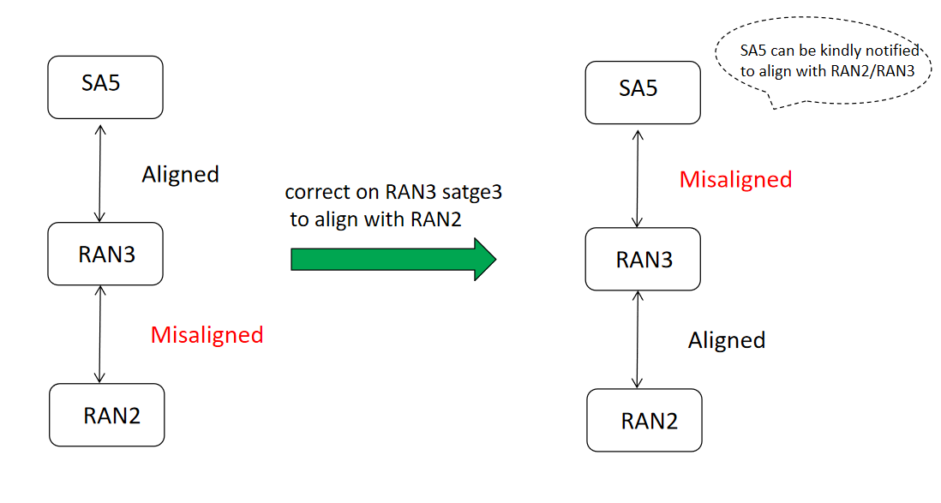  For other misalignment issue, e.g., the stage 2 and stage3 misalignment issue on M4/M5, which has no impact on ASN.1 in 38.331, we are also fine with the correction work, to fix the misalignment issue throughout specifications. As I know, RAN2 would probably work out a reply LS to RAN3 on this issue next week. Let’s see what we can do in the phase II discussion. Maybe the two type of issues can be handled together, if time allowed.

In the proposed CRs[1][2], the corrections are a bit different with the original versions submitted at last meeting. To be specific, the correction in the old CRs[6][7] are NBC, while in [1][2], a new IE named Extended Report Interval IE is introduced, as the extension of the Report Interval IE, for the 2 values that need to be added (ms20480, ms40960, ...).
Q2: Do you think the corrections in the proposed CRs are acceptable and can be agreed?
Company | Yes/No | Comments

4 Conclusion, Recommendations
See section 2.

5 References
[1] R3-214983 Value range misalignment for Report Interval IE of MDT M1 configuration (NGAP)
[2] R3-214984 Value range misalignment for Report Interval IE of MDT M1 configruation (XnAP)
[3] R3-207222 LS to SA5 on MDT Stage 2 and Stage 3 alignment
[4] S5-206297 Reply LS on MDT Stage 2 and Stage 3 alignment
[5] R3-211140 Reply LS on MDT Stage 2 and Stage 3 alignment To SA5, RAN2
[6] R3-213802 Misalignment value range for reportInterval IE of MDT(NGAP)
[7] R3-213803 Misalignment value range for reportInterval IE of MDT(XnAP)

