3GPP TSG-RAN WG3 Meeting #114-e R3-215878
E-meeting, 01-11 Nov 2021

Agenda Item: 19.2.3
Source: CATT (moderator)
Title: SoD for On-Demand PRS Transmission and Reception
Document for: Approval

Introduction
CB: # 1903_Pos_OnDemandPRS
- Take inputs from RAN1 and RAN2 into account
- RAN1/2 discussions yet to be concluded, should RAN3 wait for discussion closure?
- Should an LS be sent with the RAN3 agreements from REN3-113e?
- Inclusion of parameters in PRS CONFIGURATION REQUEST/RESPONSE?
- Enhancements to TRP INFORMATION RESPONSE?
- Capture agreements and open issues
(CATT - moderator)
Summary of offline disc R3-215878

For the Chairman’s Notes
//to be added

Discussion

Reply LS related to On-Demand PRS
RAN2 is also discussing the stage 2 signaling procedure and details of On-Demand PRS, according to the RAN2 email discussion [Post115-e][609][POS] RAT-dependent stage 2 CR [1], See the figure in the appendix, where the description of the step 0 as well as the step 4/5 should be clarified by RAN3.
In addition, according to the RAN2 LS [2] and the contributions of various companies, the following agreements were reached in the previous RAN3 meetings:
- Introduce a new non-UE associated NRPPa procedure (class 1) to support on-demand PRS. Details FFS.
- The new NRPPa procedure enables LMF to request gNB to (re)configure PRS transmission, and gNB to indicate the updated PRS configuration to LMF. Details FFS.
- Enhance the TRP Information Exchange procedure to support pre-defined PRS configurations.
In conclusion, to enable RAN2 to better design the stage 2 signaling procedure of On-Demand PRS, it is necessary to inform RAN2 of the latest progress of RAN3 meeting in the form of Reply LS.
Question 1: Do you agree to prepare a Reply LS to inform RAN2 of the latest progress of RAN3?
Company | Answer | Comment
Huawei | Yes | The RAN3 agreements are directly related to the RAN2 discussions. Since RAN2 is still discussing the procedures for the on-demand PRS, it is necessary to let the RAN2 know the RAN3 consideration and agreements. So that RAN2 could design the procedure taking RAN3 agreements into account.
Ericsson | No | No need. The above agreements have been communicated in the latest WI status reports to RAN (RP-211313 and RP-212365) and seem already captured by RAN2 in [1].

If the answer of Q1 is "Yes", it should be considered what contents need to be captured in the Reply LS？
According to the company contribution [3], the conclusion of RAN3's previous meetings need to be directly reflected in the Reply LS as below：
- Providing the requested on-demand DL-PRS configuration from an LMF to the gNB and confirmation by the gNB are supported by newly defined PRS Configuration Exchange procedure
- The gNB provides the supported (possible/allowed) on-demand DL-PRS configurations to the LMF via TRP information exchange procedure.
- The TRP capability of whether supporting the reconfiguration of DL-PRS is indicated by whether the gNB provides the (possible/allowed) on-demand DL-PRS configurations when requested by the LMF in the TRP exchange procedure.
Question 2: Do you agree that the above content can be included directly in the Reply LS? Also please indicate if anything is missing.
Company | Answer | Comment
Huawei | Yes | No comment for now
Ericsson | No | We should wait for RAN2 to finish the stage 2 CR discussion. They can liaise us before the end of the release to review the draft CR, if needed.

On the other hand, according to the RAN2 email discussion [Post115-e][609][POS] RAT-dependent stage 2 CR [1], in the latest Stage 2 draft CR, there are some points that need the clarification from RAN3, as shown below：
Editor's Note: Depending upon RAN3 input, the above description may need to be updated especially for NRPPa procedure, e.g. the name of the message, exchange between RAN and LMF on allowed PRS configuration, etc.
According to the company contribution [4], the following modified TP may reflect the conclusions of previous RAN3 meetings:
Note: Changes are highlighted in yellow.

7.x Procedures for On-Demand PRS transmission

7.x.1 General
On-Demand PRS transmission procedure allows a UE or LMF to request the PRS transmission or the change to PRS transmission characteristics for positioning measurements. Either UE or LMF can initiate the On-Demand PRS transmission request.

7.x.2 On-Demand PRS transmission procedures
Figure 7.x.2-1 shows the general positioning procedure for On-Demand PRS transmission.

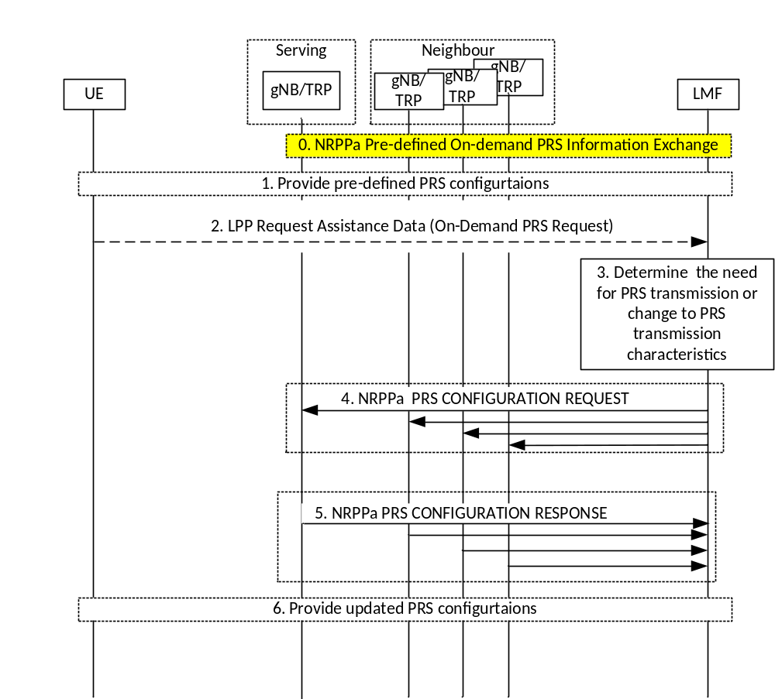
Figure 7.x.2-1: Procedures to support On-Demand PRS transmission.
0. The LMF may use the procedure in Figure 8.10.3.2.1-1 to obtain the possible On-Demand PRS configurations that the gNB can support.
1. In case of UE-initiated On-demand PRS, the LMF may configure the UE with pre-defined PRS configurations via LPP Provide Assistance Data message or via posSI.
2. In case of UE-initiated on-demand PRS, the UE sends an On-Demand PRS request to the LMF via LPP Request Assistance Data message. The On-Demand PRS request may be a request for PRS transmission or change to the PRS transmission characteristics for positioning measurements.
3. The LMF determines the need for PRS transmission or change to PRS transmission characteristics. In case of LMF-initiated On-demand PRS, the LMF may obtain UE measurements prior to step 3.
4. The LMF requests the serving and non-serving gNBs/TRPs for new PRS transmission or PRS transmission with changes to the PRS configuration via NRPPa PRS CONFIGURATION REQUEST message.
5. The gNBs/TRPs acknowledge the PRS transmission update in the NRPPa PRS CONFIGURATION RESPONSE message accordingly.
6. LMF provides the updated PRS configuration used for PRS transmission via LPP Provide Assistance Data message or posSI to the UE.

NOTE 1: LMF may use existing positioning methods to obtain (ECID) SSB/CSI-RS RSRP measurements or (DL-AoD) DL-PRS RSRP measurements in order to assist step 3.
NOTE 2: It is up to Network (LMF) implementation on the steps to follow (accept/reject/ignore) on receiving request from UE for changing the DL-PRS configurations.

Editor's Note: FFS if the UE can send the MO-LR to request On-Demand PRS.
Editor's Note: FFS on the condition when UE can trigger the On-Demand PRS request.
Editor's Note: FFS on the content of On-Demand PRS request.

Question 3：Companies are invited to provide your view on the TP update above. Also please indicate if anything is missing.
Company | Answer | Comment
Huawei | No | We would prefer not interfere with RAN2 text part now. The contribution could be submitted in RAN2. The stage 2 running CR is managing by RAN2, who can update the procedure themselves when received RAN3 LS.
Ericsson | No | Same view as Huawei. We can review the stage 2 CR later, not only for on-demand PRS, but also for the other R17 positioning topics. This can be based on LS request for stage 2 review from RAN2

Next, how can RAN3 incorporate the above TP update into the stage 2 specification? There may be two ways for choice:
- Option 1: The updated TP is reflected in the Reply LS towards RAN2, and then RAN2 modifies the Stage 2 specification
- Option 2: Waits for RAN2 to complete the initial version of the Stage 2 specification, and then RAN3 modifies the corresponding description based on the above TP update.
- Option 3: ?
Question 4: Which solution do you support to incorporate the above updated TP into the stage 2 specification?
Company | Answer | Comment
Huawei |  | See above  Option 2 is not an option, as RAN2 does not have an official picture of the RAN3 considerations and would need RAN3 to re-discuss again after the RAN2 decide something, which double the work between different groups.
Ericsson | Option 2 with comment | As it happened in the past releases, it is often that RAN2 liaises us with the stage 2 CRs (e.g. TS 36/38.300, etc.) to review the RAN3/architecture part and provide our updates before the end of the release.

Signaling details of On-Demand PRS
According to the discussion of previous RAN3 meetings, for On-demand PRS signaling procedure, the two class 1 procedures shall be considered, i.e, PRS configuration exchange and TRP Information exchange. But, “Details regarding information (e.g. parameters, PRS utilization, measurements in general, etc.) to be exchanged by the procedure is pending RAN1/RAN2”.
Based on the company's contribution [5], it is proposed that the Requested DL PRS Transmission Characteristics IE in the PRS CONFIGURATION REQUEST message can include the following parameters (per TRP): DL PRS Periodicity, DL PRS resource bandwidth, and DL PRS QCL information. In addition, another company suggested that Let RAN1 and RAN2 to finish the discussion of parameters for on-demand PRS and the design of predefined PRS configurations, before RAN3 arrange the contents in NRPPa message [3].
Question 5: Do you agree that the Requested DL PRS Transmission Characteristics IE in the PRS CONFIGURATION REQUEST message can include some parameters (per TRP), e.g, DL PRS Periodicity, DL PRS resource bandwidth, and DL PRS QCL information? Or signaling details continue to be pending RAN1/RAN2?
Company | Answer | Comment
Huawei | No | RAN3 cannot determines the parameters without information from RAN1 input. We have to wait details under discussion in RAN1/RAN2. Otherwise we will need to discuss again when receiving the parameters from RAN1/2.  The latest RAN1 agreements:  - Agreement:  - The following list of parameters is supported for UE-initiated and LMF initiated on-demand DL PRS request  - Start/end time of DL PRS transmission  - DL PRS resource repetition factor  - Number of DL PRS resource symbols per DL PRS resource  - DL-PRS CombSizeN  - Number of DL PRS frequency layers  - ON/OFF indicator (for LMF initiated request only)  - FFS values for requested on-demand DL PRS parameters and whether parameters are resource-specific, TRP-specific, or PFL-specific  It can be seen that, the parameters agreed in RAN1 are not aligned with that in [5]. For example, RAN1#106 has excluded the DL PRS resource bandwidth in the parameter list. So this parameter should not be discussed again in RAN3 to contradict with RAN1.  It seems difficult to progress considering we do not have at this stage same understanding of RAN1parameters ….
Ericsson | Yes | We thank [5] for their efforts to address the currently empty IEs early, to avoid the same situation as end of Rel-16 with many IEs to fill in like puzzle boxes. We support updating the IE with the RAN1 agreements and adding the QCL information.  The QCL information should follow the encoding we have in 9.2.44 IE, i.e., to be per PRS Resource, per PRS Resource Set with a choice between SSB and DL-PRS, etc.  On Huawei comment above, Huawei have perhaps missed the agreement mentioned in [5] from RAN1#106-e meeting. The ones listed by Huawei above are from RAN1#106bis-e and are a continuation of the previous RAN1 agreements, where it was noted: “Conclude on remaining parameters at RAN1#106-bis-e”. Perhaps the parameters listed can also be added to the resulting TPs this meeting with a FFS
  Agreement:
  At least the following list of on-demand DL PRS parameters is supported for UE-initiated and LMF-initiated on-demand DL PRS requests
  1. DL PRS Periodicity
  2. DL PRS resource bandwidth
  3. DL PRS QCL information

In the company's contribution [5], the gNB behavior is further discussed for the PRS configuration exchange procedure, it is proposed that the parameters of the DL-PRS configuration determined by the gNB for a given TRP “should” (not “may” or “shall”) match those requested by the LMF in the Requested DL PRS Transmission Characteristics IE.
Question 2: Do you agree that the parameters of the DL-PRS configuration determined by the gNB for a given TRP “should” (not “may” or “shall”) match those requested by the LMF in the Requested DL PRS Transmission Characteristics IE?
Company | Answer | Comment
Huawei | No | LMF cannot decide the behavior of the gNB, and can only suggest/request. The gNB then decide by itself. This has been the rule for all kinds of NRPPa request messages. Again, we would also take benefit to wait confirmation from RAN1.
Ericsson | Yes with comment | We view the text proposed by [5] as replicating the procedure text we currently have for the Measurement procedure, except with the "should" instead of "shall" in the PRS CONFIGURATION REQUEST. We agree that this makes sense, since as Huawei said “LMF can only suggest/request” the PRSes to fine-tune. But the gNB knows better the radio conditions than LMF, so it may actually leave some PRS activated, suggested to be turned off by LMF, due to other traffic.  One comment on [5] in 8.2.X.2:  “If DL-PRS transmission is successfully configured for at least one of the TRPs, the NG-RAN node shall respond with a PRS CONFIGURATION RESPONSE message including the On-demand PRS information IE”.

In addition, as a response, the gNB returns a PRS CONFIGURATION RESPONSE message, in which the full DL-PRS Configuration (per TRP) decided by the gNB should be included.
Question 3: Do you agree that the PRS CONFIGURATION RESPONSE message includes the full DL-PRS Configuration (per TRP) decided by the gNB?
Company | Answer | Comment
Huawei | No | It is notable that the parameter LMF can request, can be detailed parameters or preconfigured PRS configuration with an ID, according to the RAN2 agreements. If the LMF requests the preconfigured PRS configuration with an ID, there is no reason why the gNB provide the detailed configurations again and may only need to response with a confirmation.  The LMF can also request ON/OFF for the DL PRS, according the RAN1 agreements. Then, it may also not necessary to include a full configuration.
Ericsson | Yes | This information will be used later by LMF to provide updated PRS configuration to UE

If the gNB cannot configure DL-PRS transmission for any (i.e. not even one) of the TRPs in the PRS TRP List IE of the PRS CONFIGURATION REQUEST message, the PRS Configuration Exchange procedure shall fail.
Question 4: Do you agree that the gNB sends the PRS CONFIGURATION FAILURE message if it cannot configure DL-PRS transmission for any of the requested TRPs.?
Company | Answer | Comment
Huawei |  | Generally fine with the proposal. It can also be addressed together with the parameters text proposal later when confirmed by RAN1/RAN2.
Ericsson | Yes | We can check later if current cause values can be sufficient or not.

According to the conclusion of the last RAN3 meeting, the TRP INFORMATION RESPONSE Message, as a feedback of the TRP information exchange procedure can carry the pre-defined PRS resource information. Based on the company's contribution [5], the On-demand PRS TRP Information IE in the TRP INFORMATION RESPONSE message includes at least the following (other parameters FFS):
- minimum and maximum allowed values for DL PRS periodicity, and
- minimum and maximum allowed values for DL PRS resource bandwidth.
Question 5: Do you agree that the On-demand PRS TRP Information IE in the TRP INFORMATION RESPONSE message includes at least the following:
- minimum and maximum allowed values for DL PRS periodicity, and
- minimum and maximum allowed values for DL PRS resource bandwidth.
Company | Answer | Comment
Huawei | No | Similar to Question 5. The parameters have been discussion in RAN1. The DL PRS resource bandwidth has already been excluded in the latest RAN1 agreements. The way how the allowed parameters is provided to LMF are discussing in RAN1/2.
Ericsson | No | We can simply re-use the current PRS configuration in 9.2.25 with some additional status indication of the PRS transmission (PRS active/ PRS off)

Others
If you have other issues to be discussed, please elaborate:
Company | Issues to be discussed?

Conclusion, Recommendations [if needed]
To be updated base on the discussion.

References
- R2-2109673, [Post115-e][609][POS] RAT-dependent stage 2 CR, Intel
- R2-2106594, LS on On-demand PRS
- R3-215392, Discussion and Draft LS on on-demand PRS, Huawei
- R3-215607, Discussion on On-Demand PRS, CATT
- R3-214978, (TP for NR_pos_enh BL CR for TS 38.455) Further details for on-demand PRS , Nokia, Nokia Shanghai Bell

Appendix (from R2-2109673)

7.x Procedures for On-Demand PRS transmission

7.x.1 General
On-Demand PRS transmission procedure allows a UE or LMF to request the PRS transmission or the change to PRS transmission characteristics for positioning measurements. Either UE or LMF can initiate the On-Demand PRS transmission request.

7.x.2 On-Demand PRS transmission procedures
Figure 7.x.2-1 shows the general positioning procedure for On-Demand PRS transmission.

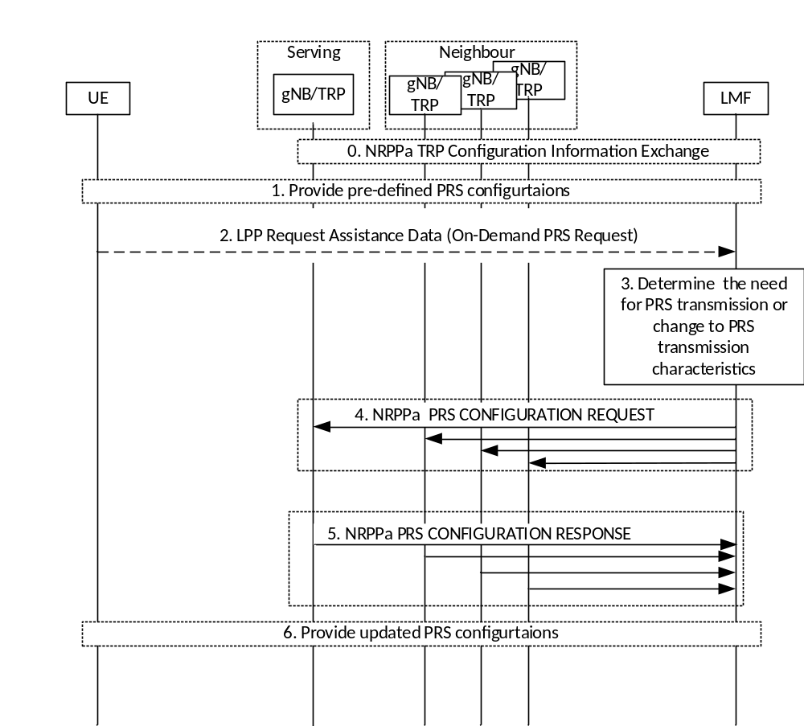
Figure 7.x.2-1: Procedures to support On-Demand PRS transmission.
0. The LMF may receive information on the possible On-Demand PRS configurations that the gNB can support during the TRP Configuration Information Exchange procedure.
1. In case of UE-initiated On-demand PRS, the LMF may configure the UE with pre-defined PRS configurations via LPP Provide Assistance Data message or via posSI.
2. In case of UE-initiated on-demand PRS, the UE sends an On-Demand PRS request to the LMF via LPP Request Assistance Data message. The On-Demand PRS request may be a request for PRS transmission or change to the PRS transmission characteristics for positioning measurements.
3. The LMF determines the need for PRS transmission or change to PRS transmission characteristics. In case of LMF-initiated On-demand PRS, the LMF may obtain UE measurements prior to step 3.
4. The LMF requests the serving and non-serving gNBs/TRPs for new PRS transmission or PRS transmission with changes to the PRS configuration via NRPPa PRS CONFIGURATION REQUEST message.
5. The gNBs/TRPs provide the PRS transmission update in the NRPPa PRS CONFIGURATION RESPONSE message accordingly.
6. LMF provides the updated PRS configuration used for PRS transmission via LPP Provide Assistance Data message or posSI to the UE.

NOTE 1: LMF may use existing positioning methods to obtain (ECID) SSB/CSI-RS RSRP measurements or (DL-AoD) DL-PRS RSRP measurements in order to assist step 3.
NOTE 2: It is up to Network (LMF) implementation on the steps to follow (accept/reject/ignore) on receiving request from UE for changing the DL-PRS configurations.
Editor's Note: Depending upon RAN3 input, the above description may need to be updated especially for NRPPa procedure, e.g. the name of the message, exchange between RAN and LMF on allowed PRS configuration, etc.
Editor's Note: FFS if the UE can send the MO-LR to request On-Demand PRS.
Editor's Note: FFS on the condition when UE can trigger the On-Demand PRS request.
Editor's Note: FFS on the content of On-Demand PRS request.

