**3GPP TSG-RAN WG3 Meeting #110-e *R3-206734***

**2 – 12 Nov 2020**

**Title:** TP on potential RAN3 impacts about the QoE measurement configuration, reporting and releasing under SA, NSA and MR-DC operation

**Source:** Huawei, China Unicom

**Agenda item:** 15.2

**Document Type:** Discussion

# 1. Introduction

This TP to 38.890 tries to reflect the following agreements:

**For QoE measurement configuration and Reporting**

* RAN is not allowed to intervene, i.e. pause, activate or de-activate an ongoing QoE measurement unless instructed otherwise by the OAM
* RAN is allowed to release an ongoing QoE measurement, and no need to inform upper layer about the release of a QoE measurement. FFS for the details under EN-DC/NR-DC operation
* RAN is allowed to configure UE to delay/suspend the reporting of a QoE report when it is available at UE side, in case e.g. overload case. The criteria could be e.g. event triggered or time based, FFS for details
* Multiple QoE measurements for a UE could be supported
* Both Management-based and signaling-based QoE measurement could be configured in a certain area and towards an individual specific UE;

# 2. Reference

1. RP-193256, New SID: Study on NR QoE management and optimizations for diverse services
2. R3-206734, Discussions on potential RAN3 impacts about the QoE measurement configuration, reporting and releasing under SA, NSA and MR-DC operation Huawei, China Unicom

# 3. Annex- TPs to be captured in TR

## 6.X General procedure for QoE measurement in NR

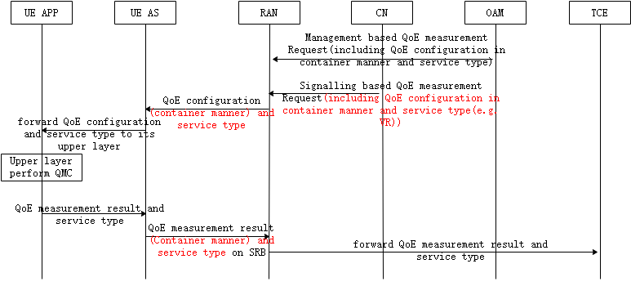

Figure 1 QoE measurement procedures in NR

From this illustrative figure above, the procedure goes as follows:

* NG-RAN receives the QoE measurement configuration from CN or OAM;
* NG-RAN configures QoE measurement with RRC message, in which at least the container of QoE measurement and configuration service type are included;
* UE (AS layer) receives the QoE measurement configuration and forward container and service type to upper layer
* UE Upper layer performs QoE measurement
* UE Upper layer incorporates QoE measurement results into a container with service type and sends to UE AS layer.
* UE AS layer reports the container of QoE measurement results and service type to RAN with RRC message
* RAN forwards the received QoE measurement results and service type to TCE

Here both Management-based and signaling-based QoE measurement could be configured in a certain area and towards an individual specific UE, and multiple QoE measurements could be configure for a UE at the same time.

Since QoE report is for the application layer to evaluate the use experience, and normally the QoE report is sent to application layer after the session is over, i.e. normally the QoE report is not for real-time usage, and one single QoE report doesn’t impact much since the application layer should evaluate the situation in a statistical way based on large amount of QoE reports, so it is technically feasible that RAN could configure UE’s reporting behaviour, e.g. delay, suspend or even drop a QoE report in case of e.g. radio resource overloaded situation. The criteria could be e.g. event triggered or time based, FFS for details

In addition, RAN is also allowed to release an ongoing QoE measurement, and does not need to inform the OAM/CN after releasing the QoE measurement configuration, FFS for the details under EN-DC/NR-DC operation. Meanwhile, RAN is not allowed to intervene, i.e. pause, activate or de-activate an ongoing QoE measurement unless instructed otherwise by the OAM.