3GPP TSG-RAN WG3 #110-e R3-207003
2-12 November 2020 Revision of R3-206892
Online

Agenda Item: 14.2
Source: ZTE (moderator)
Title: Summary of Offline Discussion on SCG (de)activation
Document for: Approval

Introduction
CB: # MRDC1-SCG_activation_deactivation
- RAN2 previous Rel-16 agreement is used for the starting point for RAN3 Rel-17 SCG activation/deactivation? (HW)
- SCG activation/deactivation discussion includes (NG)EN-DC and NR-DC? (HW)
- Support of efficient SCell activation/de-activation mechanism is out of RAN3 scope and pending RAN2 discussion? (InterDigital, HW, LG)
- Whether to support SCG Mobility in case that it is deactivated for a UE? (LG)
- Whether to support MN mobility when a SCG is deactivated for a UE?(LG)
- Which node can make the final decision on SCG activation and SCG deactivation? MN only? Both MN and SN? (InterDigital, ZTE, QC, LG, HW, CATT, Lenovo, E///, Samsung)
- Can the MN/SN independently make the final decision on SCG activation and SCG deactivation without assistant information (e.g., Activity notification) from receiving node and/or UE? (CATT, ZTE)
- Can receiving node reject the SCG activation/deactivation request? (InterDigital)
- Introduce SCG activation and SCG deactivation during SN addition? (HW, E///)
- Impact on F1 and E1 interfaces?(E///,CATT,LG)
- Impact on E1 interface? (HW,LG)
- How to transfer SCG activation and SCG deactivation indication? (HW, E///, ZTE)
- Capture agreements as stage2/stage3 CRs and check details, split work, if needed
- List open issues for next meeting in the summary
(ZTE - moderator)
Summary of offline disc R3-206892

For the Chairman’s Notes

Please see section 3.4 Summary after first round email discussion
Companies are kindly invited to input your view on Q21-26 in the Section 3.5 for the second round email discussion.

Discussion

General issue
In [7], it stated that RAN2 Release 16 agreements and Rel-17 progress can be used as the starting point for RAN3 Rel-17 SCG activation/de-activation discussion.
R2 assumes the following (can be slightly modified due to progress on Scell dormancy):
- The UE supports network-controlled suspension of the SCG in RRC_CONNECTED.
- UE behaviour for a suspended SCG is FFS
- The UE supports at most one SCG configuration, suspended or not suspended, in Rel16.
- In RRC_CONNECTED upon addition of the SCG, the SCG can be either suspended or not suspended by configuration.

- R2 suggest to not progress this objective further in Rel-16

- FFS how signalling and inter-node interaction works at activation deactivation (e.g. MN triggered, SN triggered, UE triggered, signalling mechanism, which node is in control etc)
- FFS if for deactived SCG, the UE stop monitoring PDCCH for PSCell and SCells of the SCG
- FFS if For the PSCell in deactivated SCG, the UE performs CSI/RRM measurement and report; AGC; beam management; RLM

On the one hand, in the last RAN2 #109e meeting, RAN2 has not agreed to capture the previous Rel-16 agreement into the Rel-17 WID, so it is strange for RAN3 to make this decision. On the other hand, these previous Rel-16 RAN2 agreements are useful and can be as the starting point for RAN3 Rel-17 discussion, because RAN2 will possibly agree them soon.
Question 1: Do companies agree that RAN2 Release 16 agreements can be used as the starting point for RAN3 Rel-17 SCG activation/de-activation discussion.
Company | Yes/NO | Comment
ZTE | No | RAN3 shall follow RAN2’s progress.
CATT |  | We should take the R2 R16 agreement into account and align the R17 R2 discussion and agreement
Ericsson |  | It depends on what aspects would be taken into account in RAN3. We don’t see any controversial point for now. For sure RAN2’s progress will be respected.
Nokia | Yes | Obviously, we shall monitor RAN2’s agreements and build a complementary solution. If not possible, RAN2 shall be informed. So far, there are no problems. But this is business as usual.
Huawei | No | As RAN2 have further progress this week in RAN2-112e, RAN3 should follow RAN2 latest agreements:  Agreements  The work will focus on a single deactivated SCG.  FFS if SCG RRC reconfiguration can select the SCG activation state (activated/deactivated) at PSCell addition/change, RRC resume or HO.  Continue RAN2 work with the assumption that when the SCG is deactivated, the UE does not monitor PDCCH on the PSCell. This assumption can be reconsidered if issues are found.  As a baseline, MN-configured RRM measurement/reporting procedures do not depend on the SCG activation state (deactivated or activated). Further optimisations are not precluded.  While the SCG is deactivated, PSCell mobility is supported. MN- and SN-configured measurements are supported for deactivated SCG.  FFS1: Details on the performed measurements (e.g. all SN configured measurements or subset based on certain criteria, restrictions on inter-frequency/RAT)  FFS2: Support for SCell addition/mobility  FFS3: Reporting procedure  FF4: PSCell mobility procedure  RAN2 assumes that UE will not perform SRS transmission while the SCG is deactivated. This assumption can be reconsidered if issues are found.  FFS if RACH is needed for SCG reactivation
InterDigital |  | You start with Release-16 agreements and take into account RAN2 decisions as normal, only issue becomes if/when there is a conflict – none identified so far
Lenovo and Motorola Mobility | No | RAN2 started discussing the same issue, i.e. whether to start with Release 16 RAN2 agreements and to what extent. RAN3 can simply wait for RAN2 conclusion first.
LGE |  | Depending on RAN2’s current progress
Qualcomm | Yes | We don’t see problem in RAN2 R16 agreements so far. If RAN2 change any agreements, we should follow the new agreements.
Samsung |  | Depending on RAN2 progress

Summary 1: RAN3 shall take RAN2’s progress into account.

In [7], it also states that RAN3 discussion of SCG activation/de-activation discussion needs to cover (NG)EN-DC and NR-DC.
It also states that in the last meeting, RAN1 has discussed the efficient SCell activation/de-activation mechanism and has some agreements. From our understanding and according to the scope of WID, there is no RAN3 impact to support the efficient SCell activation/de-activation mechanism, it is not needed to discuss this topic in RAN3.
According to the revised WID [1], it also indicated by yellow highlighted as below.
- Support efficient activation/de-activation mechanism for one SCG and SCells
- Support for one SCG applies to (NG)EN-DC, and NR-DC [RAN2, RAN3, RAN4]
- Support for SCells applies to NR CA, based on RAN1 leading mechanisms [RAN1, RAN2, RAN4]
- This objective applies to FR1 and FR2

Question 2: Do companies agree that RAN3 discussion of SCG activation/de-activation discussion need to cover (NG)EN-DC and NR-DC.
Company | Yes/NO | Comment
ZTE | Yes | According to WID scope, (NG)EN-DC and NR-DC shall be covered.
CATT | Yes | Align with the WID
Ericsson | Yes
Nokia | Yes
Huawei | Yes
InterDigital | Yes
Lenovo and Motorola Mobility | Yes
LGE | Yes
Qualcomm | Yes
Samsung | Yes

Question 3: Do companies agree that support of efficient SCell activation/de-activation mechanism is out of RAN3 scope and pending to RAN2?
Company | Yes/NO | Comment
ZTE | Yes | According to WID scope, it is out of RAN3 scope
CATT | Yes
Ericsson |  | It seems unnecessary to discuss this proposal since anyway this topic does not involve RAN3 in the WID. Considering SCell activation/de-activation, it always happens within one node and thus no inter-node coordination is foreseen.
Nokia |  | We shall follow the WID, as always.
Huawei | Yes
InterDigital |  | Follow the WID
Lenovo and Motorola Mobility | Yes
LGE | Yes
Qualcomm | Yes
Samsung | Yes

Summary 2: RAN3 shall follow the WID as usual.

MN initiated SCG activation and deactivation
In Rel-16, it is the MN to control SCG suspension and resume. When SCG is suspension, the UE is RRC_inactive mode. In this Rel-17 WID, when SCG is deactivated, the UE can be in RRC_connected mode. So that, it is straightforward that in Rel-17 WID, the MN can also initiate SCG activation and SCG deactivation.
There are two solutions on the table.
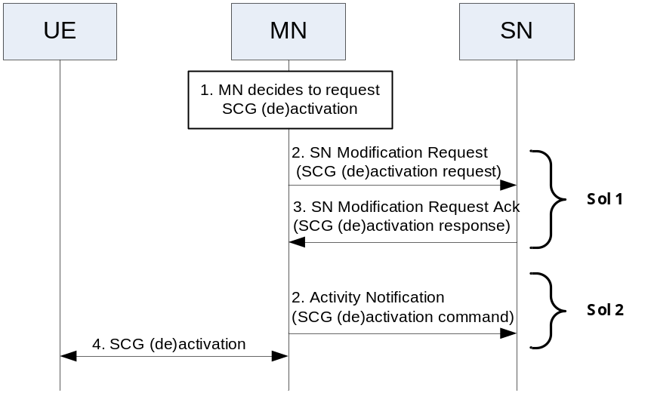
Figure 1: MN initiated SCG (de)activation
Solution 1: SN modification procedure
- Class 1 procedure
- MN requests then SN confirms (or rejects) SCG (de)activation

Solution 2: Activity Notification procedure
- Class 2 procedure
- MN commands SCG (de)activation

Solution 1
In Rel-16. MN initiated SN modification procedure is used to suspend and resume SCG lower layer. Similarly, it can be reused to activate and deactivate SCG by containing a new IE (e.g., SCG (de)activation).
Question 4: Do companies agree that MN initiated SN modification procedure can be enhanced for support of SCG (de)activation?
Company | Yes/NO | Comment
ZTE | Yes | SN modification procedure can be used for SCG (de)activation, and a new IE is added (e.g., SCG (de)activation request)
CATT | Yes
Ericsson | Yes | The open point is whether Activity Notification procedure should be triggered from SN to MN before modification procedure to inform the data activity or not, which is the same as RRC_INACTIVE.
Nokia | Yes | It does not seem necessary, at this moment, to come up with new procedures.
Huawei | Yes | It is better to reuse the legacy modification procedure.
InterDigital | Yes
Lenovo and Motorola Mobility | Yes | SCG activation/deactivation is essentially modification to SN. An explicit indicator (e.g. IE or new value of existing IE) can be added in the SN MODIFICATION REQUEST message to initiate the SCG activation/deactivation.
LGE | Yes | New IE should be added for differentiating from Rel-16
Qualcomm | Yes
Samsung | Yes | The conventional MN initiated SN modification procedure can be used by adding new IE

Summary 3：All companies agree that MN initiated SN modification procedure can be used for support of SCG (de)activation.

In Rel-16, when the MN decides to suspend/resume SCG, the SN shall confirm it. But in Rel-17, some companies (e.g., [2], [14]) suggest that the SN can reject to activate SCG request and/or deactivate SCG request?
Question 5: Do companies agree that the SN can reject SCG activation request after receiving SN modification request?
Company | Yes/NO | Comment
ZTE | Yes | When receiving SCG activation request, the SN can reject it in some cases, e.g., bad radio condition or lack of SCG resource.
CATT | Yes | SN may reject the request
Ericsson | Yes | SN should be allowed to have the right based on its own condition.
Nokia | Yes | Normal way of handling MOD REQ.
Huawei | Yes
InterDigital | Yes
Lenovo and Motorola Mobility | Yes
LGE | Yes | As normal DC rejection case
Qualcomm | Yes
Samsung | Yes

Question 6: Do companies agree that the SN can reject SCG deactivation request after receiving SN modification request?
Company | Yes/NO | Comment
ZTE | Yes | When receiving SCG deactivation request, the SN can reject it because of e.g., new DL data coming.
CATT | Yes
Ericsson | Yes
Nokia | Yes | Same as above.
Huawei | Yes
InterDigital | Yes
Lenovo and Motorola Mobility | Yes
LGE | Yes
Qualcomm | Yes
Samsung | Yes

Summary 4：All companies agree that SN can reject SCG (de)activation request after receiving SN modification request

In Rel-17 WID, in case of e.g., inter-SN change scenario, RAN2 has started to discuss whether SCG (de)activation can be also used during the SN addition period.
Question 7: Do companies agree that the MN can initiate SCG (de)activation by SN addition procedure.
Company | Yes/NO | Comment
ZTE | Yes | RAN2 seems to also agree with it.
CATT | Yes | Not only inter-SN change, but also in DC setup. The SCG (de)activation initial state may be included in the request.
Ericsson | Yes | RAN2 has concluded in email discussion. New indicator(s) is/are required in the SN Addition procedures as proposed in R3-206498.
Nokia | Yes | Such scenario has been already agreed in RAN2, hasn’t it?
Huawei | Yes but | We support it, but up to RAN2 progress, as RAN2’s latest agreements said:  FFS if SCG RRC reconfiguration can select the SCG activation state (activated/deactivated) at PSCell addition/change, RRC resume or HO.
InterDigital | Yes | Agree with ZTE and Ericsson
Lenovo and Motorola Mobility | Yes, with comment | We suppose it’s about in RRC_CONNECTED upon addition of the SCG, the SCG can be either activated or deactivated by configuration. Even though we agree with proposal, RAN3 can simply wait RAN2 conclusion.
LGE | Yes | Should be supported
Qualcomm | Yes
Samsung | Yes | From RAN3 point of view, we agree with the proposal. However, RAN2 progress should be taken into account

Summary 5：All companies agree that SN addition procedure can be used for support of SCG (de)activation, it shall be confirmed by RAN2.

Question 8: Do companies agree that the SN can reject SCG activation request after receiving SN addition request?
Company | Yes/NO | Comment
ZTE | No | In the SN addition request ACK message, the SN shall confirm the SCG activation or SCG deactivation indicated by MN. Otherwise, the SN addition request will be failed and the SN shall send SN addition request refuse message to MN.
CATT | Yes | The SN may accept the SCG addition but reject the activation and with deactivation SCG for some reason.
Ericsson | Yes
Nokia |  | This I don’t quite understand… I suppose, default, backward-compatible state is that SCG is activated at the Addition. So the SN can reject addition, but not activation alone – right?
Huawei | No | No, it is better to accept SN addition even if the SN do not agree to activate SCG in SN addition procedure, but it is Pending to Q7…
InterDigital | Yes
Lenovo and Motorola Mobility | Yes, with comment | Since we are talking about SN addition procedure, SN can of course reject the SN addition request.  We assume the question is actually asking whether “reject SCG activation” can be a cause if SN addition request is rejected. From that perspective, maybe yes, but whether RAN3 needs to add a new value in “cause” needs FFS.
LGE |  | Agree with Nokia, SN Addition itself should be rejected
Qualcomm | Yes
Samsung |  | We need separate the rejection of SN addition and rejection of SCG (de-)activation in the SN addition procedure, i.e., SN addition can be accepted by rejecting SCG (de-)activation.  Moreover, this discussion may need RAN2 progress since the current RAN2 agreement is  “FFS if SCG RRC reconfiguration can select the SCG activation state (activated/deactivated) at PSCell addition/change, RRC resume or HO”.

Question 9: Do companies agree that the SN can reject SCG deactivation request after receiving SN addition request?
Company | Yes/NO | Comment
ZTE | No | In the SN addition request ACK message, the SN shall confirm the SCG activation or SCG deactivation indicated by MN. Otherwise, the SN addition request will be failed and the SN shall send SN addition request refuse message to MN.
CATT | Yes | See Q8
Ericsson | Yes
Nokia |  | It should be left FFS, if the SN can reject inactive state indicator without rejecting the Addition.
Huawei | No | No, it is better to accept SN addition even if the SN do not agree to deactivate SCG in SN addition procedure, but it is Pending to Q7…
InterDigital | Yes
Lenovo and Motorola Mobility | Yes, with comment | Same as Q8.
LGE |  | Why SN reject it? In case of SN terminated bearer?
Qualcomm | Yes
Samsung |  | Same as Q8.

Summary 6：Majority companies think after receiving SN addition request message from MN, if the SN can admit the request, it sends SN addition request acknowledge message to MN, but if SN rejected the activation/deactivation, the SN addition procedure should be successful or not needs to be further discussed.

In Rel-16, Activity notification message is used by SN to notify the MN about user data (in) activity for SN terminated bearers, seen in TS37.340. It is straightforward that it can be reused to provide user data (in) activity status for SCG (de)activation.
Question 10: Do companies agree that Activity notification message sent from SN to MN, can be reused for the MN to decide SCG (de)activation?
Company | Yes/NO | Comment
ZTE | Yes | This message is useful to transfer the user data inactivity and activity status.
CATT | Yes | Also the SN initial modification can be used for this aim
Ericsson | Yes | Same as RRC_INACTIVE.
Nokia |  | Isn’t it up to the MN’s implementation, how it reacts upon reception of the Inactivity Notification?... This is not to be standardized, is it?
Huawei | Yes
InterDigital | Yes
Lenovo and Motorola Mobility | Yes | Fine as an input to assist MN decision. On the other hand, we don’t see any spec impact.
LGE | Yes
Qualcomm | Yes
Samsung | Yes

Summary 7：All companies agree that Activity Notification message sent from SN to MN, can be used for the MN to make final decision on SCG (de)activation. It is FFS whether no spec impacts or the Activity Notification message shall be enhanced, e.g., add a new SCG (de)activation suggestion IE.

Solution 2
In [5] and [14], some companies additionally suggest to use Activity notification message including a new IE (e.g., SCG (de)activation command) from MN to SN, to command the SN to (de) activate SCG.
However, the Activity notification procedure is class 2 procedure, the sending node cannot be confirmed whether the activity notification message has successfully sent to the receiving node, and receiving node cannot reject it.
Question 11: Do companies agree that the MN can send Activity notification message to the SN including SCG (de)activation command indicator for support of SCG (de)activation?
Company | Yes/NO | Comment
ZTE | No | We prefer to use SN addition and SN modification procedure, because we think inter-node negotiation is needed.
CATT | No | The confirmation should be provided by SN.
Ericsson | Neutral | The intention of having Activity Notification procedure from MN to SN may help reduce the delay for SCG activation/deactivation.
Nokia |  | We prefer reusing the MN-initiated modification.
Huawei | No | Share the view with ZTE.
InterDigital | No | Same view as Huawei and ZTE
Lenovo and Motorola Mobility | No | Explicit procedure as SN addition/modification is preferred.  Besides, MCG might include new SCG radio bearer configuration during SCG activation, such configuration can be conveyed in SN MODIFICATION REQUEST message not supported in ACTIVITY NOTIFICATION message.
LGE | No | MN initiated Modification is preferred
Qualcomm | Neutral | Either modification procedure or activity notification procedure is fine. We don’t have strong preference.
Samsung | No | Notification message is for the “NOTIFICATION”.  SN addition or modification message can be used.

Summary 8：Majority companies do not prefer Solution2.

Flow chart
The following figure is an example for MN initiated SCG (de)activation, if SN addition procedure, reject procedure, and activity notification are approved.
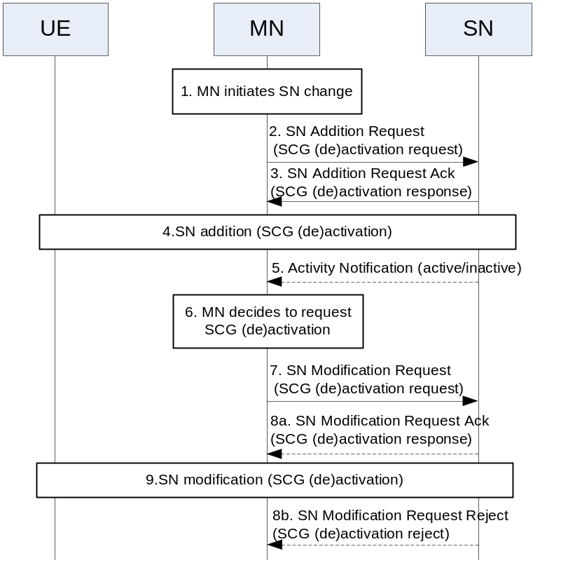
Figure 2: MN initiated SCG (de)activation
Rapporteur ’view: Step 4 and Step 9 will depend on RAN2 progress and can refer to the same procedure in current TS37.340.
Question 12: Companies are kindly invited to provide some suggestions on the MN initiated SCG (de)activation if any.
Company | Comment
ZTE | If SCG (de)activation involved SCG configuration change, the SN shall send NR RRC reconfiguration message to the UE, then solution 2 may be not feasible. Otherwise, the solution 2 is feasible and can provide better latency.
CATT | The solution#1 should be the solution for the MN initiate the SCG (de)activation with/without the information/required from SN.  The SN Additional procedure should be used for the SCG initial state of SCG (de)activation. Not used for the modification.  We should discuss whether the SCG initial state of SCG should be carried when DC setup.
Ericsson | Separate flow charts would be a clean way, for example, addition, modification, and etc.
Nokia | OK. But so far no need to capture these flows anywhere.
Huawei | For the SCG (de)activation request in the SN addition request message, it depends on RAN2 progress.
InterDigital | Separate flow charts would be a cleaner way
LGE | Can be considered later when the issues above are clear.
Qualcomm | Looks good
Samsung | It is too early to consider the whole flow chart before the above issues are solved.  In addition, the above issues didn’t take CU-DU split and CP-UP separation into account. We need consider those aspects to obtain the whole picture.

SN initiated SCG activation and deactivation
RAN2 is discussing how to trigger SCG (de)activation, by either RRC signaling or MAC CE, considering time delay. If SN is allowed to (de)activate SCG, it is benefit to shorten latency.
There are three solutions on the table for support of SN initiated (de)SCG activation.
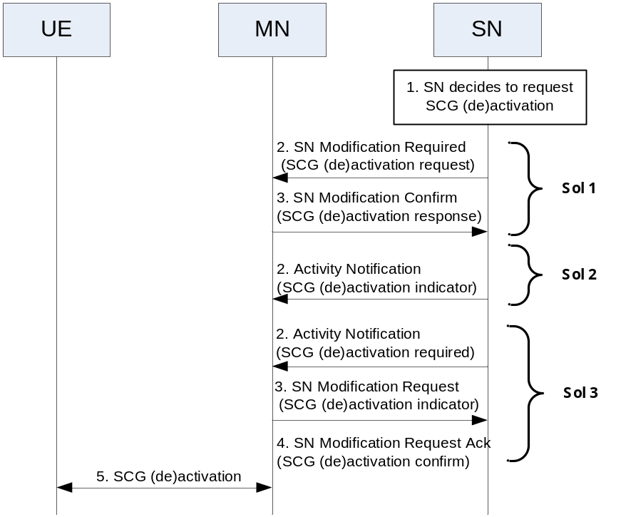
Figure 3: SN initiated SCG (de)activation
Solution 1: SN modification required procedure
- Class 1 procedure
- SN requires and MN confirms (or rejects) SCG (de)activation
Solution 2: Activity Notification procedure
- Class 2 procedure
- SN commands SCG (de)activation
Solution 3: SN initiated nested procedure
- Class 2+ Class 1 procedures
- SN triggers then MN handles SCG (de)activation

Question 13: Do companies agree that the SN can initiate SCG (de)activation?
Company | Yes/NO | Comment
ZTE | Yes/but | RAN3 shall wait for RAN2’s decision on it. So far, RAN3 can start to have some discussion, given that RAN2 will agree to support it.
CATT | Yes | SN may initiate the SN terminated SCG (de)activation without MN assessment
Ericsson | Yes
Nokia | FFS | As far as I understand, this aspect is being discussed in RAN2 at this meeting. We shall postpone RAN3’s work on this until some decision is made.
Huawei | No | The SN can trigger the SCG (de)activation by sending Activity Notification to the MN, then MN (make decision and) initiate the SCG activation/deactivation procedure.  It is better to have a single node to make the final decision, otherwise it will be a mess if two nodes make different decision and triggers the procedures at the same time.  And agree with Nokia’s view that we shall postpone this after RAN2 progress.
InterDigital | Yes | But of course, track RAN2 decision here
Lenovo and Motorola Mobility | Yes
LGE | Yes
Qualcomm | Yes
Samsung |  | It is technically reasonable to support this scenario. Also, if SRB3 is configured, SN node can (de-)activate SCG by itself. We need consider this as well.  However, this seems need RAN2 progress first.

Summary 9: Majority agree whether SN initiated SCG (de)activation is allowed for support of SCG (de)activation (i.e., whether SN is allowed to (de)activate SCG), it shall wait for RAN2 progress.

Solution 1
When the SN decides to initiate SCG (de)activation, it sends SN modification required message including SCG (de)activation required IE, then the MN can either confirm it or reject the required.
Question 14: Do companies agree that SN initiated SN modification required procedure can be enhanced for support of SCG (de)activation?
Company | Yes/NO | Comment
ZTE | Yes | Similar to MN initiated SN modification, we can use it with some enhancement, e.g., adding a new SCG (de)activation IE.
CATT | Yes
Ericsson | Yes
Nokia | Yes/FFS | This will be the most obvious candidate for signaling – but the decision shall be postponed.
Huawei | No | Same answer as Q13.
InterDigital | Yes
Lenovo and Motorola Mobility | Yes | SCG activation/deactivation is essentially modification to SN. An explicit indicator (e.g. IE or new value of existing IE) can be added in the SN MODIFICATION REQUIRED message to initiate the SCG activation/deactivation.
LGE | FFS
Qualcomm | Yes
Samsung | FFS | Agree with Nokia

Summary 10: If RAN2 agrees that SN initiated SCG (de)activation is allowed, majority companies agree that Solution1-SN initiated SN modification required procedure can be used for support of SCG (de)activation

Question 15: Do companies agree that the MN can reject SCG activation request after receiving SN modification required message?
Company | Yes/NO | Comment
ZTE | Yes | Similar to MN initiated SN modification procedure, the inter-node negotiating is also needed to confirm or reject the request/required from sending node.
CATT | No | Looks no reason the MN reject the SN initiated SCG activation
Ericsson | Yes | RAN2 is discussing for UL, UE may either request SCG activation via MCG, or by triggering random access in SCG. This could give some guidance on which node to make decision. We propose to keep FFS for now.
Nokia | FFS | Up to RAN2’s progress.
Huawei | / | Same answer as Q13.
InterDigital | Yes | but verify RAN2 progress
Lenovo and Motorola Mobility | Yes
LGE | FFS
Qualcomm | Yes
Samsung |  | Agree with Nokia

Question 16: Do companies agree that the MN can reject SCG deactivation request after receiving SN modification required message?
Company | Yes/NO | Comment
ZTE | Yes | Similar to MN initiated SN modification procedure, the inter-node negotiating is also needed to confirm or reject the request/required from sending node.
CATT | No | See Q15
Ericsson | Yes | Same as above.
Nokia | FFS | Up to RAN2’s progress.
Huawei | / | Same answer as Q13.
InterDigital | Yes | Same as above
Lenovo and Motorola Mobility | Yes
LGE | FFS
Qualcomm | Yes
Samsung |  | Agree with Nokia.

Summary 11: If RAN2 agrees that SN initiated SCG (de)activation is allowed, RAN3 has not achieved agreement whether MN can reject SCG (de)activation request after receiving SN modification required message.

In TS38.423, the Activity notification message is allowed to be sent from the MN to the SN and also from the SN to the MN
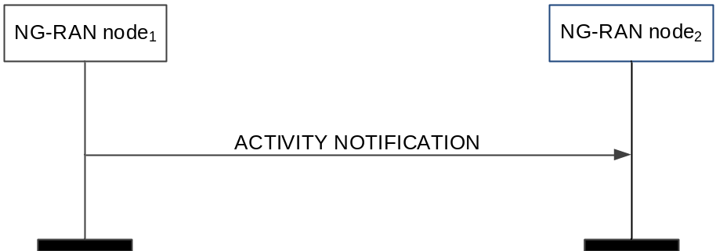
Figure 4: In Rel-15, Activity Notification
So that, it is allowed for the MN to notify the SN about user data (in) activity for MN terminated bearers. In other word, after receiving activity notification message from MN, the SN can decide to deactivate and activate SCG.
Question 17: Do companies agree that Activity notification message sent from MN to SN, can be reused for the SN to decide SCG (de)activation?
Company | Yes/NO | Comment
ZTE | Yes | It is also useful, similar to its usage when activity notification is sent from SN to MN in the MN initiated SCG (de)activation procedure.
CATT | NO | Why put this question here. This Q17 for sol#1?
Ericsson | Yes | Another option with reduced latency.
Nokia | Yes | Sure, but that would be up to the SN’s implementation how to react upon reception of the Activity Notification.
Huawei | / | Same answer as Q13.
InterDigital | Yes
Lenovo and Motorola Mobility | Yes | For SN to understand the activity in MN terminated SCG bearer and split bearer. On the other hand, we don’t see any spec impact.
LGE | Yes
Qualcomm | Yes
Samsung | Yes, but… | We think only QoS flow level notification can be applicable for SCG (de-)activation. Then, we may need some clarification if we reuse this message for SCG (de-)activation, or we can define a new IE for SCG (de-)activation.  Both UE level and PDU session level notification considers all bearers involving MN (e.g., MN-terminated bearers, SN-terminated MCG bearer and MCG part of SN-terminated MCG bearer) . However, the SCG (de-)activation is only related to the MN-terminated SCG bearer and the SCG part of the MN-terminated split bearer. Thus, only QoS flow level information can achieve this purpose.

Summary 12: If RAN2 agrees that SN initiated SCG (de)activation is allowed, majority companies agree that Activity notification message sent from MN to SN is helpful for SN to make good decision on SCG (de)activation. It is FFS whether no spec impact or the Activity Notification message shall be enhanced, e.g., add a new SCG (de)activation suggestion IE.

Solution 2
In [5] and [14], some companies additionally suggest to use Activity notification message including a new IE (e.g., SCG (de)activation indicator) from SN to MN, to notify the MN of SCG (de)activation. This solution has shorter latency than all of other solutions because the SN can firstly (de)activate SCG then send activity notification message to inform MN.
Question 18: Do companies agree that the SN can send Activity notification message to the MN including SCG (de)activation indicator for support of SCG (de)activation?
Company | Yes/NO | Comment
ZTE | Yes/but | This solution is good for latency. However, we shall wait for RAN2 progress whether there is SCG configuration change or not after SCG (de)activation.
CATT | Yes | The procedure can be used for the SN require the SCG (de)activation or assist information for MN make decision on the SCG (de)activation.  It is similar as SN initiate modification required.
Ericsson | Yes
Nokia | No | Let’s have one procedure for this.
Huawei | / | Same answer as Q13.
InterDigital | Neutral | Probably have Nokia view here probably better for one procedure
Lenovo and Motorola Mobility | No | Explicit procedure as SN addition/modification is preferred.  Besides, SCG might include new SCG radio bearer configuration during SCG activation, such configuration can be conveyed in SN MODIFICATION REQUIRED message not supported in ACTIVITY NOTIFICATION message.
LGE |  | To be selected which one to go, solution 1 or 2
Qualcomm | Yes
Samsung | Yes | This can be used for the case the SN (de-)activates SCG via SRB3 so that the Activity Notification message can be used to inform MN SCG (de-)activation state.

Summary 13: If RAN2 agrees that SN initiated SCG (de)activation is allowed, RAN3 has not achieved agreement whether the SN can send Activity notification message including SCG (de)activation indicator, to inform MN that SCG is/will be (de)activated. Some companies prefer to have only one solution for each scenario.

Solution 3
In this solution [14], 1) SN notifies MN about no data transmission or new data of UE by triggering Activity Notification procedure, 2) MN requests SN to activate/deactivate SCG in the SN Modification Request messages, then 3) SN confirms to reactivate/deactivate SCG in the SN Modification Request Ack message, or SN may say no to the command from MN by sending reject message due to new data arrives over SCG for example.
Rapporteur’ view: If the existing Activity Notification message is reused without any enhancement (i.e. not adding a new IE to request MN to (de)activate SCG), then this solution is similar to step 5-9 in figure 2, (i.e., MN initiated SCG (de)activation in solution 2).
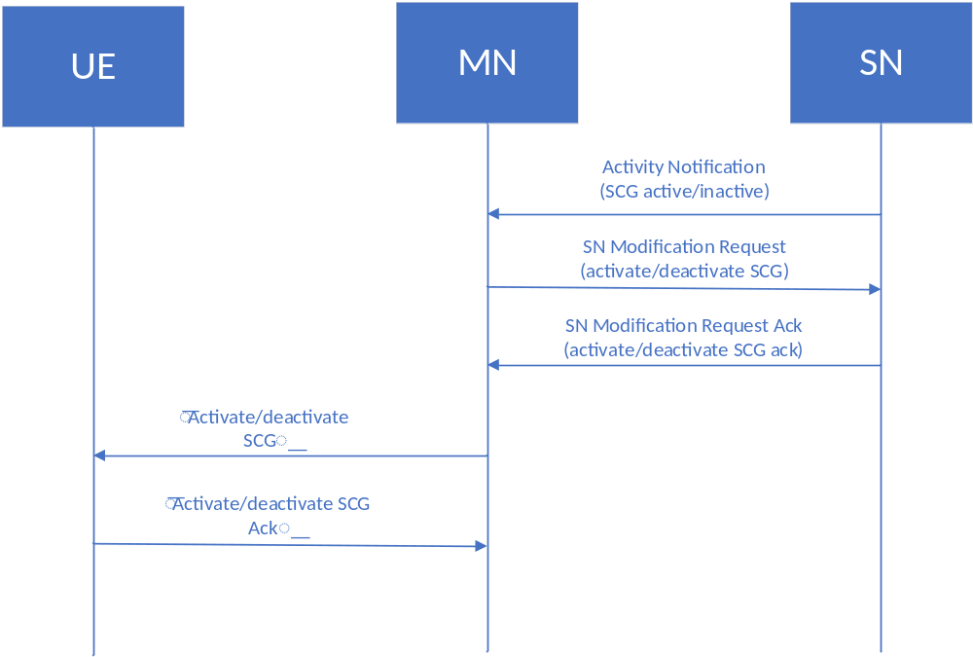
Figure 5 Example flow: SN-initiated SCG activation/de-activation with support of Activity Notification procedure

Question 19: Do companies agree with solution 3 (nested procedure) for support of SCG (de)activation?
Company | Yes/NO | Comment
ZTE | No | Unnecessary latency will be introduced.
CATT | Yes | If the SCG (de)activation decided by MN, the procedure should be similar as it.  SN initiate modification procedure or activity notification procedure should be used for the SN initiated SCG (de)activation
Ericsson | Yes | Similar as RRC_INACTIVE procedure.
Nokia | ? | Sure, this is possible implementation, but what is “nested” on the figure? Activity Notification and Modification are independent and triggered one after the other – so nothing’s nested, right?
Huawei | / | Same answer as Q13.
InterDigital | ? | Same view as Nokia
Lenovo and Motorola Mobility | No
LGE | Yes | Not nested. It is like Rel-16, right?
Qualcomm | Yes
Samsung |  | This is in the scope of MN initiated SCG activation and deactivation, which is a normal procedure in our mind.

Summary 14: The difference here on Solution 3 compared with Solution 1 is that whether the Activity Notification message should be enhanced. The summary has been merged in Summary 12.

Flow chart
The following figure is an example for SN initiated SCG (de)activation, if reject procedure and activity notification are approved.
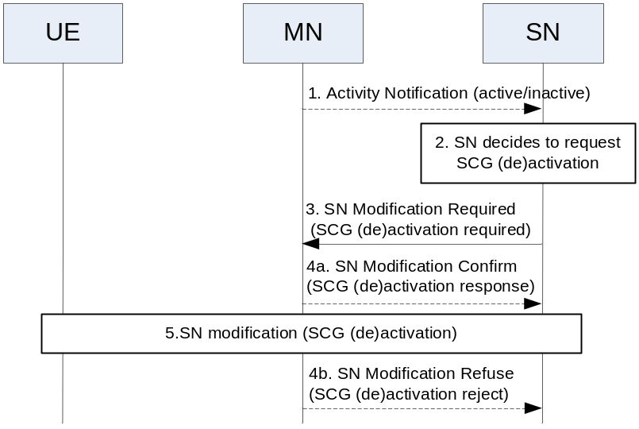
Figure 6: SN initiated SCG (de)activation
Rapporteur ’view: Step5 will depend on RAN2 progress and can refer to the same procedure in current TS37.340.
Question 20: Companies are kindly invited to provide some suggestions on the SN initiated SCG (de)activation if any.
Company | Comment
ZTE | If SCG (de)activation involved SCG configuration change, the SN shall send NR RRC reconfiguration message to the UE, then solution 2 may be not feasible. Otherwise, the solution 2 is feasible and can provide better latency.
CATT | We should firstly discuss whether the SN makes decision on the SCG (de)activation. if only the MN can make decision, the procedure should be different.
Ericsson | It is a bit early to decide the flows when the procedures used are not agreed yet.
Nokia | As declared above: we shall start from the MN-controlled (de)activation of SCG. The rest should be left FFS at this meeting.
Huawei | Same answer as Q13.
InterDigital | Might be a step too far right now
LGE | Can be discussed later
Samsung | It is too early to consider the whole flow chart before the above issues are solved.  In addition, the above issues didn’t take CU-DU split and CP-UP separation into account. We need consider those aspects to obtain the whole picture.

Summary after first round email discussion
Clarification:
Which node is allowed to initiate SCG (de)activation is clarified as below:
MN initiated SCG (de)activation: When MN decides to (de)activate SCG, it sends SCG (de)activation request/command to SN via class1/ class2 message (e.g., SN modification request/ Activity Notification message).
SN initiated SCG (de)activation: When SN decides to (de)activate SCG, it sends SCG (de)activation required/command to MN via class1/ class2 message (e.g., SN modification required / Activity Notification message).
Assistance message for MN/SN initiated SCG (de)activation: Before MN/SN makes the final decision to (de)activate SCG, other RAN node can optionally send the assistance message (e.g., existing Activity notification w/o any enhancement) to the MN/SN, to help MN/SN make the good decision on SCG (de)activation.

Summary:
Summary 1: RAN3 shall take RAN2’s progress into account.
Summary 2: RAN3 shall follow the WID as usual.
Summary 3: All companies agree that MN initiated SN modification procedure can be used for support of SCG (de)activation.
Summary 4：All companies agree that SN can reject SCG (de)activation request after receiving SN modification request.
Summary 5：All companies agree that SN addition procedure can be used for support of SCG (de)activation, it shall be confirmed by RAN2.
Summary 6：Majority companies think after receiving SN addition request message from MN, if the SN can admit the request, it sends SN addition request acknowledge message to MN, but if SN rejected the activation/deactivation, the SN addition procedure should be successful or not needs to be further discussed.
Summary 7：All companies agree that Activity Notification message sent from SN to MN, can be used for the MN to make final decision on SCG (de)activation. It is FFS whether no spec impacts or the Activity Notification message shall be enhanced, e.g., add a new SCG (de)activation suggestion IE.
Summary 8：Majority companies do not prefer Solution2.
Summary 9: Majority agree whether SN initiated SCG (de)activation is allowed for support of SCG (de)activation (i.e., whether SN is allowed to (de)activate SCG), it shall wait for RAN2 progress.
Summary 10: If RAN2 agrees that SN initiated SCG (de)activation is allowed, majority companies agree that Solution1-SN initiated SN modification required procedure can be used for support of SCG (de)activation.
Summary 11: If RAN2 agrees that SN initiated SCG (de)activation is allowed, RAN3 has not achieved agreement whether MN can reject SCG (de)activation request after receiving SN modification required message.
Summary 12: If RAN2 agrees that SN initiated SCG (de)activation is allowed, majority companies agree that Activity notification message sent from MN to SN is helpful for SN to make good decision on SCG (de)activation. It is FFS whether no spec impact or the Activity Notification message shall be enhanced, e.g., add a new SCG (de)activation suggestion IE.
Summary 13: If RAN2 agrees that SN initiated SCG (de)activation is allowed, RAN3 has not achieved agreement whether the SN can send Activity notification message including SCG (de)activation indicator, to inform MN that SCG is/will be (de)activated. Some companies prefer to have only one solution for each scenario.
Summary 14: The difference here on Solution 3 compared with Solution 1 is that whether the Activity Notification message should be enhanced. The summary has been merged in Summary 12.

Proposals:
Proposal 1: MN initiated SN modification procedure can be used for support of SCG (de)activation, and SN can reject SCG (de)activation request after receiving SN modification request message
Proposal 1.1: After receiving SN modification request message from MN, if the SN can admit the request, it sends SN modification request acknowledge message to MN, but including different SCG (de)activation result from that indicated in SN modification request message, it shall be confirmed by RAN2.
Proposal 2: SN addition procedure can be used for support of SCG (de)activation, it shall be confirmed by RAN2.
Proposal 2.1: After receiving SN addition request message from MN, if the SN can admit the request, it sends SN addition request acknowledge message to MN, but including different SCG (de)activation result from that indicated in SN addition request message, it shall be confirmed by RAN2.
Proposal 3: Activity Notification message sent from SN to MN, can be used for the MN to make final decision on SCG (de)activation. It is FFS whether no spec impacts or the Activity Notification message shall be enhanced, e.g., add a new SCG (de)activation suggestion IE.

Working Assumption:

WA1: It shall wait for RAN2 progress whether SN initiated SCG (de)activation is allowed for support of SCG (de)activation (i.e., whether SN is allowed to (de)activate SCG).
WA 2: If RAN2 agrees that SN initiated SCG (de)activation is allowed, SN initiated SN modification required procedure can be used for support of SCG (de)activation
WA 3: If RAN2 agrees that SN initiated SCG (de)activation is allowed, Activity notification message sent from MN to SN is helpful for SN to make good decision on SCG (de)activation. It is FFS whether no spec impacts or the Activity Notification message shall be enhanced, e.g., add a new SCG (de)activation suggestion IE.

FFS:
FFS 1: If RAN2 agrees that SN initiated SCG (de)activation is allowed, RAN3 has not achieved agreement whether MN can reject SCG (de)activation request after receiving SN modification required message.

FFS: Procedure/Message/IE
The following procedure/message/IE are used for support of SCG (de)activation
- SN addition request (FFS: adding a new IE, e.g., SCG(de)activation request )
- SN addition request acknowledge (FFS: adding a new IE, e.g., SCG(de)activation result)
- SN modification request (FFS: adding a new IE, e.g., SCG(de)activation request )
- SN modification request acknowledge (FFS: adding a new IE, e.g., SCG(de)activation result)
- FFS: SN modification required (FFS: adding a new IE, e.g., SCG(de)activation request)
- FFS: SN modification confirm (FFS: adding a new IE, e.g., SCG(de)activation result)
- Activity Notification (FFS: adding a new IE, e.g., SCG(de)activation suggestion)
FFS: Flow Chart
The following flow charts are used for support of SCG (de)activation

10.xx Support of SCG activation and deactivation
10.xx.1 MN initiated SCG activation and deactivation
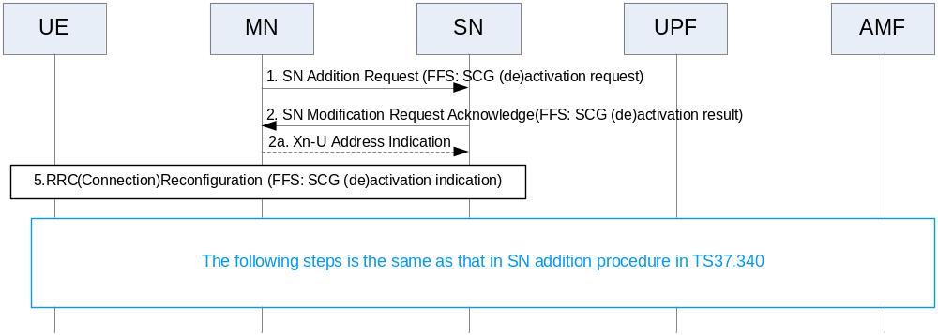
Figure 10.xx.1-1: MN initiated SCG (de)activation through SN addition

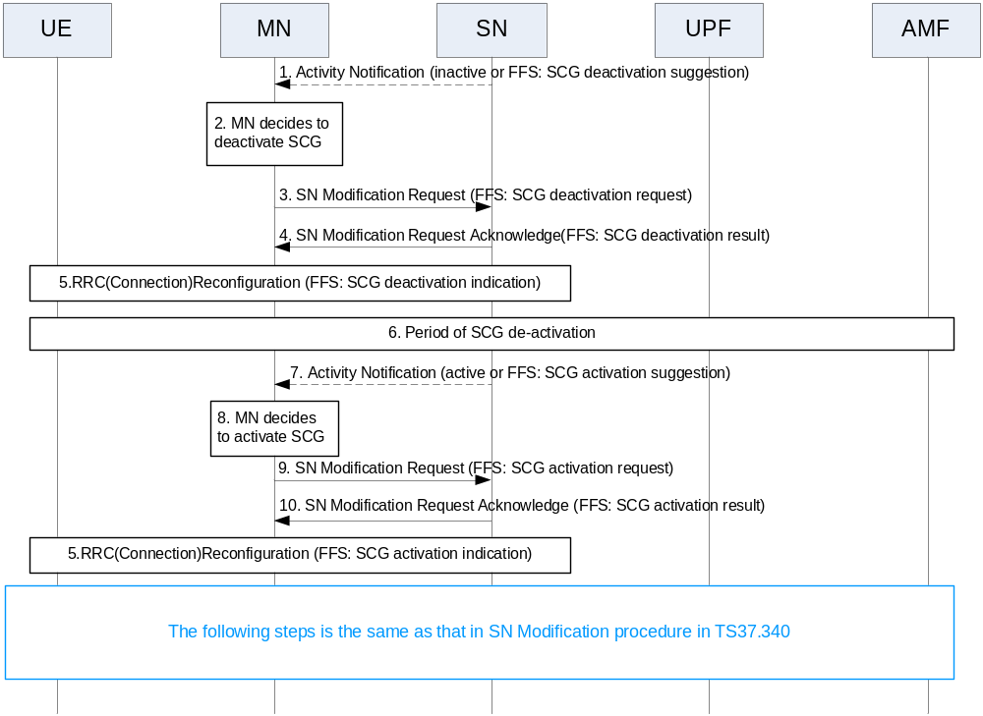Figure 10.xx.1-2: MN initiated SCG (de)activation through SN modification
10.xx.2 SN initiated SCG activation and deactivation
FFS

Second round Discussion

Clarification:
The following clarification will be used for the future discussion:
MN initiated SCG (de)activation: When MN decides to (de)activate SCG, it sends SCG (de)activation request/command to SN via class1/ class2 message (e.g., SN modification request/ Activity Notification message).
SN initiated SCG (de)activation: When SN decides to (de)activate SCG, it sends SCG (de)activation required/command to MN via class1/ class2 message (e.g., SN modification required / Activity Notification message).
Assistance message for MN/SN initiated SCG (de)activation: Before MN/SN makes the final decision to (de)activate SCG, other RAN node can optionally send the assistance message (e.g., existing Activity notification w/o any enhancement) to the MN/SN, to help MN/SN make the good decision on SCG (de)activation.

Question 21: Do companies have any different view/understanding for these clarification?
Company | Comment
ZTE | No comment

Previous Summary
Summary 1-14 are listed in the section 3.4.
Question 22: Do companies have any different view/understanding for Summary 1-14?
Company | Comment
ZTE | No comment

MN initiated SCG (de)activation
In the online discussion, the following agreements are achieved.
MN initiated SN modification procedure can be used for support of SCG (de)activation, and SN can decide whether to accept or reject SCG (de)activation request after receiving SN modification request message.
FFS on how to reject it.

Activity Notification message sent from SN to MN, can be used for the MN to make final decision on SCG (de)activation. It is FFS whether no spec impacts or the Activity Notification message shall be enhanced, e.g., add a new SCG (de)activation suggestion IE.

For original proposal 2 and proposal 2.2 in section 3.4, because SCG activation is already supported by existing SN addition procedure, and original proposal 2.2 seems as stage 3. So, it is suggested to modify them as below.
Proposal: MN can initiate SCG (de)activation by SN addition procedure, SN can decide whether to accept or reject SCG (de)activation request after receiving SN addition request message, FFS on how to reject it.
Question 23: Do company agree with this Proposal as above?
Company | Comment
ZTE | Agree.

SN initiated SCG (de)activation
In the first round email discussion, some progress on SN initiated SCG (de)activation have been achieved.
WA1: It shall wait for RAN2 progress whether SN initiated SCG (de)activation is allowed for support of SCG (de)activation (i.e., whether SN is allowed to (de)activate SCG).
WA 2: If RAN2 agrees that SN initiated SCG (de)activation is allowed, SN initiated SN modification required procedure can be used for support of SCG (de)activation
WA 3: If RAN2 agrees that SN initiated SCG (de)activation is allowed, Activity notification message sent from MN to SN is helpful for SN to make good decision on SCG (de)activation. It is FFS whether no spec impacts or the Activity Notification message shall be enhanced, e.g., add a new SCG (de)activation suggestion IE.
FFS1: If RAN2 agrees that SN initiated SCG (de)activation is allowed, RAN3 has not achieved agreement whether MN can reject SCG (de)activation request after receiving SN modification required message.
Question 24: Companies are kindly invited to input your view on these Working Assumptions and FFS for SN initiated SCG (de)activation.
Company | Comment
ZTE | Agree

Procedure/Message/IE
The following procedure/message/IE are used for support of SCG (de)activation
- SN addition request (FFS: adding a new IE, e.g., SCG(de)activation request )
- SN addition request acknowledge (FFS: adding a new IE, e.g., SCG(de)activation result)
- SN modification request (FFS: adding a new IE, e.g., SCG(de)activation request )
- SN modification request acknowledge (FFS: adding a new IE, e.g., SCG(de)activation result)
- FFS: SN modification required (FFS: adding a new IE, e.g., SCG(de)activation request)
- FFS: SN modification confirm (FFS: adding a new IE, e.g., SCG(de)activation result)
- Activity Notification (FFS: adding a new IE, e.g., SCG(de)activation suggestion)

Question 25: Companies are kindly invited to input your view on these procedures/messages/IEs for support of SCG (de)activation.
Company | Comment
ZTE | agree

Flow Chart
The following figure 7 and figure 8 are suggested to be used for support of MN initiated SCG (de)activation.
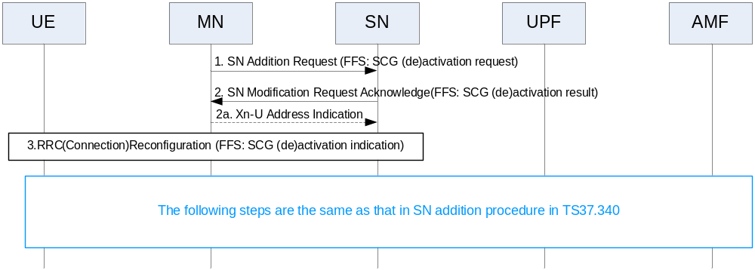
Figure 7: MN initiated SCG (de)activation through SN addition

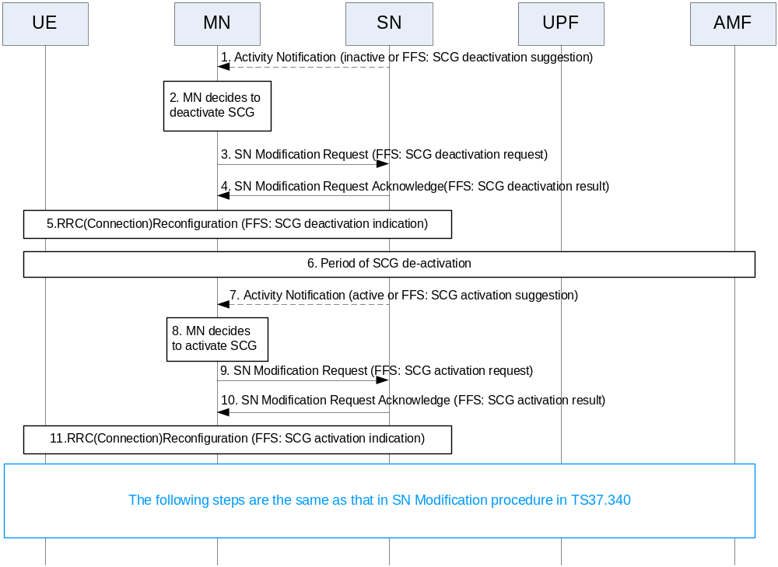
Figure 8: MN initiated SCG (de)activation through SN modification
Question 26: Do companies agree with the Fig 7 and Fig 8 with some change (if any) for support of SN initiated SCG (de)activation?
Company | Comment
ZTE | Suggest to capture into chairman note, they are useful for further discussion.

Impact on specs
According to the submitted contributions in this RAN3 meeting, some specs shall be modified, e.g., 37.340, 38.401, 36.423, 38.423, 38.473, 38.463.
TS37.340

TS 38.401

TS36.423/38.423
- SN addition
- MN initiated SN modification
- SN initiated SN modification required
- Activity notification

TS38.473
- UE context setup
- UE Context Modification

TS38.463
- BEARER CONTEXT SETUP
- BEARER CONTEXT MODIFICATION

Rapporteur’s view: Waiting for the 1st round progress.

Conclusion, Recommendations [if needed]
If needed

References
- RP-201040 Revised WID on Further Multi-RAT Dual-Connectivity enhancements, Huawei
- R3-205963 Inter-node signaling to support activation/deactivation of SCG (InterDigital)
- R3-205990 Discussion on SCG deactivation and activation (ZTE)
- R3-205991 Draft CR37340 for SCG deactivation and activation (ZTE)
- R3-206179 Signaling for Efficient SCG activation/deactivation (Qualcomm Incorporated)
- R3-206337 Consideration on Activation/Deactivation for One SCG and SCells (LG Electronics)
- R3-206341 Discussion on support of efficient activation/de-activation mechanism for one SCG and Scells (Huawei)
- R3-206342 Activation and de-activation of SCG (Huawei)
- R3-206343 Activation and de-activation of SCG (Huawei)
- R3-206355 Discussion on efficient Activation/Deactivation Mechanism for SCG (CATT)
- R3-206356 CR for TS 38.423 on efficient Activation/Deactivation Mechanism for SCG (CATT)
- R3-206357 CR for TS 38.473 on efficient Activation/Deactivation Mechanism for SCG (CATT)
- R3-206480 On support for SCG deactivation and activation (Lenovo, Motorola Mobility)
- R3-206497 Support of SCG activation/de-activation mechanism (Ericsson)
- R3-206498 Support of SCG activation/deactivation for MR-DC (Ericsson)
- R3-206499 Support of SCG activation/deactivation for MR-DC (Ericsson)
- R3-206828 Discussion on MN coordinated SGC (de-)activation (Samsung)

