3GPP TSG-RAN WG3 Meeting #107bis-e R3-202871
Electronic Meeting, April 20th – 30th, 2020

Agenda item: 15.3.1.1
Source: Intel Corporation
Title: (TP for NR_Mob_enh-Core BL CR for TS 38.401): Correction and Resolving FFS on inter-gNB-DU conditional mobility scenarios
Document for: Other

1. Introduction
This contribution proposes TP for BL CR for TS 38.401 based on [1].

2 Reference
[1] R3-202500, “Summary for CB: # 17_Email_MobEnh_CHO_CondPSCell_General”, Intel Corporation

3 TP for BL CR for TS 38.401

//////////////////////////////////////////////////////////////irrelevant operations skipped/////////////////////////////////////////////////////////////////////

8.2.1.X Inter-gNB-DU Conditional Handover or PSCell Change
This procedure is used for the case when the UE moves from one gNB-DU to another gNB-DU within the same gNB-CU during NR operation for Conditional Handover or Conditional PSCell Change. Figure 8.2.1.X-1 shows the inter-gNB-DU conditional mobility procedure for intra-NR.
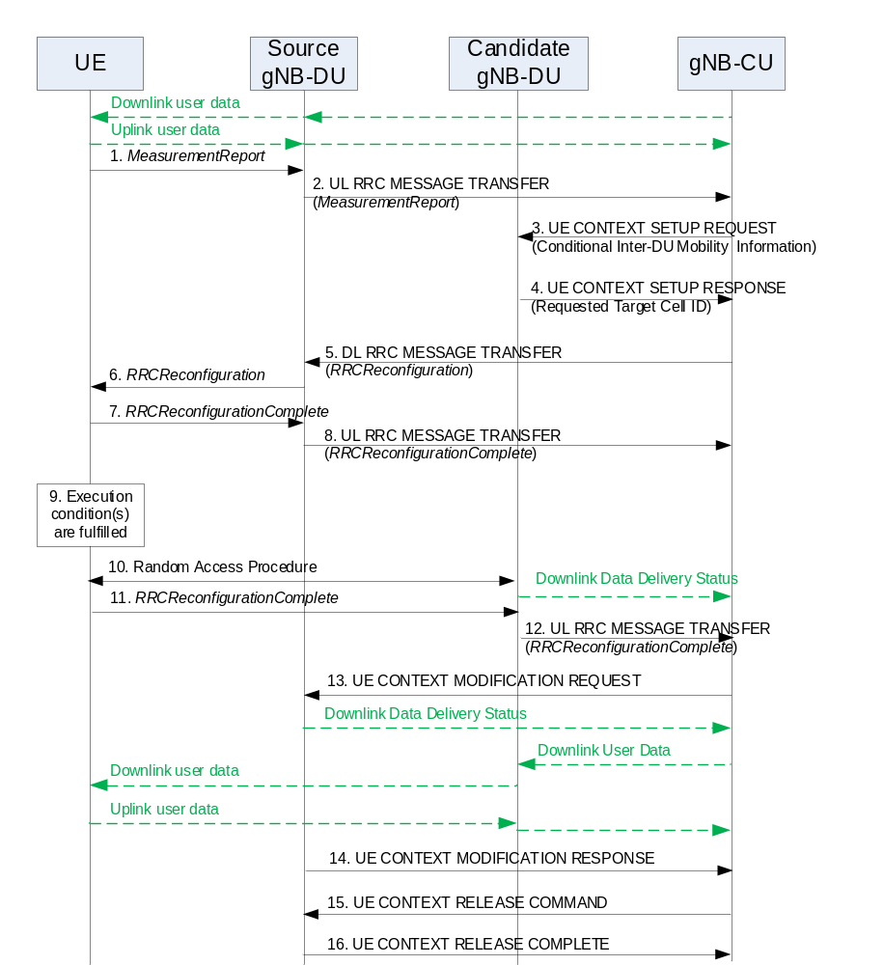
Figure 8.2.1.X-1: Inter-gNB-DU Conditional Handover or PSCell Change for intra-NR
1-2. The steps 1-2 are as defined in clause 8.2.1.1.
3. The gNB-CU sends an UE CONTEXT SETUP REQUEST message to the candidate gNB-DU to create an UE context and setup one or more data bearers. The UE CONTEXT SETUP REQUEST message includes a HandoverPreparationInformation (conditional handover) or a CG-ConfigInfo (conditional PSCell change).
4. The candidate gNB-DU responds to the gNB-CU with an UE CONTEXT SETUP RESPONSE message including the target cell ID that was requested from the gNB-CU.
5. The gNB-CU sends a DL RRC MESSAGE TRANSFER message to the source gNB-DU, which includes a generated RRCReconfiguration message.
6. The steps 6 is as defined in clause 8.2.1.1.
7-8. The UE responds to the source gNB-DU with an RRCReconfigurationComplete message, for which the source gNB-DU forwards to the gNB-CU via an UL RRC MESSAGE TRANSFER message.
9. An execution condition to trigger initiation of conditional handover or PSCell change is fulfilled.
10. A Random Access procedure is performed at the candidate gNB-DU, which becomes the target gNB-DU if successful. The target gNB-DU sends a Downlink Data Delivery Status frame to inform the gNB-CU.
11-12. The steps 11-12 are as defined in steps 9-10 in clause 8.2.1.1.

13. The gNB-CU sends a UE CONTEXT MODIFICATION REQUEST message to the source gNB-DU and indicates to stop the data transmission for the UE. The source gNB-DU sends a Downlink Data Delivery Status frame to inform the gNB-CU about the unsuccessfully transmitted downlink data to the UE. Downlink packets, which may include PDCP PDUs not successfully transmitted in the source gNB-DU, are sent from the gNB-CU to the target gNB-DU.
NOTE: The step 13 may happen before step 12, as soon as the gNB-CU knows that the UE has successfully accessed.
NOTE: It is up to gNB-CU implementation whether to start sending DL User Data to the target gNB-DU before or after reception of the Downlink Data Delivery Status from the source gNB-DU.
14. The source gNB-DU responds to the gNB-CU with the UE CONTEXT MODIFICATION RESPONSE message.
15-16. The steps 15-16 are as defined in steps 11-12 in clause 8.2.1.1.
//////////////////////////////////////////////////////////////irrelevant operations skipped/////////////////////////////////////////////////////////////////////

8.2.2.X Inter-gNB-DU Conditional PSCell Change using MCG SRB without MN negotiation
This procedure is used for the case where the UE moves from one gNB-DU to another candidate gNB-DU within the same gNB-CU when only MCG SRB is available and the MN’s configuration is not changed during EN-DC operation for Conditional PSCell Change. Figure 8.2.2.X-1 shows the inter-gNB-DU conditional mobility procedure using MCG SRB in EN-DC.
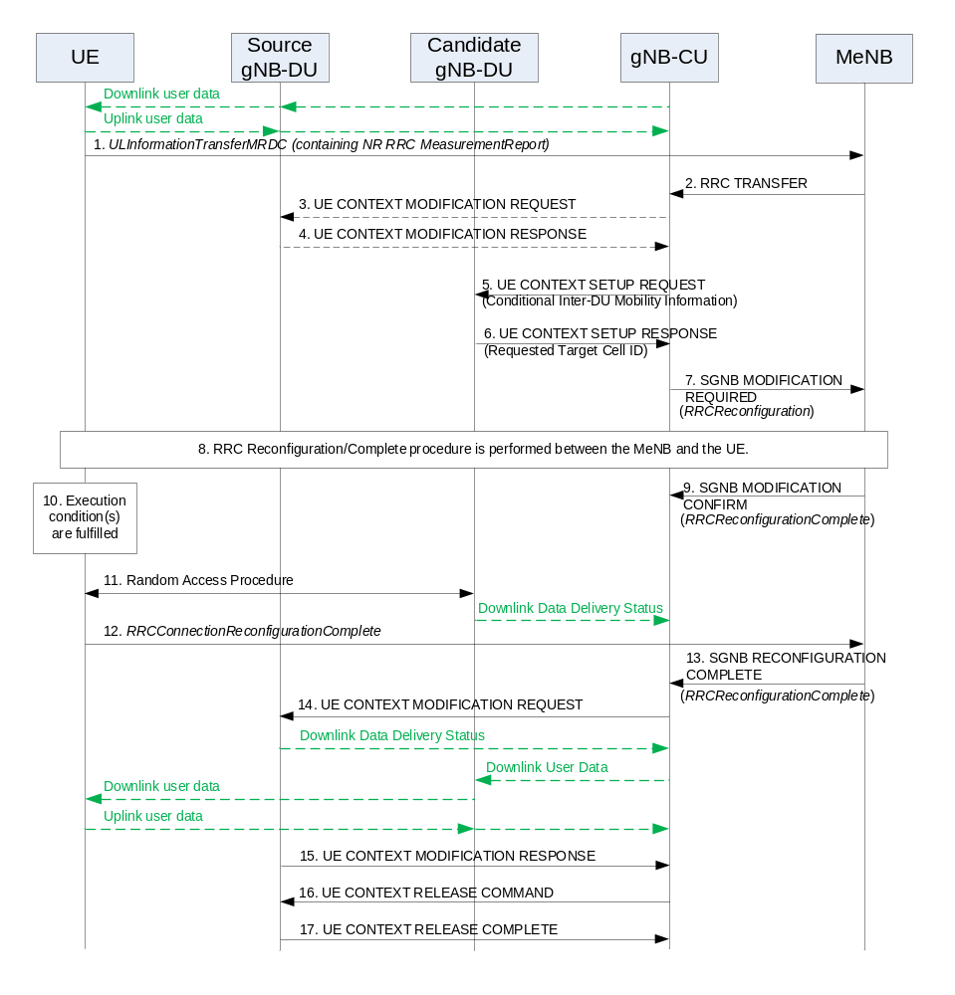
Figure 8.2.2.X-1: Inter-gNB-DU Conditional PSCell Change using MCG SRB without MN negotiation in EN-DC
1-4. The steps 1-4 are as defined in clause 8.2.2.1.
5. The gNB-CU sends an UE CONTEXT SETUP REQUEST message to the candidate gNB-DU to create an UE context and setup one or more data bearers. The UE CONTEXT SETUP REQUEST message includes a CG-ConfigInfo.
6. The candidate gNB-DU responds the gNB-CU with an UE CONTEXT SETUP RESPONSE message including the target cell ID that was requested from the gNB-CU.
7. The gNB-CU sends an SGNB MODIFICATION REQUIRED message to the MeNB, which includes a generated RRCReconfiguration message.
8. The MeNB and the UE perform RRC Connection Reconfiguration/Complete procedure.
9. The MeNB sends an SGNB MODIFICATION CONFIRM message to the gNB-CU, to convey the received RRCReconfigurationComplete message at step 8.
10. An execution condition to trigger initiation of conditional PSCell change is fulfilled.
11. Random Access procedure is performed at the candidate gNB-DU, which becomes the target gNB-DU if successful. The target gNB-DU sends a Downlink Data Delivery Status frame to inform the gNB-CU.
12-13. The UE responds with an RRCReconfigurationComplete message, which the MeNB forwards to the gNB-CU via an SGNB RECONFIGURATION COMPLETE message.
14. The gNB-CU sends a UE CONTEXT MODIFICATION REQUEST message to the source gNB-DU and indicates to stop the data transmission for the UE. The source gNB-DU sends a Downlink Data Delivery Status frame to inform the gNB-CU about the unsuccessfully transmitted downlink data to the UE. Downlink packets, which may include PDCP PDUs not successfully transmitted in the source gNB-DU, are sent from the gNB-CU to the target gNB-DU. Downlink packets are sent to the UE. Also, uplink packets are sent from the UE, which are forwarded to the gNB-CU through the target gNB-DU.
NOTE: The step 14 may happen before step 13, as soon as the gNB-CU knows that the UE has successfully accessed.
NOTE: It is up to gNB-CU implementation whether to start sending DL User Data to the target gNB-DU before or after reception of the Downlink Data Delivery Status from the source gNB-DU.
15. The source gNB-DU responds to the gNB-CU with the UE CONTEXT MODIFICATION RESPONSE message.
16-17. The steps 16-17 are as defined in steps 11-12 in clause 8.2.1.1.

//////////////////////////////////////////////////////////////irrelevant operations skipped/////////////////////////////////////////////////////////////////////

8.9.4 Inter-gNB handover involving gNB-CU-UP change
Figure 8.9.4-1 shows the procedure used for inter-gNB handover involving gNB-CU-UP change. Overall inter-gNB handover procedure is specified in TS 37.340 [12].
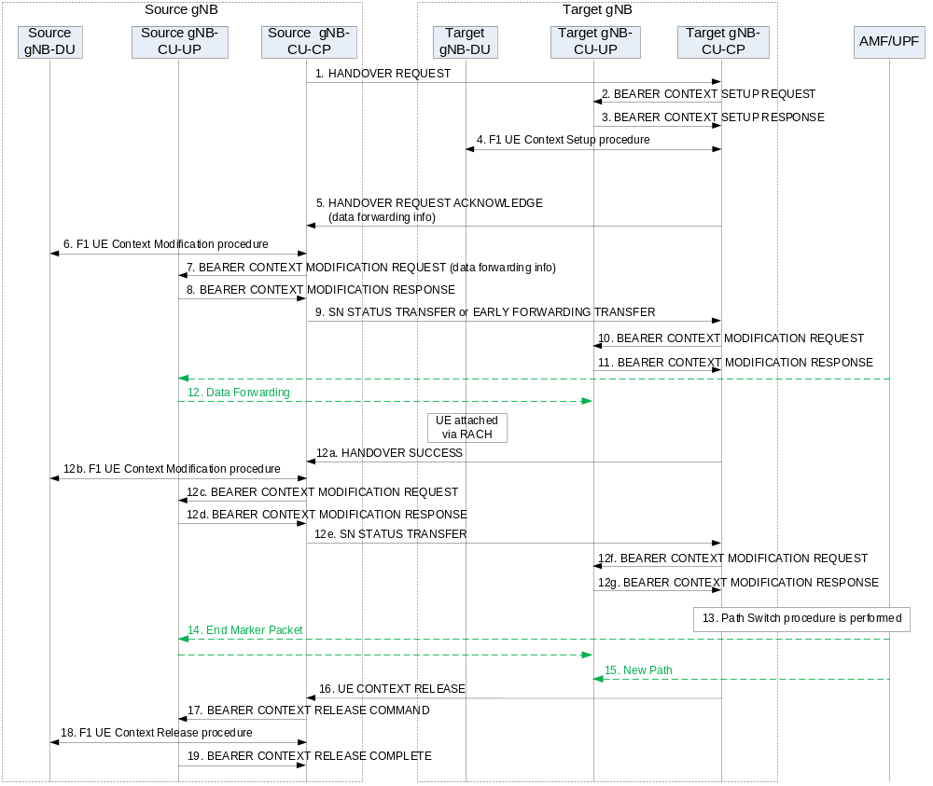Figure 8.9.4-1: Inter-gNB handover involving gNB-CU-UP change
1. The source gNB-CU-CP sends HANDOVER REQUEST message to the target gNB-CU-CP. In case of Conditional Handover, the target gNB is regarded as a candidate gNB which is only accessed by the UE when the CHO condition(s) are fulfilled.
2-4. Bearer context setup procedure is performed as described in Section 8.9.2.
5. The target gNB-CU-CP responds the source gNB-CU-CP with an HANDOVER REQUEST ACKNOWLEDGE message.
6. The F1 UE Context Modification procedure is performed to stop UL data transmission at the gNB-DU (unless DAPS Handover is performed) and to send the handover command to the UE.
NOTE: In case of Conditonal Handover, the DL RRC Message Transfer procedure is used in step 6 which carries the handover command to the UE.
7-8. Bearer context modification procedure (gNB-CU-CP initiated) is performed to enable the gNB-CU-CP to retrieve the PDCP UL/DL status and to exchange data forwarding information for the bearer.
9. The source gNB-CU-CP sends an SN STATUS TRANSFER message to the target gNB-CU-CP.
NOTE: In case of DAPS Handover, the EARLY FORWARDING TRANSFER message is sent for DRBs configured with DAPS instead of the SN STATUS TRANSFER message.
NOTE: In case of Conditional Handover, the EARLY FORWARDING TRANSFER message is sent only if the early data forwarding is applied. The message may include an candidate target cell info (FFS).
NOTE: The COUNT related info for the EARLY FORWARDING TRANSFER message is retrieved from the source gNB-CU-UP via the steps 7/8.
10-11. Bearer context modification procedure is performed as described in Section 8.9.2. The COUNT related info carried by the EARLY FORWARDING TRANSFER message is also provided to the target gNB-CU-UP.
12. Data Forwarding may be performed from the source gNB-CU-UP to the target gNB-CU-UP.
NOTE: In case of Conditional Handover, the UE performs RACH when the CHO condition(s) are fulfilled.
12a. In case of DAPS Handover or Conditional Handover, the target gNB-CU-CP sends the HANDOVER SUCCESS message to the source gNB-CU-CP to inform that the UE has successfully accessed the target cell.
12b In case of DAPS Handover or Conditional Handover, the F1 UE Context Modification procedure is performed to stop UL data transmission at the gNB-DU.
12c-12d. In case of DAPS Handover or Conditional Handover, the Bearer context modification procedure (gNB-CU-CP initiated) is performed to indicate the source gNB-CU-UP to stop packet delivery and also to retrieve the PDCP UL/DL status.
12e. In case of DAPS Handover or Conditional Handover, the source gNB-CU-CP sends the SN STATUS TRANSFER message to the target gNB-CU-CP.
12f-12g. In case of DAPS Handover or Conditional Handover, the Bearer context modification procedure is performed to provide the PDCP UL/DL status to the target gNB-CU-UP.
13-15. Path Switch procedure is performed to update the DL TNL address information for the NG-U towards the core network.
16. The target gNB-CU-CP sends an UE CONTEXT RELEASE message to the source gNB-CU-CP.
17. and 19. Bearer context release procedure is performed.
18. F1 UE context release procedure is performed to release the UE context in the source gNB-DU.

