



have the pleasure of inviting you to 3GPP RAN2#109-Bis, RAN3#107-Bis

in Sapporo, Japan from Monday 20 to Friday 24 April 2020

|  |  |
| --- | --- |
| 3GPPRAN2#109-Bis | 20 - 24 April 2020 |
| 3GPPRAN3#107-Bis | 20 - 24 April 2020 |

3GPP Meetings (RAN2#109-Bis, RAN3#107-Bis)

The Japanese Friends of 3GPP**, Anritsu, Ericsson Japan, Fujitsu, Fujitsu Connected Technologies Limited, Huawei Technologies Japan, KDDI, KYOCERA, MITSUBISHI ELECTRIC, NEC, Nokia Networks Japan, NTT DOCOMO, OKI, Panasonic, Qualcomm Japan, Rakuten Mobile, Inc., SHARP, SoftBank, and Sony Mobile Communications Japan** have the pleasure of inviting you to the above-mentioned meeting.

We look forward to seeing you all in Sapporo.

Yours sincerely,

"Japanese Friends of 3GPP"

# Meeting Registration

Please register for the meeting online via 3GPP website at:

On-line registration

<https://webapp.etsi.org/3GPPRegistration/>

# Meeting Venue

**Hotel Emisia Sapporo**

*Address : (English / Japanese)*

5-25, Atsubetsu Chuo 2-Jo 5-Chome, Atsubetsu-Ku, Sapporo, 004-0052 Japan

Phone: +81-11-895-8811

ホテルエミシア札幌

札幌市厚別区厚別中央2条5丁目5-25

TEL：011-895-8811

Access to closest station:

6 minute walk from Shin Sapporo Station, JR (Japan Railways) Chitose line

3 minute walk from Shin Sapporo Station, Subway Tozai line

English: <http://www.hotel-emisia.com/index.en.html>

Japanese: <http://www.hotel-emisia.com/index.html>

Please refer also to ANNEX 2 for Transportation to the Venue.

# Host Contact

For any questions about the meeting, please contact our Meeting Coordinators.

ILCC Co., Ltd

E-mail: [jf3wgs_sec@ilcc.com](mailto:jf3wgs_sec@ilcc.com) Tel: +81-3-5562-3665

# Accommodation

Online Reservation:

**Hotel Emisia Sapporo** offers the special package for 3GPP RAN2 / RAN3 meetings in Sapporo, Japan.

Please access the URL below for online reservations.

[**http://bit.ly/2K0MrOx**](http://bit.ly/2K0MrOx) **(Hotel Emisia Sapporo Reservation Site)**

## Please note that online reservation will be available on the website starting from Monday, December 9, 2019. (Japan Standard Time)

## Cut off date: Tuesday, March 31, 2020（Japan Standard Time）

If you want to reserve your accommodation by other means, we recommend that you reserve it at your earliest convenience.

Please refer to ANNEX 1 for Accommodation.

Please note that "Japanese Friends of 3GPP (JF3)" is not responsible for arranging accommodations such as confirmation, cancellation and changing of hotel reservation.

# Visa Request

To find out whether you need a visa for entry to Japan, please consult <http://www.mofa.go.jp/j_info/visit/visa/faq.html#q1-1> and click the link "[the List of Countries and Regions that have Visa Exemption Arrangements with Japan](http://www.mofa.go.jp/j_info/visit/visa/short/novisa.html#list)" in the Q&A No.1. The list shows "Arrangements of Exemption of Visas". If your home country’s name is not shown on the list, you need a visa.

KNT-CT Global Travel Co., Ltd. (from Kinki Nippon Tourist Group), a supporting travel agency for this event, is pleased to assist preparing necessary documents for your visa application.

If you need visa application documents, please kindly fill out the online application form questionnaire by visiting below URL **by Wednesday, March 18, 2020**, hard dead line.

**Visa Application URL :** [**https://biz.knt.co.jp/tour/2019/12/3gpp/**](https://biz.knt.co.jp/tour/2019/12/3gpp/)

After we have received your VISA application request, we will proceed to prepare necessary visa documents.

Once the documents are prepared, we will ship the originals to your indicated destination address.

For any questions, please contact [gt_iod18@or.knt.co.jp](mailto:gt_iod18@or.knt.co.jp)

# Other information Voltage

100V/50Hz. Japanese plugs are two flat pin type (A-type) plugs. Please make sure you have correct adapters. Voltage converters or adapters will NOT be provided at the meetings.

**Please bring your voltage converters and plug adapters! (100 volts/50 hertz)**

# (ANNEX 1)

**Accommodation**

**Online Reservation**

**Hotel Emisia Sapporo: 3GPP meetings will take place in the hotel.**

Hotel Emishia offers the special package for 3GPP RAN2 / RAN3 meetings in Sapporo, Japan.

Please access the URL below for online application to make your hotel reservations.

[**http://bit.ly/2K0MrOx**](http://bit.ly/2K0MrOx) **(Hotel Emisia Sapporo Reservation Site)**

## Please note that online reservation will be available on the website starting from Monday, December 9, 2019. (Japan Standard Time)

## Cut off date: Tuesday, March 31, 2020.（Japan Standard Time）

Website above will be closed as soon as reservation becomes full.

We strongly recommend you booking through the above website, as early as possible, since the reservation will be made on first come, first serve basis.

* Package Details: Please check with the website above.

**Hotel Reservation Contact**

If you have any questions or requests, please feel free to contact Hotel Emisia Sapporo.

E-Mail: reservation.sapporo@hotel-emisia.com

**Cancellation Policy**

Upon cancellation of a reservation, the Customer will be charged a certain percentage

of the total price of accommodation (cancellation charge) as listed below.

・If the reservation is canceled 7 days before the intended check-in day: 20%

・If the reservation is canceled 3 days before the intended check-in day: 50%

・If the reservation is canceled the day before the intended check-in day: 80%

・If the reservation is canceled on the intended check-in day: 100%

・If no notice (no show) is received of cancellation: 100%

◆Access

5-25,Atsubetsu Chuo 2-Jo 5-Chome, Atsubetsu-Ku, Sapporo, 004-0052 Japan

TEL:+81-11-895-8811

Access to closest station:

6 minute walk from JR Shin Sapporo Station, JR Chitose line

3 minute walk from Shin Sapporo Station, Subway Tozai line

Hotel Emisia Sapporo, located in Shin Sapporo, which has direct access to JR(train), subway, bus, and all other means of transportation. It is also close to New Chitose Airport, the gateway to Hokkaido. Smooth and easy access is to be expected.

・ New Chitose Airport: JR "Rapid Airport" (28 minutes)

・ JR Sapporo Station: JR "Rapid Airport" (8 minutes)

・ Subway Odori Station: Subway Tozai Line (20 minutes)

・ Mitsui Outlet Park: Car (30 minutes)

・ Maruyama Zoo: Subway (30 minutes)

・ Otaru: JR “Rapid Airport” (47 minutes)

**Hotel Information**

**Other hotels**

For delegates who wish to reserve your accommodation on your own, we have listed the following hotels below for your reference. Please note that JF3 Secretariat are not responsible for arranging the hotels below.

**Hotel near JR Shin Sapporo Station**

**① Shin-Sapporo ARC CITY HOTEL**

2 minute walk to the venue

<http://www.arccityhotel.com/en/>

**Hotels near JR Sapporo Station**

**JR Sapporo Station is 8 minute train ride from JR Shin Sapporo Station where the venue is located.**

**② Hotel Gracery Sapporo**

<https://sapporo.gracery.com/>

**③ JR Tower Hotel Nikko Sapporo**

<https://www.jrhotels.co.jp/tower/english/accommodation/index.html>

**④ Keio Plaza Hotel Sapporo**

<https://www.keioplaza-sapporo.co.jp/english/>

**⑤ Mitsui Garden Hotel Sapporo**

<https://www.gardenhotels.co.jp/sapporo/eng/>

# (ANNEX 2)

**Transportation to the Venue**

**Meeting Venue:**

**Hotel Emisia Sapporo**

5-25,Atsubetsu Chuo 2-Jo 5-Chome, Atsubetsu-Ku, Sapporo, 004-0052 Japan

TEL:+81-11-895-8811

The Meeting Venue is 6 minute walk from the JR Shin Sapporo Station and 3 minute walk from the Subway Tozai Line’s Shin Sapporo Station. The JR Shin Sapporo Station and the Subway Tozai Line’s Shin Sapporo Station are connected.

New Chitose Airport (CTS) is the airport adjacent to Sapporo City and the most convenient to reach the Meeting Venue.

**[From New Chitose Airport (CTS)]**

**By Train:**

Take the JR "Rapid Airport" at New Chitose Airport to Shin Sapporo Station.

Travel time: approx. 30 minutes

Fee: 880 Yen

Operating Hours: 6:56 a.m. - 10:53 p.m. (including local train)

Time Table: <http://www.new-chitose-airport.jp/en/access/jr/timejr/>

Although Shin Sapporo Station is not written in the time table, “Rapid Airport” stops at Shin Sapporo Station in 28 minutes after leaving New Chitose Airport Station.

Please refer to the example shown below of “Rapid Airport” departing at 12:45.

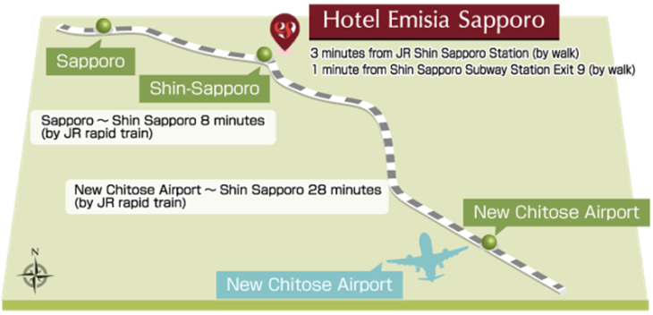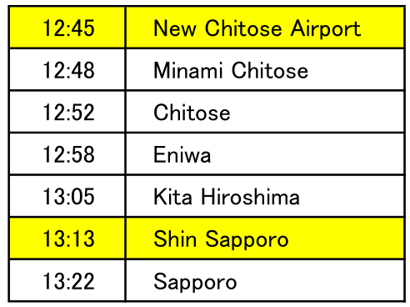

JR Hokkaido HP

<http://www2.jrhokkaido.co.jp/global/index.html>

How to use ticket vending machine

<http://www2.jrhokkaido.co.jp/global/pdf/e-ticketmachine.pdf>

Route guide from New Chitose Airport International Terminal to JR New Chitose Airport Station

<http://www2.jrhokkaido.co.jp/global/english/travel/airport.html>

**By Taxi:**

Travel time: approx. 60 minutes

Standard rate: JPY 12,000-14,400, late night rate: JPY 17,000

Map of Sapporo and surrounding area

<http://www.sapporo.travel/learn/map/?lang=en>

