3GPP TSG-RAN2 Meeting #59 R2-073413
Athens, Greece, 20-24th August 2007

Agenda Item: 4.5.2 LTE_ACTIVE mobility procedures intra-LTE - other
Souce: Samsung
Title: Measurement Gap and DRX interaction
Document for: Discussion and decision

Introduction
In LTE, DRX is designed to meet the requirements of UE power saving and efficient resource utilization; whereas, Measurement Gaps are provided (by the eNB for UEs which need to perform gap assisted measurement) for mobility support. While the sole purpose of these gaps is to assist UEs in the inter measurements (neighboring layer/ frequency/ RATs), the DRX/ DTX may also be used by the UE to perform these measurements [1].
So, in LTE Active both DRX and Measurement gaps would exist and the UE may sometimes have both these opportunities to carry out its gap assisted measurements.
In this document we discuss how DRX and Measurement GAP can co-exist.

Discussion
We shall discuss that how the gaps and DRX co-exist if both of them have been configured by the network. All through our discussions we will talk about only inter frequency/ layer/ RAT measurement(s). We intend to discuss the use of gaps after DRX.
A UE may use the DRX/ DTX to perform the inter cell (neighboring cells of a different layer/ frequency or RAT than the serving cell) measurements. The question which next comes is that after a long DRX when the UE had (and probably used) many opportunities to measure the inter cells, should it then continue to use the gaps while coming out of the DRX?
A simple rule could be that the UE must continue the measurements until the condition of the present cell improves and therefore, it mandates the use of gaps even outside the DRX as long as the serving quality is below a threshold.

Proposal 1: Even if the UE had many opportunities for measurement in the DRX, it shall continue to use the gaps while coming out of the DRX as long as the serving quality is below a certain threshold.
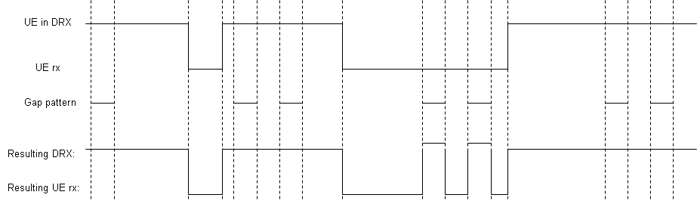
Figure 1: Both the case a and b are depicted

When the serving cell quality improves the UE can decide not to measure the neighboring cells [1] and it will help if the network can be informed about this so that it can have more scheduling freedom. So if the serving cell quality goes above a threshold then UE may decide to not continue neighbor measurements (and will therefore no longer use the measurement gaps).
We identified 2 methods on how the UE could inform the network about its decision.
- Mobility measurement reports: Network may decide based on the last measurement report (or last few measurement reports) received from the UE, that the serving cell quality is above a certain threshold and therefore the UE will abandon the neighbor measurements and therefore the gaps. This will inform the network in advance and this information may be used by the network scheduler.
- UL activity in gaps: UE upon intra measurement see that the serving cell quality is above a certain threshold and therefore will decide to abandon the measurement and gaps. It will initiate activity in the gaps for some UL transmission. Network upon seeing the UL activity of the UE may decide that the UE is no more using the gaps. This approach looks simpler but the drawback is that the network will only come to know about this upon initiation of UL activity by the UE.
Proposal 2: The UE’s decision (based on radio quality of the serving cell) of not to continue neighbor cell measurement and gap usage should be communicated to the network for a better scheduling information. One of the two methods described above could be used for this purpose.

Conclusion
RAN2 should discuss and decide:
- Proposal 1: Even if the UE had many opportunities for measurement in the DRX, it shall continue to use the gaps while coming out of the DRX as long as the serving quality is below a certain threshold.
- Proposal 2: The UE’s decision (based on radio quality of the serving cell) of not to continue neighbor cell measurement and gap usage should be communicated to the network for a better scheduling information. One of the two methods described above could be used for this purpose.

References
[1]: 3GPP TS 36.300 v 8.0.0
[2]: R2-071318 Gap control in E-UTRAN, Samsung.

The actual mobility measurements to be used (e.g. RSRP/ RSSI) are FFS.

