General Information
on 3GPP RAN1#120-bis/RAN2#129-bis/RAN3#127-bis/RAN4#114-bis/CT1#154/CT3#140/CT4#128 Meetings

from Monday 7 to Friday 11 of April 2025 in Wuhan, China

Beijing, 24 February 2025

Dear Delegate,

The 3GPP RAN1#120-bis, RAN2#129-bis, RAN3#127-bis, RAN4#114-bis, CT1#154, CT3#140 and CT4#128 meetings will be held in Wuhan, China.

RAN1#120-bis Meeting will be held in Hilton Wuhan Optics Valley.

RAN2#129-bis Meeting will be held in Hyatt Regency Wuhan Optics Valley.

RAN3#127-bis Meeting will be held in Hilton Wuhan Optics Valley.

RAN4#114-bis Meeting will be held in Crowne Plaza Wuhan Optics Valley.

CT1#154, CT3#140 and CT4#128 meetings will be held in Wuhan Marriott Hotel Optics Valley.

The locations of the hotels are shown in the following map.
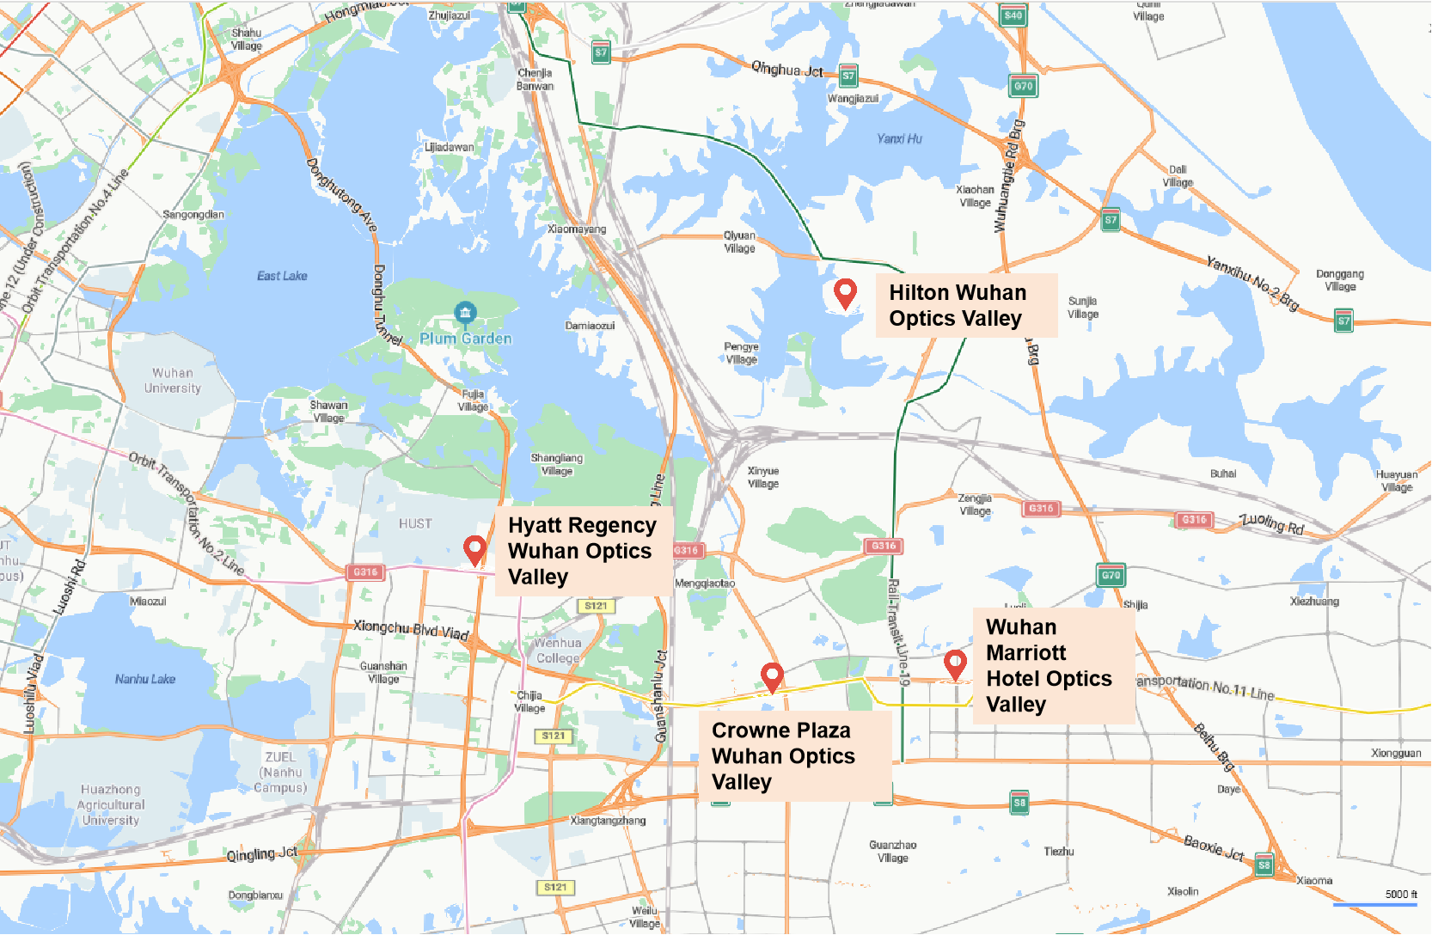

We look forward to seeing you all in Wuhan, China.

Yours sincerely,
the Chinese Friends of 3GPP

Accommodation
CF3 is not responsible for reservation confirmations, cancelled or changed reservations or no-shows. Please contact the hotel directly to make the reservation.
Meeting Venue for 3GPP RAN1#120-bis and RAN3#127-bis
Hilton Wuhan Optics Valley
No 9 Chunhe Road, Huashan Eco City, East Lake High Tech Development Zone , Wuhan, Hubei Province,China
Tel: (86) 027 5933 8888
Group Rates:
- Guest Room Gardenview with Balcony (King Bed/ 2 Double Beds): CNY 580 net per room per night with one or two daily breakfasts
- Deluxe Room with Pool and Lake View (King Bed/ 2 Double Beds): CNY 760 net per room per night with one or two daily breakfasts
- Executive Room with Lounge Access (King Bed/ 2 Double Beds):CNY 880 net per room per night with one or two daily breakfasts

* The above rate includes Service Charge and Estimated government taxes and fees. Broadband Internet access is complimentary in guest rooms.
* Cancellation Policy: Free cancellation is made 14 days before you check in, or the first night will be charged from your credit card
Hotel cut-off date, 31 Mar 2025
Hotel booking

Meeting Registration
Please register for the meetings online at:
on-line registration

Meeting Venue for 3GPP RAN2#129-bis
Hyatt Regency Wuhan Optics Valley
1077 Luoyu Road, Hongshan District, Wuhan, Hubei, China
Tel: (86)027 5122 1234
Group Rates:
- 1 King Bed Room: CNY 680 net per room per night with one or two daily breakfasts
- 2 Twin Beds Room: CNY 780 net per room per night with one or two daily breakfasts
- 1 King Bed, Club Access Room: CNY 880 net per room per night with one or two daily breakfasts

* The above rate includes Service Charge and Estimated government taxes and fees. Broadband Internet access is complimentary in guest rooms.
* Cancellation Policy: Free cancellation is made 3days before you check in, or the first night will be charged from your credit card
Hotel cut-off date, 31 Mar 2025
Hotel booking

Meeting Registration
Please register for the meetings online at:
on-line registration

Meeting Venue for 3GPP RAN4#114-bis
Crowne Plaza Wuhan Optics Valley
No.668 Gaoxin Avenue, East Lake High-tech Development Zone, Wuhan, Hubei Province, P.R.China
Guest service center Tel: +86 27 5956 8888

Reservation centre Tel：+86 27 5956 8888 ext.6628
Email: reservation@cpwhov.com
Group Rates:
- Standard Room (King Bed/ 2 Double Beds): CNY 660 net per room per night with one or two daily breakfasts
- Standard Worklife Room (King Bed/ 2 Double Beds): CNY 720 net per room per night with one or two daily breakfasts
- Premium Room (King Bed/ 2 Double Beds):CNY 988 net per room per night with one or two daily breakfasts and includes executive lounge benefits
- One King Bed Junior Suite (King Bed):CNY 1188 net per room per night with one or two daily breakfasts and includes executive lounge benefits

* The above rate includes Service Charge and Estimated government taxes and fees. Broadband Internet access is complimentary in guest rooms.
* Cancellation Policy: Free cancellation is made 3days before you check in, or the first night will be charged from your credit card
Hotel cut-off date, 31 Mar 2025
Hotel booking

Meeting Registration
Please register for the meetings online at:
on-line registration

Meeting Venue for 3GPP CT1#154, CT3#140 and CT4#128
Wuhan Marriott Hotel Optics Valley
No.797 Gaoxin Boulevard, Donghu High-tech District,Wuhan, Hubei, 430073, P.R. China
Tel: (027)8798 6888
Group Rates:
- Guest room, 1 King, City view：CNY 750 net per room per night with one or two daily breakfasts
- Guest room, 2 Double, City view：CNY 750 net per room per night with one or two daily breakfasts
- Guest room, 1 King, City view, Highfloor：CNY 850 net per room per night with one or two daily breakfasts
- Guest room, 2 Double, City view, Highfloor：CNY 850 net per room per night with one or two daily breakfasts
- Executive level, Guest room, 1 King,City view, High floor:CNY 950 net per room per night with one or two daily breakfasts

* The above rate includes Service Charge and Estimated government taxes and fees. Broadband Internet access is complimentary in guest rooms.
* Cancellation Policy: Free cancellation is made 1day before you check in, or the first night will be charged from your credit card. If you want to cancel or change, you can also contact the hotel . The telephone number is 86- 027-87986888 and the e-mail address is Caroline.Y.Chen@marriotthotels.com
Hotel cut-off date, 31 Mar 2025
Hotel booking

Meeting Registration
Please register for the meetings online at:
on-line registration

Visa letter
If you need an invitation letter for VISA for 3GPP RAN1#120-bis, RAN2#129-bis, RAN3#127-bis, RAN4#114-bis, CT1#154, CT3#140 and CT4#128 meetings to be held from Monday 7 to Friday 11 of April 2025 in Wuhan, China, please visit the website
https://www.ccsa.org.cn/english/eventsDetail/?id=15

User name: 3GPPWuhan
Password: 3GPP123

to fill in the invitation letter request form online no later than 21 March, 2025 (Beijing time, GMT+8).

Please contact the Chinese Embassy at your country for further information.

Contact person for invitation letter:
Mr. Ruixiao BAI (CCSA)
E-mail: bairuixiao@ccsa.org.cn; ccsavisa@163.com
Tel: +86-15501150226

Time Zone
GMT +8 hours

Voltage
Commercial power in China is 220V. Please be sure you have the correct adapter. Voltage converters will not be provided at the meeting.
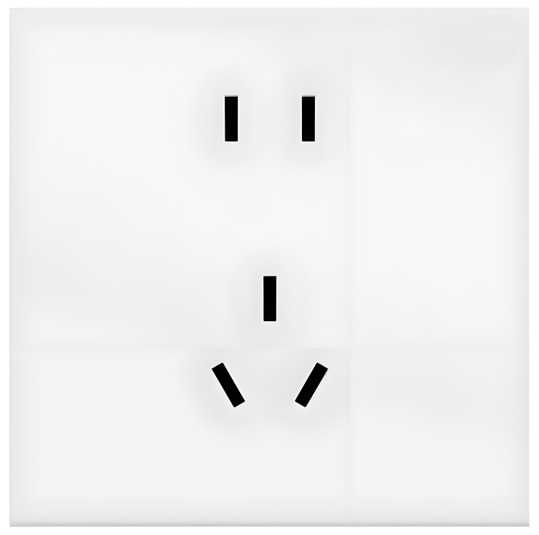
City Profile/ Area Attractions
Wuhan Tours
Host Contact
For any questions about anything relating to the meeting please contact:
Mr. Ruixiao BAI
Tel.: +86- 15501150226
- mail: bairuixiao@ccsa.org.cn

Mr. Xu QI
Tel.: +86-10-6230 4200
E-mail: qixu@ccsa.org.cn

Mr. Shizhuo ZHAO
Tel.: +86-10-6230 2645
E-mail: zhaosz@ccsa.org.cn

Attachment 1: Transport Information about the meeting venue
Attachment 1: Transport Information about Meeting Venue

Hilton Wuhan Optics Valley

Hilton Wuhan Optics Valley is about 50 km and 50 mins by car from Wuhan Tianhe Airport.
The fare for taxi from the Airport to the hotel is around CNY 150 per way. (Please take the taxi which can provide the invoice for your trip)

In case of taking a taxi, please print the following note which shows taxi driver the address of Hilton Wuhan Optics Valley in both English and Chinese.

Please take me to Hilton Wuhan Optics Valley
Address: No 9 Chunhe Road, Huashan Eco City, East Lake High Tech Development Zone , Wuhan ,Hubei Province , China

TEL：(86)027 5933 8888

请送我到武汉光谷希尔顿酒店

地址:中国湖北省武汉市东湖高新区花山生态新城春和路9号

电话: (86) 027 5933 8888

Hyatt Regency Wuhan Optics Valley

Hyatt Regency Wuhan Optics Valley is about 47 km and 52 mins by car from Wuhan Tianhe International Airport. The fare for taxi from the Airport to the hotel is around CNY 110 per way. (Please take the taxi which can provide the invoice for your trip)

In case of taking a taxi, please print the following note which shows taxi driver the address of Hyatt Regency Wuhan Optics Valley in both English and Chinese.

Please take me to Hyatt Regency Wuhan Optics Valley
Address: 1077 Luoyu Road, Hongshan District, Wuhan, Hubei, China

TEL：(86)027 5122 1234

请送我到武汉光谷凯悦酒店

地址:中国湖北省武汉市，洪山区珞瑜路1077号

电话: (86)027 5122 1234

Crowne Plaza Wuhan Optics Valley

Crowne Plaza Wuhan Optics Valley is about 55 km and 60 mins by car from Wuhan Tianhe International Airport. The fare for taxi from the Airport to the hotel is around CNY 130 per way. (Please take the taxi which can provide the invoice for your trip)

In case of taking a taxi, please print the following note which shows taxi driver the address of Crowne Plaza Wuhan Optics Valley in both English and Chinese.

Please take me to Crowne Plaza Wuhan Optics Valley
Address: No.668 Gaoxin Avenue, East Lake High-tech Development Zone, Wuhan, Hubei Province, P.R.China

Guest service center TEL：(86)27 5956 8888

请送我到武汉光谷皇冠假日酒店

地址:中国湖北省武汉市东湖新技术开发区高新大道668号

总机电话: (86)27 5956 8888

Wuhan Marriott Hotel Optics Valley

Wuhan Marriott Hotel Optics Valley is about 55 km and 60 mins away from the Airport. The fare for taxi from the Airport to the hotel is around CNY 80 per way. (Please take the taxi which can provide the invoice for your trip)

In case of taking a taxi, please print the following note which shows taxi driver the address of Wuhan Marriott Hotel Optics Valley in both English and Chinese.

Please take me to Wuhan Marriott Hotel Optics Valley
Address: No.797 Gaoxin Boulevard, Donghu High-tech District,Wuhan, Hubei, 430073, P.R. China
TEL：(027)8798 6888

请送我到武汉光谷万豪酒店

地址:中国湖北省武汉市东湖高新区高新大道797号

电话: (027)8798 6888



Have a successful meeting and enjoy your stay in Wuhan!

