3GPP TSG-RAN WG2 Meeting #119 electronic R2-220

Electronic, 17th - 29th August, 2022

Source: Huawei, HiSilicon
Title: [Offline-410][POS] Rel-17 positioning MAC (Huawei)
Agenda Item: 6.11.1
Document for: Discussion and Decision

Introduction
This document provides a summary of the following contributions submitted to AI 6.11 for MAC corrections.
- [AT119-e][410][POS] Rel-17 positioning MAC (Huawei)
Scope: Check and update the rapporteur CR in R2-2207880 to take account of decisions of this meeting. Evaluate the proposals in the following tdocs:
- R2-2207886
- R2-2208125
- R2-2208204
- R2-2208300
- R2-2208512
- R2-2208686
- R2-2207883
- R2-2207012
Intended outcome: Agreeable CR
Deadline: Tuesday 2022-08-23 1200 UTC

A questionnaire for the following list of CRs are provided:
- R2-2207880 Editor's Correction for MAC spec for Positioning Huawei, HiSilicon
- R2-2207012 Corrections for DL-PRS processing window activation Samsung
- R2-2207693 Positioning during handover and re-establishment Lenovo
- R2-2207883 Correction to TA-validation for inactive SRS transmission Huawei, HiSilicon
- R2-2208686 Correction on PPW for positioning enhancement NEC
- R2-2207886 Cancellation of SR for posMG (de-)activation request Huawei, HiSilicon
- R2-2208125 Correction to Scheduling Request for Positioning Measurement Gap Activation/Deactivation Request Qualcomm Incorporated
- R2-2208204 Miscellaneous corrections to NR positioning enhancements Lenovo
- R2-2208300 Cancellation of UL MAC CE for MG activation/deactivation Samsung
- R2-2208512 Corrections for triggered Positioning MG Req MAC CE Samsung

Contacts
Name | Company | Email

Review of editorials
In Rapp CR R2-2207880, the following issues have been raised:
- Change1: Change the reference of SRS transmission in RRC_INACTIVE from 5.25 to 5.26.
  - Note that this has also been mentioned in the CR in R2-2207693
- Change2: Add description for UL transmission when inactivePosSRS-TimeAlignmentTimer is not running, which can be seen in the following text proposal

The MAC entity shall not perform any uplink transmission on a Serving Cell except the Random Access Preamble and MSGA transmission when the timeAlignmentTimer associated with the TAG to which this Serving Cell belongs is not running and CG-SDT procedure is not ongoing. Furthermore, when the timeAlignmentTimer associated with the PTAG is not running, CG-SDT procedure is not ongoing and SRS transmission in RRC_INACTIVE as in clause 5.26 is not ongoing, the MAC entity shall not perform any uplink transmission on any Serving Cell except the Random Access Preamble and MSGA transmission on the SpCell. The MAC entity shall not perform any uplink transmission except the Random Access Preamble and MSGA transmission when the cg-SDT-TimeAlignmentTimer is not running during the ongoing CG-SDT procedure as triggered in clause 5.27. The MAC entity shall not perform any uplink transmission except the Random Access Preamble and MSGA transmission when inactivePosSRS-TimeAlignmentTimer is not running during the procedure for SRS transmission in RRC_INACTIVE as in clause 5.26.

Question0.1, Do companies agree with the following editorial change in the Rapp CR?
- Change1: Change the reference of SRS transmission in RRC_INACTIVE from 5.25 to 5.26.
- Change2: Add description for UL transmission when inactivePosSRS-TimeAlignmentTimer is not running
Company | Yes/No | Comments
Intel | Yes
CATT | Yes
Samsung | Yes
vivo | Yes
Xiaomi | Yes | The first sentence also needs to add the SRS transmission in RRC_INACTIVE is not ongoing.
ZTE | Yes
NEC | Yes

In R2-2208204, several other editorial changes have been proposed:
- In clause 5.26.2 the referenced field name inactivePosSRS-RSRP-ChangeThreshold has been corrected to inactivePosSRS-RSRP-changeThreshold.
- In the description of Positioning Measurement Gap Activation/Deactivation Request MAC CE (clause 6.1.3.40) and Positioning Measurement Gap Activation/Deactivation Command MAC CE (6.1.3.41) the definition of the “R” bit has been added.
- The editorial issues in clause 5.18.20, 6.1.3.40, 6.1.3.41 have been fixed

Question0.2: Do companies agree that the following editorial changes are needed?
- In clause 5.26.2 the referenced field name inactivePosSRS-RSRP-ChangeThreshold has been corrected to inactivePosSRS-RSRP-changeThreshold.
- In the description of Positioning Measurement Gap Activation/Deactivation Request MAC CE (clause 6.1.3.40) and Positioning Measurement Gap Activation/Deactivation Command MAC CE (6.1.3.41) the definition of the “R” bit has been added.
- The editorial issues in clause 5.18.20, 6.1.3.40, 6.1.3.41 have been fixed

Company | Yes/No | Comments
Intel | Yes | To be honest, for the change “inactivePosSRS-RSRP-changeThreshold”, the name used in MAC CR is correct. We should update RRC CR, i.e. “c” should be the capital letter.
CATT | Yes
Samsung | Yes | Also same view with Intel regarding the naming of ‘inactivePosSRS-RSRP-changeThreshold’ field.
Huawei, HiSIlicon | Yes
vivo | Yes | Agree with Intel that the “inactivePosSRS-RSRP-ChangeThreshold” is the correct naming. Suggest to change the 331 spec rather than 321 spec.
Xiaomi | Yes
ZTE | Yes
NEC | Yes

In R2-2208686, the following editorials have been provided for PPW activation/deactivation command MAC CE:
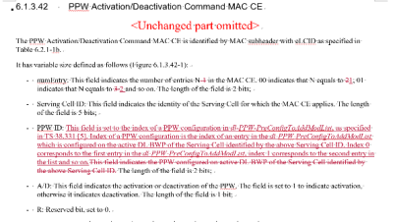

Quesiton0.3: Do companies agree with the following editorials in R2-2108686?
- (a)Change N-1 to N
- (b) Add explanations to the PPW ID
Company | (a)  Yes/No | (b)  Yes/No | Comments
Intel |  | Yes | The explanation in the CR is clear.
CATT |  | Yes | We do not see the motivation for change a)
Samsung | Yes | Yes
Huawei,HiSilicon | No | Yes | - Has already been discussed before. There is a clear reason why it is N-1
vivo | No | Yes with comments | For (a), actually, N is the number of the octets. It is impossible that N equals to 1. The change is incorrect.  For (b), suggest to further refine the “PPW ID” to “PPW index”.
Xiaomi | No | Yes
ZTE | No | Yes | N-1 is the number of entries of PPW ID, N is the total number of entries. We see there is no mistake
NEC | Yes | Yes

Discussion

Activation/Deactivation of DL-PRS processing window
In R2-2207012, issues have been raised on the (a) default PPW activation/deactivation state when the BWP is activated and (b) the PPW state when there is a reconfiguration of the PPW.
It has been proposed that
- Upon activation of DL BWP, the PPW(s) configured for that BWP are considered deactivated
- Upon reconfiguration of PPW(s) of the active DL BWP, all the PPW(s) for that BWP are considered deactivated
Based on the above, Rapp would like to ask the following question:
Question1, do companies agree with the following?
- (a) Upon activation of DL BWP, the PPW(s) configured for that BWP are considered deactivated
- (b) Upon reconfiguration of PPW(s) of the active DL BWP, all the PPW(s) for that BWP are considered deactivated
Company | (a)  Yes/No | (b)  Yes/No | Comments
Intel |  |  | Do not see the relationship between the changes “Upon activation of DL BWP, the PPW(s) configured for that BWP are considered deactivated. Upon reconfiguration of PPW(s) of the active DL BWP, all the PPW(s) for that BWP are considered deactivated.” And the reason for change. To my understanding, the simple way is, the UE just follow network indication. If the PPW X is activated, the UE shall only active PPW x. The network shall handle PPW properly upon BWP switching. If no, it is up to UE implementation on how to handle the error case.
CATT |  |  | We share the same view with intel, UE only need to follow what NW indicated. For BWP switching without activation the PPW, UE will not use the PPW then.
Samsung (Proponent) | Yes | Yes | As for other configurations that are activated/deactivated by MAC CE (which can be found in subclauses 5.18.2, 4, 6-9, and 17), this has to be clarified for the clarity. The proposed clarifications are simple and also aligned with other similar configurations.  It cannot be left UE implementation as it would result the mismatch about the state of the configurations between UE and network.
Huawei, HiSilicon | Yes | No | We think it is needed to specify the default status of the PPW  While it is not quite necessary to specify the reconfiguration of PPW when PPW is being activated. PPW requires low latency and there is no absolute need to reconfig while PPW is being activated.
vivo | Yes | Yes | The default status needs to be clarified in the spec.
Xiaomi | Yes | No | If network wants to reconfigure the PPW and the PPW is activated, the reasonable way is that the network deactivate the PPW first.
ZTE | Yes | Yes | Agree with vivo that the UE default behaviour can be added in the spec
NEC | Yes | Yes | We are fine with the proposal.

TA validation for inactive SRS
In R2-2207883, several issues with TA validation for inactive SRS transmission has been proposed. It has been analyzed that there are two scenarios for SRS transmission in RRC_INACTIVE and SDT, illustrated by the following figure:
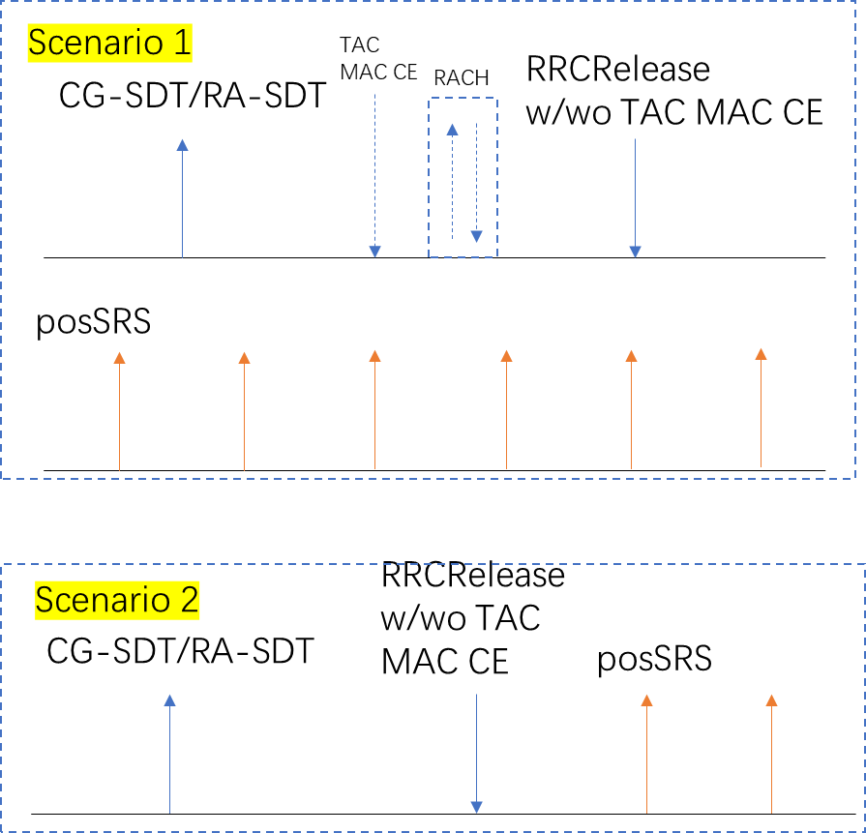

- Scenario 1 refers to the case when there are SDT procedure and SRS transmission procedure in RRC_INACTIVE going in parallel. In this case, it is possible that the UE receives TAC via either TAC MAC CE, TAC in RAR, or absolute TAC in msgB. For these cases, since TA is adjusted, it is also reasonable to update the downlink pathloss reference. Within the current spec, the pathloss update and restart of the TAT at reception of MAC CE, RRCRelease message is specified. While for RACH procedure during the SRS transmission, it is not specified yet. This needs to be added
- Scenairo2 refers to the case when SDT is terminated with SRS configuration included within the RRCRelease message. In this scenario, the SDT procedure and SRS transmission goes in serial. From the current spec, the spec is already complete for this scenario.

For scenario 1, the current spec is missing for treating the case when there is RACH performed in parallel with SRS transmission. Correction needs to be made for
1/ The inactiveposSRS-TAT should be restarted when contentions resolution is successful for 4-step RACH and 2-step RACH
2/ RSRP value of the pathloss reference should be updated when TAC is received for successful 2-step RACH and 4-step RACH

Based on the discussion above, the following TP has been provided:
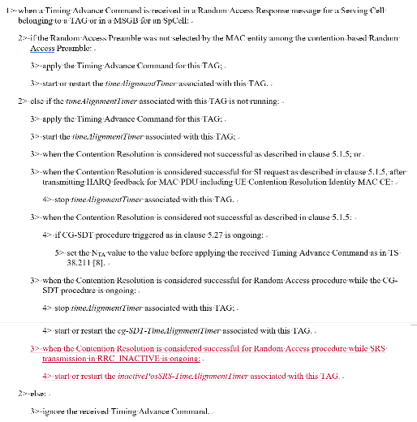
Based on the above, we ask the following question
Question2, Do companies agree that inactiveposSRS-TAT should be restarted when contentions resolution is successful for 4-step RACH and 2-step RACH?
Company | Yes/No | Comments
Intel | Yes
CATT | Yes
Samsung | Yes
Huawei, HiSIlicon | Yes
vivo | Yes
Xiaomi | Yes
ZTE | Yes
NEC | Yes

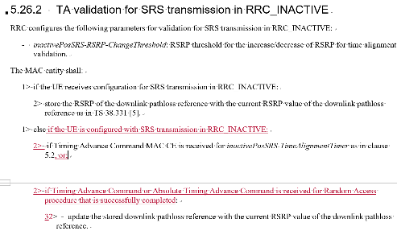
Question3: Do companies agree that RSRP value of the pathloss reference should be updated when TAC is received for successful 2-step RACH and 4-step RACH?
Company | Yes/No | Comments
Intel | Yes
CATT | Yes
Samsung | Yes | It seems reasonable to update the pathloss reference when the UE receives TAC via successful RA procdure.
Huawei, HiSilicon | Yes
vivo | Yes
Xiaomi | Yes
ZTE | Yes
NEC | Yes

Finally, for the condition for TA validation, for CG-SDT, the condition that cg-SDT-TAT is running has already been added. For SRS transmission in RRC_INACTIVE, the CR proposes the same for CG-SDT. Hence, the following has been proposed:
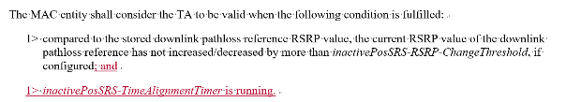
For the above change, we would like to ask the following question
Question4: Do companies agree that the condition” inactivePosSRS-TimeAlignmentTimer is running” should be added for the condition for TA validation for SRS transmission in RRC_INACTIVE?
Company | Yes/No | Comments
Intel | Yes
CATT | Yes
Samsung | Yes
Huawei, HiSilicon | Yes
vivo | Yes
Xiaomi | Yes
ZTE | Yes
NEC | Yes

MAC CE cancellation

RRC changes

In R2-2208300, the following has been argued:
Proposal 4.5: the following options to cancel a triggered UL MAC CE for MG activation and deactivation should be captured in the spec; other options can be discussed in the running CR discussion.
• When the MAC CE is transmitted
• When a request from upper layers to transmit a new request to gNB for a new/modified gap configuration is received
• When an indication from upper layers that the gaps are not needed any more or a gap with a new id needs to be activated is received
• On MAC reset
Among the four options for the cancellation. The first and last options are already captured in section 5.25 and section 5.12 separately in MAC specification (TS 38.321, v17.1.0.).

On the other hand, the second and third options are not captured yet in any specification. In case of the cancellation based on the second/third options, MAC layer is intended to just follow the request/indication from the upper layer (i.e., RRC) and thus, the specific cancellation conditions should be captured in RRC specification, TS 38.331.

Then, the following change was captured for the 2nd bullet

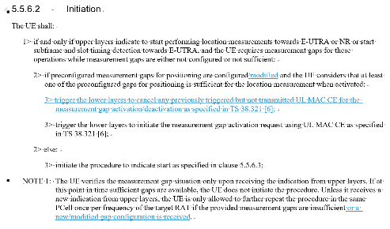
However, the moderator would like to point out that in the current MAC spec, the following has been captured:
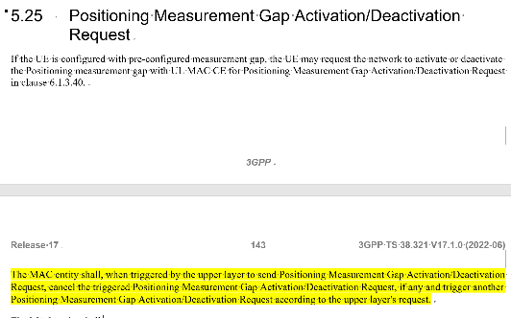

Question5: Do companies agree that the current spec has already captured the agreement that when a new request has received or the current request needs to be modified, the UE cancel the currently triggered posMG activation/deactivation request?

Company | Yes/No | Comments
Intel | Yes
CATT | Yes
Samsung (Proponent) | No | The key point of 2nd option is that ‘a new/modified gap configuration’ in RRC can trigger a new request and cancellation of previous MAC CE.  However, in the current MAC/RRC spec, we can not find any description on how the UE can trigger the new request and the cancellation when it receives a new/modified gap configuration. Thus, the proposed correction in RRC seems needed to capture the previous agreement correctly.
Huawei, HiSIlicon | Yes
vivo | Yes
Xiaomi | Yes
ZTE | Yes but | MAC spec does have the statement, but it is better to include it in RRC spec for a whole view

And the following change was captured for the 3rd bullet
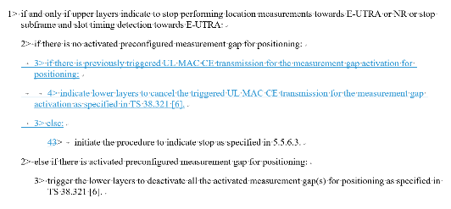

Question6: Do companies agree with the change in R2-2208300, that the triggered activation request should be cancelled by RRC when the gap is not yet activated but not needed any more?
Company | Yes/No | Comments
Intel | No | Current MAC handling has covered this scenario.
CATT | No | We agree such case is not captured by the specification now. But in last meeting, RAN2 already discussed such issues, and the conclusion is that this is a very corner case, thus no additional enhancement is needed.
Samsung (Proponent) | Yes | For Intel’s comment, the current MAC handling can not cover this scenario. Let’s assume that the UE previously transmitted UL MAC CE for pre-MG activation, but the gap is not activated yet. At this moment, if the upper layer indicates to stop performing measurement, the UE will just send LocationMeasurementIndication message as per the current spec without the MAC CE cancellation operation.  For CATT’s comment, we already have the previous agreement to capture this case in spec. Thus, the proposed correction is needed to capture the 3rd option correctly unless the agreement is reverted.
Huawei, HiSilicon | Yes | This is aligned with the previous agreement
vivo | No
Xiaomi | Yes
ZTE | Yes

Furthermore, in R2-2207886, the following has been argued:
From the perspective of RRC layer, when a MAC CE for MG activation has been sent while the MG has not been activated, it is possible that the RRC layer receives RRC reconfiguration for a certain measurement gap that can already satisfy the requirement for positioning measurement. In this case, the RRC layer should send an indication to the lower layer that the triggered MG activation request is not needed anymore. Subsequently, the MAC layer should cancel the triggered MAC CE when such indication is received from RRC layer.

So, it is possible that another MG is configured that can satisfy the requirement of the measurement before the requested MG is activated.

Based on this, the following has been proposed:
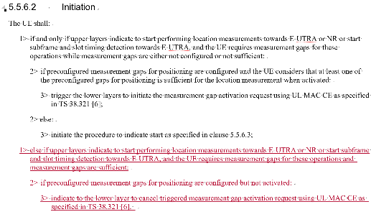

Question7, do companies agree to cancel the triggered MG activation request when there is another MG configured that can satisfy the current requirement for positioning measurement in the RRC layer?
Company | Yes/No | Comments
Intel | No | It should be a very rare case. Anyway it is RAN to decide how to handle the request. Do not see the problem for the UE to complete the request procedure.
CATT | No | In last meeting, RAN2 already discussed such issues, and the conclusion is that this is a very corner case, thus no additional enhancement is needed.
Samsung | Yes | This is another case where a new/modified MG configuration can trigger the cancellation of the previous MAC CE. We tend to agree with the motivation.
Huawei, HiSIlicon | Yes | It is possible that another configured MG can satisfy the requirement for positioning measurement.
vivo | No | It is a very rare case. Moreover, if happened, it is likely that the MAC CE has been transmitted and the cancelling is useless since RRC layer handling the RRC reconfiguration needs to takes quite a bit of time.
Xiaomi | No | No need to optimize for a very rare case.
ZTE | No | Tend to agree with other companies that no additional enhancement is needed

MAC changes
In R2-2207886, it is discussed that it is possible that when a MG activation request is triggered but not transmitted, the MG has already been activated or MG deactivation request is triggered but not transmitted, the MG has already been deactivated. This scenario is possible because we support both UE-based and LMF-based activation/deactivation request. MG activation/deactivation can be requested by either UE or LMF, it is possible that when the MAC CE for MG activation/deactivation request is triggered in the MAC layer, the MG has already been activated/deactivated, e.g., by request from LMF with NRPPa message NRPPa MEASUREMENT ACTIVATION.
Based on the above, the following TP has been provided

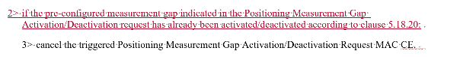
Question8: Do companies think the triggered posMG activation/deactivation request can be cancelled at the following cases?
- (a) When MAC layer has a triggered but not transmitted PosMG activation request for a certain preconfigured MG and this MG has already been activated; or
- (b) When a triggered but not transmitted posMG deactivation request and this MG has already been deactivated

Company | (a)  Yes/No | (b)  Yes/No | Comments
Intel | No | No | It should be a very rare case. Anyway it is RAN to decide how to handle the request. Do not see the problem for the UE to complete the request procedure.
CATT |  |  | Agree with Intel, this is corner case.
Samsung | Yes | Yes | Agree with the motivation.
Huawei, HiSilicon | Yes | Yes | The motivation has been mentioned above. The LMF-initiated activation/deactivation might not be aligned with the UE-initiated.
vivo | No | No | MAC layer should not do so complex handling, but just follow the command from RRC layer. The network can handle the MAC CEs.
Xiaomi | No | No | We think the key issue is that there may be conflict between UE and LMF on the activation/deactivation pre-configured MG, based on the previous discussion, this issue can be handled by network implementation.
ZTE | Yes | Yes | Only to follow the RRC layer’s indication for cancellation may not be enough, (a) and (b) are MAC automatic behaviour. Ok to specify it
NEC | No | No | Agree with Intel

In R2-2208512 thinks that
Procedure of MAC entity when it received an indication from upper layer that the triggered Positioning Measurement Gap Activation/Deactivation Request MAC CE should be cancelled are captured in TS 38.321 v17.1.0.

However the procedural text may be misled after cancelling the triggered Positioning Measurement Gap Activation/Deactivation Request MAC CE by indication from upper layer. Following the procedure, the MAC entity may instruct the Multiplexing and Assembly procedure to generate the cancelled MAC CE, or may trigger a Scheduling Request for the cancelled MAC CE.

However, the moderator would like to point out that there is a pre-condition in the chapter that all the procedures should satisify the condition that there is a triggered not cancelled MAC CE.
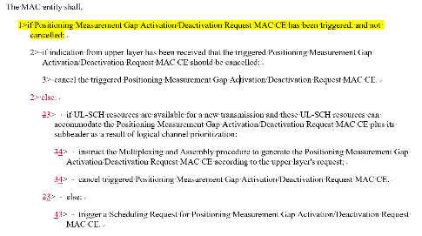

Hence, we would like to ask the following question
Question9, Do companies agree that we should Add condition to clarify operation after receiving an indication from upper layer that the triggered Positioning Measurement Gap Activation/Deactivation Request MAC CE should be cancelled?
Company | Yes/No | Comments
Intel | No | Agree Moderator’s clarification, i.e.there is a pre-condition in the chapter.
CATT | No | Agree with rapporteur’s comment.
Samsung (Proponent) | Yes | Highlighted pre-condition in the chapter is entering condition of the procedure, and is not recursive or global condition. Once the procedure started, MAC entity follows procedural text step by step.
Huawei, HiSIlicon | No
vivo | Yes | The current procedure is confusing and we agree with the intention to clarify. We understand that the reason of the issue is that the handling of cancelling indication and the handling of Gap activation/deactivation request share the same text procedure in section 5.25. We suggest to change the layout like below:  Upon receiving the indication from upper layer that the triggered Positioning Measurement Gap Activation/Deactivation Request MAC CE should be cancelled, the MAC entity shall,  - ….  Upon receiving the indication from upper layer that the Positioning Measurement Gap Activation/Deactivation Request MAC CE should be triggered, the MAC entity shall,  - ….
Xiaomi | No
ZTE | No | Agree with the original wording
NEC | No | Agree with rapporteur’s comment

SR and RACH cancellation
In R2-2208125 and R2-2207886, change has been proposed for the cancellation of SR triggered for posMG activation/deactivation request.
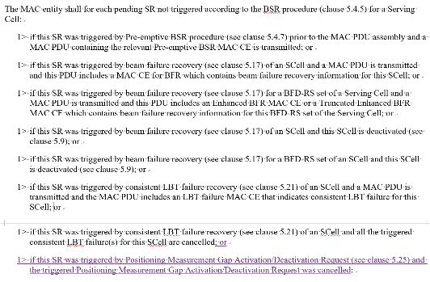
Question10: Do companies agree that SR triggered for posMG activation/deactivation request should be cancelled when the MAC CE is cancelled?
Company | Yes/No | Comments
Intel | Yes
CATT | Yes
Samsung | Yes
Huawei, HiSIlicon | Yes
vivo | Yes
Xiaomi | Yes
ZTE | Yes
NEC | Yes

In addition, R2-2207886 also proposed changes for RACH triggered for SR

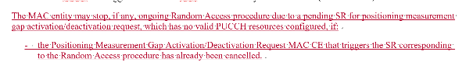

Question11: Do companies agree that RACH triggered for SR for posMG activation/deactivation request can be terminated when the Positioning Measurement Gap Activation/Deactivation MAC CE is cancelled?
Company | Yes/No | Comments
Intel | Yes
CATT | Yes
Samsung | Yes
Huawei, HiSIlicon | Yes
vivo | Yes
Xiaomi | Yes
ZTE | Yes
NEC | Yes

Conclusion
Based on the summary as above, we propose the following for discussion:
TBD

