3GPP TSG-RAN WG2 Meeting #118 Electronic R2-220xxxx
Online, May, 2022

Agenda item: 6.17.3
Source: Apple
Title: DRAFT Summary of [AT118-e][075][feMIMO] BFD Resource Handling (Apple)
WID/SID: NR_feMIMO-Core
Document for: Discussion and Decision

1 Introduction
This document reflects the content and outcome of the following email discussion:
- [AT118-e][075][feMIMO] BFD Resource Handling ()
Scope: Applies to MAC and RRC. Await info from RAN1. Take into account incoming LSes (or RAN1 decisions) when applicable/available. Address Open issues. Attempt to converge, Identify agreements and discussion points. The discussion should assume that R2 will follow R1 requests.
Intended outcome: Report for CB (maybe multiple revisions, as it may need to be updated multiple times dep on R1 progress).
Deadline: Set by rapporteur, for CB W2 Wednesday

2 Contact Points
Respondents to the email discussion are kindly asked to fill in the following table.
Company | Name | Email Address
LGE | Hanul Lee | hanul.lee@lge.com
Intel | Youn Heo | Youn.hyoung.heo@intel.com
vivo | Chenli | Chenli5g@vivo.com
Ericsson | Helka-Liina Määttänen | Helka-liina.maattanen@ericsson.com
Docomo | Masato Taniguchi | masato.taniguchi.mf@nttdocomo.com

3 Discussion

3.1 RAN1 LS (R2-2206359 / R1-2205168)
RAN1 provides the answers to the BFD resources handling in their LS as below:
Issue 7: Max values FFS in Rel-17 TS 38.331
Some maximum values are still missing from RRC configuration and RAN2 needs those for ASN.1 freezing.
Question 8: Please provide value for maxNrofCandidateBeams-r17 and maxNrofBFDResourcePerSet-r17.
Answer 8:
- maxNrofCandidateBeams-r17 is 64 per set per CC according to the latest LS reply
- Regarding maxNrofBFDResourcePerSet-r17, RAN1 has agreed to introduce MAC-CE for BFD-RS activation (in addition to RRC configuration):
  - If UE supports MAC-CE based BFD RS activation, maxNrofBFDResourcePerSet-r17 is 64
    - The intended operation is for MAC-CE to activate 1 or 2 out of the (maximum of) 64 configured BFD-RS resources from the set
  - Otherwise, maxNrofBFDResourcePerSet-r17 is 2
Issue 8: Possibilities for BFD-RS configuration
The existing RRC signalling for BFD-RS configuration allows the following possibilities:
- Alt.1: Two explicit BFD-RS sets: e.g. failureDetectionSet1-r17 and failureDetectionSet2-r17 with respective bfdRSSetId-r17
- Alt.2: Only one explicit BFD-RS set: e.g. failureDetectionSet1-r17 or failureDetectionSet2-r17 with bfdRSSetId-r17. It requires that the UE determines BFD-RS for the other BFD-RS set, e.g. according to TCI state(s) for PDCCH reception and the corresponding coreset pool index.
- Alt.3: BFD-RS without explicit BFD-RS set: e.g. failureDetectionSet1-r17 or failureDetectionSet2-r17 without bfdRSSetId-r17. It requires that the UE determines the BFD-RS set which each BFD-RS belongs to.
RAN2 thinks that at least Alt.1 is possible, but would like to understand whether RAN1 specifications support Alt.2 or Alt.3.
Question 9: Please confirm whether Alt.2 and Alt.3 are allowed configurations according to the existing RAN1 specifications, or whether RRC signalling for BFD-RS configuration should exclude Alt.2 and Alt.3.
Answer 9: Based on RAN1 agreements and Rel-17 RAN1 specification,
- Alt1 is allowed.
- Alt2 is excluded.
The current formulation of Alt3 in the LS is unclear. If the only difference between Alt1 and Alt3 is that Alt1 includes an explicit bfdRSSetId parameter in BeamFailureDetectionSet-r17 IE whereas Alt3 doesn’t, Alt3 is excluded.

Clarification on the BFD-RS sets configuration
According to the RAN1 answer 9 on Issue#8, only Alt 1 is allowed, so we can clarify in RRC that the two sets (i.e. failureDetectionSet1-r17 and failureDetectionSet2-r17) are always provided together;

Question 1: Do you agree with the following RRC design for the BFD-RS configuration?
- The two sets (i.e. failureDetectionSet1-r17 and failureDetectionSet2-r17) are always provided together.
Company | Agree or not? | Comments
OPPO | Agree
LGE | Agree
Intel | Agree
vivo | Agree
Ericsson | agree | But we should clarify do we really need the ID even that is RAN1 input. It does not seem to have any function. There is RILI109 about this: “bfdRSSetId-r17 is not used. Remove it.”
Docomo | Agree
ZTE | Agree

For the UE who supports the MAC CE based BFD-RS activation
According to the RAN1 answer 8 on Issue#7, UE will indicate the support of the MAC-CE based BFD-RS activation via its UE capability. It’s noted that RAN1 has decided to introduce the new UE capability for it.
For the UE who supports the MAC CE based BFD-RS activation, the BFD-RS configuration and activation mechanism can be described as below:
- NW can configure the candidate BFD-RS resources per set via RRC signaling;
  - The max number of the BFD-RS per set (i.e. maxNrofBFDResourcePerSet-r17) is 64;
- The new MAC CE is introduced to indicate the actual used BFD-RS resources per set
  - MAC-CE to activate 1 or 2 out of the (maximum of) 64 configured BFD-RS resources from the set.

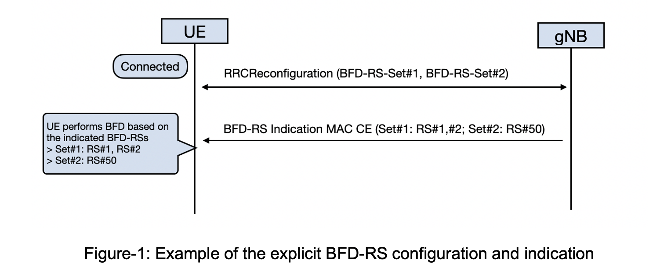

Question 2: Do you agree with the above BFD-RS configuration and activation mechanism if UE supports it?
Company | Agree or not? | Comments
OPPO | Agree
LGE | Agree | Regarding the time gap between the configuration of BFD-RS sets and the reception of the MAC CE, it should be discussed whether UE considers as no activated BFD-RS as in legacy (i.e., the UE performs beam monitoring based on the activated TCI-State for PDCCH) or UE does not perform beam monitoring.
Intel | Agree
vivo | Agree
Ericsson | agree | Agree also with LGE comment
Docomo | Agree
ZTE | Agree

Question 3: For RRC configuration, do you agree to set the max number of the candidate BFD-RS per set (i.e. maxNrofBFDResourcePerSet-r17) to 64?
maxNrofBFDResourcePerSet-r17 INTEGER ::= 64

Company | Agree or not? | Comments
OPPO | Agree
LGE | Agree
Intel | Agree
vivo | Agree
Ericsson | Agree | If Ran2 specifies the Mac CE as well
Docomo | Agree
ZTE | Agree

For the MAC CE design, according to RAN1 LS, we can assume the MAC CE design according to the following principles:
- The MAC CE is designed in the per CC per BWP granularity;
- The MAC CE always includes the full information of the two sets;
- The MAC CE includes 1 or 2 BFD-RS resources out of the configured BFD-RS resources from the set;
- UE deactivates all the previous activated BFD-RS upon receiving the new MAC CE for the same BWP and serving cell.

Question 4: For MAC CE design, do you agree with above principles for the BFD-RS indication MAC CE design?
Company | Agree or not? | Comments
OPPO | Fine with 1) and 3) are fine  Not sure about 2)  No for 4) | So far such MAC CE is designed with A/D bits. there is some argument on whether explicit activation and implicit deactivation can be done for SP SRS resource for antenna switch but RAN2 agreed not to pursue that way
LGE | Agree
Intel | Agree
Vivo | Agree
Docomo | Agree
Zte | See comments | - As (Enhanced) BFR MAC CE, we think the MAC CE shall be designed per CG not per CC/per BWP.  - Not sure, what does ‘full information’ mean here.  - Agree  - we think the beam failure is occurred per BFD RS Set not per CC/BWP, we think in this part, UE deactivates all the previous activated activated BFD RS upon receiving the new MAC CE for the same BFD RS Set of the same CC/BWP.

Figure-2 is provided as the format of the BFD-RS indication MAC CE for discussion.
- NOTE: If NW only provides one BFD-RS for a set, the V-bit is set to 0 for the second BFD-RS ID indication for this set.
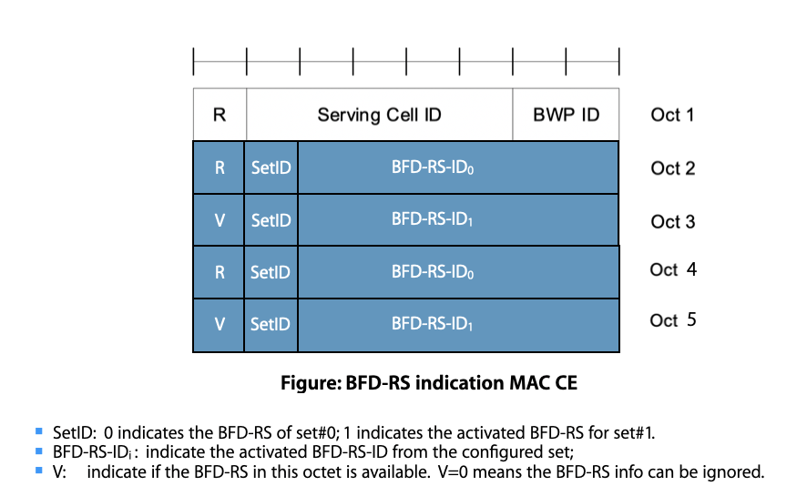
Figure-2: The BFD-RS indication MAC CE

Question 5: For MAC CE design, do you agree with format of the BFD-RS indication MAC CE as indicated in Figure-2?
Company | Agree or not? | Comments
OPPO | No | The detail format is also related to one issue whether BFD resource of both sets will be always in the same MAC CE. If yes the setID could be saved since the order can be used to implicit indicate the setID.
LGE | Agree | In our understanding, V field is always set 1 when both BFD-RS set#0 and #1 is configured, and V field is set 0 when BFD-RS set#0 is configured and BFD-RS set#1 is not configured.
Intel | Agree | We think that it doesn’t need to activate both sets simultaneously.
vivo | Agree
ZTE | See comments | We think there is a bit needed for indicating whether the second set for a serving cell/BWP is present in the MAC CE.

3.3 For the UE who doesnot support the MAC CE based BFD-RS activation
For the UE who doesnot support the MAC CE based BFD-RS activation, NW only configures and activates the BFD-RS resources per set by RRC configuration. NW can configure up to 2 BFD-RS resources per set via RRC configuration based on UE capability.

Question 5: For RRC configuration, which way do you prefer to describe the configuration restriction on the max BFD-RS resources per set for the UE who doesnot support the MAC CE based activation?
- Option 1: describe the restriction in the UE capability part (in 38.306)
- Option 2: describe the restriction in the field description of the set configuration , for example:
failureDetectionSet1, failureDetectionSet2
Configures parameters for beamfailure detection towards beam failure detection resources configured in the set. If additionalPCIList is configured for the serving cell, each RS in one set can be associted only to one PCI.
NW doesnot configure more than 2 RS in one set for the UE who can not support the MAC CE based BFD-RS activation.

Company | preference? | Comments
OPPO |  | We prefer to define one scheme. If RAN2 agree to introduce MAC CE, RRC only solution can be saved.
LGE | Option 2 | Option 2 is preferred as it is more familiar to specify in RRC.
Intel | Option 2 | It should be described in RRC field description.
vivo | Option 2
Ericsson |  | Same view as Oppo. Is there optional capability only for the MAC CE based operation?
Docomo | Option 2 | The description is more about configuration rather than capability.
ZTE | Option 2 | Option 2 is straight forward.

3.3 Other issues
Company | Comments
Ericsson | There is RILI109 about this: “bfdRSSetId-r17 is not used. Remove it.” We should clarify do we really need the ID even that is RAN1 input. It does not seem to have any function.

4 Conclusion
TBD.

