3GPP TSG-RAN WG2 Meeting #118 Electronic R2-220xxxx
Online, May, 2022

Agenda item: 5.1.4.1.2
Source: Apple
Title: DRAFT Summary of [AT118-e][018][NR1516] RRM and measurements (Apple)
WID/SID: NR_newRAT-Core
Document for: Discussion and Decision

1 Introduction
This document reflects the content and outcome of the following email discussion:
- [AT118-e][018][NR1516] RRM and measurements (Apple)
Scope: Treat R2-2204483, R2-2205678, R2-2206093, R2-2205294, R2-2205295, R2-2205296, R2-2205297, R2-2205213, R2-2205214, R2-2204611, R2-2204612, R2-2204613
Ph1 Determine agreeable parts, Ph2 for agreeable parts agree CRs (offline agreement, CB online only if necessary).
Intended outcome: Report, Agreed CRs
Deadline: Schedule 1

NOTE: Discussions with Deadline Schedule 1:
A first round with Deadline for comments W1 Thursd May 12th 1200 UTC to settle scope what is agreeable etc
A Final round with Final deadline W2 Wednesd May 18th 1200 UTC to settle details / agree CRs etc.
Additional deadlines check points etc if needed are defined by the Rapporteur of each discussion respectively. In case some parts of an email discussion need more time, doesn’t converge, need on-line treatment, then please contact the chair.

The discussion covers the following documents from AI 5.1.4.1.2 RRM and Measurements.

2 Contact Points
Respondents to the email discussion are kindly asked to fill in the following table.
Company | Name | Email Address
Huawei, HiSilicon | Lili Zheng | zhenglili4@huawei.com
Apple | Fangli XU | fangli_xu@apple.com
Xiaomi | Xing Yang | Yangxing1@xiaomi.com
ZTE | LiuJing | liu.jing30@zte.com.cn
Nokia |  | amaanat.ali@nokia.com
Samsung | Sangyeob Jung | sy0123.jung@samsung.com
Qualcomm Inc. | Mouaffac | mambriss@qti.qualcomm.com
vivo | Qian Zheng | zhengqian@vivo.com
OPPO | Haitao Li | lihaitao@oppo.com
MediaTek | Felix Tsai | chun-fan.tsai@mediatek.com
LGE | SangWon Kim | sangwon7.kim@lge.com
CATT | Shijie | shijie@catt.cn

3 Discussion

3.1 L3 Filter
L3 filter
R2-2204483 Reply LS to RAN2 on L3 filter configuration (R4-2207041; contact: Apple) RAN4 LS in Rel-15 NR_newRAT-Core To:RAN2
R2-2205678 Clarification on L3 filtering configuration (filterCoefficient) Apple, Ericsson CR Rel-16 38.331 16.8.0 3111 - F NR_newRAT-Core
R2-2205961 Clarification on L3 filtering configuration (filterCoefficient) Apple, Ericsson CR Rel-16 38.331 16.8.0 3139 - A NR_newRAT-Core Late
=> Revised in R2-2206093
R2-2206093 Clarification on L3 filtering configuration (filterCoefficient) Apple, Ericsson CR Rel-17 38.331 17.0.0 3139 1 A NR_newRAT-Core
R2-2205294 Discussion on L3 filtering Huawei, HiSilicon discussion Rel-15 NR_newRAT-Core
R2-2205295 Correction to L3 filtering (R15) Huawei, HiSilicon CR Rel-15 38.331 15.17.0 3063 - F NR_newRAT-Core
R2-2205296 Correction to L3 filtering (R16) Huawei, HiSilicon CR Rel-16 38.331 16.8.0 3064 - A NR_newRAT-Core
R2-2205297 Correction to L3 filtering (R17) Huawei, HiSilicon CR Rel-17 38.331 17.0.0 3065 - A NR_newRAT-Core

For the NR L3 filtering design is inherited from LTE. According to RRC spec description, for the filterCoefficient configuration, NW and UE operation should comply with the following principle:
- UE’s L3 filter input rate is (from L1) is UE implementation dependent (as described in NOTE3);
- NW provides the filterCoefficient configuration based on the assumed sample rate (according to the description marked in yellow as below);
- UE adapts its Layer 3 filter implementation and scales the filter coefficient based on the UE’s actual L1 input rate; (according to the description marked in green as below).
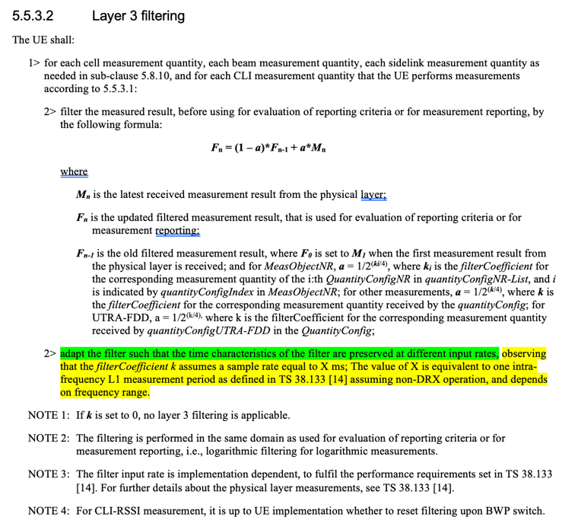

In RAN2#116e meeting, RAN2 discussed the sample rate X(ms) associated to the L3 filter configuration (i.e., filterCoefficient k) based on R2-2110022. And RAN2 reached the following common understandings during the offline discussion which were indicated in the LS to RAN4 (R2-2111590).
- The UE and gNB have the same understanding on the sample rate X.
- The sample rate X is not changed due to L1/L2 operation, e.g. SCell activation/deactivation, BWP switching, etc.
In RAN4 LS (R2-2204483/ R4-2207041), RAN4 provided the following feedback:
- According to current spec, the value of the sample rate X will be changed due to the L1/L2 operation, since the parameters which influence the value is changeable by the L1/L2 operation.
- The lower bound(200ms, 400ms) of intra-frequency measurement period, which is only related to FR is unchangeable by the L1/L2 operation.

Taking RAN4 feedback into account, in order to avoid the X value changeable due to L1/L2 operation, R2-2205678 and R2-2206093 propose to clarify that the sample rate X is set to the fix value as RAN4 indicated, i.e. 200ms for FR1 and 400ms for FR2.
Proposal: Change the value setting of the sample rate X for L3 filtering and set X value to 200ms for FR1 and 400ms for FR2.
TP:

But R2-2205294 - R2-2205297 propose to make the sample rate X changeable and use the configured value of the filter coefficient k without adaptation.
Proposal 1: When performing L3 filtering, the filter coefficient k uses the value received from the network, which is independent from the L1/L2 operation; the sample rate X follows the definition of 38.133, which is changeable by the L1/L2 operation.
TP:
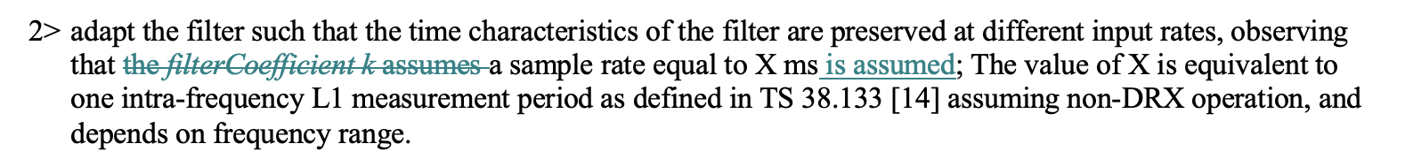

Question 1: Which option of the L3 filter clarification do you prefer?
- Option 1: Set the sample rate X for L3 filtering as the fix value (R2-2205678 and R2-2206093)
- Option 2: The sample rate X is changeable due to L1/L2 operation, and UE uses the configured value of the filter coefficient k without adaptation. (R2-2205294 - R2-2205297)
Company | Preferred Option? | Comments
Huawei, HiSilicon | Option 2 | Proponent of Option2.  According to RAN4 LS, the value of the sample rate X will be changed due to the L1/L2 operation, so Option 1 is NBC and not aligned with RAN4 spec.  We would like to further clarify whether filterCoefficient k or sample rate X is changeable:  In LTE, the sample rate is a fixed value, but the L1 measurement period is changeable, so it is reasonable to adapt the filter coefficient k considering the relationship between sample rate and L1 measurement period, as captured in 36.331:  In NR, the sample rate X equals to L1 measurement period and both of them are changeable, which means the sample rate has already been adapted to the L1 measurement period. In this case, the UE should directly use the filter coefficient k configured by the network and no further adaptation is needed. If needed, it is unclear which principle should the adaptation follow.  Based on the above, the filter coefficient k is the value received from the network, which is independent from the L1/L2 operation; the sample rate X follows the definition of 38.133, which is changeable by the L1/L2 operation.
  2> adapt the filter such that the time characteristics of the filter are preserved at different input rates, observing that the filterCoefficient k assumes a sample rate equal to 200 ms;
Apple | Option 1 | Option 1 is aligned with the RAN2 common understanding, i.e., UE and NW should hav ehte same understanding on the sample rate X for configuration.  But Option 2 is not aligned with it.  < from RAN2#115e meeting chairman notes>  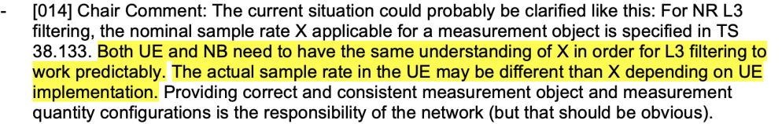  <RAN2 common understanding in RAN2#116e is reflected in the LS to RAN4 - R2-2111590>  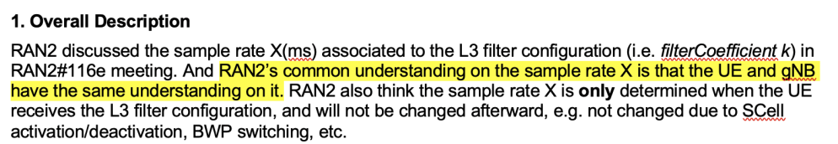
Xiaomi | Option 2 | Option1 is not aligned with RAN4 LS.
ZTE | See comments | Option 1 allows the network to refine the K configuration if the network wants. But it may have NBC problem as HW pointed out.  Option 2 disallows the network to refine the K configuration because L1/L2 operation occurs more frequent than RRC reconfiguration.  However, due to lack of simulation results or test results, it is unclear about significance of refining the k value in real deployment, and how much difference in performance between Option 1 and Option 2?  We would like hear more views from companies, right now, either Option 1 or Option 2 is ok for us.
Nokia | See comments | In our view the current specification is correct and no changes are needed. In Nokia’s understanding the following text on adaptation of the filter needs to be kept in TS38.331: "adapt the filter such that the time characteristics of the filter are preserved at different input rates, observing that the filter Coefficient k assumes a sample rate equal to X ms; The value of X is equivalent to one intra-frequency L1 measurement period as defined in TS 38.133 [14] assuming non-DRX operation, and depends on frequency range."  - In order for the UE to meet all the UE RRM requirements in TS38.133 UE typically needs to have higher sampling rate than indicated by the L1 measurement period.  - The filter parameter k is indicated for the L1 measurement period and when UE uses higher sampling rate, the UE needs to adjust the actual filter coefficient to match with the actual sampling rate while keeping the filter effect and length in time unchanged compared to the k valued signalled by the network assuming the L1 measurement period.  - RAN4 has often assumed 50 ms sampling interval in its intra-frequency neighbour cell measurement related test cases when the intra-frequency L1 measurement period has been 200 ms in order to have enough oversampling for each measurement period and enable sliding window with much smaller step than 200 ms (i.e., 50 ms in this case).  If at all anything needs to be fixed or aligned to the RAN4 LS input we suggest to either introduce a NOTE or just extend the current  Option 1: Add a note  Option 2: Extend current description  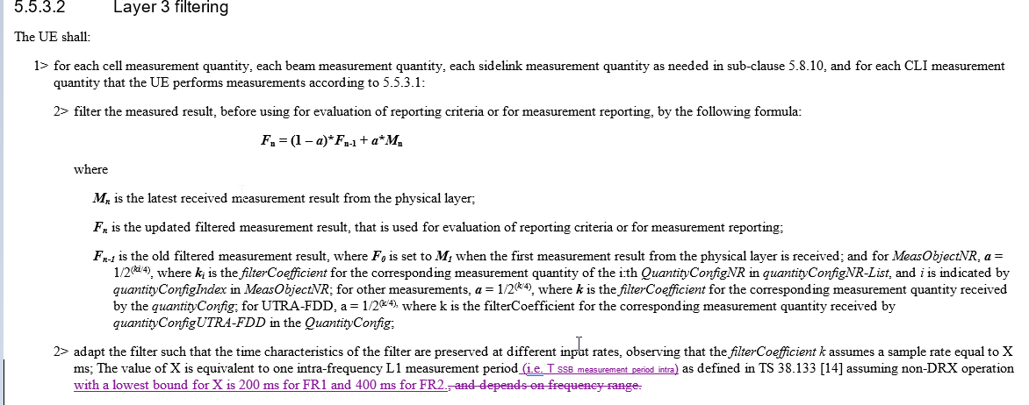
Samsung | Option 2 | We understand that Option 1 is not entirely aligned with current RAN4 specification i.e. sample rate X can be changed due to the L1/L2 operation.  Simplest way seems to keep RAN4 specification reference as is in our specification and the UE just applies the configured filter coefficient without adaptation.
Qualcomm Inc | Option-2 | Option-2 is aligned with RAN4 requirement.  In addition, adjusting a parameter provided by the network (in this case it is the filter coefficient) doesn’t make sense as it makes the configuration of this parameter obsolete.
Ericsson | Option-1 | With the option-2, the issue of ambiguity between the network and the UE remains as the value of ‘X’ is dependent on the L1/L2 operation as indicated in the RAN4 LS.
vivo | Option-1 with comments | Option-1 is preferred because we think the UE should be allowed to adapt the filter as legacy and the ambiguity between the UE and the NW needs to be resolved.  Moreover, we believe that Option1 is aligned with RAN4 understanding according to RAN4 LS.To address the concern from above companies , we suggest some rewording based on TP of Option-1. For example, see in yellow:  2> adapt the filter such that the time characteristics of the filter are preserved at different input rates, observing that the filterCoefficient k assumes a sample rate equal to X ms; The value of X is defined with the lower bound of 200ms for FR1 and 400ms for FR2.
OPPO | Option 2 | We also understand option 1 is not aligned with RAN4 specification as the sample rate X will change due to L1/L2 operation.
MediaTek | Option 1 or None | RAN4 LS simply clarify the define the L1 measurement period may be changed due to L1/L2 operation, it does not really say we should use option 2. We understand the L3 filter coefficient configuration is inherit from LTE and the intention is to follow same principle as in LTE. So, option 1 is more aligned with the original intention.  On the other hand, we also don’t know the real difference between option 1, 2 and do nothing. Considering the uncertainty of measurement result, this part is basically not testable. UE implementation will use higher sampling rate than the RAN4 defined measurement period ant take the configured filter coefficient into account. So, no change at all (i.e. leave to UE implementation) is also fine to us.
LGE | Option 2 | Option 1 is not aligned with RAN4 requirement.
CATT | Option 2 | Based on the LS, it can be seen that sample rate X can be changed due to the L1/L2 operation. But for filter coefficient, we don’t see it needs to be adaptive from the LS, the simple way is to apply the configured filter coefficient to avoid the different understanding on the sample rate X between NW and UE, which will lead to the different result of the adapted filter coefficient.

Question 2: Which release of the spec do you prefer the clarification to start with, i.e. Rel-15 or Rel-16?
Company | Release? | Comments
Huawei, HiSilicon | R15 | Note that the changes in R2-2205295 (and accompanying shadow CRs) do not change the logic of current text, and bring no backward compatibility issues.
Apple | Rel-15
Xiaomi | R15
Nokia | Rel-15, but | We would request companies to accept our compromise text above which is fully backward compatible and does not remove any existing text from the specifications adversely impacting understanding.
Samsung | See comments | If we go for Option 1, we think it should be from Rel-16.  If we go for Option 2, we think that there seems no functional difference from both UE side and NW side. If it is the correct understanding, then it seems OK to have the clarification from Rel-15.
Qualcomm Inc | Rel-15
Ericsson | Rel-15 | It is good to clarify this issue for Rel-15 UEs as well.
vivo | Rel-15
OPPO | Rel-15
LGE | Rel-15
CATT | Rel-15

Summary:
4/13 companies prefer Option 1, because the L3 filter coefficient configuration is inherited from LTE, and option 1 is aligned with the original principle and aligned with the previous RAN2 common understanding.

7/13 companies prefer Option 2, since most companies think Option 2 is aligned with current situation according to RAN4 specification.

In addition, 1 company is fine with either option 1 or option 2, and 2 companies think we can keep the current spec as it is since there is no test case for it.

Since company’s views are diverse on the spec change, from rapporteur point of view, since there is no test case for it, and both options propose not to perform the adaptation of the filterCoefficient k after the configuration, it is proposed to capture in the chairman notes that the L3 filter configuration (i.e. filterCoefficient k) is not adapted after the configuration, and no spec change is needed.

Proposal 1: Capture in chairman notes that the L3 filter configuration (i.e. filterCoefficient k) is not adapted after the configuration, and no spec change is need.

3.2 Correction on quantity configuration (R2-2205313/14)
R2-2205313 Correction on quantity configuration Xiaomi CR Rel-15 38.331 15.17.0 3067 - F NR_newRAT-Core
R2-2205314 Correction on quantity configuration Xiaomi CR Rel-16 38.331 16.8.0 3068 - A NR_newRAT-Core

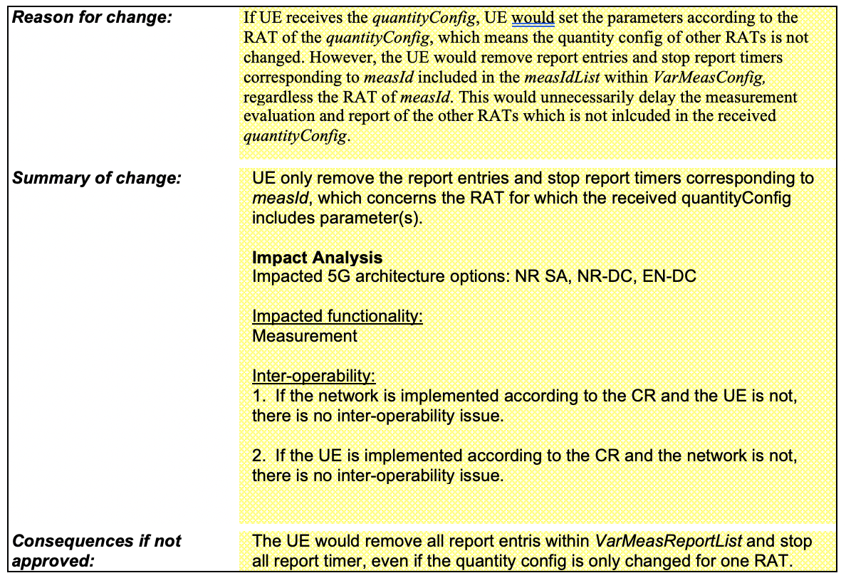

Question 3: Do you agree with the CR?
Company | Agree or not? | Comments
Huawei, HiSilicon | No | The logic inherits from LTE. The same proposal was discussed in R2-090471 and was rejected.  R2-090471: Correction on Quantity Configuration LG Electronics Inc. CR 36.331 F Disc  Proposal 1:  - NTT DCM indicates that we agreed yesterday that the quanity config should always be present. This is covered in the NTT DCM CR so no need for this.  => Noted  Proposal 2:  => Noted (already covered by NTT DCM CR)  Proposal 3:  - Samsung indicates this was discussed when this was introduced. Network can configure all RAT’s initially and then there is no problem.  => Not needed  Proposal 4:  - Nokia thinks it is a bit more clearer.  => Proposal 4 will be included by ASN.1 rapporteur.
Apple | No | This is a change of UE behaviour. We dont see a strong reason for that.
Xiaomi | Yes | The change is more aligned with the logic of the delta configuration.  Thanks HW for the information. Seems the assumption is NW has to provide all RAT’s quantity configuration in LTE. We can check whether it’s still NW vendor’s common understanding in NR.
ZTE | No | This is optimization, not correction.  Since it is aligned with LTE and the change itself may cause NBC problem. We think the CR is not needed.
Nokia | No | Exactly this is not essential correction agree with the companies saying No.
Samsung | No | It has been from LTE so we do not see any necessity on this.
Ericsson | No | The filtering parameters are not changed dynamically for UEs and even if they are changed dynamically, it is not a frequent operation that impacts the overall network performance. The current changes reduce the measurement report delay in very corner case scenarios and therefore, we believe these changes are not a necessary correction.
vivo | No | No problem is foreseen since LTE.
OPPO | No | Agree that this is not essential correction.
MediaTek | No | This is not a correction and is NBC.
LGE | Yes | The problem is very clear. When NW updates the quantityConfig only for EUTRA, UE removes the measurement reporting entry even for NR. Though the quantity configuration is not updated frequently, it can contribute to the mobility failure by delaying the measurement reporting. This should be fixed at least from NR.
CATT | No | No need to further optimization.

Summary:

10/12 companies say No with the following two reasons:
- The logic is inherited from LTE and no problem is foreseen;
- The issue was discussed before but not agreed, since network can configure all RAT’s initially and then there is no problem.
Therefore, R2-2205313 and R2-2205314 are not pursued.

Proposal 2: The CR R2-2205313 and R2-2205314 are not pursued.

3.3. Corrections on T321&T322 timer start (R2-2204611/12/13)
R2-2204611 38331CR Corrections on T321 and T322 timer start-R15 OPPO CR Rel-15 38.331 15.17.0 2981 - F NR_newRAT-Core
R2-2204612 38331CR Corrections on T321 and T322 timer start-R16 OPPO CR Rel-16 38.331 16.8.0 2982 - A NR_newRAT-Core
R2-2204613 38331CR Corrections on T321 and T322 timer start-R17 OPPO CR Rel-17 38.331 17.0.0 2983 - A NR_newRAT-Core

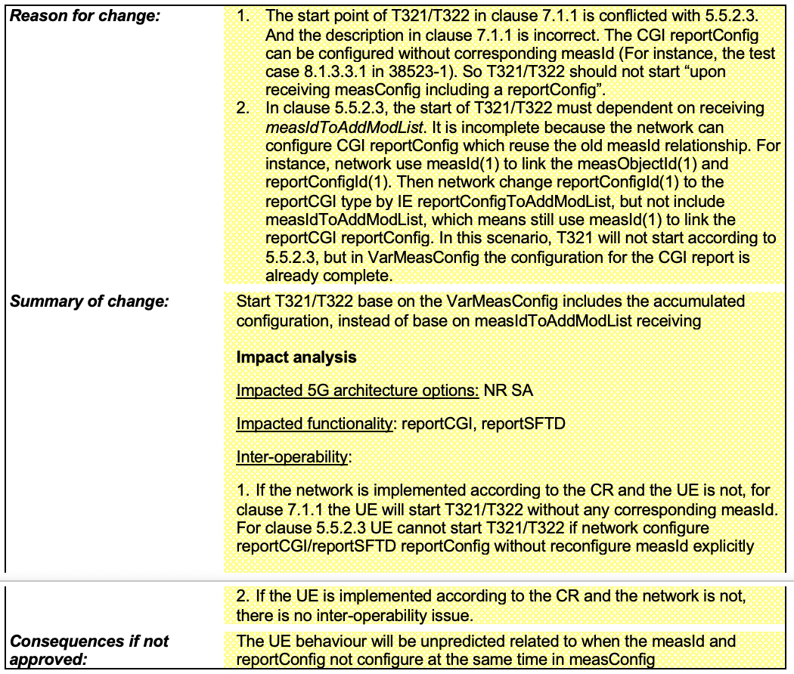

Question 4: Do you agree with the CR?
Company | Agree or not? | Comments
Apple | No | The change looks like a cleanup. The purpose is already understandable from the original text, even though it is not optimum.
Xiaomi |  | Depends on whether NW would configure the measurement in such way, i.e. change report config without meas id change. Seems to be a corner case. We can check NW vendor’s understanding.
ZTE | No | The following sentence in the cover page is misleading. CGI reporting must have corresponding measId.  “The CGI reportConfig can be configured without corresponding measId”  If I understand correctly, this CR focus on the scenario e.g. a specific reportConfig is reconfigured from “event/periodical” to “reportCGI”, and the associated measObject and measID remain the same, so measObject and measID are not included in RRCReconfiguration message.  Actually, we don’t think this is a typical use case, and we don’t know if all existing UEs support such reconfiguration?  From network perspective, it is safer to remove the old reconfigConfig and add a new one for reportCGI.  If above operation is allowed, then it should also be allowed in LTE, which means LTE spec also needs update...  So we think the CR is not needed. Regarding the “conflict” between 7.1.1 and 5.5.2.3, we think there is no room for misunderstanding in real implementation.
Nokia | No | We am also not sure of the entire background of this. Anyway, to us this CR is doubtful, if we move procedure between the sections - this could be OK, but we have doubts if other changes are feasible – the proponents claim reportCGI does not require measID configuration and such test cases have been defined in 3GPP. However, in NR RRC framework reportCGI is a part of report configuration which is configured via measurement config. So can measConfig be provided without measID? In timer description (7.1) the wording is weird (If measConfig become available). What this availability suddenly means?
Samsung | No | We understand that NW reconfigures measId when reportConfig is changed. Also, current procedure text has been specified from LTE so we do not see any problem.
Qualcomm Inc. | Not | It’s a common understanding that the timers should start upon MeasID change/add … if there is a real need to do a change, it may be modifying the timer start time definition in the table in section 7.1.1 to reflect the common understanding.
Ericsson | No | As the procedural text has been the same for LTE and no issue has been observed in the field, there is no need to change the procedural text in NR. Further, the cover page is confusing as pointed out by ZTE
vivo | No | It’s up to NW implementation to avoid the potential issue, e.g., always configure measId when CGI reportConfig is configured.
OPPO | Yes | Proponent.
MediaTek | No | We think that the scenario (changing report type on the fly without adding new measurement ID) is not common in real NW implementation. We think the NW should remove the old report type and adding a new measurement ID to avoid potential IOT issue.
Huawei, HiSilicon | No | From our perspective, the sensible implementation is to configure a measId together with a reportConfig for CGI reporting.
LGE | No | We prefer to leave it up to NW implementation, e.g., always configure measId when CGI reportConfig is configured.
CATT | No | It can be avoided via NW implementation.

Summary:

11/13 companies say No with the following two reasons:
- The logic is inherited from LTE and no problem is foreseen;
- NW will reconfigure measId when reportConfig is changed, and the problematic scenario as described in the CR can be avoided by NW implementation.
Therefore, R2-2205313 and R2-2205314 are not pursued.

Proposal 3: The CR R2-2204611, R2-2204612 and R2-2204613 are not pursued.

4 Conclusion
Based on the above discussions, the following proposals are made:

Proposal 1: Capture in chairman notes that the L3 filter configuration (i.e. filterCoefficient k) is not adapted after the configuration, and no spec change is need.

Proposal 2: The CR R2-2205313 and R2-2205314 are not pursued.

Proposal 3: The CR R2-2204611, R2-2204612 and R2-2204613 are not pursued.

