3GPP TSG RAN WG2 Meeting#117-e R2-22xxxxx
Electronic Meeting, 21 February 2022 - 03 March 2022

Agenda item: 8.11.2.3
Source: Lenovo, Motorola Mobility
Title: Report of [Pre117-e][608][POS] Open issues on on-demand PRS
Document for: Discussion and Decision

Introduction
This pre-meeting report collects companies’ inputs and provides a summary of proposals to address the remaining open-issues for the on-demand PRS feature.

- [Pre117-e][608][POS] Open issues on on-demand PRS (Lenovo)
This offline discussion will report the following:
- Proposals related to Stage 2 and 3 running CRs
- Proposals addressing the remaining issues identified by the open issue list.

As per the Chair’s guidance the following discussion timeline is noted:
- Start of Pre-discussions that collects structured company input:-
  - Start Date: 9th February 2022

The Rapporteur would like to divide this Pre-meeting discussion into 2 phases for easier collection, review and update of proposals:
- Phase 1-Initial collection of companies inputs/views (Pre-meeting discussion Stop):
  - Phase 1 deadline: 14th February 2022, 23:00 UTC
- Phase 2- Review and Feedback on Rapporteur’s Proposals:
  - Phase 2 deadline: 17th February 2022, 10:00 UTC

Contact Information
Company | Delegate Contact | E-mail
Huawei, HiSilicon | Yinghao Guo | yinghaoguo@huawei.com
Xiaomi | Xiaolong Li | lixiaolong1@xiaomi.com
Qualcomm | Sven Fischer | sfischer@qti.qualcomm.com
CATT | Jianxiang Li | lijianxiang@catt.cn
Apple | Sasha Sirotkin | ssirotkin@apple.com
ZTE | Yu Pan | pan.yu24@zte.com.cn

Background
During the RAN2#116bis-e Post-meeting discussion in [1, R2-2202005], the following list of open issues were identified for the completion of the on-demand PRS feature (the Rapporteur has also enumerated the open issues with the corresponding question(s) for easier mapping to the relevant Sections of this Pre-meeting discussion):
Topic | Open issues  Note: Open Issues should be defined for aspects that need to be closed, important to make already agreed functionality work in a reasonable way. Not yet agreed optimizations that may not be needed shall not be listed as Open Issues. | Related to the completion of WI?  The topic has to be removed from Rel-17 scope if the corresponding open issues cannot be resolved. | Remark | Open Issue# - Associated Question
Stage 2 | Stage 2 text | ? | Status: draft in stage 2, check the status of stage 2 email discussion 116bis-629 | 1 – Q1
Stage 3 | Trigger criterion/pre-condition for UE initiated On-Demand PRS | Yes | Status: check the status of LPP email discussion 116bis-628  RAN2#116bis:  If the LMF indicates predefined configurations, the UE can request them via LPP RequestAssistanceData. | 2 – Q2, Q3
 | The content of On-Demand PRS request, e.g. explicit indication, parameter/value;  FFS: whether UE can request only the explicit parameters that NW indicates and their value range is within the value range that NW supports. | Yes | Status: check the status of LPP email discussion 116bis-628  RAN2#116bis:  LPP signaling supports index-based and explicit request of DL-PRS parameters from the UE. The UE is not required to implement requesting explicit parameters and the LMF is not required to grant them if the UE does request. | 3 – Q4, Q5, Q6, Q7
 | PosSI as response for On-Demand PRS request | Yes | Status: discussion see R2-2200047  Suggest to approve the proposal 6 based on majority;  14 companies have responded. It is clear majority (13 Vs 1) that For On-Demand PRS, posSI cannot be the response for On-Demand PRS request .  Proposal 6 For On-Demand PRS, posSI cannot be the response for On-Demand PRS request. | 4 – Q8
 | Content of MO-LR, e.g. NR ECID | Yes | Status: discussion see R2-2200047  Suggest to approve the proposal 4 based on majority;  14 companies have responded. Only two companies support that proactive signaling to provide NR ECID measurements in MO-LR message while requesting for DL-PRS AD (as in legacy Rel-16 without on demand PRS) is supported.  Proposal 4 UE does not need to include NR ECID (RRM measurements) in MO-LR message while requesting for DL-PRS AD . | 5 – Q9
 | RAN1 parameters on On-Demand PRS  FFS on the response of UE initiated on-demand PRS  FFS on the configuration of configured available PRS, i.e., how much set of contribution can be provided, what are included within the pre-configured available PRS. | Yes | Status: check the status of LPP email discussion 116bis-628 | 6 – Q10, Q11, Q12, Q13, Q14, Q15
 | We have not discussed if UE should provide the reason as why UE prefers to request a new PRS characteristics. A generic reason may help NW understand what is lacking. | No | Rapporteur considers this as optimization, we could have it only if there is consensus. | 3 (related to content of OD-PRS request) – Q7
UE capability | UE capability on On-Demand PRS  FFS on per positioning method | Yes | Status: check the status of LPP email discussion 116bis-628, and the status of RAN1 feature list;  RAN2#116bis:  Proposal 3.2.3-1: [Easy agreements] [10/10] For On-Demand PRS, introduce LPP capability on UE-initiated On-Demand PRS Request;  Should be decided in RAN2 although RAN1 mentioned it in their feature list R1-2200767  RAN1 has deleted 27-5-1 [UE-initiated] on-demand PRS from their list, and rely on RAN2 | 7 - Q16, Q17
NRPPa | NRPPa change | Yes | Status: RAN3 to decide; | Not treated, under RAN3 scope

This report will use the above remaining issues as baseline to gather companies’ views.

Open Issue#1: Stage 2 issues

Question 1
In order to stabilize the Stage 2 text on On-demand PRS, companies are kindly invited to review and provide any comments/feedback (if any) to the latest version of the running CR in [2, R2-2201815], which is based on the outcome of the [Post116bis-e][629][POS] running CR discussion and used as baseline for gathering companies’ views on this aspect.
Companies are encouraged to provide their feedback/comments on the latest version of the Stage 2 text of the TS38.305 running CR in [2, R2-2201815]:
Section | Company | Identified issues & Suggested Changes
7.x.1
7.x.2
Other Identified Changes

Rapporteur’s Summary:
[TBD]

Stage 3 Remaining Issues
This Section discusses the remaining identified Stage 3 open issues.

Open Issue#2: Trigger criterion/pre-condition for UE initiated On-Demand PRS
The trigger criterion for UE-initiated on-demand PRS was extensively discussed during the past meetings but not yet finalized. It has already been agreed during the RAN2#116bis-e meeting, that the UE may request for the indicated pre-defined PRS configurations from the LMF via the LPP RequestAssistanceData message. In addition, during the Post116-e email discussion [601][3, R2-2200047], the pre-requisite conditions for on-demand PRS request were also discussed.
On one hand, a blind request of the requested on-demand PRS parameters by the UE, may allow the network to efficiently meet the UE’s on-demand PRS request via the already agreed explicit request. From the UE perspective, this may seem more reasonable than the UE indicating its preferred pre-defined on-demand PRS configuration from the index of received pre-defined on-demand PRS configurations, which may or may not meets its positioning requirements. In this case, the network is not mandated to fulfil the UE’s on-demand PRS request as per the agreements made during the RAN2#115-e meeting.
However, the currently agreed network aware UE-initiated on-demand PRS request is firstly contingent on the LMF indication of the pre-defined on-demand PRS configurations. This may imply that if the LMF does not indicate any pre-defined configurations to the UE and the UE is capable of supporting the UE-initiated on-demand PRS feature then this may result in the UE never transmitting an on-demand PRS request in the first place, unless provided by the network. As discussed in the previous meeting and noted by the Chair, this may be resolved according to one of the following methods:
- Based on the network awareness of the UE supporting UE-initiated on-demand PRS (via capability signalling), such that the network may be first aware on whether to initially provide the pre-defined on-demand PRS configurations to the UE based on the capability signalling.
- The UE may indicate its need for requesting a set of pre-defined on-demand PRS configurations e.g., via LPP RequestAssistanceData.

Blind Request of UE-initiated on-demand PRS

Question 2
Companies are invited to provide their input on whether a blind UE-initiated on-demand PRS request should be supported. In addition, please also indicate if the LMF response to the blind request should be best effort, i.e., it is up to the LMF to respond to the UE’s on-demand PRS blind request.
Company | Yes/No | Comments
Huawei, HiSilicon | No | We need to first clarify that here the discussion is only for parameter-based PRS request. For configuredID-based PRS request, agreement has already been made that UE can only make the request after PRS request configuration has been delivered to the UE.  Then, for parameter-based PRS request, we think no blind request should be allowed that the UE should be allowed to make the request only after the PRS request configuration, same as configuration-based PRS request. The reason is that in order for the UE to make the request, the UE would need to perform some measurements on the PRS such that informed decisions can be made. SO anyway, the UE already has the AD when UE makes the request
Xiaomi | No | When network don’t support on-demand PRS, blind request don’t have any benefit and will lead additional positioning latency.
Qualcomm | Yes | The feature can be supported with the existing LPP transactions and produres and no changes are needed. The UE cannot make any PRS measurements if there is no PRS, and the UE is also not required to make PRS measurements without PRS assistance data.  Any LPP Request Assistance Data is usually a "blind" request.
CATT | No | Blind request should be avoided, since it is probably rejected by LMF.
Apple | No | What would be the point in that?
ZTE | Yes | For index based request we agree with HW. For parameter based, according to the agreement of last meeting: ‘The UE is not required to implement requesting explicit parameters and the LMF is not required to grant them if the UE does request.’ That means even if UE’s request is within NW’s capability, NW may also reject the request, so we think blind request is also feasible.

Rapporteur’s Summary:
[TBD]

Network-aware request of UE-initiated on-demand PRS

Question 3
Companies are invited to provide their input on whether the following pre-condition options may be supported for the LMF to provide/not provide an index of pre-defined on-demand PRS configurations to the UE:
- Option 1: The LMF is implicitly aware of UE-initiated on-demand PRS support via capability information signalling, e.g., using LPP ProvideCapabilityInformation.
- Option 2: UE explicitly indicates its need for on-demand PRS to the LMF, e.g., using LPP RequestAssistanceData
- Option 3: No extra/other pre-conditions are necessary for the LMF to provide pre-defined on-demand PRS configuration(s).

Company | Options 1/2/3 | Comments
Huawei, HiSilicon | 1 | There is no need for explicit request from the UE for the AD. If the UE does not want the configuration, the UE does not need to report the capability for on-demand PRS request in the first place, even if the UE may support on-demand PRS.  No strong view for Option2, we should not spend too much time on this anymore.
Xiaomi | 1
Qualcomm | 2 | Option 2 seems the only agreement we have so far and which is sufficient:  "UE-initiated on-demand PRS request is enabled by enhancing LPP RequestAssistanceData."
CATT | 1
Apple | 1
ZTE | 1 | Whether UE can send on-demand PRS request or not should be know by LMF

Rapporteur’s Summary:
[TBD]

Open Issue#3: On-demand PRS Request Content
Based on the previous RAN2#116bis-e meeting agreement, the following request options are supported:
- Explicit request of on-demand PRS parameters
- Index-based request of on-demand PRS parameters

In the case of the explicit on-demand PRS request, an open issue remains on whether the UE may freely request a specific set of explicit (individual) on-demand PRS parameters, as already provided by RAN1, e.g., PRS bandwidth, periodicity, etc. based on its own positioning requirements or whether the explicit request by the UE may only depend on the parameters provided by the network. It is assumed that the network will provide a list of supported parameters via separate prior signalling, e.g., an index of pre-defined on-demand PRS configurations. It also noteworthy to mention that the network may still attempt to fulfill the UE’s request in a best effort manner and in cases where the requested PRS parameter(s) and value ranges are not supported, may not fulfil the UE’s explicit on-demand PRS request at all.

Question 4
In the case of an explicit request of on-demand PRS parameters, companies are invited to provide their preference on the following options:
- Option 1: UE may request any of the explicit parameters from the RAN1 agreed parameter list.
- Option 2: UE may only explicitly request the parameters that were indicated by the network via prior signalling, e.g., based on an index of pre-defined PRS configurations.
- Option 3: Other, please specify

Company | Option 1/2/3 | Comments
Huawei, HiSIlicon |  | This question is duplicated with Question2 on blind request?
Xiaomi | 1 | Option 1 is more flexible, and there is no issue if LMF don’t support parameters requested by UE since the final decision is made by LMF and LMF can attempt to fulfill the UE’s request in a best effort way.
Qualcomm | 1 | What would be the purpose/use case for specifying the RAN1 parameter in LPP, but only a subset is allowed at the end?
CATT |  | See the comment of Question 2.
Apple | 3 | In general, we think only the index based request is needed. If we are to support explicit parameters request in the end, then there is no need to make this even more complex by introducing restrictions – that is, we do not support option 2.
ZTE | 1 | Whether UE can send on-demand PRS request or not should be know by LMF

Rapporteur’s Summary:
[TBD]

Question 5
Another related remaining open issue is to understand the types of supported value ranges associated to an explicit request of on-demand PRS parameters, which may or may not go beyond the value range supported by the network. From the Rapporteur perspective, it seems relatively straight-forward to re-use the value ranges of the PRS parameters supported in Rel-16.
In the case of an explicit UE request of on-demand PRS parameters, do companies confirm that the already defined value ranges in Rel-16 are applicable to the agreed RAN1 on-demand PRS parameters? If the answer is No, companies are encouraged specify in the comments, which on-demand PRS parameter(s) may require different value ranges.
Company | Yes/No | Comments
Huawei, HiSIlicon | Yes
Xiaomi | Yes
Qualcomm | Yes | This seems according to RAN1 parameter list.
CATT | Yes
Apple |  | If we are to support this in the end, then of course there is no need to define new value ranges.
ZTE | Yes | If UE requests explicit parameters based on R16 value range, then no available PRS configurations for parameter-based request is needed

Rapporteur’s Summary:
[TBD]

Question 6
Based on the latest version of the TS37.355 draft running-CR discussion under Clause 6.4.3 [4, R2-2201723] (See Figure 1), the index-based request may consist of the UE indicating its preferred pre-defined on-demand DL-PRS configuration(s) in decreasing order of appearance.
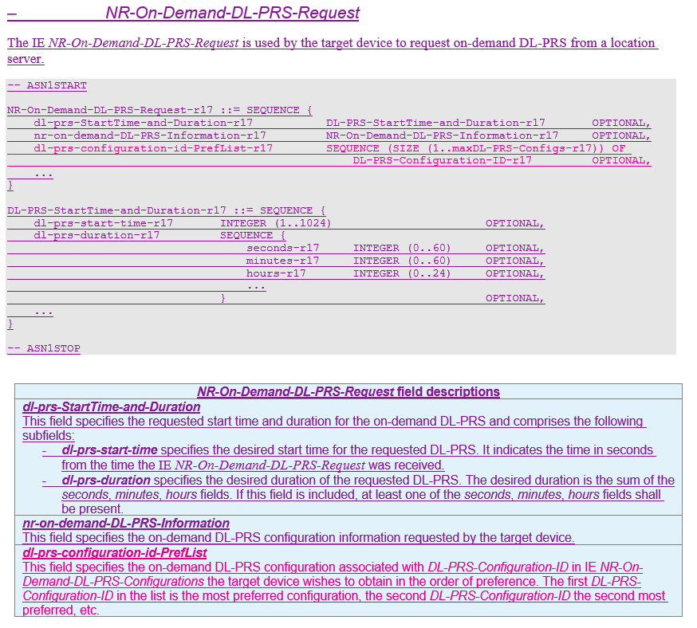
Figure 1: Extract of On-demand PRS Request from latest TS 37.355 Running CR [4]
In the case of an index-based on-demand PRS request, are companies in agreement that the UE may indicate its preferred on-demand PRS pre-defined configuration(s) via one or more PRS configuration IDs requested in decreasing order of preference (i.e., from most preferred to least preferred on-demand PRS configuration)?
Company | Yes/No | Comments
Huawei, HiSilicon | Yes
Xiaomi | Yes
Qualcomm | Yes | Even if a NW indicates multiple on-demand configurations, not all may be possible/available at the desired time.
CATT | No | We understand this is to avoid the issue that UE always request the best configuration, even a less better configuration can already satisfy the positioning QoS requirement.  But we think this is not an essential issue, even UE always request the best configuration, anyway LMF is aware of the positioning QoS, and it is LMF to make the final decision on whether to accept the request of UE.  Or if majority think this issue is essential, instead of the solution proposed in the running CR, we can add an restriction that UE always request the lowest configuration that can satisfy the positioning QoS requirement.
Apple | Yes
ZTE | Yes | It saves time since any one of the list can be indicated by LMF

Rapporteur’s Summary:
[TBD]

Question 7
Another issue noted in [1, R2-2202005] was the provision of a reason cause to the network as to why the UE would want to request a new on-demand PRS configuration. The Rapporteur’s view is that since the standard LPP procedure for the UE to request assistance data does not explicitly require such a reason cause, there is no substantial motivation to introduce it for the UE’s request for on-demand PRS. It has also been noted in [1, R2-2202005], that this issue may not be critical to the completion of the on-demand PRS feature. However, further company inputs are encouraged to determine the need for the UE to transmit a reason indication to the network as to why a UE prefers to request for a new on-demand PRS configuration (new PRS characteristics).
Do companies agree that an explicit UE reason may not be required to be signalled to the network when the UE requests an on-demand PRS configuration?
Company | Yes/No | Comments
Huawei, HiSilicon | No | There is no need for cause for on-demand PRS request
Xiaomi | Yes | The explicit UE reason is not needed, and the requested parameters can reflect the cause.
Qualcomm | Yes | There is no need for a cause for any assistance data request. Per definition/specification, the UE sends a LPP Request Assistance Data when the available assistance data are not sufficient.
CATT | No | Seems within SON/MDT scope, but not POS enhancement.
Apple | Yes | Note: looks like companies that answered “no” actually meant “yes”
ZTE | Yes | UE’s reason will not affect LMF’s decision when LMF configuring on-demand PRS response

Rapporteur’s Summary:
[TBD]

Open Issue#4: Response to On-demand PRS Request
During the Post116-e email discussion [3, R2-2200047], the issue related to the response signalling of a UE-initiated on-demand PRS response was discussed but not finalized. In addition, companies were of the view that since LPP RequestAssistanceData is initiated to request the preferred on-demand PRS configuration parameters, the appropriate network response via the LPP ProvideAssistanceData message is deemed necessary as a response to the on-demand PRS request. Furthermore, according to the Rapporteur’s understanding, the on-demand SIB/posSIB functionality discussed in [3, R2-2200047] is considered to be a separate aspect. Therefore based on the consensus in [3, R2-2200047], the following question is provided to re-check companies understanding on the type of response signalling to an on-demand PRS request:

Question 8
Do companies agree that for On-Demand PRS, the posSI message cannot be the response for On-Demand PRS request?
Company | Yes/No | Comments
Huawei, HiSilicon | posSIB cannot be the response | LPP response is needed after request.
Xiaomi | Yes | On-demand PRS configuration may be UE specific.
Qualcomm | Yes
CATT | No | Only LPP response is allowed for LPP request.
Apple | Yes
ZTE | Yes | On-demand PRS request is UE specific so it is hard to broadcast the response

Rapporteur’s Summary:
[TBD]

Open Issue#5: RRM measurements in MO-LR LCS message
An open issue, which was extensively discussed over the past meetings was the provision of RRM measurements to the network in order to aid the LMF in determining the appropriate DL-PRS configurations within the initial on-demand PRS configuration attempt via the MO-LR LCS message, which has been highlighted by a few companies to be beneficial for UE-initiated on-demand PRS. The RRM measurements, will enable the LMF to determine the rough coarse location of the UE in order to provision the optimal on-demand PRS configuration, e.g., the LMF may only configure TRPs within the vicinity of the UE’s rough location based on the RRM measurements.
On the other hand, many companies support the view that the RRM measurements may not have any specification impact since the LMF may utilize existing signalling mechanisms, e.g., NR-ECID-RequestLocationInformation IE to allow the UE to provide any available RRM measurements, which can be used to enhance the on-demand PRS configuration. The Rapporteur notes that this mechanism may already be supported for an ongoing LPP session based on the aforementioned request. The following question is provided to re-check companies understanding of transmitting RRM measurements as part of the MO-LR LCS message:

Question 9
Do companies agree on transmitting RRM Measurements as part of the MO-LR LCS message?
Company | Yes/No | Comments
Huawei, HiSIlicon | NO | MO-LR can send E-CID measurements as in legacy  Why are we discussing these issues at all?
Xiaomi |  | There is no need to introduce any optimization for LMF determining on-demand PRS configuration.
Qualcomm |  | No change compared to Rel-9 is needed. Any UE triggered LCS message can include up to 3 LPP PDUs.
CATT | No | Not clear what it is the issue, this already be supported in current specification, i.e., the MO-LR can include up to three LPP message, within which LPP ProvideLocationIInformation message can be included to indicate the E-CID measurements.
Apple | No | No new functionality is needed
ZTE | No | No additional auxiliary information (reason for request, ECID measurement, RRM measurement) to demonstrate necessity of on-demand PRS request is needed.

Rapporteur’s Summary:
[TBD]

Open Issue#6: On-demand PRS Configuration
According to the latest version of the TS37.355 draft running-CR discussion [4, R2-2201723], a number of FFS points were raised with regard to the content of (pre-defined) On-demand PRS configuration message provided by the LMF. The list of questions below aim to gather companies’ views on the following:
- Response of UE-initiated on-demand PRS request
- Content of the pre-defined on-demand PRS configuration, number of pre-defined configurations in a set, variable/fixed number of parameters within a set
- Configuration ID association

UE-initiated on-demand PRS response
The degree of network control over a UE-initiated on-demand PRS request has also been discussed over the past few meetings [3, R2-2200047] [5, R2-2111256]. The discussed options carried over from the previous RAN2#116bis-e meeting include the following [3, R2-2200047]:
- Option A: UE can only request on-demand PRS based on prior reception of on-demand PRS configuration
- Option B: Configuration of a prohibit timer
- Option C: Reattempt timer
- Option D: Stop or Error or Abort message indication from the LMF
- Option E: None

Option A represents the pre-condition, allowing the UE to only perform UE-initiated on-demand PRS requests based on prior reception of the sets of pre-defined on-demand PRS configurations. Options B and C represent timer-based solutions either to prevent the UE from transmitting subsequent requests or enable the UE to transmit an on-demand PRS request after a certain duration has elapsed. The timer configurations may also be signalled along with pre-defined on-demand PRS configurations to control the number on-demand PRS requests transmitted upon reception of the on-demand PRS configuration. In addition, the Rapporteur notes that one of the reasons that a UE may transmit subsequent on-demand PRS requests is if the received pre-defined list of on-demand PRS configurations do not meet the UE’s positioning requirements (as required by the internal LCS client). Furthermore, since the LMF may ignore the request as per the earlier RAN2#115-e agreements, this may result in the UE transmitting multiple requests in succession, provided that the requests are continually ignored by the network. If the request is rejected by the LMF, then Option D may be considered as a viable rejection response to UE’s on-demand PRS request.

Question 10
The aforementioned options are therefore consolidated as follows:
- Option 1: UE can only request on-demand PRS based on prior reception of on-demand PRS configuration
- Option 2: To limit the number of UE on-demand PRS requests after reception of an on-demand PRS configuration, a timer may be configured (e.g., prohibit timer, reattempt timer)
- Option 3: To reject a UE’s request for further on-demand PRS configurations, Stop/Error/Abort message indication from the LMF is signalled to the UE.
- Option 4: No mechanism to control the UE’s on-demand PRS request(s) needs to be specified in Rel-17.
- Option 5: No mechanism to reject a UE’s on-demand PRS request(s) or respond to a partially/completely unfulfilled request(s) needs to be specified in Rel-17.

Companies are encouraged to provide their preference on the above options. Note that since Options 1-3 are not mutually exclusive, companies may also indicate their support for more than one option accordingly.
Company | Option 1/2/3/4/5 | Comments
Huawei, HiSIlicon | Option3 | Is option1 duplicated with the discussion above?  Option3, on rejecting UE’s request, this is already supported by the current LPP running CR. The LMF can send on-demand-dl-prs-supportedButCurrentlyNotAvailableByServer to the UE  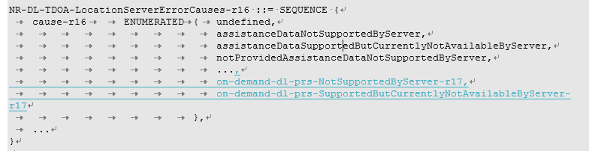
Xiaomi | Option 1 and  Option 3
Qualcomm | None | No new agreement is needed. The feature can be supported with the existing LPP transactions and procedures and the current set of agreements. E.g.,  - If the LMF indicates predefined configurations, the UE can request them via LPP RequestAssistanceData.  - LPP signalling supports index-based and explicit request of DL-PRS parameters from the UE.  -The UE is not required to implement requesting explicit parameters and the LMF is not required to grant them if the UE does request.  Therefore, the introduction of additional location server error causes is sufficient.
CATT | Option 2, but no strong view
Apple | Option 1 and 4
ZTE | Option 3 | Agree with HW

Rapporteur’s Summary:
[TBD]

Content of on-demand PRS configuration
The on-demand PRS configuration may consist of a set of on-demand PRS parameters agreed by RAN1. The following agreements were already made with respect to both LMF-initiated and UE-initiated on-demand PRS during RAN1#107-e [6, R1-2112792]:
Agreement
- From RAN1 perspective, for LMF-initiated request of on-demand DL PRS, the following group of on-demand DL PRS parameters is defined and signaled
  - per resource set per positioning frequency layer per FR
- DL PRS Periodicity
- DL PRS Resource Bandwidth
- DL PRS Resource Repetition Factor
- Number of DL PRS Resource Symbols per DL PRS Resource
- DL-PRS CombSizeN
Two options for indication of DL PRS QCL-Info, either
  - Option 1: per resource set per positioning frequency layer per FR
- LMF recommends a list of QCL sources
  - Option 2: per resource set per positioning frequency layer per FR
    - LMF requests to provide the QCL information in the assistance data in NRPPa
  - per FR
    - Number of DL PRS frequency layers
  - either per resource set per positioning frequency layer or per UE
    - Start/end time of DL PRS transmission
  - either per resource, or per resource set, or per UE
    - ON/OFF indicator (for LMF initiated request only)
Agreement
- From RAN1 perspective, for UE-initiated request of on-demand DL PRS, the following group of on-demand DL PRS parameters is defined and signalled
  - per positioning frequency layer per FR
- DL PRS Periodicity
- DL PRS Resource Bandwidth
- DL PRS Resource Repetition Factor
- Number of DL PRS Resource Symbols per DL PRS Resource
- DL-PRS CombSizeN
  - per FR
- Number of DL PRS frequency layers
  - per UE
- Start/end time of DL PRS transmission
Two options for indication of DL PRS QCL-Info, either
  - Option 1: per resource per resource set per positioning frequency layer per FR
    - UE recommends a list of QCL sources
  - Option 2: per resource set per positioning frequency layer per FR
UE requests to provide the QCL information in the assistance data

The number of on-demand PRS parameters in an on-demand PRS configuration can be summarized as follows:
Table 1: Summary of parameters contained within an on-demand PRS configuration
No. | On-demand PRS Parameter | Resource Granularity
1 | DL PRS Periodicity | per positioning frequency layer per FR
2 | DL PRS Resource Bandwidth | per positioning frequency layer per FR
3 | DL PRS Resource Repetition Factor | per positioning frequency layer per FR
4 | Number of DL PRS Resource Symbols per DL PRS Resource | per positioning frequency layer per FR
5 | DL-PRS CombSizeN | per positioning frequency layer per FR
6 | Number of DL PRS frequency layers | Per FR
7 | Start/end time of DL PRS transmission | Per UE
8 | DL PRS QCL-Info | per resource set per positioning frequency layer per FR
9 | ON/OFF indicator (LMF-initiated on-demand PRS only) | either per resource, or per resource set, or per UE

Question 11
The following question is intended to address the content of the on-demand PRS configuration and not any on-demand PRS request signalling.
Do companies agree that the content of a single (pre-defined) on-demand PRS configuration for:
- LMF-initiated on-demand PRS may comprise the PRS parameters No. 1-9 listed in Table 1 above;
- UE-initiated on-demand PRS may comprise the PRS parameters No. 1-8 listed in Table 1 above.
Company | Yes/No | Comments
Huawei, HiSilicon | No need for discussion in LMF-initaited in R2 | For UE-initiated on-demand PRS, the agreement has been quite clear and no need for discussion in R2
Xiaomi | Yes
Qualcomm | Yes | This should follow the RAN1 parameter list.
CATT | No need to discuss LMF initiated in RAN2 | Same view of HW.
Apple |  | If we are discussing the content of the pre-defined configuration, why do we need to differentiate between LMF-initiated and UE-initiated?
ZTE | Yes

Rapporteur’s Summary:
[TBD]

Question 12
The number of on-demand PRS parameters (pre-defined) on-demand PRS configuration may be fixed or variable, i.e. when the number is fixed, the LMF may decide to always signal the parameters listed in Table 1 as part of a (pre-defined) on-demand PRS configuration. When the number is variable, the LMF may decide to only signal a subset of the parameters in Table 1 and this subset number of parameters is up to the LMF implementation/network deployment.

Companies are invited to provide their views on the following options related to the number of on-demand PRS parameters that can be signalled within a single (pre-defined) on-demand PRS configuration?
- Option 1: The number of on-demand PRS parameters may be fixed to 9 parameters for LMF-initiated on-demand PRS and 8 parameters for UE-initiated on-demand PRS as indicated in Table 1.
- Option 2: The number of on-demand PRS parameters to be signalled is up to network implementation/deployment for both LMF-initiated and UE-initiated on-demand PRS.
- Option 3: Other, please specify alternative.

Company | Option 1/2/3 | Comments
Huawei, HiSIlicon | Option1 | No need for discussion about LMF-initiated PRS request in R2
Xiaomi | Option 1
Qualcomm | None | Why should the number of on-demand PRS parameters be specified? This number is nowhere used…? The number of parameters can always be extended after the ASN.1 ellipsis "…".
CATT | Option3 | We support that a single on-demand PRS configuration include a complete set of PRS configurations, including frequency layer/TRPs/PRS resource set/PRS resources, and naturally these 8 parameters can be implicitly included within the set of PRS configurations.
Apple |  | The question is not clear. Why are we discussing the number of parameters?
ZTE | Option 1

Rapporteur’s Summary:
[TBD]

Question 13
Another remaining open issue involves the number of on-demand PRS configurations that may be signalled to the UE as part of an index/set, which depends on the network deployment and possible UE capability (e.g., number of on-demands PRS configurations that may be stored by the UE (See Sec. 3.6, Q17)). An on-demand PRS index/set may comprise one or more on-demand PRS configurations, where each on-demand PRS configuration consists of the parameters listed in Table 1 together with an associated configuration ID. The number of on-demand PRS configurations within an index/set is yet to be finalized.

Companies are invited to provide their views on the following options related to the number of on-demand PRS configurations that may be signalled as part of an index/set?
- Option 1: The number of on-demand PRS configurations within an index may be fixed to a maximum value of N, where N is to be specified.
- Option 2: The number of on-demand PRS configurations within an index is up to network implementation.
- Option 3: Other, please specify

Company | Option 1/2/3 | Comments
Huawei, HiSilicon | Option1
Xiaomi | Option 1
Qualcomm | None | With the current agreements, there is only one configuration per index. I.e., we may have N pre-defined configurations, and each configuration is associated with an ID. Why should there be multiple pre-defined configurations "within an index"?
CATT | Option 1
Apple | None | Agree with QC, there is only one configuration per index.
ZTE | Option 1 | We understand option 1 like QC’s view. Is that a typo?

Rapporteur’s Summary:
[TBD]

Question 14
The definition of the PRS configuration ID was also identified as an open issue in the TS37.355 running CR [4, R2-2201723]. The function of such an ID may be to uniquely distinguish the multiple pre-defined configurations provided by the network. According to the latest version of the TS37.355 draft running-CR discussion [4, R2-2201723], the configuration ID is defined by an ID number and configuration name (See Figure 2). Although the need for a configuration name associated with the ID number is still to be determined.
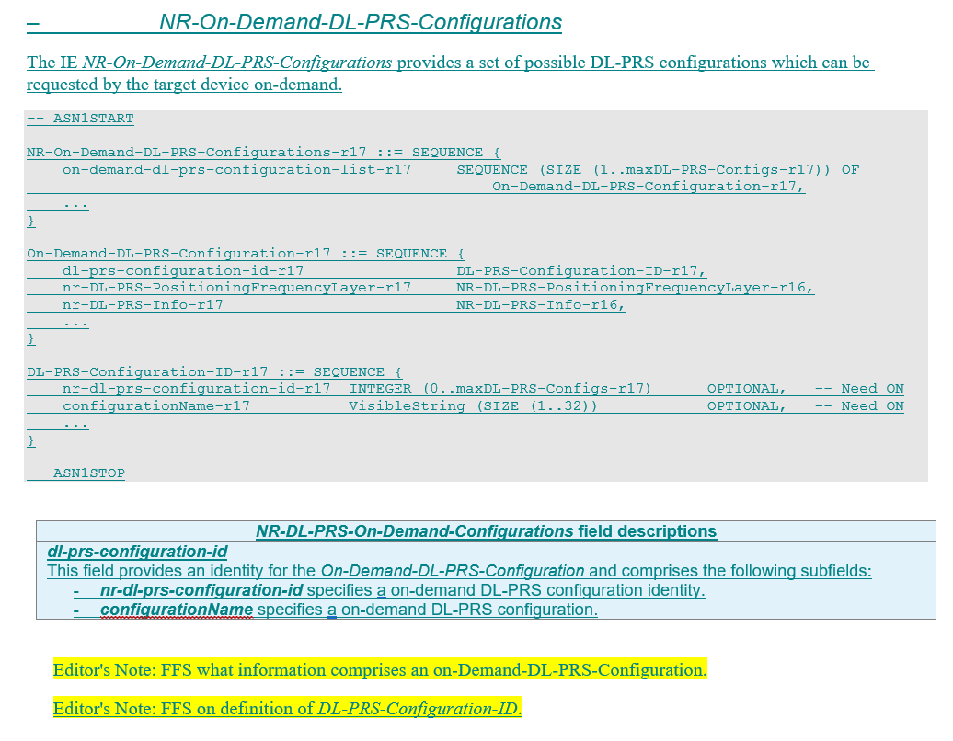
Figure 2: Extract of On-demand PRS Config. IE from latest TS 37.355 Running CR [4]
Do companies agree that the configuration ID includes an ID number and configuration name as illustrated in the extract from Figure 2?
Company | Yes/No | Comments
Huawei, HiSilicon | No | Not sure why configuration name is useful
Xiaomi | No | Configuration ID is sufficient.
Qualcomm | Yes | Configuration Name can disambiguate the ID (e.g., could be a PLMN ID, LMF ID, etc. as desired by a deployment). The UE may receive the pre-defined configurations from different sources/LMFs (LPP, posSIB, MO-LR).
CATT | No | ID is enough.
Apple | No | ID is sufficient
ZTE | No

Rapporteur’s Summary:
[TBD]

Question 15
Another issue relates to the provision of a single on-demand PRS configuration, in the case that multiple LPP ProvideAssistanceData messages have been received by the UE corresponding to different positioning methods, e.g., Multi-RTT, DL-TDOA, and DL-AoD. From the Rapporteur’s perspective, the provision of on-demand PRS assistance data per positioning is a natural extension to the UE’s request of on-demand PRS per positioning method (via RequestAssistanceData) as agreed upon in RAN2#116-e. An issue, however, could be related with any impacts on signalling overhead.
Do companies agree that the on-demand PRS configuration(s) can be provided to the UE on a per positioning method basis?
Company | Yes/No | Comments
Huawei, HiSIlicon | Yes | Since PRS configuration can be different for different positioning methods, on-demand PRS configuration can also be different for different positioning methods.
Xiaomi | Yes
Qualcomm | Yes | This follows general LPP logic.
CATT | Maybe | In general we are ok with implementation of the current running CR, but in case of hybrid positioning, further enhancement may be required to avoid repeated on-demand PRS configurations. And we will further discuss this issue in our tdoc.
Apple | Yes
ZTE | No | We think there is no issue if on-demand PRS configuration is provided commonly, and UE request uniquely for different positioning methods. It is somewhat like the mechanism of nr-DL-PRS-AssistanceData-r16 and nr-SelectedDL-PRS-IndexList-r16 in current spec

Rapporteur’s Summary:
[TBD]

Open Issue#7: UE-capability for on-demand PRS

Question 16
It has already been agreed during the Ran#116bis-e meeting that there is a need for a separate UE-initiated on-demand PRS capability. A follow-up open issue is to collect company views on whether the UE-initiated on-demand PRS may be requested per positioning method. Since the on-demand PRS is request is per positioning method (based on earlier RAN2#116-e agreement), it is of the Rapporteur’s view that the UE-initiated on-demand PRS Capability exchange between LMF and UE may also be similarly structured in terms of requested positioning method.
Do companies agree that the LMF may request UE-initiated on-demand PRS capability per positioning method, while the UE may similarly respond on its UE-initiated on-demand PRS capability per positioning method?
Company | Yes/No | Comments
Huawei, HiSIlicon | No | Not sure why a UE can request PRS for one positioning method but cannot request for another method.
Xiaomi | No strong view | Both On-demand PRS capability per positioning method or only reporting its on-demand PRS regardless of positioning method are OK.
Qualcomm | Yes | This follows general LPP logic. The LMF requests the capability based on what the LMF needs in a particular situation and depends on which positioning methods a LMF supports.
CATT | Yes | Yes that the on-demand PRS capability is signaled per positioning method.
Apple | Yes
ZTE | No | Agree with HW

Rapporteur’s Summary:
[TBD]

Question 17
In addition, it has already been agreed that the UE may receive an index with multiple pre-defined on-demand PRS configurations, where the UE may store these configurations until it is overridden by a new index containing a pre-defined on-demand PRS configurations. This may affect the number of pre-defined on-demand PRS configurations to be stored in the UE depending on the UE’s capabilities, which may vary accordingly.
Companies are invited to provide their views on the following UE behaviour related to the reception of the on-demand PRS configuration index and whether it has an impact on the UE-initiated on-demand PRS capability:
- The UE may store a number of pre-defined on-demand PRS configurations until it is overridden by a new index of on-demand PRS configurations.
- The number of pre-defined on-demand PRS configurations that a UE may store has an impact on the UE’s capability.

Company | Agree/Disagree | Comments
Huawei, HiSilicon |  | The question is not clear
Xiaomi |  | We think this question relates the question 13. The max number of on-demand PRS configuration stored by UE is N, which N is based on UE capability.
Qualcomm |  | Not clear what new agreement is needed.
CATT |  | Not clear the intention of this question.
Apple |  | The question is not clear
ZTE |  | We are not sure in different LPP sessions can UE use the same on-demand PRS configuration like pre-configured AD in latency reduction.

Rapporteur’s Summary:
[TBD]

Other Identified Issues

Question 18
Companies are invited to indicate any other unresolved issues not covered in the above discussion.
Company | Comments

Rapporteur’s Summary:
[TBD]

Conclusions

Easy Agreements
[TBD]

Require Further Discussion
[TBD]

References
- R2-2202005, “Report of email discussion [Post116bis-e][634][POS] Positioning open issues list (Intel)”, Intel, Jan. 2022.
- R2-2201815, “Running 38.305 CR for Positioning WI on RAT dependent positioning methods”, Intel, v16.7.0, Jan. 2022.
- R2-2200047, “Report on Procedures and signalling for on-demand PRS”, Ericsson, Jan. 2022.
- R2-2201723, “Running LPP CR for NR positioning enhancements”, Qualcomm Inc., Jan. 2022.
- R2-2111256, “Summary of Agenda Item 8.11.4: On-demand PRS”, Lenovo, Motorola Mobility, Nov. 2021.
- R1-2112792, “Session notes for 8.5 (NR Positioning Enhancements)”, RAN1#107-e, Huawei (Session Chair), November 2021.
- R2-2201767, “Report of offline discussion [AT116bis-e][610][POS] Positioning UE capabilities (Intel)”, Jan. 2022.

Annex A: Previous Agreements on On-demand PRS
RAN2#113bis-e (April 2021) (R2-2104305):
Agreements:
UE-initiated on-demand PRS request is enabled by enhancing LPP RequestAssistanceData. FFS how much control the network has over the UE request.
The UE-initiated mechanism is enabled by the UE request triggering a request from the LMF, and the actual PRS changes are requested by the LMF irrespective of whether the procedure is UE- or LMF-initiated.
Put the stage 2 description for UE-initiated and LMF-initiated PRS request under the same framework.
RAN2#114-e (May 2021) (R2-2106475):
Agreements:
The network can signal predefined PRS configurations to the UE and the UE can select one to request. FFS if the UE can request a configuration with different parameters and exactly which parameters are flexible.

Agreements:
Proposal 2:Define a new LPP assistance data IE which can contain a set of possible on-demand DL-PRS configurations, where each on-demand DL-PRS configuration has an associated identifier.
Proposal 3 (modified): The new LPP assistance data IE from Proposal 2 can be included in an LPP Provide Assistance Data message and/or a new posSIB.

Agreements:
Proposal 4 (modified): The procedure(s) for on-demand DL-PRS should support at least the following functionality (up to RAN3 what is in NRPPa vs. OAM, etc.):
-Providing the requested on-demand DL-PRS configuration information from an LMF to the gNB (e.g., explicit parameter or identifier of a predefined DL-PRS configuration), and confirmation of the request by the gNB
-Provision of (possible/allowed) on-demand DL-PRS configurations that the gNB can support from a gNB to an LMF
-TRP capability transfer (e.g., whether the RAN node supports the reconfiguration of DL-PRS, etc.)

RAN2#115-e (August 2021) (R2-2108835)
Agreements (R2-2108400 Report on [Post114-e][603][POS] Procedures and signalling for on-demand PRS (Ericsson) Ericsson):
Before providing available DL-PRS configuration to the UE, the LMF may obtain configuration information on what DL-PRS can be supported from one or more TRPs via NRPPa.
Capture the steps provided above as a baseline, along with a note indicating it remains FFS if the UE can send the MO-LR to request on-demand PRS.
FFS if we indicate to SA2 that MO-LR can be used to trigger on-demand PRS procedure.
It is up to Network (LMF) implementation on the steps to follow (accept/reject/ignore) on receiving request from UE for changing the DL-PRS configurations.

RAN2#116-e (November 2021) (R2-2111295)
Agreements:
Proposal 1: RAN2 to agree to support the UE originated request of on-demand PRS via MO-LR for autonomous self location. (11/14)
Proposal 3: RAN2 to agree that UE can send an MO-LR Request message included in an UL NAS TRANSPORT message to the serving AMF including an LPP Request Assistance Data message which is used for on-demand DL-PRS transmission, and the MOLR-Type of this MO-LR Request message is “assistanceData”. (12/14)
Proposal 4: RAN2 to agree the following general stage 2 procedure as baseline for UE initiated on-demand PRS via MO-LR. (13/14) [Figure 2 of R2-2109483, with the associated list of steps as given in section 5 of R2-2109483.] To be discussed in development of the running stage 2 CR (post-meeting) how much of this detail we need to capture in 38.305

Agreements:
Proposal 1.1: The UE may initiate an on-demand PRS request per positioning method including DL-TDoA, DL-AoD and Multi-RTT, via the existing LPP RequestAssistanceData message.
Proposal 1.2: There is no need for introducing a new LPP message to carry the on-demand PRS request.

RAN2#116bis-e (January 2022) (R2-2201665)

Agreements:
If the LMF indicates predefined configurations, the UE can request them via LPP RequestAssistanceData.

Agreement:
LPP signalling supports index-based and explicit request of DL-PRS parameters from the UE. The UE is not required to implement requesting explicit parameters and the LMF is not required to grant them if the UE does request.

Agreements:
Proposal 3.2.1.2-1: [Easy agreements] [8/9] For storing LPP capability in the AMF, do not introduce “variability indicator ” in LPP capability.
Proposal 3.2.1.3-1 (modified): [Easy agreements] [10/10] Include the capability to support validity area in each method ProvideCapabilities message, where “method” can be any of the LPP positioning methods that rely on DL-PRS. FFS on other validity criteria.
Proposal 3.2.3-1: [Easy agreements] [10/10] For On-Demand PRS, introduce LPP capability on UE-initiated On-Demand PRS Request;

