3GPP TSG RAN WG2 Meeting #117 R2-220xxxx
Electronic meeting, 21th Feb– 3rd Mar, 2022

Source: Huawei, HiSilicon
Title: [Pre117-e][607][POS] Open issues on positioning latency enhancements (Huawei)
Agenda item: 8.6.5
Document for: Discussion and Decision

Introduction
The following email discussion has been triggered after RAN2#116bie-e:
[Pre117-e][607][POS] Open issues on positioning latency enhancements (Huawei)
Under the scope of the above email discussion, this questionnaire intends to address the open key issues for positioning latency enhancements.

The discussion below is mainly based on the open issues provided by the following contributions:
- R2-2201722 Summary of [Post116bis-e][628][POS] 37.355 running CR (Qualcomm)
- R2-2202005 Report of email discussion [Post116bis-e][634][POS] Positioning open issues list (Intel)
The discussion is also based on the following running CRs for MAC, stage2, RRC and LLP
- R2-2202011 Running draft MAC CR for R17 positioning Huawei, HiSilicon
- R2-2202048 Capturing RRC impacts for RAT dependent Positioning Ericsson
- R2-2201815 Running 38.305 CR for Positioning WI on RAT dependent positioning methods Intel
- R2-2201723 Running LPP CR for NR positioning enhancements Qualcomm
Handling of the open issue list is based on the following guideline from the chairman.
- R2-220xxxx Coordinated Company Input For Rel-17 Open Issues Planning R2 117-e and impacts to R2 116bis-e MediaTek (R2 Chairman)

Contact Information
Company | Contact: Name (E-mail)
Fraunhofer | Birendra Ghimire (birendra.ghimire@iis.fraunhofer.de)

Scheduled location time

Issue1: Absolute Time or a Window
The following has been captured in the open issue list
Stage 3 details- FFS if the “Scheduled Location Time” is an absolute time or a window. | Yes | Statue: draft in LPP running CR, check the status of LPP email discussion 116bis-628
While in the current LPP running CR, the schedueled location time is captured as an absolute time, as follows:
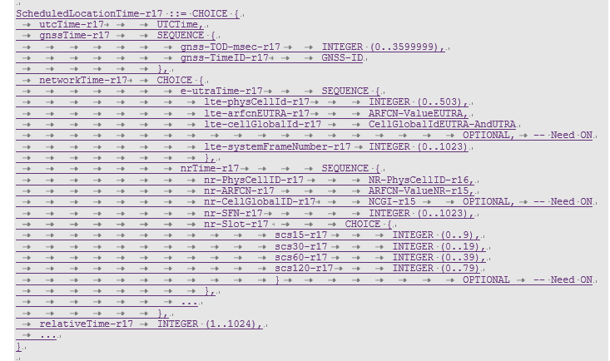
Also with the following field description:
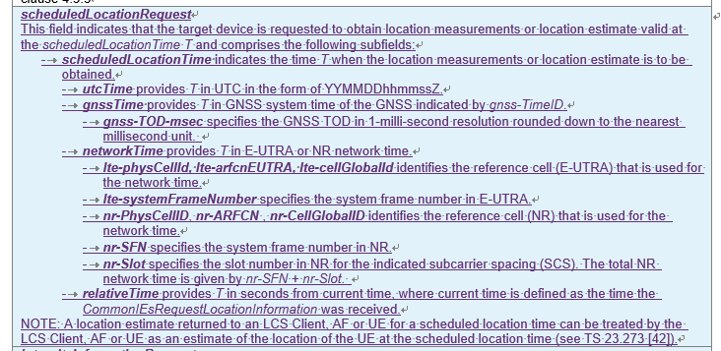

For the current CT4 discussion, the following CRs have been agreed:
- C4-220350 for 24.080 for LCS message
- C4-220368 for 29.515 for GMLC
- C4-220369 for 29.518 for AMF
Within the CRs above, the scheduled location time is defined as DateTime and the DateTime is defined in the IETF spec RFC3339. While in the IETF spec, the following format for the DateTime is defined under the URL
https://xml2rfc.tools.ietf.org/public/rfc/html/rfc3339#anchor14
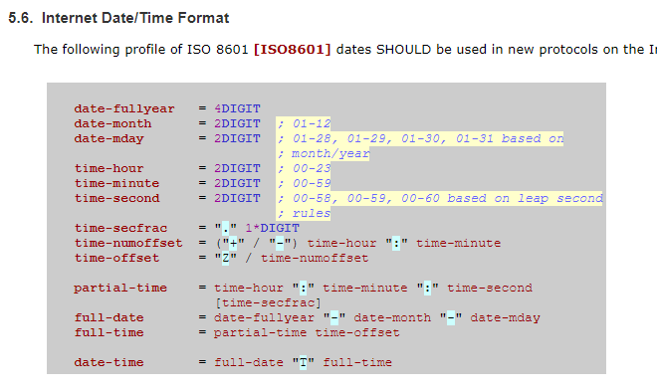
As can be seen above, the scheduled location time is defined as a time instance in the LCS message, AMF service API and GMLC service API.

Question1: Do companies agree that scheduled location time is an absolute time in LPP spec?
Company | Yes/No | Comments
Fraunhofer | Yes

Summary:

Issue2: UE capability
The following has been included in the summary for LPP spec for the list of open issues for the UE capability of schedueled location time:
R2-B4 | Capability for scheduled location request | Differentiation between UE-based and UE-assisted support and indication of time bases supported. | OTDOA-ProvideCapabilities-->scheduledLocationRequest-r17  A-GNSS-ProvideCapabilities-->scheduledLocationRequest-r17  ECID-ProvideCapabilities-->scheduledLocationRequest-r17  TBS-ProvideCapabilities-r13-->scheduledLocationRequest-r17  Sensor-ProvideCapabilities-r13-->scheduledLocationRequest-r17  WLAN-ProvideCapabilities-r13-->scheduledLocationRequest-r17  BT-ProvideCapabilities-r13-->scheduledLocationRequest-r17  NR-ECID-ProvideCapabilities-r16-->scheduledLocationRequest-r17  NR-DL-TDOA-ProvideCapabilities-r16-->scheduledLocationRequest-r17  NR-DL-AoD-ProvideCapabilities-r16-->scheduledLocationRequest-r17  NR-Multi-RTT-ProvideCapabilities-r16-->scheduledLocationRequest-r17 | Huawei, vivo, Nokia
R2-B5 | Time base(s) supported for scheduled location | Is a single time (e.g., UTC) enough for all methods? | OTDOA-ProvideCapabilities-->scheduledLocationRequest-r17  A-GNSS-ProvideCapabilities-->scheduledLocationRequest-r17  ECID-ProvideCapabilities-->scheduledLocationRequest-r17  TBS-ProvideCapabilities-r13-->scheduledLocationRequest-r17  Sensor-ProvideCapabilities-r13-->scheduledLocationRequest-r17  WLAN-ProvideCapabilities-r13-->scheduledLocationRequest-r17  BT-ProvideCapabilities-r13-->scheduledLocationRequest-r17  NR-ECID-ProvideCapabilities-r16-->scheduledLocationRequest-r17  NR-DL-TDOA-ProvideCapabilities-r16-->scheduledLocationRequest-r17  NR-DL-AoD-ProvideCapabilities-r16-->scheduledLocationRequest-r17  NR-Multi-RTT-ProvideCapabilities-r16-->scheduledLocationRequest-r17 | vivo, Nokia, ZTE

First, for the differentiantion of UE-based and UE-assistaed support for the time base, the following has been captured in the current LPP spec, take DL-TDOA, which supports both UE-based and UE-assistaed positioning, as an example.

It can be seen that for the support of different time bases, e.g., utcTime, networkTime, etc., the capability report is differentiated in terms of positioningModes, in terms of UE-based, UE-assisted, standalone
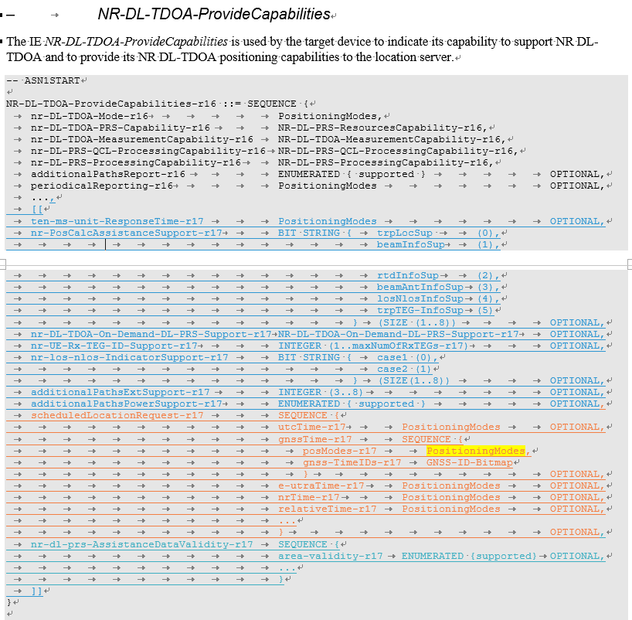
It should be further discussed whether it is necessary for the UE capability reporting for positioning methods that support multiple positioning modes to differentiate its UE capability of time based for different positioning modes.

Question2: Do comapies agree that it is necessary for the UE capability reporting for positioning methods that support multiple positioning modes to differentiate its UE capability of time based for different positioning modes?
Company | Yes/No | Comments

Summary:

Furthermode, in the current indiacation of scheduled location time, the indication can be via different format based on different time bases:
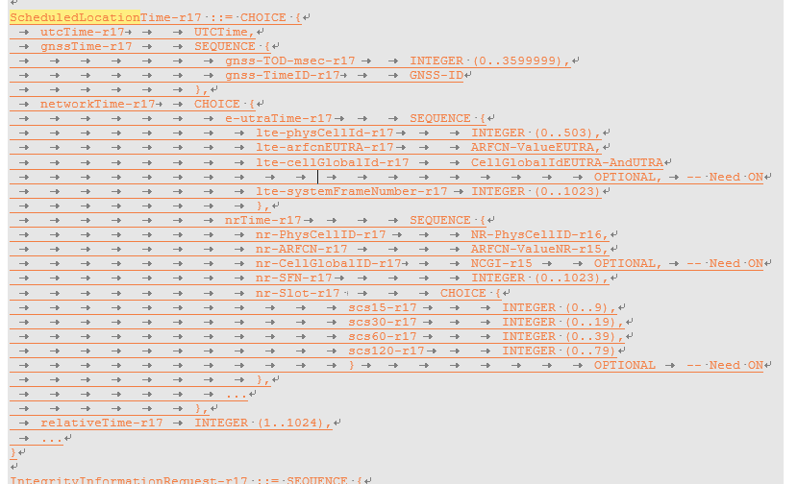

Question3: Do companies agree that the indication of scheduled location time can be based on different time bases?
Company | Yes/No | Comments

Summary:

Preconfigured Assistance Data
Regarding the preconfigured AD, the following issues have been listed in the open issue list:

Validity condition for pre-configured assistance data-area ID  FFS on details and whether it would be included in RRC broadcast.  FFS if there would be Signaling for multiple area IDs in the same instance. Signalling details can be discussed in the LPP running CR discussion.  FFS on the meaning/ value range of area ID | Yes | Status: check the status of LPP email discussion 116bis-628  check the status of RRC email discussion 116bis-631  RAN2#116bis:  Proposal 3a (modified): Pre-configured DL-PRS assistance data can be associated with a “validity area” at least in LPP. FFS on details and whether it would be included in RRC broadcast.  Pre-configured DL-PRS assistance data can consist of multiple instances, where each instance is applicable to a different area within the network. FFS on additional specification impacts and whether this can already be supported with the agreement made that pre-configured DL-PRS assistance data can be associated with a “validity area”. Single instance of AD is not excluded; FFS if there would be ignaling for multiple area IDs in the same instance. Signalling details can be discussed in the LPP running CR discussion.

Issue3: definition of area ID
Currently in the LPP CR, the Area ID is listed as FFS and it has also been listed in the open issue list above. Since this issue has not been discussed in any detail in the previous meeting, we the issue should be handled by the company input to the next R2 meeting.

Summary:
Thus we propose the following:
Proposal : How to define the area ID for pre-confguerd PRS should be addressed based on the companies’ contribution to the future meetings.

Issue4: Signaling of multiple area ID in the same instance
When multiple area IDs are configured within a single instance of PRS assistance data, the LMF needs to know which set of assistance data the UE is using and this set of AD corresponds to which area. During the last R2 meeting, it has been proposed that the area ID should be sent to the LMF when UE reports the PRS measurements to the LMF.

Question4: Do companies agree that the UE should report area ID along with PRS measurement to the LMF?
Company | Yes/No | Comments
Fraunhofer | Yes | It simplifies if we assume that an instance of an AD contains only one validity area, and multiple instances address different validity areas. Then reporting Area ID uniquely identifies the AD.  Otherwise, we need to report AD instance too, to ensure that the LMF and the UE have the same understanding of the AD used by the UE.

Summary:

Issue5: RRC broadcast of area ID

PRS assistance data can be broadcasted in the RRC system information by posSIB. Then, whether the area ID can also be included in the posSIB has been raised and listed in the open issue list.

Question5: Do companies agree that the area ID can be broadcasted in the system information?
Company | Yes/No | Comments
Fraunhofer | Yes | In our understanding, the simplest form of area ID can be group of cells where the UE is connected/camped. This allows the AD the UE has acquired in one cell to be used in a group of cells, without having to newly acquire the information.  In case the areaID contains only one cell, this corresponds with the Rel. 16 behaviour.

Summary:

Issue6: Support of mulitple AD instance for pre-configured PRS
In the running LPP CR, the following issue has been raised on whether it can already be supported by the current LPP spec. The following observation has been made by the LPP rapporteur in the editor’s note:
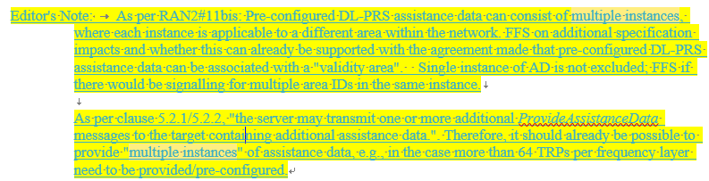
Thus, we ask the following question:

Question6: Do companies agree that multiple AD instances can already be supported by the current LPP spec?
Company | Yes/No | Comments
Fraunhofer | No | In Rel. 16, there was only possibility to provide a single NR-DL-PRS-AssistanceData instance, which was shared among TDOA, AoD and multi-RTT. Therefore, current specifications, as they stand, do not allow multiple assistance data without clarification.  We need to clarify how multiple AD instants are differentiated from single AD instants. One way is to provide different identifiers (e.g. different area ID), other way is to provide them as lists of NR-DL-PRS-Assistance data.  Since the preconfigured assistance data can be reused across multiple positioning sessions, it is important to define how the AD is maintained.  In particular, our opinion is that if the AD in ProvideAssistanceData has the same Area ID as the AssistanceData stored by the UE, then the UE shall discard the old AD instance and use the newly provided instance.  This is similar to Rel. 16 behaviour, where the old AD is replaced by the newly provided AD and used for reporting measurements. Now, the old AD instance with the same validity area as the new AD instance will be replaced. The other instances will be left as they are (stored – depending on UE capability on how many instances it will store).

Summary:

Issue 7: remaining issues for preconfigured AD
Validity Conditions for DL-PRS Assistance Data  Proposal 1: RAN2 to discuss further whether pre-configured assistance data should be associated with a “validity time” or not.  Proposal 2: RAN2 to discuss further whether pre-configured assistance data could be explicitly modified or released. | ? | Status: No majority see R2-2201875  P1: (9:6)  P2: (8:4 and 2 neutral).  Ericsson commented that Given that we have also agreed that multiple instance of AD can be provided, and UE may store it based upon its memory capacity; UE may discard the last stored AD if it happens to obtain new; it can still however store multiple latest AD.  Suggestion: stop the discussion on them considering RAN2 has discussed this issue several meeting. Then it means the UE shall discard any stored configuration when receiving a new configuration from the network. .  Low priority, company tdoc

As recommended by the moderator of the open issue list, this issue does not have high priority for the current discussion. Thus, companies are invited to propose company tdoc on this.
Proposal: Companies should propose company contributions on (a) whether preconfigured AD can be explicitly modified or released (b) validity time is defined for the pre-configured AD.

MG enhancement
The following has been included in the open issue list for MG enhancement. The issues that need to be addressed in this discussion are highlighted in yellow
Stage 2 text | ? | Status: draft in stage 2, check the status of stage 2 email discussion 116bis-629  Note: need to be updated based on the details of RRC/MAC and NRPPa;
Pre-configuration of MG(s) in RRC (Each MG in the pre-configuration is associated with an ID)  FFS on MG configuration (R2 and R1 to resolve) | Yes | Status: check the status of RRC email discussion 116bis-631  RAN2#116bis:  Proposal 4: The pre-configured Measurement Gap Configurations for Positioning are provided via RRCReconfiguration message. The pre-configured Measurement Gap Configurations for Positioning are included in IE MeasGapConfig.  Proposal 5: The content of the pre-configured Measurement Gap Configurations for Positioning includes at least the existing measurement gap parameters together with an ID identifying each Measurement Gap Configuration for Positioning.  Proposal 6: The existing RRC LocationMeasurementIndication procedure to request the positioning measurement gaps can still be used by a UE, even when pre-configured measurement gaps are provided to the UE.
UL MAC CE for MG activation/deactivation request  Other parameter are FFS.  FFS on Exact format of the UL MAC CE for MG activation/deactivation request and DL MAC CE for MG/PPW activation/deactivation command, e.g., fields, LCIDs, etc (R2 to resolve)  How to trigger the UL MAC CE for MG activation/deactivation request (R2 to resolve) | Yes | Status: check the status of MAC email discussion 116bis-632  RAN2#116bis:  Proposal 5a: A new UL MAC CE for positioning measurement gap activation and deactivation request is introduced.  Proposal 5b: The new UL MAC CE for positioning measurement gap activation and deactivation request includes at least the ID of the pre-configured positioning measurement gap configuration for which the activation/deactivation is requested.  Proposal 5e: The Scheduling Request should be triggered when there is no PUSCH and UL MAC CE for positioning measurement gap activation/deactivation request is triggered.
DL MAC CE for MG activation/deactivation  Other parameter are FFS.  FFS on Exact format of the UL MAC CE for MG activation/deactivation request and DL MAC CE for MG/PPW activation/deactivation command, e.g., fields, LCIDs, etc (R2 to resolve)  How to trigger the UL MAC CE for MG activation/deactivation request (R2 to resolve) | Yes | Status: check the status of MAC email discussion 116bis-632  RAN2#116bis:  Proposal 5c (modified): A new DL MAC CE for positioning measurement gap activation and deactivation command is introduced for positioning latency reduction. LS to RAN1/4 indicating our conclusion, and confirming that DL MAC CE can also be used for positioning measurement gap deactivation as well as activation (to be drafted by email).  Proposal 5d: The new DL MAC CE for positioning measurement gap activation and deactivation command includes at least the ID of the pre-configured positioning measurement gap configuration which has been configured/activated by the gNB.
UE capabilities for MG enhancements | Yes | Status: check the status of RAN1 feature list  RAN2 also needs to discuss how to capture UE capability based on RAN1 feature list R1-2111810R1-2200767  RRC:27-10, 27-11  LPP:27-10a,
NRPPa change | Yes | Status: RAN3 to decide;
QC:  Measurement gap activation via LMF"  The gNB may activate the pre-configurated measurement gap upon receiving the request from a UE or LMF."  Question:  Is the LMF activation of measurement gaps only for pre-configured measurement gaps? It's not clear to me from the RAN1 LS.  [Rapp] Good question, I think the LMF may activate the measurement even if there is no preconfigured MG. But we need to discuss this. Added it as open issue. | Yes | Rapp, this can be a general issue for MG. (from stage 2 discussion)

Issue8: MG preconfiguration
In the last R2 meeting, the following have been agreed for the MG preconfiguration
Proposal 4: The pre-configured Measurement Gap Configurations for Positioning are provided via RRCReconfiguration message. The pre-configured Measurement Gap Configurations for Positioning are included in IE MeasGapConfig.
Proposal 5: The content of the pre-configured Measurement Gap Configurations for Positioning includes at least the existing measurement gap parameters together with an ID identifying each Measurement Gap Configuration for Positioning.
However, in the current running RRC CR, the configuration for MG has not been captured. Since further inputs are needed from R1 on the positioning MGs that can be preconfigured, e.g., maximum number of pre-configured MG for positioning and so on. We think we should wait for the further R1 inputs on the RRC configuration for pre-configured MG. And it can be up to the decision of the RRC rapporteur on how to capture it in the RRC spec and reviewed during the running CR email discussion

Proposal: Wait for R1 inputs on pre-configured positioning MG configuration and up to the RRC rapporteur how to capture in the RRC spec.

Issue9: LCID for DL/UL MAC CE for MG
Another issue to be dicussed is whether to adopt LCID or eLCID for UL/DL MAC CE for MG.

Question7: Whether LCID/eLCID should be adopted for UL MAC CE for MG activation/deactivation request and DL MAC CE for MG activation/deactivation command?
Company | UL MAC CE  (LCID or eLCID) | DL MAC CE  (LCID or eLCID) | Comments

Summary:

Issue10: Applicability of LMF-based MG activation request
In the R1 LSs for preconfiguation of MG/PPW, the following has been included:
R2-2200074 LS on latency improvement for PRS measurement with MG (R1-2112784; contact: Huawei) RAN1 LS in Rel-17 NR_pos_enh To:RAN2, RAN3
RAN1#107-e reached the following agreement on PRS measurement with preconfiguration of MG(s) and MG activation request by UE.

Agreement
Preconfiguration of MG(s) in RRC is supported from RAN1 perspective.
  - Each MG in the preconfiguration is associated with an ID
  - The information in the UL MAC CE for MG activation request by the UE can be one ID associated with the preconfiguration of the MG
  - Send an LS to RAN2 and RAN3

In addition RAN1 understands it is up to RAN2 and/or RAN3 to decide how gNB determines the preconfiguration of MG(s).

RAN1 also agreed MG activation request to the gNB by the LMF in RAN1#106bis-e.

Agreement:
Support the following options (in the agreement made in RAN1#106-e) for a new mechanism of MG activation request for the purpose of positioning.
- Option 2: by UE (via UCI or UL MAC CE)
  - Select only one of UCI and UL MAC CE in RAN1#106bis-e
- Option 1: by LMF (via an NRPPa message)
  - Note: This is transparent to the UE

As the follow-up, RAN1 concluded in RAN1#107-e that it is up to RAN3 to design the necessary information to be transferred in the NRPPa message.

R2-2200089 LS on PRS processing window (R1-2112881; contact: Huawei) RAN1 LS in Rel-17 NR_pos_enh To:RAN2, RAN3
RAN1 discussed the PRS processing window for PRS measurement outside the measurement gap, and reached the following agreements in RAN1#107-e.

Agreement
PRS processing window request to the gNB by the LMF is supported from RAN1 perspective.
  - It is up to RAN3 to design the necessary information to be transferred in the NRPPa message.
  - Note: It is up to gNB to determine the usage of measurement gap or PRS processing window
  - Include it in the LS to RAN2 and RAN3.

Agreement
For PRS processing window configuration and indication, at least the following mechanism is supported
  - RRC (pre-)configuration for PRS processing window configuration and DL MAC CE activation for PRS processing window, respectively.
Include it in the LS to RAN2 and request RAN2 to decide whether DL MAC CE is feasible for this indication.

During the discussuion for open issue list, companies make the comment that whether the activation/deactivation request from LMF can also be used for normal MG configuration instead of being limited to pre-configured MG. The thinking from the moderator is that this depends on how LMF makes the request. If the LMF is aware of the MG preconfiguration and makes the request by MG id, it is obvious that in this case, it can only be applicable for pre-configured MG. But if the LMF makes the request by exact MG configuration, like the LocationMeasurementIndication RRC message, it can be generally applicable for both pre-configured MG and normal MG configuration.
While in the LS from R1, not such information on the request from the LMF given. The moderator thinks that the LMF should not be made aware of the MG configuration since this is related to the scheduling for the gNB. Hence, the request from the LMF

Question8: Do companies agree that the MG activation/deactivation request from the LMF can also be applicable to pre-R16 MG configuration in addition to positioning MG preconfiguration?
Company | Yes/No | Comments

Summary:

Issue11: Triggering of the UL MAC CE
As can be seen above, how to trigger the UL MAC CE for MG activation/deactivation request has also been listed in the open issue list. However, there is no previous discussion/proposal on this. Companies are thus welcomed to provide companies tdoc on this for proper solution.

Proposal: Companies are invited for company tdocs on how to trigger the UL MAC CE for MG activation/deactivation request.

PPW
The following has been included in the open issue list for PRS processing window. The issues that need to be addressed in this discussion are highlighted in yellow
Stage 2 text | ? | Status: draft in stage 2, check the status of stage 2 email discussion 116bis-629  Note: need to be updated based on the details of RRC/MAC and NRPPa;
Pre-configuration of PPW  FFS:Whether PRS processing window configuration is provided per BWP or not is up to RAN1 to decide.  FFS: Whether UE can be configured with multiple PRS processing windows should be decided by RAN1.  FFS on PPW configuration (R2 and R1 to resolve)  FFS on the max number of PPW configurations (from Stage 2 discussion) | Yes | Status: check the status of RRC email discussion 116bis-631  RAN2#116bis:  Proposal 7: The PRS processing window configuration is provided via RRCReconfiguration message. Whether PRS processing window configuration is provided per BWP or not is up to RAN1 to decide.
UL MAC CE for PPW activation request  Whether UL MAC CE can also be used for PRS processing window activation/deactivation should be decided by RAN1. | ? | Status: unrelated to RAN2;
DL MAC CE for MG activation/deactivation  FFS on Exact format of the DL MAC CE for MG/PPW activation/deactivation command, e.g., fields, LCIDs, etc (R2 to resolve)  FFS on (R2 to resolve) PDCCH monitoring during RAR window and contention resolution timer | Yes | Status: check the status of MAC email discussion 116bis-632  RAN2#116bis:  Proposal 8: A new DL MAC CE for PRS Processing Window activation and deactivation command is introduced.  Proposal 9: The new DL MAC CE for PRS Processing Window activation and deactivation command includes at least the ID of the pre-configured PRS Processing Window configuration, at least in the case when multiple PRS Processing Windows can be configured.  Proposal 10: The UE ignalin related to the PRS Processing Window feature is captured in the MAC specification.
UE capabilities for MG enhancements | Yes | Status: check the status of RAN1 feature list  RAN2 also needs to discuss how to capture UE capability based on RAN1 feature list R1-2111810R1-2200767  RRC: 27-3-2,  LPP: 27-3-3
NRPPa change | Yes | Status: RAN3 to decide;

Issue12: RAR window/contention resolution timer and PPW
In legacy MAC spec, it has been specified when the RAR window or contention resolution timer is running while the UE is in measurement gap, the UE should continue to monitor PDCCH, aka, the RAR window and contention resolution timer have higher priority than MG.

For PPW, we think the same should be applied that since RACH has already been initiated by the UE, the UE should try to terminate the RACH procedure by monitor PDCCH during RAR window and contention resolution timer.

Question9: Do companies agree that UE should monitor PDCCH during RAR window/msgB window ot contention resolution timer for the affected symbols by PPW?
Company | Yes/No | Comments

Summary:

Issue13: DL MAC CE for PPW activation/deactivation command
Similar to MG activation/deactivation MAC CEs, for PPW, we have the following question:

Question10: Whether LCID or eLCID should be adopted for DL MAC CE for PPW activation/deactivation command?
Company | LCID/eLCID | Comments

Summary:

Issue14: Response Time granularity
In the current LPP running CR, the following has been captured for the response time
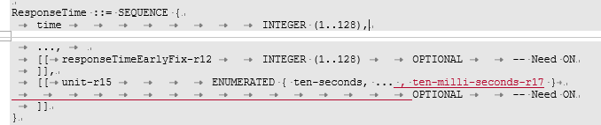
Thus, a unit of ten-milliseconds has been introduced. Within the open issue list, it is proposed to confirm on this granularity of the response time

Question11: Do company agree to have the 10 milliseconds granularity in the responseTime?
Company | Yes/No | Comments

Final WF:

Other
In this section, companies are invited to provide inputs on the remaining issues that need to be addressed for latency reduction for R17 positioning:
Company | Proposed remaining issues

Conclusions

