3GPP TSG-RAN WG2 #117-e Tdoc R2-220XXXX
Electronic meeting, Feb 21st – Mar 3rd, 2022

Agenda Item: 8.12.2.2.1
Source: Ericsson (Rapporteur)
Title: Email discussion report for [Pre117-e][105][RedCap] CP open issues
Document for: Discussion, Decision

1 Introduction
In RAN2#116bis-e, it was agreed to have post email discussions after the meeting to update the running CRs based on the agreements made during the meeting and to identify the remaining open issues. The open issues were then captured in a document with the intention to determine which issues are to be handled via Pre-RAN2#117 offline discussion(s) and which others are to be handled based on company contributions.
In this document, the discussion continues based on the list of open issues captured in R2-2201887 and R2-2201889 as the outcome of the related offline discussions after RAN2#116bis-e regarding TS 38.331 and TS 38.304, respectively.

Contact information

Company | Contact person - email@address.com
OPPO | Haitao (lihaitao@oppo.com)
CATT | Xiangdong zhang (zhangxiangdong@catt.cn)
Nokia | Jussi-Pekka Koskinen (jussi-pekka.koskinen@nokia.com)
Apple | Naveen Palle (naveen.palle@apple.com)
Ericsson | Emre A. Yavuz (emre.yavuz@ericsson.com)
ZTE | LiuJing (liu.jing30@zte.com.cn)
Qualcomm | linhaihe@qti.qualcomm.com
Intel | Yi.guo@intel.com
DOCOMO | tianyang.min.ex@nttdocomo.com

2 Discussion

2.1 Identification, access and camping restrictions
In RAN2#116bis-e, UE behaviour for the following cases were discussed but no conclusion was made:
- the cell does not indicate support for RedCap UEs
- Red Cap UE is unable to acquire SIB1
- cellBarred in MIB is set
For i. and ii. the following options have been proposed:
- UE considers IFRI as “allowed”
- UE follows the IFRI in MIB

Q 2.1.1 Assuming that common UE behaviour is preferred for cases i. and ii. above, which option do you prefer? Please elaborate your reply and comment especially if you think that UE behaviour should be different for cases i. and ii.

Company | Option  (a or b) | Comments
OPPO | a
CATT | a
Nokia | b | It seems obvious there is a reason for NW to set IFRI as “not allowed”
Apple | a | i and ii can be from different cases (for eg., NW deployment differences) and common UE behavior might not be the best for both i and ii, but we are ok to go with common approach, as ultimately it’s chipset vendor’s implementation when it comes to the cell search in such cases
Ericsson | b | It is important that RedCap UEs follow the legacy behavior where possible. If a (legacy) cell indicates that the cell is barred and that intra-frequency reselection is not allowed, this must also be respected by RedCap UEs particularly since UEs that may end up operating in a non-best cell, may impact network performance severly.  The same should apply when it is not possible for a RedCap UE to camp in a cell due to lack support for RedCap.  Note that failing to acquire SIB1 could be a sign that the cell supports only EN-DC (NSA). So, also in this case the UE should not reselect to another cell on the same carrier unless it is allowed.
ZTE | a | The IFRI in MIB is configured for non-RedCap UEs, we think network will not consider RedCap UEs when setting legacy IFRI. Since RAN2 has agreed to introduce RedCap specific IFRI, we think it is improper for RedCap UEs to follow the legacy IFRI in both i and ii.
Qualcomm | a | In case of (i), since the cell does not support RedCap, then its SI, including IFRI in MIB, is irrelevant to RedCap UEs. RedCap UEs thus should be allowed to check other cells on that frequency.  In case of (ii), since UE gets no information from the current cell, it should be allowed to try again with other cells on that frequency.
Intel | B | RAN2 already agreed that RedCap UE shall follow cellBarred in MIB, then naturally the UE shall also follow the IFRI in MIB if Redap specific barring indication is not there. We should use same solution for all these cases.
DOCOMO | b | For NSA cell, if operator set MIB as cellBarred, the expected UE behavior is not to search another cell on the same frequency. So option b is reasonable for this case.

Summary – Q 2.1.1

TBD

Based on the observations above, the rapporteur proposes the following:

- ???

For iii. above, i.e., cellBarred in MIB is set to barred, the following options have been proposed:
- UE follows legacy IFRI in MIB
- UE acquires SIB1 and follows the RedCap-specific IFRI provided in SIB1

Q 2.1.2 Which option do you prefer for case iii. above? Please elaborate your reply.

Company | Option  (a or b) | Comments
OPPO | b
CATT | b | That is the reason to define Redcap-specific IFRI.
Nokia | b first, then a | If SIB1 does not provide RedCap-specific IFRI or the UE cannot acquire SIB1, the legacy IFRI is followed.
Apple | b | Same comment as CATT
Ericsson | a | As explained above for the previous question, it is important that RedCap UEs follow the legacy behavior where possible. If MIB indicates that the cell is barred, regardless of whether SIB1 indicates support for RedCap, the RedCap UE, as others, is not allowed to camp in the cell and thus should follow the legacy IFRI in MIB.
ZTE | b | Same comment as CATT
Qualcomm | b | Same comment as CATT
Intel | B | RAN2 already agreed that RedCap UE shall follow cellBarred in MIB, then naturally the UE shall also follow the IFRI in MIB if the RedCap UE is barred based on MIB. We should use same solution for all these cases.
DOCOMO | a | If MIB is set cellBarred, UE should follow the legacy behavior i.e. IFRI in MIB.

Summary – Q 2.1.2

TBD

Based on the observations above, the rapporteur proposes the following:

- ???

In RAN2#116bis-e the following working assumption was made:
Working assumption:
System information can provide information on which frequencies accept RedCap UE access (e.g. by considering whether supporting RedCap).

The proposal was supported by many companies, yet a working assumption was made since a few companies preferred support for providing information also on cell level and few others think that this is an optimization that adds complexity with no significant gain.

Q 2.1.3 Do you agree that the working assumption can be confirmed? Please comment especially if you do not agree and elaborate about the signalling aspects of the solution you propose, i.e., how such information can be provided, in which SIB etc.

Company | Yes/No | Comments
OPPO | See comments | We don’t think it is efficient to indicate RedCap’s access support per frequency. With this, if one neighbor cell within the frequency does not accept RedCap UE’s access, network has to set the whole frequency as not accepting RedCap UE’s access, which will prevent RedCap UE from reselecting to those RedCap-supporting neighbor cells. We think the RedCap-supporting information should be indicated via a cell list.
CATT | Yes | In SIB4
Nokia | Yes
Apple | Yes with comments | We tend to agree with Oppo for an “optional” cell-list as well (i.e., not limit to freq alone).  Also, as discussed below, there can be other access limiting factors: HD-FDD operation, 1Rx/2Rx barring etc, and it’s better to have these in SIB3/4 for the Ncells. Maybe define an ASN.1 structure in SIB1 for redcap, and that can be reused in cell-list of SIB3/4.
Ericsson | No (and not per cell either) | We do not think this is essential functionality. It is an optimization, and gains are not significant given the increased SI overhead (also for legacy UEs) and complexity. Therefore, this should not be prioritized in Rel-17.  Regarding the proposals about providing such information per cell rather than per frequency; this would increase the SI overhead and complexity further with still no significant gain. We do not think the scenario where one or some cells do not support RedCap on a certain frequency as opposed to the rest is a realistic deployment case.
ZTE | Yes | We agree with the working assumption, to indicate the information in SIB4.  In addition to freq list, from network perspective, we are also fine to support per-cell indication as indicated by OPPO and Apple.
Qualcomm | See comment | It depends on whether RedCap deployment is expected to be homogeneous on a per frequency basis. We do not expect that would be the case. For example, operators may initially deploy RedCap UEs only in areas where there are high demands.  So we agree with OPPO that cell list can be a better approach.
Intel | Yes | To our understanding, it is the compromise among companies after several meetings’ discussion, we should follow it.
DOCOMO | Yes

Summary – Q 2.1.3

TBD

Based on the observations above, the rapporteur proposes the following:

- ???

RAN2 has agreed to introduce means for the network to control UEs with, for example, 1 Rx branch to access the network in order to avoid any impact on the performance. It has been agreed in RAN1 that a capability bit on Half-duplex FDD operation type A for RedCap UEs is introduced, therefore a similar mechanism, which indicates that HD-FDD is supported in the serving cell, may need to be introduced especially considering that half-duplex (HD) in FDD bands is not supported in NR prior to the RedCap feature. Note that supporting HD-FDD in the network may require quite large implementation effort and thus it would be beneficial to have an indication for HD-FDD to facilitate early support of FD-FDD RedCap UEs.
Q 2.1.4 Do you think that support for Half-Duplex FDD RedCap should be indicated in SIB1? Please elaborate your reply.

Company | Yes/No | Comments
OPPO | No | HD-FDD operation is RRC connected state feature. We think this can handled by the UE capability and connection management, e.g. if NW does not support HD-FDD, it can send UE to idle state.
Nokia | No
Apple | Yes
Ericsson | Yes | It is essential that UEs that omit basic legacy functionality (e.g., full-duplex FDD operation) do not enter a legacy cell. The procedures captured in the running CR so far do not ensure that!
ZTE | Yes | The solution proposed by OPPO may cause PingPong problem.
Qualcomm | Yes | gNB is not mandatorily required to support HD-FDD. UE should not wait until it is connected to find out whether the gNB supports HD-FDD or not.
Intel | No strong opinion | As mentioned by OPPO, it can be resolved by gNB rejection. We also understand that to add network HD-FDD capability in SIB can avoid some UE power consumption. But it is a bit of an optimization.
DOCOMO | Yes | Agree with Ericsson’s view.

Summary – Q 2.1.4

TBD

Based on the observations above, the rapporteur proposes the following:

- ???

2.2 eDRX
In RAN2#115-e, the following was agreed:

“RAN2 considers the configuration as an invalid case, where INACTIVE eDRX cycle is configured but IDLE eDRX cycle is not configured. FFS whether to capture this restriction in RAN2 spec”

Q 2.2.1 Do you think that the case for invalid configuration should be captured in the specs? Please elaborate your reply and, if you agree, provide your opinion on how and where it should be captured.

Company | Yes/No | Comments
OPPO | Yes | It can be captured in the field description of INACTIVE eDRX cycle in 38.331.
CATT | Yes | The restriction for configuration of inactive eDRX should be added in the spec, by adding in the field description of the INACTIVE eDRX cycle that it can only be configured when the idle eDRX is configured for the UE, otherwise it should be absent.
Nokia | Yes | This can be captured in Stage-2
Apple | Yes | Same view as Oppo
Ericsson | Yes | One option can be to capture those in the form of a table.
ZTE | Yes | We prefer to capture it in TS 38.331, either adding “Cond” to ran-ExtendedPagingCycle IE or updating field description of the IE:  - Option 1:  Condition: The field is optionally present, Need R, if eDRX-Allowed-r17 field is present in SIB1 of the current cell.  - Option 2:  ran-ExtendedPagingCycle  Refers to the eDRX cycle for RAN-initiated paging. Value rf256 corresponds to 256 radio frames, value rf512 corresponds to 512 radio frames and so on. This field can be configured only if eDRX-Allowed-r17 is present in SIB1 of the current cell.
Qualcomm | Yes | Field description in 38.331 can be one option. But we think SA2 spec (e.g. TS23.501) can be a better place to capture it, as other requirements on eDRX configurations such as max eDRX cycle for RRC Inactive are already captured there.
Intel | Yes | To avoid potential IoT problem and wrong network implementation, it would be good to capture it somewhere. But we are also fine to go with majority view.
Samsung | Yes | It needs to be captured in field description of ran-ExtendedPagingCycle (38.331).

Summary – Q 2.2.1

TBD

Based on the observations above, the rapporteur proposes the following:

- ???

In RAN2#115-e, the following was agreed:

“RAN2 considers the configuration as invalid case, where INACTIVE eDRX cycle is longer than IDLE eDRX cycle. FFS whether to capture this restriction in RAN2 spec.”

Q 2.2.2 Do you think that the case for invalid configuration should be captured in the specs? Please elaborate your reply and provide your opinion regarding how and where it should be captured.

Company | Yes/No | Comments
OPPO | Yes | It can be captured in the field description of INACTIVE eDRX cycle in 38.331.
CATT | Yes | Similar with the answer of 2.2.1, it can be specified in the field description of the INACTIVE eDRX cycle that its value should be no longer than the ldle eDRX cycle.
Nokia | Yes | Stage-2
Apple | Yes | Same view as Oppo
Ericsson | Yes | Same suggestion as above.
ZTE | Yes | IDLE eDRX cycle is not configured by gNB (no IE can be referred to), so probably it is better to capture this restriction in stage 2 spec.
Qualcomm | Yes | See our reply to Q2.2.1
Intel | Yes | To avoid potential IoT problem and wrong network implementation, it would be good to capture it somewhere. But we are also fine to go with majority view.
Samsung | Yes | It needs to be captured in field description of ran-ExtendedPagingCycle (38.331)

Summary – Q 2.2.2

TBD

Based on the observations above, the rapporteur proposes the following:

- ???

The following note is captured in subclause 5.2.2.2.2 on “SI change indication and PWS notification” in the running CR for TS 38.331:

“Editor’s Note: The details for modification period, eDRX acquisition period and which eDRX/DRX cycles are referred to below are subject to further changes once relevant agreements are made.”
The following options have been considered regarding which DRX cycle UE should consider for comparing with the modification period to decide if eDRX acquisition period is used.:
- CN_eDRX for both RRC_IDLE and RRC_INACTIVE (same as LTE)
- CN_eDRX for RRC_IDLE, and RAN eDRX, if configured, for RRC_INACTIVE, i.e., use CN_eDRX if RAN eDRX is not configured.

Q 2.2.3 Which option do you prefer? Please elaborate your reply.

Company | Option  (a or b) | Comments
OPPO | b with modification | For UE in RRC INACTIVE, since UE would always monitor for RAN paging based on RAN eDRX if configured for RRC_INACTIVE or RAN DRX if RAN eDRX is not configured, we think it would be better to use RAN eDRX (if RAN eDRX is configured) or RAN DRX (if RAN eDRX is not configured) to compare with the modification period.  The proposed option b-bis:  CN_eDRX for RRC_IDLE, and RAN eDRX, if configured, for RRC_INACTIVE, i.e., use RAN DRX if RAN eDRX is not configured.
CATT | a | We think it is fine to align with LTE which is also the simplest solution.
Nokia | b | Agree with OPPO
Apple | a | We agreed to this already…?
Ericsson | a | We prefer to follow LTE to make the implementation simple and straightforward especially since this would make the SI change indication mechanism simpler, i.e., legacy mechanism can be used.
ZTE | a | To align with LTE.
Qualcomm | b | LTE uses only CN_eDRX because UE has only one eDRX configuration
Intel | b with modification (b-bis) | Option b is our first preference with the same modification suggested by OPPO. The value range of eDRX is quite large; therefore we understand it is preferable that we use the one specific to UE’s current state.  We would like to clarify that even the same notification via systemInfoModification-eDRX is used for UE in IDLE and INACTIVE, the advantage from UE side is that UE with shorter eDRX could acquire the updated information earlier.  Said this, we understand that both options work and we would be ok going with majority view.
Samsung | None | We would like to clarify although CN_eDRX (or RAN_eDRX) is configured, UE in RRC_IDLE (or RRC_INACTIVE) may "use" different DRX cycle with CN_eDRX (or RAN_eDRX). DRX cycle UE uses is defined as 'T' in clause 7.1 in 38.304 CR. We think modification period (MP) should be compared with DRX_cycle UE "uses", rather than "configured" eDRX cycles (CN_eDRX or RAN_eDRX)  Example 1) When CN_eDRX >10.24s, UE in RRC_IDLE uses DRX cycle (T) of min (UE specific cycle, default cycle) within PTW. In this case, even if CN_eDRX > MP, there is no reason for UE to use eDRX acquisition period (which delays SI update much longer) as long as T < MP.  Example 2) When CN_eDRX >10.24s and RAN_eDRX ≤10.24s, UE in RRC_INACTIVE uses DRX cycle (T) of min (default cycle, UE specific cycle, RAN_eDRX) within PTW. Assume T < RAN_eDRX. In this case, even if RAN_eDRX > MP, there is no reason for UE to use eDRX acquisition period (which delays SI update much longer) as long as T < MP.  Note: If UE receives short message in the "first paging occasion" in PTW, UE should compare MP with T outside PTW, since UE has been used T outside PTW. (Otherwise, UE compares MP with T within PTW). In example 1, T outside PTW can be assumed as CN_eDRX.  Our view can be captured as TP in 38.331:  5.2.2.2.2 SI change indication and PWS notification  (...)  If the UE receives a Short Message, the UE shall:  (...)  1> if DRX cycle (T) UE is using according to TS 38.304 is not longer than the modification period and the systemInfoModification bit of Short Message is set:  2> apply the SI acquisition procedure as defined in sub-clause 5.2.2.3 from the start of the next modification period;  - if DRX cycle (T) UE is using according to TS 38.304 is longer than the modification period and the systemInfoModification-eDRX bit of Short Message is set:  2> apply the SI acquisition procedure as defined in sub-clause 5.2.2.3 from the start of the next eDRX acquisition period boundary.  NOTE: If UE receives the short message in the first paging occasion in PTW, UE should use T outside PTW to compare with modification period.

Summary – Q 2.2.3

TBD

Based on the observations above, the rapporteur proposes the following:

- ???

The following note is captured in subclause 5.2.2.2.2 on “SI change indication and PWS notification” in the running CR for TS 38.331:

“Editor’s Note: The case for RRC_INACTIVE is FFS”

Q 2.2.4 Please provide your preference regarding the case for RRC_INACTIVE considering the procedure in subclause 5.2.2.2.2.

Company | Comments
OPPO | Depending on the outcome of Q 2.2.3, the procedure text should be added for RRC_INACTIVE case.
CATT | It depends on the answer of Q2.2.3, if option a is adopted, for RRC inactive state, if the idle eDRX cycle longer than the modification period and the systemInfoModification-eDRX bit of Short Message is set, UE shall apply the SI acquisition procedure.  An example of the modification on the spec as following:  - if the UE is in RRC_IDLE, configured with an eDRX cycle longer than the modification period and the systemInfoModification-eDRX bit of Short Message is set:  2> apply the SI acquisition procedure as defined in sub-clause 5.2.2.3 from the start of the next eDRX acquisition period boundary.
Apple | Same view as CATT
Ericsson | This depends on the outcome of Q.2.2.3. We prefer to use the same mechanism for both RRC_IDLE and RRC_INACTIVE and adopt the text from LTE in principle.
ZTE | With the answer to Q2.2.3, CN_eDRX is used for both RRC_IDLE and RRC_INACTIVE for comparing with SI modification period, we think the procedure in 5.2.2.2.2 for UE in RRC_INACTIVE is same as RRC_IDLE.
Qualcomm | Same view as OPPO
Intel | Dependent on conclusions in previous Q.2.2.3
Samsung | Please refer our answer in Q 2.2.4

Summary – Q 2.2.4

TBD

Based on the observations above, the rapporteur proposes the following:

- ???

The following note is captured as part of the ASN.1 coding for the RRCRelease message in the running CR for TS 38.331:

ExtendedPagingCycle-r17 ::= ENUMERATED {rf256, rf512, rf1024, spare1} -- Editor's note: TBD how many spare values are needed.

Only one spare value is available currently, but more may be required for forward compatibility.

Q 2.2.5 Please provide your preference regarding the number of spare values needed and motivate why.

Company | # of spare values | Comments
OPPO | 1 | But no strong view.
CATT | Slightly prefer 1 in R-17 | Even considering the inactive eDRX cycle extension beyond 10.24, the maximum inactive eDRX cycle would also need to be discussed, so the number of the spare bits is not clear. Anyway, if extension is needed in the future, an ExtendedPagingCycle-r18 can be introduced.
Nokia | 1 | Should suffice as we can add a new IE in a later release if more values required.
Apple | No strong view, but ok with 1 for R17
Ericsson | See the comment | We prefer to have a number of spare values enough for at least the include the possible values for idle mode.
ZTE | 1 | We think 1 is sufficient for R17. If more is needed in future (R18), a separate IE can be introduced.
Qualcomm | 1 | Same view as the comments above
Intel |  | No strong view. We understand that it is difficult to predict how many values will be required if/when eDRX in INACTIVE can be set above 10.24 as it dependent on CT1. Therefore current TP seems sufficient and if/when supported for values above 10.24sec, we would need to provide it via a different field via non-critical extension. Therefore if this field is optional, there would not be need to signal both fields in future.
Samsung | 1

Summary – Q 2.2.5

TBD

Based on the observations above, the rapporteur proposes the following:

- ???

The following note is captured in subclause 7.x on “Paging in extended DRX” in the running TS 38.304 CR:
The PH for CN is the H-SFN satisfying the following equations:
H-SFN mod T_{eDRX_CN}= (UE_ID_H mod T_{eDRX_CN}), where
- UE_ID_H
- xx most significant bits of the Hashed ID.
Editor’s note: FFS how many bits we use above for UE_ID_H.
- T_{eDRX_CN}: UE-specific eDRX cycle in Hyper-frames, (T_{eDRX_CN} = 2, …, 1024 Hyper-frames) configured by upper layers.

Q 2.2.6 Please indicate your preference regarding the number of most significant bits that should be used for UE_ID_H? Please elaborate your reply.

Company | # of bits | Comments
OPPO | 12 | To align with NB-IoT.
CATT | 12 | In LTE the UE_ID_H is defined as follows:  - UE_ID_H:  - 10 most significant bits of the Hashed ID, if P-RNTI is monitored on PDCCH or MPDCCH  - 12 most significant bits of the Hashed ID, if P-RNTI is monitored on NPDCCH  And in LTE the range of the eDRX cycle is as follows:  - T _{eDRX,H} : eDRX cycle of the UE in Hyper-frames, (T_{eDRX,H} =1, 2, …, 256 Hyper-frames) (for NB-IoT, T_{eDRX,H} =2, …, 1024 Hyper-frames) and configured by upper layers.  We can see the eDRX cycle can be up to 1024HSFN in LTE NB-IoT which aligns with NR, so 12 bits used for UE_ID_H can similarly be used for NR
Nokia | 12 | Same as LTE.
Apple | 12 | To align with LTE
Ericsson | 10 | Same as in LTE (Note that “same as LTE” would mean 10 not 12 and NPDCCH refers to NB-IoT not LTE)
ZTE | 13 | After thinking more, we think 13 bits will be needed.  In LTE, 12 bits are needed, because up to 10bits will be used to determine PH, and 2 bits are used to determine the PTW_start.  For NR eDRX, for PTW_start, considering the fomular is updated from “mod 4“ to “mod 8“, so 1 additional bit will be needed.  SFN = 128 * i_{eDRX_CN}, where  - i_{eDRX_CN} = floor(UE_ID_H /T_{eDRX_CN}) mod 8  If 12 bits are used, in case TeDRX,H =1024 Hyper-frames, there are only 4 available PTW_start positions, not 8.
Qualcomm | 12 | We are fine with reusing the LTE design
Intel | 12 | RAN2 agreed “UE_ID for eDRX is defined by 5G-S-TMSI mod 4096”, therefore we are also ok aligning with NB-IoT on this.  [ZTE] The agreement is made for UE_ID, not UE_ID_H.  UE_ID is used to determine PF and PO while UE_ID_H is used to determine PH and PTW_start.
Samsung | 12

Summary – Q 2.2.6

TBD

Based on the observations above, the rapporteur proposes the following:

- ???

2.3 RRM relaxations

The following note was captured in the procedural part of the “Relaxed measurement criterion for a stationary UE” in the subclause 5.7.4.X in the running CR for TS 38.331:

5.7.4.X Relaxed measurement criterion for a stationary UE
The relaxed measurement criterion for a stationary UE is fulfilled when:
- (Srxlev_{RefStationaryConnected} – Srxlev) < SSearchDeltaP-StationaryConnected,
Where:
- Srxlev = current Srxlev value of the PCell cell (dB).
- Srxlev_{RefStationaryConnected} = reference Srxlev value of the PCell cell (dB), set as follows:
- After MAC of an MCG successfully completes a Random Access procedure after applying an reconfigurationWithSync in spCellConfig of an MCG, or
Editor's Note: The above bullet and how to capture the case if RRM relaxation is not configured at the time of handover is TBD.
- If (Srxlev – Srxlev_{RefStationaryConnected}) > 0, or
- If the relaxed measurement criterion has not been met for TSearchDeltaP-StationaryConnected:
- The UE shall set the value of Srxlev_{RefStationaryConnected} to the current Srxlev value of the serving cell.

Q 2.3.1 Please provide your preference regarding the following bullet

“After MAC of an MCG successfully completes a Random Access procedure after applying an reconfigurationWithSync in spCellConfig of an MCG,”

and how to capture the case if RRM relaxation is not configured at the time of handover.

Company | Comments
OPPO | We understand this relates to initiation of Srxlev_{RefStationaryConnected,} but we think handover is not the only case which needs to be addressed. To us, following cases are relelvant:  Case 1: configuration (first time) of RRM relaxation  In this case, initiation of Srxlev_{RefStationaryConnected} shoud be specified.  Case 2: handover  In this case, handover command may not explicitly include RRM relaxation (e.g. delta configuation), but UE should still set the initial value of Srxlev_{RefStationaryConnected}.
CATT | If the RRM relaxation is not configured for the UE by the target gNB for handover case, the UE shall not perform the evaluation of the Relaxed measurement criterion for a stationary UE, i.e. the UE shall not perform the procedural text of 5.7.4.X
Nokia | We agree with CATT
Ericsson
ZTE | Agree with CATT, if RRM relaxation criterion is not configured by the target cell, then UE will not perform the evaluation, and section 5.7.4.x will not be invoked.
Qualcomm | Agree with CATT
Intel | We can add this case as  - After MAC of an MCG successfully completes a Random Access procedure after applying an reconfigurationWithSync in spCellConfig of an MCG, or  - After RRM relaxation criterion is sucessfully configured after applying RRCReconfiguration without an reconfigurationWithSync in spCellConfig of an MCG, or  - If (Srxlev – Srxlev_{RefStationaryConnected}) > 0, or  - If the relaxed measurement criterion has not been met for TSearchDeltaP-StationaryConnected:  - The UE shall set the value of Srxlev_{RefStationaryConnected} to the current Srxlev value of the serving cell.
Samsung | Agree with CATT

Summary – Q 2.3.1

TBD

Based on the observations above, the rapporteur proposes the following:

- ???

The following note was captured in the subclause 5.2.4.9.0 on “Relaxed measurement rules” in the running CR for TS 38.304:

Editor's note: When the network configures both R16/R17 relaxation criteria and the UE fulfils both, it is TBD if the UE performs Rel-17 RRM relaxation method or it is up to UE implementation to select either Rel-16 or Rel-17 relaxation operation.

The following options have been considered when the network configures both R16/R17 relaxation criteria and the UE fulfils both:
- UE performs Rel-17 RRM relaxation method
- it is up to UE implementation to perform either Rel-16 or Rel-17 relaxation method
- Wait for RAN4’s decision

Q 2.3.2 Which option do you prefer? Please elaborate your reply.

Company | Option  (a or b) | Comments
OPPO | A | But b is also ok.
CATT |  | No strong view, both can work.  Option a can bring more power saving, but option b can leave more flexibility for UE.
Nokia |  | Both works
Apple | B
Ericsson
ZTE | B | For idle/inactive UEs, network does not care and cannot be aware which RRM relaxation method will be selected, so it is up to UE to decide.
Qualcomm | c | RAN4 have been discussing this issue. We should wait for their conclusion.  If RAN2 decide to have its own agreement, we are fine with Option b.
Intel | A | B is also ok.
Samsung | c | Agree with QC

Summary – Q 2.3.2

TBD

Based on the observations above, the rapporteur proposes the following:

- ???

Regarding the same case above, Rel-16 low mobility and Rel-17 stationary criteria are evaluated based on independent Tsearch periods, which may have different durations and therefore the evaluations can be out of synch. It has been observed that typically a UE considers one criterion fulfilled first while still waiting for the other to conclude. Based on the current text, the UE may simply proceed with the RRM relaxation actions related to the first criterion fulfilled. The UE may wait for the measurement period of the second criterion to conclude, but it is possible that the UE does not end up in a state where both criteria are fulfilled at the same time.
Q 2.3.3 Do you agree with the assessment above? Please elaborate your reply and provide comments regarding how to capture the UE behaviour especially if you reply “Yes”.

Company | Yes/No | Comments
OPPO | Yes
CATT | Yes | One option is to make the stationary criterion has higher priority if configured by NW, i.e. UE should first check whether stationary criterion is fulfilled, it means the evaluation time shouldn’t less than the Tsearch for stationary criterion. If the stationary criterion is not fulfilled, UE should evaluate the low mobility criterion.  Or it can be left to UE implementation.
Nokia | Yes
Apple | Yes | Can be left to UE impl, but expect that UE follows the specified procedure
Ericsson
ZTE | Yes | Since the issue is only applicable to idle/inactive UEs, we also think this can be up to UE implementation, as long as UE performs RRM relaxation when relaxation criterion is fulfilled for corresponding Tsearch.
Qualcomm |  | It can be left to UE implementation
Intel | Yes
Samsung |  | Up to UE implementation

Summary – Q 2.3.3

TBD

Based on the observations above, the rapporteur proposes the following:

- ???

2.4 NCD-SSB
For further discussion regarding the configuration of SSBs and the corresponding measurement objects, possible deployment and configuration variants should be considered. The rapporteur takes the variants listed in R4-2201780 as reference for this discussion.

RedCap UE's BWP contains CD SSB

When the network configures a RedCap to use the Cell-defining (CD) SSB, it can do so using BWP#0 or a dedicated BWP, e.g., BWP#1 in the example below. In this case, the CD-SSB can be used for all purposes including serving- and neighbour cell measurements. Hence, an NCD-SSB is not required and not configured for this UE.

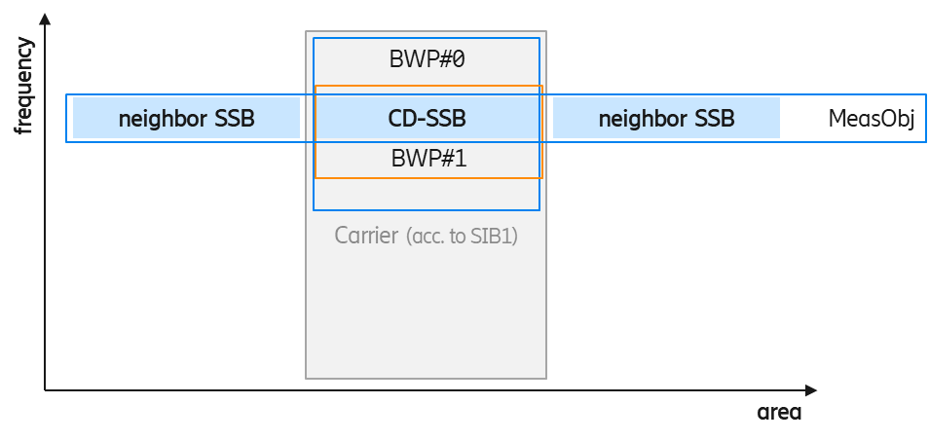
Figure 1. RedCap UE operating on dedicated BWP that contains the CD-SSB

RedCap UE’s BWP does not contain CD-SSB

In this case the NW configures the NCD-SSB in UE’s dedicated BWP. There are two scenarios to consider:

- All neighbour cells send SSBs on UE’s NCD-SSB frequency
- Some neighbour cells do not send SSBs on UE’s NCD-SSB frequency

In scenario a)., RedCap UEs may measure serving- and neighbour cells on NCD-SSB frequency which requires no measurement gaps. UEs measure (neighbour) cells according to the configured Measurement Object (MeasObj).

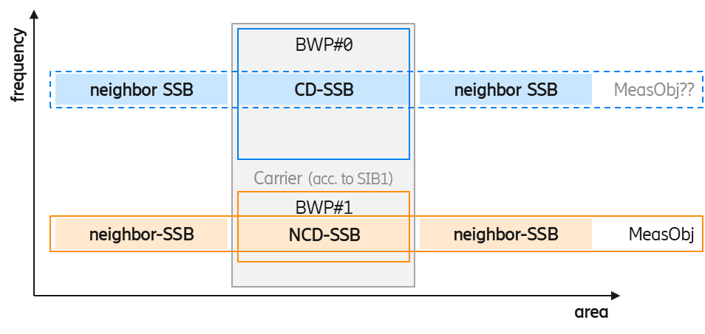
Figure 2. RedCap UE operating on dedicated BWP that does not contain the CD-SSB - all neighbour cells broadcast their SSB on the UE's NCD-SSB frequency

The rapporteur observes two possible approaches for this scenario:
- UE can follow the legacy principles, i.e., it would configure an MO on the NCD-SSB frequency (but no gaps) and associate necessary report configurations (e.g., A3, A2, ...).
- instead of configuring a MeasObj on the NCD-SSB frequency explicitly, RAN2 could specify that a UE that is configured with a dedicated BWP that contains an NCD-SSB should perform serving- and neighbour cell measurements on the NCD-SSB instead of on the CD-SSB, i.e., the UE would re-interpret the MeasObj based on the given NCD-SSB configuration.

In case RAN2 follows the first approach, rapporteur thinks that the following should be considered: whether the network should also configure a MO on CD-SSB and, if not, whether the network should set the servingCellMO to the ID of the NCD-SSB.

In scenario b), where some neighbour cells do not send an SSB on UE’s NCD-SSB frequency, measurements should be done on the CD-SSB frequency, otherwise, the UE may end up in a neighbour cell without noticing it and without providing a corresponding measurement report to its serving gNB.

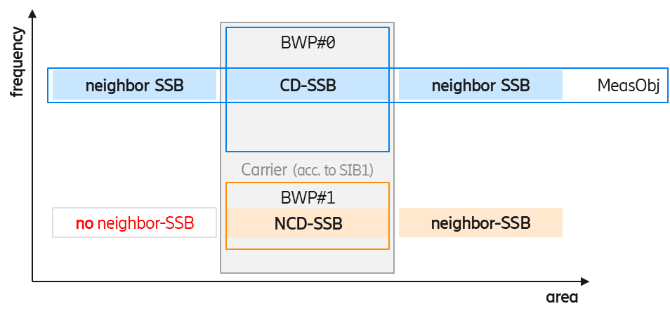
Figure 3. RedCap UE operating on dedicated BWP that does not contain the CD-SSB - some neighbour cells do NOT broadcast their SSB on the UE's NCD-SSB frequency

Even though it may be a rare case, rapporteur thinks that it would be better if the network configures the MeasObj and suitable measurement configurations on the CD-SSB frequency as shown in Figure 3 above. In this case configuring a MeasObj on the NCD-SSB frequency appears unnecessary for the sole purpose of performing serving cell measurements and all information about the NCD-SSB would be given in the serving cell configuration (either explicitly or inherited from the CD-SSB configuration).

In case RAN2 follows the 1st approach above, the rapporteur would like to ask companies the following two questions:

Q 2.4.1 Do you think the network should configure a MO on the NCD-SSB if it wants the UE to perform neighbour cell measurements thereon (as in legacy)? Please elaborate your reply.

Company | Yes/No | Comments
OPPO | Yes
CATT | Yes | As in legacy
Nokia |  | Legacy principles can naturally be applied.
Apple | We do not see the need | As long as it is clear to the UE and the NW that the UE will have to use NCD-SSB for serving cell measurements, when in that BWP, then either explicit MO config (scenario 1) or UE internal translation of meas obj (scenario 2) serve the same purpose.  For Ncell measurement, then the NW would know if the UE needs gaps or not (based on intra-freq or not) and in scenario b, the NW has to configure gaps to the UE.  The key is that NW and the UE are both in sync, on which BWP the UE is operating in.  We think it’s simpler to not explicitly configure MOs, rather just use scenario 2 (UE assumes that MO is now based on NCD-SSB)… But we are open to a less complicated approach.
Ericsson | Yes | This is the legacy behavior and allows supporting all relevant scenarios (e.g., measurements only on NCD-SSB without gaps; measurements on CD-SSB with gaps).
ZTE | Yes | We think legacy principles should be applied for neighbor cell measurements. Which means UE needs to perform neighbor cell measurements based the configured MO (more accurate the configured MeasId).  We think scenario 1) is more common scenario in the area where Redcap is deployed.
Qualcomm | Yes | We prefer Approach #1 because it reuses the existing framework and is simpler for UE to implement.
Intel | Yes

Summary – Q 2.4.1

TBD

Based on the observations above, the rapporteur proposes the following:

- ???

Q 2.4.2 Do you think that the network should also configure MO on CD-SSB even if it does not expect the UE to perform neighbour measurements thereon? Please elaborate your reply.

Company | Yes/No | Comments
OPPO |  | We think this may be up to network’s implementation.
CATT | See my comments | If the NW doesn’t expect the UE to perform neighbor measurement on the CD-SSB, the NW doesn’t need to configure MO on CD-SSB.  But currently, the field description about servingCellMO in the 38331is as following:  measObjectId of the MeasObjectNR in MeasConfig which is associated to the serving cell. For this MeasObjectNR, the following relationship applies between this MeasObjectNR and frequencyInfoDL in ServingCellConfigCommon of the serving cell: if ssbFrequency is configured, its value is the same as the absoluteFrequencySSB and if csi-rs-ResourceConfigMobility is configured, the value of its subcarrierSpacing is present in one entry of the scs-SpecificCarrierList, csi-RS-CellListMobility includes an entry corresponding to the serving cell (with cellId equal to physCellId in ServingCellConfigCommon) and the frequency range indicated by the csi-rs-MeasurementBW of the entry in csi-RS-CellListMobility is included in the frequency range indicated by in the entry of the scs-SpecificCarrierList.  If the NW wants to configure the servingCellMO to associate with the CD-SSB, the NW can configure a MO on CD-SSB.  So it is up to NW to decide to configure MO on CD-SSB.
Nokia |  | Up to NW.
Ericsson | No | The NW could omit the MO on the CD-SSB if it does not want the UE to measure neighbor cells on that frequency. But of course the network may decide to configure it like any other MO on any other frequency.
ZTE | No | Our understanding is that:  “network does not need to configure MO on CD-SSB, if the network does not expect UE to perform BOTH serving cell and neighbour cell measurements on the frequency of CD-SSB ”  Please note that current NR spec allows network to not configure MO on SCell, and in this case, UE does not need to measure the SCell and corresponding intra-f neighbour cells.
Qualcomm | No | If network does not expect a UE to perform measurements on CD-SSB of any cells on a frequency, then we do not see the need to configure MO on CD-SSB for that frequency.
Intel | No | It is strange to configure MO on CD-SSB if network does not want the UE to do measurement on it. If we allow this, then in report configuration, we have to indicate whether NCD-SSB or CD-SSB should be used for measurement in case both NCD-SSB and MO-SSB are configured for the same frequency?

Summary – Q 2.4.2

TBD

Based on the observations above, the rapporteur proposes the following:

- ???

Q 2.4.3 Regarding the discussion on scenario b), do you think the network should configure a MO on the NCD-SSB frequency if it wants the UE to use it only for serving cell measurements? Please elaborate your reply.

Company | Yes/No | Comments
OPPO | Yes
CATT | No | In currently,UE and NW assume the measurement on the servingCellMO to be the measurement of the serving cell. If no further enhancement needed, MO on the NCD-SSB for serving cell measurements is not needed.  In legacy, activated BWP may be a BWP which is not including CD-SSB, currently the servingCellMO is used for serving cell measurement. Of course it is up to NW implementation to decide whether to configure one MO to assoicate with the NCD-SSB or CSI-RS.
Nokia |  | Up to NW.
Ericsson | No | When configured with the NCD-SSB, UE has all required information to measure its serving cell’s SSB thereon. A general statement, as follows, seems sufficient: “A UE operating on a BWP for which a NCD-SSB is configured shall use it for all purposes for which it would otherwise have used the CD-SSB (sync, serving cell measurements, …)”
ZTE | Yes, but with comments | Approach2 (UE re-interprets the CD-SSB MO based on the given NCD-SSB configuration) is feasible for SSB-based measurement, but it cannot work if network also wants to configure CSI-RS based RRM measurement in BWP#1.  So we think it is more future proof to use MO to instruct UE to perform measurement.  However, we DON’T think RAN2 needs to support the case that “only serving cell is measured”. If anyway neighbour cells are measured on a different carrier (e.g. CD-SSB), then gap is inevitable, the benefit of performing serving cell on NCD-SSB is gone, as UE can also perform serving cell measurement on CD-SSB, and evaluate A3/A5 on the same frequency.  If company really wants to support “only measuring serving cell without neighbour cells on NCD-SSB”, based on current specification, they can try following configuration:  1. Configure a MO1 on NCD-SSB, set servingCellMO to the MO ID1;  2. Do not configure any reportConfig linked with the MO1;  3. Must configure a MeasId links another MO2 associated with ReportConfig in which rs-type set to ssb. The SSB frequency configured in MO2 (can be CD-SSB) must be different from MO1.  In summary, we think MO needs to be provide no matter only serving cell or both serving and neighbour cells are measured. And no need to specify any enhancement to support “only measuring serving cell” case.
Qualcomm | Yes | We think using the existing MO framework to configure UE’s measurements for various configurations scenario is a simpler and more robust way to do it.
Intel | Yes

Summary – Q 2.4.3

TBD

Based on the observations above, the rapporteur proposes the following:

- ???

Q 2.4.4 If you replied with “Yes” to the previous question, do you think that the network should refer to this MO explicitly from within the ServingCell configuration (similarly to servingCellMO)? Please elaborate your reply.

Company | Yes/No | Comments
OPPO | Yes
Ericsson | No | We tend to agree with other companies’ views raised in the previous meeting that such additional explicit cross-reference is technically not needed and complicates the configuration.
ZTE | Yes, but with comments | The current specification refers to servingCellMO in many places, so if approach 1 (separate MO) is adopted instead of approach 2 (UE re-interpretation). Then there is a need to reconfigure the servingCellMO field.  But whether this needs a separate servingCellMO IE? Please see our response to Q2.4.7.
Qualcomm | Yes
Intel | Yes

Summary – Q 2.4.4

TBD

Based on the observations above, the rapporteur proposes the following:

- ???

RedCap UE’s BWP contains neither CD-SSB nor NCD-SSB

The network’s configuration should follow the previous case above, i.e., network will configure the servingCellMO to the MO on the CD-SSB.

Q 2.4.5 Regarding scenario a); which approach do you prefer? Please elaborate your reply.

Company | 1 or 2 | Comments
OPPO | Neither | Network should configure an MO on the CD-SSB frequency.
CATT | 1 | Follow the legacy
Nokia |  | Legacy principles.
Apple | 1 | Follow the legacy
Ericsson
ZTE | 1? | This question is a bit unclear to us.  A RedCap may be configured with multiple BWPs:  - #BWP0 contains CD-SSB;  - #BWP1 contains NCD-SSB;  - #BWP2 contains neither CD-SSB nor NCD-SSB.  Assuming #BWP0 will never be activated due to large BW, and network only activates #BWP1 or #BWP2, if network configures UE to perform measurement on NCD-SSB when #BWP1 is activated, then ServingCellMO is set to the MO ID of NCD-SSB. Even if the UE switches to #BWP2, the UE can continue performing measurement on NCD-SSB (with gap assistance). There is no need to mandate UE to measure CD-SSB when #BWP1 is activated.  So we understand the UE just needs to measure the MO indicated in ServingCellMO, no matter it is CD-SSB or NCD-SSB.
Qualcomm | 1 | For the same reason given in our reply to Q2.4.1
Intel |  | For a UE indicating support of FG 6-1a (BWP operation w/o CORESET#0 or SSB in an RRC-configured DL BWP), the situation would be similar as this case. We can follow the same principle here.

Summary – Q 2.4.5

TBD

Based on the observations above, the rapporteur proposes the following:

- ???

Non-overlapping BWPs
If the UE supports DCI-based BWP-switching, the network could configure different NCD-SSB in different non-overlapping dedicated BWPs (only one NCD-SSB per BWP!) as depicted below.

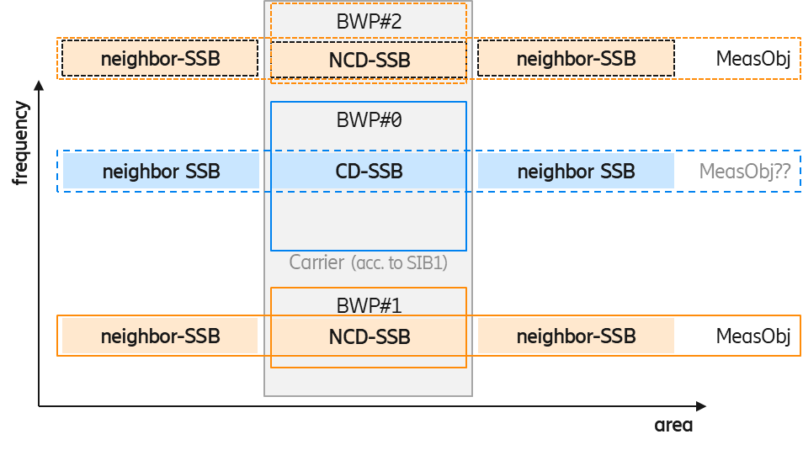
Figure 4. RedCap UE configured with several non-overlapping BWPs
that contain different NCD-SSBs.

In this scenario the UE may always use the SSB in its currently active BWP. If all neighbour nodes are known to send the same SSBs, the UE may measure serving- and neighbour cells on the NCD-SSB frequency. To achieve that, the network should configure MOs and report configurations on each NCD-SSB frequency of the UE. However, the NW does not need to configure gaps.
Assuming that the NCD-SSB is configured in the BWP-DownlinkDedicated anyway, the rapporteur observes that RRC signalling offers the possibility to configure a UE with several NCD-SSB. Note that if this is not meant to be allowed, a restriction should be specified.
Q 2.4.6 Do you think that such configuration should be allowed? Please elaborate your reply.

Company | Yes/No | Comments
OPPO | Yes | Several BWP-DownlinkDedicated containing NCD-SSB.
CATT | Yes | It is up to NW implementation to configure MO associated with different SSB. No restriction is needed.
Nokia | Yes | No need to restrict.
Apple | Yes | Should be allowed irrespective of the MO discussion.
Ericsson | Yes (probably) | As said above, configuring different NCD-SSBs in different BWPs (no more than one NCD-SSB per BWP!!) does not require changes in the ASN.1 structure.  A UE that supports DCI-based BWP switching should also be able to acquire and use a different SSB when changing the BWP (as it does when switching from the initial BWP to the dedicated BWP with NCD-SSB).  And it allows the network to spread the RedCap load on a wide carrier.  However, if hidden challenges are identified we are also fine to restrict the configuration to at most one NCD-SSB per UE’s serving cell.
ZTE | Not essential, but will not object if majority wants | We prefer to finalize one NCD-SSB scenario first, then back to this to see if anything specifically needed.  But even if multiple NCD-SSBs can be supported. Why the SSB is per-BWP configured? Network may configure multiple BWPs contains the same NCD-SSB, does it mean network needs to configure the same SSB configuration in BWP-DownlinkDedicated of each overlapped BWP?  In our understanding, NCD-SSB is per-cell configured (i.e. in ServingCellConfig)
Qualcomm | Yes | The current measurement signaling framework fully supports such configurations. No restriction needs to be specified.
Intel | Yes | It is still one NCD-SSB per MO. And MG may still be needed.

Summary – Q 2.4.6

TBD

Based on the observations above, the rapporteur proposes the following:

- ???

Q 2.4.7 If it is allowed to configure several NCD-SSBs, Which MO should be set in servingCellMO? Any of the NCD-SSBs? Or the CD-SSB? Or none, since the UE can derive it anyway? Please elaborate your reply.

Company | Comments
OPPO | The NCD-SSB contained in the current active BWP.
CATT | As legacy servingCellMO should associated with the MO configured with CD-SSB if the MO assoicated with SSB.  measObjectId of the MeasObjectNR in MeasConfig which is associated to the serving cell. For this MeasObjectNR, the following relationship applies between this MeasObjectNR and frequencyInfoDL in ServingCellConfigCommon of the serving cell: if ssbFrequency is configured, its value is the same as the absoluteFrequencySSB and if csi-rs-ResourceConfigMobility is configured, the value of its subcarrierSpacing is present in one entry of the scs-SpecificCarrierList, csi-RS-CellListMobility includes an entry corresponding to the serving cell (with cellId equal to physCellId in ServingCellConfigCommon) and the frequency range indicated by the csi-rs-MeasurementBW of the entry in csi-RS-CellListMobility is included in the frequency range indicated by in the entry of the scs-SpecificCarrierList.
Nokia | Up to NW.
Apple | Scenario 2 from the first NCD-SSB question, the UE and NW remap the serving cell MO to the NCD-SSB, without explicit config.
Ericsson | There is no need to mandate one specific SSB. As discussed on Q 2.4.3 and 2.4.4 network may need to configure MOs on CD-SSB or NCD-SSB or both. Configuring at least one of them as servingCellMO (in the legacy field) should be sufficient.
ZTE | We think a normal deployment will not configure two SSBs within 20MHz BW. (one SSB occupies ~5MHz or ~10MHz bandwidth)  So it implies that if the UE is switched from a BWP to another BWP that contains different SSBs, most likely network has to reconfigure UE’s specific channel BW, and this can only be done via RRC message. Then in the same RRC message, network can reconfigure the servingCellMO to another MO ID.  So from UE perspective, the UE just needs to measure the MO indicated in ServingCellMO, no matter it is CD-SSB or NCD-SSB.
Qualcomm | The MO corresponding to the NCD-SSB in the current active BWP.
Intel | Agree with OPPO.

Summary – Q 2.4.7

TBD

Based on the observations above, the rapporteur proposes the following:

- ???

Other aspects

In RAN2#116bis-e the following working assumption was made:
Working assumption:
The periodicity of NCD-SSB shall be not less than the periodicity of serving cell’s CD-SSB.

Q 2.4.8 Do you agree that the working assumption can be confirmed? Please comment especially if you do not agree.

Company | Yes/No | Comments
OPPO | Yes
CATT | Yes
Nokia | Yes
Apple | Yes, and | As expressed earlier, we like to keep the NCD-SSB and CD-SSB periodicity the same. Also helps with MO discussion ..
Ericsson | Yes
ZTE | Yes
Qualcomm | Yes | We don’t see use cases which would require NCD-SSB to have shorter periodicity
Intel | Yes | We can accept this.

Summary – Q 2.4.8

TBD

Based on the observations above, the rapporteur proposes the following:

- ???

Q 2.4.9 Do you think it should be possible to use NCD-SSB to trigger the handover procedure? If so, in which field should it be indicated? How should ServingCellConfigCommon-> absoluteFrequencySSB be set in this case? Still to the CD-SSB?” Please elaborate your reply.

Company | Yes/No | Comments
OPPO | No | UE will read MIB in the target, for which NCD-SSB should not be indicated.
CATT |  | Triggering of handover is up to NW implementation.  I think this question should be “whether it should be possibleto use measurement on the NCD-SSB as the serving cell measurement”. It depends on whether the servingCellMO can be associated with the CD-SSB.
Nokia |  | NW can trigger HO based on any information.
Apple | Yes, and | This can be another reason to remap the MO to NCD-SSB implicitly then explicit config. And also same view as CATT
Ericsson
ZTE | No | Seems companies misunderstood the question. We understand the question is asking about the SSB indicated in HO command, not the SSB indicated in measurement report for triggering HO.  Of course, the measurement on NCD-SSB can be used to trigger handover(as in legacy). But for HO command, we still think only CD-SSB can be indicated in the legacy absoluteFrequencySSB IE, because UE has to know the CD-SSB of target cell in order to read MIB/SIB1 later.
Qualcomm |  | Same comment as CATT
Intel | No | The main purpose is to assist the UE to read SIB in new cell. The network can configure SMTC to help UE find the CD-SSB. If no SMTC, the UE may spend 5ms to search for it.

Summary – Q 2.4.9

TBD

Based on the observations above, the rapporteur proposes the following:

- ???

Q 2.4.10 Do you think a non-RedCap UE should be able to use NCD-SSB instead of CD-SSB with an optional capability? Please elaborate your reply.

Company | Yes/No | Comments
OPPO |  | No strong view. For simplicity, we can focus on RedCap UEs in Rel-17.
CATT |  | It is allowed to configure MO to associated with NCD-SSB in current spec.
Nokia |  | It should already be allowed.
Apple |  | Not essential now.
Ericsson
ZTE | Yes | This function is also beneficial for non-RedCap UEs, especially the support of performing RLM/BFD based on SSB when the active BWP does not contain CD-SSB. So we think it is useful to apply it to non-RedCap UEs.  In our understanding, there is no additional effort in supporting this (only capability needs to be defined for non-RedCap UEs).
Qualcomm | Yes | That would give network more flexibility in configuring BWPs for non-RedCap UEs
Intel |  | We can focus on RedCap in Rel-17.

Summary – Q 2.4.10

TBD

Based on the observations above, the rapporteur proposes the following:

- ???

3 Conclusion
Based on the discussion above rapporteur suggests a discussion on the following proposals:

Proposal 1 ???

References
- R2-2201886 Running 331 CR for RedCap Ericsson
- R2-2201887 Open issue list for 38.331 for RedCap Ericsson
- R2-2201888 Running 304 CR for RedCap Ericsson
- R2-2201889 Open issue list for 38.304 for RedCap Ericsson
- R4-2201780 Discussion on the use of NCD-SSB MediaTek

