3GPP TSG-RAN WG2 Meeting #117 electronic R2-2203681
Online, 21st Feb – 03rd Mar, 2022

Agenda item: 6.2.2
Source: Huawei, HiSilicon
Title: Summary [AT117-e][707][V2X/SL] Control plane corrections (Huawei)
Document for: Discussion and Decision

Introduction
This document summarizes the offline discussion as:
- [AT117-e][707][V2X/SL] Control plane corrections (Huawei)
Scope: Discuss whether the proposed change in R2-2202714, R2-2203290, R2-2203286, R2-2203287, R2-2203288 and R2-2203289 are acceptable or not (including which proposed change is most acceptable to the companies if there are multiple candidate changes) and merge all acceptable changes.
Intended outcome: Agree 38.331 rapporteur CR in R2-2203680 and individual 38.304 CR. Discussion summary in R2-2203681. Email approval.
Deadline: 2/28 13:00 UTC for discussion, 3/1 09:00 UTC for rapporteur’s CR and summary.
Contact list:
Company | Name | E-mail
Huawei, HiSilicon | Tao Cai | tao.cai@huawei.com
Ericsson | Antonino Orsino | antonino.orsino@ericsson.com

On changes proposed in R2-2202714[1]

On the first change
Tdoc | Reason for change  /Summary of change | Details of change
R2-2202714 | In the field description of IE ReportConfigNR-SL, description of SL-CBR is incorrectly added, and the value description for cN-Threshold is missing  /In clause 6.3.2, add the value description of cN-Threshold and remove description of SL-CBR. | 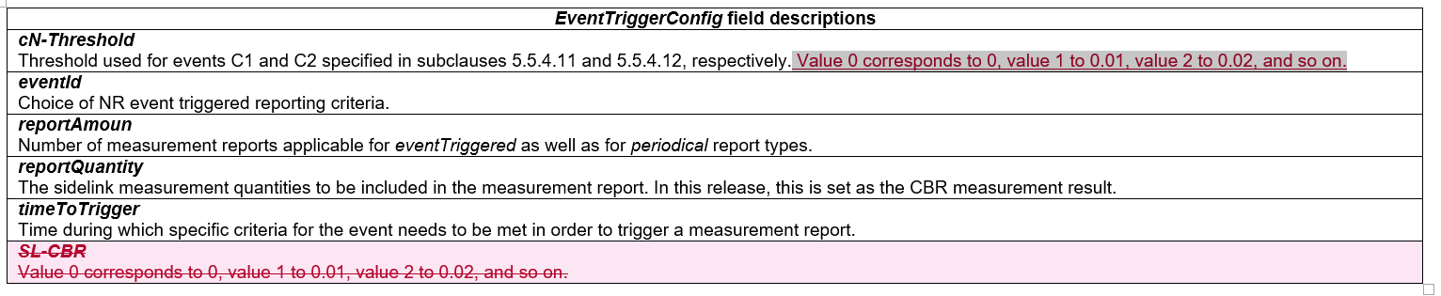
Q1: Would your company agree to have the above change? Please list further comments if any
Company | Agree/disagree on having the change | Further comments
Ericsson | Partially | Strictly speaking, the fields cN-Threshold are of type SL-CBR-r16 and in the field description of sl-CBR-RangeConfigList, that points to the field SL-CBR-r16, is already clear what the value correspond to.  sl-CBR-RangeConfigList  Indicates the list of CBR ranges. Each entry of the list indicates in SL-CBR-LevelsConfig the upper bound of the CBR range for the respective entry. The upper bounds of the CBR ranges are configured in ascending order for consecutive entries of sl-CBR-RangeConfigList. For the first entry of sl-CBR-RangeConfigList the lower bound of the CBR range is 0. Value 0 corresponds to 0, value 1 to 0.01, value 2 to 0.02, and so on.  According to this, the first change is not needed but the second one if fine.

On the second change

Tdoc | Reason for change/Summary of change | Details of change
R2-2202714 | In IE SL-BWP-Id, field sl-BWP-Id is used to identify a sidelink bandwidth part, which refers to the IE BWP-Id. IE BWP-Id is initially used as an identifier for Bandwidth Parts (BWP) in Uu, where value 0 refers to the initial BWP, and values from 1 to maxNrofBWPs refer to other BWPs.  However, as initial BWP has not been defined over the sidelink, clarifications on the value range of SL-BWP-Id are needed to avoid misunderstanding.  /Add a field description for IE sl-BWP-Id to clarify that the sidelink bandwidth parts are identified from BWP-Id 1 to maxNrofBWP. | 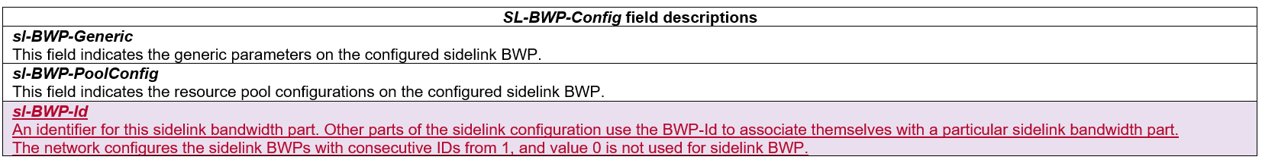
Q2: Would your company agree to have the above change? Please list further comments if any
Company | Agree/disagree on having the change | Further comments
Ericsson | See comments | We prefer to limit the change to the first sentence (An identifier for this sidelink bandwidth part). Our concern is that in sidelink there is only one BWP and, even if the signalling may allow the configuration of more than one BWP, we think that this should not be taken as something that “can happen”. For this reason, we prefer to not have the other sentences.  Otherwise, we need to clarify that only one BWP can be configured for SL and thus only ID 1 is configured in this release.

2.3 On the third change
Tdoc | Reason for change/Summary of change | Details of change
R2-2202714 | Description of SL-Thres-RSRP is incorrectly added in the field description of IE SL-Thres-RSRP-List.  /In clause 6.3.5, remove description of SL-Thres-RSRP in the field description, and add in the IE description of SL-Thres-RSRP-List . | 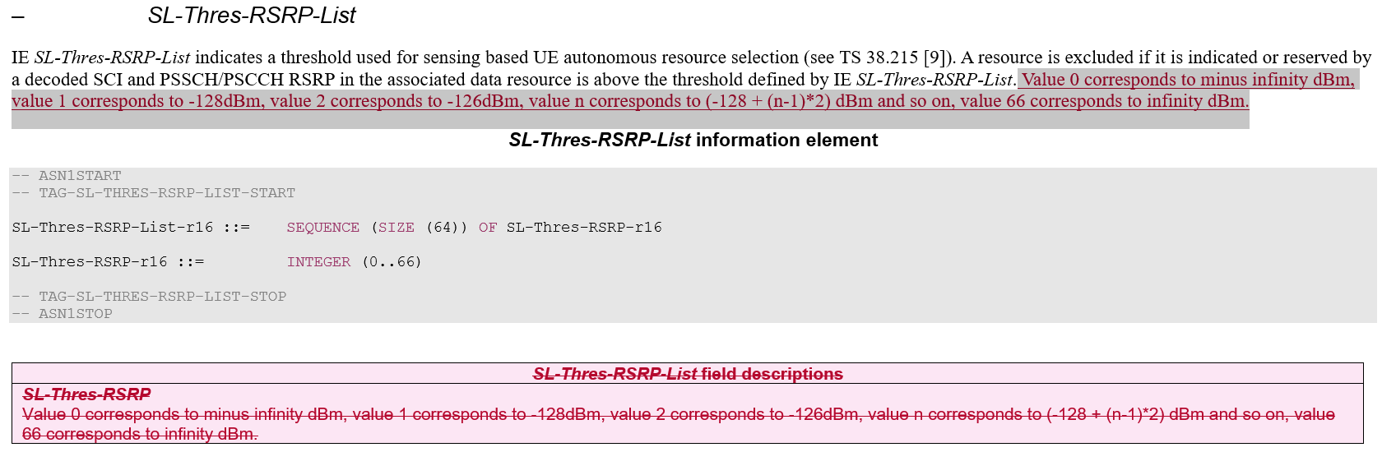
Q3: Would your company agree to have the above change? Please list further comments if any
Company | Agree/disagree on having the change | Further comments
Ericsson | Agree

2.4 On the other changes
Tdoc | Reason for change/Summary of change | Details of change
R2-2202714 | Fix the editorial errors. | 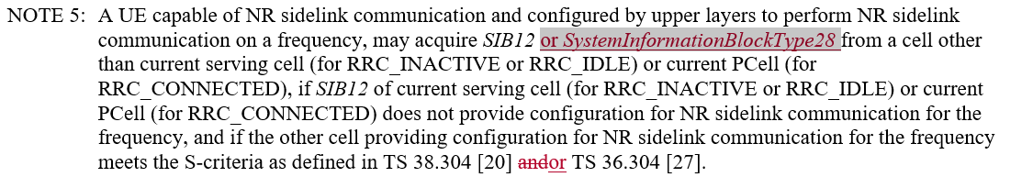  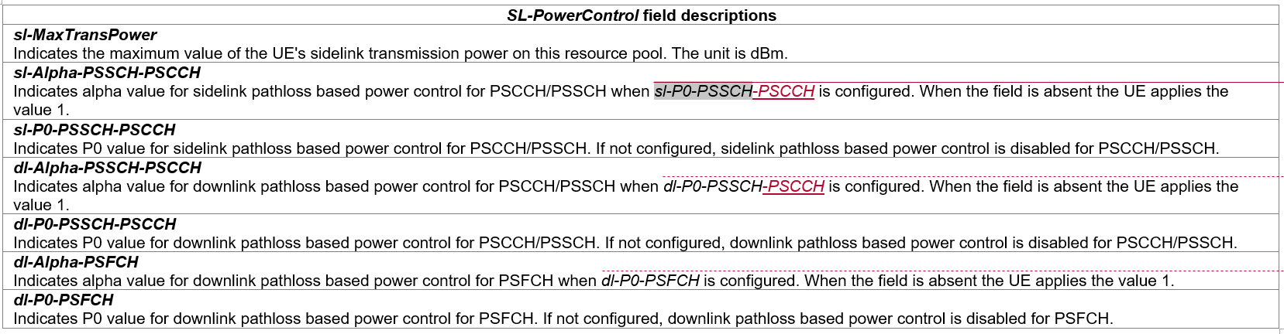  Other editorial changes on word style, space etc.
Q4: Would your company agree to have the above editorial changes? Please list further comments if any
Company | Agree/disagree on having the change | Further comments
Ericsson | Agree

On the changes related to TS 38.304[2]
Tdoc | Reason for change/Summary of change | Details of change
R2-2203289 | System information in NR specification is captured by using “SIB*”, not “SystemBlockInformationType*” which is used in LTE specification. To differentiate the NR system information and LTE system information, the wording of system information needs to be modified.  /In clause 8.1, change “SystemInformationBlockType12/13/14” to “SIB12/13/14”. | 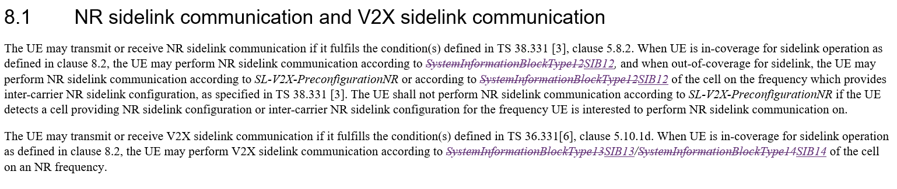
It is understood that only “short names/SIBs” are used in TS 38.331, the proposal for changing the “long names” to “short names” in TS 38.304, when referring to TS 38.331 or referring to “the cell on an NR frequency”, is reasonable.
Rapporteur would suggest to agree this CR for TS 38.304, after revising on “summary of change” in the cover sheet.
Q5: Would your company agree to above Rapporteur suggestion? Please list further comments if any
Company | Agree/disagree | Further comments
Ericsson | Ok but fix during CR implementation | Unless there are other changes impacting 38.304, this is a purely editorial change and we suggest to fix this during the CR implementation (after plenary) without the need of an actual CR.

On the changes related to HARQ attribute of SL-SRBs [3][4][5][6]
The discussed issue [6] is related to the agreed change “Network always includes this field” (sl-HARQ-FeedbackEnabled) in RAN2#116 meeting. Various solutions are suggested in [3][4][5][6].

Proposed solution 1:
Tdoc | Reason for change/Summary of change | Details of change
R2-2203286 | 1. Since (for 116 meeting agreed change on sl-HARQ-FeedbackEnabled), only RRC signaling is modified, the agreed change can only be applied on SL DRB. As SL SRB are used for sidelink unicast communication, all SL SRBs use specified RB configuration, and it does not include the HARQ attribute. Based on current spec(i.e. only LCH with HARQ disabled can use resource pool without PSFCH), SL SRB still can not use the SL grant associated to resource pool without PSFCH resource pool. Therefore, to align SL DRB configuration, HARQ attribute will always be configured for SL SRB.  2. And to reduce the latency of SL SRB, HARQ disabled is configured in specified SCCH configuration (TS 38.331).  (for SL-SRB 3 and similarly for SL-SRB 0,1,2) | 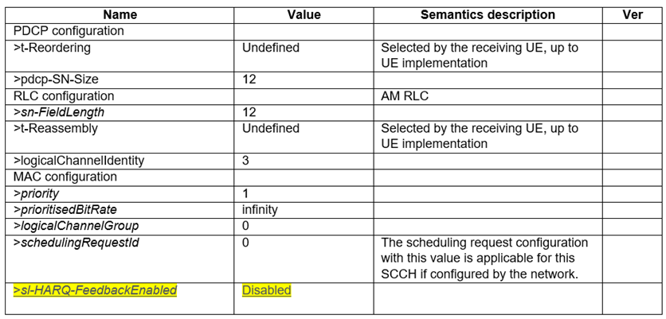

Proposed solution 2a:
Tdoc | Reason for change/Summary of change | Details of change
R2-2203288 | Add the description of how to handle the SL SRB without HARQ attribute during LCP in TS 38.321. | 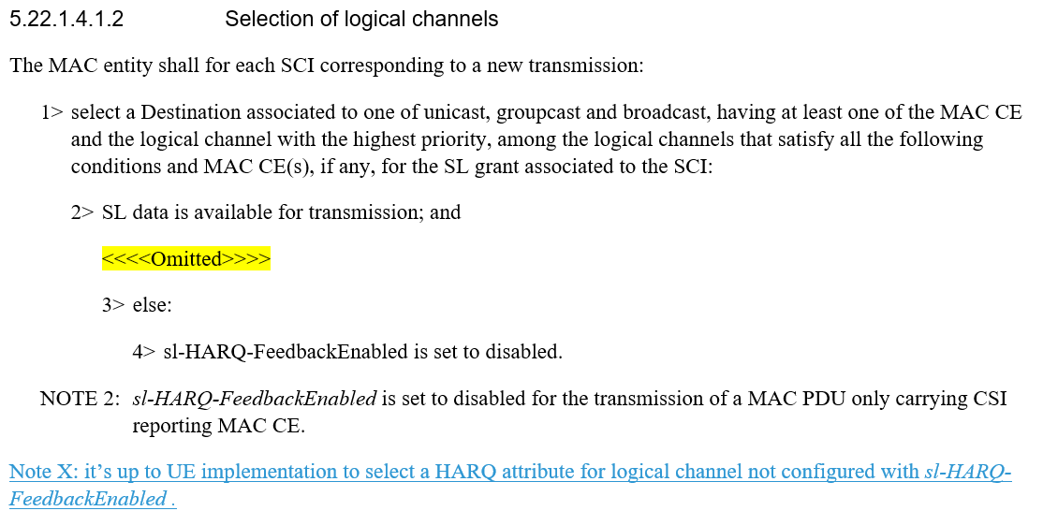

Proposed solution 2b:
Tdoc | Reason for change/Summary of change | Details of change
R2-2203287 | To provide more flexible, the HARQ attribute of SL SRB is selected by UE implementation (TS 38.331): | 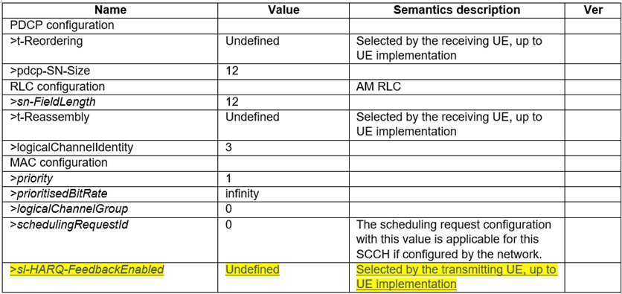

Proposed solution 3
Tdoc | Reason for change/Summary of change | Details of change
R2-2203290 | The HARQ attribute for transmission of the MAC PDU is determined by the highest priority LCH with sl-HARQ-FeedbackEnabled. The LCH without HARQ attribute can be multiplexed with LCH with HARQ attribute. (TS 38.321) | 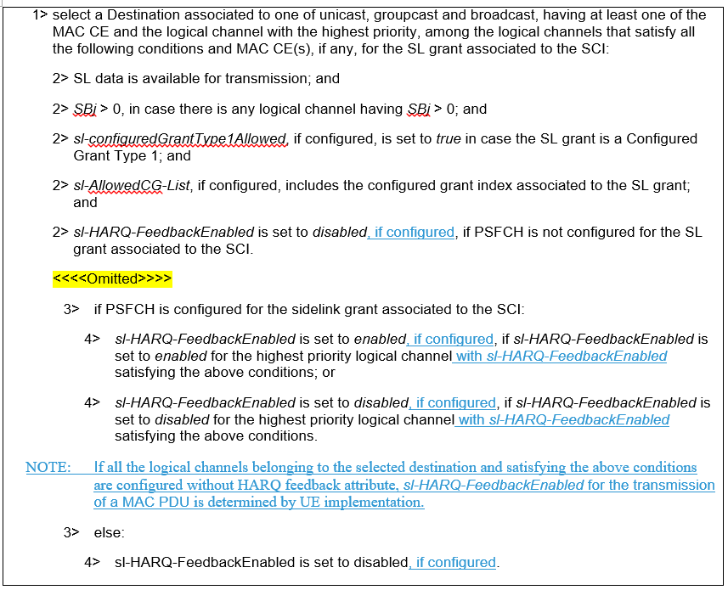

Q6: In order to solve the issue raised on SL-SRB, which option(s) below would your company prefer, please provide further comments if any.
Option 1: In TS 38.331, in SCCH configuration for SL-SRB 0/1/2/3, adding attribute “sl-HARQ-FeedbackEnabled” with fixed value “Disable”.
Option 2a: In TS 38.321, capturing “It’s up to UE implementation to determine the HARQ attribute of LCH without sl-HARQ-FeedbackEnabled during LCP.”
Option 2b: In TS 38.331, in SCCH configuration for SL-SRB 0/1/2/3, adding attribute “sl-HARQ-FeedbackEnabled” as “Undeinfed” with description as “Selected by the transmitting UE, up to UE implementation”.
Option 3: In TS 38.321, capturing “The HARQ attribute for transmission of the MAC PDU is determined by the highest priority LCH with sl-HARQ-FeedbackEnabled. The LCH without HARQ attribute can be multiplexed with LCH with HARQ attribute”.
Option 4: Others, please elaborate.
Company | Option(s) | Further comments
Ericsson | Option 2b | This is the simplest solution and the one with less standardization efforts. Also, this is in line with other parameter of the SCCH configuration.

Q7: On Proposal 3 in [6], would your company support “to delete “Network always includes this field.” in field description of sl-HARQ-FeedbackEnabled (in TS 38.331), if above Option 2a or Option 3 is agreed”?
Company | Support/Not support | Further comments
Ericsson | Not support | This is clearly a NBC and it not acceptable to us (given that there are other changes that are BC on the table).

Conclusion

Reference:
      - R2-2202714, Miscelleneous CR on 38.331, Huawei, HiSilicon.
      - R2-2203289, Correction on TS 38.304, ZTE Corporation, Sanechips.
      - R2-2203286, Correction on HARQ attribute of SL SRB option1, ZTE Corporation, Sanechips, OPPO.
      - R2-2203287, Correction on HARQ attribute of SL SRB option2b, ZTE Corporation, Sanechips, vivo.
      - R2-2203288, Correction on HARQ attribute of SL SRB, ZTE Corporation, Sanechips.
      - R2-2203290, Discussion on HARQ attribute of SL SRB, ZTE Corporation, Sanechips, vivo.

