3GPP TSG-RAN WG2 Meeting #117 Electronic R2-220xxxx
Online, 21 Feb – 03 Mar 2022

Agenda item: 8.21.2
Source: Huawei, HiSilicon
Title: Report of [AT117-e][074][TEI17] EPS Fallback (Huawei)
Document for: Discussion and Decision

1 Introduction
This document is the report of the following email discussion:
- [AT117-e][074][TEI17] EPS Fallback (Huawei)
Scope: Related to R2-2202818, R2-2202505, R2-2202791. Whether to have a EPS fallback enhancement where the UE goes directly to EUTRA for conn establishment upon paging in NR (MT), or NAS indication in the UE (MO). Determine and clarify the potential impact to other groups and security implications for MT and MO cases, aiming to understand whether the scope for this proposal can be kept limited to RAN2. If possible, determine if LS is needed to SA3.
Intended outcome: Report, agreeable LS to SA3 if applicable.
Deadline: For on-line CB W2 Thursday

2 Contact points
Company | Name | Email
Qualcomm Incorporated | Masato | mkitazoe@qti.qualcomm.com
Vodafone | Chris | chris.pudney@vodafone.com
China Telecom | Pei Lin | linp@chinatelecom.cn
Apple | Yuqin Chen | yuqin_chen@apple.com
Lenovo | Prateek | pmallick@lenovo.com

3 Discussion
AS discussed during W2 Monday session, R2-2202818, R2-2202505, R2-2202791 propose similar solution for EPS fallback enhancement, i.e. the idle/inactive UE goes directly to E-UTRA for connection establishment upon paging (for voice) in NR (MT), or NAS indication in the UE (MO).
The motivation is to reduce EPS fallback latency for idle/inactive UE, which is long according to the existing EPS fallback procedure and has negative impact on UE experience. The performance gain on the latency reduction is clear as analysed in the contributions. There is wide support of addressing latency reduction for EPS fallback, while some companies raise the comments that whether other WGs are impacted need further discussion.
Considering the difference among the solutions in R2-2202818, R2-2202505, R2-2202791 is only on which message to indicate EPS fallback, i.e. via paging or SIB, which is in RAN scope, the potential impact to other groups (if any) should be same, and is discussed together without differentiation as follows.

3.1 Potential impact to SA2/CT1
In SA2, the stage 2 procedure of EPS fallback has been captured in TS 23.501 clause 5.16.3.10 and TS 23.502 clause 4.13.6.1, which is specific to the connected UEs via HO and redirection. In 38.300, Inter system fallback towards E-UTRAN is performed when 5GC does not support emergency services, voice services, for load balancing etc. Depending on factors such as CN interface availability, network configuration and radio conditions, the fallback procedure results in either RRC_CONNECTED state mobility (handover procedure) or RRC_IDLE state mobility (redirection), see TS 23.501 [3] and TS 38.331 [12].
Analysis:
Some companies commented online/offline whether the solutions have impact on core network. Starting with MT case, the existing procedures for VoLTE call establishment in MT side is shown in the below figure (copied from GSM Association Official Document N2020.01 - VoLTE Service Description and Implementation Guidelines), it is understood VoNR also reuse the same IMS procedures.
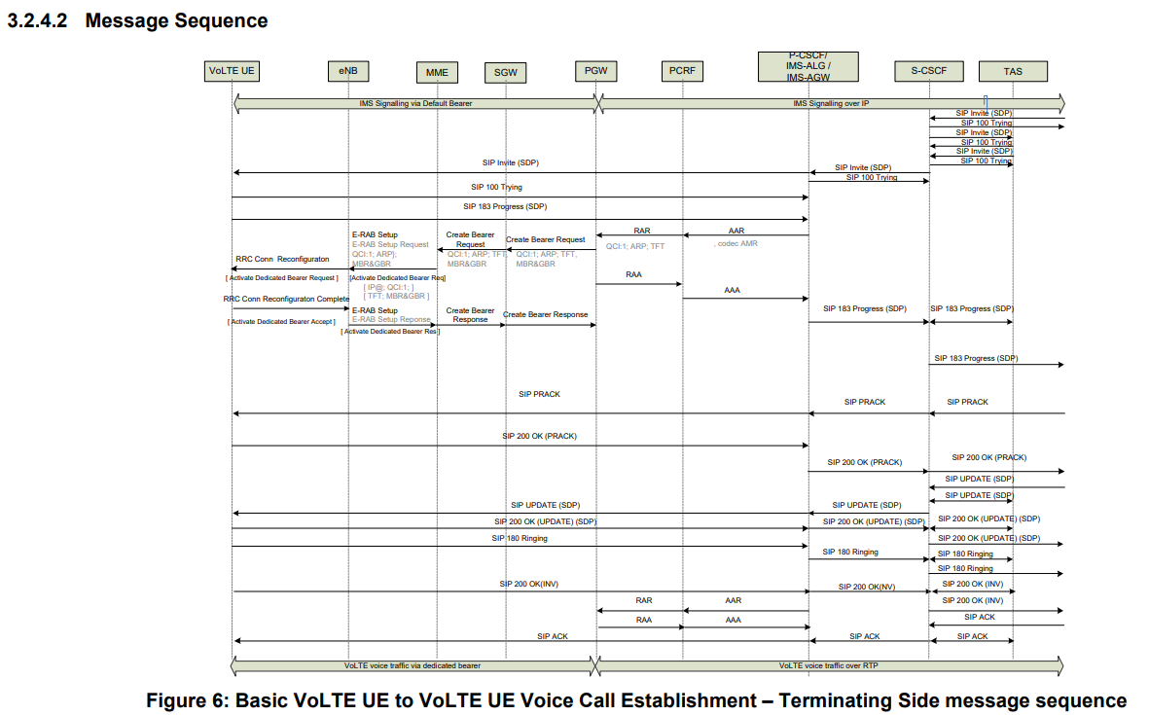
We can see:
- The IMS system is above core network and RAN. The IMS session is established between UE and IMS system, and the SIP signalling is carried via QCI5 in LTE (5QI5 in NR), while the voice traffic is via QCI1 in LTE (5QI1 in NR).
- In the existing EPS fallback procedure,
  - If the UE is in connected, the gNB will trigger EPS fallback via HO/redirection to EPS in the step of QCI1 setup request. After UE accessing E-UTRA, the IMS session and 5QI5 are resumed and 5QI1 is established for voice traffic. This is because 5GC-EPC interworking can ensure the lossless IMS session continuity for connected mobility and idle mobility as 5.17.2.2 in TS 23.501.
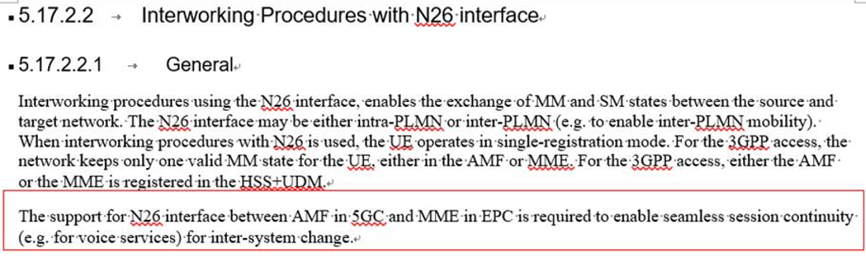
  - If the UE is in idle/inactive, the SIP Invite message (DL arrival of QCI5) will trigger paging message. Upon UE entering connected state in NR, the IMS session is resumed and the SIP Invite message can be sent to the UE, followed by same steps for connected UE.
Back to the paging/SIB triggered EPS fallback solution, after receiving the paging triggered by SIP Invite message, the UE autonomously selects E-UTRA for connection establishment instead of responding the paging message in NR. The same procedure of redirection will be performed in LTE side. For instance, by TAU, the IMS session and QCI5 will be resumed, and SIP signalling from MO side will arrive the MT UE, which triggers QCI1 setup for voice traffic.
For MO case, the UE just decides to initiate call via NR or E-UTRA based on SIB indication, nothing new compared with the existing MO call procedure. Note that even in today, the UE may do so by UE implementation.
To summarize, the above VoLTE procedure is not changed by the solution for MT case or MO case. The UE still uses the existing IMS procedures and inter-system idle mobility procedure defined in SA2/CT1. The only change is the UE is aware about this is a voice call from the paging message and then enters connected mode in E-UTRA to resume data transmission including IMS session as usual. Thus there should be no new SA2/CT1 procedure/signalling needed, and no change on the existing stage 3 SA2/CT1 procedure. (The stage 2 procedure may need update to cover the new solution for idle/inactive UE (if agreed), but should not require SA2 big effort on technical discussion. Thus the impact if any should be minimum.)

Question 1.1: Do companies agree no new SA2/CT1 procedure/signalling is required to enable the paging/SIB triggered EPS fallback solution and no stage 3 procedure for voice call setup is impacted by the new solution?
Company | Yes/No | Comments
Qualcomm Incorporated | No | MT enhancement:  Voice indication in paging so far is only for MUSIM, and the use of it by AMF is conditioned to UE’s MUSIM capability signalled via NAS. If the feature needs to be repurposed for this MT enhancement, then new UE capability may be necessary. [Moderator] The NAS capability (named as Paging indication for voice services) can be reused here. The only use of the capability to network is to know if paging can include voice cause value. No new capability is required and no impact on NAS procedure in this case.  - It is not always TAU that the UE initiates after reselecting to LTE. It can be Attach with PDN connectivity request, if without N26 interface. This may require some changes in TS 23.401 if it needs to be triggered by paging in NR.  [Moderator] Sorry for misleading. We used TAU as a general term. We understand the NAS message for TAU or Attach is not triggered by the content in the paging, S similar like legacy, the UE is only needs to know mt access is needed and which RAT to be used. For instance in R16 EPS fallback enhancement, upon HO failure, UE can first go to E-UTRA (initiating TAU or Attach) but not re-establish in NR. In that case, no new CT1/NAS impact. Here we have the same case.  - Since the UE “disappears” from NR after voice indication via paging, a new paging strategy (e.g. for re-paging) may have to be employed by 5GS. This requires knowledge at 5GC on UE capability for this MT enhancement.  [Moderator] We do not get the point of re-paging. We understand during 5GC-EPC interworking, after 5GC transfer the UE context and traffic to EPC, it will release UE context (no paging anymore.).  - We also understand that the stage-2 procedure in TS23.502 has to be changed to cover this new procedure.  [Moderator] Like we clarified, the stage 2 procedure may need to include the new case, but the only difference is on RAN part in the whole E2E procedure.  MO enhancement:  - We would like to ask the proponent to clarify:  - The state of upper layer (NAS, IMS) when the MO triggers reselection to LTE.  - Which layer (NAS or IMS?) triggers MO voice call after reselection to LTE.  - Note that similar (at least from the view point of external UE behaviour) procedure is defined in TS24.501 for emergency call fallback where NAS triggers fallback when MO emergency call is not successful due to e.g. lower layer failure. This involves not only NAS, but also IMS layer.  [Moderator] We prefer to focus on MT case, but our understanding for this question is that emergency fallback is not the same thing as EPS fallback. Emergency fallback is requested by UE via NAS message (i.e. Call->NAS message of emergency request), but EPS fallback is triggered by network (i.e. Call->transmission on 5QI5/5QI1, network trigger fallback after seeing 5QI1). Thus we believe there is not much impact on IMS layer or NAS layer when cell change during IMS voice (excluding emergency).  All in all, we do not think RAN2 alone cannot fully assess and conclude on SA2/CT1 impact.
Vodafone | No? | We are very interested in reducing the call setup latency, but, we are not sure that this approach works.  - If paged “for voice”, how does the UE know whether the network wants the UE to establish the voice call on NR or over EPS? (The network’s choice between VoNR and EPS fallback may well change over the lifetime of the device as NR coverage improves.) At the moment, I don’t think that the NAS signalling provides any information on this?  [Moderator] The network choice will be put in paging/SIB indicating EPS fallback. And when UE receiving paging with voice cause value or paging indicating EPS fallback, it knows.  - (picking up on a QC comment), if the UE disappears from NR and starts to Attach to LTE, the AMF (UE idle) or RAN (UE Inactive) paging timer can expire and then paging is retransmitted over a wider area -> this re-paging is very damaging to the Paging Early Indication feature.  [Moderator] This depends on network deployment. We understand the typical paging cycle is 1280 ms, and the UE accessing LTE requires less than 1s, will not result in multiple paging. And MUSIM seems have more serious situation in this sense, the UE paged for cause other than voice is even allowed not to response the paging message.  - I suspect that the QC comment on paging cause being linked to the UE supporting MUSIM is correct. i.e. AMF support is linked to R17 core network functionality and R17 UE availability / R17 test specs. This may not be fast to deliver.  [Moderator] We are not denying currently the NAS capability is introduced for MUSIM, but the same capability can extended to normal UE, the point is this will not impact any CT1 signalling or stage 3 procedure.  - The detection of voice calls at the AMF is an optional feature that was copied from the EPC MME. It was specified for the (IMS system, PDN GS, Serving GW and) MME because some Release 8 MMEs were struggling with the load from paging on multiple eNBs. However, since Release 8 times, processing power has increased massively, so it is not clear that the AMF, SMF, UPF and IMS needs to bother implementing the PPD feature. In that case the AMF will not be able to generate the paging cause.  [Moderator] This comment is more on paging including voice cause as agreed already for MUSIM?  - Historically, multiple core network vendors have mis-implemented their core network products such that they do not recognise a LAU/RAU/TAU as a paging response. It can be expected to have similar problems with the introduction of the AMF(s). Companies need to investigate this issue.  [Moderator] This comment is not specific to the solution here? seems a more general 5GC-EPC interworking scenario.  - For the MO case there are probably fewer issues but the network’s preference for VoNR or VoLTE would not be known by the UE.  [Moderator] Not sure if MO case is needed, but if so SIB can indicate EPS fallback to UE.  - To me, a simpler (and faster to market?) solution is that the UE starts measuring on LTE frequencies as soon as the customer opens the UE’s phone application (MO case) or is paged (MT case) and uses the measured values as soon as the network configures the UE to report them.  [Moderator] The solution based on EMR has been discussed and disagreed in previous RAN2 meeting. The reason is that when the UE performs EMR it is not aware of when call is coming, thus the measurement results may never be used and power consumption cannot be neglected.
China Telecom | Yes | From our point of view, reducing the EPS fallback latency for idle/inactive UE is very important. As analysed by the rapporteur, we also think no new SA2/CT1 procedure/signalling and no change on the existing stage 3 SA2/CT1 procedure are needed. The potential impact to SA2 is quite small, but the performance gain of enhancement seems attractive.
Apple | Basically yes | For MT service, if companies are really concerned, we would be open to send an LS to SA2/CT1 for confirmation.  For MO service, how UE handles IMS/NAS layer can be left for implementation. As Huawei mentioned during online session, some UE(s) are performing similar practice of leaving NR autonomously when MO voice is initiated. Compared to left to UE implementation, we would like to have a standardized solution, i.e. letting gNB indicate if VoNR is supported or not.
Lenovo | Yes but | Apart from SA3 security check, the changes are mainly in RAN2 for broadcast and paging procedure. There’re possibly no changes for SA2/ CT1 in our understanding but we can ask them to be sure e.g., to address QC/ Vodafone points.

Question 1.2: Do companies identify any other potential SA2/CT1 impact? If so please list the detailed aspects.
Company | Yes/No | Comments
Qualcomm Incorporated | Yes | Please see our input to Q1.1.
Vodafone | Yes | See answer to Q1.1.
China Telecom | No | We agree with the rapporteur’s analysis.
Apple | Basically No | But we would be fine to confirm with SA2/CT1 on any RAN approach for EPS fallback enhancement.

3.2 Potential impact to SA3
During online discussion, there was comment that in the EPS fallback solution, paging indicating voice is more risky than MUSIM. However, we understand the paging cause for MUSIM does impact the UE’s decision on releasing the link where receiving paging or response to the paging link, the result is just like EPS fallback. In addition, the similar solution is specified in LTE, i.e. paging indicating CS or PS domain. In case of CS domain, UE needs to initiate CSFB and let NW to move it to LTE, similar outcome of paging triggered EPS fallback.
Furthermore, we observed SA3 has discussed the security requirement specific to paging in MUSIM and there is no problem foreseen (i.e. in SA3 agreed TP S3-212687, the conclusion is no security threats of exposing 'paging cause’).

Question 2.1: Regarding SA3 impact, do companies agree there is no new issue compared with MUSIM?
Company | Yes/No | Comments
Vodafone | No | For MUSIM, a false base station could page the UE and the UE would establish a radio link with that false base station and then see security fail and the UE returns to its previous network (with little signalling to that network).  Here, a false base station can page the UE (or many UEs) and cause it (them) to change to an LTE cell, perform an inter-RAT TAU (which causes some network load for each UE). Then the UE fails to find the MT call and returns to 5GS and perfroma an inter-RAT mobility-registration (causing more CN load).  [Moderator] Sorry but we fail to understand, if assuming false paging may lead to UE accessing/registering to the network, the signalling impact on normal paging seems not differ from voice paging.
China Telecom | Yes | We agree with the rapporteur’s analysis.
Apple | Yes | Using SIB1 should be fine as SIB1 already carries a lot of crucial information.
Lenovo | No | The impact on SA3 also depends on what exact solution is pursued. We believe there could faster solutions indicating target frequency in a paging message. In such a case it may be useful to ask SA3.  The comment we made online was not on the voice indication but on the voiceFallbackIndication if received in inactive state. In this case the UE will move to idle state and perform inter-RAT cell reselection. Furthermore, the security issue is not about exposing paging cause in cleartext but the actions that will take on this.  In RAN2#101 the following agreement was made after discussion of R2-1803778 (“Report of Email Discussion [NR-AH1801#14][NR] RRC inactive procedures”):  8 RAN paging is not used to move UEs from RRC_INACTIVE to RRC_IDLE.  This agreement was made in order to prevent a “fake” gNB moving UEs to idle state.

Question 2.2: If companies answer for 2.1 is no, do companies think LS to SA3 is needed? If so, what’s the content?
Company | Yes/No | Comments
Vodafone | yes | If we are progressing with this idea, then an LS to SA3 AND (at least) SA2 is needed.
Lenovo | Yes | RAN2 needs to include possible solutions and we would like to check if including a E-UTRA frequency in the Paging (to further cut down the time to move to E-UTRA) is acceptable from SA3 and if they see a way to overcome possible security threats.

4 Conclusion
TBD

